

EFFECT OF CARBON FIBER LOADING IN GAPHITE-POLYPROPYLENE COMPOSITE PROPERTIES AS BIPOLAR PLATE FOR POLYMER ELECTROLYTE MEMBRANE FUEL CELL

(Kesan Penyebaran Serat Karbon Dalam Gaphit- Polipropilena Komposit Sebagai Plat Dwikutub Untuk Sel Fuel Membran Elektrolit Polimer)

Mohd Zulkefli Selamat*, Noor Ashikin Jamil, Rafidah Hasan, Sivakumar Dharmalingam

Centre of Advanced Research on Energy (CARe),

Faculty of Mechanical Engineering,

Universiti Teknikal Malaysia Melaka, Hang Tuah Jaya, 76100 Durian Tunggal, Melaka, Malaysia

*Corresponding author: zulkeflis@utem.edu.my

Received: 8 August 2021; Accepted: 30 September 2021; Published: xx October 2021

Abstract

The performance of Polymer Electrolyte Membrane Fuel Cells (PEMFC) is dependent on the properties of bipolar plates (BP). In this research, the BP had been developed using hybrid fillers; graphite (G) as the main filler and carbon fiber (CF) as the second filler while polypropylene (PP) as a binder in G/CF/PP composite. All materials were in powdered form and the composition of this composite was fixed at 80% (fillers) and 20% (PP). The contents of CF was varied from 5% up to 20% of the total weight of fillers (80%). Ball mill was used to mix the fillers and binder together before being pressed by compression molding (hot press) in a rectangular shape (140 mm x 60 mm) mould. The electrical and mechanical properties of the developed composite were measured to investigate its suitability of BP to be used as PEMFC. The result showed that the electrical and mechanical properties decreased as the loading of CF was increased. The composite with 5% of CF loading showed the highest value of electrical conductivity (262.75 S/cm) and flexural strength (40.2 Mpa). Images of the fractured surface for G/CF/PP composites for various CF contents was determined by Scanning Electron Microscope (SEM). This finding shows that the properties G/CF/PP composite is suitable for BP of PEMFC in the future.

Keywords: graphite, carbon fiber, polypropylene, electrical conductive polymer composite, bipolar plate

Abstrak

Prestasi Sel Bahan Bakar Membran Polimer Elektrolit (PEMFC) bergantung pada sifat plat dwikutub (BP). Dalam penyelidikan ini, BP telah dikembangkan menggunakan pengisi hibrid; grafit (G) sebagai pengisi utama dan serat karbon (CF) sebagai pengisi kedua sementara polipropilena (PP) sebagai pengikat dalam komposit G/CF/PP. Semua bahan dalam bentuk serbuk dan komposisi komposit ini ditetapkan pada 80% (pengisi) dan 20% (PP). Kandungan CF divariasi dari 5% hingga 20% dari jumlah berat bahan pengisi (80%). Kempa bebola digunakan untuk mencampurkan pengisi dan pengikat bersama sebelum ditekan dengan acuan mampatan (tekan panas) dalam bentuk segi empat tepat (140 mm x 60 mm). Sifat elektrikal dan mekanikal komposit yang dihasilkan diukur untuk mengkaji kesesuaiannya untuk digunakan sebagai BP untuk PEMFC. Hasilnya menunjukkan bahawa sifat elektrik dan mekanikal telah menurun apabila kandungan CF meningkat. Komposit dengan kandungan CF 5% menunjukkan nilai tertinggi bagi kekonduksian elektrik (262.75 S/cm) dan kekuatan lenturan (40.2 Mpa). Imej permukaan patah untuk komposit G/CF/PP untuk pelbagai kandungan CF ditentukan oleh Mikroskop Elektron Pengimbas (SEM). Dapatan ini menunjukkan bahawa sifat komposit G/CF/PP sesuai untuk BP PEMFC pada masa akan datang.

Kata kunci: grafit, serat karbon, polipropilena, komposit polimer konduktif elektrik, plat bipolar

Introduction

Fuel cell which only uses hydrogen and oxygen from the air offers environmentally beneficial energy sources to generate electricity through an electrochemical reaction that converts chemical energy into electrical energy with high efficiency [1]. Polymer Electrolyte Membrane Fuel Cell (PEMFC) or also called proton exchange membrane fuel cells are widely applied in automobiles and BP is one of the most important components in the PEMFC stack [2-5]. The functions of BP in the PEM Fuel Cell system are [6]:

- To separate the individual components of fuel cells from each other.
- To electrically connect them in series
- To distribute the process gases (hydrogen and oxygen) to the positive and negative electrodes, respectively.
- As a cooling system of the fuel cells.

There is a strong relationship between the material employed in the manufacturing of the bipolar plate and its final properties. The most commonly used material for a bipolar plate is Gaphite which has good electrical conductivity and excellent corrosion resistance with a low density [7]. However, it is very brittle and lacks mechanical strength and has poor ductility, and causes the fuel cell stack to be heavy and voluminous [4, 8-9]. The other materials such as metal-based require a proper machining process, special coating, have extra weight, and have a high tendency to corrode, even though they have good electrical conductivity [10, 11]. Hence, conductive polymer composite (CPC) with carbon-based BP is an attractive option to be used for PEMFC [8, 9]. On the other hand, Gaphite/polymer composites can be considered as an ideal material for producing BP [11, 12, 14]. Thus, in this research graphite and carbon fiber were used as fillers for BP in order to improve the electrical and mechanical properties and ease to manufacture, besides reducing the weight and fabrication cost [2, 9, 12, 15].

Moreover, CF has a high tensile and compressive strength, and have a high resistance to corrosion, creep, and fatigue [10,16-17]. The main material for filler in this research was G powder which can be obtained either naturally or synthetically [18]. While CF was being used as a second filler. The other material used in producing this composite was the polymeric binder or matrix. The main function of the binder is to provide greater strength and geometric stability. In this research, the PP was selected as the binder. G/CF/PP composite that being produced must achieve the required target specified by the United States of America Department of Energy (DOE) for the BP as shown in Table 1 [5,11]. The objective of this research is to study the effect of CF loading on G/CF/PP composite properties such as electrical conductivity and mechanical properties.

Table 1. Requirement properties for the bipolar plate (DOE target) [6, 11]
Property | Value
Electrical conductivity | > 100 [Scm⁻¹]
Thermal conductivity | > 10 [W(mK)⁻¹]
Flexural strength | > 25 [MPa]
Shore Hardness | > 50
Bulk Density | < 5 [g/cm3]

Materials and Methods
Materials of composites
The polymer matrix used in this research was PP Grade Titan 600 which was purchased from Polypropylene Malaysia Sdn. Bhd. The main conductive filler was G powder and the second filler was chopped CF purchased from Zoltek Industries. Comparison of the properties between PP, CF, and G are shown in Table 2. Figure 1 shows the materials involved in this research.

Preparation of composites
A ball mill machine was used to mix the fillers and binder. Firstly, the PP granular was pulverized into a powdered form. The amount of fillers in one composition was fixed at about 80% and another 20% was the binder. CF loading was varied from 0% to 20% respectively from the filler content as shown in Table 3. The mixed composite was poured into a steel mould and pressed in the hot compression molding machine at 185 ^{ᵒ}C with 70 tonnes to produce a rectangular specimen (140 mm x 60 mm). After being pressed, the mould was cooled by air until it reached room temperature. A 200 Tonne high precision hydraulic compression molding machine was used to prepare the specimen.
Testing
The in-plane conductivity, flexural strength, shore hardness, and bulk density were determined to study the effect of CF loading on the properties of G/CF/PP composite. The in-plane conductivity was measured using Jandel Multi Height Four Point Probes as shown in Figure 1. Shore hardness was measured by using Shore Durometer (Type D) and bulk density was measured by using Densimeter according to ASTM D792. While the flexural strength was determined using Universal Testing Machine according to ASTM D790.

Microstructure
SEM micrograph of the fractured surface for G/CF/PP composites for various CF content with the same total binder was determined by using Joel Scanning Electron Microscope (SEM). The sample had been cut with the height not more than 1 cm and the surfaces of all the samples were coated with a thin film of platinum. The Polaron SC 7640 Sputter machine was used for about 5 minutes to improve the conductivity and avoid electron charging effects during the examination.

Table 2. Properties of G, CF and PP
Material | G | CF | PP
Gade | 3243 | Chop Flake | Titan
Density [g/cm³] | 1.74 | 1.72 | 0.91
Thermal stability [^{ᵒ}C] | 350-400 | 2000 | 175-220
Size | ≤60[µm] | 7.2 [µm] | 250 [µm]
Resistivity | 1295 [10⁸Ωm] | 0.00155 [Ωcm] | 1[10¹⁴Ωm]

Table 3. Composition of G/CF/PP composite by weight percentage
Fillers [%] |  | Binder [%]
G | CF | PP
80 | 0 | 20
75 | 5 | 20
70 | 10 | 20
65 | 15 | 20
60 | 20 | 20

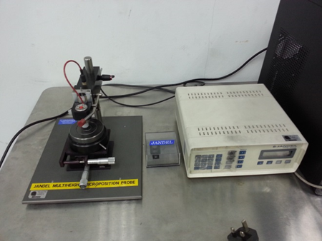
Figure 1. Jandel Multi Height Four Point Probes

Results and Discussion
Physical observation of composites

Based on the images shown in Table 4, there are lumps of materials that can be seen on the surface of 15 % CF and 20 % CF specimens. Besides that, the specimens of 15 % CF and 20 % CF have uneven and bumpy surfaces. This is due to the mixture of G/CF/PP composite that tends to agglomerate when the quantity of CF content is higher. The surface conditions of these composites affect the final properties and the test result of the G/CF/PP composites.

Effects of in-plane conductivity on G/CF/PP composite
In-plane electrical conductivity of G/CF/PP composites with various CF loadings was shown in Figure 2. The electrical conductivity of G/CF/PP composite has increased with the increase of CF loading from 116.29 S/cm (0% CF) to 262.75 S/cm (5% CF). However, when the CF content is further increased, the electrical conductivity has decreased to 105.10 S/cm (10% CF). This is due to the presence of voids in the G/CF/PP composite and the volume has increased with the increment of CF content. Voids have become obstacles or barriers on the network and interaction of conductive fillers. This has affected the in-plane electrical conductivity of G/CF/PP composites [8, 19-20]. The percentage of increment between G/PP composite and G/CF/PP composites with 5% CF content is about 125.94 %. As compared to the DOE target, the value of electrical conductivity of 5% CF content is higher than the target value, which is 100 S/cm. The results are supported by Lee et al. and Mathur et al., in which the electrical conductivity increases with the increasing of carbon fiber loading until the maximum loading and then decreases with further increase in carbon fiber content [7, 8, 18]

The effect of flexural strength of G/CF/PP composite
The flexure strength result is shown in Figure 3. The highest flexural strength of G/CF/PP composite of 40.2 MPa is observed at the CF loading of 5% and it is more than 100% enhancement as compared to the gear/PP composite with no CF content. The value of flexural strength is decreased with a further increment of CF content of 10% to 20%. CF acts as a reinforcement material as CF has a high aspect ratio and its fibrous characteristic can improve the electrical conductivity and flexural strength [8, 9, 22]. Lee et al. also reported the same behaviour of G/CF composites. The flexural strength for 10% and 15% of CF content decreases and later increases with the increasing of CF loading. During the test run for 20% of CF content, the samples did not break in the middle as they should be. It is due to the uneven and rough surface of the specimen and agglomeration between the three materials. This finding shows that there is imperfect bonding between the fibers and binders [8]. This explains the unstable trend in the flexural strength of the composites with high filler loadings. All the composition of G/CF/PP composites achieve higher than the DOE target, which is 25 MPa.

Table 4. Photographs of G/CF/PP composite for each composition

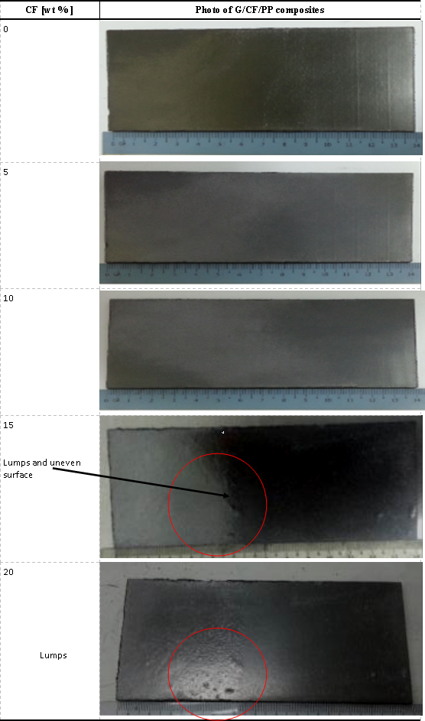

Figure 2. Electrical conductivity and flexural strength against CF content in G/CF/PP composite

Figure 3. Flexural strength against CF content in G/CF/PP composite

The effect of hardness of G/CF/PP composite
The hardness of the composite plate shows a significant improvement from 58.56 (0% CF) to 64.33 (5% CF) although it decreases with the continuing of the CF content as shown in Figure 4. The increment in hardness of the specimens with the addition of CF content can be attributed to the well-known ribbon or glassy carbon structure of PAN based carbon fibers [9]. The increment of hardness value is due to the application of pressure during compression moulding, which increases the interconnectivity and interactions between the reinforcing constituent [10]. Furthermore, the surface’s condition of the composites has highly influenced the result of shore hardness. With more CF content the composite tends to agglomerate, it affects the result of the hardness test. The hardness value is reduced with more CF content. As compared to DOE target, all value of the shore hardness of G/CF/PP are higher than target value, which is 50. According to the result, the composition for a bipolar plate of G/CF/PP composites with 5% CF content is highly recommended.

The effect of bulk density of G/CF/PP composite
Figure 5 shows that the value of bulk density for G/CF/PP composites. It decreases with the increasing of CF contents. Initially, at 0% of CF, the value of bulk density is 1.718 g/cm³ and it drops with the loading of 5% of CF (1.700 g/cm³) and until 1.634 g/cm³ for 20% of CF. The minimum value of bulk density is 1.630 g/cm³ for 15% of CF loading. G has the highest value of density, so when the value of G decreases, the value of bulk density of the specimens also decreases. Besides that, the bulk density for all compositions meets the DOE target, which is lower than 1.9 g/cm^{3.} The density of the specimens decreases with the additional CF contents due to their lower density as compared to G and PP.

Microstructure

Table 5 shows the fractured surface of G/CF/PP composites captured by SEM for various CF content. The scanning electron micrograph shows that the CF is evenly distributed in G/PP composites. Based on the images in Table 5, the CF distribution in each percentage has been distributed well and no agglomeration of CF can be observed. More pulled out fibers are observed than broken fibers as the CF content is increased. Previous research by Lee et al. stated that this indicates that there is incomplete bonding between the fibers and binder, thus making the fibers are easy to pull out. Thus, it explains the decreasing value of the flexural strength with higher CF contents. The voids that occurred during the fabrication process affect the electrical conductivity and mechanical properties result of the composites [23-24]. Moreover, when the CF content increases, the voids also increase. When the voids increase, the result for electrical conductivity and mechanical properties such as flexural strength and hardness decrease. It is proven by the result discussed previously.

Figure 4. Shore hardness versus CF content in G/CF/PP composite

Figure 5. Bulk density versus CF content in G/CF/PP composite
Table 5. Scanning Electron Micrographs of fractured surfaces of G/CF/PP composites for various CF content
CF [wt% ] | SEM micrograph of G/CF/PP composites
0 | 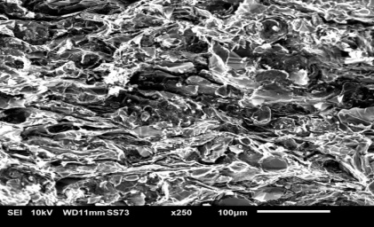
5 | 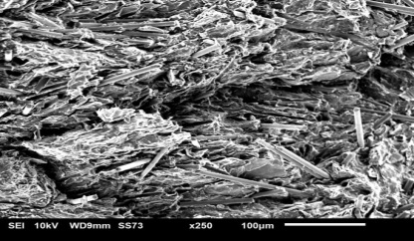
10 | 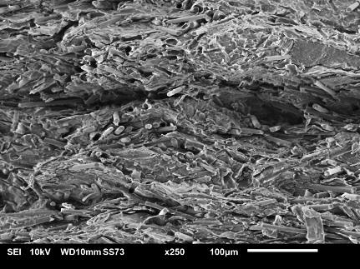  Void
15 | 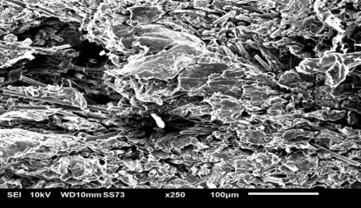  Voids
20 | 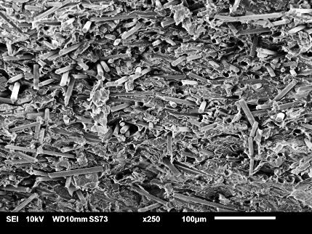  Pulled out fibers  Void

Conclusion

This research has shown that CF as a second filler with polypropylene as a binder had improved the strength and mechanical properties of BP. The addition of CF to the G/PP composite affected the electrical, hardness, strength, and density of G/CF/PP composites. By adding 5 % of CF to the G/PP composite, the in-plane conductivity, flexural strength, and hardness increased and achieved the DOE target for BP. However, by increasing the CF content in the G/PP composite, the in-plane conductivity, flexural strength and hardness were decreased. On the other hand, the density of G/CF/PP composite was decreased with the CF content. The scanning electron micrograph also showed that the material especially CF was distributed evenly in the G/CF/PP composites. It was found that the composite with 5 % of CF content was highly suitable as a bipolar plate for PEMFC. The addition of CF in the G/PP composite can offer a high opportunity in the production of high conductive composites, especially for PEMFC bipolar plates.

Acknowledgement
The authors would like to thank the Malaysia Ministry of Higher Education, Malaysia, and Ministry of Science, Technology, and Innovation for sponsoring this work under Grant PJP/(2013)/FKM(6A)/S01181 and Universiti Teknikal Malaysia Melaka (UTeM) for the financial sponsor of this research.

References
- Sadelil, Y., Soedarsono, J.W., Prihandoko, B. and Harjanto, S. (2012). The effects of gompression pressure applied on the manufacture of carbon composite bipolar plate for PEMFC by utilizing gaphite waste products. Advanced Materials Research, 42: 6-66.
- Besmann, T. M., Henry, J. J. and Klett, J.W. (2002). Carbon composite bipolar plate for PEM fuel cells. National Laboratory R&D Review DOE Fuel Cells for Transportation Program Denver, Colorado.
- Brief, T. (2008). Carbon-filled polymer blend based bipolar plates for PEM fuel cell stack. Chapter in Polymer membranes for fuel cells. Springer: pp 281-305.
- Hwang, I. U., Yu, H. N., Kim, S. S., Lee, D. G., Suh, J. Do, Lee, S. H., Ahn, B. K., Kim, S. H. and Lim, T.W. (2008). Bipolar plate made of carbon fiber epoxy composite for polymer electrolyte membrane fuel cells. Journal of Power Sources, 184(1): 90-94.
- Yean D. K., Chong K. W., Cheng Y., Po C. L., Yu S. S. and Cheng Y. L. (2020). Fuel cell stack design using carbon fiber composites. Sensors and Materials, 32(12): 4233-4244.
- Stauffer, D. B., Hirschenhofer, J. H., Klett, M. G. and Engleman, R. R. (1998). Fuel cell handbook (No. DOE/FETC-99/1076). Federal Energy Technology Center (FETC), Morgantown, WV, and Pittsburgh, PA.
- Selamat, M. Z., Ahmad, M. S., Daud, M. A. M., Jusoff, K., and Saparudin, M. F. (2013). The hybrid conductive filler in the bipolar plate for polymer electrolyte membrane fuel cells. Australian Journal of Basic and Applied Sciences, 7(3): 72-77.

- Lee, J. H., Jang, Y. K., Hong, C. E., Kim, N. H., Li, P. and Lee, H. K. (2009). Effect of carbon fillers on properties of polymer composite bipolar plates of fuel cells. Journal of Power Sources, 193(2): 523-529.
- Mathur, R. B., Dhakate, S. R., Gupta, D. K., Dhami, T. L. and Aggarwal, R. K. (2008). Effect of different carbon fillers on the properties of Gaphite composite bipolar plate. Journal of Materials Processing Technology, 203(1-3): 184-192.
- Dicks, A. L. (2006). The role of carbon in fuel cells. Journal of Power Sources, 156(2): 128-141.
- Ahmad, M. S., Selamat, M. Z., Daud, M. A. M., Yunus, I. K. M. and Azman, M. S. (2013). Effect of different filler materials in the development of bipolar plate composite for polymer electrolyte membrane fuel cell (PEMFC). Applied Mechanics and Materials, (315): 226-230.
- Antunes, R. A., Lopes de Oliveira, M. C. and Ett, G. (2011). Investigation on the corrosion resistance of carbon black–Gaphite-poly(vinylidene fluoride) composite bipolar plates for polymer electrolyte membrane fuel cells. International Journal of Hydrogen Energy, 36(19): 12474-12485.
- Selamat, M. Z., Ahmad, M. S., Daud, M. A. M. and Ahmad, N. (2013). Effect of carbon nanotubes on properties of gaphite/carbonblack/poly- propylene nanocomposites. Advanced Materials Research, 795: 29-34.
- Zulfiqar A., Yuan G., Bo T., Xinfeng W., Ying W., Maohua L., Xiao H., Linhong L., Nan J. and Jinhong Y. (2021). Preparation, properties and mechanisms of carbon fiber/polymer composites for thermal management applications. Polymers, 13:169.
- Blunk, R., Abd Elhamid, M. H., Lisi, D. and Mikhail, Y. (2006). Polymeric composite bipolar plates for vehicle applications. Journal of Power Sources, 156(2): 151-157.
- Bourell, D. L., Leu, M. C., Chakravarthy, K., Guo, N. and Alayavalli, K. (2011). Gaphite-based indirect laser sintered fuel cell bipolar plates containing carbon fiber additions. CIRP Annals - Manufacturing Technology, 60(1): 275-278.
- Brocks, T., Cioffi, M. O. H. and Voorwald, H. J. C. (2013). Effect of fiber surface on flexural strength in carbon fabric reinforced epoxy composites. Applied Surface Science, 274: 210-216.
- Selamat, M. Z., Sahari, J., Muchtar, A. and Muhamad, N. (2011). Simultaneous optimization for multiple responses on the compression moulding parameters of composite gaphite - polypropylene using Taguchi method. Key Engineering Materials, 471-472: 361-366.
- Selamat, M. Z., Sahari, J., Muhamad, N. and Muchtar, A. (2011). The effects of thickness reduction and particle sizes on the properties gaphite - polypropylene composite. International Journal of Mechanical and Materials Engineering, 6(2): 194-200.
- Iswandi, Sulong, A. B. and Husaini, T. (2019). Effects of graphite/polypropylene on the electrical conductivity of manufactured bipolar plate. Malaysian Journal of Analytical Sciences, 23(2 ): 355-361.
- Suherman, H., Sulong, A. B. and Sahari, J., 2013. Effect of the compression molding parameters on the in-plane and through-plane conductivity of carbon nanotubes/graphite/epoxy nanocomposites as bipolar plate material for a polymer electrolyte membrane fuel cell. Ceramics International, 39(2): 1277-1284.
- Dweiri, R. and Sahari, J. (2007). Electrical properties of carbon-based polypropylene composites for bipolar plates in polymer electrolyte membrane fuel cell (PEMFC). Journal of Power Sources, 171(2): 424-432.
- Zakaria, M. Y., Sulong, A. B., Sahari, J. and Suherman, H. (2015). Effect of the Addition of Milled Carbon Fiber as a Secondary Filler on the Electrical Conductivity of Gaphite/Epoxy Composites for Electrical Conductive Material. Composites Part B: Engineering, 83: 75-80.
- Alol, A., Otunniyi, I. O. and Pienaar H.C.V.Z. (2019). Prospects of graphite - polypropylene/epoxy blend composite for high performance bipolar plate in polymer electrolyte membrane fuel cell. IOP Conference Series: Material Science and Engineering, 655: 012035.

