

EFFECT OF PLANT ORGANS OF Ficus deltoidea IN THE SYNTHESIS

OF SILVER NANOPARTICLES

(Kesan Organ Tumbuhan Ficus deltoidea dalam Mensintesis Nanopartikel Perak)

Shahrulnizahana Mohammad Din^{1,2}, Nik Ahmad Nizam Nik Malek^{1,3,*}, Mustaffa Shamsuddin⁴, Juan Matmin⁴

¹Department of Biosciences,
Faculty of Science,
Universiti Teknologi Malaysia, 81310 UTM Johor Bahru, Johor, Malaysia
²Department of Chemistry Malaysia,
Johore Branch, Jalan Abdul Samad, 80100 Johor Bahru, Johor, Malaysia
³Centre for Sustainable Nanomaterials (CSNano),
Ibnu Sina Institute for Scientific and Industrial Research (ISI-SIR),
Universiti Teknologi Malaysia, 81310 UTM Johor, Malaysia
⁴Department of Chemistry,
Faculty of Science,
Universiti Teknologi Malaysia, 81310 UTM Johor Bahru, Johor, Malaysia

*Corresponding author: niknizam@utm.my

Received: 8 September 2021 ; Accepted: 26 September 2021 ; Published: xx October 2021

Abstract
The effect of different plant organ extracts (leaf, stem, fig and root) of Ficus deltoidea var. kunstleri (King) Corner (Mas Cotek) in the synthesis of silver nanoparticles (AgNP) was studied. The plant analysis using liquid chromatography-mass spectrometry (LCMS) yielded more than 100 phytochemical compounds in each organ, of which around 50 % belong to the phenolics, flavonoids and polyphenols compounds. The biomarker compounds (vitexin and isovitexin) were only found in the leaf, and Total Phenolic Content (TPC), as well as Total Flavonoid Content (TFC) were observed to be the highest in fig compared to other organs. The localized surface plasmon resonance (LSPR) of the biosynthesised AgNP using all organs was found at 409 to 428 nm. The capping and stabilization of AgNP by phytochemical compounds were verified by Fourier transform infrared (FTIR) spectroscopy as the vibration and stretching of -NH, -CH₃, -CH₂, -CH, C=O and -OH functional groups were found. There was a high abundance of phytochemical compounds in each organ: gallic acid, kaempferol-3-(6''-caffeoylglucoside), quercetin-3-O-rhamnoside and kaempferol 3-(3'',4''-diacetylrhamnoside) in leaf, stem, fig and root, respectively. These compounds belong to the phenolics, flavonoids and polyphenols groups responsible for reducing Ag⁺ to Ag⁰ (AgNP). The results indicated that the fig which contained the highest TPC and TFC formed the highest LSPR peak for the formation of AgNP. The most important finding was the ability of each plant organ of F. deltoidea in the AgNP biosynthesis.

Keywords: plant organs, Ficus deltoidea, biosynthesis, nanoparticles

Abstrak

Kesan ekstrak organ tumbuhan yang berbeza (daun, batang, ara dan akar) dari pokok Ficus deltoidea var. kunstleri (King) Corner (Mas Cotek) dalam mensintesis nanopartikel perak (AgNP) dianalisis dalam kajian ini. Analisis pokok menggunakan spektometri jisim kromatografi cecair (LC-MS) menemui lebih dari 100 sebatian fitokimia di setiap organ, di mana sekitar 50% tergolong dalam sebatian fenolik, flavonoid dan polifenol. Sebatian penanda bio (vitexin dan isovitexin) hanya terdapat pada daun, dan kandungan jumlah fenolik (TPC) serta kandungan jumlah flavonoid (TFC) diperhatikan pada bahagian ara adalah tertinggi berbanding organ lain. Resonans plasmon permukaan setempat (LSPR) bagi AgNP biosintesis menggunakan semua organ didapati dalam lingkungan 409 hingga 428 nm. Pembatasan dan penstabilan AgNP oleh sebatian fitokimia disahkan oleh spektroskopi inframerah transformasi Fourier (FTIR) sebagai getaran dan perenggangan kumpulan berfungsi -NH, -CH₃, -CH₂, -CH, C=O dan -OH di kesan. Terdapat sebilangan besar bahan fitokimia di setiap organ iaitu galik asid, kaempferol-3-(6"-kafeglukosida), quersetin-3-O-ramnosida dan kaempferol 3-(3",4"-diasetilramnosida) di bahagian daun, batang, ara dan akar masing-masing. Sebatian ini tergolong dalam kumpulan fenolik, flavonoid dan polifenol yang bertanggungjawab untuk penurunan Ag⁺ ke Ag⁰ (AgNP). Hasil kajian menunjukkan bahagian ara yang mengandungi TPC dan TFC tertinggi membentuk puncak LSPR tertinggi untuk pembetukan AgNP. Penemuan yang paling penting adalah kemampuan setiap organ pokok F. deltoidea dalam biosintesis AgNP.

Kata kunci: organ tumbuhan, Ficus deltoidea, biosintesis, partikel-nano

Introduction

Plant organs such as leaves, stems, roots, flowers, fruits, and seeds have diverse phytochemical compounds [1]. The type and concentration of the phytochemical compounds depend on the metabolism and the functions of the plant organs [2]. Diversity of the growing climate, different harvesting times and stress conditions affect the concentration of the phytochemical compound in the same species or source of the plant [3, 4, 5]. Phytochemical compounds are plant-part specific and vary extensively among different plant populations [5]. It usually consists of tannins, saponins, alkaloids, terpenoids, steroids, proteins, amino acids, phenolic and flavonoid compounds [6]. These phytochemicals give colour and odour for protection and reproduction, serve as phytoalexins for pathogen resistance, are involved in hormonal functions for growth and signalling, act as antifeedants or toxins for pests protection, and allelochemicals for defence against herbivorous animals [7].

Furthermore, plant phenolics and flavonoids can reduce Ag⁺ to Ag⁰ producing silver nanoparticles (AgNP) because of their functional groups being rich in electrons, forming complexes that are disunited to form AgNP. It is acknowledged that the hydroxyl group (O-H) of the phenolics and flavonoids firmly hold the Ag⁺ in an oligomeric cluster, resulting in the formation of aggregates that stabilise into AgNP [8].

For many years, plants with high phytochemicals have been used as medicinal herbs due to their high nutritional values, rich sources of antioxidants that may slow down ageing processes, reduce inflammation and prevent certain diseases [1, 9]. One of the native medicinal plants available in Malaysia is Ficus deltoidea Jack var. kunstleri (King) Corner, which is also known as Mas Cotek. Traditionally, this plant has been developed as an alternative treatment for diabetes, hypertension, blood flow, gout, pneumonia, cardiac problems, diarrhoea and skin infection [10]. The chemical marker of this plant which are vitexin and isovitexin (flavonoid group) have many medicinal benefits to human. Previous studies have shown that these substances exhibit anti-tumour, anti-inflammatory, and antinociceptive properties [7, 8].

Typically, F. deltoidea can reach a height of 2 m, possesses whitish-grey stems and bark when mature. It has broadly spoon-shaped leaves, The leaves range in sizes from 4 to 8 cm with bright green colour on top and rust-red to olive-brown at the bottom. Furthermore, this plant produces yellow to orange figs with a width of about 1.0 to 1.5 cm [12] and also has fibrous brown roots. The different organs of F. deltoidea like the leaf, stem, fig and root may contain different phytochemical compounds. In the biosynthesis of AgNP, the reducing ability of any plant organ strongly depends on the presence of a phytochemical compound. However, there are still limited studies on the effect of plant organs on the synthesis of AgNP. This study focused on the analysis of phytochemical compounds of different organs of F. deltoidea and its initial effect on the formation of AgNP.

Materials and Methods
Chemical and reagents
Silver nitrate (AgNO₃) ≥ 99.0% was purchased from Vchem. Aluminum chloride (AlCl₃) ≥ 98.0%, sodium nitrite (NaNO₂) ≥ 99.0%, sodium hydroxide (NaOH) 99%, nitric acid (HNO₃) 69%, potassium bromide for infrared (IR) spectroscopy, methanol ≥ 99.8% for liquid chromatography usage, ethanol ≥ 99.9% for liquid chromatography usage, formic acid 97.5-98.5% and quercetin ≥ 95% were procured from Merck. Both vitexin ≥ 95.0% and isovitexin ≥ 98.0% were acquired from Sigma-Aldrich. Gallic acid was purchased from R&M Chemical.

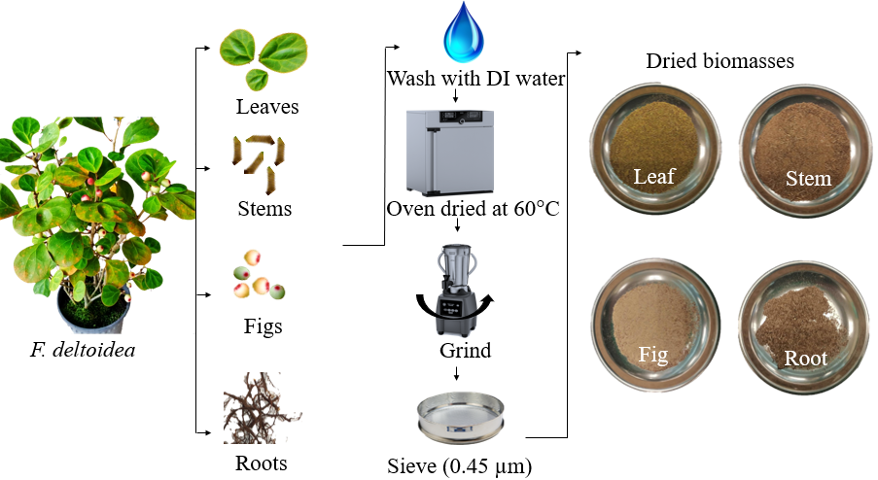

Figure 1. Illustration of the process flow of preparing dried plant biomasses of different organs

F. deltoidea plant extract
The F. deltoidea, with the age of about four years, was provided by the Department of Agriculture Malaysia, Pontian, Johor Branch. The plant was segregated according to its organs: leaf, stem, fig and root. They were cleaned with deionised water to remove unwanted impurities like sand, gravel, insects, bugs, and other contaminants. After that, the plant organs were dried in a 60 °C oven. The dried plant organs were then ground and sieved with a mesh size of 0.45 µm. The dried powdered biomasses were stored in a chiller at 4 °C for later use. Figure 1 shows the illustration of the process flow to obtain the dried plant biomasses.

The process involved mixing 2 g of the dried biomass with 100 ml of boiled deionised water. A hotplate with a magnetic stirrer was used to stir the mixture for 30 minutes at 100 °C [13]. The plant extracts were then filtered with Whatman No 1 filter paper, and the filtrate was stored at 4°C for future use.

Screening of Phytochemical Compounds using Liquid Chromatography Mass Spectrometer (LC-MS)
Ethanol 96% was used as a maceration solvent to macerate 45 g of dried biomass. This procedure took three days to complete. The maceration solvent was replaced for every 24 hours. The ratio of the dried biomass powder weight (g) to solvent (ethanol 96%) volume (L) was 500:6. The maceration solution was collected, and an evaporator was used to separate the solvent and dissolved chemicals generated from the dried biomass. The evaporation procedure was used to generate a paste of approximately 45 g, which was then considered to be at 100% concentration. The LCMS analysis was performed using the Shimadzu LCMS 2010 EV and a reverse phase LC system. The mobile phase of acetonitrile distillation to water ratio was 7:3, and the ammonium acetate concentration was 10 mmol/L. The LC pump gradient system with a vacuum pump flow velocity of 1 mL/min and C-18 column (150 mm × 2.1 mm) with a column temperature of 40 °C were used in this analysis. Only 10 µL of the sample was injected in a single run using a gas nitrogen generator at 250 °C. Positive Ion Electroscopy was used with a Mass Spectrometry Detector (SPD-10 AVP).
Analysis of Vitexin and Isovitexin using High-Performance Liquid Chromatography (HPLC)
Vitexin and isovitexin were selected as chemical markers for F. deltoidea varietal identification [10]. A round bottom flask was filled with 5.0 g of dried biomass and added with 80 mL of ethanol 96%. The sample was allowed to cool after being refluxed for 30 minutes. Thereafter, the sample was filtered with Whatman No. 1 filter paper and the filtrate was evaporated. Methanol (HPLC grade) was used to dissolve 50.0 mg of the dried extracts. It was then injected into the High-Performance Liquid Chromatography (HPLC) column after being filtered with a 0.45 µm syringe filter using HPLC Agilent 1260 Infinity. The injection volume was 10 µl, and the isocratic mobile phase that carried the sample to be separated was a mixture of six volumes of 1% formic acid and four volumes of methanol. The flow rate was set to 1.0 mL/min and the sample was separated in a C-18 column with 250 mm × 4.6 mm and an oven temperature of 30 °C. For each sample, the run time was 15 minutes.

Total Phenolic Content and Total Flavonoid Content
Total phenolic content (TPC) was determined by mixing 1.0 mL of the sample with 0.5 mL of Folin-Ciocalteu reagent and 1.5 mL of Na₂CO₃ 20% solution. The mixture was then incubated for half an hour at 40 °C before being measured with a Jenway 7200 Visible spectrophotometer at 750 nm. For Total Flavonoid Content (TFC) analysis, 0.3 mL NaNO₂ solution 5% was mixed with 1 mL sample and the mixture was left for five minutes. After that 0.3 mL of AlCl₃ 10% solution was added to the sample and the solution was makeup to 10 mL. The sample was measured using the visible spectrophotometer at 510 nm. TPC and TFC values were calculated based on the formula (Equation 1 and 2) obtained from the literature [13], which were expressed in mg of Gallic acid per 1g dry extract (Gallic Acid Equivalent; GAE) and mg of Quercetin equivalent (QE) per gram of dry mass (g), respectively.

$Total phenolic compound, (GAE)\left(\frac{mg}{g}\right), =\frac{C_{1}V}{M}$ (1)
$Total Flavonoid Content, \left(QE\right)\left(\frac{mg}{g}\right), =\frac{C_{1}V}{M}$ (2)
where, GAE is gallic acid equivalent, QE is quercetin equivalent, C₁ is concentration gained from calibration curve, V is volume of extract, mL and M is mass of plant biomass (g).

Formation of AgNP using Organs of F. deltoidea
For the formation of the AgNP, the aqueous plant extracts were added to 10 ml of AgNO₃ 1 mM according to the synthesis conditions as shown in Table 1. The synthesis parameters were selected based on our experiment on optimizing the AgNP synthesis method (Data not shown and will be published elsewhere). The formation of AgNP was monitored using a Jenway 7200 Visible Spectrophotometer in the visible range of 350 to 750 nm. This is due to the fact that AgNP exhibited a localized Surface Plasmon Resonance (LSPR) band at this range based on its free electron excitation [14]. The functional groups of F. deltoidea extracts and biosynthesised AgNP (powder form) were analyzed using Fourier Transform Infrared Spectroscopy (FTIR). This analysis was performed on a Perkin Elmer FTIR 1600 using the KBr technique in the range of 4000 – 400 cm⁻¹.

Results and Discussion
The LCMS results in Figure 2 indicated that the leaf, stem, fig, and root produced signals at different retention times (RT) of 127, 129, 104, and 119 peaks, respectively. The RT signals could be attributed to the presence of phytochemical compounds. Based on the chromatogram, it can be said that more than 50% of them were phenolics, flavonoids and polyphenol compounds. Among the phytochemical compounds found in F. deltoidea are rutin, quercetin, naringenin, vitexin, and isovitexin. The selected phytochemical compounds content (in percentage) is shown in Table 2.

Notably, these phytochemical compounds act as biological defenses for unicellular and multicellular plants, protect biological cells, tissues and organs of plants from damages caused by oxidative stress, and as plant metabolites, they prevent inflammation and promote carbohydrate metabolism [14-19]. The highest phytochemical compounds identified in each organ are tabulated in Table 2. On that note, gallic acid was identified in the leaf, kaempferol-3-(6''-caffeoylglucoside) in the stem, quercetin-3-O-rhamnoside in fig and kaempferol 3-(3'',4''- diacetylrhamnoside) in the root. The molecular structures of these phytochemical compounds are shown in Figure 3.

To validate the chromatogram, the retention time (RT) of a specific flavonoid of vitexin and isovitexin at 7.4 and 8.7 minutes, respectively was used in the HPLC analysis (Figure 4). Notably, these compounds were found at 17.84 ± 2.57 ppm of vitexin and 13.92 ± 0.44 ppm of isovitexin in the leaves of F. deltoidea. It was abundantly found in the leaf organ. This finding is in line with the study that has been conducted by Abdullah et al. [17], which found that the concentration of vitexin was higher than that of isovitexin in the leaf of F. deltoidea. He at al. [18] mentioned that in Lemna minor plant, vitexin was found to be converted to isovitexin and not in reverse direction. These phytochemical compounds serve as siderophores, attractants and feeding deterrents in plant [17]. From previous studies, these compounds also found in various plants such as mung beans, wheat leaves and bamboo [18].
Figure 5 shows the TPC and TFC values of the extracts of F. deltoidea measured using the Folin-Ciocalteu method and Aluminium chloride colourimetric assay, respectively. It is important to determine both compounds composition in the plants as the formation of AgNP highly depends on their presence. This was emphasised by Asmat-Campos et al. as they stated that the presence of polyphenol promotes the reduction and capping of nanoparticles [19]. In the Folin-Ciocalteu method, the reagent used was composed of a mixture of phosphotungstic acid and phosphomolybdic acid, which were reduced to a mixture of blue oxides of tungsten and molybdenum once the phenols were oxidised. The blue colour produced had a maximum absorption in the 750 nm range and was proportionate to the total amount of phenolic compounds present in the sample [20]. To determine the TFC, the Aluminium chloride reacted with the flavone, flavanol and hydroxyl/dihydroxyl group in the flavonoids [21]. From the result, the leaf organ of F. deltoidea contains 28.56 ± 0.87 (GAE) mg/g TPC and 761.32 ± 13.00 (QE) mg/g. These results are lower than the leaf of Vigna Unguiculate Dhawala which contains 508.7 (GAE) mg/g and 1303.1 (QE) mg/g, respectively [22]. Meanwhile, the fig organ of F. deltoidea had the highest TPC and TFC values compared to other organs. Even though the number of phytochemical compounds in fig is the lowest, this organ has the highest TPC and TFC values.

Table 1. AgNP synthesizing conditions

Plant Organs | Plant Extract Volume (mL) | Reaction Time (Hours) | Reaction Temperature (°C) | pH of Plant Extract
Leaf | 1.0 | 30 | 60 | 10
Stem | 1.0 | 21 | 90 | 12
Fig | 0.8 | 33 | 100 | 10
Root | 3 | 21 | 90 | 12

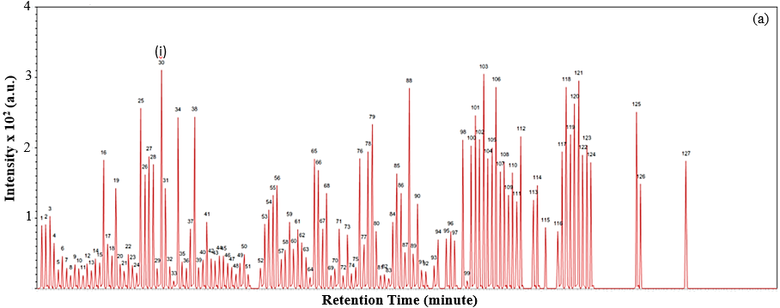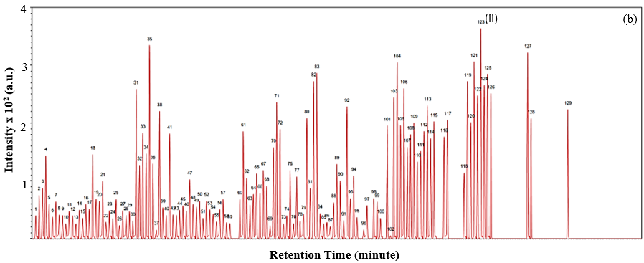

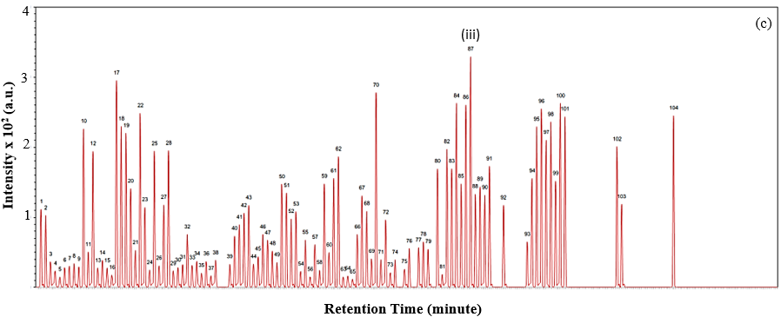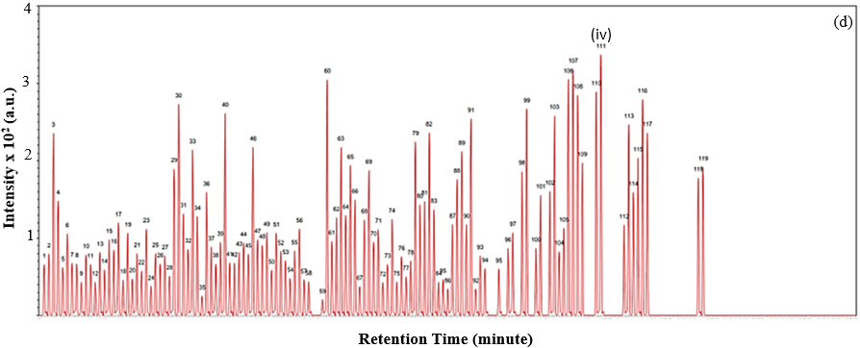
Figure 2. LCMS chromatogram of the phytochemical compounds found in (a) leaf, (b) stem, (c) fig and (d) root of F. deltoidea. The labelled peaks are the highest phytochemical compounds contained in each organ which are (i) gallic acid was identified in the leaf, (ii) kaempferol-3-(6''-caffeoylglucoside) in the stem, (iii) quercetin-3-O-rhamnoside in fig and (iv) kaempferol 3-(3'',4''- diacetylrhamnoside) in the root.

Table 2. The percentage of phytochemical compounds in F. deltoidea

Phytochemical Compounds | Retention Time (min) | Mass to Ion Ratio (m/z) | % Compound
Phytochemical Compounds | Retention Time (min) | Mass to Ion Ratio (m/z) | Leaf | Stem | Fig | Root
P-coumaric acid | 1.859 | 164.05 | 1.91 | 1.79 | 2.71 | 1.28
Gallic acid^{i} | 3.042 | 170.02 | 2.32 | 2.32 | 2.28 | 1.45
Chlorogenic acid | 12.421 | 354.10 | 2.12 | 1.58 | 2.55 | 1.72
Luteolin-7-glucoside | 22.628 | 448.10 | 2.15 | 1.80 | 2.41 | 1.05
Quercetin-3-O-rhamnoside^{iii} | 24.003 | 432.11 | 2.14 | 1.39 | 3.02 | 1.75
Kaempferol 3-(3''-  acetylrhamnoside) | 24.77 | 75.03 | 1.23 | 1.60 | 1.21 | 2.15
Kaempferol 3-(3'',4''-  diacetylrhamnoside)^{iv} | 28.208 | 516.13 | 1.10 | 1.42 | 1.08 | 2.28
Kaempferol-3-(6''-  caffeoylglucoside)^{ii} | 35.508 | 610.13 | 2.21 | 2.52 | 2.17 | 1.89

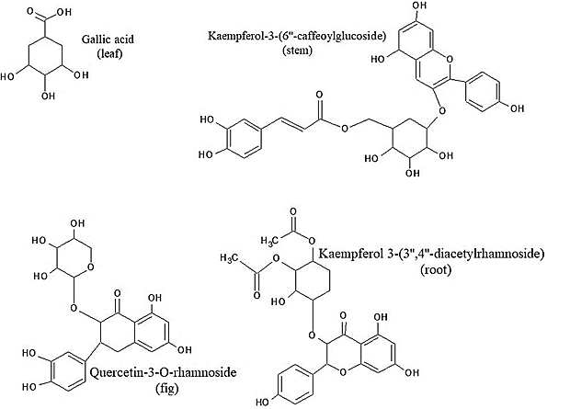

Figure 3. Molecular structures of main phytochemicals compounds in each F. deltoidea organs

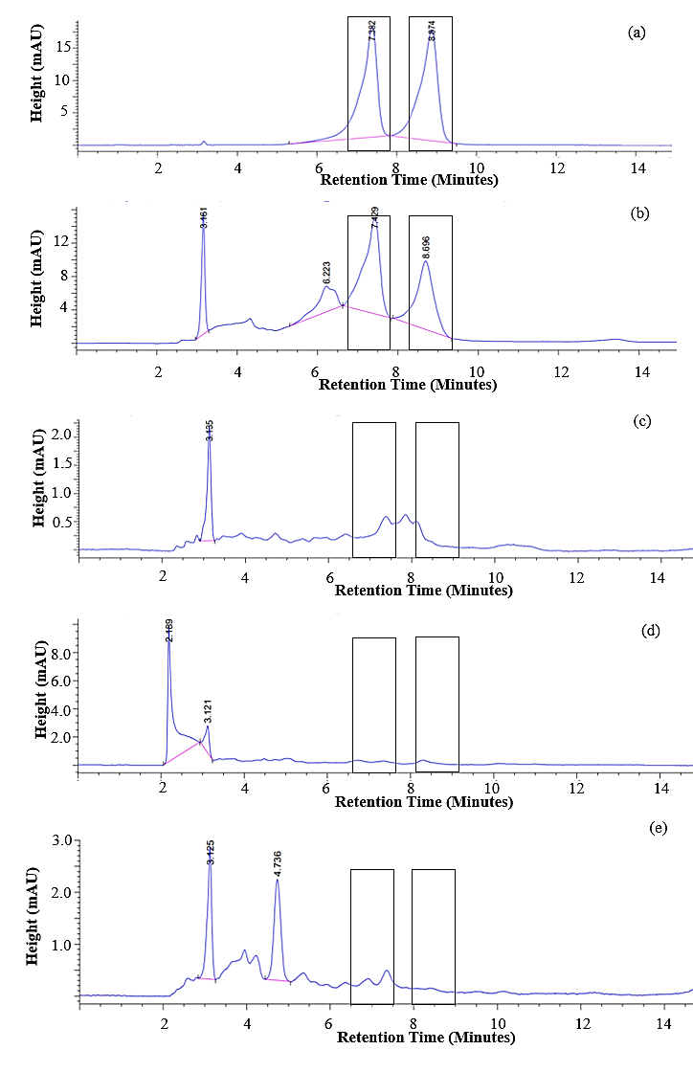

Figure 4. HPLC chromatograms of vitexin and isovitexin in (a) mixed standards, (b) leaf, (c) stem, (d) fig and (e) root

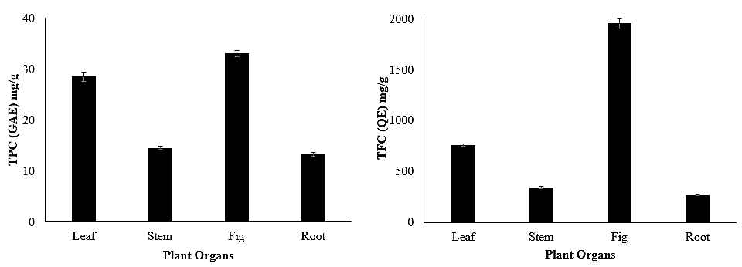
Figure 5. TPC and TFC values of different plant organs of F. deltoidea

In this study, different organs of the plant extract were used in the biosynthesis of AgNP. As shown in Figure 6(a), the formation of AgNP was conducted by monitoring the LSPR peak in the range of 350 to 750 nm. The FTIR spectra of the plant biomass and the biosynthesised AgNP using each plant organ can be seen in Figure 6(b and c).

In Figure 6(a), the LSPR absorbance peak of the biosynthesised AgNP using F. deltoidea was observed in the visible region between 409 and 428 nm. Based on the LCMS result, the stem had the highest number of phytochemical compounds while fig recorded the lowest percentages; however, the TPC, TFC and capability to form AgNP according to LSPR peak did not follow this trend. This means that the phenolics, flavonoids and polyphenol compound greatly influenced the ability to synthesis AgNP compared to the number of phytochemical compounds in the plant organ. According to Beer-Lambert’s Law, it can be deduced that the formation of AgNP was highest when using the fig organ. This aligns with the works of Lavola et al. [5], where they discovered that phenolic content in the fruit of Empetrum hermaphroditum was the highest compared to other organs. Nonetheless, the role of each organ in plant physiology could be attributed to the presence of different phenolics content [23]. This also leads to different organ capabilities in the biosynthesis of AgNP. Moreover, the complexity and massive amounts of different phytochemicals in any plant extract is the major challenge in determining the exact phytochemical responsible for the biosynthesis of AgNP [22, 23]. Taking this into account, it is safe to suggest that the oligomeric cluster may comprise one or more phytochemicals that capped and stabilised the AgNP [26].
In the FTIR spectra of F. deltoidea plant extract, the peak at 3430 cm⁻¹ revealed stretching of the amide (N–H) bond and hydroxyl (–OH) groups. From the IR spectra, the absorption peak at 2920 cm⁻¹ could be attributed to –CH₃ and –CH₂ stretching vibrations. C-H stretching from the alkane group causes the absorption peak at 2830 cm⁻¹. The C=O stretching had a peak at 1735 cm⁻¹, whereas C=C stretching had a peak at 1620 cm⁻¹. The O-H bending from the carboxylic acid functional group is represented by the peak at 1430 cm⁻¹. All of these functional groups corroborated the phytochemical compounds identified by LCMS. The same stretching and vibration bands were observed in the biosynthesised AgNP, indicating the presence of phytochemical compounds from F. deltoidea in the AgNP samples, which acted as a capping and stabilising agent in Figure 6(b and c).

From the plant analysis, F. deltoidea can be interpreted as a herbal plant that is rich in phenolics, flavonoids and polyphenols compounds. Its organs (leaf, stem, fig and root) have unique functions and metabolisms that make the amount and variety of phytochemical compounds differ from one another. Hence, they have the ability and capability of synthesising AgNP. It can be expected that the AgNP produced has distinct characteristics. The high TPC and TFC values impacted the formation of AgNP tremendously. This was reflected by the fact that the plant organ (fig) that had the highest phenolics and flavonoids exhibited the highest LSPR peak. This composition contributed to the highest formation of biosynthesis AgNP by the fig organ. In this study, phytochemical compounds are not only used as a reducing agent but also proved to be the stabilising agent for AgNP.

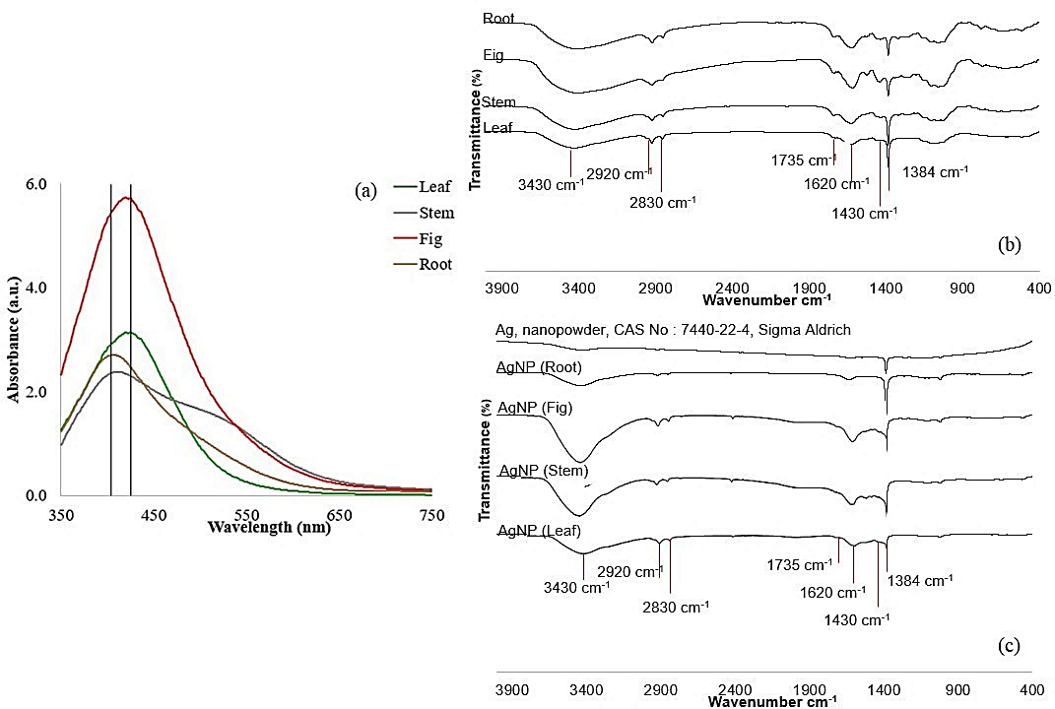
Figure 6. (a) LSPR absorbance for AgNP, (b) FTIR spectra of plant biomasses (b) and (c) biosynthesised AgNP

Conclusion
F. deltoidea Jack var kunstleri (King) Corner is a native herb that is rich in phytochemical compounds. From the LC-MS analysis, more than half of the phytochemicals belong to the phenolics, flavonoids and polyphenols group. The validation analysis also revealed that a specific flavonoid of vitexin and isovitexin were only detected in the leaf organ. The phytochemical compounds in plant extracts have the capability in the biosynthesis of AgNP by assisting the LSPR absorbance peak formed at 409 to 428 nm. The FTIR result revealed that the phytochemical compounds also served as a capping and stabilising agent for the formation of AgNP due to the diverse composition and high content of phytochemical compounds in F. deltoidea. In conclusion, this study adds to the body of knowledge on phytochemical compounds in plant organs spectrum in biosynthesising AgNP. Thus, this information could be used to manufacture AgNP from suitable plant organs.

Acknowledgement
The Author would like to give thanks to the Ministry of Higher Education and Universiti Teknologi Malaysia for funding and supporting this research project under Fundamental Research Grant Scheme (FRGS/1/2020/STG04/UTM/02/3) with Vot No: 5F291 and UTM-TDR project (Vot No: 06G71 and 06G72).

References
- Muhamad I. I, Hassan N. D, Mamat S. N. H., Nawi N. M., Rashid W. A. and Tan N. A. (2017). Extraction technologies and solvents of phytocompounds from plant materials: Physicochemical characterization and identification of ingredients and bioactive compounds from plant extract using various instrumentations. Ingredients Extraction by Physico-Chemical Methods in Food, pp. 523-560.
- Deepak K., Shirsat R. and Kawale M. (2016). An overview of major classes of phytochemicals: Their types and role in disease prevention. Hislopia Journal, 9: 1-11.
- Ou B., Huang D., Hampsch-Woodill M., Flanagan J. A. and Deemer E. K. (2002). Analysis of antioxidant activities of common vegetables employing oxygen radical absorbance capacity (ORAC) and ferric reducing antioxidant power (FRAP) assays: A comparative study. Journal of Agricultural and Food Chemistry, 50 (11): 3122-3128.
- Rao B. N. (2003). Bioactive phytochemicals in Indian foods and their potential in health promotion and disease prevention. Asia Pacific Journal of Clinical Nutrition, 112(1): 9-22.
- Lavola A., Salonen A., Virjamo V. and Julkunen-Tiitto R. (2017). Phytochemical Variation in the plant-part specific phenols of wild crowberry (Empetrum hermaphroditum Hagerup) populations. Phytochemistry Letter, 21: 11-20.
- Alim A., Ghazali W. A. S. W., Ali N. A. M. and Ponnuraj K. T. (2017). Phytochemical properties and traditional uses of selected medicinal plants in Malaysia: A review. Journal of Biomedical Science, 2(2): 4–25.
- Huang Y., Xiao D., Burton-freeman B. M. and Edirisinghe I. (2016). Chemical changes of bioactive phytochemicals during thermal processing, pp. 1-9.
- Goswami M., Baruah D. and Das A. M. (2018). Green synthesis of silver nanoparticles supported on cellulose and their catalytic application in the scavenging of organic dyes. New Journal of Chemistry, 42(13): 10868–10878.
- Altemimi A., Lakhssassi N., Baharlouei A., Watson D. G. and Lightfoot D. A. (2017). Phytochemicals: Extraction, isolation, and identification of bioactive compounds from plant extracts. Plants, 6 (4): 1-23.
- Afzan A., Kasim N., Hadiani N., Norfaizura I., Abdul A., Ali M. and Mat N. (2019). Differentiation of Ficus deltoidea varieties and chemical marker determination by UHPLC-TOFMS metabolomics for establishing quality control criteria of this popular Malaysian medicinal herb. Metabolomics, 15(3): 1–11.
- Nasma A., Aishath N., Azilah A., and Sulaiman A. Z. (2018). Optimization of vitexin and isovitexin compounds extracted from dried mas cotek leaves using one-factor-at-a-time (OFAT) approach in aqueous extraction. International Food Research Journal, 25(6): 2560-2571.
- Bunawan H., Amin N. M., Bunawan S. N., Baharum S. N. and Noor N. M. (2014). Ficus deltoidea Jack: A review on its phytochemical and pharmacological importance. Evidence-Based Complementary and Alternative Medicine, 2014: 1-8.
- Singhal A., Singhal N., Bhattacharya A. and Gupta A. (2017). Synthesis of silver nanoparticles (AgNPs) using Ficus retusa leaf extract for potential application as antibacterial and dye decolourising agents. Inorganic and Nano-Metal Chemistry, 47(11): 1520-1529.
- He Y., Wei F., Ma Z., Zhang, H., Yang Q., Yao B. and Zhang Q. (2017). Green synthesis of silver nanoparticles using seed extract of Alpinia katsumadai, and their antioxidant, cytotoxicity, and antibacterial activities. RSC Advances, 7 (63): 39842-39851.
- Labeeuw L., Martone P. T., Boucher, Y. and Case R. J. (2015). Ancient origin of the biosynthesis of lignin precursors. Biology Direct, 10 (23): 1–21.
- Mierziak J., Kostyn K., and Kulma A. (2014). Flavonoids as important molecules of plant interactions with the environment. Molecules, 19 (10): 16240-16265.
- Abdullah F. I. and Chua L. S. (2017). Prediction of c-glycosylated apigenin (Vitexin) biosynthesis in Ficus deltoidea based on plant proteins identified by LC-MS/MS. Frontiers in Biology, 12(6): 448-458.
- He M., Min J. W., Kong W. L., He X. H., Li J. X. and Peng B. W. (2016). A review on the pharmacological effects of Vitexin and Isovitexin. Fitoterapia, 115:74–85.
- Asmat-Campos D., Abreu A. C., Romero-Cano M. S., Urquiaga-Zavaleta J., Contreras-Cáceres R., Delfín-Narciso D., Juárez-Cortijo L., Nazario-Naveda R., Rengifo-Penadillos R. and Fernández I. (2020). Unraveling the active biomolecules responsible for the sustainable synthesis of nanoscale silver particles through nuclear magnetic resonance metabolomics. ACS Sustainable Chemistry & Engineering, 8(48): 17816-17827.
- Kamtekar S., Keer V. and Patil V. (2014). Estimation of phenolic content, flavonoid content, antioxidant and alpha amylase inhibitory activity of marketed polyherbal formulation. Journal of Applied Pharmaceutical Science, 4 (9): 1–65.
- Arifin R. N. A. R. and Jumal J. (2021). Antioxidant activity of Averrhoa bilimbi Linn. leaves extract using two different types of solvents. Malaysian Journal of Science, Health & Technology, 7: 76–82.
- Perera B. R. and Kandiah M. (2018). Microwave assisted one-pot green synthesis of silver nanoparticles using leaf extracts from Vigna unguiculate: evaluation of antioxidant and antimicrobial activities. International Journal of Interdisciplinary and Multidisciplinary Studies, 5(2): 62-78.
- Karalija E., Muratović E., Tarkowski P., and Zeljković S. Ć. (2017). Variation in phenolic composition of Knautia arvensis in correlation with geographic area and plant organ. Natural Product Communications, 12(4): 545-548.
- Kalia A., Manchanda P., Bhardwaj S. and Singh G. (2020). Biosynthesized silver nanoparticles from aqueous extracts of sweet lime fruit and callus tissues possess variable antioxidant and antimicrobial potentials. Inorganic and Nano-Metal Chemistry, 50(11): 1053-1062.
- Ovais M., Khalil A., Islam N., Ahmad I., Ayaz M., Saravanan M., Shinwari Z. and Mukherjee S. (2018). Role of plant phytochemicals and microbial enzymes in biosynthesis of metallic nanoparticles. Applied Microbiology and Biotechnology, 102(16): 6799–6814.
- Borhamdin S., Shamsuddin M. and Alizadeh A. (2016). Biostabilised icosahedral gold nanoparticles: synthesis, cyclic voltammetric studies and catalytic activity towards 4-nitrophenol reduction. Journal of Experimental Nanoscience, 11(7): 518-530.

