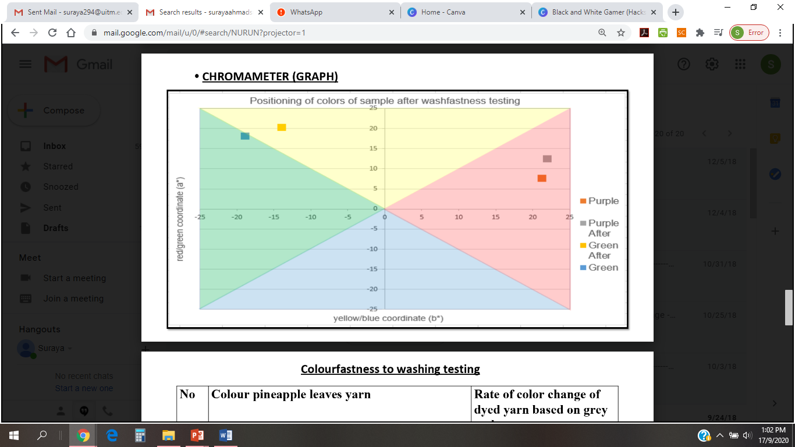

Legend:
non-mordanted
mordanted (vinegar)
mordanted (calamansi)

