PHYSICOCHEMICAL PROPERTIES OF SAGO BARK BIOCHAR AND ITS POTENTIAL AS PLANT GROWTH MEDIA

(Sifat Fizikokimia Bio-Arang Sisa Kulit Sagu dan Potensinya
Sebagai Media Pertumbuhan Tanaman)

Nor Khairunnisa Mohamad Fathi¹, Sharifah Mona Abd Aziz Abdullah^{2,*},
Mohamad Fhaizal Mohamad Bukhori², Rafeah Wahi¹, Mohd Alhafiizh Zailani²

¹Faculty of Resources Science and Technology,
²Centre for Pre-University Studies,
Universiti Malaysia Sarawak, 94300 Kota Samarahan, Sarawak, Malaysia

*Corresponding author: aaasmona@unimas.my

Abstract
Biochar application as a soil amender can alter soil physical properties with its effects on soil aeration, water holding capacity, soil workability and plant growth. Sago biochar (SBB) was produced through carbonization of the sago bark waste in an oxygen free environment. This study aims to improve the morphological characteristics and physicochemical properties of SBB. The SBB was chemically treated using HCl and NaOH. The morphological characteristics of samples were analysed using SEM and BET. Meanwhile, the physicochemical analysis was performed using FTIR, CHN analyser and AAS. The treated sago biochar (TSB) showed the highest surface area (158.82 m²/g) and can be classified as macropores (53.4 nm). This indicates that the TSB has large pores influencing the cohesiveness of soil particles, water storage, and increase in water holding capacity (97.63%). It also had the highest Ca and Mg (6.67% and 4.37%, respectively) which can assist in the production of chlorophyll in plant. TSB also showed a higher micronutrient concentration (Mn, Cu, and Fe) particularly the Fe concentration (2.00 mg/kg). The findings suggested that TSB could be used to improve soil qualities such as water holding and nutrients content, indicating that it has a good potential as a soil amender.

Keywords: chemical modification, plant growth study, biochar, soil amender, Metroxylon sagu Rottb

Abstrak
Bio-arang diaplikasikan sebagai bahan pembaikpulih tanah di mana ia dapat mengubah sifat fizikal tanah dan memberi pengaruh terhadap pengudaraan tanah, daya tahan air, kemampuan kerja tanah dan pertumbuhan tanaman. Bio-arang sisa kulit sagu (SBB) dihasilkan melalui pengkarbonan sisa kulit sagu dalam persekitaran bebas oksigen. Kajian ini bertujuan untuk menambahbaik ciri morfologi dan sifat fizikokimia SBB. SBB dirawat secara kimia menggunakan HCl dan NaOH. Ciri morfologi pada sampel dianalisis menggunakan SEM dan BET. Sementara itu, analisis fizikokimia dilakukan dengan menggunakan FTIR, CHN dan AAS. SBB yang dirawat (TSB) mempunyai luas permukaan tertinggi (158.82 m²/g) dan boleh dikelaskan sebagai makropori (53.4 nm). Ini menunjukkan bahawa TSB mempunyai liang besar yang akan mempengaruhi kejelekitan zarah tanah, penyimpanan air, dan peningkatan daya tahan air (97.63%). TSB mempunyai kandungan Ca dan Mg tertinggi (masing-masing sebanyak 6.67% and 4.37%) yang dapat membantu dalam penghasilan klorofil dalam tumbuhan. TSB juga menunjukkan kepekatan mikronutrien yang lebih tinggi (Mn, Cu, dan Fe) terutamanya kepekatan Fe (2.00 mg/kg). Hasil kajian mendedahkan bahawa TSB dapat digunakan untuk memperbaiki kualiti tanah seperti daya tahan air dan kandungan nutrien, sekaligus menunjukkan pontesinya sebagai pembaikpulih tanah.

Kata kunci: penguahsuaian kimia, kajian pertumbuhan tumbuhan, bio-arang, pembaikpulih tanah, Metroxylon sagu Rottb

Introduction
Sago (Metroxylon sagu Rottb) is a species from the genus Metroxylon which is under the Palmae family. Sago palm is one of the oldest tropical plants which has been domestically and commercially exploited for its stem starch [1]. Sago is distributed in many countries including Indonesia, Malaysia, Papua New Guinea, Philippines, Thailand, and Brunei [2]. According to Ehara et al. [2], sago distribution worldwide spreads 6.5 million ha⁻¹ and the Papua area has led the distribution of around 4.7 million ha. Meanwhile, the distribution of sago in Malaysia was primarily in Sarawak (67%), Sabah (22%), and West Malaysia (11%). There are over 40 operational sago factories in Sarawak, primarily in Mukah and Dalat [3]. Domestically, Sarawak is annually exporting about 25,000 to 40,000 tons of sago products to several countries [1]. Sago products has multiple usages including food (biscuit and sago pearl) and manufacturing (biodegradable plastic, alcohol, citric acids, and biochar) [4].
Generally, most of the sago factories which are located near riverbanks are lack of waste management plan. Most of the waste was improperly disposed into the rivers which become a potential threat to the environment, biological, and aquatic life [3]. Approximately 0.75 tonnes of sago bark waste are generated from every tonne of sago flour processing. These wastes undergo carbonization in a closed furnace for the generation of heat for the drying process of sago flour [5]. This process produces biochar as the by-product which is beneficial for soil improvement.
Biochar is a carbon-rich product that acquired from the heating of biomass (wood, leaves, or manure) in a controlled condition and temperature above 250ºC with practically or completely absence of oxygen [6]. Application of biochar as soil amender is reported can alter the physical and chemical properties of soils such as the texture, structure, pore size distribution, bulk density, pH, and organic matter. This influences the aeration, water holding capacity, and available nutrients which will affect the plant performance [7]. Meanwhile, Piash et al. [6] reported that besides as a carbon-rich substance, biochar contains other main minerals such as calcium (Ca), magnesium (Mg), and inorganic carbonates. In addition, biochar also contains organic matter and nutrients which could influence the fertility of agricultural growth media by affecting the soil pH, electric conductivity (EC), organic carbon (OC), total nitrogen (TN), available phosphorus (P), and the cation-exchange capacity (CEC) [8].
Chemical treatment using acids on biochar was reported to enhance the adsorption capacity, increase water solubility, and plant availability of nutrients [9]. On that note, to enhance the properties of biochar, chemical modification using acid-base is reported to increase the pore volume of biochar while increases the acidic property and produces a positive charge on the surface which is favourable for the adsorption of negatively charged species [10]. According to Alzaydien [11], chemical modification of biochar using acid can develop more pores and cavities resulting in an enhanced adsorption capability. Chemically modified biochar was also reported to have a high tendency to adsorb inorganic contaminants through surface adsorption and retention of carboxyl functional group [12].
Past researchers have published numerous articles and review papers on the effect of biochar on soil structure and soil aggregation in plant growth performance including, maize (Zea mays L.) [13]; red chilli (Capsicum annum L.) [14]; lettuce and cabbage (Lactusa sativa and Brassica chinensis) [7]; and cowpea and peanut (Vigna unguiculata L., and Arachis hypogaea L.) [15]. Study reported by Carter et al. [7], the rice-husk biochar was slightly alkaline, improved the pH of the soil, and had higher quantities of several trace metals and exchangeable cations (K, Ca, and Mg). Furthermore, water holding capacity of soil increased depending on type of biochar feedstock [16]. The same author also reported that the quantities of macropores and micropores in biochar attributed to a higher water holding capacity. Therefore, biochar could be a promising material for boosting acid soil productivity due to its liming effect, water and nutrient retention capability, and carbon sequestration capacity [17]. On top of this, the application of biochar as potential agricultural growth media fertility and soil amender would significantly reduce the cost and usage of commercial fertilizer which will be turned into cost-effective farming. Therefore, the current study aims to analyse the raw material of sago bark waste (SBW), sago biochar (SBB) and chemically treated sago biochar (TSB) properties. The biochar characterisation included the surface morphology, surface area measurements, water holding capacity, infrared spectra analysis, proximate and elemental analysis. Lastly, this study also evaluates the potential of SBB and TSB as soil amendments.

Materials and Methods

Samples preparation
The SBW and SBB were collected from sago factory in Mukah, Sarawak. Samples were oven-dried at 60 ºC, 24 hours, grounded and sieved using No. 10 mesh (2 mm sieve size) prior to analysis. TSB was prepared from SBB via acid base treatment, as follows: SBB sample (5 g) was soaked in NaOH solution (2 M, 25 mL) at 60 ºC for 2 hours prior to oven-drying (105 ºC, 24 hours). Sample was subjected under reflux with HCl (5 M, 25 mL) at 95 ºC for 2 hours. The sample was washed with hot distilled water to obtain TSB of pH 7 and oven-dried (105 ºC, 24 hours) [18, 19]. The prepared sample in this study is shown in Figure 1.

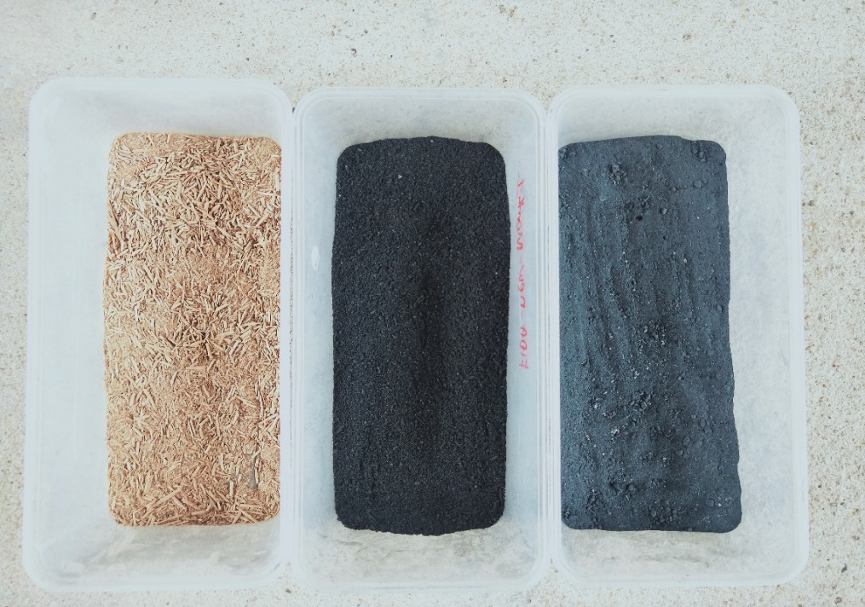
(a)
(b)
(c)

Figure 1. Sample of SBW (a), SBB (b), and TSB (c) with particle size < 2 mm

Physical characterisation
The surface morphology of sample was studied at magnification of 500× using Field Emission Scanning Electron Microscopy (FESEM) (JSM-6390LA, JEOL). Meanwhile, the elements presence on the surface of samples were determined by Energy Dispersive X-ray (EDX) (JSM-IT500HR, JEOL) [20]. The Brunauer, Emmet and Teller (BET) surface area and pore volume analysis was carried out using Surface Area Analyzer (Quantachrome® ASIQwin™). Prior to gas adsorption measurements, the solid products were vacuum degassed at 200 ºC for 8 hours under vacuum conditions. Nitrogen gas was used as adsorptive gas at 77K. The N₂ adsorption isotherm was measured and interpreted using BET theory [19]. Water holding capacity (WHC) was conducted following [21]. Samples were oven-dried (105 ºC, 24 hours), weighed (W₁) followed by 48 hours immersion in water. Samples were then vacuum-filtered and the wet sample mass was recorded (W₂). The WHC was calculated using equation 1:
$WHC \left(\%\right)=\frac{\text{(}{\text{W}}_{\text{2}}\text{- }{\text{W}}_{\text{1}}\text{)}}{{\text{W}}_{\text{1}}}×100\%$ (1)

Chemical characterisation
The samples were characterised by proximate analysis and ultimate analysis (CHNS Elemental Analyzer Flash EA1112 series, ThermoScientific) [22]. The Fourier Transform Infrared Spectroscopy (Nicolet iS10 FTIR Spectrometer, ThermoScientific) was used for samples functional group and identification of structural changes analysis. The samples’ pH and conductivity were determined using CyberScan pH/Conductivity/TDS meter (Eutech Instrument) from a prepared solution with a ratio of 1:2.5 (sample: distilled water) [22]. For the total macro- and micronutrient element content analysis, samples were ashed in a closed muffle furnace at 900 ºC for 4 hours. An amount of 2 mL of concentrated HCl and 10 mL of 20% HNO₃ were added and allowed to digest in water bath for 1 hour. Finally, the solution was filtered into a 100 mL volumetric flask for further analysis [23]. The phosphorus content analysis was carried out by UV/Vis spectrometer (Cary 60 UV-Vis, Agilent) at a wavelength of 410 nm with a mixture of 10 mL of ash solution and 25 mL of working molybdovanate reagent. Meanwhile, the total macro- and micronutrient element content of further dilution of ash solutions were analysed using atomic absorption spectrometer (Cary 500 AnalytikJena, ThermoScientific).

Statistical analysis
The SPSS 26 software (SPSS for Windows, SPSS IBM, Armonk, Nueva York, USA) was used for statistical analysis. One-way ANOVA analysis was used for analysing the significance of the differences between the means. Treatment means were compared by Tukey’s test at p ≤ 0.05.

Results and Discussion

SEM analysis
From the SEM image in Figure 2, there are oval-shaped structures were observed on SBW which represent the starch granules. It also shown that natural cavities or porous structure were present in SBW cells. Functionally, these structures allow the release of volatile matter during the carbonisation process [10]. As compared with previous work by Hedge et al. [24] on the same feedstock (SBW), similar results were recorded on the carbon (55.03%), oxygen (43.43%), potassium (0.53%) and calcium (0.57%) composition. Meanwhile, a higher content of silicon (3.02%) was detected in this study compared to the previously reported by Hegde et al. [24].

There were differences on the SBB micrograph when compared with SBW in term of the porous surface structure with irregular cavities due to the pyrolysis. As reported by Zhang and You [21], the biochar pores are quite large, cylindrical-like and have a same direction in their arrangement. The starch granules had been diminished due to high heating temperature. The formation of porous holes in biochar has causes the devolatilization of sago bark. According to Gondim et al. [16], the fewer amount of micropores and thick lignified cell walls of biochar will result in the decrease in water holding capacity. The SBB had the highest carbon content (88.76 ± 0.06%) than the SBW and TSB because of the degree of carbonization applied on SBW [25]. Liang et al. [26] reported that an EDX spectra of carbonize furfural residue at 500ºC showed the presence of carbon (82.4%) and oxygen (13.9%) which demonstrate that the carbon was the main skeleton in the biochar. Comparing with Suárez et al. [27] work, similar results on the carbon content (>80%) in three different biochar samples (Eucalyptus grandis, Acacia magnium, and Gmelia arborea) are reported. This is due to the high degree of carbonization and a decrease in oxygen suggesting the possible increase in the surfaces’ hydrophobicity of the biochar [27].

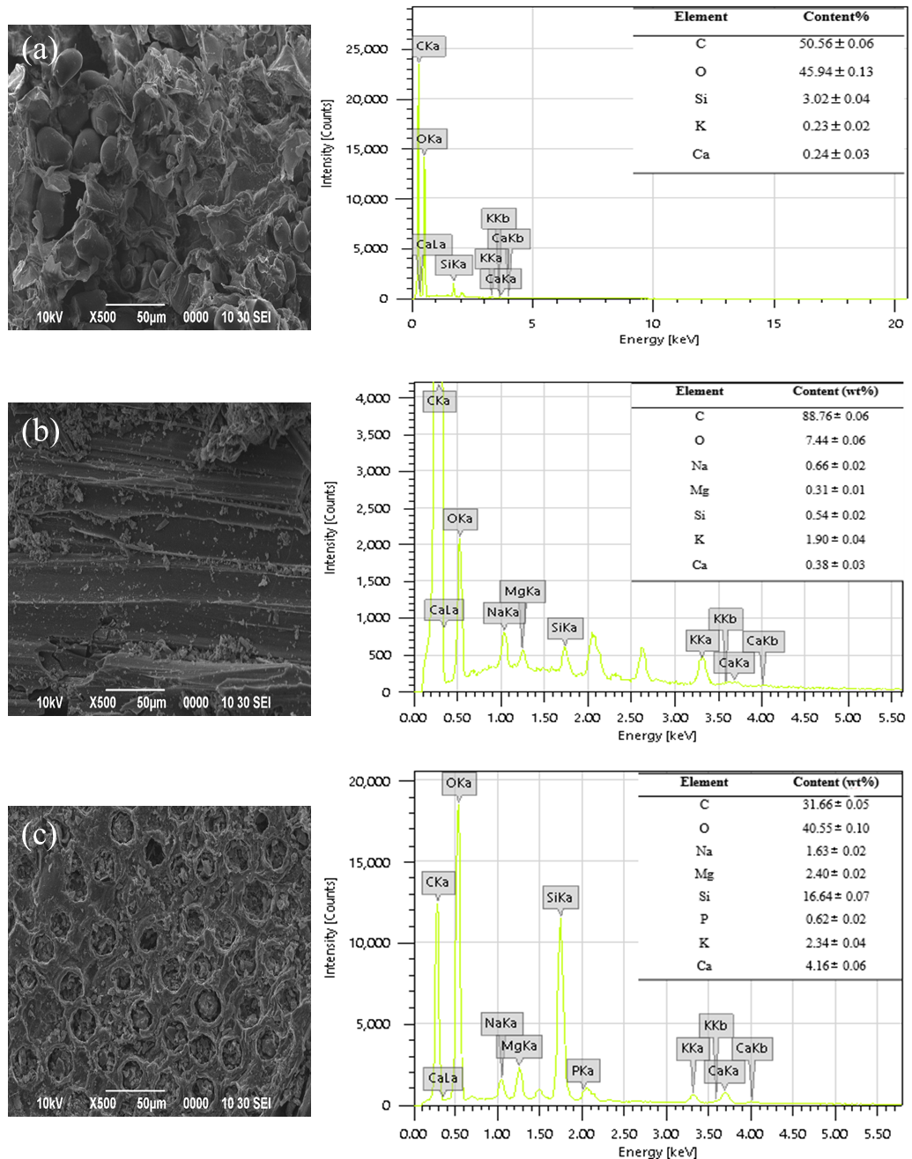

Figure 2. SEM and EDX spectra images of (a) SBW, (b) SBB, and (c) TSB at 500x magnification
An increase in porosity for the TSB sample was due to the volatile compounds escaping the structure during the thermochemical degradation. The homogenous type of pore structures was well developed on the surface of the TSB, thus, resulting a larger surface area which represent the best development of pores compared to the SBW and SBB samples. The diffusion of sodium (Na) species into the biochar help to enhance the pore sizes and the formation of new pores. According to Tan et al. [10], there was an inconsistent pore structure on the surface of the activated carbon after the treatment using a high concentration of acid (5 M). The high concentration of acid resulting in the decrease in the BET surface area and produces the honeycomb structure. The higher amounts of micropores can increase the plant available water and improving the soil water retention [16]. Spectra image of EDX for the TSB showed a high content in oxygen (40.55±0.10%), silicon (16.64±0.07%), sodium (1.63±0.02%), magnesium (2.40±0.02%), calcium (4.16±0.04%), and potassium (2.34±0.04%) compared to the SBW and SBB. The high oxygen content in TSB surface is possibly due the increase number of oxygen-containing functional group after the acid and base modification. Meanwhile, high Si content may be attributed to the high ash content in the biochar [28] which is consistent with the ash content result (Table 2) for TSB in the current study. However, study reported by Ibrahim et al. [29] is in contrast with the current result where the Si content decreased after acid modification of biochar which might be due to the removal of silica bodies on the surface of untreated biochar. Therefore, the acid and base treatment in current study might affect the percentage of soluble organic component and thus relatively increased the percentage of inorganic component in TSB. Si content is recognized as a functional nutrient in all plant growth because it can increase the pathogen resistance and essential for sustainable crop production [30] while the higher Ca, Mg and K content making TSB suitable as a component of a plant growth media [31].

Surface area, total pore volume, and average pore diameter analysis
The main surface analysis was performed to measure the BET surface area, total pore volume, and average pore size of all samples (SBW, SBB, and TSB) (Table 1). The BET surface area increases in the following manner, SBW (10.964 m²/g), SBB (64.140 m²/g), and TSB (158.817 m²/g). The surface area of TSB was increased by 59.61% after the chemical modification of SBB. This shows that the TSB could provide a greater adsorption capacity due to the pore enlargement and surface destruction during the acid-base modification [27, 32]. According to Tan et al. [10], treatment of activated carbon with 1 M NaOH has reduces the surface area which is mainly attributed by the reduce in the micropore volume. The average pore diameter of SBW, SBB and TSB were 26.77, 15.40 and 53.40 nm, respectively. The porous media pore size can be categorised as follows; micropores (<2 nm), mesopores (2-50 nm), and macropores (>50 nm) [21]. Hence, the TSB can be classified as macropores due to the presence of large pores which can significantly improve the cohesiveness of soil particles, water storage, and water holding capacity in soil [33].

Table 1. Physical properties of the SBW, SBB, and TSB

Sample | BET Surface Area  (m²/g) | Total Pore Volume  (cc/g) | Average Pore Size  (nm) | WHC  (%)
SBW | 10.964 | 1.467×10⁻² | 26.77 | 117.39±0.54ª
SBB | 64.140 | 4.943×10⁻² | 15.40 | 86.34± 0.38^{c}
TSB | 158.817 | 4.24×10⁻¹ | 53.40 | 97.63±0.14^{b}
The numbers to the right of each value represent the standard deviation of the mean. Significant differences between treatments are indicated by different letters ^{abc} in superscript to the right of each value

Water holding capacity (WHC) analysis
Several studies have shown that greater water holding capacity is caused by high surface area of the biochar [34, 35, 36]. In this study, the WHC of TSB (97.63%) was significantly higher than SBB (86.34%) (Table 1). The results demonstrate that the SBB and TSB both has a good water retention in soil which improves the soil water content, reducing the mobility of water and subsequently decrease the water stress in plant [34]. In addition, the high ash content of SBB and TSB which were reported in different section of this study also contributed to the high micro porosity of the biochar. This will result in hydrophobicity which influences the water retention of soil [37]. Meanwhile, the soil aggregates will create pores which can store water for plants to access. The fine-textured material of TSB results in a rapid water drainage due to its large pore size. Therefore, the SBB and TSB will potentially enhance the fertility of the agricultural growth media and subsequently the crop yield by providing a good soil water holding capacity.

Proximate analysis
The proximate analysis was done to measure the moisture content, volatile matter, ash content, and fixed carbon of samples. Generally, all of the samples (SBW, SBB, and TSB) was significantly different from each other at p < 0.05 (Table 2). The result shows that the SBB (3.76%) and TSB (6.27%) have recorded a lower moisture content compared to its feedstock, SBW (8.82%). The lower moisture content was due to water dehydration during the carbonisation of SBW. Meanwhile, the volatile matter content of SBB (37.14%) and TSB (33.61%) was decreased ~ 50% as compared to SBW. According to Gunamantha & Widana [38], biochar with a high volatile matter content is less stable and has a higher amount of labile carbon, which provides energy for microbial activity while limiting the nitrogen available for plant growth, resulting in plant growth suppression. ﻿Biochar with volatile matter content more than 35% is considered high (causing nitrogen deficiency) whereas volatile matter below 10% is considered low [38], hence, TSB in this study is not predicted to limit plant growth. The ash content of SBB and TSB is higher than that of its feedstock, SBW at 28.81% and 30.55% respectively. This is related to the accumulation of inorganic constituents which is also related to high nutrient contents in both SBB and TSB [39]. The fixed carbon content in both SBB (30.38%) and TSB (29.57%) showed a similar trend as the ash content. According to Gunamantha & Widana [38], higher fixed carbon content of biochar compared to its feedstock, implies a reduction in carbon emissions and may have a critical influence due to their mineral content.

Table 2. Proximate analysis of the SBW, SBB, and TSB

Sample | Moisture | Volatile Matter | Ash Content | Fixed Carbon
 |  | (wt. %)
SBW | 8.82 ± 0.22ª | 70.71 ± 1.16ª | 18.86 ± 0.66ª | 1.61 ± 0.06ª
SBB | 3.76 ± 0.25^{b} | 37.14 ± 0.94^{b} | 28.81 ± 0.72^{b} | 30.38 ± 0.96^{b}
TSB | 6.27 ± 0.04^{c} | 33.61 ± 0.41^{c} | 30.55 ± 0.34^{c} | 29.57 ± 0.57^{c}
The numbers to the right of each value represent the standard deviation of the mean. Significant differences between treatments are indicated by different letters ^{abc} in superscript to the right of each value in each column

Ultimate analysis
The ultimate analysis was conducted to measure the composition of carbon, hydrogen, oxygen, sulphur, and nitrogen in the samples. Generally, the analysis of all samples (SBW, SBB, and TSB) was significantly different at p < 0.05 (Table 3). The percentage of carbon content was the highest in the SBW followed by SBB and TSB. The carbon content recorded in this study was lower compared to Wahi et al. [19]. It could be manifested that the carbonisation of the SBW was exposed to oxygen that causes high measurement of oxygen in the SBB. A decreasing trend was observed in the hydrogen contents from the SBB (2.37%) and TSB (1.26%) due to the carbonisation process. This also indicate the increased in the aromaticity which agrees with previous work by Zhao et al. [41]. The amount of nitrogen (< 1%) was almost absent in all samples. The lowest N availability was by the TSB (0.18%) that gives a high C/N ratio which effects the N immobilization due to the adsorption of NH₄⁺ by the biochar [40]. An increase in oxygen (77.27%) and a decrease in carbon (21.22%) in the TSB were due to a crosslinking reaction on the surface of biochar and the modifying agents [43]. The TSB had the highest O/C ratio (4.88%) indicating the decrease in hydrophobicity, increase in cation exchange capacities (CECs), and the presence of more carbonyl, hydroxyl, and carboxylate groups [34, 43].

Table 3. Ultimate analysis (C, H, N, O, S) by weight (%) of SBW, SBB and TSB

Sample | C | H | N | O | S | O/C
SBW | 42.97 ± 1.39ª | 6.13± 0.27ª | 0.28± 0.03ª | 50.62 ± 1.50ª | 0ª | 1.57± 0.10ª
SBB | 25.11 ± 1.37^{b} | 2.37 ± 0.67^{b} | 0.58 ± 0.66^{b} | 71.94 ± 0.60^{b} | 0ª | 3.72± 0.17^{b}
TSB | 21.22 ± 1.51^{c} | 1.26 ± 0.46^{b} | 0.18 ± 0.01^{b} | 77.27 ± 1.48^{c} | 0.07 ± 0.01^{b} | 4.88± 0.42^{c}
The numbers to the right of each value represent the standard deviation about the mean. Significant differences between treatments are indicated by different letters ^{abc} in superscript to the right of each value in each column

Fourier Transform Infrared Spectroscopy (FTIR) analysis
The comparison of IR absorption spectra between the samples are shown in Figure 3 and Table 4. The FTIR spectra shows the presence of OH bonds at a frequency range between 3600 cm⁻¹ and 3200 cm⁻¹. The SBW sample shows strong intensity of O-H stretching which indicates the presence of alcohols and phenols at 3426 cm⁻¹. The same result was displayed by previous research on the raw empty fruit bunch which a broad characteristics peak at 3259.38 cm⁻¹ was spotted in the SBW that indicates the presence of O-H stretching [40]. The bands between 3700-3400 cm⁻¹ was slightly diminished for both SBB and TSB when compared with SBW. However, some of the functional group of O-H at 3423 cm⁻¹ was spotted in TSB. The same result was shown for HCl treated of empty fruit bunch biochar where the O-H stretching was further reduced as some volatile matter was released during the washing pre-treatment [38]. According to Figuerado et al. [44], the presence of carboxyl and phenol groups in the soil can contribute to the formation of soil charges. The presence of medium broad band at 3423 cm⁻¹ in the TSB shows the presence of new hydroxyl group which probably due to the modification process of the biochar with NaOH. The treatment might improve the number of –OH groups in the surface of the SBB. Meanwhile, new bands were observed for the SBB which is due to the carbonization of SBW in the closed furnace [45]. Both the SBW and SBB showed the presence of aliphatic functional groups at the range of 2850-2970 cm⁻¹ [27]. The C=O stretching of aldehydes and ketones functional groups was spotted at 1654 cm⁻¹. Suárez et al. [27] reported that this functional groups are formed by the dissociation of cellulose and hemicellulose which can be found in the raw wood material. Based on a previous report, the variable peaks observed at 1462 cm⁻¹ in the TSB showed the presence of aromatic quinones associated with lignin in the biochar. This feature could improve the biochar-soil amendment [27]. The presence of a band at 1048.32 cm⁻¹ indicated the presence of CO-O-CO bond in the SBB compared to SBW. It can be observed that all samples have O=C=O bond (carbon dioxide) and CO-O-CO anhydride group which are typically found in the IR spectra of biochar’s [45, 46, 47].

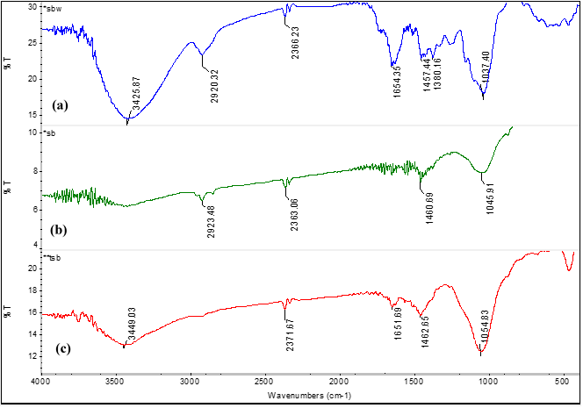

Figure 3. The FTIR spectra for the (a) SBW, (b) SBB, and (c) TSB

Table 4. Functional group observed in FTIR spectra for the SBW, SBB and TSB

Absorption  (cm⁻¹) | SBW  (cm⁻¹) | SBB  (cm⁻¹) | TSB  (cm⁻¹) | Vibration Characteristic
3550-3200 | 3426 | - | 3423 | O-H stretching (alcohol & phenols)
2970-2850 | 2920 | 2923 | - | C-H stretching
2349 | 2366 | 2366 | 2363 | O=C=O stretching (carbon dioxide)
1750-1650 | 1654 | - | - | C=O (aldehyde and ketones)
1500 | - | - | 1462 | C=C stretching (aromatic)
1050-1040 | 1037 | 1046 | 1055 | CO-O-CO stretching (anhydride)
^{- means not detected}

pH and electrical conductivity (EC) analysis
Based on the pH values recorded (Table 5), SBB has the highest pH value of 10.41 while TSB has a relatively lower pH value of 8.98. Both biochar’s are alkaline implying that they could be utilised as liming agents to remediate soil acidity. According to Berek [17], the presence of carbonates and oxides (basic cations) in biochar will neutralize the excess H⁺ ions from the acidic soil causing an increase in soil pH. Meanwhile, according to Ding et al. [48], biochar with a high pH value has the ability to hold the NH₄⁺ and K-fertilizers in the soil. In this study, the SBW recorded the lowest value of 2.86 mS, followed by TSB (5.17 mS), and SBB (18.78 mS) for the EC. EC is a measure of the amount of salt and its ability to conduct electricity. The result indicates the existence of more water soluble salts in SBB than in TSB. The higher EC in SBB might be attributed to the higher concentration of residues or ash induced by the loss of volatile matter during pyrolysis. Meanwhile, lower EC in TSB is possibly due to the removal of soluble salts during acid and base treatment. The EC results for SBB and TSB is comparable with the EC value of biochar’s reported from previous studies which is ranging from 0.04 mS cm-1 to 54.2 mS cm-1 [49]. In this study, the SBB had the highest value in pH and conductivity which imply the ionic concentration in the SBB was higher compared to the SBW and TSB.

Table 5. pH and electrical conductivity (EC) value of the SBW, SBB, and TSB

Sample | pH | EC (mS cm⁻¹)
SBW | 4.29 | 2.86
SBB | 10.41 | 18.78
TSB | 8.98 | 5.17

Macronutrient and micronutrient content
The macronutrient phosphorus (P), potassium (K), calcium (Ca), and magnesium (Mg) and micronutrient iron (Fe), manganese (Mn), copper (Cu) contents of the SBW, SBB, and TSB samples is shown in Figure 4. Generally, all samples were significantly different at a p<0.001. The macronutrient contents in both the SBB and TSB showed a higher concentration compared to the SBW. During pyrolysis, cation elements present in feedstock forming metal oxides in the ash that were merged with the biochar [50]. According to Karimi et al. [51], the high ash contents of biochar as well as soluble alkaline components released from the biochar, contributed to increased nutrient values. The available P for both the SBB and TSB samples (1.41±0.05% and 1.57±0.07%, respectively) were almost similar. This indicates that P availability in both samples would affect in the increase of soil pH and consequently will improve retention of exchangeable anion [42]. According to Hussain et al. [52], biochar can provide a P nutrient source which is similar to the commercial P fertilizer. This suggesting that biochar application in agricultural practices would significantly reduce the cost and usage of commercial fertilizer.

The K (6.47±0.43%) was recorded the highest in the SBB meanwhile the Ca (6.67±0.58%) and Mg (4.37± 0.15%) were recorded as the highest in the TSB. Significantly, the K helps to regulate the stomatal conductance in the plant leaf and water used efficiency which is important for plant growth performance [53]. According to Novak et al. [50], pecan shell-based biochar can improve K, Ca and P concentration in a loamy sand soil. The Mg is assisting in major constituent of the chlorophyll molecule which actively involved in photosynthesis, and the Ca has a key role in the development of the cell wall membrane in plant cell [52].

For micronutrient content, the TSB showed a higher concentration compared to the SBW and SBB especially for the Fe concentration (2.00 ± 0.10 mg/kg). The Fe was the highest available metals in micronutrients content. Significantly, the Fe element is essential for the processes in plants, especially in the photosynthesis and the chloroplast development [54]. The results for the Mn and Cu contents for both SBB (0.005±0 and 0.010±0 mg/kg) and TSB (0.006±0 and 0.013±0 mg/kg) were relatively similar. Cu and Mn are essential for the plant development which only requires a small amount in which their range of critical deficiency levels are 1-5 mg/kg of plant dry mass [55]. Biochar also has been reported to reduce the bioavailability of heavy metals in soil particularly the soil with high pH value and amounts of lime [56].

Figure 4. Total macronutrient a) P, b) K, c) Mg, d) Ca, and micronutrient e) Mn, f) Fe, g) Cu element contents of the SBW, SBB and TSB. The error bars represent standard deviation of the mean (n=3) and bars with different letters^{abc} indicate statistically significant (p <0.001) differences.

Conclusion
The SBB and TSB were analysed for their characteristics which contribute to the soil amender properties in promoting plant growth. The SBB had recorded a pH value of 10.41 which is suitable for crops cultivated on acidic soil. Meanwhile, the TSB is suitable for crops cultivated on slightly acidic soil. From the BET analysis, the surface area of the TSB had increased by 59.61% compared to the SBB which potentially to have a higher water holding capacity in soil due to the high storage capacity. The FESEM-EDX spectra images showed that the TSB had developed a new porous structure and has a high content of silicon which essential for the sustainable of crop production. Both SBB and TSB had a slightly diminished bands between 3700-3400 cm⁻¹ compared to the SBW. However, the O–H functional group, at 3423 cm⁻¹ was spotted in the TSB due to the present of new hydroxyl groups after the modification process of the biochar in the presence of NaOH. Finally, the TSB had the highest Ca and Mg (6.67% and 4.37%, respectively) contents which these elements can assist in the production of the chlorophyll molecules in plant. These results imply the potential of acid-base treatment in improving the characteristics of the biochar as a good soil amender. Future research needs to address the impact of the wide range of biochar applications on the other plant growth media and plant growth.

Acknowledgement
The authors thank the Universiti Malaysia Sarawak for financial support to conduct this work through the Tun Openg Chair grant (Grant No.: C09/TOC/1753/2018).

References
- Lim, L.W. K., Chung, H. H., Hussain, H. and Bujang, K. (2019). Sago palm (Metroxylon sagu Rottb.): Now and beyond. Pertanika Journal Tropical Agricultural Science, 42(2): 435-451.
- Ehara, H., Toyoda, Y. and Johnson, D.V. (2018). Sago palm: Multiple contributions to food security and sustainable livelihoods. In sago palm: multiple contributions to food security and sustainable livelihoods. Springer, Singapore.
- Jong, F. S. (2018). An Overview of Sago Industry Development, 1980s–2015. In: Ehara H, Toyoda Y, Johnson D. (eds) Sago Palm. Springer, Singapore.
- Singhal, R. S., Kennedy, J. F. and Gopalakrishnan, S. M. (2017). Industrial production, processing, and utilization of sago palm-derived products. Carbohydrate Polymer, 72: 1-20.
- Rasyid, T. H., Kusumawaty, Y. and Hadi, S. (2020) The utilization of sago waste: prospect and challenges. IOP Conference Series: Earth and Environmental Science, 415: 12-23.
- Piash, M. I., Hossain, M. F. and Zakia, P. (2019). Effect of biochar and fertilizer application on the growth and nutrient accumulation of rice and vegetable in two contrast soils. Acta Scienctific Agriculture, 3(2): 74-83.
- Carter, S., Shackley, S., Sohi, S., Suy, T. B. and Haefele, S. (2013). The impact of biochar application on soil properties and plant growth of pot grown lettuce (Lactuca sativa) and cabbage (Brassica chinensis). Agronomy, 3: 404-418.
- Bayu, D., Tadesse, M. and Amsalu, N. (2016). Effect of biochar on soil properties and lead (Pb) availability in a military camp in South West Ethiopia. African Journal of Environmental Science and Technology, 10(3): 77-85.
- Sahin, O., Taskin, M. B., Kaya, E. C. and Gunes, A. (2017). Effect of acid modification of biochar on nutrient availability and maize growth in a calcareous soil. Soil Use and Management, 33: 447-456.
- Tan, I. A. W., Abdullah, M. O., Lim, L. L. P. and Yeo, T. H. C. (2017). Surface modification and characterization of coconut shell-based activated carbon subjected to acidic and alkaline treatments. Journal of Applied Science & Process Engineering, 4(2): 186-194.
- Alzaydien, A. S. (2016). Physical, chemical and adsorptive characteristics of local oak sawdust based activated carbons. Asian Journal of Scientific Research, 9(2): 45-56.
- Zhao, S. X., Ta, N. and Wang, X. D. (2017). Effect of temperature on the structural and physicochemical properties of biochar with apple tree branches as feedstock material. Energies, 10(9): 1293.
- Sukartono, W. H., Kusuma, Z. and Nugrobo, W. H. (2011). Soil fertility status , nutrient uptake , and maize (Zea mays L .) yield following biochar and cattle manure application on sandy soils of Lombok, Indonesia. Journal of Tropical Agriculture, 49(1-2): 47-52.
- Wisnubroto, E.I., Utomo, W.H. and Indrayatie, E.R. (2017). Residual effect of biochar on growth and yield of red chili (Capsicum annum L.). Journal of Advanced Agricultural Technologies 4(1): 28-31.
- Yamato, M., Okimori, Y., Wibowo, I. F., Anshori, S. and Ogawa, M. (2006). Effects of the application of charred bark of Acacia mangium on the yield of maize, cowpea and peanut, and soil chemical properties in South Sumatra, Indonesia. Soil Science and Plant Nutrition, 52(4): 489-495.
- Gondim, R. S., Muniz, C. R., Eduardo, C. and Lima, P. (2018). Explaining the water-holding capacity of biochar by scanning electron microscope images. Revista Caatinga, 31(4): 972-979.
- Berek, A. K. (2019). The potential of biochar as an acid soil amendment to support Indonesian food and energy security - A review. Tropical Agricultural Science, 42(2): 745-759.
- Tan, G., Xu, N., Xu, Y., Wang, H. and Sun, W. (2016). Sorption of mercury(II) and atrazine by biochar, modified biochars and biochar based activated carbon in aqueous solution. Bioresource Technology, 2016: 1-43.
- Wahi, R., Zuhaidi, N. F. Q., Yusof, Y., Jamel, J. and Kanakaraju, D. (2018). Chemically treated microwave biochar from sago bark waste. Proceedings of ISER 119th International Conference, Kuala Lumpur, Malaysia, 1st-2nd April 2018: 52–54.
- Hamzah, Z. and Shuhaimi, S. N. A. (2018). Biochar : effects on crop growth. IOP Conference Series: Earth and Environmental Science, 215: 1-8.
- Zhang, J. and You, C. (2013). Water holding capacity and absorption properties of wood chars. Energy & Fuels, 27: 2643-2648.
- Ahmad, N.F., Alias, A.B., Talib, N. and Rashid, Z. (2018). Characteristics of rice husk biochar blended with coal fly ash for potential sorption material. Malaysian Journal of Analytical Sciences, 22(2): 326-332.
- Estefan, G., Sommer, R. and Ryan, J. (2013). Methods of soil, plant, and water analysis: A manual for the West Asia and North Africa region (3rd edition). International Center for Agricultural Research in the Dry Areas (ICARDA). Beirut, Lebanon.
- Hegde, G., Abdul Manaf, S. A., Kumar, A., Ali, G. A. M., Chong, K. F., Ngaini, Z. and Sharma, K. V. (2015). Biowaste sago bark based catalyst free carbon nanospheres: waste to wealth approach. American Chemical Society Sustainable Chemistry and Engineering, 3(9): 2247-2253.
- Ma, X., Zhou, B., Budai, A., Jeng, A., Hao, X., Wei, D., Zhang, Y. and Rasse, D. (2016). Study of biochar properties by scanning electron microscope-energy dispersive x-ray spectroscopy (SEM-EDX). Communications in Soil Science and Plant Analysis, 47(5): 593-601.
- Liang, H., Chen, L., Liu, G. and Zheng, H. (2016). Surface morphology properties of biochars produced from different feedstocks. Proceedings of the 2016 International Conference on Civil, Transfortation and Environment, pp. 1205-1208.
- Suárez, H. L., Alba N., A. A. and Barrera, Z. R. (2017). Morphological and physicochemical characterization of biochar produced by gasification of selected forestry species. Revista Facultad de Ingeniería, 26(46): 123-130.
- Palniandy, L. K., Yoon, L. W., Wong, W. Y., Yong, S. T. and Pang, M. M. (2019). Application of biochar derived from different types of biomass and treatment methods as a fuel source for direct carbon fuel cells. Energies, 12(2477): 1-15.
- Ibrahim, I., Tsubota, T., Hassan, M. A. and Andou, Y. (2021). Surface functionalization of biochar from oil palm empty fruit bunch through hydrothermal process. Processe, 9(149): 1-14.
- Varela, M. O., Rivera, E. B., Huang, W. J., Chien, C. C. and Wang, Y. M. (2013). Agronomic properties and characterization of rice husk and wood biochars and their effect on the growth of water spinach in a field test. Journal of Soil Science and Plant Nutrition, 13(2): 251–266.
- Prasad, M., Chrysargyris, A., McDaniel, N., Kavanagh, A., Gruda, N. S. and Tzortzakis, N. (2019). Plant nutrient availability and pH of biochars and their fractions, with the possible use as a component in a growing media. Agronomy, 10(10): 1-17.
- Li, L., Liu, S. and Liu, J. (2011). Surface modification of coconut shell based activated carbon for the improvement of hydrophobic VOC removal, Journal of Hazardous Materials, 192(2): 683-690.
- Lu, S., Sun, F. and Zong, Y. (2014). Catena effect of rice husk biochar and coal fly ash on some physical properties of expansive clayey soil (Vertisol). Catena, 114: 37-44.
- Batista, E. M. C. C., Shultz, J., Matos, T. T. S., Fornari, M. R., Ferreira, T. M., Szpoganicz, B., De Freitas, R. A. and Mangrich, A. S. (2018). Effect of surface and porosity of biochar on water holding capacity aiming indirectly at preservation of the Amazon biome. Scientific Reports, 8(1): 1-9.
- Mukherjee, A. and Lal, R. (2013). Biochar impacts on soil physical properties and greenhouse gas emissions. Agronomy, 3(2): 313-339.
- Southavong, S., Preston, T. R. and van Man, N. (2012). Effect of biochar and biodigester effluent on growth of water spinach (Ipomoea aquatica) and soil fertility. Livestock Research for Rural Development, 24(2): 1-15.
- Pühringer, H. (2016). Effects of different biochar application rates on soil fertility and soil water retention in on-farm experiments on smallholder farms in Kenya. In Department of Soil and Environment, Swedish University of Agricultural Sciences.
- Gunamantha, I. M. and Widana, G. A. B. (2018). Characterization the potential of biochar from cow and pig manure for geoecology application. International Conference Series:Earth and Environmental Science, 131(012055) :1-6.
- Zhao, S. X. Z., Ta, N. and Wang, X. D. (2017). Effect of temperature on the structural and physicochemical properties of biochar with apple tree braches as feedstock material. Energies, 10(1293): 1-15.
- Meri, N. H., Alias, A. B., Talib, N., Rashid, Z. A. and Ghani, W. A. (2018). Effect of chemical washing pre-treatment of empty fruit bunch (EFB) biochar on characterization of hydrogel biochar composite as bioadsorbent. IOP Conference Series: Materials Science and Engineering, 358: 1–7.
- Zhao, B., O’Connor, D., Shen, Z., Tsang, D. C. W., Rinklebe, J. and Hou, D. (2020). Sulfur-modified biochar as a soil amendment to stabilize mercury pollution: An accelerated simulation of long-term aging effects. Environmental Pollution, 264: 114687.
- Ndor, E., Ogara, J. I., Bako, D. A. and Osuagbalande, J. A. (2016). Effect of biochar on macronutrients release and plant growth on degraded soil of Lafia, Nasarawa State, Nigeria. Asian Research Journal of Agriculture, 2(3): 1–8.
- Godwin, P. M., Pan, Y., Xiao, H. and Afzal, M. T. (2019). Progress in preparation and application of modified biochar for improving heavy metal ion removal from wastewater. Journal of Bioresources and Bioproducts, 4(1): 31-42.
- Figuerado, N. A., Costa, L. M., Melo, L. C. A., Siebeneichlerd, E. A. and Tronto, J. (2017). Characterization of biochars from different sources and evaluation of release of nutrients and contaminants. Revista Ciencia Agronomica, 48(3): 1–10.
- Tomczyk, A., Sokołowska, Z. and Boguta, P. (2020). Biochar physicochemical properties: Pyrolysis temperature and feedstock kind effects. Reviews in Environmental Science and Biotechnology, 19(1): 191-215.
- Ghani, W.A., Mohd, A., Silva, S, G., Bachmann, R.T., Taufiq, Y.H., Rashid, U. and Al-Muhtaseb, A. H. (2013). Biochar production from waste rubber-wood-sawdust and its potential use in C sequestration: Chemical and physical characterization. Industrial Crops & Products, 44: 18-24.
- Liu, Y., He, Z. and Uchimiya, M. (2015). Comparison of biochar formation from various agricultural by-products Using FTIR spectroscopy, Modern Applied Science, 9(4): 246-253.
- Ding, A. Y., Liu, Y., Liu, S., Huang, X. and Li, Z. (2017). Potential benefits from biochar application for agricultural use: A review. Pedosphere: An International Journal, 2017: 1-20.
- Singh, B., Dolk, M. M., Shen, Q. and Arbestain, M. C. (2017). Biochar: A guide to analytical methods chapter 3 biochar pH, electrical conductivity and liming potential. CSIRO Publishing. Access from https://biochar-international.org/wpcontent/uploads/2019/11/2017_Biochar_pH_electrical_conductivity_ and_liming_potential_Singhetal.pdf
- Novak, J. M., Busscher, W. J., Laird, D. L., Ahmedna, M., Watts, D. W. and Niandou, M. A. S. (2009). Impact of biochar amendment on fertility of a southeastern coastal plain soil. Soil Science, 174(2): 105-112.
- Karimi, A., Moezzi, A., Chorom, M. and Enayatizamir, N. (2019). Application of biochar changed the status of nutrients and biological activity in a calcareous soil. Journal of Soil Science and Plant Nutrition. (20): 450-459.
- Hussain, M., Farooq, M., Nawaz, A., Al-Sadi, A. M., Solaiman, Z. M., Alghamdi, S. S., Ammara, U., Ok, Y. S. and Siddique, K. H. M. (2017). Biochar for crop production: potential benefits and risks. Journal of Soils and Sediments, 17(3): 685-716.
- Abdul, N. F. and Abdul, N. S. (2017). Microbial & biochemical technology the effect of biochar application on nutrient availability of soil planted with MR219. Journal of Microbial & Biochemical Technology, 9(2): 583–586.
- Mukhti, G. (2014). Heavy metal stress in plants. International Journal Advance Residual, 2(6): 1043-1055.
- Ducic, T. and Polle, A. (2005). Transport and detoxification of manganese and copper in plants. Brazillian Journal of Plant Physiology, 17(1): 1-16.
- Salmani, M. S., Khorsandi, F., Yasrebi, J. and Karimian, N. (2014). Biochar effects on copper availability and uptake by sunflower in a copper contaminated calcareous soil. International Journal of Plant, Animal and Environmental Sciences, 4(3): 389-394.

