

CHEMICAL COMPOSITION OF KASTURI TOBACCO RESINOID DETERMINED BY GAS CHROMATOGRAPHY-MASS SPECTROMETRY

(Komposisi Sebatian Kimia Resinoid Tembakau Kasturi Menggunakan Kromatografi Gas-Spektrometri Jisim)

Larissa Tania^{1,5}, Ari Satia Nugraha^{2,5}, Tri Handoyo^{3,5}, Banun Kusumawardani^{4,5}*

¹Graduate School of Biotechnology, Postgraduate Program,
²Drug Utilisation and Discovery Research Group, Faculty of Pharmacy,
³Department of Agronomy, Faculty of Agriculture,
⁴Department of Biomedical Sciences, Faculty of Dentistry,
⁵Center for Development of Advance Science and Technology,
University of Jember, Jember 68121, East Java, Indonesia

*Corresponding author: banun_k.fkg@unej.ac.id

Received: 19 July 2021; Accepted: 8 August 2021; Published: xx August 2021

Abstract
In Indonesia, Kasturi tobacco is widely cultivated in Jember and Bondowoso Districts. This local tobacco planted in dry season and sundried processed which the leaves were used as the raw material of premium cigarettes. The leaves constitute of diverse molecules with various biological or pharmacological activities that have been widely used in medical treatments in form of natural based medicament. This study aimed to determine the chemical composition in the Kasturi tobacco leaves using gas chromatography-mass spectrometry (GC-MS). Kasturi tobacco leaves were air-dried prior extraction using stirred assisted maceration method for 24 hours in methanol. Less polar components was extracted using n-hexane and vacuum dried before fractionation under a silica column chromatography. Fractions were analyzed using gas chromatography-mass spectrometry resulted in detection of esters, hydrocarbons, alcohol, nitrogenous compounds and terpenoids including, two unique tobacco resinoids α-CBT (4,8,13-cyclotetradecatriene-1,3-diol) and the labdanoid (11E, 13Z)-labdadien-8-ol and (12Z)-abienol.

Keywords: diterpenoid, fractionation, gas chromatography-mass spectrometry, Kasturi tobacco leaves, resinoid

Abstrak
Di Indonesia, tembakau Kasturi ditanam secara meluas di daerah Jember dan Bondowoso. Tembakau tempatan ini di tanam pada musim kering dan proses pengeringan di mana daun digunakan sebagai bahan mentah dalam pembuatan rokok premium. Bahagian daun yang kaya dengan aktiviti biologi dan farmakologi telah digunakan secara meluas bagi rawatan perubatan dalam bentuk ubatan semulajadi. Kajian ini bertujuan mengkaji komposisi kimia di dalam daun tembakau Kasturi menggunakan kromatografi gas-spektrometri jisim (GC-MS). Daun tembakau Kasturi terlebih dahulu dikeringkan sebelum pengekstrakan kaedah maserasi berbantukan pengacauan selama 24 jam di dalam larutan metanol. Sebatian tak berkutub diekstrak mengunakan n-heksana dan pengeringan vakum sebelum pemisahan dilakukan melalui kromatografi turus silika. Hasil analisis kromatografi gas-spektrometri jisim mengesan kehadiran ester, hidrokarbon, alkohol, sebatian nbernitrogen dan terpenoids termasuklah resinoids unik iaitu α-CBT (4,8,13-siklotetradekatrien-1,3-diol) and the labdanoid (11E, 13Z)-labdadien-8-ol and (12Z)-abienol.

Keywords: diterpenoid, pemisahan, kromatografi gas-pektrometri jisim, daun tembakau Kasturi, resinoid

Introduction
Tobacco (Nicotiana tabacum L.) is one of the industrial plants that is widely cultivated throughout the world due to its social and economic value [1]. Medicinal uses have also driven tobacco as one of the largest studied crops globally [2]. Tobacco leaves are the major components in cigarettes and cigars production. Sundried-tobacco leaves have been also a source of aroma products including tobacco concrete, tobacco resinoids and tobacco absolute which is an re-extraction product from tobacco concrete or tobacco resinoids using polar solvents at low temperature [2-4]. Tobacco leaves contain various chemical compounds with diverse biological or pharmacological activities such as alkaloids, isoprenoids, phenolics, and terpenoids [5, 6]. Tobacco leaves or its extract have been part of traditional medicine as sedative, anesthetic, emetic, expectorant, diuretic, antispasmodic, anticonvulsant, anti-rheumatic, anti-inflammatory and wound healing agents [7]. Recent studies found tobacco leaves to have potential as source for an anticancer agent [8].

One of the tobacco varieties cultivated in Indonesia is Kasturi in which this local tobacco was planted in dry season (Voor Oogst) in Jember and Bondowoso Districts. Kasturi tobacco used as a blending component for premium cigarettes [9]. Only selected Kasturi tobacco leaves were largely used as the raw material of cigarettes or cigars resulting low quality leaves as waste which used as source for medicinally important molecules.

Several methods for the analysis of chemical compounds in tobacco leaveswere reported including gas chromatography (GC) [10], gas chromatography-mass spectrometry (GC-MS) [11], and high-performance liquid chromatography (HPLC) [12]. Analysis by gas chromatography-mass spectrometry (GC-MS) has high sensitivity and selectivity so it is widely used in quantitative analysis [13]. This study aimed to determine the volatile chemotype composition in the Kasturi tobacco leaves using gas chromatography-mass spectrometry (GC-MS).

Materials and Methods
Chemicals, materials and instrumentations
Chemical methanol, n-hexane, dichloromethane, ethyl acetate and HCl were obtained from Merck (Darmstadt, Germany). Dragendorff reagent and silica gel (70-230 mesh) for the column chromatography (CC) were purchased from Sigma-Aldrich (St. Louis, MO, USA). Gas chromatography was performed in a Shimadzu GCMS-QP2010 Plus gas chromatograph with a mass selective detector (Shimadzu Corporation, Kyoto, Japan) and DB-5ms UI column (0.25 µm film thickness, 30mx0.25mm) (J&W Scientific, Folsom, CA). Instrument and data collection controlled with Shimadzu LabSolutions GC/MS solution software. The commercial mass spectral libraries (NIST 08 and Wiley7) database was employed to search chemical similarity.

Preparation of tobacco resinoid
Kasturi tobacco leaves obtained from Ledokombo Village, Jember District, East Java Province-Indonesia. The tobacco leaves used are tobacco leaves waste at the post-harvest processing stage. Voucher sample was kept in Graduate School of Biotechnology, Postgraduate Program, University of Jember, East Java-Indonesia under accession number KT01J. Kasturi tobacco leaves (1000 g) are air-dried then ground and sieved with 80 mesh to produce tobacco leaves powder (50 g). Tobacco leaves powder was then macerated with methanol (500 mL) and stirred for 24 hours followed by filtration. To the filtrate, n-hexane (250 mL) was added and was stirred for 25 minutes. The n-hexane was separated and treated with HCl solution (10%, 0.5 mL). After acid layer removal, the hexane fraction was tested against dragendorff reagent for alkaloid clearance indication. HCl treatment was repeated until dragendorff test was negative. Finally, alkaloid free n-hexane fraction was evaporated using a rotary vacuum evaporator (1.13 g).

Fractionation of tobacco resinoid
Tobacco resinoid (1 g) was fractionated through a silica column chromatography (2.5x30 cm) containing silica gel using 5 solvents, n-hexane 100% (50 mL), dichloromethane 50% (25 mL): n-hexane 50% (25 mL), dichloromethane 100% (50 mL), ethyl acetate 50% (25 mL): dichloromethane 50% (25 mL) and ethyl acetate 100% (50 mL). Further, the fractions were analyzed using gas chromatography-mass spectrometry (GC-MS).

GC-MS analysis
The sample solution was prepared by dissolving 10 mg tobacco resinoid in dichloromethane in a 10 mL volumetric flask. Sample (1.0) µL was injected into a GC-MS with a method with initial temperature at 160 °C for 2 minutes, increased at 10 °C min⁻¹ to 210 °C and held for 35 minutes. Then increased at 10 °C min⁻¹ until it reaches 250 °C and held for 15 minutes. Helium was used as a carrier gas at a flow of 1.2 mL min⁻¹ [14]. The data obtained was analyzed using GC-MS software which is equipped with a library of NIST 08 and Wiley7.

Results and Discussion
Tobacco (Nicotiana tabacum L.) belongs to the Nicotiana genus which is the most commercial species among the Solanaceae members. Tobacco leaves are used as materials for various tobacco products although they have harmful effects on human health [15]. On the other hand, several secondary metabolites in tobacco were developed for medicinal uses. The utilisation of tobacco plant metabolites attracts researchers to developed innovation through extraction and fractionation of tobacco, to obtain its beneficial constituents [1].

The GC-MS chromatogram indicated various peaks of individual compounds at 60 minutes of running time (Figure 1). Kasturi tobacco resinoids fraction number 2 has highest numbers of individual compound peaks, followed by fraction number 1, fraction number 3, fraction number 4, and fraction number 5 Kasturi tobacco resinoids. The chemical composition of Kasturi tobacco resinoids were grouped according to the class of chemical compounds and presented in percent of the total number of compounds identified in Figure 2 and Table 1. In this study, the predominant class of chemical compounds in Kasturi tobacco resinoid were 22% esters, followed by 17% hydrocarbons, 15% alcohol, 10% nitrogenous compound and 7% terpenoids. The hydrocarbon affect the color of the Kasturi tobacco resinoids, while the presence of esters and diterpene contributes to the Kasturi tobacco resinoids's odor [1].

In the fraction number 1 Kasturi tobacco resinoid using n-hexane solvent contained 38% ester compounds, 36% hydrocarbon compounds, 14% alcohol, 8% ether, and 4% phenol. The fraction number 2 of Kasturi tobacco resinoid with n-hexane:dichloromethane contained 20% hydrocarbon compounds, 22% esters, 12% terpenoids, 10% alcohol, 4% haloalkanes, 6% phenols, 4% ether, and 22% other compounds. In the fraction number 3 of Kasturi tobacco resinoid with dichloromethane solvent contained 30% ester compounds, 22% alcohol, 16% hydrocarbons, 14% carboxylic acids, 8% ether, 4% haloalkanes, 4% terpenoids, and 2% nitrogenous compounds. In the fraction number 4 of Kasturi tobacco resinoid with dichloromethane:ethyl acetate contained 18% phenol, 16% alcohol, 14% esters, 14% carboxylic acids, 14% nitrogenous compound, 12% hydrocarbons, 6% terpenoids, 2% haloalkanes, and 2% ketone. While in the fraction number 5 of Kasturi tobacco resinoid with ethyl acetate, there were 34% nitrogenous compounds, 16% carboxylic acids, 14% alcohol, 12% phenol, 8% esters, 4% terpenoid, 2% ketone, 2% aldehyde, and 8% other compounds. In the Virginia, Burley and Oriental tobacco resinoid have dominant chemical composition, were the aliphatic hydrocarbons, oxygenated aliphatic compounds, diterpenes and triterpenes. The differences in chemical composition from tobacco were likely impacted by the types and varieties, climatic condition, the location where the plant is grown and the parts of plant extracted [1, 15].

On tobacco leaves, there is a trichome gland that contains important biochemical compounds in large quantities, such as sucrose esters, waxes, microelements, and diterpenoid [16]. Depending on their genetic background, tobacco cultivars produce macrocyclic cembranoids, carbocyclic labdanoids, or both [17, 18]. Bioconversion and biodegradation of these compounds lead to a large number of derivatives of diterpenoids and norterpenoids that play an important role as a tobacco fragrance [19].

In tobacco was found two main classes of diterpenoids which are the cembranoid and labdanoid, an analysis of terpenoid classes found in the Kasturi tobacco resinoid (Figure 3). The results were found the presence of diterpene compounds with the chemical structure of the cembranoid and labdanoid in fraction number 2 and fraction number 3 of Kasturi tobacco resinoid.

There are many cembranoid in tobacco that has been reported, α- and β- 2,7,11-cembratriene-4,6-diol (CBT) are the most widely distributed, and showed potential as anticancer agent [8]. α-CBT structure namely, 4,8,13-cyclotetradecatriene-1,3-diol was found in fraction 2 of Kasturi tobacco resinoid. Biodegradation during the preservation of tobacco leaves leads to the formation of various flavor compounds with the C8-C19 chemical framework. Labdanoid diterpenes namely, (11E, 13Z)-labdadien-8-ol and (12Z)-abienol were found in the fractions 2 and 3 of Kasturi tobacco resinoid. Z-abienol is the main labdanoid found in oriental tobacco. Labdanoid concentrations decrease significantly during the drying process with air or sunlight [20].

The biochemical profile of diterpenoid differs between types of tobacco has been reported. Oriental tobacco usually contains both types of diterpenoids, while Burley tobacco only contains cembranoids. Diterpenoid is an essential precursor of substance aroma of tobacco and affects insect resistance, thus, identify factors involved in the synthesis of diterpenoid and glandular trichomes secretion can help to increase the aroma of tobacco and resistance to biotic stress [21].

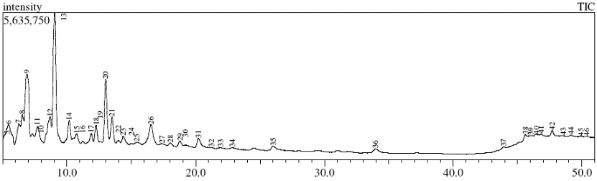
(a)

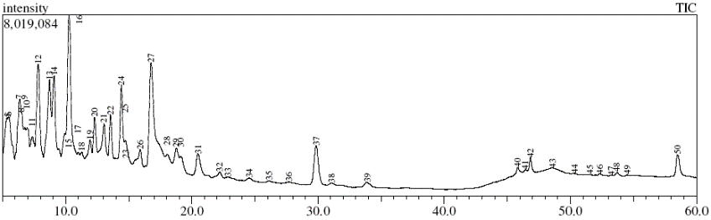
(b)

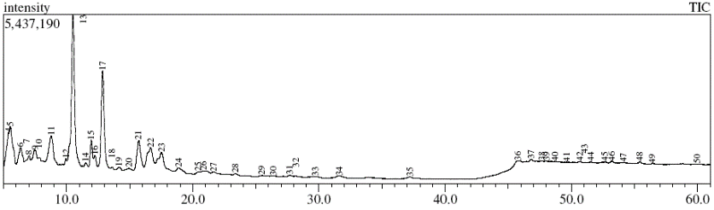

(c)

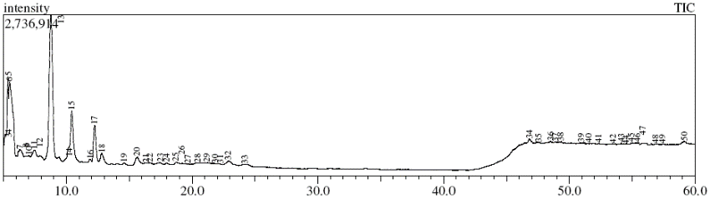

(d)

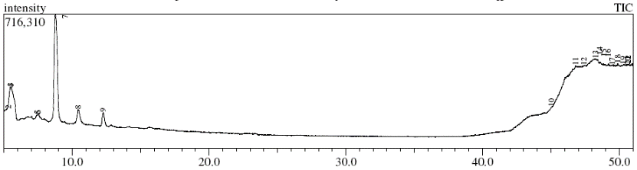
(e)

Figure 1. Chromatogram of Kasturi tobacco resinoid (a) fraction 1, (b) fraction 2, (c) fraction 3, (d) fraction 4, (e) fraction 5

Figure 2. Chemical composition of Kasturi Tobacco Resinoid

Table 1. Kasturi tobacco resinoid composition by classes of chemical compounds
Chemical Compounds | % Fraction Component
Chemical Compounds | F1 | F2 | F3 | F4 | F5
Hydrocarbon | 36 | 20 | 16 | 12 | 0
Haloalkane | 0 | 4 | 4 | 2 | 0
Ester | 38 | 22 | 30 | 14 | 8
Eter | 8 | 4 | 8 | 0 | 0
Ketone | 0 | 0 | 0 | 2 | 2
Carboxylic acid | 0 | 0 | 14 | 14 | 16
Alcohol | 14 | 10 | 22 | 16 | 14
Nitrogenous compound | 0 | 0 | 2 | 14 | 34
Terpenoid | 0 | 12 | 4 | 6 | 4
Aldehyde | 0 | 0 | 0 | 0 | 2
Phenol | 4 | 6 | 0 | 18 | 12
Other | 0 | 22 | 0 | 0 | 8

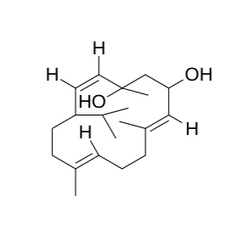
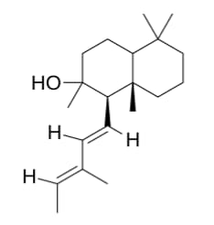
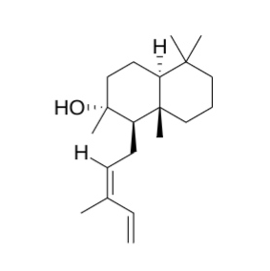

(1) (2) (3)

Figure 3. Chemical structure of (1) 4,8,13-cyclotetradecatriene-1,3-diol, (2) (11E,13Z)-labdadien-8-ol, (3) (12Z)-abienol

Conclusion
In the Kasturi tobacco resinoid contained ester compounds, followed by hydrocarbons, alcohol, nitrogenous compounds, terpenoids, and other chemical compounds. The hydrocarbon compound is affect the color of the product, while the presence of esters and diterpenes contribute to the Kasturi tobacco resinoids's odor. The presence of two main classes of diterpenoid found in tobacco, which are the cembranoid and labdanoid, in Kasturi tobacco resinoid there are known compounds with the structure of α-CBT (4,8,13-cyclotetradecatriene-1,3-diol and a labdanoid compound, (11E, 13Z)-labdadien-8-ol and (12Z)-abienol. The existence of two diterpene compounds in tobacco can be influenced by the type of tobacco. Not in all types of tobacco can find both of these diterpenoid compounds, sometimes it only contains one of them. In Oriental tobacco usually contains both of diterpenoid compound, while Burley tobacco only contains cembranoid. This study could provide an early information for the use of Kasturi tobacco leaves as source for bioactive compounds. This benefited the industry which produced biomass waste from under quality leaves and non-industrial usage part of tobacco crops.

Acknowledgement
This research has been supported by Research Institute of University of Jember, Indonesia (Grant No. 3240/UN25.3.1/LT/2019)
References
- Popova, V., Tumbarski, Y., Ivanova, T., Hadjikinova, R. and Stoyanova, A. (2019). Tobacco resinoid (Nicotiana tabacum L.) as an active ingredient of cosmetic gels. Journal of Applied Pharmaceutical Science. 9(09): 111-118.
- Antonova, D., Ivanova, D., Antonov, L. and Abe, I. (2016). Insight into the aroma profile of bulgarian tobacco absolute oil. Industrial Crops and Products, 94: 226-232.
- Baser, K. H. C., and Buchbauer, G. (2010). Handbook of essential oils: Science, technology, and applications. CRC Press, Boca Raton: pp. 42-85.
- Bauer, K., Garbe, D. and Surburg, H. (2001). Common fragrance and flavor materials. Preparation, properties and uses, 4th edition. Wiley-VCH, Weinheim, New York: pp. 177-238.
- Banožić, M., Banjari, I., Jakovljević, M., Šubarić, D., Tomas, S., Babić, J. and Jokić, S. (2019). Optimization of ultrasound-assisted extraction of some bioactive compounds from tobacco waste. Molecules, 24(8): 1-14.
- Rodgman, A. and Perfetti, T. (2013). The chemical components of tobacco and tobacco smoke, 2nd edition. CRC Press, Boca Raton: pp. 28.
- Kishore, K. (2014). Monograph of tobacco (Nicotiana tabaccum). Indian Journal of Drugs, 2(1): 5-23.
- El Sayed, K. A. and Sylvester, P. W. (2007). Biocatalytic and semisynthetic studies of the anticancer tobacco cembranoids. Expert Opinion on Investigational Drugs, 16: 877-887.
- Balai Penelitian Tanaman Pemanis dan Serat. http://balittas.litbang.pertanian.go.id/index.php/id/tentang-kami/komoditas/pemanis/60-info-teknologi/104-kasturi [Access online 15 May 2020].
- Saunders, J. A. and Blume, D. E. (1981). Quantitation of Major Tobacco Alkaloids by High Performance Liquid Chromatography. Journal of Chromatography A, 205: 147-154.

- Severson, R. F., Ellington, J. J. and Schlotzhauer, P. F. (1977). Gas chromatographic method for the determination of free and total solanesol in tobacco. Journal of Chromatography A, 139: 269-282.
- Qian, X. B., Ye, J. P., Chen, X. M., Zhang, C. H., Liang, Y.J., Li, Z. H. and Yang, J. (2014). Analysis of cembranoids in flue-cured tobacco by accelerated solvent extraction and gas chromatography-mass spectrometry-selected ion monitoring. Journal of the Chinese Chemical Society, 61: 1133-1140.
- Pizzuti, I. R., de Kok, A., Cardoso, C. D., Reichert, B., de Kroon, M., Wind, W., Righi, L. W. and da Silva, R. C. (2012). A multi-residue method for pesticides analysis in green coffee beans using gas chromatography–negative chemical ionization mass spectrometry in selective ion monitoring mode. Journal of Chromatography A, 1251: 16-26.
- Zhou, Y., Yang, Y., Li, X. L., Chen, Z. Y., Liu, Q. B., Zhu, X. L. and Yang, J. (2016). Determination of cembrenediols in tobacco by gas chromatography–mass spectrometry-selected ion monitoring with precolumn derivatization. Acta Chromatographica, 28(4): 513-524.
- Popova, V., Ivanova, T., Stoyanova, A., Georgiev, V., Hristeva, T., Nikolova, V., Docheva, M.., Nikolov, N. and Damianova, S. (2018). Phytochemicals in leaves and extracts of the variety “plovdiv 7” of bulgarian oriental tobacco (Nicotiana tabacum L.). Trends in Phytochemical Research, 2: 27-36.
- Johnson, A.W., Severson, R. F. and Hudson, J. (1985). Tobacco leaf trichomes and their exudates. Tobacco Science, 29: 67-72.
- Colledge, A., Reid, W. W. and Russel, R. (1975). The diterpenoids of nicotiana species and their potential technological significance. Chemistry & Industry, 5(13): 570-571.
- Reid, W.W. (1974). The phytochemistry of the genus nicotiana. Ann. Tabac, SEITA 2: 145-178.
- Enzell, C. R. and Wahlberg, I. (1990). Tobacco isoprenoids - precursors of important aroma constituents. Pure and Applied Chemistry, 62(7): 1353-1356.
- Leffingwell, J.C. (1999). Tobacco: Production, chemistry, and technology. Blackwell Science, London: pp. 265-284.

- Huang, M., Zhang, H., Wang, Z., Niu, D., Li, Y. and Cui, H. (2018). Comparative studies of leaf surface chemical biosynthesis in different tobacco cultivars. Acta Physiologiae Plantarum, 40: 67.

