
COLOUR STRENGTH AND WASHFASTNESS OF SILK FABRIC DYED WITH METHANOLIC EXTRACTED RANGOON CREEPER USING INFRA-RED DYEING MACHINE

(Kekuatan Warna dan Ketahanan Cucian Kain Sutera Diwarnakan dengan Akar Dani yang Diekstrak dengan Pelarut Metanol Menggunakan Mesin Pencelup Infra-Merah)

Suhaidi Ariffin¹, Wan Syazehan Ruznan¹*, Muhammad Nurkhairunizam Yazid², Suraya Ahmad Suhaimi¹,
Mu’adz Ahmad Mazian², Muhammad Mu’az Mustamam²

¹Clothing Innovation and Textile Research Association (CITRA),
²Faculty of Applied Sciences,
Universiti Teknologi MARA Cawangan Negeri Sembilan, Kampus Kuala Pilah, 72000 Kuala Pilah, Negeri Sembilan, Malaysia

*Corresponding author: syazehan@uitm.edu.my

Received: 21 June 2021; Accepted: 11 August 2021; Published: 29 August 2021

Abstract
Extracting dyes from plant sources is one of the eco-friendly ways to reduce environmental pollution. Since the discovery of synthetic dyes back in 1856, the use of natural dyes in the textile industry has become lessen. This work focuses on the determination of new colours from Rangoon creeper petals through the methanolic extraction method and dyed by using an Infra-Red dyeing machine to generate a new colour pallet that is similar to PANTONE® colour and to study its washfastness properties. Silk fabric was used and dyeing was carried out with calamansi and vinegar as the mordanting agents. Dyed silk samples were measured by using X-rite RM2000 Capsure to get the commercial PANTONE® colour code. The CIELAB colours coordinates were retrieved from the PANTONE® website and the L*a*b* values plotted indicates that all dyed silks were in the yellow-red quadrant. Colourfastness to washing shows an excellent rating i.e., 4/5, indicating outstanding stability. Thus, it was found that the colour produced from Rangoon creeper petals is suitable as a natural dye and also established high commercial value because the colour obtained is commensurate with the colour displayed by PANTONE® colours.

Keywords: rangoon creeper, natural dye, methanol extraction, infra-red dyeing

Abstrak
Mengekstrak pewarna daripada tumbuhan adalah salah satu kaedah mesra alam untuk mengurangkan pencemaran alam sekitar. Sejak penemuan pewarna sintetik pada tahun 1856, penggunaan pewarna semula jadi dalam industri tekstil semakin berkurangan. Kajian ini memfokuskan kepada penemuan warna baharu daripada kelopak bunga Akar Dani melalui kaedah pengekstrakan metanol dan diwarnakan dengan menggunakan mesin pencelup Infra-Merah bagi menghasilkan palet warna baharu yang serupa dengan warna PANTONE®, serta mengkaji sifat ketahanan warna. Kain sutera digunakan dan pencelupan dilakukan dengan limau kasturi dan cuka sebagai agen pengikat. Sampel sutera yang dicelup diukur dengan menggunakan X-rite RM2000 Capsure untuk mendapatkan kod warna PANTONE® yang komersial. Koordinat warna CIELAB diambil dari laman web PANTONE dan nilai L*a*b* yang ditunjukkan menunjukkan bahawa semua sutera yang dicelup berada di kuadran kuning-merah. Ketahanan warna terhadap cucian menunjukkan tahap cemerlang iaitu 4/5. Oleh itu, didapati bahawa warna yang dihasilkan daripada kelopak Akar Dani sesuai sebagai pewarna semula jadi dan juga memiliki nilai komersial yang tinggi kerana warna yang diperolehi setara dengan warna yang ditunjukkan oleh warna PANTONE®.

Kata kunci: akar dani, pewarna semula jadi, pelarut metanol, pencelupan infra-merah

Introduction
Textile industry is one of the biggest industries in the world. This industry is not only producing textile materials and garments, but also the products that people use in their daily lives. This growing industry is now becoming a major contributor in strengthening the economic scale. However, activities from the textile industry were reported to generate a large number of industrial effluents contributing to water pollution [1, 2]. Most of the dyes disposed to the environment were synthetic dyes, and these synthetic substances are typically carcinogenic. If the effluent treatment plant is not well controlled, the chemicals released will cause water pollution and also harm the water ecosystems [3, 4]. A few approaches can be implemented to overcome the problem, and one of them is by using dye extracted from natural sources.

Nowadays, the extraction process of dye compounds from natural sources especially plants has become an alternative strategy by many industrial practices. In general, natural dyes are inexpensive, biodegradable, non-toxic and have higher compatibility with the environment. Hence, the utilization of plants as raw material for natural dye has been applied on textile substrates. Natural dyes from flowers are not new in textile dyeing, with a few researches works in dyeing and printing conducted using natural dyes from flowers [5, 6, 7]. However, experimentation of Rangoon creeper flowers as a natural dye is scarce. Rangoon creeper or its botanical name, Quisqualis indica (Q. indica L.) belongs to the family of Combretaceae (Figure 1). It is indigenous in Africa, Indo Malaysian region and cultivated all over India. This flowering plant which is known as Akar Dani in Malaysia is largely grown as an ornamental plant and was reported to have many phytoconstituents in each part of the plant, also showing different bioactivities as well [8]. The flower is unique with a nice fragrant, which normally blooms in abundance. Moreover, the flowers are very attractive with white petals, which turns to pink and red when matured and borne in clusters. Anthocyanins are chemical compounds that are responsible to give pigment colours of red, pink, blue and purple for flowers.

This work aimed to explore the local-wild Rangoon creeper flowers for dye production by using solvent extraction techniques. The shades obtained were compared with the PANTONE® colour chart to establish the commercial value of the colour. A replacement for synthetic dyes is much in need, thus it is important to produce the colour that matches global colour references such as PANTONE® colours. Colours produced from Rangoon creeper with matching shade to PANTONE® colours are expected to have great commercial value in the colouration industry.

Materials and Methods

Sources
The flower of Q. indica L. (Rangoon creeper) was collected at Kampong Beting, Kuala Pilah, Negeri Sembilan, which wildly grow along the roadside in the village. Fresh samples were immediately transported to the laboratory to be processed. The petals were plucked and dried at room temperature for 5 days to remove water content. Then, the dried petals were ground into powder form by using a mixer grinder for better extraction.

Textile substrates used in this research work is 100% silk fabric. Fabrics made of natural protein fibre was selected to have a better affinity with natural dyes. Sodium chloride was used as a fixator agent, while vinegar and calamansi were used as mordanting agents, which work not only as a fixator but also as a catalyst in dyeing textile substrates using natural dyes. Natural mordants were selected in this work to make the dyeing more sustainable.
Extraction
Alcoholic extraction method was applied in which precisely 200 g of fine dried powder sample were infused in 2.0 L methanol solvent for 2 days at room temperature (25±2 °C) [9]. The solvent-containing extract was then decanted and filtered using Whatman filter paper no.1 by gravity filtration. The filtrate was evaporated under reduced pressure at 40°C using a rotary evaporator and dried at room temperature to give viscous concentrated crude methanolic dye extract.

Preparation for dyeing
Preparation for dyeing was done using MLR of 1:100, 10 g/L of mordant and 10 g/L of sodium chloride salt on the amount of solutions. Dye solution with 1% concentration was prepared by adding 2 g of extracted colorants in the 200 mL of distilled water.

Simultaneous mordanting
Simultaneous or meta mordanting was conducted by immersing the fabric sample in the dye bath containing mordant, dye extract and sodium chloride salt. Dyeing took place at 80 ºC for 60 minutes using the MLR of 1:100.

Dyeing
Dyeing was carried out by using an Infra-Red dyeing machine. Three samples of 100% silk fabric were prepared with a standard weight of 2 g each. Infra-Red dyeing machine rotated for 3 minutes clockwise and changed the rotational direction to anti-clockwise with an interval of 3 seconds. The dyeing process started at 40 ºC then raised to 80 ºC with a gradient of 5 ºC/min. When it reached 80 ºC, it was held for 60 minutes before cooled down to 40 ºC. The fabrics were then removed after dyeing and rinsed with cold distilled water before drying under shade.

Colour value
All dyed samples were evaluated for colour shade using X-rite RM2000 Capsure. This shade is similar to the standard PANTONE® colour. This hand-held colour measurement tool kept the PANTONE® library and will match the PANTONE® colour shade to the dyed fabric sample. The colours obtained were also measured using CIELAB colour space.

Colourfastness to washing
Colourfastness to washing is a test to identify how strong the colour molecules stay and are bound in the fibre after washing. The test was carried out for 30 minutes at 60 ºC in accordance with MS ISO 105-C03–1996. The fabric samples were then rinsed and dried prior to evaluation under the lighting cabinet. Greyscales for assessing colour change were used to analyse the colour change of the dyed fabric samples, and also the staining of adjacent white fabrics. Change in colour and staining were rated using greyscales standard ranging from 1 to 5, where 1 is poor and 5 is excellent in accordance with ISO 105-A02:1993.

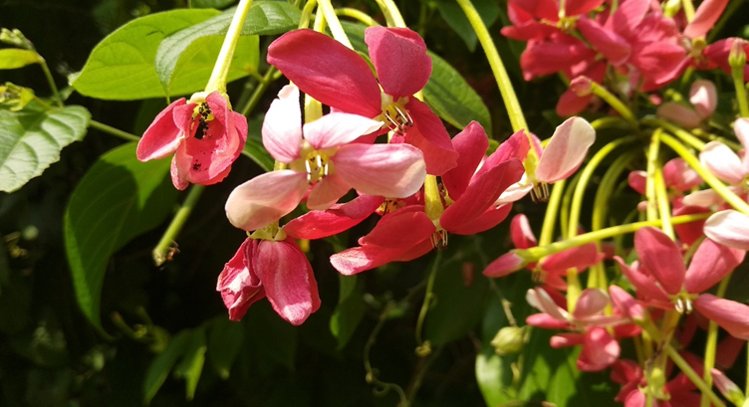

Figure ‎1. Quisqualis indica flowers

Results and Discussion

Extraction of Rangoon creeper flowers
Colours extracted from Rangoon creeper flowers were documented in several articles, and most of them used aqueous extraction techniques [10]. Extracting colour from creeper’s flowers using chemical solvent was scarcely found in Malaysia. This work has successfully extracted Rangoon creepers flowers using methanol as solvent extraction medium to obtain dark brown viscous concentrated crude methanolic dye extract with a concentration of 21.142 g/L. The whole process is shown in Figure 2.

Colour measurement
Colour measurement was successfully done by capturing the shades of the dyed samples. Silk fabric samples dyed using vinegar as mordanting agent showed earthy shades. Basically, all dyed samples were categorised using a type of mordant as the dye is the same. There are grouped as non-mordanted, vinegar and calamansi. Principally, all samples have the same colour hue. The lightest shades were displayed by silk samples dyed using calamansi as mordant (Figure 3a), followed by darker shades by non-mordanted dyed samples (Figure 3b). The darkest shades were showed by samples dyed using vinegar as mordants (Figure 3c).
The colours plotted using CIELAB colour space showed that all dyed samples were plotted in the yellow-red space as shown in Figure 4 below. Colour values i.e., RGB, L*a*b* and Delta E were stated in Table 1. All measured colours were plotted in the 2D colour plot and all dyed fabrics have the same shade. Fabric dyed with Rangoon creeper flowers using calamansi as mordanting agent give ore reddish shade as compared to fabric with vinegar as mordant and non-mordanted fabric.

Colourfastness to washing
Colourfastness to washing shows good results for all mordanted and non-mordanted samples. Non-mordanted samples gave slightly different shades but were acceptable, which give a rating of 4 (good). Although the mordanted samples are slightly different before and after washing, the hue is still the same. Mordanted samples show excellent ratings i.e., 4/5, which is almost similar to the unwashed samples. The excellent ratings obtained for both mordanting agents show that calamansi and vinegar are suitable to be used in natural dyeing. Both mordants are able to hold the colour on the textile substrates after washing. The results also show that there is almost no stain of the dye on the adjacent fabrics for both mordanted samples.

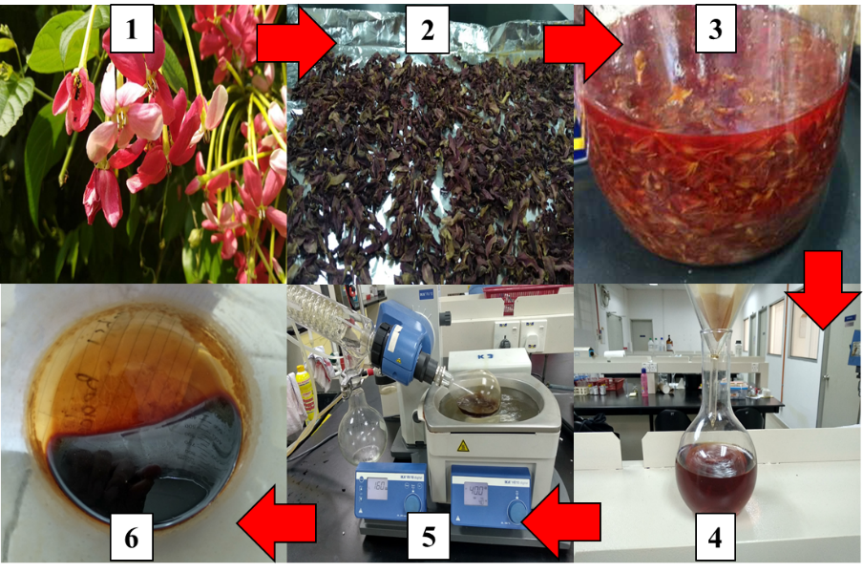
Figure 2. Methanolic dye extract process: (1) raw sample, (2) drying, (3) soaking with methanol, (4) filtered, (5) evaporate to dryness, and (6) dye extract
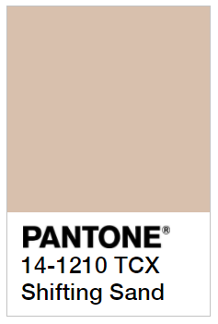  (a) | 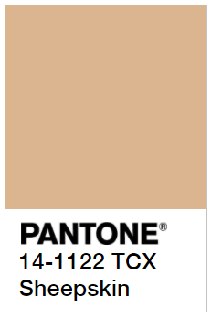  (b) |   (c)
Figure 3. Dyed silk fabric samples with different mordant (a) calamansi, (b) non-mordanted, (c) vinegar

Table 1. RGB and L*a*b* data for non-mordanted and mordanted samples
Mordants | R | G | B | L* | a* | b*
Non-mordanted | 204 | 166 | 127 | 70.62 | 8.57 | 25.45
Calamansi | 216 | 185 | 152 | 77.01 | 6.24 | 20.87
Vinegar | 182 | 149 | 116 | 63.91 | 7.62 | 22.08

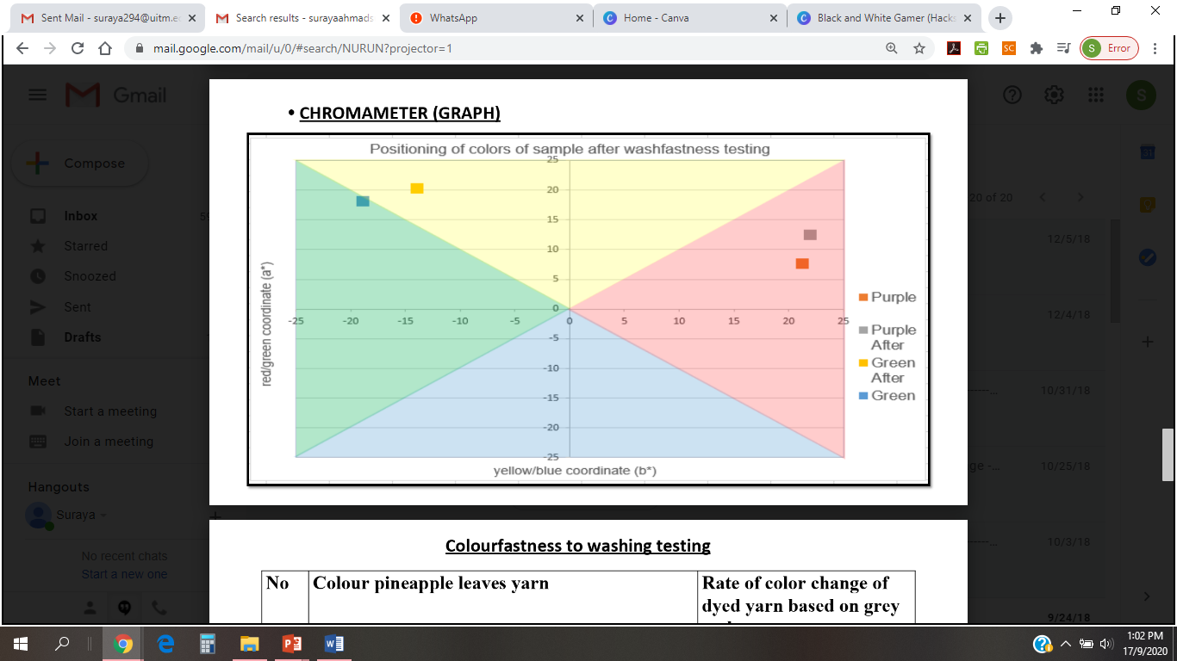

Legend: non-mordanted
mordanted (vinegar)

mordanted (calamansi)

Figure 4. 2D plot for fabrics dyed with Rangoon creeper flower

Table 2. Rating for colourfastness to washing
Mordants | Change in  Colour | Staining on White Fabrics |  | Indicator
Mordants | Change in  Colour | 100% silk | 100% cotton | Indicator
Non-mordanted | 4 | 4 | 4 | Good
Calamansi | 4/5 | 5 | 4/5 | Excellent
Vinegar | 4/5 | 5 | 4/5 | Excellent

Conclusion
Natural dyes show substantial growth for the past few years due to their non-toxicity of natural and sustainable sources with minimal environmental impact characteristics. The application of natural dye on textile substrates using alcoholic extraction has created attention to the scientific community to use this large diversity of natural dye sources in the textile dyeing industry. In the current study, emphasis has been laid on the extraction and colourimetry of natural dye from the flower. Natural colourants extracted from the Rangoon creeper demonstrate good colour strength and are comparable with PANTONE®. The colour yield has shown different shades of brown, with excellent colourfastness to washing. Infra-Red dyeing technique used also make the dyeing process more sustainable with more even colour on textile substrates.

Acknowledgement
This is a self-funded study by the collaboration of teaching practitioners of different fields. The authors would like to thanks UiTM Negeri Sembilan Branch, Kuala Pilah Campus for providing facilities for this study.

References
- Kishor, R., Purchase, D. Saratale, G. D., Saratale, R. G., Ferreira, L. F. R., Bilal, M., Chandra, R. and Bharagava, R. N. (2020). Ecotoxicological and health concerns of persistent coloring pollutants of textile industry wastewater and treatment approaches for environmental safety. Journal of Environmental Chemical Engineering, 9(2): 1-18.
- Hassaan, A., M. (2017). Health and environmental impact of dyes: Mini review. American Journal of Environmental Science and Engineering 1(3): 64-67.
- Behera, M., Nayak, J., Banarjee, S., Chakrabortty, S. and Tripathy, S. K. (2021). A review on the treatment of textile industry waste effluents towards the development of efficient mitigation strategy: An integrated system design approach. Journal of Environmental Chemical Engineering 9(4): 1-21.
- Tkacyzk, A., Mitrowska, K. and Posyniak, A. (2020). Synthetic organic dyes as contaminants of the aquatic environment and their applications for ecosystems: A review. Science of the Total Environment 717: 1-19.
- Ludin, N. A., Al-Alwani, M.A.M., Mohamad, A. B., Kadhum, A. A. H., Hamid, N. H., Ibrahim, M. A., Teridi, M. A. M., Al-Hakeem, A., Mukhlus, A. and Sopian, K. (2018). Utilization of natural dyes from Zingiber officinale leaves and Clitoria ternatea flowers to prepare new photosensitiser for dye-sensitised solar cells. International Journal of Electrochemical Science, 13(2018): 7451-7465.
- Kim, H. J., Bin, Y.T., Karthick, S. N., Hemalatha, K. V., Raj, C. J., Venkatesan, S., Park, S. and Vijaykumar, G. (2013). Natural dye extracted from rhododendron species flowers as a photosensitizer in dye-sensitized solar cell. International Journal of Electrochemistry Science, 8: 6734-6743.

- Singh, S., Bothara, S. B. and Singh, S. (2011). Acid-base indicator properties of dye from local flowers: Cassia anugostifolia Linn., Thevetia peruviana (Pers.) K. Schum and Thevetia thvetiodes (Kunth) K. Schum. Pharmacognosy Journal, 3(19): 35-39.
- Sahu, J., Patel, P. K. and Dubey, B. (2012). Quisqualis indica Linn: A review of its medicinal properties. International Journal of Pharmaceutical and Phytopharmacological Research, 1(5): 313-321.
- Voon, Ching, H., Bhat, R. and Rusul, G. (2012). Flower extracts and their essential oils as potential antimicrobial agents for food uses and pharmaceutical applications. Comprehensive Reviews in Food Science and Food Safety, 11(1): 34-55.
- Soniya, M. and Anitha, D. (2018). Microwave extraction of dye from Madhumalti flower. Journal of Research Angrau, 46(4): 61-66.

