

SYNTHESIS AND CHARACTERIZATION OF ACETOL FROM PALM-BASED GLYCEROL

(Sintesis dan Pencirian Asetol daripada Gliserol Berasaskan Sawit)

Roila Awang¹* and Mohamad Hanif Mohamed²

¹Engineering and Processing Division,
Malaysian Palm Oil Board No.6, Persiaran Institusi, Bandar Baru Bangi, 43000 Kajang, Selangor, Malaysia
²Department of Chemistry, Faculty of Science,
Universiti Putra Malaysia, 43400 Serdang, Selangor, Malaysia

*Corresponding author: roila@mpob.gov.my

Received: 10 July 2021; Accepted: 20 August 2021; Published: 29 August 2021

Abstract
Glycerol conversion to value-added product, acetol was studied through the dehydration reaction of glycerol catalyzed by copper chromite in a single step reactive distillation. The physical properties of the synthesized acetol such as its appearance, density and viscosity were compared with those of a commercial product. The effects of reaction temperature (190 ºC and 200 ºC), reaction period (1.5-7 hours), catalyst loading (0.63-7.0%) and water content (2-20% w/w) in the glycerol feedstock were studied to optimize its production. The results show conversion of glycerol increased with the increase of reaction period and catalyst loading while the presence of water in the glycerol feedstock decreased the conversion and also reduced the residue which provided ease of removal and recycles the catalyst. Optimum conditions for the conversion of glycerol to acetol was at a reaction period of 3.5 hours with 2.5% catalyst concentration and 200 ºC reaction temperature without dilution where 64.47% of the product was obtained. Fourier transform infrared (FTIR), gas chromatography (GC) and nuclear magnetic resonance (NMR) were used to characterize and validate the product from the dehydration reaction of glycerol. FTIR spectrum of the product showed stretching of the carbonyl group which suggested that acetol had been successfully synthesized. All of the analyses (GC and NMR) validate that acetol was successfully synthesized.

Keywords: acetol, dehydration, glycerol, palm-based, synthesis

Abstrak
Penukaran gliserol kepada produk bernilai tinggi, asetol telah dikaji melalui tindak balas nyah-hidrat gliserol dimangkin oleh kuprum kromit dalam penyulingan reaktif satu langkah. Ciri-ciri fizikal asetol yang dihasilkan seperti penampilan, ketumpatan dan kelikatan telah dibandingkan dengan produk komersil. Kesan suhu tindak balas (190 ºC and 200 ºC), tempoh tindak balas (1.5-7jam), kuantiti mangkin (0.63-7.0%) dan kandungan air (2-20% w/w) dalam stok suapan gliserol dikaji untuk mengoptimumkan penghasilannya. Hasil kajian menunjukkan penukaran gliserol meningkat dengan peningkatan tempoh tindak balas dan kuantiti mangkin manakala kehadiran air dalam stok suapan gliserol merendahkan penukaran dan juga mengurangkan sisa dimana memudahkan pengasingan dan kitar semula mangkin. Keadaan optimum untuk penukaran gliserol kepada asetol adalah pada tempoh tindak balas sebanyak 3.5 jam dengan kuantiti mangkin 2.5% dan 200 ºC suhu tindak balas tanpa pencairan stok suapan dimana ia memperolehi 64.4% produk. Inframerah transformasi Fourier (FTIR), kromatografi gas (GC) dan resonans magnetik nuklear (NMR) telah digunakan untuk mencirikan dan mengesahkan produk daripada tindak balas nyah-hidrat gliserol. Spektrum IR produk menunjukkan regangan kumpulan karbonil menunjukkan asetol telah berjaya dihasilkan. Semua analisis (GC dan NMR) mengesahkan bahawa asetol berjaya disintesis.

Kata kunci: acetol, dehidrasi, gliserol, berasaskan sawit, sintesis

Introduction
Glycerol is a clear, odorless and viscous liquid that is the main component of triglycerides. It is derived from soap or biodiesel processing and can be found in animal fats, vegetables oils or petrochemical feedstock. Despite its many uses as an ingredient or processing aid in cosmetics, toiletries, personal care and food products, glycerol is usually used in a highly refined and purified form [1]. The accumulation of the biodiesel by-product/unrefined glycerol has caused an oversupply and consequently a fall in glycerol price. This scenario has created new markets for polymers, ethers and other fine chemicals. Because of its multifunctional structure and properties, glycerol can be converted into a variety of products through various reaction pathways such as dehydration, oxidation, etherification and esterification reaction. Glycerol can be used to make a wide range of chemicals, including ethylene glycol, acetol, dihydroxyacetone, propylene glycol and many others [2].

Acetol is a ketone compound that acts as an organic synthesis intermediate. It is widely used in food, textile and in cosmetics industry as its unique structure allows the promotion of a variety of reactions including dehydration, hydrogenation, oxidation and polymerization [3]. A review on the application and production of acetol has been published [4]. Acetol could be obtained through multiple ways [5] but due to some reasons stated, the best method in producing acetol is by using glycerol as a feedstock. In the absence of hydrogen, glycerol can be dehydrated to acetol via a reactive distillation technique. In this study, acetol was isolated from the dehydration of palm-based glycerol as an intermediate for propylene glycol synthesis and the effect of various reaction parameters were also investigated.

Materials and Methods
Materials
Glycerol (98%) was purchased from an oleochemical company in Malaysia. Crude glycerol was obtained from a palm biodiesel plant. Acetol (technical grade, 90%) and copper chromite (catalyst grade, 100%) were purchased from Sigma-Aldrich. Analytical grade methanol was obtained from JT Baker. All other reagents were of analytical grade and were used as received.

Dehydration of glycerol to acetol
The general procedure was according to Dasari [6]. The experiments were carried out in a 150 mL fully agitated glass reactor. A desired amount of glycerol and catalyst were added into the glass reactor. The reaction flask was then attached to the condenser and vacuum pump to obtain a reduce pressure. The reaction mixture was stirred throughout the experiments at 200 rpm using magnetic stirrer. The glass reactor was immersed in a constant temperature oil bath, the temperature of which was maintained within ± 5 °C of the desired temperature. The catalyst was first heated at 100 °C overnight before being charged into the reactor. The percentage conversion of glycerol is defined as the ratio of moles of glycerol consumed in the reaction to the initial moles of glycerol before the reaction. All experiments were repeated twice.

Effect of reaction period on dehydration reaction
The mixture of 50 g glycerol and 1.25 g of copper chromite catalyst was placed in a three-necked round bottom flask. The reaction mixture was heated at the minimum reaction temperature of 190 ºC and 200 ºC. The reaction was then stirred throughout the chosen reaction periods- 1.5, 2.5, 3.5, 4.0, 5.0 and 7.0 hours. The percentage of conversion was defined as number of mole glycerol reacted as compared to number of mole initial glycerol used.

Effect of catalyst concentration on dehydration reaction
The optimum reaction period was then selected to undergo catalyst concentration study. The reaction mixture of 50 g glycerol and a chosen amount of copper chromite catalyst (0.63, 1.25, 2.5, 5.0 and 7.0 % (w/w)) was placed in a three-necked round bottom flask. The reaction mixture was heated at selected reaction temperature (190 ºC and 200 ºC) and stirred for 3.5 hours. The percentage conversion was determined as described earlier.

Effect of glycerol concentration as a feedstock on dehydration reaction
The reaction was carried out using a chosen dilution of 2%, 5%, 7%, 10%, 15% and 20% water concentration of glycerol as feedstock with 1.25 g copper chromite at different reaction temperature (190 ºC and 200 ºC) for 3.5 hours. The percentage conversion was determined as described earlier.

Analytical method
The products obtained were tested for different physical and chemical properties. Hydroxyl value was determined according to AOCS method [7]. Sample was weighed into a 250 mL Erlenmeyer flask, followed by the addition of 25 mL of acetic anhydride-pyridine reagent (1:3 v/v). Then, the flask was placed in a water bath maintained at 98 ºC for 1 hour. After that, the flask was removed from the water bath and cooled to room temperature before titration. Titration was conducted using a 0.5 N standardize NaOH solution and phenol-phthalein as indicator. Density was determined using digital Densitometer, DE 40 (Metler Toledo) according to ASTM D 4052. Fourier transform infrared (FTIR) spectra were recorded on a Perkin Elmer Spectrum One model spectrophotometer. Carbon NMR (¹³C-NMR) and proton NMR (¹H-NMR) were recorded on a JOEL ECA-400 spectrometer at 400 MHz. The chemical shifts are expressed in ppm with tetramethylsilane as internal standard.

GC analysis was carried out using a Shimadzu GC-17A, fitted with a non-polar BPX-5 (30m×0.25mm×0.25µm film thickness) capillary column. The samples had undergone silylation process before being injected into the GC. The initial oven temperature was set at 60 °C, followed by ramping at 60-300 °C and held at this temperature for 5 min. The injector and detector were set at 300 °C. Helium was used as the carrier gas.

Results and Discussion
The development of products from the dehydration of glycerol catalyzed by copper-chromite was monitored by thin layer chromatography (TLC) in a solvent system containing chloroform and methanol of 7:3 ratio. The spot representing the raw material appeared at a retention factor (R_{f}) value of 0.46, while an additional spot which appeared at a R_{f} value of 0.80 represented the product (Figure 1). The formation of acetol was then confirmed using FTIR spectroscopy, GC and NMR analyses (Figures 2-4).

In the FTIR spectrum of the product (Figure 2), the prominent carbonyl peak centered at 1720 cm⁻¹ wave number. The transmittance peak of the hydroxyl group (OH) can still be observed at 3200-3400 cm⁻¹ but the peak is broader than the starting material due to the presence of water as a by-product. Meanwhile, the-OH bending bands were observed at 1653 and 1040 cm⁻¹, suggesting that the compound still possessed its primary OH group.

Formation of acetol was confirmed by GC analysis. The identification of the product mixture was based on the comparison of retention time (RT) of the peaks with commercially available acetol. As shown in Figure 3, the chromatogram of the product mixture after conversion to trimethylsilyl (TMS) derivatives revealed the presence of other compounds along with acetol.

The NMR spectra for the commercially available acetol and the product mixture were very similar. The spectrum showed a single peak at 2.18 ppm for -CH₃. This is due to CH₃CO- which rotates freely around the bond between CH₃CO- and -CH₂OH, while the signal at 4.27 ppm represents hydrogen from the hydroxyl group. As for ¹³C-NMR, the existence of the C=O for ketone compound was observed at 207.6 ppm. The signal resonating at 65.67 ppm showed the presence of the hydroxyl group. -CH₃ for the product appeared at 21.66 ppm (Figures 4a-b).

Properties of the starting material, crude product and purified product are shown in Table 1. The reaction progress can be described by means of the changes in substrate concentration. In this study, the change in glycerol concentration was monitored. In order to optimize the reaction, the effect of the following variables was investigated (i) reaction time (ii) catalyst concentration and (iii) initial water content.

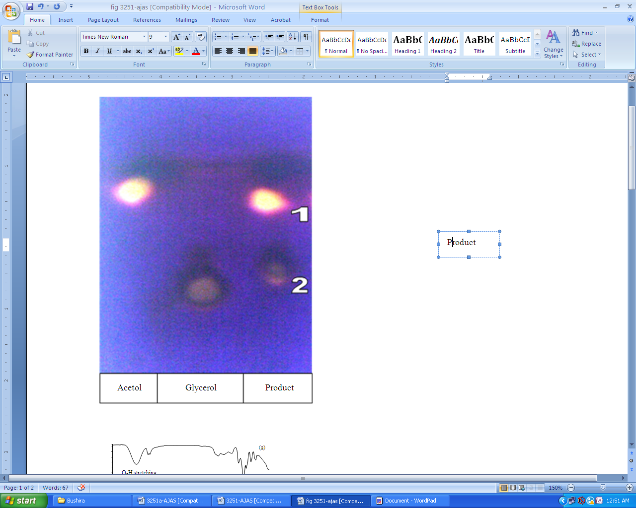
Figure 1. Thin layer chromatography of commercial sample, glycerol and reaction product (1) acetol; (2) glycerol

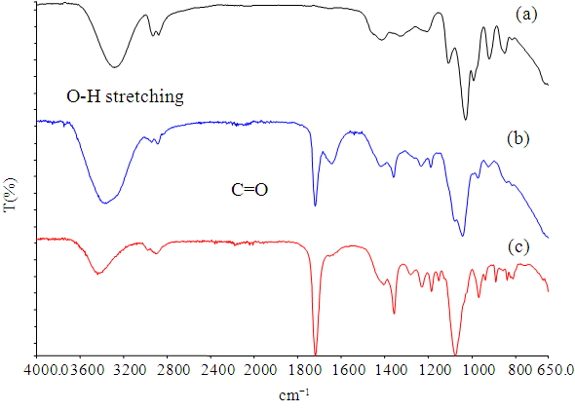
Figure 2. Overlay FTIR spectrum of (a) glycerol; (b) crude product and (c) purified product
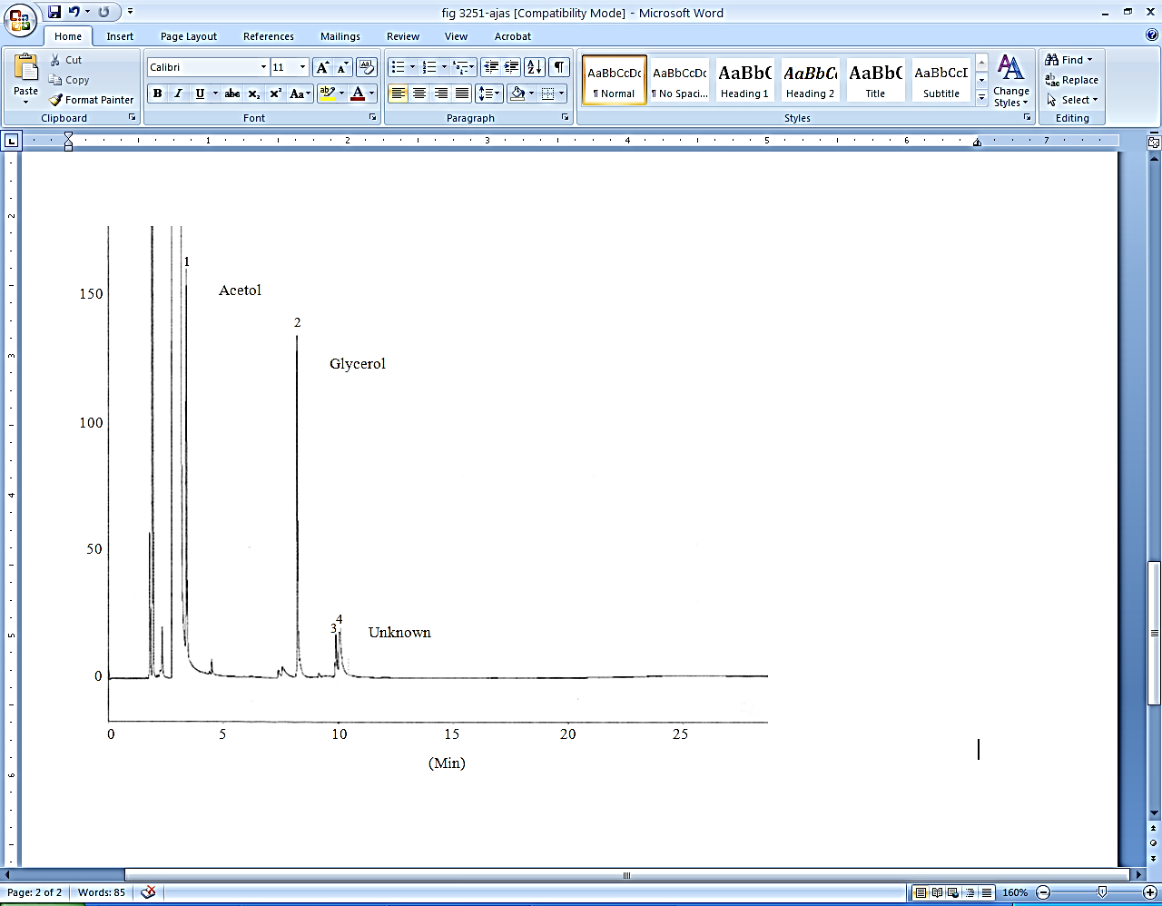
Figure 3. GC chromatogram of the reaction product

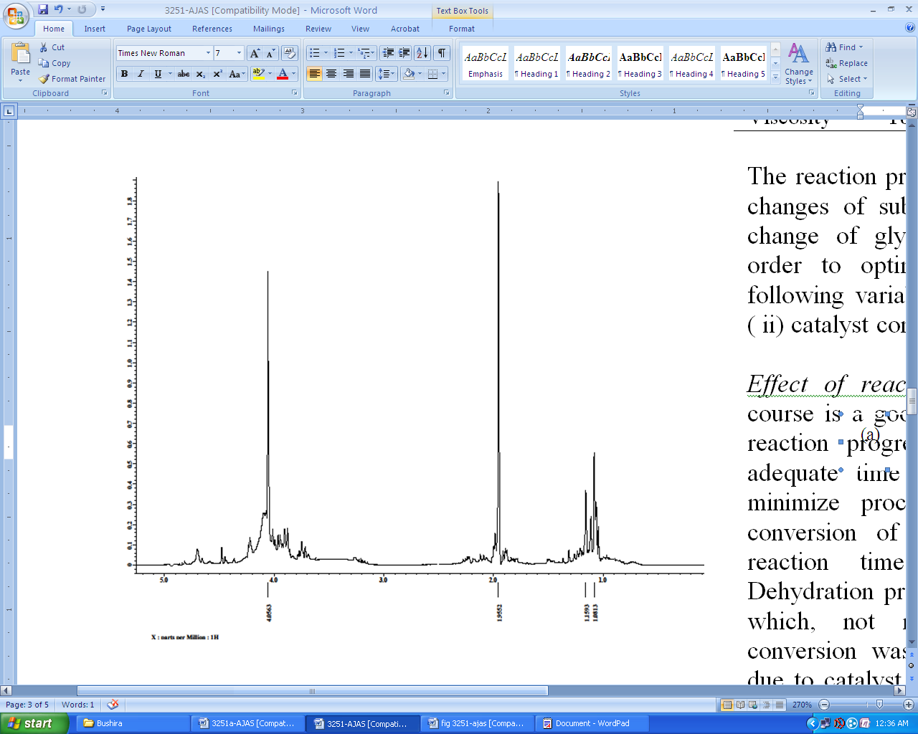
(a)
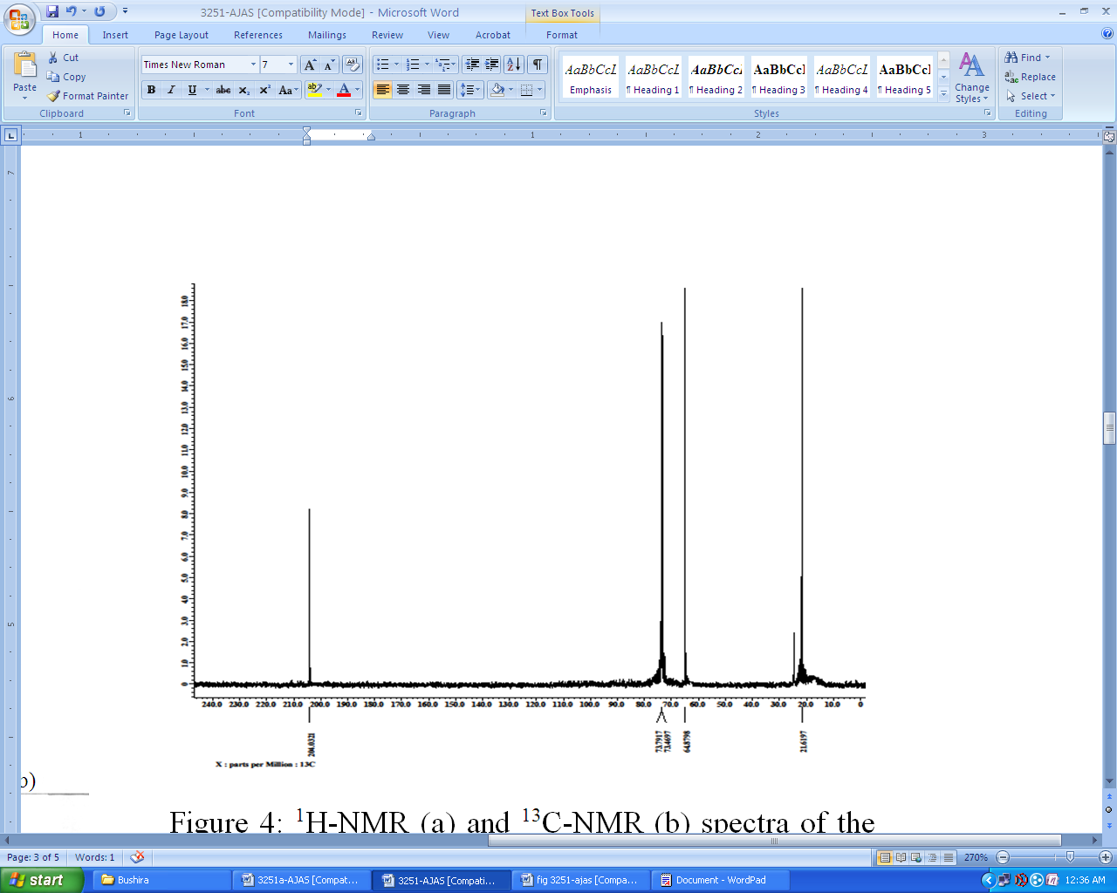
(b)
Figure 4. ¹H-NMR (a) and ¹³C-NMR; (b) spectra of the reaction product

Table 1. Properties of glycerol, crude product, purified product and commercial sample
 | Glycerol | Crude | Purified | Standard
Colour | Colorless | Light yellow | Yellowish | Colourless-yellowish
Hydroxyl value (mg KOH/g) | 1827.6 | 980-1400 | 790-843 | 757.2
Density (g/cm³) | 1.26 | 1.04 | 1.08 | 1.08
Viscosity (mm²/s) | 186.87 | 2.35 | 2.58 | 2.50

Effect of reaction time and temperature
Time course is an excellent predictor of catalyst performance and reaction progress. It can pin point the shortest or sufficient time required to achieve good yields and reduce process costs. Figure 5 showed the conversion of glycerol to acetol increases as the reaction time increased for both temperatures. The dehydration process proceeded rapidly within 3 hours, after which, not much difference in the percentage conversion was observed. This observation might be due to catalyst deactivation. The percentage conversion of the reaction carried out at 200 °C was always higher than the reaction at 190 °C. The behavior and stability of the catalyst, as well as the rate of reaction, are affected by changes in reaction temperature. Chiu and his colleagues [8] stated that the batch mode reactive distillation at higher temperature of 240 ºC achieved up to 86.6% with 5% copper chromite as catalyst but no total reaction time was mentioned. The highest conversion obtained in this study is 77% with 6 hours reaction period. Based on this data, it is suggested that the reaction at 200 ºC with half of the catalyst concentration, (2.5%, w/w), is better in term of economic value due to lower catalyst concentration and temperature used as the difference of the conversion is only 10%. In addition, reaction at 200 ºC prevents the formation of propylene glycol and acrolein compared to that of at 240 ºC reaction temperature.

Effect of catalyst concentration
The influence of varying the amount of catalyst on the dehydration process was investigated by carrying out the reaction in various amounts of catalyst ranging from 0.63-7.5% by weight of reactant. In most reactions, catalyst content influences the total reaction time required to reach the desired conversion. In this study, increasing the catalyst content from 0.63-2.5% (3.97-fold) increases the percentage conversion of glycerol by 2.52-fold for the reaction carried out at 190 °C and 3.35-fold for the reaction carried out at 200 °C. Further increase to 7.5% (3-fold) of the amount of catalyst only gave an increase in percentage conversion to 1.33-fold for the reaction at 190 °C and 1.23-fold at a temperature of 200 °C (Figure 6). When a higher level of catalyst was used, the rate of reaction increased and up to a point where the percentage conversion was unchanged. In this case substrate limitation or/and catalyst deactivation might be a reason.

Effect of initial water content
In this study, water was added to the glycerol at concentrations of 2, 5, 10, 15 and 20% by weight. The reactions were carried out at 200 °C for 3.5 hours in the presence of 2.5% w/w catalyst. Under test conditions, Figure 7 depicts the influence of initial water content on total glycerol conversion. The glycerol conversion decreases as the amount of initial water in the reaction mixture increases. The accumulation of the water-insoluble residue showed an inverse relationship with increasing initial water content. This was in agreement with the results reported by Chiu et al. [8]. The initial water content prevents residue formation by removing acetol and water vapors from the reaction mixture until it can degrade or polymerize into residue [9].

Reusability of catalyst
Catalyst reuse provides a number of cost advantages, which are often essential prerequisites for establishing an economically viable process. In this study, the catalyst recovery was done according to literatures [6, 9]. After each cycle, the catalyst was washed with methanol until the wash was clear, and then dried overnight in an oven at 100 ˚C for catalyst activation as well as methanol removal. Figure 8 demonstrated that the catalyst can be reused up to five cycles. The conversion of glycerol was maintained above 58% after repeated runs. However, after 5 cycles of use, the residue began to foam on the catalyst. Once the reaction mixture started foaming, the catalyst could not be recovered anymore.

Figure 5. Effect of reaction time on % conversion

Figure 6. Effect of catalyst concentration on % conversion

Figure 7. Effect of initial water content on % conversion

Figure 8. Reusability of catalyst

Conclusion
Acetol was successfully synthesized through dehydration of glycerol catalyzed by copper catalyst under reduced pressure. The acetol from this reaction can be hydrogenated to form propylene glycol. Further study on the synthesis of acetol should be carried out using other type of glycerol available in market particularly crude glycerol which is biodiesel by-product.

Acknowledgement
The researchers would like to thank Director General of MPOB for his permission to publish this paper.

References
- Choi, W. J. (2008). Glycerol-based biorefinery for fuels and chemicals. Recent Patents Biotech. 2: 173-180.

- Pathak, K., Reddy, K. M., Bakhshi, N. N. and Dalai, A. K. (2010). Catalytic conversion of glycerol to value added liquid products. Applied Catalysis A: General, 372: 224-238.
- Dasari, M. A., Kiatsimkul, P., Sutterlin, W. R and Suppes, G. J. (2005). Low-pressure hydrogenolysis of glycerol to propylene glycol. Applied Catalyst A: General, 281: 225-231.
- Mohamad, M. H., Awang, R. and Yunus, W. M. Z. W. (2011). A review of acetol: Application and production. American Journal of Applied Sciences, 8: 1135-1139.
- Kinage, A. K., Upare, P. P., Kasinathan, P., Hwang, Y. K. and Chang, J. S. (2010). Selective conversion of glycerol to acetol over sodium-doped metal oxide catalysts. Catalysis Communications, 11: 620-623.
- Dasari, M. A. (2006). Catalytic conversion of glycerol and sugar alcohol to value-added products. PhD Thesis, University of Missouri-Columbia.
- American Oil Chemical Society (1993). Official methods and recommended practices. 4th Edition. AOCS Press, Champaign.
- Chiu, C. W., Dasari, M. A., Suppes, G. J. and Sutterlin, W. R. (2006). Dehydration of glycerol to acetol via catalytic reactive distillation. American Institute Chemical Engineers Journal, 52: 3543-3548.
- Chiu, C. W., Tekeei, A., Sutterlin, W. R., Roncho, J. M. and Suppes, G. J. (2008). Low-pressure packed-bed gas phase conversion of glycerol to acetol. American Institute Chemical Engineers Journal, 54: 2456-2463.

