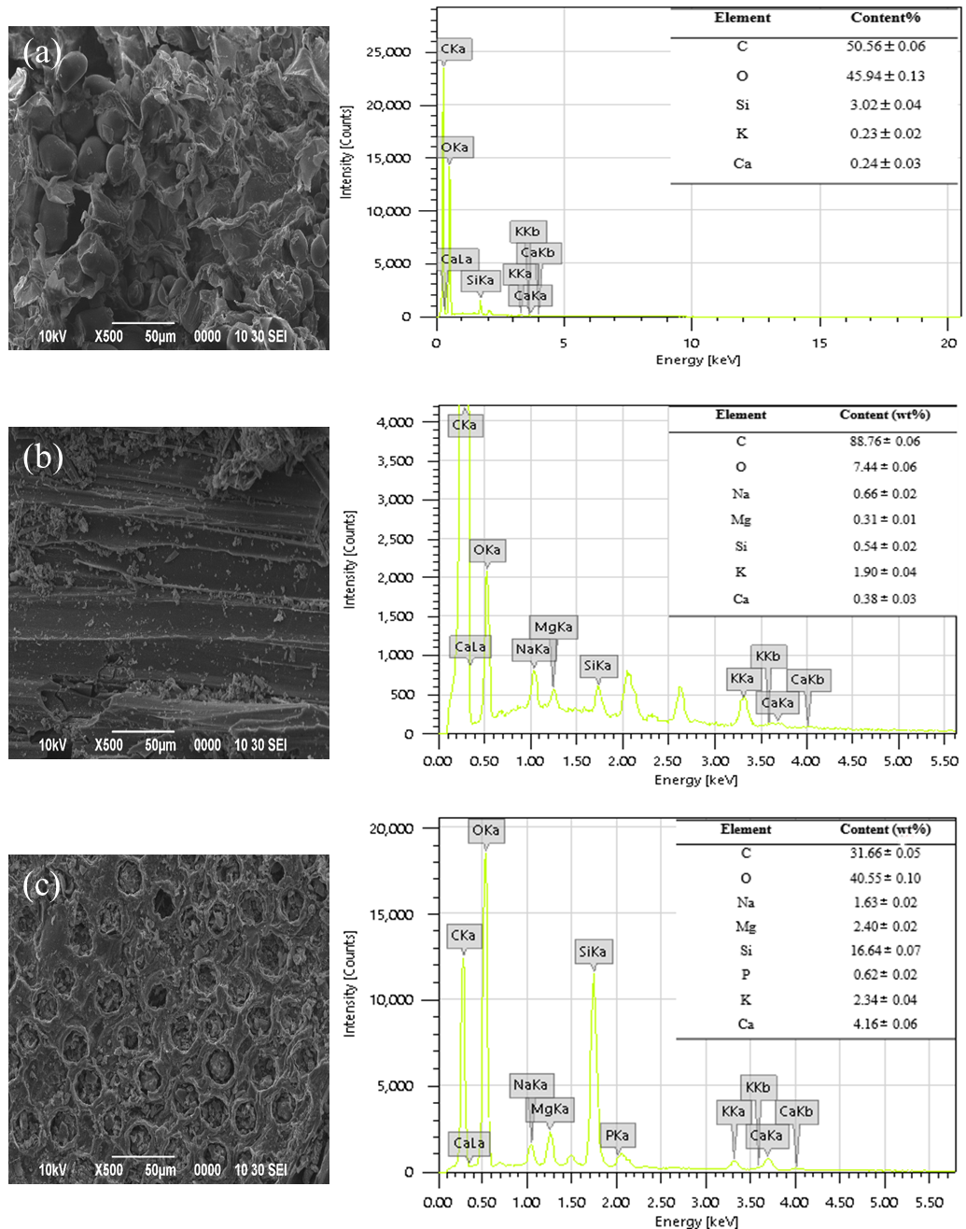
Figure 2. SEM and EDX spectra images of (a) SBW, (b) SBB, and (c) TSB at 500x magnification

