

HARDNESS REMOVAL OF GROUNDWATER THROUGH SAND,

ZEOLITE AND RICE HUSK ACTIVATED CARBON

(Rawatan Air Bawah Tanah Menggunakan Pasir, Zeolit dan Karbon Reaktifdari Sekam Padi bagi Penyingkiran Keliatan Air)

Nor Izzah Abdul Aziz¹, Norzila Othman¹, Wahid Ali Hamood Altowayti¹*, Zalilah Murni Yunus²,
Marlinda Malek³, Nurina Fitriani⁴, Muhammad Tahir⁵, Firhat Muhammad Fikri⁶

¹Faculty of Civil Engineering and Built Environment
²Faculty of Science Technology & Human Development
Universiti Tun Hussein Onn Malaysia, 86400, Batu Pahat Johor, Malaysia
³Institute of Sustainable Energy,
Universiti Tenaga Nasional Selangor, 43000 Kajang, Selangor, Malaysia
⁴Faculty of Science and Technology,
Universitas Airlangga, Surabaya, Jawa Timur 60115, Indonesia
⁵Faculty of Engineering,
Universiti Teknologi Malaysia, 81310 Skudai, Johor, Malaysia
⁶Bendang Afwa Enterprise Sdn Bhd
Bukit Tembaga, Kuala Nerang, Kedah, Malaysia

*Corresponding authors: wahidali@uthm.edu.my

Received: 10 June 2021; Accepted: 16 July 2021; Published: xx August 2021

Abstract
Recently the treatment for hard water was by using a technique that will give an impact on the environment and consumer. Sand, zeolite and rice husk-activated carbon can be used as a media for water hardness treatment by adsorption process. Performance of sand, zeolite and rice husk activated carbon (RHAC) for removal of Ca²⁺ and Mg²⁺ in hard water was investigated by employing a batch experimental set-up. The study considered X-ray fluorescence (XRF) spectroscopy analysis for the evaluation of the chemical composition of the media and Fourier transform infrared (FTIR) spectroscopy for the surface functional group. Experimental adsorption data were modelled by Langmuir, Freundlich and BET. The adsorption process followed the Langmuir isotherm model with high coefficients of correlation R² (0.9888) for Ca²⁺ and R² (0.9662) for Mg²⁺. The R_{L} value in this study was less than one for both Ca²⁺ and Mg²⁺, indicating that the absorption of the metal ion onto all the media is favourable. The pseudo-second-order fitted well in correlation to the experiment results. The results indicate that sand, zeolite, and RHAC have chemisorption mechanisms and can be alternative media for hard water treatment using the adsorption process. Furthermore, there will be an advantage in terms of economic and environment-friendly media.

Keywords: adsorption kinetic study, filter media, groundwater treatment, hard water, isotherm study

Abstrak
Rawatan keliatan air yang sedia ada memberi kesan kepada pengguna dan alam sekitar. Pasir, zeolit dan karbon teraktif dari sekam padi boleh digunakan sebagai media bagi rawatan air liat. Semua media ini akan bertindak sebagai penyerap. Eksperimen kaedah kelompok digunakan bagi menyiasat keberkesanan pasir, zeolit dan karbon teraktif dari sekam padi dalam menyerap dan merendahkan nilai bagi ion Ca²⁺ dan Mg²⁺ di dalam air bawah tanah. Analisis spektroskopi pendaflour sinar-X (XRF) ke atas komposisi bahan kimia dan spektroskopi infra merah transformasi Fourier (FTIR) pada setiap media turut dijalankan. Hasil dapatan daripada ekperimen kaedah kelompok, keputusannya disuaipadan dengan kaedah permodelan Langmuir, Freundlich and BET bagi mengenalpasti sifat kebolehserapan semua media. Proses penjerapan adalah memenuhi kriteria permodelan Langmuir dengan nilai pekali R² (0.9888) untuk Ca²⁺, dan R² (0.9662) untuk Mg²⁺. Nilai bagi R_{L} bagi kajian ini adalah adalah kurang dari nilai satu, maka menunjukkan semua media berfungsi sebagai agen penjerap bagi ion Ca²⁺ dan Mg²⁺. Kajian kinetik mekanisme penjerapan dikategorikan sebagai tertib pseudo-kedua, ini membuktikan media pasir, zeolit dan karbon teraktif dari sekam padi mempunyai mekanisme penjerapan secara tindakbalas kimia. Maka dengan itu kaedah penjerapan dengan menggunakan media ini dapat digunakan sebagai rawatan kepada keliatan air. Media pasir, zeolit dan karbon teraktif dari sekam padi mudah didapati adalah merupakan kelebihan untuk dipilih sebagai media rawatan bagi keliatan air.

Kata kunci: kajian penjerapan kinetik, media penapis, rawatan air bawah tanah, keliatan air, kajian isoterm

Introduction
Particularly in Malaysia, drinking water is mainly supplied through surface water treatment plants and distributed to the public by a centralised piping system. The implication of water scarcity in Malaysia has been increased widely and demand for other water supply sources has been increased such as groundwater [1]. Groundwater is being utilized for drinking purposes in some Malaysian states like Kelantan, Terengganu, Pahang, Perlis, Kedah, Sabah, and Sarawak [2]. Demands for groundwater as an alternative source for water supply are also increasing due to surface water pollution. However, groundwater is a fresh source of water, which is available beneath the Earth’s surface. But its quality is a problem in terms of hardness, salinity and presence of iron, manganese, ammonium, fluoride and rarely nitrate and arsenic [3].

The hardness of groundwater is determined mainly by its content of Ca²⁺ and Mg^{2+.} High concentrations in Ca²⁺ and Mg²⁺ also increase total dissolved solids (TDS) levels in groundwater [3]. Although Ca²⁺ and Mg²⁺ contents in groundwater do not have any dangerous health impacts, it creates a scaling problem for household utensils and poses problems in cleaning through detergents [4]. Hardness can be classified as temporary hardness and permanent hardness. Dissolved bicarbonate minerals cause temporary hardness in the water like calcium bicarbonate and magnesium bicarbonate. The temporary hardness of water can be removed by boiling it or by adding lime. However, the permanent hardness of water cannot be treated by boiling. Permanent hardness is due to dissolved sulphate and chloride ions like calcium sulphate and magnesium sulphate [5]. Recently, there are a few techniques for the removal of hardness of water such as ion exchange, adsorption, filtration, precipitation by lime soda and softening process. Water softening is defined as a treatment process where the Ca2+ and Mg2+. ions are removed from water [6]. Table 1 describes the technique for hard water treatment and the comparison of advantages and disadvantages. Therefore, it is essential to establish an efficient, rapid, and eco-friendly technique to remove Ca²⁺ and Mg^{2+.} ions from groundwater.

Low-cost media which is also easy to handle, and the media's capability to be regenerated are the main factors that will decrease the operating and maintenance cost [11, 12]. Among the hard water treatment techniques, the absorption process is more reliable whereby adsorbent techniques can be employed. Adsorption brings advantages economically has good efficiency and promising good metal binding [8]. In this study sand, zeolite and activated carbon are selected as filtration media due to their performance and ability according to previous researches on hard water treatment, whereby every media has its ability and advantages. Table 2 describes the function of the selected media based on the previous studies.

Recently, the batch experiment was used to determine the adsorption isotherm and kinetic by doing the analysis based on every media separately. Therefore, the objective of this study was to investigate the hard water treatment efficiency of sand, zeolite and rice husk activated carbon (RHAC) as filter media for Ca²⁺ and Mg²⁺ removal from groundwater using batch experiment. The analysis from the batch experiment was based on all media and the result will be compared with individual media. This will be the novelty of this study.

Table 1. Advantages and disadvantages for hard water treatment technique
Technique | Materials and Method | Advantages | Disadvantages | Reference
Ion exchange | Ion-exchange resin, (sodium as a softening salt with chlorine) | The resin can be automated control.  Resins could remove all hardness from the water | More power feeding and periodical revival of saturated ion-exchanger resin are required. Regeneration process effluent has possible hazards. | [7]
Adsorption | Activated carbon | It can be formed from any carbonaceous materials that are rich in elemental carbon and a low proportion of inorganic components, natural materials like agricultural by-products have the potential to be utilized as precursors of activated carbon. | The carbon adsorption process is controlled by the diameter of pores in the carbon media and by the diffusion rate of organics via pores (based on activated carbon precursors) | [8]
Filtration  (membrane) | Membrane | Easy removal of bacteria, microorganisms, particulates, and natural organic materials, but can impart colour, tastes, add odours to water and react with disinfectants to form disinfection by-products. | Fouling creates problems in the membrane for the treatment of water.  High operation and maintenance cost | [9]
Precipitation using lime-soda | Lime as hydroxide and soda ash as carbonate ion | Rich source, high efficiency of removal. Economic and easy to operate | It could produce a large amount of sludge which will relate to the increased cost of dewatering the sludge and it will also take a long time to settle | [10]

Table 2. The function of sand, zeolite and rice husk activated carbon
Media | Function | Reference
Sand | Sand filtration units can remove up to 99% of bacteria and other unnecessary contaminants from the water supply. | [13]
Rice husk activated carbon (RHAC) | RHAC adsorbents are proved to have magnificent removal capabilities for most heavy metal ions furthermore it will save disposal costs and alleviate potential environmental problems | [14]
Zeolite | It is an active sorbent and ion–exchange media for metal ions which could be used as ion exchange for the removal of heavy metals from wastewater | [15]

Materials and Methods

Groundwater sample
Raw groundwater containing high Ca2+ and Mg2+ was collected at Bukit Tembaga, Kuala Nerang, Kedah. A high level of hardness in Bukit Tembaga was possibly due to the geological formation of the area that consists of main alluvium, gravel and sand layers and hard limestone rock [3]. The samples were taken directly from the well, which was equipped with a pump for 9 months from April 2016 until January 2017. The chosen period will cover all the climate conditions, rainy and dry seasons, and was collected at different times, morning, noon, and evening. Every sample must be in triplicate, and the result was from the average data. The preliminary data of groundwater on site were observed after the sampling is done. The water samples were analysed using atomic adsorption spectroscopy (AAS) to determine the concentration of Ca2+ and Mg2+ ions.

Media preparation
Activated carbon was prepared from rice husk with impregnation method by nitric acid and carbonization process. Impregnation is the process where rice husk was impregnated in nitric acid (HNO3) of 10% concentration. Nitric acid with low concentration was used as this water will be treated for drinking purposes [16]. The impregnation process will enhance the development of the pore size of activated carbon [17]. The rice husk was carbonized at the temperature of 450 oC for 20 minutes. The carbonization process produces a distribution of interval pores and affects the carbon surface, which generally enhances its absorptive capacity [18].
Raw sand was cleaned with distilled water. Next, it was dried in an oven for 24 hours. The optimal sieve size of 0.7 mm was chosen in preparing the filtration media. The effective size for the filtration sand range between 0.15 to 0.20 mm, uniformity coefficient < 2.5 and the maximum quantity of fine sand grains of 4% < 0.1 mm passing through a 150 sieve [19]. The chiloptilolite zeolite which in the range of 0.3 – 1.0 mm in size were purchased from Syarikat Scientific Bersatu. The raw zeolite was cleaned with distilled water and dried in an oven for 24 hours to clean any dirt.

Media characterization
The study of the surface chemistry of solids is possible by using X-ray fluorescence (XRF) spectroscopy analysis. Sample preparation involved sequence works; grinding the media, pulverizing the media to less than 150 micrometres, weighted 8.0 g of the sample and mixed with 2.0 g of binder to make a homogenous pellet. The PE-MAN Manual Hydraulic Press was used to form the mixture into a pallet. FTIR spectrometer (PE Spectrum 100, USA) was employed to determine the presence of a surface functional group for each media.

Batch adsorption experiment
Adsorption is mainly affected by initial ion concentration, temperature, pH, and mass media [8]. A batch adsorption experiment was performed to investigate all factors. Adsorption isotherm is designated to an adsorbent capacity, solute-solution contact and the degree of accumulation of adsorbed materials on the surface of the adsorbent [20]. In addition, adsorption isotherm was considered at various initial concentrations of Ca2+ (45, 60, 75, 90, 105 and 120 mg/L) and Mg2+ cations (45, 112, 180, 247, 283 and 344 mg/L). Optimum pH of 7 was applied. The mass of sand, zeolite and RHAC of 4, 3.6 and 1 g was suspended in groundwater of 100 mL volume. The flasks were located on an orbital shaker and agitated at 125 rpm at room temperature. Next, the suspension was filtered through a 0.45µm nylon membrane filter and the filtrate was analysed for the residual concentration using Atomic absorption spectrophotometry (AAS). The data from the batch adsorption experiment were collected and analysed using Langmuir, Freundlich and BET adsorption isotherm.

Langmuir isotherm
The Langmuir isotherm is widely used for homogeneous surfaces. The model assumes that the adsorption energy is the same for all surface sites, indicating monolayer adsorption by the substrates. The Langmuir isotherm as shown in equation 1 [21, 22]:

$q_{e}=\frac{q_{m} K_{L} C_{e}}{1+K_{L} C_{e}}$ (1)

where qm is maximal adsorption capacity, K_{L} is a constant related to free energy adsorption. The essential characteristics of Langmuir isotherm can be expressed by a dimensionless constant called separation factor (or equilibrium parameter), R_{L}, which is defined by the following equation:

$R_{L }=\frac{1}{1+K_{L}C_{0}}$ (2)

where, C₀ is highest initial concentration of metal ions (mg/L) and R_{L} provides the important indication whether the isotherm is either unfavourable (R_{L} > 1), linear (R_{L} = 1), favourable (0 > R_{L} > 1), or irreversible (R_{L} = 0) [23].

Freundlich isotherm
Freundlich isotherm assumes that the adsorption process takes place on a heterogeneous surface. The Freundlich exponential equation as in equation 3 [24, 25]:

$q_{e} = K_{F} C_{e}^{\frac{1}{n}}$ (3)
where K_{F} and 1/n are Freundlich isotherm constant related to adsorption capacity and intensity of adsorption. A larger value for 1/n points out a larger change in effectiveness over different equilibrium concentrations and describes that the change in adsorbed concentration was greater than the change in solute concentration [20, 26].

To linearize the equation, as in equation 4.

$logq_{e = }logK_{F}+n_{F}logC_{e}$ (4)

where qe = quantity adsorbed per unit mass (mol/g); C_{e} = equilibrium solution concentration (mol/L); K_{F} = L/g and 1/n = nF = is empirical Freundlich constant. K_{F} (mg/g (L/mg)1/n) is defined as the adsorption capacity of the adsorbent 1/n is heterogeneous as its value gets to closer to zero [27].

Brunauer Emmett and Teller
Adsorbate molecules generally procedure multilayer, in which, few molecules adsorbed on already adsorbed molecules and thus, the Langmuir isotherm is not valid. However, Stephan Brunner, Paul Emmett and Edward Teller developed an isotherm model in 1938 that could be considered more appropriate and named it as BET isotherm model. As an extension of the Langmuir model, this model changes the assumption from a monolayer to several molecular layers. The additional layer of adsorbate molecules above the monolayer is likely to equilibrate with the layer below it and layers of different thicknesses can coexist and take the following equation 5.

(5)

Adsorption kinetic experiment
The kinetic experiment was conducted by mixing 4 g sand, 3.6 g zeolite and 1 g RHAC with the optimum initial concentration of Ca²⁺ or Mg²⁺ of 308.8 mg/L and 405 mg/L each in a conical flask. The flasks were placed on an orbital shaker and agitated at 125 rpm with different contact times (15, 30, 45, 60 and 75 minutes) [28]. The samples were directly filtered after each interval through a 0.45µm nylon membrane filter and the filtrate was analysed for the residual concentration using atomic absorption spectrophotometry (AAS). The data collected were modelled using pseudo-first-order and pseudo-second-order.

The pseudo –first order is described as an equation 6 below [29]:

ln (q_{e} - q_{t}) = ln q_{e} – k1t (6)

This equation posited that the adsorption rate is based on the adsorption capacity, where q_{e} and q_{t} (mg/g) are the amounts of adsorbate adsorbed at equilibrium and any time, t (h), respectively and k1(1/h) is the constant adsorption rate. The plot of ln (q_{e} – q_{t}) versus t gives the slope of k1 and intercept of ln q_{e}. The pseudo-second-order kinetic expression for adsorption system has been applied in earlier studies including those concerning the adsorption of anions [30]. In this study, the kinetics for the Ca²⁺ and Mg²⁺ ion adsorption was described using a pseudo-second-order mechanism. Pseudo – second-order kinetic model, which is based on the equilibrium adsorption is described in equation 7 below:

$\frac{t}{q_{t}}= \frac{1}{k_{2}q_{e}^{2}}+ \frac{1}{q_{e}} t$ (7)

whereas, k₂ is the constant rate of pseudo-second-order biosorption (g mg⁻¹ min⁻¹). Pseudo-second order constant rate k₂ and qe values were calculated from the slope and intercept of the plots t/q versus t. Adsorption experiments for the kinetic study were carried out by shaking a 250 mL conical flask with 100 mL groundwater filled with 4 g sand, 3.6 g zeolite and 1g RHAC. The Ca²⁺ and Mg²⁺ anions concentration in groundwater solutions are 303.8 mg/L and 405mg/L. The pre-determined contact times for the experiments were 30, 45, 60, and 75, 90, 105 and 120 minutes. The groundwater pH was maintained at 7.

Results and Discussion

Groundwater characterization
Table 3 presents the result for groundwater from the study area. From the Table 3, only a certain element in the groundwater is above the permittable v alue by WHO. Turbidity values are higher due to suspended sediments, such as particles of clay, soil, and silt commonly entered the water from disturbed sites and the effect of the water quality. It is important to note that a higher turbidity level will not influence the groundwater quality. The content in total dissolved solids (TDS) is ion and cations, which are calcium, magnesium, sodium, potassium, hydrogen carbonate, chloride sulphate and nitrate anion in groundwater. From the Table 3, the amount of Ca²⁺, Mg²⁺ and potassium is higher than the permittable value by WHO. This could be attributed to the water movement through soil and rock which will dissolve small amounts of naturally occurring minerals and carries them into it. Furthermore, water has a great tendency to dissolve calcium and magnesium [3].

Groundwater with higher content of Calcium and Magnesium can be classified as hard water [4]. Hard water has serious consequences on the human health and environment, and increase potential health risks caused by hard water like a kidney stone, dermatitis, a reproductive health issue and pancreatic cancer [31]. Ion exchange, filtration using membrane, precipitation using lime soda and adsorption are among treatment methods in water softening. According to Sepehr et al. [32] adsorption is an important method that could be used effectively for softening of water and it has great potential to replace expensive conventional softening approaches other than reducing the usage of extra chemicals. Therefore, in this study, sand, zeolite and RHAC were selected as filtration media.

Characterization of media
The result for the chemical composition of sand, zeolite, and RHAC are tabulated in Table 4. A previous study on RHAC by Ghosh and Bhattacherjee [33] had proved its possibility to be used in wastewater treatment. The main components of an adsorbent such as silica oxide, ferric oxide, calcium oxide and magnesium oxide were found in all media (sand, zeolite and RHAC). This factor will be contributing to the media showing a high possibility of metals removal. The chemical compositions of sand and zeolite are comparable to previous findings of Abdolahnejad et al. [6], where he considered sand and zeolite as filtration media for the purpose of water softening.
Figure 1 shows rice husk activated carbon spectra with 450 °C firing temperature and impregnated with 10% of HNO₃. Based on the FTIR analysis of RHAC, the result indicated the presence of a broad spectrum of important functional groups such as alcohol, phenol and carboxylic groups. The maximum spectrum at 3353 cm⁻¹ is usually the characteristic of stretching vibration of the hydrogen-bonded hydroxyl group of water adsorbed in RHAC. The bands between 2220-2300cm⁻¹ corresponded to the vibration in the alkane group which corresponded (C=N) strength to the vibration in alkanes and alkyl groups. Band 700-1755cm⁻¹ correspond to carbonyl stretching. The carbonyl stretching absorption is one of the strongest IR absorptions. It is very useful in structure determination as one can determine the number of carbonyl groups. It also originated from a C-O single bond in functional groups such as carboxylic acids, alcohols and others [8].

The presence of hydroxyl groups, carbonyl group, ethers and aromatic compounds is evidence of the lignocellulosic structure rice husk and is also observed in other materials such as Brazilian coconut shell [34], and jackfruit peel waste [35] which were used as activated carbon precursor.

FTIR analysis result of zeolite as in Figure 2 displays bands between 1640-1500 cm⁻¹ which were attributed to the flexion vibration of alkenes (C- C=C) symmetric stretch. Wavenumber 1060-895 cm⁻¹ indicate the characteristic of asymmetric stretching of C-N bonds from substitute amines. Finally, typical stretching broadband of zeolite is present around 3361 cm⁻¹, the same as RHAC, which relate to the hydroxyl (O-H) group such as alcohol and phenols [36]. The hydroxyl and carboxyl groups, among the most common functional groups, found to contribute widely to the adsorption of heavy metals, such as Pb(II), Hg(II), Cr(II), Cd(II) and Ni(II) ions onto various adsorbents [37].

Figure 3 shows the characteristic of sand spectra between 1300-1000cm^{-1.} The sand surface is composed of a plan of oxygen atoms bound to the silica tetrahedral layer and hydroxyl groups that are associated with the edge of the silicate structure units. These functional groups provide surface sites for the chemisorption of metal ions. The surface hydroxyl groups dissociate in water and serve as Lewis bases towards metal ions. The metals favor the metal surface bonding (adsorption) reaction due to their hydrolysis properties [38]. This shows that the presence of silica in sand contributes to the removal. On the other hand, Mg²⁺ and Ca²⁺ removal through physical adsorption or ion exchange were dominant in anthracite and quartz sand [30]. The identified group for sand was similar to research by Guchi [39], which shows that sand is a suitable filtration technology to remove waterborne pathogens and reducing turbidity. The sand can improve the physical, chemical, and microbiological quality of water in a single treatment process without the addition of chemicals and can produce an effluent low in turbidity and free of bacteria, parasites and viruses.

Table 3. Groundwater parameter for the study area
Parameter | Value in mg/L  (unless otherwise stated) | Drinking Water Standard  (WHO2006)
Turbidity | 120 NTU | 0.1 NTU
Total dissolved solids (TDS) | 450 | 500
Dissolved oxygen (DO) | 9.5 | NA
pH | 6.23 | 6.5-8.5
Chloride (Cl⁻) | 32.97 | 250
Sulphate (SO₄²⁻) | 20.05 | 250
Potassium (K⁺) | 288.2 | 200
Calcium (Ca²⁺) | 308.8 | NA
Magnesium (Mg²⁺⁾ | 450 | 30
NA is not available

Table 4. Chemical composition for filter media
Chemical  Composition | Sand  (%) | Zeolite  (%) | RHAC  (%)
SiO₂ | 0.77 | 65.7 | 78.79
Al₂O₃ | 0.11 | 13.5 | NIL
Fe₂O₃ | 0.36 | 1.3 | 1.29
Na₂O | NIL | 1.16 | 0.01
K₂O | NIL | 3.14 | 0.06
CaO | 54.71 | 3.10 | 2.61
MgO | 0.21 | 0.63 | 1.41
SO₃ | NIL | NIL | 9.00
Total | 56.17 | 88.58 | 93.16
Loi | 43.83 | 11.42 | 6.84

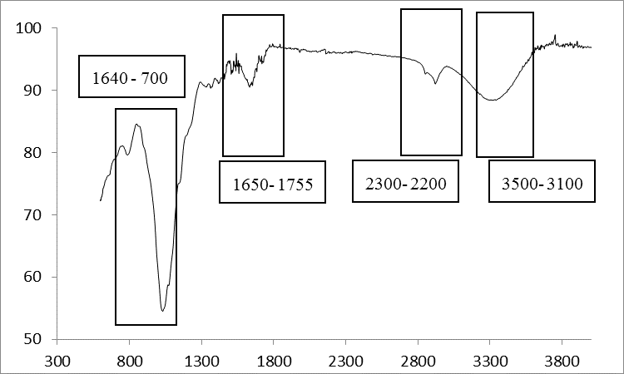
Wavenumber cm⁻¹
Transmittance %
Figure 1. FTIR spectra for RHAC

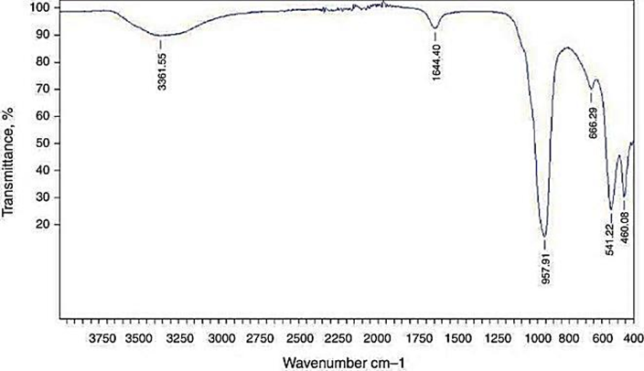
1060 - 895
1640-1500
- 3200
Figure 2. FTIR spectra for zeolite

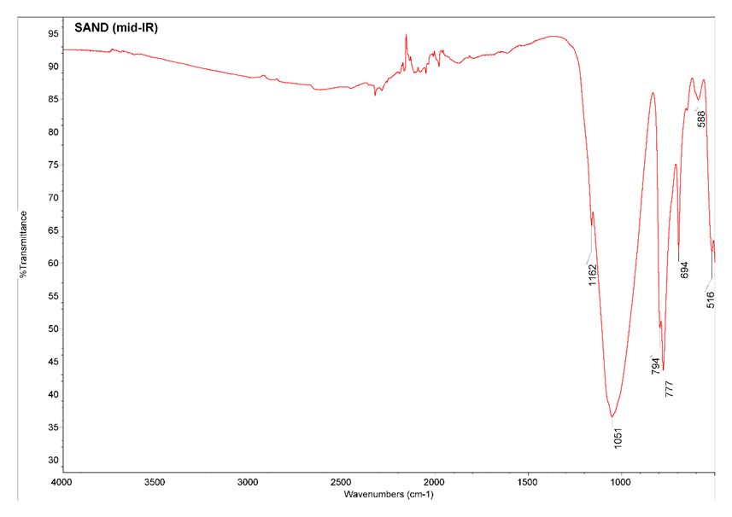
1300-1000
900-650
Figure 3. FTIR spectra for sand

Adsorption isotherms
BET isotherm of Mg²⁺ and Ca²⁺ showed linear correlation coefficient, R² of 0.9662 and 0.9888 respectively (Figure 4 and Figure 5).

Freundlich adsorption of all media resulted in a linear correlation coefficient, R² of 0.4734 and 0.9831. The values of Mg²⁺ and Ca²⁺ were 0.317 and -270.27 respectively as in Figure 6 and Figure 7.

The Langmuir isotherm constant b and q_{max} were calculated from the slope and intercept of the plot C_{e}/q_{e} versus C_{e} (Figure 8 and Figure 9).

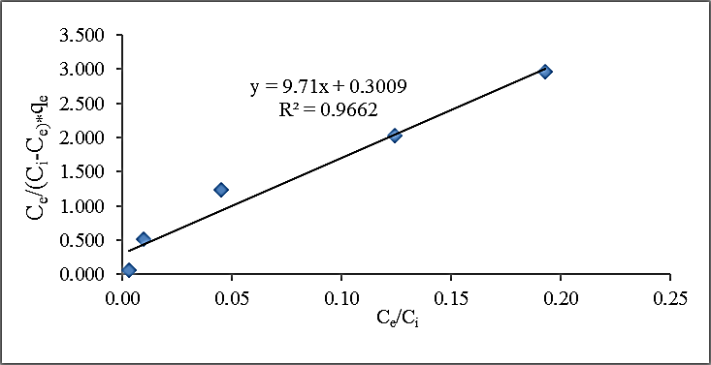
Figure 4. BET sorption isotherm of Mg²⁺

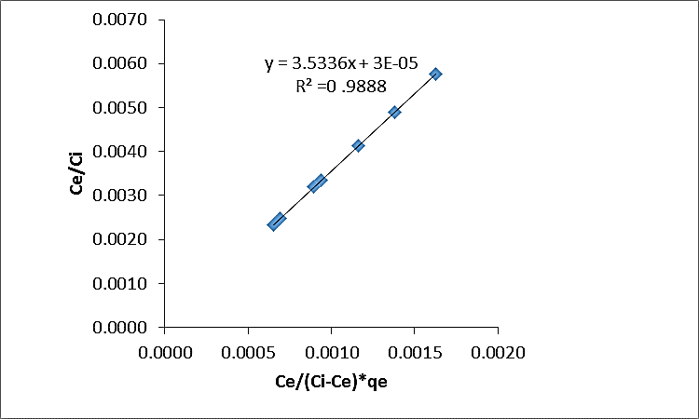
Figure 5. BET sorption isotherm of Ca²⁺

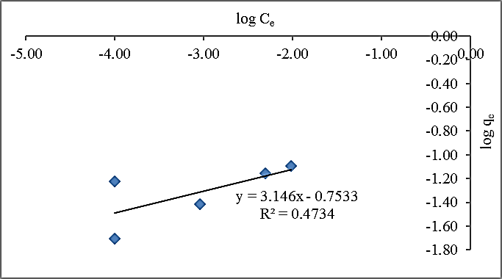
Figure 6. Freundlich sorption isotherm of Mg²⁺

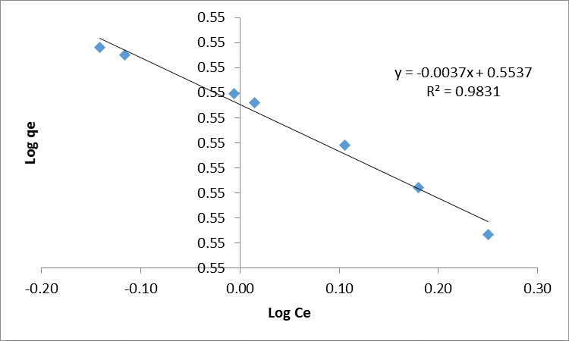
Figure 7. Freundlich sorption isotherm of Ca²⁺

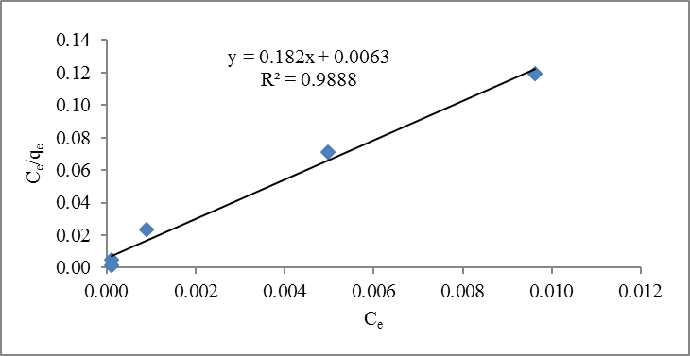
Figure 8. Langmuir sorption isotherm of Mg²⁺

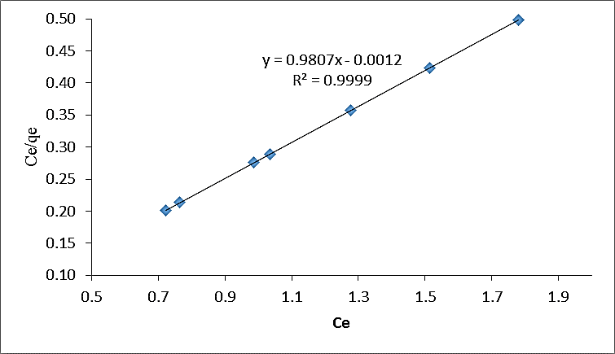
Figure 9. Langmuir Freundlich sorption isotherm of Ca²⁺

The equilibrium adsorption of Langmuir, Freundlich and BET for all media are summarized in Table 5. The Langmuir isotherm constant b and q_{max} were calculated from the slope and intercept of the plot C_{e}/q_{e} versus C_{e.} It demonstrates a linear correlation coefficient, R² of 0.9888 and 0.999 and the sorption capacity q_{max} were 5.49 mg/g for Mg²⁺ and 1.02mg/g for Ca²⁺, respectively.

Freundlich adsorption of Mg²⁺ and Ca²⁺ resulted from linear correlation coefficient, R² of 0.4734 and 0.9831 respectively. The value of n of Mg²⁺ and Ca²⁺ are 0.317 and -270.27 respectively. BET isotherm of all media showed that the linear correlation coefficient, R² were 0.9662 and 0.9888 respectively. The sorption capacity, q_{max} were 5.49 mg/g for Mg²⁺ and 1.02 mg/g for Ca²⁺ as in Table 5.

From Table 5, it can be concluded that all the media were best fitted with Langmuir isotherm which refer to monolayer adsorption. The sorption capacity, q_{max}, which was the indicator of maximum sorption capacity conforming to comprehensive monolayer coverage that defines the metal uptake for Ca²⁺ and Mg²⁺ were close to experimental sorption capacity. Sorption of Ca²⁺ and Mg²⁺ by all media give the R_{L} values of 0.00323 mg/l and 0.00077 mg/l as in Table 6 which indicate that all the media are favourable and effective for the adsorption process.

Furthermore, Langmuir's assumption of Ca²⁺ and Mg²⁺ revealed the simultaneous occurrence of both physisorption and chemisorption onto sand, zeolite and RHAC. The result obtained from the present study was compared to previous research. It was noted that the performance of combined media in the absorption experiment is still in line with the previous findings that used single media for the experiment as tabulated in Table 7. Langmuir isotherm assumes that the number of adsorption sites is fixed and that adsorption is reversible. Adsorption cannot occur beyond monolayer coverage and each site can hold only one adsorbate molecule.

Kinetics adsorption study
The mechanism of adsorption not only depends on the physical and chemical characteristics of the adsorbent but also the mass transfer process [28]. From Table 8, the R² value suggests that the adsorption of Mg²⁺ and Ca²⁺ onto the sand, zeolite, and RHAC does not follow the pseudo-first-order kinetics model.

In a conclusion, the continuous reaction follows the pseudo-second-order mechanism rather than a pseudo-first-order mechanism. The best fit of pseudo-second-order kinetics also suggests that the rate-limiting step of the sorption process could be chemisorption involving valence forces through sharing the exchange of electrons. Similar phenomena of sorption of other metal onto the sand [30], zeolite [42] and RHAC [43] was also noticed.

Table 5. Adsorption isotherm constants sorption of Ca²⁺ and Mg²⁺ onto all media
Isotherm | Parameter | Magnesium (Mg) | Calcium (Ca)
BET | R²  K_{B}  Q_{m}(mg/g) | 0.9662  31.2  9.40 | 0.9888  7.106  0.28
Freundlich | R²  K_{F}  N | 0.4734  0.176  0.317 | 0.9831  1.13  -270.27
Langmuir | R²  b  q_{max} (mg/g) | 0.9888  28.91  5.49 | 0.9999  0.00122  1.02

Table 6. R_{L} value all media
Metal | R_{L} | Condition
Ca²⁺ | 0.00323 | Favourable
Mg²⁺ | 0.00077 | Favourable

Table 7. Adsorption isotherm constants sorption onto single media
Langmuir  Isotherm Model | Removal | Estimated  Isotherm Parameters |  |  | Reference
Langmuir  Isotherm Model | Removal | q_{max} (mg/g) | k_{L} (L/mg) | R²
Sand | Phosphorus  Uranyl ions | 0.169  25 | 0.242  0.052 | 0.991  0.992 | [30]  [38]
Zeolite | Ca²⁺  Cd²⁺ | 1.03  54.05 | 0.1114  0.114 | 0.999  0.999 | [15]  [40]
Activated Carbon | Mg²⁺  Phenol | 0.207  1.152 | 4.25  14.47 | 0.999  0.996 | [41]  [27]

Table 8. Kinetic parameters of biosorption of Ca²⁺ Mg²⁺ onto all media
Kinetic |  | Parameter | Magnesium
Pseudo 1st order |  | R² | 0.7161
Pseudo 1st order |  | k₁ | 1.001
Pseudo 1st order |  | q_{e} | 442.48
Pseudo 2nd order |  | R² | 0.9495
Pseudo 2nd order |  | K₂ | -0.00333
Pseudo 2nd order |  | q_{e} | 5.03

Conclusion
This study concluded that the ability of sand, zeolite and RHAC as a filter media for hard water treatment was proven based on the experimental results. Moreover, the following conclusions were made based on the investigation; i) the adsorption isotherms can be well fitted by the Langmuir model representing monolayer sorption on a homogenous surface, ii) this study noticed that R_{L} value was less than one, which shows that the adsorption of Ca²⁺ and Mg²⁺ onto the sand, zeolite, and RHAC is favourable, and iii) the kinetics of the adsorption process followed the pseudo-second-order kinetic model, which indicates chemisorption.

Furthermore, it was observed that all the media is greatly available locally, therefore, making an economic adsorbent, abundantly available with substantial-high adsorption capacity. It could be treated as an economic filter media for hard water treatment.

Acknowledgment
This research was supported by Office for Research, Innovation, Commercialization, Consulting Management (RMC), University Tun Hussein Onn, Malaysia (UTHM) under GPPS vot; U569 and FRGS vot 1575 and RMC Bold2025.

References
- Ahmed, F., Siwar, C. and Begum, R. A. (2014). Water resources in Malaysia: Issues and challenges. Journal of Food Agriculture Environment, 12(2): 1100-1104.
- Ab Razak, N. H., Praveena, S. M., Aris, A. Z. and Hashim, Z. (2015). Drinking water studies: A review on heavy metal, application of biomarker and health risk assessment (a special focus in Malaysia). Journal of Epidemiology and Global Health, 5(4): 297-310.
- Aziz, N. I. A. and Othman, N. (2017). Groundwater quality and soil characterization: A case study at Bukit Tembaga, Kuala Nerang, Kedah. In MATEC Web of Conferences, 103, p. 05011.
- Mahasti, N. N., Shih, Y. J., Vu, X. T. and Huang, Y. H. (2017). Removal of calcium hardness from solution by fluidized-bed homogeneous crystallization (FBHC) process. Journal of the Taiwan Institute of Chemical Engineers, 78: 378-385.
- Ojo, O. I., Otieno, F. A. and Ochieng, G. M. (2012). Groundwater: Characteristics, qualities, pollutions and treatments: An overview. International Journal of Water Resources and Environmental Engineering, 4(6): 162-170.
- Abdolahnejad, A., Ebrahimi, A. and Jafari, N. (2014). Application of Iranian natural zeolite and blast furnace slag as slow sand filters media for water softening. International Journal of Environmental Health Engineering, 3(1): 26.
- Gomelya, M., et al., Research into ion exchange softening of highly mineralized waters. 2016. Gomelya, M., Hrabitchenko, V., Trokhymenko, А., & Shabliy, T. (2016). Research into ion exchange softening of highly mineralized waters. European of Enterprise Technologies, 4(10): 4-9.
- Othman, N., Mohd-Asharuddin, S. and Azizul-Rahman, M. F. H. (2013). An overview of fruit waste as sustainable adsorbent for heavy metal removal. Applied Mechanics and Materials, 389: 29-35).
- Gando-Ferreira, L. M., Gaspar, C. S. S., Monteiro, M. and Moreira, M. J. A. (2017). Studies on integration of ion exchange and nanofiltration for water desalination. Separation Science and Technology, 52(16): 2600-2610.
- Abdullahi, M. E., Folorunsho, A. D., Agaie, B. G. and Jibril, M. (2012). Predictive model for lime dosage in water treatment plant. International Journal of Scientific and Research Publications, 2(12): 1-5.
- Ayob, S., Othman, N., Altowayti, W. A. H., Khalid, F. S., Bakar, N. A., Tahir, M. and Soedjono, E. S. (2021). A review on adsorption of heavy metals from wood-industrial wastewater by oil palm waste. Journal of Ecological Engineering, 22(3): 249-265.
- Hess, A. F., Rachwa, A. and Chipps, M. J. (2002). Filter maintenance and operations guidance manual. American Water Works Association.
- Yongabi, K. A. (2013). A sustainable low-cost phytodisinfectant-sand filter alternative for water purification. Doctoral dissertation, University of Adelaide.
- Chowdhury, S., Chakraborty, S. and Saha, P. (2011). Biosorption of basic green 4 from aqueous solution by Ananas comosus (pineapple) leaf powder. Colloids and surfaces B: Biointerfaces, 84(2): 520-527.
- Rahman, M. M., Awang, M. B. and Yusof, A. M. (2012). Preparation, characterization and application of zeolite-Y (Na-Y) for water filtration. Australian Journal of Basic and Applied Sciences, 6(1): 50-54.
- Allwar, A., Hartati, R. and Fatimah, I. (2017). Effect of nitric acid treatment on activated carbon derived from oil palm shell. In AIP Conference Proceedings, 1823(1): 020129.
- Nahil, M. A. and Williams, P. T. (2012). Pore characteristics of activated carbons from the phosphoric acid chemical activation of cotton stalks. Biomass and Bioenergy, 37: 142-149.
- Yunus, Z. M., Al-Gheethi, A., Othman, N., Hamdan, R. and Ruslan, N. N. (2020). Removal of heavy metals from mining effluents in tile and electroplating industries using honeydew peel activated carbon: A microstructure and techno-economic analysis. Journal of Cleaner Production, 251: 119738.
- Xin-Hui, D., Srinivasakannan, C., Jin-Hui, P. E. N. G., Li-Bo, Z. and Zheng-Yong, Z. (2011). Preparation of activated carbon from Jatropha hull with microwave heating: optimization using response surface methodology. Fuel Processing Technology, 92(3): 394-400.
- Ayawei, N., Ebelegi, A. N. and Wankasi, D. (2017). Modelling and interpretation of adsorption isotherms. Journal of Chemistry, 201: 3039817.
- Altowayti, W. A. H., Allozy, H. G. A., Shahir, S., Goh, P. S. and Yunus, M. A. M. (2019). A novel nanocomposite of aminated silica nanotube (MWCNT/Si/NH₂) and its potential on adsorption of nitrite. Environmental Science and Pollution Research, 26(28): 28737-28748.
- Altowayti, W. A. H., Othman, N., Goh, P. S., Alshalif, A. F., Al-Gheethi, A. A. and Algaifi, H. A. (2021). Application of a novel nanocomposites carbon nanotubes functionalized with mesoporous silica-nitrenium ions (CNT-MS-N) in nitrate removal: Optimizations and nonlinear and linear regression analysis. Environmental Technology & Innovation, 22: 101428.
- Altowayti, W. A. H., Algaifi, H. A., Bakar, S. A. and Shahir, S. (2019). The adsorptive removal of As (III) using biomass of arsenic resistant Bacillus thuringiensis strain WS3: Characteristics and modelling studies. Ecotoxicology and Environmental Safety, 172: 176-185.
- Allozy, H. G. A. and Abd Karim, K. J. (2020). Removal of copper ions from aqueous solutions using poly (vinylbenzyl chloride). Malaysian Journal of Analytical Sciences, 24(6): 978-991.
- Altowayti, W. A. H., Haris, S. A., Almoalemi, H., Shahir, S., Zakaria, Z. and Ibrahim, S. (2020). The removal of arsenic species from aqueous solution by indigenous microbes: Batch bioadsorption and artificial neural network model. Environmental Technology & Innovation, 19: 100830.
- Haris, S. A., Altowayti, W. A. H., Ibrahim, Z. and Shahir, S. (2018). Arsenic biosorption using pretreated biomass of psychrotolerant Yersinia sp. strain SOM-12D3 isolated from Svalbard, Arctic. Environmental Science and Pollution Research, 25(28): 27959-27970.
- Liu, Q. S., Zheng, T., Wang, P., Jiang, J. P. and Li, N. (2010). Adsorption isotherm, kinetic and mechanism studies of some substituted phenols on activated carbon fibers. Chemical Engineering Journal, 157(2-3): 348-356.
- Aljeboree, A. M., Alshirifi, A. N. and Alkaim, A. F. (2017). Kinetics and equilibrium study for the adsorption of textile dyes on coconut shell activated carbon. Arabian Journal of Chemistry, 10: S3381-S3393.
- Bahari, Z. M., Altowayti, W. A. H., Ibrahim, Z., Jaafar, J. and Shahir, S. (2013). Biosorption of As (III) by non-living biomass of an arsenic-hypertolerant Bacillus cereus strain SZ2 isolated from a gold mining environment: Equilibrium and kinetic study. Applied Biochemistry and Biotechnology, 171(8): 2247-2261.
- Jiang, C., Jia, L., Zhang, B., He, Y. and Kirumba, G. (2014). Comparison of quartz sand, anthracite, shale and biological ceramsite for adsorptive removal of phosphorus from aqueous solution. Journal of Environmental Sciences, 26(2): 466-477.
- Ab Kadir, N. N., Shahadat, M. and Ismail, S. (2017). Formulation study for softening of hard water using surfactant modified bentonite adsorbent coating. Applied Clay Science, 137: 168-175.
- Sepehr, M. N., Zarrabi, M., Kazemian, H., Amrane, A., Yaghmaian, K. and Ghaffari, H. R. (2013). Removal of hardness agents, calcium and magnesium, by natural and alkaline modified pumice stones in single and binary systems. Applied Surface Science, 274: 295-305.
- Ghosh, R. and Bhattacherjee, S. (2013). A review study on precipitated silica and activated carbon from rice husk. Journal of Chemical Engineering Process Technology, 4(4): 1-7.
- Vargas, A. M., Cazetta, A. L., Garcia, C. A., Moraes, J. C., Nogami, E. M., Lenzi, E. and Almeida, V. C. (2011). Preparation and characterization of activated carbon from a new raw lignocellulosic material: Flamboyant (Delonix regia) pods. Journal of Environmental Management, 92(1): 178-184.
- Prahas, D., Kartika, Y., Indraswati, N. and Ismadji, S. J. C. E. J. (2008). Activated carbon from jackfruit peel waste by H₃PO₄ chemical activation: Pore structure and surface chemistry characterization. Chemical Engineering Journal, 140(1-3): 32-42.

36. Gopalakrishnan, Y., Al-Gheethi, A., Abdul Malek, M., Marisa Azlan, M., Al-Sahari, M., Radin Mohamed, R. M. S. and Noman, E. (2020). Removal of basic brown 16 from aqueous solution using durian shell adsorbent, optimisation and techno-economic analysis. Sustainability, 12(21): 8928.
37. Yang, X., Wan, Y., Zheng, Y., He, F., Yu, Z., Huang, J. and Gao, B. (2019). Surface functional groups of carbon-based adsorbents and their roles in the removal of heavy metals from aqueous solutions: A critical review. Chemical Engineering Journal, 366: 608-621.
38. Elhefnawy, O. A. and Elabd, A. A. (2017). Natural silica sand modified by calcium oxide as a new adsorbent for uranyl ions removal from aqueous solutions. Radiochimica Acta, 105(10): 821-830.
39. Guchi, E. (2015). Review on slow sand filtration in removing microbial contamination and particles from drinking water. American Journal of Food and Nutrition, 3(2): 47-55.
40. Selim, M. M., EL-Mekkawi, D. M., Aboelenin, R. M., Sayed Ahmed, S. A. and Mohamed, G. M. (2017). Preparation and characterization of Na-A zeolite from aluminum scrub and commercial sodium silicate for the removal of Cd²⁺ from water. Journal of the Association of Arab Universities for Basic and Applied Sciences, 24(1), 19-25.
41. Lestari, A. Y. D., Malik, A., Ilmi, M. I. and Sidiq, M. (2018). Removal of calcium and magnesium ions from hard water using modified Amorphophallus campanulatus skin as a low cost adsorbent. In MATEC Web of Conferences, 154: 01020.
42. Xue, Z., Li, Z., Ma, J., Bai, X., Kang, Y., Hao, W. and Li, R. (2014). Effective removal of Mg²⁺ and Ca²⁺ ions by mesoporous LTA zeolite. Desalination, 341: 10-18.
43. Yao, S., Zhang, J., Shen, D., Xiao, R., Gu, S., Zhao, M. and Liang, J. (2016). Removal of Pb(II) from water by the activated carbon modified by nitric acid under microwave heating. Journal of Colloid and Interface Science, 463: 118-127.

