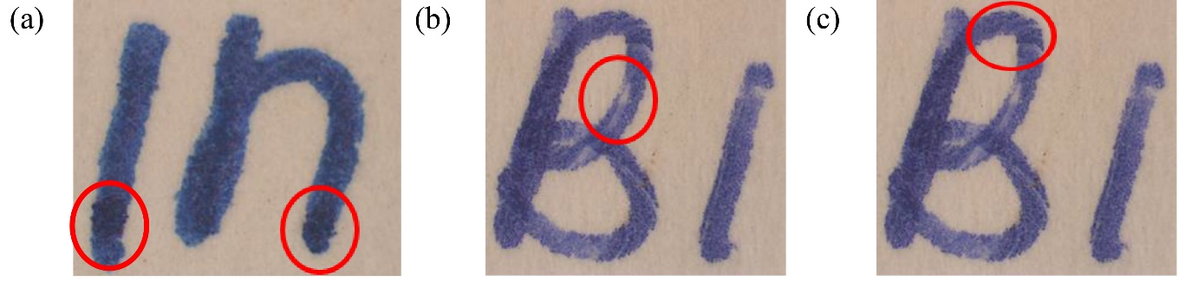

Figure 1. Microscopic images of handwriting samples showing special characteristics

Table 2. Luminescence characteristic of 20 ink samples
Sample | Wavelength of Filter Barrier
Sample | 400 – 535 nm | 485 – 610 nm | 605 – 730 nm
BP01 | Yellowish glow | Yellowish glow | Whitish glow
BP02 | Yellowish glow | Yellowish glow | Whitish glow
BP03 | ND | ND | ND
BP04 | ND | ND | ND
BP05 | Bluish glow | Bluish glow | Whitish glow
BP06 | Bluish glow | Bluish glow | Whitish glow
BP07 | ND | ND | ND
BP08 | Bluish glow | Bluish glow | Whitish glow
BP09 | Yellowish glow | Yellowish glow | Whitish glow
BP10 | Bluish glow | Bluish glow | Whitish glow
GP01 | ND | ND | ND
GP02 | ND | Bluish glow | Bluish glow
GP03 | ND | Bluish glow | Bluish glow
GP04 | ND | Bluish glow | Bluish glow
GP05 | ND | ND | ND
GP06 | ND | ND | ND
GP07 | ND | ND | ND
GP08 | ND | ND | ND
GP09 | ND | ND | ND
GP10 | ND | ND | ND

*ND-Not detected

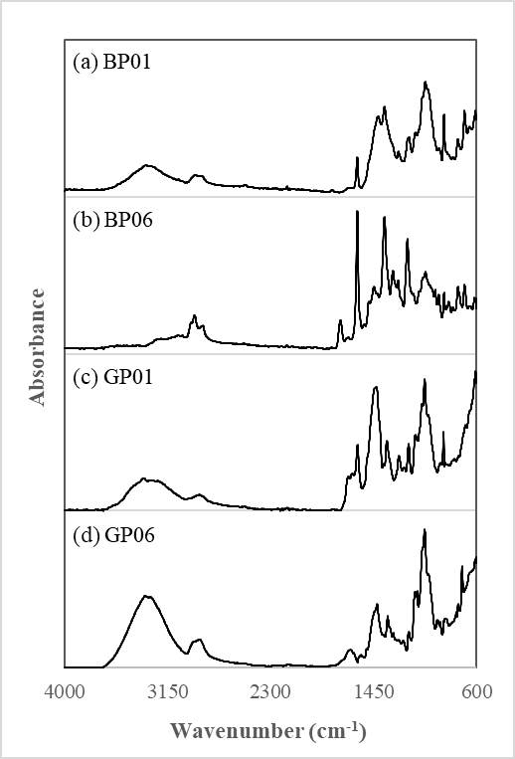

Figure 2. Representative ATR-FTIR profiles of ballpoint pen inks (a-b) and gel pen inks (c-d)

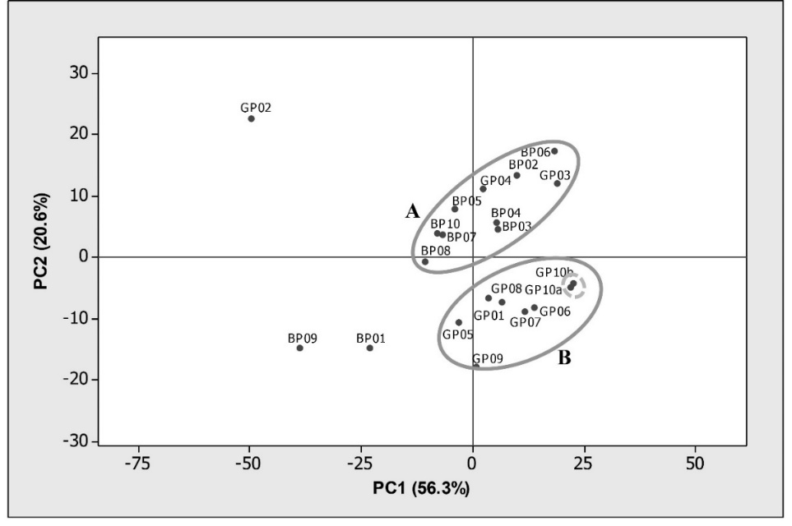

Figure 3. Score plot of 20 ink samples upon PCA

Table 3. Separation of ink components with respective R_{f} values
Solvent System | Methanolic Sample
Solvent System | BP01 | BP02 | BP03 | BP04 | BP05 | BP06 | BP07 | BP08 | BP09 | BP10 | GP02 | GP03 | GP04
A | 0.59  0.73  0.78  0.83  0.85  0.89 | 0.73  0.77  0.82  0.83  0.87 | 0.62  0.72  0.77  0.81  0.85  0.89 | 0.73  0.77  0.81  0.85  0.89 | 0.57  0.75  0.79  0.82  0.85  0.88 | 0.57  0.73  0.78  0.82  0.87  0.90 | 0.57  0.78  0.82  0.85 | 0.58  0.75  0.78  0.82  0.84  0.87 | 0.58  0.73  0.78  0.82  0.85  0.88 | 0.53  0.62  0.76  0.81  0.83  0.88 | 0.57  0.77  0.81  0.83  0.87 | 0.58  0.74  0.84  0.86  0.89  0.92 | 0.58  0.73  0.83  0.85  0.88  0.91
B | 0.19  0.26  0.49  0.55  0.60  0.65 | 0.27  0.49  0.55  0.64  0.71 | 0.20  0.26  0.49  0.54  0.60  0.66 | 0.28  0.51  0.57  0.65  0.72 | 0.28  0.49  0.52  0.58  0.61  0.67 | 0.28  0.49  0.52  0.58  0.60  0.67 | 0.28  0.49  0.52  0.58 | 0.19  0.24  0.47  0.53  0.58  0.64 | 0.19  0.26  0.50  0.55  0.60  0.65 | 0.29  0.35  0.39  0.56  0.60  0.64 | 0.28  0.49  0.51  0.57  0.59 | 0.28  0.50  0.52  0.60  0.61  0.67 | 0.29  0.49  0.52  0.60  0.62  0.68

From the 13 methanolic soluble samples subjected to TLC analysis, the solvent system consisting of ethyl acetate: ethanol: distilled water in a ratio of 14:7:6 allowed for the grouping of 13 samples into seven different groups. The number and colour of bands from these samples were observed to vary from four to six in red and blue shades in addition to several spots which fluoresced under UV light. The result suggested the possible utilisation of different or a combination of different colouring agents by manufacturers to give the desired colours that appear hardly distinguishable under naked-eye visualisation. On the other hand, the solvent system consisting of n-butanol: ethanol: distilled water in a ratio of 4:1:1 needed a longer separation time. One ink sample (BP08) exhibited the same band number and band pattern as the other two ink samples (i.e., BP05 and BP06) with the former solvent system, was successfully distinguished by this solvent system.

The separation of a compound or ink mixture highly depends on the type of absorbent and solvent system used [16]. Hence, a particular solvent system is not adequate to separate all dye substance [16]; therefore, different solvent systems could result in varying dye separation. Despite resulting in relatively poor separation, the second solvent system still helped in discriminating the inks which are indistinguishable by the first solvent system and vice versa. Therefore, it is essential to employ different solvent systems for better discrimination of pen inks, if a sufficient sample is available for such analysis.

Comparison of ink samples

Under most circumstances, non-destructive visual microscopic examination and comparison against respective ink samples are preferred to avoid any further damage on the disputed documents, particularly for those stand exhibit in court. Undoubtedly, destructive methods, including TLC analysis in this study, provided much detailed information although it could impose irreversible damage to the documents, but shall only be attempted whenever sufficient samples are available and allowed for such analysis. In this study, a series of different analytical techniques, initiated by microscopic examination, VSC observation, ATR-FTIR spectroscopy, and TLC analysis has successfully created possible discrimination among ink samples. A schematic diagram summarising how the samples were successively distinguished by each technique is presented in Figure 4.

In many instances, microscopic examination alone allowed the differentiation of two main types of pen inks, namely the ballpoint pen inks and gel pen inks, in line with the label on each pen. Based on luminescence behaviour, not all ink samples luminescence to establish sample-to-sample linkage but could assist in the exclusion of an ink sample from a source of origin. ATR-FTIR showed that ink samples from the same types tend to locate closer in the score plot, as they could have contained very similar compositional profiles. However, it was also found that two ink samples labelled as gel pens in the study were also clustered together with other ballpoint pen ink samples, and thus required careful interpretation during forensic document examination on their ATR-FTIR profiles. The use of ATR-FTIR data point and PCA score plot clustering is useful to include or exclude a group of pen samples suspected to have been used in an alteration.

Dye-based ballpoint pen inks were found soluble in methanol, supporting the microscopic examination demonstrating ballpoint pen morphological features. The three ink samples, namely GP02, GP03 and GP04, that showed gel pen ink characteristics through microscopic examination were also found to be dissolved in methanol and luminesced under 485-610 and 605-730 nm light sources. These samples exhibited hybrid characteristics from both ballpoint pen and gel pen inks. By TLC, inks samples could be further discriminated from the rest, given that they were priorly dissolved in methanol. It was worth noting that TLC analysis was only restricted to ballpoint pen and hybrid pen inks. The technique is necessary in some cases where samples are sufficient and other non-destructive techniques were not able to discriminate among the samples.

In brief, the 20 ink samples were categorised into 11 different groups upon analyses. The presence of hybrid pen ink possessing both ink characteristics of ballpoint and gel pens as found in our study demonstrated that careful interpretation during the forensic investigation against written document related to ink is required, especially when alteration involves gel pen inks. Under one analytical technique, a hybrid pen may resemble the characteristics of either gel pen ink or a ballpoint pen ink and could lead to false positive or false negative results. This may make even an unauthentic document seem authentic if not carefully interpreted. Nonetheless, further analytical work is necessary for defensible characterisation of the source of pens, including identification of specific compounds in the ink composition.

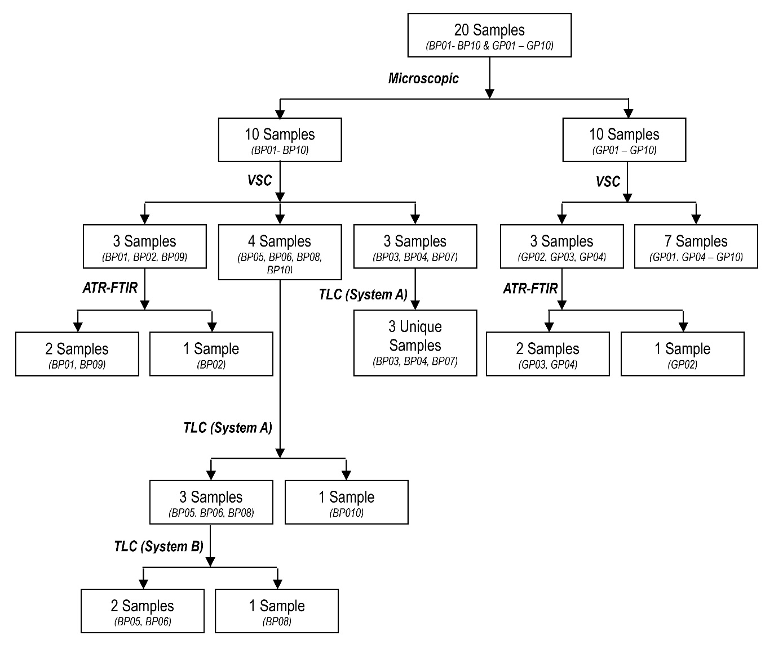

Figure 4. Discrimination of pen samples by a series of analytical techniques

Conclusion

Based on a combination of analytical techniques, the ink from pen samples tested in this study could be discriminated from the others, especially between a ballpoint pen and gel pen inks. Marked differences between the characteristics of these inks were evidently making them readily distinguishable. Nevertheless, a conclusion should not be made solely based on microscopic findings as gel pen inks could show characteristics similar to ballpoint pen inks according to their chemical compositions. The experimental protocol used in this study can be used for the exclusion of different sources of pen inks by comparing the profiles on suspected samples and crime scene samples. We also highlighted the characteristics of hybrid pen that worth serious attention during a forensic investigation, especially when it is widely used in the future.

Acknowledgement
The authors thank the financial support via the Fundamental Research Grant Scheme (FRGS) from the Ministry of Education Malaysia (203/PPSK/6171208).

References
- Calcerrada, M. and García-Ruiz, C. (2015). Analysis of questioned documents: A review. Analytica Chimica Acta, 853: 143-166.
- Hammand, D. L. (2013). Encyclopedia of forensic sciences. Overview of forensic document examination. Elsevier, London: pp. 391-394.
- Lindblom, B. S. (2006). Scientific examination of questioned document. Pens and pencils. CRC Press, Baco Raton: pp. 147-158.
- Bell, S. (2008). Encyclopedia of forensic science. Infobase Publishing, New York: pp. 375-379.
- Allen, M. (2015). Foundations of forensic document analysis: Theory and practice. John Wiley & Sons, Oxford: pp. 163-175.
- Gernandt, M. N. and Urlaub, J. J. (1996). An introduction to the gel pen. Journal of Forensic Sciences, 41 (3): 503-504.
- Djozan, D., Baheri, T., Karimian, G. and Shahidi, M. (2008). Forensic discrimination of blue ballpoint pen inks based on thin layer chromatography and image analysis. Forensic Science International, 179 (2–3): 199-205.
- Barker, J., Ramotowski, R. and Nwokoye, J. (2016). The effect of solvent grade on thin layer chromatographic analysis of writing inks. Forensic Science International, 266: 139-147.
- Cruces-Blanco, C., Gámiz-Gracia, L. and García-Campaña, A. M. (2007). Applications of capillary electrophoresis in forensic analytical chemistry. Trends in Analytical Chemistry, 26(3): 215-226.
- Braz, A., López-López, M. and García-Ruiz, C. (2013). Raman spectroscopy for forensic analysis of inks in questioned documents. Forensic Science International, 232(1-3): 206-212.
- de Souza Lins Borba, F., Honorato, R. S. and de Juan, A. (2015). Use of Raman spectroscopy and chemometrics to distinguish blue ballpoint pen inks. Forensic Science International, 249: 73-82.
- Bügler, J. H., Buchner, H. and Dallmayer, A. (2005). Characterization of ballpoint pen inks by thermal and desorption and gas chromatography-mass spectrometry. Journal of Forensic Sciences, 50(5): 1209-1214.
- Bügler, J. H., Buchner, H. and Dallmayer, A. (2008). Age determination of ballpoint pen ink by thermal desorption and gas chromatography-mass spectrometry. Journal of Forensic Sciences, 53(4): 982-988.
- Weyermann, C., Kirsch, D., Vera, C. C. and Spengler, B. (2007). A GC/MS study of the drying of ballpoint pen ink on paper. Forensic Science International, 168 (2–3): 119-127.
- Harris, J. (2013). A preliminary report on the nondestructive examination of ballpoint pen ink on questioned documents by FT-IR spectroscopy. The Canadian Society of Forensic Science Journal, 24(1): 5-21.
- Sharma, V. and Kumar, R. (2017). Fourier transform infrared spectroscopy and high performance thin layer chromatography for characterization and multivariate discrimination of blue ballpoint pen ink for forensic applications. Vibrational Spectroscopy, 92: 96-104.
- Abdul Halim, M. I., Saim, N., Osman, R., Jasmani, H. and Zainal Abidin, N. N. (2013). Discrimination of black ballpoint pen inks by high performance liquid chromatography (HPLC). Malaysian Journal of Analytical Sciences, 17(2): 230-235.
- Chen, H-S., Meng, H-H. and Cheng, K-C. (2002). A survey of methods used for the identification and characterization of inks. Forensic Science Journal, 1: 1-14.
- Neumann, C. and Margot, P. (2009). New perspectives in the use of ink evidence in forensic science. Part III: Operational applications and evaluation. Forensic Science International, 192(1–3): 29-42.
- Bell, S. (2013). How to identify a forgery: A guide to spotting fake art, counterfeit currencies and more. Skyhorse Publishing Inc, New York: pp. 43-52.
- Ellen, D., Day, S. and Davies, C. (2018). Scientific examination of documents: Methods and techniques. CRC Press, Baco Raton: pp. 128-136.
- Mazella, W. D. and Buzzini, P. (2005). Raman spectroscopy of blue gel pen inks. Forensic Science International, 152(2-3): 241-247.
- Reed, G., Savage, K., Edwards, D. and Daeid, N. N. (2014). Hyperspectral imaging of gel pen inks: An emerging tool in document analysis. Science and Justice, 54(1): 71-80.

