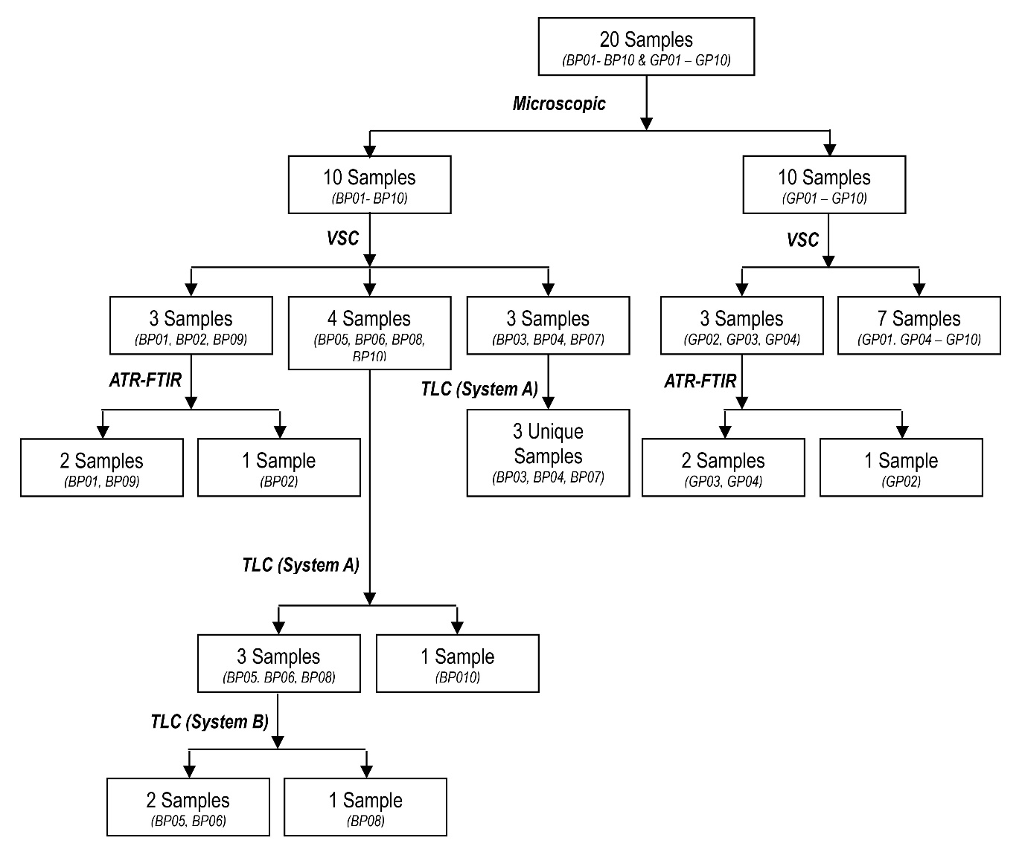

Figure 4. Discrimination of pen samples by a series of analytical techniques

Conclusion

Based on a combination of analytical techniques, the ink from pen samples tested in this study could be discriminated from the others, especially between a ballpoint pen and gel pen inks. Marked differences between the characteristics of these inks were evidently making them readily distinguishable. Nevertheless, a conclusion should not be made solely based on microscopic findings as gel pen inks could show characteristics similar to ballpoint pen inks according to their chemical compositions. The experimental protocol used in this study can be used for the exclusion of different sources of pen inks by comparing the profiles on suspected samples and crime scene samples. We also highlighted the characteristics of hybrid pen that worth serious attention during a forensic investigation, especially when it is widely used in the future.

Acknowledgement
The authors thank the financial support via the Fundamental Research Grant Scheme (FRGS) from the Ministry of Education Malaysia (203/PPSK/6171208).

References
- Calcerrada, M. and García-Ruiz, C. (2015). Analysis of questioned documents: A review. Analytica Chimica Acta, 853: 143-166.

