

FORENSIC DISCRIMINATION OF BLUE PEN INKS: EMERGENCE OF HYBRID PEN INKS

(Diskriminasi Forensik Bagi Dakwat Pen Biru: Kemunculan Dakwat Pen Hibrid)

Linthini Gannetion¹, Siti Nur Musliha Mohamad Noor², Poh Ying Lim³, Kah Haw Chang¹,

Ahmad Fahmi Lim Abdullah¹*

¹Forensic Science Programme, School of Health Sciences,

Universiti Sains Malaysia, 16150 Kubang Kerian, Kelantan, Malaysia

²Document Examination Division, Forensic Science Analysis Centre,

Department of Chemistry, Jalan Sultan, 46661 Petaling Jaya, Selangor, Malaysia

³Department of Community Health, Faculty of Medicine and Health Sciences,

Universiti Putra Malaysia, 43400 Serdang, Selangor, Malaysia

*Corresponding author: fahmilim@usm.my

Received: 18 May 2021; Accepted: 22 July 2021; Published: xx August 2021

Abstract

Pens are frequently used to make alterations to documents during forgery. Comparing to conventional inks, hybrid pen ink brings a different challenge to forensic document examiners in differentiating ink entries on a questioned document. Therefore, this study aims to investigate the characteristics of different blue pen inks using non-destructive approaches followed by destructive techniques. Twenty blue pens consisting of ten ballpoint pens and ten gel pens of various brands were subjected to microscopic examination, video spectral comparator examination, attenuated total reflectance-Fourier transform infrared (ATR-FTIR) spectroscopy, and thin layer chromatography (TLC) using two different solvent systems. The microscopic examination showed significant different optical features on handwritten samples produced by ballpoint and gel pens. Luminescence behaviour of certain inks allowed discrimination, and ATR-FTIR coupled with principal component analysis clustered ink samples of similar compositional profiles in a score plot. TLC allowed further discrimination of ink samples from ballpoint and hybrid pens. The proposed analysis scheme had categorised the ink samples into 11 groups. To conclude, the hybrid pen labelled as gel pen appeared optically like gel pen. However, it possesses chemical characteristics similar to a ballpoint pen. Therefore, its emergence deserves attention during forensic questioned document examination, particularly for the determination of pen inks.

Keywords: forensic science, questioned document, ink, hybrid pen, discrimination, alteration.

Abstrak

Pen sering digunakan untuk membuat pindaan ke atas dokumen ketika pemalsuan. Berbanding dengan dakwat yang lazim, kemunculan dakwat pen hibrid mendatangkan suatu cabaran yang berbeza kepada pemeriksa dokumen forensik dalam membezakan entri dakwat pada suatu dokumen yang dipertikaikan. Justeru, kajian ini bermatlamat untuk menyiasat ciri-ciri dakwat pen biru yang berbeza dengan menggunakan pendekatan bukan-pemusnah diikuti dengan teknik pemusnah. Dua puluh pen biru yang terdiri daripada sepuluh pen mata bulat dan sepuluh pen gel dari pelbagai jenama telah dikenakan kepada pemeriksaan mikroskop, pemeriksaan perbanding spektrum video, spektroskopi infra merah transformasi Fourier dengan pantulan penuh pengecilan (ATR-FTIR) dan kromatografi lapisan nipis (TLC) dengan menggunakan dua sistem pelarut berbeza. Pemeriksaan mikroskop menunjukkan perbezaan ciri-ciri optik yang bererti pada sampel bertulis yang dihasilkan oleh pen mata bulat dan pen gel. Perilaku pendarcahaya pada sebahagian dakwat membenarkan pembezaan dan ATR-FTIR bersama dengan analisis komponen utama mengelompokkan sampel dakwat dengan profil kandungan yang serupa dalam suatu plot skor. TLC membolehkan diskriminasi sampel-sampel seterusnya daripada dakwat pen mata bulat dan dakwat pen hibrid. Skema analisis yang dicadangkan telah mengumpulkan sampel dakwat kepada 11 kumpulan. Secara kesimpulan, pen hibrid yang dilabelkan sebagai pen gel kelihatan serupa seperti pen gel secara optik. Namun, dakwat tersebut membawa ciri-ciri kimia serupa dengan dakwat pen mata bulat. Dengan itu, kemunculannya perlu diberi perhatian ketika pemeriksaan forensik dokumen yang dipertikaikan, terutamanya bagi penentuan dakwat pen.

Kata kunci: sains forensik, dokumen yang dipertikaikan, dakwat, pen hibrid, diskriminasi, pindaan.

Introduction

A written document can be forged or altered by over-writing, extending, or interlining pre-existing handwriting on the document. Such acts are frequently done by the fraudsters to gain monetary profit or other illegal purposes [1, 2]. Usually, these types of alterations are made intentionally in ways that do not create suspicion to the recipients or victims. Therefore, the newly pen entries must appear optically similar to the original entries on the altered document as much as possible. For investigation of forged document, both optical and chemical characterisation of writing inks can help establish whether an alteration was made, the types of ink used, and the probable source of pen [2, 3].

Writing inks are generally complex homogenous medium made up of colourants, either dyes or pigments, with various combinations of solvents, resins, surfactants, lubricants, emulsifiers and/or additives [1, 4]. Different ink compositions would be used by the manufacturers to achieve the desired property or to fulfil the market trend [5]. Therefore, ink compositions for a particular colour would vary between manufacturers. Variations can occur between batches even by the same manufacturers. These variations could provide important evidential values for the discrimination of inks upon forensic examination on the suspected-ink entry in a document [1-3]. Of the common pens available, ballpoint pens and gel pens are widely used where ink from gel pens could be easily distinguishable than other pen types [6]. Hybrid pen was also recently available at the marketplace. This type of pen provides solid entries as demonstrated in conventional gel pen, but with fast drying and non-smudging characteristics of a ballpoint pen. Innovations on ink formulation and pen product variations have certainly posed a different challenge to forensic document examiners in differentiating ink entries on questioned documents.

Previous studies have suggested the utilisation of a wide range of analytical techniques to analyse and further distinguish the ink composition. The techniques included thin-layer chromatography (TLC) [7, 8], capillary electrophoresis [9], Raman spectroscopy [10, 11], gas chromatography–mass spectrometry [12-14], attenuated total reflectance-Fourier transform infrared (ATR-FTIR) spectroscopy [15, 16], as well as high performance liquid chromatography [16, 17]. These analytical techniques possessed respective advantages to provide useful information on ink compositions [18], especially when the ink samples are available in bulk. Nonetheless, unlike bulk ink analysis, ink analysis in forensic document examination shall, as much as possible, be non-destructive to preserve its inherent value in the court of law [19].

As part of our continuous research in forensic document examination, this research aims to characterise the characteristics of pen inks labelled with ballpoint and gel pens. Analysis of ink components from the selected samples began with non-destructive techniques followed by the application of destructive TLC for discriminative purpose. It is hoped that through a combination of analytical techniques commonly used in a forensic context, we can provide useful insights on the characteristics of pen inks, especially with the emergence of new pen types and formulations.

Materials and Methods

Sample preparation

Twenty blue pens, consisting of ten ballpoint pens (labelled as BP) and ten gel pens (labelled as GP) were purchased from the local market. Note that the types of pen were classified according to the label on each pen, as shown in Table 1.

This study was carried out at the Questioned Document Examination Laboratory of Department of Chemistry Malaysia and the Forensic Laboratory of Royal Malaysian Police College, Kuala Lumpur. Before writing, each pen was tested by gently scribbling on a piece of paper to ensure it was functioning before sampling. Then, using each pen, a straight horizontal line of 1 mm thickness was drawn on a piece of white A4 paper (PaperOneTM, Copier 70 gsm, Singapore). On a separate piece of paper, the words “Blue Pen Inks” were written using each pen by the same person to ensure standardised writing. The written samples were properly labelled for traceability. Note that the papers used were of the same type from the same rim. Prior to examination and analysis, samples were kept in a hardcover envelope in between two pieces of white A4 papers to avoid any possible two-way smudging of ink materials.

Chemicals and materials

Analytical grade methanol, ethyl acetate, ethanol, n-butanol, and 2 M hydrochloric acid (HCl) were purchased from Sigma-Aldrich (St. Louis, MO). Silica gel 60 F254 TLC plates (20 cm x 20 cm) from Merck (Kenilworth, NJ) and developing chambers were used to carry out TLC analysis.

Microscopic examination

Ink samples written on paper were firstly examined under a Leica MZ16 stereomicroscope (Leica Microsystems, Leica MZ16, Heerbrugg, Switzerland) to investigate the general morphological characteristics of pen ink deposited on the paper. The TL RC 1 external cold light source (Leica Microsystems, Heerbrugg, Switzerland) was set at 2650 K and the written ink lines were studied under the magnification of 16×. Images of ink samples were then captured using Leica FC 290 digital camera (Leica Microsystems, Heerbrugg, Switzerland) attached to the stereomicroscope and saved as TIFF files. The microscopic system was supported by Leica Application Suite software (Leica Microsystems, Heerbrugg, Switzerland).

Video spectral comparator examination

A VSC-6000 video spectral comparator (Foster + Freeman, Worcestershire, United Kingdom) was used to examine the written ink lines and to identify differences in inks. The VSC was connected to a digital camera and a high-resolution grating spectrometer integrated with various light sources and optical filters. Written ink samples were viewed by multispectral light sources from ultraviolet to infrared regions. Barrier filters with wavelengths ranging from 400-730 nm were used to investigate the luminescence properties of ink samples. All digital images were captured, and any luminescence characteristic of inks was recorded.

Attenuated total reflectance-Fourier transform infrared spectroscopy and principal component analysis

Infrared spectra of ink samples were also obtained using Bruker FTIR Tensor 27 (Bruker Corporation, Billerica, MA) equipped with a single reflection zinc selenide attenuated total reflectance (ATR) sampling accessory. Absorbance was measured in the wavelength ranging from 600 to 4000 cm⁻¹ while the resolution was set at 4 cm⁻¹. Sixteen scans were performed for each sample. OPUS 7.0.122 software (Bruker Corporation, Billerica, MA) was utilised for spectra acquisition.

Each written ink sample on paper was positioned in contact with ATR on the crystal plate at controlled ambient temperature (≈25 ºC). Before scanning each sample, a reference background spectrum was taken at a spot close to the written line. The spectrum of each sample was taken in duplicates, compared, and evaluated. All the absorbance values of the spectrum were recorded as data points and saved to Microsoft Excel® (Redmond, WA). The data points of regions with noticeable variations ranging between 1800 and 600 cm⁻¹ were normalised and subjected to principal component analysis (PCA) using Minitab 18 software (Minitab Inc., State College, PA). The experimental data were decomposed into a manageable form for the multivariate analysis. The normalised data point was transformed into principal components (PC), and a score plot of the first two PCs was used to generate a score plot to explore the pattern of sample clustering.

Thin layer chromatography

Six strips of respective ink samples applied on white paper were cut into a dimension of 1 mm × 5 mm and placed in separate 1 mL glass tubes. Prior to TLC, an additional solubility test was carried out. In a separate glass tube with ink samples, 100 μL of methanol was added, respectively. Each glass tube was vigorously shaken for 1 minutes and the solubility characteristics of ink samples in methanol were recorded.

For TLC analysis, supernatant methanolic solutions were used for spot application on the TLC plate. Note that only the methanol-soluble ink samples were subjected to TLC. Negative control with the blank white paper of the same dimension was also prepared. Two solvent systems, namely ethyl acetate: ethanol: distilled water (14:7:6) and n-butanol: ethanol: distilled water (4:1:1) were used in this study [8]. TLC plates were heated at 100 ˚C for 1 hour and cooled before spotting with the methanolic ink extracts. Spotted TLC plates were developed in two separate TLC chambers containing different solvent systems. The developed TLC plate was examined under white and ultraviolet lights. R_{f} values of different visible bands and their respective colours were recorded.

Table 1. Labelling of ballpoint pen and gel pen ink samples
Sample | Types | Brand | Specific Name
BP01 | Ballpoint Pen | G’Soft® | BP-GS-56
BP02 | Ballpoint Pen | G’Soft® | Ballpoint 5566
BP03 | Ballpoint Pen | Pilot | Super-GP
BP04 | Ballpoint Pen | Pilot | BP-S
BP05 | Ballpoint Pen | Paper Mate® | Fine Blue
BP06 | Ballpoint Pen | Paper Mate® | Kilometrico 100
BP07 | Ballpoint Pen | Paper Mate® | Kilometrico 80%
BP08 | Ballpoint Pen | Faber-Castell | 1422
BP09 | Ballpoint Pen | Faber-Castell | Speedx 7
BP10 | Ballpoint Pen | Stabilo | Excel 828N F
GP01 | Gel Pen | Faber-Castell | True Gel
GP02 | Gel Pen | Pilot | Super Gel
GP03 | Gel Pen | Pilot | Wing Gel
GP04 | Gel Pen | Pilot | G-1
GP05 | Gel Pen | Carera | Soft-gel S-Fine
GP06 | Gel Pen | Carera | V-gel
GP07 | Gel Pen | Carera | Soft-gel Fine
GP08 | Gel Pen | M&G | K3
GP09 | Gel Pen | Test Good | Zhi Xin
GP10 | Gel Pen | Reynolds | Racer Gel

Results and Discussion

Microscopic examination

In general, based on microscopic examination, the distribution of ink onto the paper substrate upon writing was found different where ten written samples using gel pens have shown more even and smoother ink distribution with visible ink diffusing into the paper substrate. Ink bleedings from gel pen inks were observed, as demonstrated in Figure 1(a). In comparison, the written ink using ballpoint pens was found to exhibit poorer and less smooth ink distribution with features of halo, Figure 1(b) and fine striations, Figure 1(c). Halo and fine striations had been absent in those handwritten samples produced by gel pen in this study.

During writing, ink is deposited onto the substrate and the solvents are subsequently evaporated leaving behind the coloured particles [20]. In this study, the paper used as the substrate was a porous surface, and it allows the diffusion of liquid ink into the paper. Therefore, a less viscous characteristic of ink reserved in a pen could potentially produce a more even appearance of trace on a paper upon writing as demonstrated by gel pen ink. On the other hand, a relatively thicker or paste-like consistency ballpoint pen ink could have contributed to less diffused writing features on the paper substrate making the inked-trace appear as being stained on the surface of the paper.

In our written ink samples using ballpoint pens, the formation of a halo as a small gap that discontinued smooth writing was observed in eight out of ten handwriting samples and it could be due to the inadequate ink flow from the pen reservoir [21]. This feature was found along with fine striations on the handwriting samples as a distinctive pattern [3]. Accumulation of dried ink might cause uneven distribution of ink on the rollerball of a ballpoint pen [21]. Note that in our case, the functionality of all pens was tested before writing. Observation of halos and gaps could be due to the restriction of the smooth flow of more viscous ink from the reservoir onto a substrate, leading to a tendency of ink to be retained on the surface of roller ball.

The mechanism of ink deposition has contributed to different morphological features on written samples produced by different types of pens. In general, the microscopic examination could suggest the types of pens of different ink type, in this case, ballpoint pen and gel pen inks. However, microscopy alone could not confidently help to discriminate traces written with two pens of very similar type, and therefore more detailed physical and chemical examinations are required.

Hyperspectral Imaging using Video Spectral Comparator-6000

Under UV light examination, all 20 samples revealed no luminescence characteristics. However, certain ink samples luminesced with the application of different barrier filters to the light sources, and the luminescence characteristics of written ink samples in this study were demonstrated in Table 2.

Based on VSC analysis, the ink samples could be categorised into three different luminescent categories, namely (i) inks that contained no luminescent component, (ii) inks that contained luminescent components and (iii) inks that luminesce at certain wavelength exposure [18]. Out of 20 samples, ten of them (i.e., 7 ballpoint pen inks and 3 gel pen inks) showed no luminescence regardless of the filter barriers. Based on the luminescence characteristic, both filters of respective wavelength values ranging from 400 – 535 nm and 485 – 610 nm did not show much difference in luminescence output, except in three samples (i.e., GP02, GP03 and GP04) that demonstrated bluish glows when applied with the latter. The filter of longer wavelength (i.e., 605-730 nm) provided only limited information, where only five samples (i.e., BP02, BP05, BP08, BP09 and BP10) luminesced in white and another three in blue (i.e., GP02, GP03 and GP04) against dark backgrounds. However, a combination of filters of varying wavelengths was found to be useful for ink discrimination. Based on the results, four different groups of ink characters could be established, firstly by 485 – 610 nm wavelength filter to determine the presence of luminescence characteristic as well as their respective colours, followed by the filter of longer wavelength (605- 730 nm) to differentiate the bluish and whitish glowed samples as ballpoint pen and gel pen inks, respectively. It was also important to note that the luminescence characteristic of a pen was not determined by the types of pens. In this study, both ballpoint and gel pen inks might luminesce.

Attenuated total reflectance- Fourier transform infrared spectroscopy

Through ATR-FTIR spectroscopy, complex interacting vibrations were observed in the ‘fingerprint’ region (1800- 600 cm⁻¹). It is worth noting that no attempt was made to predict the compounds since the aim of this study is to relatively compare the ATR-FTIR spectra to establish the possible similarities among the ink samples. Figure 2 illustrates the general pattern of ATR-FTIR profiles of representative pen inks. ATR-FTIR spectra patterns of the ink samples were observed to be different, particularly between the different types of pen inks. Detailed comparison demonstrated the variations in the respective ATR-FTIR profiles even though the ink samples were originated from the same types.

For more objective comparison, the data points of ATR-FTIR spectra were normalised to the total area of the spectrum to correct the multiplicative scaling effect and subjected to PCA, in a situation where information on ink sample classification is needed, such as to investigate unknown origins of ink samples. Figure 3 illustrates the score plot generated through PCA. Note that the score plot was developed with the first two PCs, accounting for 76.9% of the explained variance. Generally, two main clusters of ink samples were evident in the score plot. Cluster A was mainly constituted by ballpoint pen ink samples, and Cluster B mainly consisted of only gel pen ink samples. Note that there were two gel pen ink samples (i.e., GP03 and GP04) found to be located within Cluster A with a majority of ballpoint pen ink samples. In other words, these two samples could have contained composition more similarly to ballpoint pen inks.

Through PC1 (56.3%), it was observed that three samples (i.e., BP01, BP09 and GP02) were justified to be away from the two main clusters, where one sample located at the left upper quadrant and the other two situated at the left lower quadrant of the score plot. On the contrary, samples in Cluster A showed positive score while those in Cluster B reported with the negative score on PC2 (20.6%). It is possible that closely located samples in the respective clusters could have produced from very similar ingredients.

Duplicate samples, namely GP10a and GP10b as indicated by the dotted line, were located very closely in the score plot to suggest the distance between two points that could be arisen from the same sample. Samples, such as BP03 and BP04, which were also very close to each other, therefore could not be differentiated through the score plot, possibly due to their very similar ink compositions between samples. Note that only the first two PCs were considered and interpreted in this study, where PC3 (9.2%) did not demonstrate any influence over the separation in PCA.

Thin layer chromatography

The solubility of ink samples in methanol was investigated before TLC, where 13 samples were found soluble in methanol. Of these samples, 10 were the ballpoint pens while three were gel ink samples, namely GP02, GP03 and GP04. It is interesting to find that these three ink samples were luminesced under VSC observation, distinguishing them from other gel pen inks. It was also noted that they were clustered closer to the cluster consisting of ballpoint pen inks in ATR-FTIR score plot. Conventionally, only dye-based inks are found soluble in methanol while pigment-based inks previously found in gel pens are generally insoluble [7, 22, 23]. Gel pens made up of pigments are reported to be more resistant to strong organic solvents [4]. Our results showed that the three ink samples with different observations could be made up of dye, although they exhibited gel pen ink characteristics upon writing and marketed as gel pens. Table 3 shows the outcome upon TLC using two different solvent systems on 13 methanolic samples.

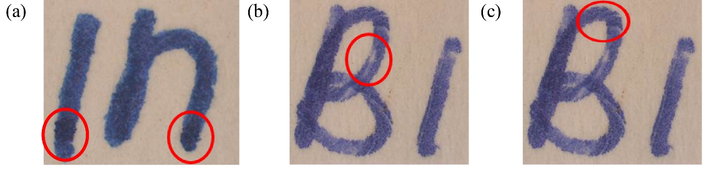

Figure 1. Microscopic images of handwriting samples showing special characteristics

Table 2. Luminescence characteristic of 20 ink samples
Sample | Wavelength of Filter Barrier
Sample | 400 – 535 nm | 485 – 610 nm | 605 – 730 nm
BP01 | Yellowish glow | Yellowish glow | Whitish glow
BP02 | Yellowish glow | Yellowish glow | Whitish glow
BP03 | ND | ND | ND
BP04 | ND | ND | ND
BP05 | Bluish glow | Bluish glow | Whitish glow
BP06 | Bluish glow | Bluish glow | Whitish glow
BP07 | ND | ND | ND
BP08 | Bluish glow | Bluish glow | Whitish glow
BP09 | Yellowish glow | Yellowish glow | Whitish glow
BP10 | Bluish glow | Bluish glow | Whitish glow
GP01 | ND | ND | ND
GP02 | ND | Bluish glow | Bluish glow
GP03 | ND | Bluish glow | Bluish glow
GP04 | ND | Bluish glow | Bluish glow
GP05 | ND | ND | ND
GP06 | ND | ND | ND
GP07 | ND | ND | ND
GP08 | ND | ND | ND
GP09 | ND | ND | ND
GP10 | ND | ND | ND

*ND-Not detected

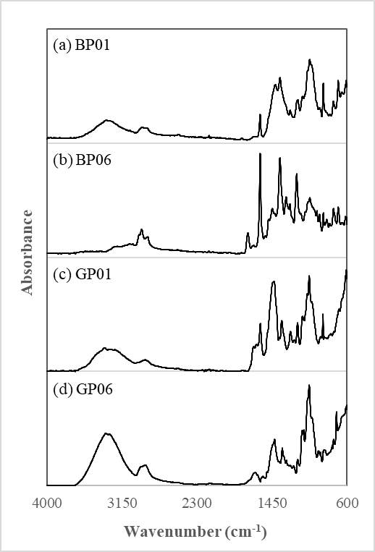

Figure 2. Representative ATR-FTIR profiles of ballpoint pen inks (a-b) and gel pen inks (c-d)

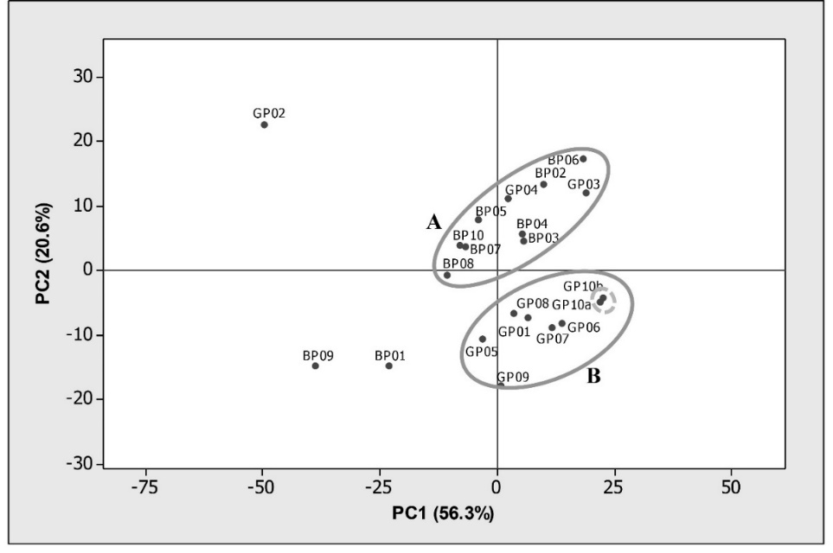

Figure 3. Score plot of 20 ink samples upon PCA

Table 3. Separation of ink components with respective R_{f} values
Solvent System | Methanolic Sample
Solvent System | BP01 | BP02 | BP03 | BP04 | BP05 | BP06 | BP07 | BP08 | BP09 | BP10 | GP02 | GP03 | GP04
A | 0.59  0.73  0.78  0.83  0.85  0.89 | 0.73  0.77  0.82  0.83  0.87 | 0.62  0.72  0.77  0.81  0.85  0.89 | 0.73  0.77  0.81  0.85  0.89 | 0.57  0.75  0.79  0.82  0.85  0.88 | 0.57  0.73  0.78  0.82  0.87  0.90 | 0.57  0.78  0.82  0.85 | 0.58  0.75  0.78  0.82  0.84  0.87 | 0.58  0.73  0.78  0.82  0.85  0.88 | 0.53  0.62  0.76  0.81  0.83  0.88 | 0.57  0.77  0.81  0.83  0.87 | 0.58  0.74  0.84  0.86  0.89  0.92 | 0.58  0.73  0.83  0.85  0.88  0.91
B | 0.19  0.26  0.49  0.55  0.60  0.65 | 0.27  0.49  0.55  0.64  0.71 | 0.20  0.26  0.49  0.54  0.60  0.66 | 0.28  0.51  0.57  0.65  0.72 | 0.28  0.49  0.52  0.58  0.61  0.67 | 0.28  0.49  0.52  0.58  0.60  0.67 | 0.28  0.49  0.52  0.58 | 0.19  0.24  0.47  0.53  0.58  0.64 | 0.19  0.26  0.50  0.55  0.60  0.65 | 0.29  0.35  0.39  0.56  0.60  0.64 | 0.28  0.49  0.51  0.57  0.59 | 0.28  0.50  0.52  0.60  0.61  0.67 | 0.29  0.49  0.52  0.60  0.62  0.68

From the 13 methanolic soluble samples subjected to TLC analysis, the solvent system consisting of ethyl acetate: ethanol: distilled water in a ratio of 14:7:6 allowed for the grouping of 13 samples into seven different groups. The number and colour of bands from these samples were observed to vary from four to six in red and blue shades in addition to several spots which fluoresced under UV light. The result suggested the possible utilisation of different or a combination of different colouring agents by manufacturers to give the desired colours that appear hardly distinguishable under naked-eye visualisation. On the other hand, the solvent system consisting of n-butanol: ethanol: distilled water in a ratio of 4:1:1 needed a longer separation time. One ink sample (BP08) exhibited the same band number and band pattern as the other two ink samples (i.e., BP05 and BP06) with the former solvent system was successfully distinguished by this solvent system.

The separation of a compound or ink mixture highly depends on the type of absorbent and solvent system used [16]. Hence, a particular solvent system is not adequate to separate all dye substance [16]; therefore, different solvent systems could result in varying dye separation. Despite resulting in relatively poor separation, the second solvent system still helped in discriminating the inks which are indistinguishable by the first solvent system and vice versa. Therefore, it is essential to employ different solvent systems for better discrimination of pen inks, if a sufficient sample is available for such analysis.

Comparison of ink samples

Under most circumstances, non-destructive visual microscopic examination and comparison against respective ink samples are preferred to avoid any further damage on the disputed documents, particularly for those stand exhibit in court. Undoubtedly, destructive methods, including TLC analysis in this study, provided much detailed information although it could impose irreversible damage to the documents, but shall only be attempted whenever sufficient samples are available and allowed for such analysis. In this study, a series of different analytical techniques, initiated by microscopic examination, VSC observation, ATR-FTIR spectroscopy, and TLC analysis has successfully created possible discrimination among ink samples. A schematic diagram summarising how the samples were successively distinguished by each technique is presented in Figure 4.

In many instances, microscopic examination alone allowed the differentiation of two main types of pen inks, namely the ballpoint pen inks and gel pen inks, in line with the label on each pen. Based on luminescence behaviour, not all ink samples luminescence to establish sample-to-sample linkage but could assist in the exclusion of an ink sample from a source of origin. ATR-FTIR showed that ink samples from the same types tend to locate closer in the score plot, as they could have contained very similar compositional profiles. However, it was also found that two ink samples labelled as gel pens in the study were also clustered together with other ballpoint pen ink samples, and thus required careful interpretation during forensic document examination on their ATR-FTIR profiles. The use of ATR-FTIR data point and PCA score plot clustering is useful to include or exclude a group of pen samples suspected to have been used in an alteration.

Dye-based ballpoint pen inks were found soluble in methanol, supporting the microscopic examination demonstrating ballpoint pen morphological features. The three ink samples, namely GP02, GP03 and GP04, that showed gel pen ink characteristics through microscopic examination were also found to be dissolved in methanol and luminesced under 485-610 and 605-730 nm light sources. These samples exhibited hybrid characteristics from both ballpoint pen and gel pen inks. By TLC, inks samples could be further discriminated from the rest, given that they were priorly dissolved in methanol. It was worth noting that TLC analysis was only restricted to ballpoint pen and hybrid pen inks. The technique is necessary in some cases where samples are sufficient and other non-destructive techniques were not able to discriminate among the samples.

In brief, the 20 ink samples were categorised into 11 different groups upon analyses. The presence of hybrid pen ink possessing both ink characteristics of ballpoint and gel pens as found in our study demonstrated that careful interpretation during the forensic investigation against written document related to ink is required, especially when alteration involves gel pen inks. Under one analytical technique, a hybrid pen may resemble the characteristics of either gel pen ink or a ballpoint pen ink and could lead to false positive or false negative results. This may make even an unauthentic document seem authentic if not carefully interpreted. Nonetheless, further analytical work is necessary for defensible characterisation of the source of pens, including identification of specific compounds in the ink composition.

20 Samples
(BP01- BP10 & GP01 – GP10)
10 Samples
(BP01- BP10)
10 Samples
(GP01 – GP10)
Microscopic Examination
4 Samples
(BP05, BP06, BP08, BP10)
3 Samples
(BP01, BP02, BP09)
3 Samples
(BP03, BP04, BP07)
7 Samples
(GP01. GP04 – GP10)
3 Samples
(GP02, GP03, GP04)
VSC
VSC
1 Sample
(BP02)
2 Samples
(BP01, BP09)
3 Unique Samples
(BP03, BP04, BP07)
1 Sample
(GP02)
2 Samples
(GP03, GP04)
ATR-FTIR
ATR-FTIR
TLC (System A)
2 Samples
(BP05, BP06)
3 Samples
(BP05. BP06, BP08)
1 Sample
(BP010)
1 Sample
(BP08)
TLC (System A)
TLC (System B)

Figure 4. Discrimination of pen samples by a series of analytical techniques

Conclusion

Based on a combination of analytical techniques, the ink from pen samples tested in this study could be discriminated from the others, especially between a ballpoint pen and gel pen inks. Marked differences between the characteristics of these inks were evidently making them readily distinguishable. Nevertheless, a conclusion should not be made solely based on microscopic findings as gel pen inks could show characteristics similar to ballpoint pen inks according to their chemical compositions. The experimental protocol used in this study can be used for the exclusion of different sources of pen inks by comparing the profiles on suspected samples and crime scene samples. We also highlighted the characteristics of hybrid pen that worth serious attention during a forensic investigation, especially when it is widely used in the future.

Acknowledgement
The authors thank the financial support via the Fundamental Research Grant Scheme (FRGS) from the Ministry of Education Malaysia (203/PPSK/6171208).

References
- Calcerrada, M. and García-Ruiz, C. (2015). Analysis of questioned documents: A review. Analytica Chimica Acta, 853: 143-166.
- Hammand, D. L. (2013). Encyclopedia of forensic sciences. Overview of forensic document examination. Elsevier, London: pp. 391-394.
- Lindblom, B. S. (2006). Scientific examination of questioned document. Pens and pencils. CRC Press, Baco Raton: pp. 147-158.
- Bell, S. (2008). Encyclopedia of forensic science. Infobase Publishing, New York: pp. 375-379.
- Allen, M. (2015). Foundations of forensic document analysis: Theory and practice. John Wiley & Sons, Oxford: pp. 163-175.
- Gernandt, M. N. and Urlaub, J. J. (1996). An introduction to the gel pen. Journal of Forensic Sciences, 41 (3): 503-504.
- Djozan, D., Baheri, T., Karimian, G. and Shahidi, M. (2008). Forensic discrimination of blue ballpoint pen inks based on thin layer chromatography and image analysis. Forensic Science International, 179 (2–3): 199-205.
- Barker, J., Ramotowski, R. and Nwokoye, J. (2016). The effect of solvent grade on thin layer chromatographic analysis of writing inks. Forensic Science International, 266: 139-147.
- Cruces-Blanco, C., Gámiz-Gracia, L. and García-Campaña, A. M. (2007). Applications of capillary electrophoresis in forensic analytical chemistry. Trends in Analytical Chemistry, 26(3): 215-226.
- Braz, A., López-López, M. and García-Ruiz, C. (2013). Raman spectroscopy for forensic analysis of inks in questioned documents. Forensic Science International, 232(1-3): 206-212.
- de Souza Lins Borba, F., Honorato, R. S. and de Juan, A. (2015). Use of raman spectroscopy and chemometrics to distinguish blue ballpoint pen inks. Forensic Science International, 249: 73-82.
- Bügler, J. H., Buchner, H. and Dallmayer, A. (2005). Characterization of ballpoint pen inks by thermal and desorption and gas chromatography-mass spectrometry. Journal of Forensic Sciences, 50(5): 1209-1214.
- Bügler, J. H., Buchner, H. and Dallmayer, A. (2008). Age determination of ballpoint pen ink by thermal desorption and gas chromatography-mass spectrometry. Journal of Forensic Sciences, 53(4): 982-988.
- Weyermann, C., Kirsch, D., Vera, C. C. and Spengler, B. (2007). A GC/MS study of the drying of ballpoint pen ink on paper. Forensic Science International, 168 (2–3): 119-127.
- Harris, J. (2013). A preliminary report on the nondestructive examination of ballpoint pen ink on questioned documents by FT-IR spectroscopy. The Canadian Society of Forensic Science Journal, 24(1): 5-21.
- Sharma, V. and Kumar, R. (2017). Fourier transform infrared spectroscopy and high performance thin layer chromatography for characterization and multivariate discrimination of blue ballpoint pen ink for forensic applications. Vibrational Spectroscopy, 92: 96-104.
- Abdul Halim, M. I., Saim, N., Osman, R., Jasmani, H. and Zainal Abidin, N. N. (2013). Discrimination of black ballpoint pen inks by high performance liquid chromatography (HPLC). Malaysian Journal of Analytical Sciences, 17(2): 230-235.
- Chen, H-S., Meng, H-H. and Cheng, K-C. (2002). A survey of methods used for the identification and characterization of inks. Forensic Science Journal, 1: 1-14.
- Neumann, C. and Margot, P. (2009). New perspectives in the use of ink evidence in forensic science. Part III: Operational applications and evaluation. Forensic Science International, 192(1–3): 29-42.
- Bell, S. (2013). How to identify a forgery: A guide to spotting fake art, counterfeit currencies and more. Skyhorse Publishing Inc, New York: pp. 43-52.
- Ellen, D., Day, S. and Davies, C. (2018). Scientific examination of documents: Methods and techniques. CRC Press, Baco Raton: pp. 128-136.
- Mazella, W. D. and Buzzini, P. (2005). Raman spectroscopy of blue gel pen inks. Forensic Science International, 152(2-3): 241-247.
- Reed, G., Savage, K., Edwards, D. and Daeid, N. N. (2014). Hyperspectral imaging of gel pen inks: An emerging tool in document analysis. Science and Justice, 54(1): 71-80.

