

SYNTHESIS AND CHARACTERIZATION OF RUBBER SEED SHELL IMPREGNATED WITH CALCIUM OXIDE AS CATALYST FOR BIODIESEL PRODUCTION

(Sintesis dan Pencirian Kulit Biji Getah dengan Resapan Kalsium Oksida Sebagai Bahan Pemangkin Untuk Penghasilan Biodiesel)

Nurul Farhanah Zakaria¹, Sarah Laila Mohd Jan¹*, Siti Norhafiza Mohd Khazaai^{1,2}, Mohd Lokman Ibrahim^{2,4}, Mohd Hasbi Ab. Rahim³ , Gaanty Pragas Maniam³

¹Faculty of Applied Sciences,

Universiti Teknologi MARA Cawangan Pahang, Kampus Jengka, 26400 Jengka, Pahang, Malaysia

²Faculty of Applied Sciences,

Universiti Teknologi MARA, 40450 Shah Alam, Selangor, Malaysia

³Faculty of Industrial Sciences & Technology,

Universiti Malaysia Pahang, Lebuhraya Tun Razak, 26300 Gambang, Kuantan, Pahang, Malaysia

⁴Centre of Nanomaterial Research, Institute of Sciences,

Universiti Teknologi MARA, 40450 Shah Alam, Selangor, Malaysia

*Corresponding author: sarahlaila@uitm.edu.my

Received: 30 April 2021; Accepted: 13 July 2021; Published: 29 August 2021

Abstract

Biomass can be manipulated as a promising heterogeneous catalyst that provides greener synthesis route for sustainable production of biodiesel. The oven-dried rubber seed shell (RSS) biomass was ground, and calcined at 700 °C for 4 hours. Later, RSS/CaO catalysts were prepared using the wet impregnated method with 1:4 ratios and calcined at 450 °C for 4 hours. The physicochemical properties were characterized by using thermogravimetric analysis (TGA), Fourier-transform infrared spectroscopy (FTIR) and scanning electron microscopy-energy dispersive X-ray (SEM-EDX). Methyl ester yield obtained was 68.6% by employing 10 wt.% of catalyst loading with 1:12 oil to methanol molar ratio at a temperature of 70 °C within 3 hours. Therefore, the present study verified that the RSS/CaO catalyst was one of the suitable catalysts for methyl ester production.

Keywords: methyl ester, biomass, waste cooking oil

Abstrak

Biojisim boleh dimanipulasi sebagai bahan pemangkin heterogen harapan yang boleh menyediakan laluan sintesis lebih mesra alam sekitar untuk pengeluaran biodiesel yang lebih mampan. Kulit biji getah yang telah dikering dalam oven kemudiannya dikisar dan dikalsinasi pada suhu 700 °C selama 4 jam. Bahan pemangkin RSS/CaO disediakan dengan menggunakan kaedah resapan basah dengan nisbah 1:4 dan dikalsinasi pada suhu 450 °C selama 4 jam. Sifat fizikokimia dicirikan dengan menggunakan analisis termogravimetrik (TGA), spektoskopi infrmerah transformasi Fourier (FTIR) dan mikroskopi imbasan elektron-tenaga serakan sinar-X (SEM-EDX). Hasil metil ester yang diperoleh adalah 68.6% dengan menggunakan 10% berat pemangkin dengan nisbah molar minyak dan metanol 1:12 pada suhu 70 °C dalam 3 jam. Oleh itu, kajian ini mengesahkan bahawa bahan pemangkin RSS/CaO adalah salah satu pemangkin yang sesuai untuk pengeluaran metil ester.

Kata kunci: metil ester, biojisim, sisa minyak masak

Introduction

Green catalyst refers to the catalyst synthesized from biomass, and many researchers are progressively developing low cost of biomass-derived catalyst to reduce the cost of biodiesel production as well as to solve the problems of biomass waste disposal [1]. An abundance of biomass residue resulted mainly from various human and agricultural activities. The biomass waste produced by the agricultural sector in Malaysia was predicted to reach 110 million tons in 2020. The biomass waste such as empty fruit bunch, peels, kernels, seeds, trunk, shell and many more can be recycled into a new valuable product for various applications rather than be disposed at landfill or burned into ashes [2]. Biomass can be converted into the solid base catalyst by direct carbonization or combustion at high temperature [3].

The utilization of biomass-derived solid heterogeneous catalyst is a lot cheaper due to high abundance and availability of biomass, able to reduce the problem regarding solid waste disposal, pollution free [4], low production cost and highly efficient catalytic ability [5]. The reviews from various researchers had explored and listed several catalysts derived from various biomass such as waste egg shell, waste coral, animal bones, ashes, agricultural waste, mollusk shell, palm and coconut shell, peanut hull, sea sand, bamboo, sugarcane, banana trunk, rice husk, cocoa pod husk, wood, sewage sludge and snail shell that showcased excellent catalytic ability in transesterification of feedstock with high yield of methyl ester [1, 2].

About 1.3 million hectares of land in Malaysia is devoted for rubber plantation and produce approximately 150 kg of RSS per hectares every season that only regarded as waste as it is not edible [6]. The RSS falls naturally from the rubber tree and left to rot on the soil [7]. In order to reduce the solid waste generated from rubber plantation in our country, the research of raw RSS as a potential basic and acidic heterogeneous catalyst in biodiesel production is much needed. Solid biomass-derived catalyst can function as basic or acidic catalyst support by firstly converted into carbonaceous materials then functionalized with active group. The acidity and basicity of the catalyst depends on the chemicals used during the chemical impregnation (CI) of active sites [8].

Currently, in order to accomplish the concept of green chemistry, there has been a great shift in focus towards producing solid biomass-derived catalyst as the precursor for transesterification of biodiesel. An intense research of cost-efficient green technology for biodiesel production is much needed. Biodiesel is nominated as the promising alternative of fuel due to properties such as free of toxic, biodegradable, compatible with environment, low greenhouse gas emission, low viscosity, excellent lubricity, high flash point and cetane number [9]. To manufacture biodiesel, extensive study has been conducted on renewable resources, the majority of which are plant-based oil (sunflower oil, palm oil, rice bran oil) and waste cooking oil (WCO). WCO was selected as a biodiesel resource in this study because it is considered environmentally friendly due to the recycling act and good management of improper dumping of WCO. Date pits [10], coconut husk [11], Tucuma peel [3], and fly ash [12] are just a few examples of the biomass-derived catalysts that have been studied and have shown tremendous results in biodiesel production with 98–70% yield.

In this present study, rubber seed shell (RSS) of Hevea brasiliensis is chosen as the biomass to synthesis the heterogeneous catalyst for biodiesel production. Previous studies reported that apart from carbon, the RSS has mineral composition of calcium, magnesium; sodium and potassium thus fulfill the criteria worthy of biomass-derived heterogeneous catalyst [13].

Materials and Methods

Materials

Rubber seed was collected in local estate and it is consisting of the outer shell and inner kernel. Later, the kernel was separated from the seed in order to obtain the biomass sample, rubber seed shell (RSS). Waste cooking oil (WCO) was obtained from a local household kitchen. WCO was filtered to remove the impurities and heated at 120 °C for 2 hours to eliminate the moisture content [14]. An analytical grade of methanol, n-heptane, petroleum ether, and chloroform were obtained from Merck. An analytical grade of methyl heptadecanoate, phenolphthalein, 4-nitroaniline and 2,4-dinitroaniline were purchased from Sigma Aldrich company (Switzerland).

Preparation of RSS/CaO catalyst

RSS was washed with distilled water to remove any dirt and impurities. Then, the RSS sample was placed in fan-assisted drying oven at 80 °C for 12 hours to remove any moisture. The oven-dried RSS biomass was ground, placed in crucibles and calcined at 700 °C for 4 hours in a muffle furnace. The resulted RSS-derived carbon material was impregnated with an aqueous solution of Ca(NO₃)₂•4H₂O at constant temperature and stirring rate for 2 hours with the ratio of 1:4 [3, 12]. The dried sample was then calcined at 450 °C for 4 hours to transform the impregnated Ca(NO₃)₂•4H₂O into active calcium oxide group [10].

Characterization of RSS/CaO catalyst

Thermo gravimetric analysis (TGA) using TGA-SDTA 851 Mettler Toledo was carried out to find the minimum calcination temperature of converting RSS into a stable carbon material [11]. The functional group of calcined RSS and RSS/CaO catalyst were identified using Perkin Elmer SpectrumTM 400 FTIR Spectrometer. The surface morphology of calcined RSS and RSS/CaO catalyst were also examined under scanning electron microscopy (SEM) followed by EDX Oxford Instrument for elemental analysis.

Evaluation of catalytic analysis

The transesterification temperature, time and methanol-to-oil ratio was kept constant at 70 °C, 3 hours and 12:1 to investigate the effect of catalyst loading. The WCO and methanol was refluxed in a water bath with the presence of various RSS/CaO catalyst loading (6, 8, 10, 15 and 20 wt.%). The reaction mixture was cooled down at room temperature and left overnight to remove the residual methanol. The catalyst was separated from the liquid phase using centrifugation at 3000 rpm for 20 minutes. The biodiesel yield was calculated by following equation 1 [13].

Biodiesel yield (%) =$\frac{\text{upper biodiesel layer weight}}{\text{WCO weight}}\text{ ×100}$ (1)

The collected upper biodiesel layer was analyzed using gas chromatography equipped with mass spectrometry (GC-MS) to identify the type of FAME content that present [15]. Agilent 7890B gas chromatographer equipped with 5977A MSD and Zebron ZB-Wax capillary column with diameter 30m x 0.2mm x 0.25µm was used. The probability of each chromatogram peaks were indeed methyl ester were confirmed by matching the unknown spectra with the mass spectra in the National Institute of Standards and Technology (NIST) library database. Equation 1 was used to calculate the reaction yield as the internal standard was not employed when analyzing the collected upper layer using the GC-MS.

Results and Discussion

Characterization of RSS/CaO catalyst: Thermo-gravimetric analysis ((TGA)

The calcination temperature was chosen at 700°C for dried RSS based on the TGA result in Figure 1. Apart from achieving thermal stability, high calcination temperature is preferable as shorter calcination time is required to produce catalyst with uniform surface [16]. Biomass that was calcined at high temperature can be directly used as catalyst for biodiesel production [3, 17]. Unfortunately, the firstly calcined RSS at 700 °C in the present study does not exhibit any catalytic activity as there was no conversion observed during transesterification reaction due to the low number of active sites. Therefore, the calcined RSS was further treated with aqueous solution of Ca(NO₃)₂•4H₂O to functionalized the carbonaceous material with CaO active sites. Ca(NO₃)₂•4H₂O was chosen as the precursor due to lower calcination temperature was required to form CaO as compared to other precursor such as calcium carbonate [11]. Widely known CaO have excellent catalytic ability, it is still very important to anchor CaO on RSS carbon support to avoid Ca²⁺ ion leaching into the reactants [17]. Furthermore, the oxygen ion on the CaO surface easily reacts with methanol and glycerol forming hydrogen bonds [18]. As a result, the viscosity of glycerol increases leading to strenuous separation. Anchoring CaO on a fixed carbon support can solve the discussed issues. Another function of RSS carbon support is to provide larger surface area for better catalytic ability [11].

Fourier-transform infrared spectroscopy

Calcined RSS does not exhibit any peak indicating there is no functional group present apart from the carbonaceous residue according to Figure 2. After anchoring the calcined RSS with CaO, four prominent peaks were observed on the infrared spectrum. RSS/CaO spectrum exhibited a broad peak at 1469 cm⁻¹ due to the bending vibration of Ca-O thus confirmed the attachment of CaO onto the carbon support. The sharp peak observed at 3640 cm⁻¹ belongs to the hydroxyl group (-OH) stretching vibration of Ca(OH)₂ due to the interaction of CaO with moisture when exposed to the surrounding. The peak at 875 cm⁻¹ is due to the stretching vibration of carbonate ion (CO₃)²⁻ [16]. The presence of carbonate ion furthers proven with the occurrence of weak band at 1085 cm⁻¹ that belongs to C-O stretch [19].

Scanning electron microscopy-energy dispersive X-ray

Based on Figure 3(a) and (b), the calcined RSS at 700°C exhibited smooth and protruding bead-like agglomerated surfaces that able to provide high surface area for attachment of active sites. The EDX elemental analysis of calcined RSS shows that carbon (86.16 wt.%) dominates the composition followed by oxygen (13.56 wt.%) and trace amount of calcium (0.28 wt.%). The soil and climate condition are factors that determine the mineral content of grown biomass [19]. Similarly reported, a trace element of calcium in RSS biomass was found [13]. Meanwhile, according to Figure 4(a) and (b), the attachment of CaO active sites had modified the surface morphology of RSS. After activation, the catalyst exhibited more regular flakes-like flat surface structure. The particle sizes reduction was also observed for RSS/CaO that further increases the surface area which is a very significant feature of heterogeneous catalyst [16]. RSS/CaO catalyst consist of higher amount of calcium (35.18 wt.%) and oxygen (47.04 wt.%) due to activation process followed by the carbon support (17.79 wt.%). The RSS/CaO elements mapping also shown that carbon and calcium are superimposed. Superimposed images are due to formation of mixed phases of elements proving that CaO is definitely attached onto the carbon support [20]. The regular spatial distribution as observed in Figure 4(d) showed that the impregnated CaO was well scattered over the RSS carbon support.

Catalytic activity of RSS/CaO for biodiesel production

The transesterification reaction of WCO to produce biodiesel was successfully conducted using the synthesized RSS/CaO catalyst. As shown in Figure 5, the minimum concentration (6 wt.%) of RSS/CaO catalyst required to convert WCO to FAME within 3 hours. The most optimum catalyst loading is 10 wt.% that shows the best catalytic activity with highest biodiesel yield at 68.6%. Similarly, fly ash/CaO catalyst achieved slightly higher biodiesel yield at 71.1% by employing 6 wt.% catalysts [11]. The result trend is consistent with several studies that suggested higher catalyst concentration contained a lot more active sites thus provide better catalytic activity [3, 5, 15, 16]. In addition, higher CaO sites leads to higher formation of calcium methoxide, Ca-(CH₃O)₂ that amplified the reaction rates [16]. Meanwhile, decrease in biodiesel yield at catalyst concentration exceeding optimum load is due to increase in viscosity of reactant that declines the mass transfer rate between reactant and catalyst surface [3]. The FAME composition was qualitatively determined using GC-MS. The chromatogram peaks reflect all kinds of compounds that exist in the biodiesel. Out of ten prominent peaks that appeared, six peaks were verified as FAME using mass spectral NIST library (dodecanoic acid methyl ester, methyl tetradecanoate, hexadecanoic acid methyl ester, methyl stearate, eicosanoic acid methyl ester, octadecatrienoic acid methyl ester). Four of them were similar to the previous study [15]. Slight variations in type of FAME produced may be due to the different sources of WCO were employed.

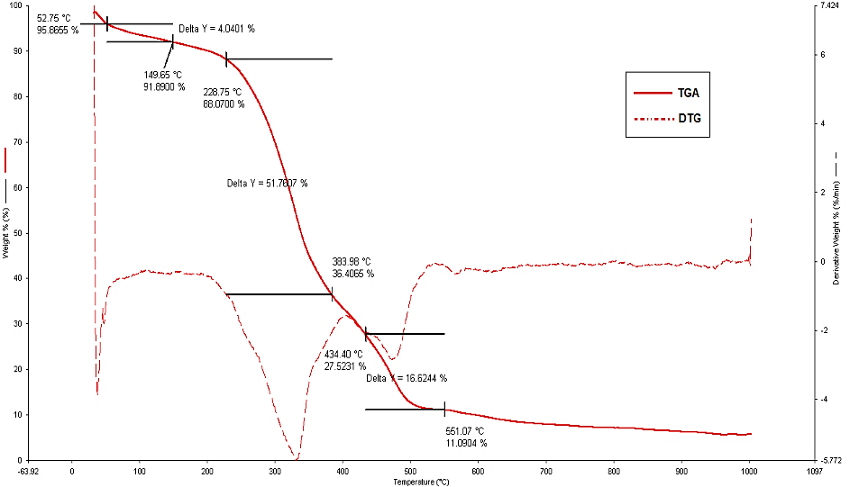

Figure ‎1. TGA-DTG curve for raw dried RSS

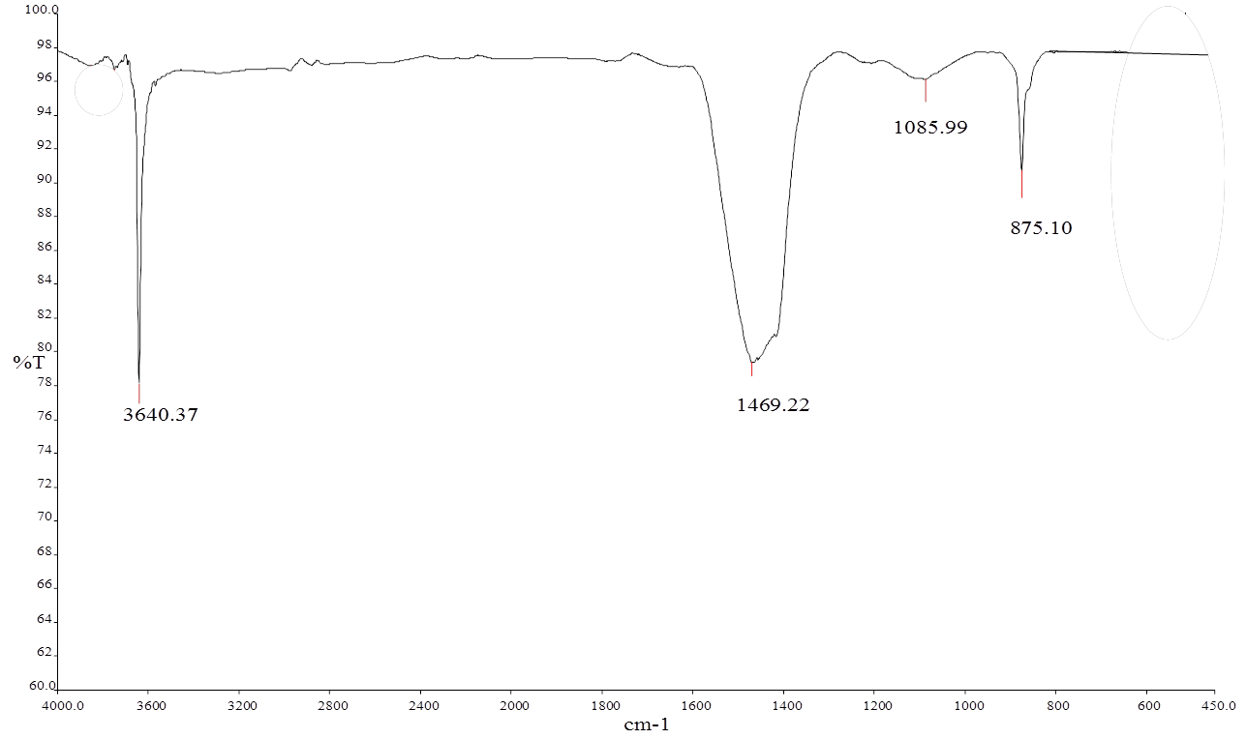
RSS/CaO
Calcined RSS

Figure 2. IR spectrum of calcined RSS and RSS/CaO catalyst

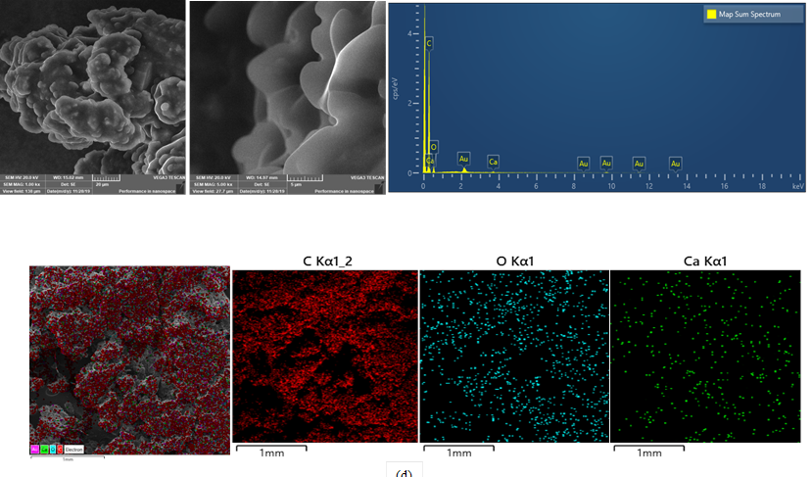
d)
a)
b)
c)

Figure ‎3. Calcined RSS at 700°C (a) 1000x magnification (b) 5000x magnification (c) element spectrum (d) element mapping

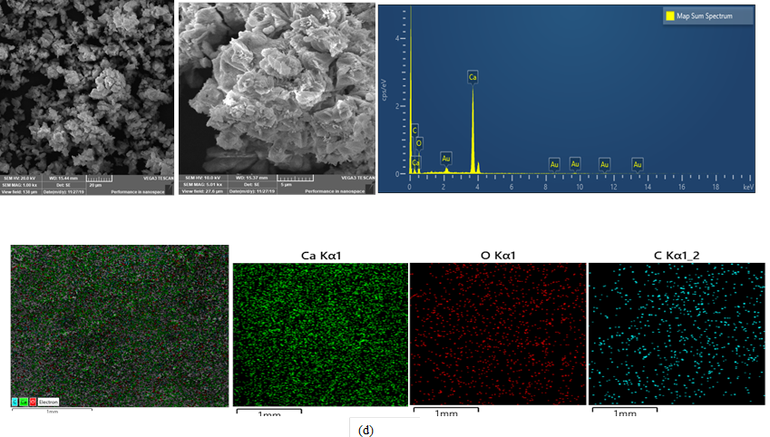
d)
c)
b)
a)

Figure ‎4. Calcined CaO/RSS at 700°C (a) 1000x magnification (b) 5000x magnification (c) element spectrum (d) element mapping

Figure 5. The effect of catalyst loading on the biodiesel yield

Conclusion

RSS is an attractive carbon source for catalyst support as thermal analysis conducted by TGA showed that RSS had high thermal stability. Impregnation of CaO active sites had modified and improved the RSS carbon structure thus increased the catalytic ability of the catalyst. The attachment of CaO onto carbon support was confirmed by the presence of significant functional group bands on IR spectrum as well as SEM-EDX morphological and elemental analysis. Certify the catalyst capable of yielding 68.8% of methyl ester within 3 hours of reaction time at 70 °C with MeOH/oil mass ratio, 12:1; catalyst amount, 10 wt.%. Qualitative analysis of collected upper layer by GC-MS also confirmed that WCO was successfully transformed into FAME.

Acknowledgement

The authors would like to thank Ministry of Higher Education, Malaysia, Universiti Malaysia Pahang and Universiti Teknologi MARA Pahang for research project (600-TNCPI 5/3/DDN (06)(001/2020) and (FGRS/1/2019/STG01/UMP/02/2).

References
- Abdullah, S. H. Y. S., Hanapi, N. H. M., Azid, A., Umar, R., Juahir, H., Khatoon, H. and Endut, A. (2017). A review of biomass-derived heterogeneous catalyst for a sustainable biodiesel production. Renewable and Sustainable Energy Reviews, 70: 1040-1051.
- Tang, Z. E., Lim, S., Pang, Y. L., Ong, H. C. and Lee, K. T. (2018). Synthesis of biomass as heterogeneous catalyst for application in biodiesel production: State of the art and fundamental review. Renewable and Sustainable Energy Reviews, 92: 235-253.
- Mendonça, I. M., Paes, O. A. R. L., Maia, P. J. S., Souza, M. P., Almeida, R. A., Silva, C. C. S., Duvoisin Jr. and de Freitas, F. A. (2019). New heterogeneous catalyst for biodiesel production from waste tucumã peels (Astrocaryum aculeatum meyer): Parameters optimization study. Renewable Energy, 130: 103-110.
- Chellappan, S. and Nair, V. (2018). Synthesis, optimization and characterization of biochar based catalyst from sawdust for simultaneous esterification and transesterification. Chinese Journal of Chemical Engineering, 26: 2654-2663.
- Mazaheri, H., Ong, H. C., Masjuki, H. H., Amini, Z., Harrison, M. D., Wang, C. T., Kusumo, F. and Alwi, A. (2018). Rice bran oil based biodiesel production using calcium oxide catalyst derived from chicoreus brunneus shell. Energy, 144: 10-19.
- Hassan, S. N. A. M., Ishak, M. A. M., Ismail, K., Ali, S. N. and Yusop, M. F. (2014). Comparison study of rubber seed shell and kernel (Hevea brasiliensis) as raw material for bio-oil production. Energy Procedia. 52: 610-617.
- Khazaai, S. N. M., Maniam, G. P., Rahim, M. H. A., Yusoff, M. M. and Matsumura, Y. (2017). Review on methyl ester production from inedible rubber seed oil under various catalysts. Industrial Crops and Production, 97: 191.
- Muthusamy, K., Nordin, N., Vesuvapateran, G., Ali, M., Mohd Annual, N. A., Harun, H. and Ullap, H. (2014). Exploratory study of rubber seed shell as partial coarse aggregate replacement in concrete. Research Journal of Applied Sciences, Engineering and Technology, 7: 1199-1202.
- Shah, B., Sulaimana, S., Jamal, P. and Alam, M. Z. (2014). Production of heterogeneous catalysts for biodiesel synthesis. International Journal Chemical Environmental Engineering, 5(2): 73-75.
- Al-Muhtaseb, A. A. H., Jamil, F., Al-Haj, L., Zar Myint, M. T., Mahmoud, E., Ahmad, M. N., Hasan, A. O. and Rafiq, S. (2018). Biodiesel production over a catalyst prepared from biomass-derived waste date pits. Biotechnology Reports, 20: 00284.
- Vadery, V., Narayanan, B. N., Ramakrishnan, R. M., Cherikkallinmel, S. K., Sugunan, S., Narayanan, D. P. and Sasidharan, S. (2014). Room temperature production of jatropha biodiesel over coconut husk ash. Energy, 70: 588-594.
- Helwani, Z., Fatra, W., Saputra, E. and Maulana, R. (2018). Preparation of CaO/fly ash as a catalyst inhibitor for transesterification process off palm oil in biodiesel production. IOP Conference Series: Materials Science and Engineering, 334: 012077.
- Ekebafe, L., Imanah, J. and Okieimen, F. (2010). Physico-mechanical properties of rubber seed shell carbon-filled natural rubber compounds. Chemical Industry and Chemical Engineering Quarterly, 16: 149-156.
- Shohaimi, N. A. M. and Marodzi, F. N. S. (2018). Transesterification of waste cooking oil in biodiesel production utilizing CaO/Al₂O₃ heterogeneous catalyst. Malaysian Journal Analytical Sciences, 22: 157-165.
- Onoji, S. E, Iyuke, S. E., Igbafe, A. I. and Daramola, M. O. (2017). Transesterification of rubber seed oil to biodiesel over a calcined waste rubber seed shell catalyst: Modeling and optimization of process variables. Energy Fuels, 31: 6109-6119.
- Abbaszaadeh, A., Ghobadian, B., Omidkhah, M. R. and Najafi, G. (2012). Current biodiesel production technologies: A comparative review. Energy Conversion Managment, 63: 138-148.
- Lv, C., Liu, P., Yuan Z., Yan, F. and Luo, W. (2010). The nanometer magnetic solid base catalyst for production of biodiesel. Renewable Energy, 35: 1531-1536.
- Khan, N. B. A. and Yacob, A. R. (2017). Potassium hydroxide and calcium oxide activated carbon for transesterification reaction of biodiesel. eProceedings Chemistry, 2: 63-69.
- Reshad, A. S., Tiwari, P. and Goud, V. V. (2018). Thermo-chemical conversion of waste rubber seed shell to produce fuel and value-added chemicals. Journal Energy Insdustry, 91: 940-950.
- Neri, G., (2003). K- and Cs-FeV/Al₂O₃ soot combustion catalysts for diesel exhaust treatment. Applied Catalysis B: Environmental, 42(4): 381-391.

