Transmittance (100%)

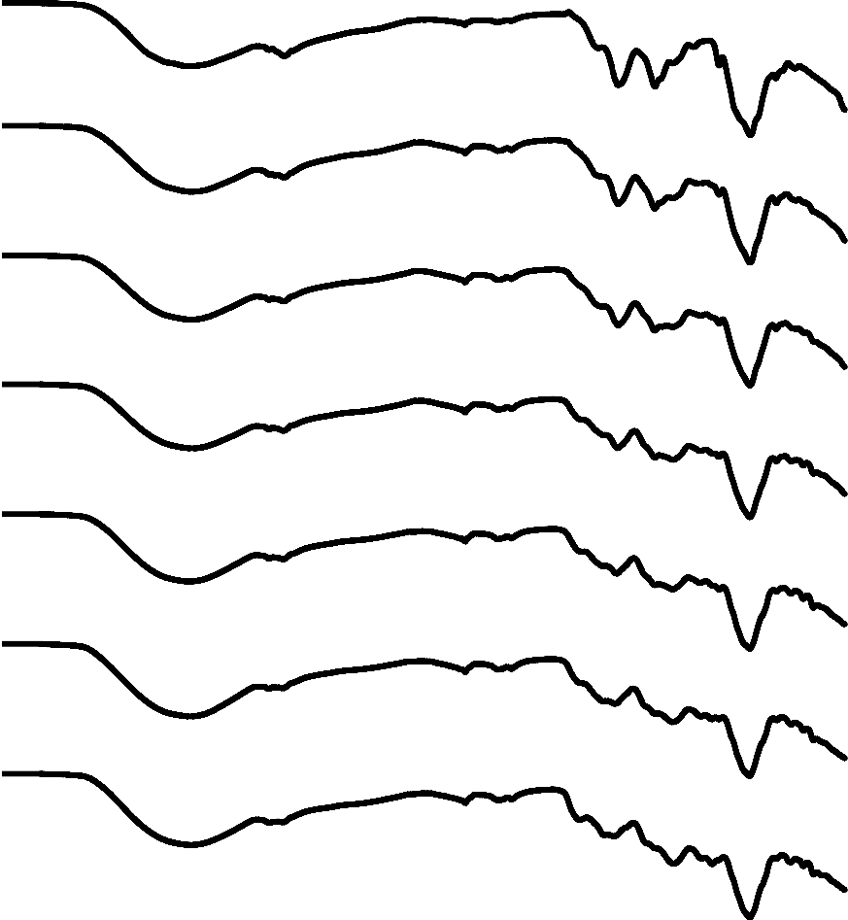
(G)
1147 cm⁻¹
(F)
1400 cm⁻¹
1021 cm⁻¹
1550 cm⁻¹
2874 cm⁻¹
(E)
(D)
(C)
(B)
2154 cm⁻¹
(A)
3281 cm⁻¹
4000.00 3500.00 3000.00 2500.00 2000.00 1500.00 1000.00 500.00
Wavelength cm-1
Figure 1. Spectra of CH-PPE edible films (A) 1.5%CH+0%PPE (B) 1.5%CH+1%PPE (C) 1.5%CH+2%PPE (D) 1.5%CH+3%PPE (E) 1.5%CH+4%PPE (F) 1.5%CH+5%PPE (G) 1.5%CH+6%PPE

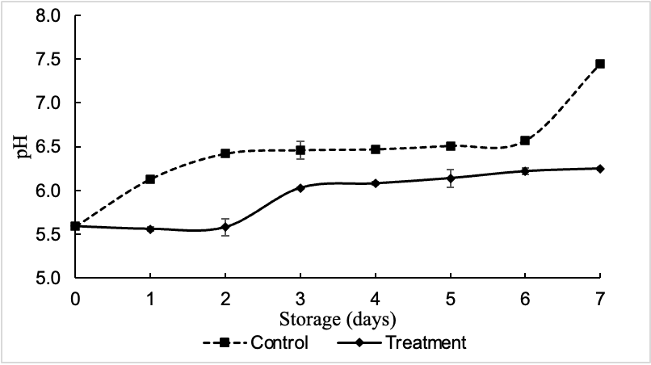

Figure 2. The change of pH throughout the 7 storage days at 4°C.

9

8
Control beef sample
7

6

5

4
Treatment beef sample
3

2

1

0
0
1
2
3
4
5
6
7
STORAGE DAYS

Figure 3. Total plate count of beef meat at both control and treatment samples during 7 storage days at
4 °C

