
CLASSIFICATION MODEL FOR DETECTION AND DISCRIMINATION OF INEDIBLE PLASTIC ADULTERATED PALM COOKING OIL USING ATR-FTIR SPECTROSCOPY COMBINED WITH PRINCIPAL COMPONENT ANALYSIS

(Model Pengkelasan bagi Pengesanan dan Pengasingan Produk Cemaraduk Plastik dalam Minyak Masak Sawit Menggunakan Spektroskopi ATR-FTIR dengan Gabungan Analisis Komponen Prinsipal)

Dzulkiflee Ismail¹, Aliyalina Rahimi¹, Wan Rosli Wan Ishak², Naji Arafat Mahat³, Wan Nur Syuhaila Mat Desa¹*

¹ Forensic Science Programme, School of Health Sciences
² Nutrition Programme, School of Health Sciences
Universiti Sains Malaysia, Health Campus, 16150 Kubang Kerian, Kelantan, Malaysia
³Department of Chemistry, Faculty of Science,
Universiti Teknologi Malaysia, 81310 Skudai, Johor, Malaysia

*Corresponding author: wannurs@usm.my

Received: 17 March 2021; Accepted: 28 May 2021; Published: xx June 2021

Abstract
Adulteration of edible oil by replacing or admixing cheaper or waste oil is an irresponsible act motivated by profiteering. A more sinister act of dissolving inedible plastic materials in hot oil during frying to enhance the crispiness and prolong the shelf life of deep-fried snacks has been alleged. In this study, a protocol using ATR-FTIR spectroscopy combined with principal component analysis (PCA) for detection of inedible plastic materials in palm cooking oil is presented. To achieve this, palm cooking oil samples purchased from convenience stores were heated and adulterated either with low-density polyethylene (LDPE), high-density polyethylene (HDPE) or polypropylene (PP). The resultant spectra from 4000-600 cm⁻¹ were subjected to direct visual examinations prior to PCA. Detection of plastic materials in the samples from direct visual examinations of the resultant spectra was difficult as all samples revealed similar spectra dominated by major absorption bands at 2922 cm⁻¹, 2853 cm⁻¹, 1740 cm⁻¹, 1465 cm⁻¹, 1377 cm⁻¹ and 721 cm⁻¹, which were typical of triacylglycerols. Despite the similarities, the detection was possible when the resultant spectra were subjected to PCA. The results demonstrated the potential of ATR-FTIR spectroscopy combined with PCA for the detection of inedible plastic adulterated palm cooking oil.

Keywords: ATR-FTIR spectroscopy, cooking oil, adulteration, polyethylene, polypropylene

Abstrak
Cemaraduk minyak makan dengan menggantikan atau mencampurkan bersama minyak murah atau minyak sisa adalah tindakan tidak bertanggungjawab didorong oleh sikap meraih keuntungan. Tindakan yang lebih tidak bertanggungjawab adalah melarutkan plastik tidak boleh dimakan ke dalam minyak panas semasa menggoreng bertujuan untuk meningkatkan kerangupan dan memanjangkan jangka hayat makanan gorengan telah diperkatakan. Kajian ini membentangkan protokol menggunakan kaedah spektroskopi ATR-FTIR yang digabungkan bersama analisis komponen prinsipal (PCA) untuk mengesan bahan plastik tidak boleh dimakan dalam minyak sawit goreng. Untuk mencapai matlamat ini, sampel minyak masak sawit dibeli dari kedai serbaneka telah dipanaskan dan diadukkan bersama polietilena ketumpatan rendah (LDPE), polietilena ketumpatan tinggi (HDPE) atau polipropilena (PP). Spektra inframerah yang diperoleh dari 4000-600 cm⁻¹ telah diperiksa terlebih dahulu melalui kaedah pemeriksaan visual langsung sebelum PCA. Pengesanan bahan plastik tidak boleh dimakan dalam semua sampel melalui kaedah pemeriksaan visual dari spektra inframerah yang dihasilkan adalah sukar berikutan kesemua sampel menghasilkan spektra serupa dengan jalur penyerapan utama tipikal triasilgliserol pada 2922 cm⁻¹, 2853 cm⁻¹, 1740 cm⁻¹, 1465 cm⁻ ¹, 1377 cm⁻¹ dan 721 cm⁻¹. Walaupun terdapat persamaan, pengesanan dilakukan dengan jayanya menggunakan PCA. Hasil kajian menunjukkan potensi penggabungan spektroskopi ATR-FTIR bersama PCA untuk pengesanan plastik tidak boleh dimakan teraduk dalam minyak masak sawit.

Kata kunci: spektroskopi ATR-FTIR, minyak masak, pengadukan, polietilena, polipropilena

Introduction
Palm cooking oil is a popular choice for deep frying due to its excellent and versatile techno-economic advantages for almost all frying activities [1]. In certain South East Asia countries, deep-fried snacks such as deep-fried banana, deep-fried fish fritter and fried chicken are commonly found in street stalls sold by hawkers. Recently, the practise of adding and dissolving inedible plastic materials such as used plastic carrier bags, used plastic packaging and used straws into hot oil by irresponsible street hawkers prior to frying is rumoured. Purportedly, this practise helps to enhance the crispiness, as well as prolong the freshness and the shelf-life of deep-fried snacks [2]. If this allegation is true, such malpractice is undoubtedly alarming as it poses serious health implications to the consumers since a wide range of chemicals used in the manufacture of plastics such as bisphenol-A (BPA), melamine, thalates, antiminitroxide, brominated flame retardants and poly-fluorinated chemicals are known to be toxic [3,4]. Among health problems associated with toxins found in plastics are liver dysfunction, cancers, skin diseases, neuro-toxicity, lung problems and gastrointestinal issues [3, 4]. This malicious practice which is undoubtedly a serious food safety issue warrants the development of a sensitive detection technique, capable of detecting dissolved inedible plastic materials.

Infrared (IR) spectroscopy has emerged as one of the useful analytical tools for monitoring food safety issues. In order to further enhance its detection ability, it is often combined with chemometrics techniques [5, 6]. This hybrid approach has been used, among others to detect the adulteration of extra virgin olive oil with sunflower, peanut, canola, corn, sunflower and soybean oil [7], the adulteration of high-priced walnut oil with low-priced sunflower and soybean oil [8], the presence of chicken fat in butters [9], the adulteration of rapeseed oil with waste cooking oil [10], the presence of lard in French fries pre-fried in palm oil adulterated with lard [11] and the adulteration of pekmez, a Turkish sweet with glucose syrup, high fructose corn syrup and other sugars [5].

IR spectroscopy is a spectroscopy technique that uses the electromagnetic radiation within the IR region. When transmitted through a sample, this electromagnetic radiation stimulates vibrational motions of the molecules within the sample [6, 12]. When the vibration of a molecule matches with the frequency of the transmitted IR radiation, a spectral band or peak is produced. Different molecules absorb IR radiation at different frequencies, hence producing different spectral bands characteristic which are useful for identification. Early IR spectrophotometers require tedious sample preparation. With the advancement of technology, attenuated total reflectance (ATR) attachment is introduced. This attachment has revolutionized FTIR spectroscopy which allows for direct in-situ, straightforward sample analysis with minimal to no sample pre-treatment requirement.

Principal Component Analysis (PCA) is one of the chemometrics techniques that has been used to monitor and detect adulterants in food. This particular chemometrics technique allows large sample of data sets to be described using a much smaller number of principal components or PCs. The first PC, known as PC1 describes the gross average features of the data sets while the second PC, or PC2, and the subsequent PCs introduce further specific features of decreasing significance [13, 14]. PCA is a suitable tool for simplification, data reduction, outlier detection and pattern recognition highlighting the variance or differences within a dataset. In the case of PCA performed on a FTIR spectra, it allows the investigation of trends in the studied samples and relationships or differences between samples.

As far as this study is concerned, no work has been done focussing on the detection of plastic adulterated cooking oil using ATR-FTIR spectroscopy combined with PCA. Therefore, in this study, the authors intend to demonstrate the use of this hybrid approach for the detection and discrimination of inedible plastic in palm cooking oil.

Materials and Methods
Sample collection
New and unused 1 kg refined palm cooking oils (RCO) (n = 6) of similar brand were purchased from a local convenience store over a period of 6 months while low-density polyethylene (PE1), high-density polyethylene (PE2) and polypropylene (PP) plastic bags were purchased directly from a plastic bag retail store to reflect the alleged field practice. Fresh bananas purchased from the local market were selected as the item to fry because it was an easy local snack to prepare compared to other processed foods such as chicken meats. The heating and cooking procedures were conducted using a stainless-steel frying pan (Zebra Inc., Thailand) and a portable cooking stove (Power Plus, China) equipped with a portable butane gas canister (Chelstar, Korea).

Sample preparation
Each packet of 1 kg (equivalent to approximately 1200 mL) (n=6) RCO was divided to five equal portions to prepare for control unadulterated (URCO), heated refined oil (HRCO), heated with food (HRCOB), adulterated without food (ARCO, referred as RCO-PE1, RCO-PE2 and RCO-PP according to the plastic materials used to adulterate them) and adulterated with food (ARCOB, referred as ARCO-B-PE1, ARCO-B-PE2 and ARCO-B-PP according to the plastic materials used to adulterate them) oil sets.

HRCO (n=5) was prepared by heating approximately 400 mL of control cooking oil to approximately 200 °C (K-type digital thermocouple, MYPIN, China) until small bubbles and thin white smoke were released. The heating time to achieve the condition was about 2 minutes. Once heating was completed, sample was allowed to stand to cool off at room temperature at approximately 25 ºC.

Adulterated oil samples without food (ARCO) (n=5) were prepared by gradually dissolving approximately four grams of PE1 strips into hot RCO as previously described. The amount of plastic incorporated reflects the average weight of one plastic bag. Similar procedures were repeated for PE2 and PP plastic materials.

For HRCOB (n=5) and ARCOB (n=5) samples, slices of banana were fried for 2 minutes each under a similar set-up. Upon cooling, the oil samples from each set were filtered using a filter paper (Whatman, Merck, Germany). Approximately 2 mL of the filtered oil was then transferred into a separate half dram glass vial (Bischem, Malaysia) and kept at 4°C in refrigerator prior to subsequent ATR-FTIR analysis.

ATR-FTIR analysis
The IR spectra were obtained using a Bruker Tensor 27 FTIR spectrometer (Bruker Technologies, USA) equipped with a zinc selenide (ZnSe) ATR sampling interface. The instrument control and data acquisition were operated by OPUS Ver. 7.0.122 software (Bruker, Germany). To check for detection accuracy, the FTIR spectrometer was calibrated against a standard polystyrene film (Bruker Optics, Germany). All IR spectra were obtained in the frequency region of 4000-600 cm⁻¹ where 16 scans were collected at a resolution of 4 cm⁻¹.

Sample IR spectra acquisition was performed by placing a drop of oil sample on the surface of the ZnSe sampling interface. Once measurement had been completed, the oil sample was removed from the interface using dry tissues (Kimberly Clark, UK) and subsequently was wiped again using a clean tissue soaked with methanol before and after each analysis. The plastic materials were also measured in ATR mode. Confirmation of the IR profiles of the plastic materials used as the adulterants were accomplished by comparison with literature references [15]. Spectrum acquisition for each sample was performed in six replicates at room temperature (25 ºC).

Sample variations
In this study, variations within and between samples were assessed through repeatability and reproducibility measurements respectively using the URCO as the samples. The former was measured by conducting six consecutive measurements or spectra acquisitions on one of the URCO samples while the latter was measured by conducting one measurement to each of the six batches of the URCO samples. Both repeatability and reproducibility were expressed using relative standard deviation (%RSD) which is defined as the percentage ratio of standard deviation over mean or average of below than 5% as stated by international analytical guidelines [15].

Data pre-processing and principal component analysis
The resultant IR spectra were converted to comma-separated values (.CSV) format prior to importing to the Excel spreadsheet (Microsoft, USA) for further data preparation and pre-processing. A series of data pre-processing strategies which were auto-scaling, column centring and square root transformation were applied to the IR data matrices. Once the series of data pre-processing were completed, the pre-processed IR data matrices were imported to Minitab Version 16.2.3 statistical software (Minitab Inc., USA) environment for principal component analysis (PCA). Assessment of the ability of PCA to detect and discriminate the non-plastic adulterated oil from its non-adulterated counterparts was made based on score plots observations in which the principal component (PC) score plots were constructed using the first two resultant principal components.

Results and Discussion
In this study, the %RSD for both repeatability and reproducibility were computed using the absorbances recorded by six prominent peaks manually selected from the IR spectra of the URCO oil samples. The %RSD for repeatability recorded for the six prominent peaks at 2922.01 cm⁻¹, 2852.27 cm⁻¹, 1743.56 cm⁻¹, 1463.89 cm⁻¹, 1159.16 cm⁻¹ and 721.34 cm⁻¹ were 0.45%, 0.44%, 0.28%, 0.27%, 1.77% and 0.24% respectively while their %RSD for reproducibility were 0.57%, 0.63%, 0.44%, 0.57%, 0.66% and 0.88%, respectively. Following the analytical guideline mentioned earlier, the low percentage of these %RSD values indicated good repeatability and reproducibility of the analyses.

ATR-FTIR spectral analysis of the plastic materials
The IR spectra of PE1, PE2 and PP used as the adulterants are shown in Figure 1 to Figure 3 respectively. Close manual visual examinations of PE1 and PE2 IR spectra in Figure 1 and Figure 2 revealed similar absorption peaks occurring at ~2910 cm⁻¹ which corresponds to C-CH₃ and ~2843 cm⁻¹ corresponding to CH₂. Methylene deformations i.e. CH₂ vibrations were observed at ~1460 cm⁻¹ and ~720 cm⁻¹ due to their bending vibrations [16]. The difference in the degree of branching within PE1 and PE2 structures could possibly accounts for different proportions of peak intensity. The spectrum of PP shown in Figure 3 revealed characteristic absorption bands in the functional group with a more complicated absorption band in the fingerprint regions in comparison to PE due to different monomer build-up of propene (C₃H₆) in PP plastic such as the addition of a methyl side group. Characteristic split peaks at ~2954 cm⁻¹ and ~2914 cm⁻¹ correspond to methyl groups while ~2866-2835 cm⁻¹ designates the CH groups within the sample. The complicated PP fingerprint region with weak absorption band within ~1160 cm⁻¹ and ~790 cm⁻¹ regions showed vibration characteristic of polypropylene. Table 1 to Table 3 detail out the absorption peaks and the corresponding functional groups recorded for PE1, PE2 and PP respectively. These absorption peaks are in conformance
to those described by Asensio et al. [14] and Moinuddin [17].

ATR-FTIR spectral analysis of the cooking oil samples
Triacylglycerols (TAGs) are the major organic compounds of oils and fats of plant origin including palm oil, therefore they dominate the spectra as seen in Figure 4. The IR spectra of the samples including those adulterated with the plastic materials show that there were several absorption bands in the functional group regions compared to the absorption bands in the fingerprint region. Strong absorption bands were observed in the region of 3000-2800 cm⁻¹ caused by C-H stretching vibrations. Bands at 3009 cm⁻¹ correspond to the stretching vibration of C=H. The stretching vibration of methylene (-CH₂-) and methyl (-CH₃) functional groups can be seen at 2922 cm⁻¹ and 2853 cm⁻¹, respectively. Methylene and methyl groups were also observed at 1465 cm⁻¹ and 1377 cm⁻¹ due to their bending vibrations [16] The sharp peak around 1740 cm⁻¹ was due to C=O double bond stretching vibration. Deformation and bending of C-H and stretching vibration of C-O result in peaks at 1500-650 cm⁻¹ region [17-19]. The functional groups associated with the absorption peaks identified from the spectra of the cooking oil samples are summarised in Table 4.

In general, the oil spectra in Figure 4 did not show any major differences between them. Further examination on the fingerprint regions (between 1500-600 cm⁻¹) also revealed a similar spectral pattern with a very minimal shift of absorption band positions and intensity across the samples despite the inclusion of plastic adulterants and further subdued under different conditions. These samples may have undergone a different degree of chemical reactions after adulteration. Furthermore, during cooking, hydrolysis, oxidation, polymerisation and isomerisation reactions are inevitable thus may have resulted in the multitude of assorted by-products [14, 17]. Hence, it is postulated that those chemical reactions may bring evident changes to the spectra especially between the unadulterated cooking oils (URCO and HRCO) and the plastic adulterated cooking oils (ARCO-PE1, ARCO-PE2 and ARCO-PP), however this is not the case. Perhaps the changes due to those reactions are significantly small which explain the subtle differences between the spectra which have hampered the differentiation of the samples by direct visual examination and recognition. Furthermore, since the manual visual examination is subjective, it is therefore practical to incorporate statistical methods which can aid in explaining the differences between the cooking oil samples or in other words, capture the differences between the samples.

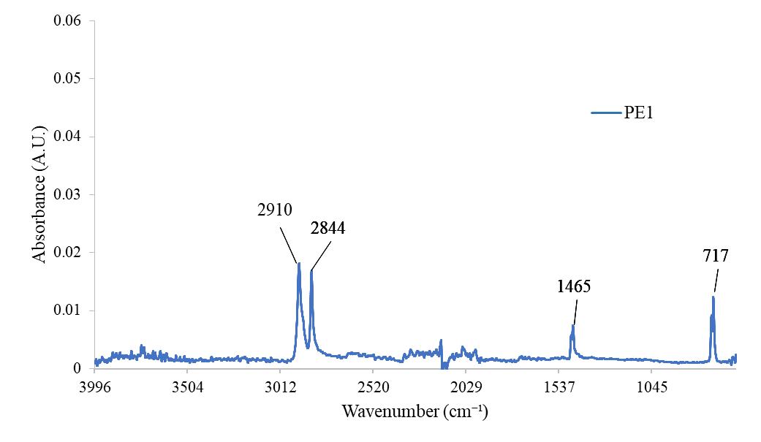
Figure 1. IR spectrum of PE1 (LDPE)

Table 1. The functional groups associated with absorption peaks identified in PE1
Absorption Peak (cm⁻¹) | Functional Group
2910 | C-CH₃
2844 | CH₂
1465 | CH₃
717 | -CH=CH-(cis)

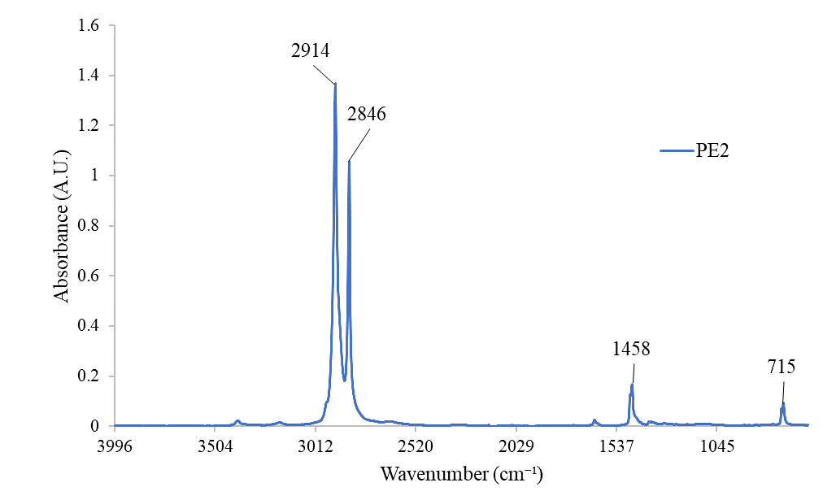
Figure 2. IR spectrum of PE2 (HDPE)

Table 2. The functional groups associated with absorption peaks identified in PE2
Absorption Peak (cm⁻¹) | Functional Group
2914 | C-CH₃
2846 | CH₂
1458 | CH₃
715 | -CH=CH-(cis)

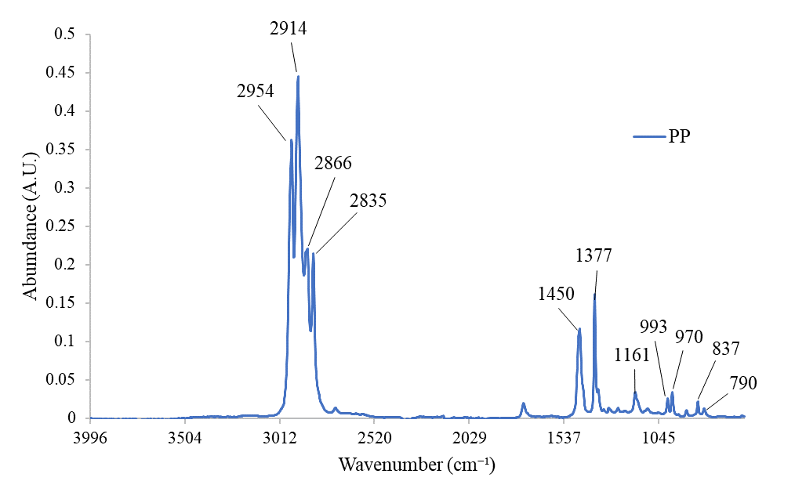
Figure 3. IR Spectrum of PP

Table 3. The functional groups associated with absorption peaks identified in PP
Absorption Peak (cm⁻¹) | Functional Group
2954 | C-CH₃
2914 | C-CH₃
2866 | CH₂
2835 | CH₂
1450 | CH₃
1377 | CH₃
1161 | Acetates
993 | -CH=CH₂
970 | -CH=CH- (trans)
837 | C=CH₂
790 | -CH=CH-(cis)

Data pre-processing and principal component analysis
Prior to applying PCA, the IR spectra of the oil samples were pre-processed using a series of pre-processing techniques previously mentioned in the pre-processing section, aiming to minimise data variation due to run-to-run variation and to overcome the dominating effect of strong peak absorbance over weaker absorbance intensity. The entire IR spectrum region from 4000-600 cm⁻¹ with 3401 variables would be the best option for performing PCA, however due to its extremely large number of variables, it limits the software’s ability to execute the principal component analysis. Since the frequency region from 4000 cm⁻¹-1501 cm⁻¹ did not carry much information as evident in Figure 4, and to overcome the limitation associated with the software, it was decided to focus only on the characteristic fingerprint region (from 1500-600 cm⁻¹). This approach was sensible as unlike the frequency region, the fingerprint region carries more useful information as evident in Figure 4 which corroborates with prior information [13,14]. Additionally, it has a much lower number of variables (901 variables), which has proven to be beneficial in reducing the computational burden of the software. Subsequently, pre-processing and PCA were performed on the fingerprint regions.

A large number of PCA score plots had been generated in this study from the pairwise combinations of specific fingerprint region with different pre-processing strategies. However, for simplicity of discussion, only PCA score plot that has generated the easiest interpretable outcome i.e. score plot of square root transformed is reported here. Figure 5 shows the PCA score plot of the square root transformed dataset plotted using the first two principal components, namely PC1 and PC2. The former PC explains 67.2% of the variation or variability in the dataset while the second PC explains 14.8% of the variation in the dataset. The combination of these two PCs hence explains 81.8% (PC1 = 67.2% + PC2 = 14.6% = 81.8%) of the variation in the dataset which means that the PCA has adequately captured relevant information within the dataset.

Close examinations of the PCA score plot reveal nine neat clusters or groupings (designated as cluster A, B, C, D, E, F, G, H and I) associated with each of the nine cooking oil samples in this study which can be divided into two hyperplanes. Cooking oil samples without plastic materials are clustered into three separate clusters, identified as cluster A (U-RCO), B (H-RCO) and C (H-RCO-B) at the lower region of the score plot. The cooking oil samples which contained or were adulterated with plastic materials only are also clustered into three clusters as shown by cluster D (RCO-PE1), E (RCO-PE2) and F (RCO-PP) at the upper region of the score plot spanning from left to the upper centre of the plot. It is particularly interesting to note that cooking oil samples containing plastic materials which were used to fry the bananas are also clustered into three separate clusters as cluster G (ARCO-B-PE1), H (ARCO-B-PE2) and I (ARCO-B-PP) at a position away from the rest of the cooking oil samples. This rather interesting finding indicates the capability of this hybrid approach for monitoring cooking oil adulterated with plastic materials which are not intended for human consumption.

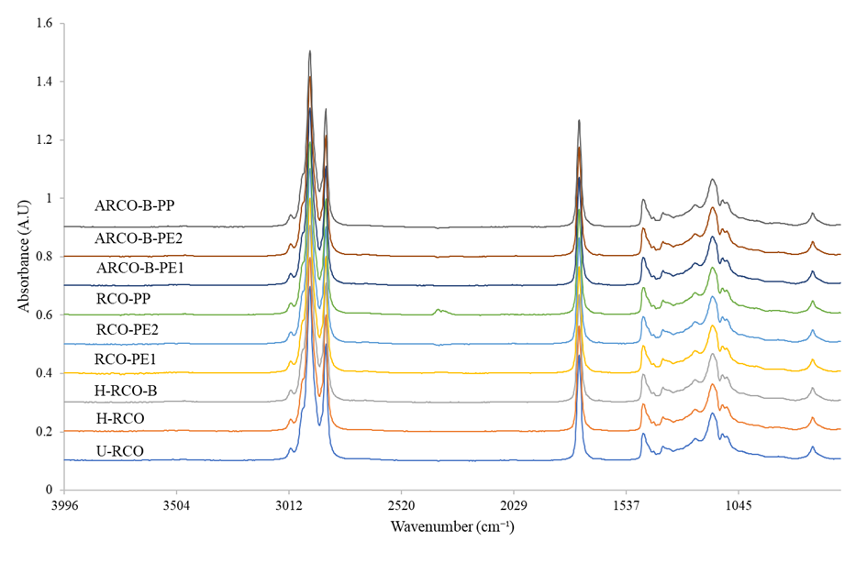
Figure 4. FTIR spectra of the cooking oil samples.

Table 4. The major peaks found in the spectra of the cooking oil samples and their corresponding functional groups [17]
Wavenumber (cm⁻¹) | Peak Assignment
3009 | C-H stretching vibration of the cis-double bond (=CH)
2960 | Symmetric and asymmetric stretching vibration shoulder of the aliphatic CH₃ group
2852, 2920 | Symmetric and asymmetric stretching vibration of the aliphatic CH₂ group
1743 | Ester carbonyl functional group of the triglycerides
1465 | Bending vibrations of the CH₂ and CH₃ aliphatic groups
1377 | Bending vibrations of CH₂ groups
1098, 1117, 1160, 1236 | Stretching vibration of the C-O ester groups
721 | Overlapping of the CH₂ rocking vibration and the out-of- plane vibration of cis-disubstituted olefins

Figure 5. PCA score plot of the square root transformed dataset for the cooking oil samples

Conclusion
ATR-FTIR spectroscopy in combination with PCA can be successfully used for initial detection and discrimination of cooking oil adulterated with inedible plastic materials. Using specific IR information, PCA was able to discriminate between unadulterated and plastic adulterated cooking oil despite the dominant effect and high degree of the chemical profile similarities of TAG against the minute amount of plastic adulterants. As this study serves as an approach to simple and fast detection of inedible plastic in cooking oil, the characterisation of adulterated compounds from such activities indeed warrants further investigation.

Acknowledgements
The authors greatly acknowledged the funding provided by the Universiti Sains Malaysia under the Short-Term Grant Scheme (304/PPSK/61313030) which has enabled this work to be conducted.

References
- Almeida, D. T., Viana, T. V., Costa, M. M., Silva, C. S. and Feitosa, S., (2019). Effects of different storage conditions on the oxidative stability of crude and refined palm oil, olein and stearin (Elaeis guineensis). Food Science and Technology, 39 (Suppl. 1): 211-217.
- Daily Express, (2014), Plastic Materials used in frying banana fritters? http://www.dailyexpress. com.my/news.cfm?NewsID=94247. [Accessed online 23 November 2020].
- Ram, P., Tapos, K., Md.Saiful, I., Mohammad, A. H., Md. Mahfuzar, R. and Mahabubur, R. M. (2018). Toxic effects of plastic on human health and environment: A consequences of health risk assessment in Bangladesh. International Journal of Health, 6(1): 1-5.
- Zuleyha, E. (2021) Melamine exposure from the weaning period causes apoptosis, inflammation and damage to the blood-brain barrier. Journal of Chemical Neuroanatomy, 113(1): 1-9.
- Yaman, N. and Velioglu, S. D. (2019). Use of attenuated total reflectance—Fourier transform infrared (ATR-FTIR) spectroscopy in combination with multivariate methods for the rapid determination of the adulteration of grape, carob and mulberry Pekmez. Foods, 8(7): 231-233.
- Smith, R. (2019), Food fraud and adulteration detection using FTIR spectroscopy, food safety tech., https://foodsafetytech.com/feature_article/ food-fraud-and-adulteration-detection-using-ftir-spectroscopy /2/ [Access online 12 November 2020].
- Meng, P., Suqin, S. and Qun, Z., (2018) a simple and portable screening method for adulterated olive oils using the hand‐held FTIR spectrometer and chemometrics tools. Journal of Food Science, 83(6): 1605-1612.
- Bingning L., Haixia W., Qiaojiao Z., Ouyang J. and Wu, Y., (2015), Rapid detection of authenticity and adulteration of walnut oil by FTIR and fluorescence spectroscopy: A comparative study. Food Chemistry, 181 (1): 25-30.
- Nurrulhidayah, A., Rohman, A., Amin, I., Shuhaimi, M., Khatib, A. (2013). Analysis of chicken fat as adulterant in butter using Fourier transform infrared spectroscopy and chemometrics. Grasas y Aceitas, 64 (4): 395-355.
- Wu, Z., Li, H. and Tu, D. (2015). Application of Fourier transform infrared (FT-IR) spectroscopy combined with chemometrics for analysis of rapeseed oil adulterated with refining and purificating waste cooking oil. Food Analytical Methods, 8(10): 2581-2587.
- Rohman, A., Che Man, Y. B., Hashim, P. and Ismail, A. (2011). FTIR spectroscopy combined with chemometrics for analysis of lard adulteration in some vegetable oils. CyTA - Journal of Food, 9(2): 96-101.
- Skoog, D. A., West, D. M, Holler, F. M. and Crouch, S. R. (2020). Fundamentals of Analytical Chemistry: 10th Ed., Saunders College Publications. Philadelphia: pp 746-759.
- Nur Farah Dina, A., Foo K. H, Naji A. M., Wan Nur Syuhaila M. D, Mohd Rahim K., Mohammad Afiq M. H., Hasmerya M. and Dzulkiflee I., (2021). Counterfeit one hundred Malaysian ringgit banknotes discrimination using chemical imaging inspection and pattern recognition. Australian Journal of Forensic Sciences, 53(3); 1-15.
- Asensio, R.C., Moya, M. S. A., Roja, J. M., and Gomez, M. (2009). Analytical characterization of polymers used in conservation and restoration by ATR-FTIR spectroscopy. Analytical and Bioanalytical Chemistry, 395(7): 2081-2096.
- Association of Official Analytical Chemists, AOAC (2019). Official Methods of Analysis., 21st edition USA: AOAC International.
- Pavia, D. L., Lampman, G. M., Kriz, G. S. and Vyvyan J. A. (2008). Introduction to spectroscopy. Cengage Learning, Stamford: pp. 31-35.
- Moinuddin S. (2011). Municipal waste plastic conversion into different category liquid hydrocarbon fuel, chemistry, emission control, radioactive pollution and indoor air quality, Nicolas Mazzeo, IntechOpen https://www.intechopen.com/ books/chemistry-emission-control-radioactive-pollution-and-indoor-air-quality/municipal-waste-plastic-conversion-into-different-category-liquid-hydrocarbon-fuel [Access online 20 February 2021].
- Lerma-García, M. J., Ramis-Ramos, G., Herrero-Martínez, J. M. and Simó-Alfonso, I. E. F. (2010). Authentication of extra virgin olive oils by Fourier-transform infrared spectroscopy. Food Chemistry, 118 (1): 78-83.
- Rohman, A. and Che Man, Y. B. (2011). The use of Fourier transform mid infrared (FT-MIR) Spectroscopy for detection and quantification of adulteration in virgin coconut oil. Food Chemistry, 129(2): 583-588.

