ELECTROCHEMICAL IMPEDIMETRIC BIOSENSOR BASED ON SILICON-ON-INSULATOR NANOGAP FOR THE DETECTION OF BANANA BLOOD DISEASE BACTERIUM

(Biosensor Impedimetrik Elektrokimia Berasaskan Silikon-Pada-Penebat Jurang Nano

untuk Pengesanan Bakteria Penyakit Darah Pisang)

Masniza Sairi^{1,*}, Khairul Anuar Shafie¹, Ahmad Syazwan Ismail², Nur Azura Mohd Said², Noor Azlina Masdor², Nur Humaira Md Salleh³, Ten Seng Teik¹, Siti Noraini Bunawan², Mohd Afendy Abdul Talib²,

Nur Sulastri Jaffar⁴, Izyani Raship⁵

¹Engineering Research Centre

²Biotechnology and Nanotechnology Research Centre

³Director General Office

⁴Horticulture Research Centre

⁵Industrial Crop Research Centre

MARDI Headquarters, Persiaran MARDI-UPM, 43400 Serdang, Selangor

*Corresponding author: masniza@mardi.gov.my

Abstract

An impedance biosensor for the detection of blood disease bacterium (BDB) in banana was developed based on a 70 nm nanogap sensor. The nanogap was fabricated using a silicon-on-insulator (SOI) wafer of 190 nm thickness Si layer supported on 350 nm thickness SiO₂ layer via photolithography, Si etching, and electron beam lithography. The sensing area underwent surface modification, antibody immobilization, and blocking agent addition, followed by BDB culture detection. Electrochemical impedance spectroscopy (EIS) analysis was used to detect various concentrations of BDB culture from 10¹ to 10⁴ CFU/mL. The working dynamic range for the nanogap sensor was 10¹–10³ CFU/mL. A limit of detection (LOD) of 6.73 CFU/mL was achieved. The nanogap sensor represents an attractive strategy for a label less immunosensor at low concentration bacteria culture detection, hence useful for plant disease management.

Keywords: blood disease bacterium, nanogap sensor, electrochemical impedance spectroscopy, limit of detection, plant disease management

Abstrak

Biosensor impedans untuk pengesanan bakteria penyakit darah (BDB) pada pisang telah dibangunkan berasaskan penderia jurang nano berjarak 70 nm. Penderia jurang nano difabrikasi menggunakan substrat silikon-pada-penebat (SOI) pada lapisan Si berketebalan 190 nm yang disokong oleh lapisan SiO₂ 350 nm melalui proses fotolitografi, goresan Si, dan litografi pancaran elektron. Kawasan penderiaan menjalani pengubahsuaian permukaan, pengikatan antibodi, dan penambahan agen penghalang, diikuti dengan pengesanan kultur BDB. Analisis spektroskopi impedans elektrokimia (EIS) digunakan untuk mengesan kepekatan kultur BDB yang berbeza dari 10¹ hingga 10⁴ CFU/mL. Julat dinamik berfungsi untuk penderia jurang nano adalah 10¹ hingga 10³ CFU/mL. Had pengesanan (LOD) dicapai pada 6.73 CFU/mL. Penderia jurang nano menunjukkan potensi untuk pengesanan kultur bakteria sensor immuno tanpa label pada kepekatan rendah yang berguna untuk pengurusan penyakit tumbuhan.

Kata kunci: bakteria penyakit darah, penderia jurang nano, spektroskopi impedans elektrokimia, had pengesanan, pengurusan penyakit tumbuhan

Introduction

Banana blood disease is a type of wilting disease affecting banana plants in countries such as India, Indonesia, the Philippines, and Malaysia. This disease is one of the most severe diseases in the banana growth sector that spreads widely and halts banana plant growth, resulting in critical yield losses. Blood disease, in particular, is caused by the blood disease bacterium (BDB), previously known as Pseudomonas celebensis, which demonstrates comparable symptoms as Moko disease [1,2]. The blood disease spreads widely across the tropical and subtropical regions through pollination insects, contaminated soil environment, and planting equipment. The symptoms started with the color of young leaves that changes from green to yellow or brown, followed by wilting. Other symptoms are smelly bacterial slime presence, vascular discoloration, bacterial ooze, and reddish-brown fruit rot [2-4]. The disease suppresses banana production globally, in which the loss can be within 10-93%, depending on the infection severity [3]. Thus, efforts to suppress pathogenic bacteria development are essential.

Biosensor technology has been reported in disease diagnostics, drug detection, and food quality control [5]; recently, the technology has been applied in plant disease detection [6]. Detection via biosensors can eliminate or simplify sample preparation steps and detect a broad spectrum of analytes in complex sample matrices. An electrochemical biosensor is favored among other classes of biosensors (e.g., optical and piezoelectric sensors) due to its low cost, ease of use, portability, and simplicity of construction [5-7]. The principle of electrochemical biosensor lies in the coupling of the bioreceptors on a transducer (i.e., electrode) with its specific analytes that convert the binding event to a signal that can be analyzed [8].

An antibody-based biosensor or immunosensor is one of the tools of interest in biosensing and it is remarked to hold great potential for agricultural plant pathogen detection as the biosensor enables pathogen detection in air, water, and seeds with on-site application [9]. Antibody-based electrochemical biosensors can be performed by amperometric, potentiometric, impedimetric, or conductometric techniques. The capability of electrochemical antibody-based biosensors to detect plant pathogens has been reported for tungro virus in rice [10], cucumber mosaic virus [11], rice bacterial leaf streak [12], and citrus bacterial canker [13]. However, most of these detection methods employed amperometric measurement that requires indirect detection format using labeled antibodies. With this regard, electrochemical impedance spectroscopy (EIS) has great advantages in probing detection at the molecular level where it requires no label, thus offering direct detection of the target analyte [14].

The impedance of an interface is usually determined by applying a sinusoidal voltage perturbation while measuring the current response [15, 16]. The impedance or EIS data can be represented and analyzed using various techniques, such as the Bode and Nyquist plots [17, 18]. The Bode plot represents the impedance magnitude |Z| (log scale) versus frequency, f (log scale) of how resistive the system to current flow at the applied frequency. On the other hand, the Nyquist plot represents the out-of-phase or imaginary component (Z_{j}) versus the in-of-phase or real component (Z_{r}) contribution to impedance (both in log scales) and the relationship at varying frequencies. In the Nyquist plot, the highest frequency data points are located at lower impedances and vice versa. Since the Nyquist plot masks the impedance dependence on frequency, the Bode plot serves as an alternative approach [5, 17, 19].

This research project investigates the electrochemical behavior of BDB culture with varying concentrations at the fabricated nanogap sensors. Quantitative methods involving the detection of BDB culture using EIS are presented.

Materials and Methods

Reagents

All reagents were used without further purification unless stated otherwise. 2% (3-aminopropyl)triethoxysilane (APTES), 0.4 M 1-ethyl-3-(3-dimethylaminopropyl)carbodiimide (EDC), and 0.1 M N-hydroxysuccinimide (NHS) were purchased from Sigma Aldrich Pty. Ltd., Germany and Japan. 0.1 M sodium carbonate bicarbonate (carbonate buffer) was purchased from Merck & Co., Inc., Germany. 0.01 mg/mL antibody blood disease bacterium (Ab BDB) was produced at the Animal House, MARDI, Malaysia. Phosphate buffered saline (PBS) solution (pH 7.0, 0.01 M) was prepared by dissolving a PBS tablet in 200 mL of deionized water. All solutions were prepared in deionized water from a Sartorius Arium ® Pro water purification system (Sartorius, Germany).

Fabrication of nanogap sensors

The nanogap sensors used in this study, as depicted in Figure 1(a), were fabricated at the Department of Mechanical Engineering and Institute of Nanotechnology, Southern Taiwan University of Science and Technology, Tainan, Taiwan. The substrate used in the fabrication was a 6-inch p-type silicon-on-insulator (SOI) wafer with 190 nm thickness Si layer supported on 350 nm thickness buried oxide layer. The SOI wafer was selected to reduce the device parasitic element and improve the final performance with higher sensitivity [20]. The 70 nm gap sensors with gold electrodes were fabricated via photolithography, Cr and Au deposition, and Si etching. The depth-to-width ratio of the etching was set to 1:2 (gap: thickness). The fabricated nanogap sensors were randomly sampled and measured the EIS values using a Precision Impedance Analyzer WK 6500B (Wayne Kerr Electronics, UK) for failure testing (electrical characterization to study the potential and stability of the fabricated nanogap sensors).

Prior to detection procedures, the nanogap sensors were plasma-cleaned with Plasma Cleaner PDC-32G-2 (Harrick Plasma, USA) and dried in air to remove any unwanted contamination and particles on the sensing surface area. All experiments were conducted at room temperature (20 °C).

Bacteria culture preparation

BDB was isolated from a diseased banana plant by the Horticultural Research Centre, MARDI. Next, the bacterium was grown in media culture. For sensor study, the BDB was used as antigen at varying concentrations (10⁰, 10¹, 10², 10³, and 10⁴ CFU/mL) using a serial dilution procedure.

Polyclonal antibody production

Polyclonal antibody against BDB was produced via in-vivo immunization in two New Zealand White breed rabbits with the bacteria based on the guidelines by Leenaars and Hendriksen [21]. Prior to the first injection, a batch of blood was collected by bleeding the central auricular artery on the rabbit's ear into a sterilized vacutainer tube (BD Vacutainer System) and this pre-immune blood was assigned as control. Both booster injections and bleeding activities were alternately performed every fortnight until the highest activity of the antibody was achieved. The antibody production protocol was reviewed and approved by the Animal Ethics Committee of Malaysian Agricultural Research and Development Institute, Malaysia (Approval number 20170717/R/MAEC00015).

Electrochemical procedure

A two-electrode electrochemical cell (set up) was employed in this study (Figure 1(b)). A four-point probe sample board, model Ecopia SPCB-1 (Aseptec Sdn. Bhd., Malaysia) was used to hold the nanogap sensor in place. The sample board has a gold-plated spring-loaded cell with good Ohmic contact and can mount a board with 2 mm thickness and up to 20 mm on one side. For this setup, only a two-point probe was used for impedance measurement.

Following the assembly of the electrochemical cell (set up), EIS was performed using a Metrohm Autolab PGSTAT 20 (Eco Chemie, The Netherlands) expanded with a frequency response analysis module for EIS, interfaced to a computer, running the Nova 1.10 software package supplied with the instrument. EIS was conducted at the frequencies between 0.1 and 100,000 Hz, where the values are distributed logarithmically through the range. The root mean square (RMS) amplitude of the applied potential was 50 mV. A quiet time of 5 s at the start of each scan was implemented to stabilize and minimize the background charging current. The initial potential for EIS was first determined by the open circuit potential (OCP) procedure. All measurements were performed in triplicate. The electrochemical cell (set up) was housed in a Faraday cage for the duration of the experiment to minimize electrical noise.

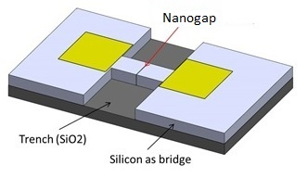 | (a) | 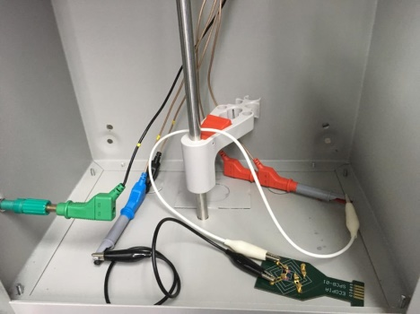 | (b)

Figure 1. (a) Nanogap sensor design and (b) experimental set-up

Detection procedure

Bare nanogap sensors were first characterized electrochemically via EIS. The sensing area underwent surface modification through incubation with 2% APTES for 1 hour at room temperature and then cleaned with deionized water and blew dry. Next, the sensing area was immobilized with 1 mg/mL polyclonal antibody against BDB coupled with EDC and NHS for 1 hour, and then cleaned with PBS solution and rinsed with deionized water. Finally, BDB culture as the antigen was incubated for 1 hour on the sensing area before EIS measurement.

Results and Discussion

Nanogap sensors characterisation

Nine randomized fabricated nanogap sensors were sampled and measured the impedance spectra. The nanogap sensors demonstrated repeatable and stable impedance values with an average of 30.73 ± 0.78 kΩ at 10.65 kHz (Table 1).

Table 1. Impedance values at the frequency of 10.65 kHz
Sensor | Impedance (kΩ)
1 | 30.91
2 | 30.08
3 | 29.63
4 | 31.01
5 | 30.41
6 | 32.32
7 | 30.36
8 | 31.26
9 | 30.58
Average | 30.73
Std. Dev. | 0.78

Impedimetric BDB detection

A simplified schematic diagram for EIS analysis of an electrode/electrolyte interface is illustrated in Figure 2. The electrified interface can be modeled by an equivalent circuit known as the Randles circuit. When a potential difference is applied across the interface, the electrical double layer is developed, which is composed of the electrical charge at the electrode surface and the charge of distributed ions in the solution in the immediate vicinity of the electrode. This double layer is equivalent to that of a double-layer capacitor with a capacitance of C_{dl}. The electrolyte side of the double layer is assumed to be made up of several distinct layers, mainly the inner Helmholtz plane (IHP) and the outer Helmholtz plane (OHP) [17, 22].

The electrons transfer to/from the electroactive species by overcoming the activation barrier or polarization resistance, R_{p} and electrolyte solution resistance, R_{s}. The Warburg impedance, Z_{w} is resulted by the diffusion from the bulk electrolyte to the electrode, while the charge transfer resistance, R_{ct} (R_{p} at an equilibrium potential) demonstrates the charge transfer-limited process [23]. The interfacial electron transfer kinetics is affected by the distribution of bacterial cells between the electrodes, which increase or decrease electron transfer conductivity in the electrolyte environment [23].

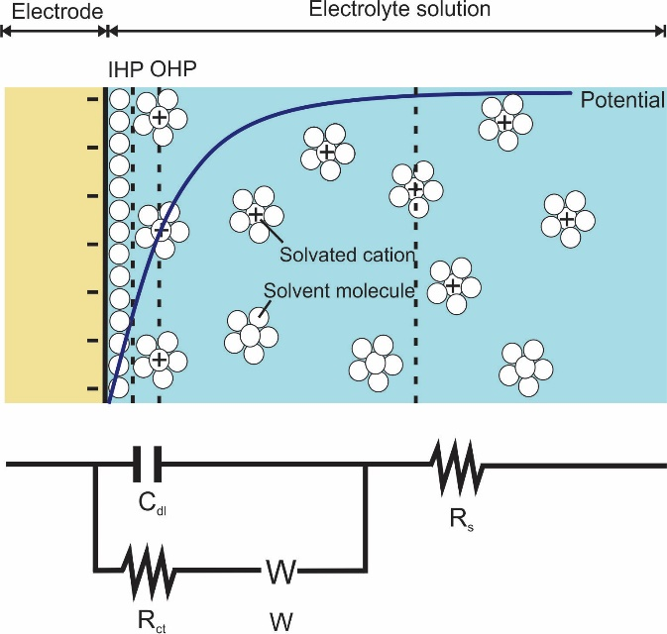

Figure 2. The simplified schematic diagram for EIS analysis of an electrode/electrolyte interface

(adapted from [24])

The variation of the impedance spectra of the functionalized nanogap sensor with a fixed concentration of immobilized antibody (0.01 mg/mL) at varying concentrations of BDB culture (from 10¹ to 10⁴ CFU/mL) was studied (Figure 3). The surface saturation could be obtained with 0.01 mg/mL of antibody concentration, which was determined prior to the saturation concentration of the antibody in the nanogap sensor study (data not shown). The selection of the antibody saturation concentration is important for high sensitivity detection [5].

It was observed that the semicircle diameter (of the Nyquist plot) increased accordingly with BDB concentration from 10⁰ to 10³ CFU/mL on the sensing surface area. This is likely due to many BDB molecules bound to immobilized antibody, which acts as a definite barrier for the charge transfer between the electrodes. However, the semicircle decreased at the concentration of 10⁴ CFU/mL, indicating that the hybridization process between the antibody and BDB culture approached saturation (Figure 3(a)).

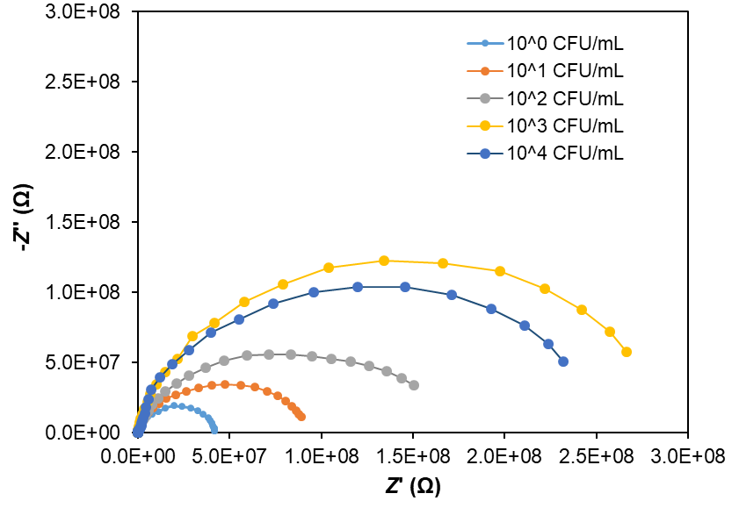
(a)

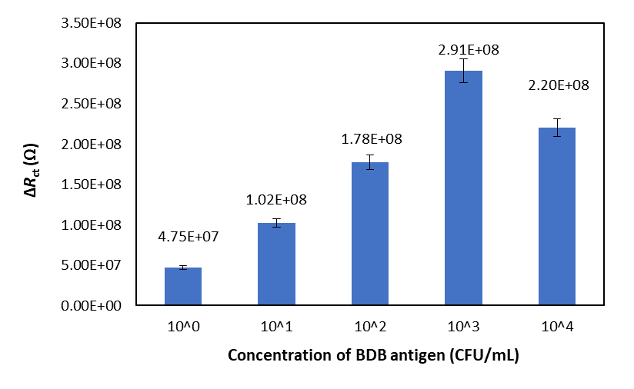
(b)

Figure 3. (a) The Nyquist plot for BDB culture detection and (b) the charge transfer resistance (ΔR_{ct}) calculated from the Nyquist plot semicircles using a nanogap sensor with 0.01 mg/mL antibody at varying concentrations of BDB culture

At low and high frequencies in the Nyquist plot, bacteria sensing is mass transfer controlled and kinetics controlled, respectively. In the kinetics-controlled region (high frequency), the semicircle diameter indicates the R_{ct} [23]. The R_{ct} is the most applied parameter to estimate bacterial concentration; when bacterial cells bind to the target bioreceptors at the working electrode, WE surface, the redox reaction is hindered and R_{ct} increases [16]. In this research, the ΔR_{ct} increased from 10¹ to 10³ CFU/mL and then decreased (Figure 3(b)). The linear relationship between ΔR_{ct} responses and BDB culture concentration ($∆R_{ct} \left(Ω\right)=8×{10}^{7}x-5×{10}^{7}$; R² = 0.97) demonstrated the working dynamic range for the nanogap sensor of 10¹ – 10³ CFU/mL (Figure 4). The R_{ct} increased as the bacteria (Escherichia coli, E. coli) concentration increased, as reported previously [25]. In this case, the higher content of E. coli cells is linked to the interface, generating a higher content of blocking to the electron transfer of the redox probe. The research group reported a linear response in the electron transfer resistance for the concentration of E. coli between 6 × 10⁴ and 6 × 10⁷ cells/mL [25].

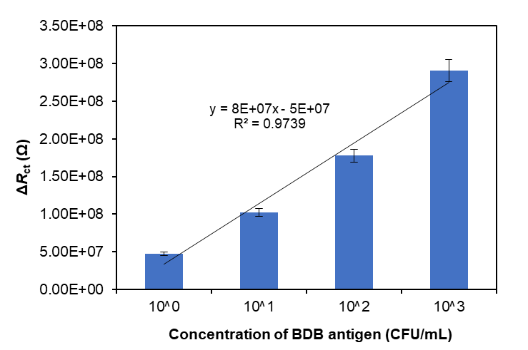

Figure 4. Working dynamic range for nanogap sensor

On the other hand, the limit of detection (LOD) is the BDB culture concentration that induces a signal variation (in this case, impedance response). The LOD of the nanogap sensor was calculated to be 6.73 CFU/mL, which is sufficiently low for bacterial culture detection. The LOD of 10 bacterial cells/mL has been reported for a microfluidic chip implementing the EIS method to detect E. coli in field water [23]. An immunobiosensor chip has reported the LOD of 6 × 10³ cells/mL in the detection of E. coli O157:H7 using EIS [25]. Furthermore, a label-free impedance immunosensor based on microfluidic technology has reported the LOD of 3 × 10³ CFU/mL to detect Salmonella typhimurium [16, 26]. The results achieved in this research demonstrated the fabricated impedance nanosensor with antibody-antigen binding that offers attractive future potential for BDB detection in real samples with better sensitivity.

Conclusion

The electrochemical behavior of BDB culture with various concentrations from 10¹ to 10⁴ CFU/mL at the fabricated nanogap sensors was investigated. The results showed that the BDB culture could be detected via EIS with the working dynamic range of 10¹–10³ CFU/mL. The LOD was calculated to be 6.73 CFU/mL, which is suitable for applications of bacteria detection in real samples. In the future, studies on the optimization of detection time, the matrix effect in a real sample, cross-reaction with other plant disease bacteria, nanogap sensors stability, and prediction models are suggested.

Acknowledgment

This research was supported by the Malaysian Agricultural Research and Development Institute (MARDI) via the 11th Malaysian Development Plan Fund (P-RH405-1001). The authors would like to express utmost gratitude to the Biotechnology and Nanotechnology Research Centre and Engineering Research Centre at MARDI for the use of facilities for the research. The gratitude is also extended to Southern Taiwan University of Science and Technology, Taiwan for the nanogap sensors fabrication.

References

- Fegan, M. and Prior, P. (2006). Diverse members of the ralstonia solanacearum species complex cause bacterial wilts of banana. Australasian Plant Pathology, 35(2): 93-101.
- Teng, S.-K., Abd Aziz, N. A., Mustafa, M., Laboh, R., Ismail, I. S., Sulaiman, S. R., Azizan, A. A. and Devi, S. (2016). The occurrence of blood disease of banana in Selangor, Malaysia. International Journal of Agriculture & Biology, 18: 92-97.
- Latupeirissa, Y., Nawangsih, A. A. and Mutaqin, K. H. (2014). Selection and identification of bacteria from tongkat langit banana (Musa troglodytarun L.) to control the blood disease bacteria. Journal of the International Society for Southeast Asian Agricultural Sciences, 20(2): 110-120.
- Teng, S.-K., Abd Aziz, N. A., Mustafa, M., Laboh, R., Ismail, I. S. and Devi, S. (2016). In-vitro study on the effect of endogeic earthworm on blood disease bacterium (BDB) in banana - a preliminary observation. The Asia Journal of Applied Microbiology, 3(1): 1-11.
- Adnane, A. (2011). Electrochemical biosensors for virus detection. In P. A. Serra (Ed.), Biosensors for Health, Environment and Biosecurity. IntechOpen, London: pp. 321-330.
- Fang, Y. and Ramasamy, R. P. (2015). Current and prospective methods for plant disease detection. Biosensors, 5(3): 537-561.
- Maalouf, R., Fournier-Wirth, C., Coste, J., Chebib, H., Saïkali, Y., Vittori, O., Errachid, A., Cloarec, J.-P., Martelet, C. and Jaffrezic-Renault, N. (2007). Label-Free detection of bacteria by electrochemical impedance spectroscopy: Comparison to surface plasmon resonance. Analytical Chemistry, 79(13): 4879-4886.
- Silvestrini, M., Habtamu, H. B., Moretto, L. M. and Ugo, P. (2014). Electrochemical biosensors for sensitive molecular diagnostics. Proceedings of the Cross-Border Italy-Slovenia Biomedical Research, 2014: 184-190.
- Skottrup, P. D., Nicolaisen, M. and Justesen, A. F. (2008). Towards on-site pathogen detection using antibody-based sensors. Biosensors and Bioelectronics, 24(3): 339-348.
- Muhammad Nur Aiman, U., Tijjani, A., Hasfalina, C. M., Faridah, S., Zamri, I., Uda, H. and Shahrul, A. B. A. (2014). Reviewed immunosensor format using nanomaterial for tungro virus detection. Advanced Materials Research, 832: 410-414.
- Rafidah, A. R., Faridah, S., Shahrul, A. A., Mazidah, M. and Zamri, I. (2016). Chronoamperometry measurement for rapid cucumber mosaic virus detection in plants. Procedia Chemistry, 20: 25-28.
- Hazana, R., Nur Azura, M. S. and Faridah, S. (2019). Immunosensor development for the detection of Xanthomonas oryzae pv. oryzicola in rice bacterial leaf streak. Transactions of the Malaysian Society of Plant Physiology, 26: 315-320.
- Haji-Hashemi, H., Norouzi, P., Safarnejad, M. R., Larijani, B., Habibi, M. M., Raeisi, H. and Ganjali, M. R. (2018). Sensitive electrochemical immunosensor for citrus bacterial canker disease detection using fast Fourier transformation square-wave voltammetry method. Journal of Electroanalytical Chemistry, 820: 111-117.
- Lisdat, F. and Schäfer, D. (2008). The use of electrochemical impedance spectroscopy for biosensing. Analytical and Bioanalytical Chemistry, 391: 1555-1567.
- Santos, A., Davis, J. J. and Bueno, P. R. (2014). Fundamentals and applications of impedimetric and redox capacitive biosensors. Journal of Analytical & Bioanalytical Techniques, 7(16): 1-15.
- Grossi, M. and Riccò, B. (2017). Electrical impedance spectroscopy (EIS) for biological analysis and food characterization: A review. Journal of Sensors and Sensor Systems, 6: 303-325.
- Bard, A. J. and Faulkner, L. R. (2001). Electrochemical methods: Fundamentals and applications. John Wiley and Sons Inc., New York: pp. 833.
- Mitchell, R. A. (2012). Electrical properties of nano-scale liquid/liquid interfaces contained at arrays of solid state nano-pores. Honours Thesis, Curtin University.
- Orazem, M. E. and Tribollet, B. (2008). Electrochemical impedance spectroscopy. John Wiley and Sons Inc., New Jersey: pp. 523.
- Usenko, A. Y. and Carr, W. N. (1999). Silicon-on-insulator technology for microelectromechanical applications. Semiconductor Physics Quantum Electronics and Optoelectronics, 1(1): 93-97.
- Leenaars, M. and Hendriksen, C. F. M. (2005). Critical steps in the production of polyclonal and monoclonal antibodies: Evaluation and recommendations. ILAR Journal, 46(3): 269-279.
- Zoski, C. G. (2007). Handbook of electrochemistry. Elsevier B.V., The Netherlands: pp. 892.
- Jiang, J., Wang, X., Chao, R., Ren, Y., Hu, C., Xu, Z. and Liu, G. L. (2014). Smartphone based portable bacteria pre-concentrating microfluidic sensor and impedance sensing system. Sensors and Actuators B: Chemical, 193: 653-659.
- Park, S.-M. and Yoo, J.-S. (2003). Electrochemical impedance spectroscopy for better electrochemical measurements. Analytical Chemistry, 75(21): 455-461.
- Ruan, C., Yang, L. and Li, Y. (2002). Immunobiosensor chips for detection of Escherichia coli O157: H7 using electrochemical impedance spectroscopy. Analytical Chemistry, 74(18): 4814-4820.
- Ghosh Dastider, S., Barizuddin, S., Yuksek, N. S., Dweik, M. and Almasri, M. F. (2015). Efficient and rapid detection of salmonella using microfluidic impedance based sensing. Journal of Sensors, 2015: 1-8.

