
VOLTAMMETRIC TECHNIQUE FOR DETERMINATION OF ARSENIC RESIDUES IN CALCIUM CARBIDE RIPENED CLIMACTERIC FRUITS

(Teknik Voltammetrik bagi Penentuan Sisa Arsenik dalam Pematangan Buah Klimakterik Menggunakan Kalsium Karbida)

Nurasmat Mohd Shukri¹, Noor Zuhartini Md Muslim¹*, Nur Fazeera Kamal¹, Faizuan Abdullah²

¹School of Health Sciences,
Universiti Sains Malaysia, 16150 Kubang Kerian, Kelantan, Malaysia
²Department of Chemistry, Faculty of Science,
Universiti Teknologi Malaysia, 81310 Johor Bahru, Malaysia

*Corresponding author: zuhartini@usm.my

Received: 13 December 2020; Accepted: 9 February 2021; Published: 25 April 2021

Abstract
Calcium carbide (CaC₂) often being used as one of the fruit ripening agents due to cheaper cost and readily available in the market. However, it is not recommended to use CaC₂ in Malaysia, because the arsenic (As) residues which present as impurities in this fruit ripening agents can cause serious adverse effect to human consumption. Voltammetric measurement using a gold electrode in acidic medium (2 M HCl) was developed to determine the As residues in the fruit samples. This technique observed the electrochemical behaviour and quantitative analysis of the As(V) species at the gold electrode. It was found that As(V) undergone irreversible oxidation process at the gold electrode. The working parameters validated for differential pulse anodic stripping voltammetry (DPASV) were E_{i} = -0.20 V, E_{f} = +0.30 V, v = 0.02 V/s, E_{acc1} = -1.10 V, t_{acc1} = 120 s, E_{acc2} = +0.04V, t_{acc2} = 10 s and pulse amplitude = 0.05 V which produced peak potential at +0.10 V. The LOD and LOQ using statistical method were 1.3 ppb and 4 ppb, respectively. While by visual observation were 0.7 ppb and 2 ppb, respectively. The method successfully applied for the estimation of As residue in fruit ripening that was used CaC₂ as a ripening agent and also As(V) in fruits bought from local market. Therefore, the developed voltammetry method can be a great potential instrument to measure As(V) in fruit sample.

Keywords: differential pulse anodic stripping voltammetry, gold electrode, arsenic, calcium carbide, climacteric fruits

Abstrak

Kalsium karbida (CaC₂) sering digunakan sebagai salah satu agen pematangan buah kerana harganya yang lebih murah dan mudah didapati di pasaran. Walau bagaimanapun, tidak digalakkan menggunakan CaC₂ di Malaysia, kerana sisa arsenik (As) yang hadir sebagai kekotoran pada agen pematangan buah ini boleh menyebabkan kesan buruk yang serius terhadap penggunaan manusia. Pengukuran voltammetrik menggunakan elektrod emas dalam medium berasid (2 M HCl) dikembangkan untuk menentukan sisa As dalam sampel buah. Teknik ini memerhatikan tingkah laku elektrokimia analisis kuantitatif spesies As(V) pada elektrod emas. Didapati bahawa As(V) menjalani proses pengoksidaan yang tidak berbalik pada elektrod emas. Parameter kerja yang disahkan untuk voltammetri denyut pembeza pelucutan anodik (DPASV) adalah E_{i} = -0.20 V, E_{f} = +0.30 V, v = 0.02 V/s, E_{acc1} = -1.10 V, t_{acc1} = 120 s, E_{acc2} = +0.04V, t_{acc2} = 10 s dan nadi amplitud = 0.05 V yang menghasilkan potensi puncak pada +0.10 V. LOD dan LOQ menggunakan kaedah statistik masing-masing adalah 1.3 ppb dan 4 ppb, sementara dengan pemerhatian visual masing-masing 0.7 ppb dan 2 ppb. Kaedah ini berjaya digunakan untuk perkiraan sisa As dalam pematangan buah yang mengunakan CaC₂ sebagai agen pematangan dan As(V) pada buah-buahan yang dibeli di pasar tempatan. Oleh itu, kaedah voltammetri yang dikembangkan dapat menjadi instrumen berpotensi besar untuk mengukur As(V) dalam sampel buah.

Kata kunci: voltammetri denyut pembeza pelucutan anodik, elektrod emas, arsenik, kalsium karbida, buah klimaterik

Introduction
The ripening of fruits after storage has shown many commercial advantages since it effectively lengthens the season fruits may be kept without the need to undergo canning processes [1]. Fruits generally store better if they are picked before they are mature. The ripening process will soften the cell wall substances and digest the starch and other constituents of the fruit, making the ripe fruit subject to bruising and effective medium for fungal growth [2]. The transportation of the unripe fruit can be handled easier as fruits that are green and firmer so the injury can be reduced as compared to ripe fruits [3].

According to Prasanna et al. [3], ripe fruit cannot be kept as well as green fruits due to the digestion and chemical transformation occurred at a high rate in ripe fruits. Thus, unripe fruits are preferable to be stored as to lengthen the period of availability and get to regulate the supply in the market. Therefore, the use of artificial fruit ripening agents has become prevalent mostly due to the commercial purposes of unripen fruit. Artificial ripening agent is used for fruits supply in the market to make it available for the customer during off-season [1].

Nowadays, several artificial ripening agents are available and used, such as calcium carbide, ethylene gas, carbon monoxide, potassium sulphate, ethephon, potassium dihydrogen orthophosphate, putrisein, oxytocin and protoporphyrinogen [4]. They are used during pre-harvest, post-harvest, transportation, capping and storage [4]. They accelerate fruits for ripening and inducing colour changes in unripe fruits. However, artificial fruit ripening is considered as a matter of concern because of various health-related issues [5]. There are direct and indirect health hazards associated with artificial ripening agents and their impurities.

One of the artificial ripeners that are far more concerned in this research is calcium carbide (CaC₂). Calcium carbide is a chemical compound which is used in the production of acetylene and calcium cyanamide [6]. It is also produced industrially in an electric arc furnace from a mixture of lime and coke at an extreme temperature which generally had around 80% of CaC₂ by weight [7].

Calcium carbide has been used extensively in Asian countries for fruits ripening [8]. The extensive use of this chemical is due to its low price and availability [5]. In Malaysia, for example, it can easily purchase from rural shops for RM5.50/kg [9]. The dose recommended for CaC₂ to be applied onto fruits is about 0.3-10 g for each kilogram of yields [8]. However, not all farmers obey to this recommended level because of the higher amount of CaC₂ is required to wholly ripened the fruits.

The CaC₂ content of the product is assessed by measuring the amount of acetylene produced during hydrolysis. Calcium carbide not only changed the skin colour of the fruits, but it also initiates the enzymatic action that breaks down the glucose resulting in a quick ripening of the fruits [10]. Use of CaC₂ sometimes gives ripening colour to raw fruit. It also increases the shelf life and maintains the ripened colour [10].

Calcium carbide leave behind residues of heavy metals like arsenic (As) and phosphorus on the fruit surface, which are potentially carcinogenic. Arsine gas released from CaC₂ combines with oxygen and other elements to form inorganic arsenic compounds [11]. As a rule, inorganic arsenic exhibit more significant toxicity than organic arsenicals. Intentional or unintentional ingestion of As can lead to serious health issues or sometimes can be vital. Since the commercial CaC₂ contains As and phosphorus as impurities, concurrently the detected As residues in the ripened fruits can be used as a tool to identify fruits ripened by using carbide gas. However, it
is not recommended to used CaC₂ in Malaysia as this artificial ripening agent can cause severe adverse effect to human consumption. Some of the imported artificial ripened fruit went through the border of Malaysia and sold to the local market. The information on the detection and determination of As residue in CaC₂ ripened fruit can therefore serve as an indicator for the presence of CaC₂ used in artificial fruit ripening in the local market.

Thus, the present study is carried out to detect the As residues from the CaC₂ ripened fruits using voltammetry of the electrochemical technique. The use of electrochemical techniques is of considerable importance in analytical techniques due to their high degree of sensitivity, accuracy, precision, and selectivity as well as large linear dynamic range, with relatively low-cost instrumentation [12, 13]. The stripping voltammetry technique involves two main steps. The first step is a controlled potential electrolysis enough to deposit the analyte on the electrode. The second step consists of the application of a voltage scan to the electrode that causes an electrolytic dissolution [14]. The observation from this study can be used as an indicator that the local or imported fruit trader has utilized the CaC₂ for their fruits ripening. The result from this study is compared with the limit of total arsenic proposed by Food Regulations of 1985 and FDA/WHO which is not more than one ppm.

Materials and Methods

Apparatus, materials and reagent

A VA 797 Computrace Metrohm Voltammetric Analyser interfaced with multi-mode electrode stand model 663 VA (Metrohm) was used for all voltammetric measurements, composed of a stationary gold working electrode, an Ag/AgCl (KCl 3 M) as a reference electrode, platinum as the auxiliary electrode, a purge tube for purging (nitrogen) and stirring the solution during the deposition step. The software used to control the whole system, and the acquisition and processing of the data was VA Computrace software (Metrohm) installed in a computer.

Reagents were of pro-analysis grade (Merck or R&M chemicals) and deionized water (18.2 MΩ cm resistivity) by Sartorius Atrium pro DI ultrapure water system. All the glassware’s were cleaned by soaking in 10% nitric acid (HNO₃) and rinsed thoroughly using deionized water prior to use. 0.1 M of sodium hydroxide (NaOH) solution was prepared by dissolving 40 mg of NaOH pellet with deionized water. 0.5 M sulphuric acid (H₂SO₄) was prepared from H₂SO₄ solution diluted with deionized water. 3 mL of concentrated HCl (37% w/w) added with deionized water into 10 mL of the volumetric flask to get a total concentration of 2 M HCl.

The 1000 ppm As(V) stock solution was commercially available and bought from Agilent technologies. The solution was stored at room temperature. The required working and standard solutions of 10 ppm, 1 ppm, and 50 ppb of As(V) were prepared daily by diluting the stock solutions with deionized water.

Voltammetric techniques: Electrode pre-treatment
The electrode must be kept in 0.1 M NaOH when not in used or at least 30 minutes for cleaning purposes. Then, it was rinsed thoroughly with ethanol and deionized water alternatively and electrochemically activated. The gold electrode must be electrochemically conditioned in order to obtain reproducible curves for each determination. This step should be done every day before starting the measurements and when the background current varies enormously from measurement to measurement.

The electrochemical activation of the electrode surface carried out by cyclic voltammetry with 0.5 M H₂SO₄ as supporting electrolyte. The electrode was polarized between 0 to +1.5 V at 0.1 V/s by applying 10 cycles. Linear potential sweep CV was performed daily to monitor the electrode surface electrochemical activation, and this conditioning must be performed several times if the background was still not consistent yet.

Electrochemical behaviour of As
The electrochemical behaviour of As was studied using cyclic voltammetry experiment in an electrochemical cell to ascertain the peak potential for As element in the fruit sample. 0.4 mL of 1 ppm of As(V) standard solution was spiked using micropipette into a voltammetric cell with supporting electrolyte, 2 M of HCl. The resulting concentration of the stock solution in the cell was 20 ppb of As(V) standard. The CV was performed by scanning from anodic direction and then switched to the cathodic direction. The instrument parameters used for the analysis of arsenic were sweep rate of 0.1 V/s with initial purge time of 200 s, start potential and second vertex potential, +0.5 V, switch potential or first vertex potential, -0.3 V at voltage step of 0.018 V.

Determination of As(V) by differential pulse anodic stripping voltammetry
All solutions (samples and standards) were prepared to a final volume of 20 mL, starting the analysis with the blank solution. The blank corresponded to 2 M HCl and was purged for two minutes with nitrogen gas. The determination was carried out in 10 mL of sample or standards added with 3 mL of concentrated HCl dilute to 10 mL total volume to obtain 2 M HCl in the solution.

In the validation of the chemical conditions, the standard addition method was employed for the determination of As(V). The aliquots of the reagents or known concentration of standards were spiked manually to the blank in the cell and purge of two minutes was used. Each scan has undergone triplicate measurement to ensure that the peak current was constant.

The DPASV procedure was employed by starting the determination of As(V) standard with the purging of the solution with purified nitrogen gas for 300 s to avoid contamination with oxygen. The electrode was pre-treated with cleaning potential of -1.10 V for 120 s and deposition potential at +0.04 V for 10 s, with an equilibration time of 5 s after stirring. The gold electrode scanned in the anodic direction from -0.2 V to +0.3 V with differential pulses at a speed rate of 0.02 V/s, a potential step of 6 mV and an amplitude of 50 mV. The working method parameters were adjusted from recommended parameters given in the operating instruction manual of the instrument or application bulletin 226/2e [15].

Validation
In order to confirm if the method was suitable for this analysis, a validation was required for observing the overall performances of the developed method. Different validation methods were employed to ensure that the results obtained were accurate and reliable for the intended use. The validation method involved precision, linearity range response, the limit of detection (LOD), the limit of quantification (LOQ) and the accuracy [16].

The precision and sensitivity of the instrument responses were evaluated from six independent measurements of As(V) standard. 20 mL of 2 M HCl were analyzed before and after five additions of 0.4 mL of 50 ppb As(V) standard solution. The precision was calculated as the relative standard deviation (RSD) of the total of six measurements for each addition. The linear range of response was examined based on calibration curves exploring a range of As(V) concentrations between 1 to 5 ppb.

LOD and LOQ were determined for analyte concentration giving a signal to the blank solution, yB, plus three or ten standard deviations of the blank, respectively [17]. In addition to the statistical methods for accessing LOD and LOQ, another practical approach on determining the LOD and LOQ of the ASV method was through visual evaluation of the produced output. This method involved by diluting 4 ppb initial concentration of As(V) with 1.7 mL of 2 M HCl (supporting electrolyte) until the minimum detectable level. In contrast, LOQ is calculated as three times the LOD value.

The recovery test to evaluate the accuracy of the method was performed by using spiked sample added with As(V) concentration of 10 ppb and 20 ppb. For each spiked sample at different concentrations, the analyte concentration was obtained in triplicate measurement to calculate the mean concentration.
Fruits samples analysis
Four uniforms, mature green but unripe mangoes were randomly procured from the private compound around Health Campus of Universiti Sains Malaysia and brought to the analytical laboratory for experimentation. Nine samples believed to be ripened mangoes also procured from the local fruit market in Kota Bharu and Kubang Kerian, Kelantan to compare and authenticate the results for the presence of arsenic residues in traditionally ripened fruits. Besides, for detection of As residues in randomly chosen fruits, there were two sets of fruits; local fruits and imported fruits were collected. The origin of the fruits was known based on the seller information or displayed on the price label.

Meanwhile, a hand of banana was bought from the local market, and only one finger was used for each treatment. Three sets of bananas were also purchased from two different fruit markets where each group contained four fingers of banana. Only two fingers of banana from each batch were analyzed for As(V) detection. One set of bananas was from a local orchard, and another two bunches of bananas were imported from other countries.
The fruits that need to undergo treatment with CaC₂ were washed with water to remove the latex and left dried until no moisture was visible on the fruit surfaces. The fruits were then packed into a container and kept at room temperature for further treatment. Commercial grade CaC₂ was bought from an online store to be used as the ripening agent.

Treatments of fruits using calcium carbide
The extent of residues of As present on the mango fruit ripened by using CaC₂ was determined on the fruit surface only. For conducting these studies, the harvested fruits were ripened by using commercial grade CaC₂ in the form of solution and powdered sachet. Calcium carbide was crushed into small pieces and weighed using analytical weighing balance. Each fruit was subjected to three levels of CaC₂ treatment as followed: 2% solution, 5 and 10 g CaC₂ per average of 230 g fruit to induce ripening. T₁ being the controls (without CaC₂) as per following treatment schedule (Table 1).

These treatments of fruit using CaC₂ were adapted from a study done by Chandel et al. [11]. The fruit from each treatment was labelled into eight respective samples, where M1, M2, M3 and M4 referred to mangoes while B1, B2, B3, and B4 were for bananas. Each of the fruit was washed using distilled water, and the resultant wash water was introduced into glass bottles, which then appropriately labelled and preserved in a refrigerator at 15°C for other sample digestion process.

Sample preparation for wet digestion
For estimation of As(V) on the fruit surface, the fruit of each treatment was washed in 0.5 L of deionized water by allowing it to dip for one hour. The fruit surface then washed thoroughly to collect all the adhering residues in the wash water which later used for estimation of As residues on the fruit surface.

Wet digestion method
The wet digestion method was modified from the standard analytical method established by AOAC [18] to meet the sample requirement. 10 mL of washed water of the fruit was placed into the Erlenmeyer flask. 5 mL of H₂SO₄ and 5 mL of HNO₃ were added in the Erlenmeyer flask and were allowed to digest the sample fluid. The sample was then heated gently on a hot plate at low temperature for the destruction of organic matter. The Erlenmeyer flask was covered with a watch glass to avoid massive loss due to evaporation of the solution.

Heating was continued until the liquid appear darkened in color. Further, HNO₃ was added in small proportions and heated to fuming for 20 to 30 minutes until the solution failed to dim. When the organic matters were merely oxidized, the solution was allowed to cool. Then, the solution was boiled gently to fuming after addition of 10 mL of deionized water. Finally, the digest was cooled at ambient temperature and made to a known volume of 50 mL by using deionized water. The digested sample was transferred into a capillary tube, and aliquots of digest sample were taken for determination of As residues by using voltammetric analysis.

Voltammetric determination of washed water fruit samples
Differential pulse anodic stripping voltammetry (DPASV) was carried out by adding 10 mL of digested sample into an electrochemical cell containing 10 mL of 2 M HCl solution. The peak for As(V) was appeared after adding 0.1 mL of 1 ppm As(V) standard solution into the voltammetry cell.

The amounts of As residues in washed water were calculated according to the obtained regression equation derived from the calibration curve from the analysis of the sample. The 10 mL sample introduced into the 20 mL of the volumetric cell only represented one part out of 50 mL of total wash water of fruit samples. The total concentration of As residues in the sample were calculated as following Equation 1:

10 mL of fruit wash water contains arsenic = X ppb

50 mL of fruit wash water contain arsenic = $\frac{\text{X × 50 mL}}{\text{10 mL}}$= 5X ppb (1)

Table 1. Treatments schedule for ripening of fruits
Treatment No. | Details
T1 | The fruit was allowed ripening naturally without using CaC₂. The fruit was placed inside a plastic container and allowed to ripen at ambient temperature (30-37°C).
T2 | The fruit was dipped in 2% CaC₂ solution (10 g/ 0.5 litres water) and kept for 1 hour. After the treatment, the fruit was removed from the solution and air-dried to remove adhering moisture. The treated fruits were then placed in a plastic container and allowed to ripen at ambient temperature (30-37°C).
T3 | Fruit ripened by using 5 g of CaC₂ sachet placed in a single layer. Fruit packed in a plastic container to which the sachet made up from 5 g of powdered CaC₂ weighted and put inside a folded paper. The fruit left in the closed box was kept at ambient temperature (30-37°C) to allow the fruit to ripen.
T4 | Fruit ripened by using 10 g of CaC₂ sachet placed inside a closed plastic container. Total of 10 g CaC₂ sachet placed in two layers to which 5 g per layer of powdered CaC₂ was put inside folded paper (below and above the fruit). The container after closing was kept at ambient temperature (30-37°C) to allow the fruit to ripen.

Results and Discussion

Treatments of the gold electrode surface
In electroanalytical procedures with solid electrodes, it is necessary to employ pre-treatment or activation steps. This pre-treatment step is essential to maintain the electrode surface reproducibility and applicable state for the electrochemical measurement [19]. As claimed by other researchers [20, 21] quality and reproducibility of the As(V) signal were improved after a proper electrode conditioning was done. The voltammograms in Figure 1 obtained from cyclic voltammetry during electrochemical activation and polarization in 0.5 M H₂SO₄ as supporting electrolyte (Figure 1(a)) was used for daily monitoring of the electrode surface. A gradually decreased peak height was observed if the gold electrode surface was still unsatisfactory clean.

In order to identify the reproducible state of the gold electrode for each determination, particular voltammogram was obtained as in Figure 1 (a), also known to several works which referred them as clean gold electrode surface [21, 22, 23]. The electrode was scanned in positive direction giving anodic peak formation at +1.30 V. A constant anodic peak formed after several repeated cycles were due to the oxidation of gold electrode.

The nature of species that adhered on the gold surface during oxidation is not known. However, some of the authors suggested that the peak formation on the surface is from the presence of monolayer of oxides or hydrated oxides (Au₂O₃/Au couple) [22, 23]. A monolayer of oxide was utterly formed at about +1.5 V corresponding to this potential.

Figure 1 (b) shows the cyclic voltammogram when the electrode was not cleaned adequately after several analyses of samples were completed. The presence of additional peaks; anodic peak at +1.15 V and cathodic peak at +0.80 V probably due to the electrochemistry of the gold electrode. Gold can exist in different oxidation states (Au⁰, Au^{I} and Au^{III}); thus, it could form into multilayers of oxides which caused the formation of the additional peak. According to Burke et al. [24], the presence of these multilayer oxides could reduce the electrode performance and might affect the As signal in subsequent determination.

The electrode needs to be sufficiently soaked into 0.1 M of NaOH for at least 30 minutes and alternately rinsed with ethanol and water before chemically activated. It was mentioned by Giacomino et al. [21] that the sequence of cleaning processes has its function on cleaning the deposited layer to improve the electrode performance. The researchers believed that complete or in part hydration layer of the gold surface might be replaced by forming a layer of hydroxides with the presence of NaOH. Ethanol was utilized to remove the electrode's surface covered with hydroxides and solubility of ethanol with water able to removes traces of ethanol at the gold surfaces [21]. After proper cleaning processes, cyclic voltammogram in Figure 1(a) was able to be retrieved.

Figure 1(c) shows the development of cyclic voltammogram that appeared to be relatively different with the Figure 1(a) as there was no peak of oxidation and decreased in the current charge for reduction peak of the gold electrode. The electrode also started at a slow sweep rate over the potential. Giacomino et al. [21] claimed that the possibility of this outcome might come from the formation of many layers of oxides (passivating layer) on the electrode surface which causes the electron transfer to be inefficient and reduce the analyte deposition on the electrode. The gold electrode should be polished with aluminum oxide if rinsing with NaOH and ethanol as well, because electrochemically conditioning has no longer provide satisfactory results [15].

Determination of As(V) standard using voltammetry
To investigate the suitable parameters that supported the instrument conditions, a few test runs were conducted. The position of the purging tube for nitrogen flows should be placed near the auxiliary electrode to minimize the gas bubbles adhered to the auxiliary electrode during determination. Deaeration with nitrogen was necessary for the removal of the oxygen to reduce the background due to oxygen reduction for about 200 s or 300 s, working respectively with CV or differential pulse (DP).

In the determination of As using a gold electrode, supporting electrolyte serves as a medium used to maintain the migration of ions in solution by electrons transfer from the electrode to the analyte [25]. With regard that As(V) characteristic has traditionally been observed as poorly electroactive in alkaline, neutral or acidic media, many studies have successfully demonstrated the excellent ability of As(V) in reaction with a high concentration of acid [15, 26]. HCl is the most suitable and widely used supporting electrolyte in which able to avoid the formation of hydrolyzed species during stripping step of As [27]. The presence of chloride acts as a bridge that reacts with arsenic to form AsCl₃, which can be indicated based on the positive shift of peak potential and As signal was observed as the digested sample added concurrently increased resistant in migration of ions.

Although in the bulletin of Metrohm [15] has recommended the usage of concentrated HCl as supporting electrolyte, this study has proved 2 M HCl was enough to provide well-defined As(V) signal in ASV determination. This parameter was supported by previous studies which employed 2 M of HCl in their studies [28]. Thus, higher concentrations of HCl was not necessarily in this study because it offered a similar sensitivity to detect the signal of As metal and able to minimize the amount of acidic waste generated. This phenomenon explained that at this concentration of acid, it could provide good sensitivity and narrow arsenic peaks which indicated the fast charge-transfer reaction occurred in 2 M HCl supporting electrolyte.

Cyclic voltammetry studies for As(V) standard
Cyclic voltammetry analysis usually employed to acquire qualitative information about electrochemical reactions. In this study, CV analysis of 20 ppb As(V) standard at gold electrode offers a rapid location of redox potentials of this species and convenient evaluation of the effects of 2 M HCl as the supporting electrolyte upon the redox process. Five cycles of repetitive CV were carried out to obtain the information of As(V) electrochemical behavior by scanning in anodic direction and switch in cathodic order to measure the current resulting from the applied potential.

In acidic medium, the redox process of As(V) possessed one well-defined oxidation peak potential at +0.15 V, as shown in Figure 2. There was also anodic current at a positive potential more than +0.5 V and large cathodic current at negative potentials than -0.1 V. According to Wei and Somasundaran [29], the large cathodic current at the negative potential was believed to cause by hydrogen development or possibly arsine gas.

As(III) was easily oxidized to As(V) which is electro inactive except in an extreme condition of high acid concentration or at very negative potentials like -1.20 V [30]. No cathodic peak for As(V) reduction was observed, which suggested that it was irreversible at the gold electrode. This result supported by Giacomino et al. [21] finding where As(V) has not reduced back to As(III) in the reverse scan.

From this information, the electrochemical behaviour of As(V) at cyclic voltammetry was known and noted. Subsequent analysis on As(V) determination using DPASV was then employed. Any anodic peak presence around the potential +0.15 V could be recognized as peak potential for As(V) and needed to confirm by addition of As(V) standard using DPASV.

Validation of the differential pulse anodic stripping voltammetry method in As(V) analysis
The validation of the DPASV method for analysis of As(V) was evaluated based on the precision, linearity, LOD, LOQ and accuracy by recovery test [16].

Precision and linearity
Figure 3 shows the voltammogram for As(V) which indicated that the measurements had good repeatability. The six analyses for each concentration; 1, 2, 3, 4, and 5 ppb of As(V) standard obtained RSD values of 9.23%, 6.11%, 3.59%, 3.41% and 2.46%, respectively. The RSD value of less than 10% believed to give good precision, as mentioned by Taşdemir [31].

Dependence of peak current (in terms of peak height) on the concentration of As(V) was studied using DPASV method. Inset in Figure 3 illustrates the calibration curve for the standard addition of As(V) using DPASV on rotating gold electrode up to five standard addition. The results showed that the anodic peak current has a linear relationship with the concentration in the range of 1 to 5 ppb. The regression equation is: Ip (µA) =0.2225 [As(V)] + 0.0524 having the R² value of 0.9983, which close to 1 signified that the model fitted the data obtained.

Limit of detection and limit of quantification
Based on the Miller and Miller [17] approach, the limit of detection (LOD) and limit of quantification (LOQ) were calculated to be 1.3 ppb and 4 ppb, respectively. The LOD obtained was in good agreement with that reported on validation for As(V) determination by Garlaschelli et al. [16]. Another approach on the determination of LOD by visual detection was taken to confirm the lowest peak signal could be detected. Table 2 records the previous studies that focused on detecting As(III) and As(V) in different types of samples by using gold-based electrode which applied different voltammetric techniques. The previous studies obtained different LOD and LOQ values of 0.08 – 0.7 µg/L and 0.5- 0.93 µg/L, respectively [30, 32-37].

In this study, by visually observed the voltammogram, undetectable peak illustrated at 0.5 ppb. Having the initial concentration of 4 ppb of As(V), 1.7 mL of supporting electrolyte added for each dilution addition giving the particular final concentration of As(V). The LOD from visual determination showed significantly lower LOD by the minimum detectable peak present at 0.7 ppb While; the LOQ was three times the LOD by means; the LOQ was 2 ppb [16, 17, 38]. This data indicated that by practical, the DPASV method using gold as electrode could be considered one of the sensitive methods for detecting As species in climacteric fruit as the lower values of LOD and LOQ produced.

Accuracy
The accuracy of the determination was investigated based on the recovery tests of the spiked sample on a randomly selected sample at two different concentrations (10 ppb and 20 ppb). The actual amount of As(V) in the sample was calculated by using the regression equation derived from the calibration curve and was subtracted with the original amount in the sample before spiked. The percentage recoveries for As(V) spiked at a concentration of 10 ppb, and 20 ppb were 101.43 ± 0.84% and 98.12 ± 0.24%, respectively. The per cent showed high accuracy of recovery, and these values fall within an acceptable range of the standard per cent recovery between 70 to 120% [39].

Fruit samples analysis: Physical characteristic of fruit treated using calcium carbide
Fruit naturally ripens on trees and fruit harvested when green (let to ripe) has quite different physicochemical changes between them. From the previous study, artificial ripening agent (CaC₂) could affect the ripening process [40]. Physical changes of fruit ripened with different treatment of CaC₂ are recorded in Table 3 for mango (M1-M4) and banana (B1-B4) samples.

In brief, a total of four mangoes of the same type (apple mango) and banana (Rastali) were treated using different amounts of CaC₂ which were kept to ripe for five and three days, respectively. Color development is a vital maturity index of many fruits and associated with ripening [41]. By day five, all the mangoes were ripened shown by color changes from green to yellow.
Sample M1 was let to be naturally ripened without any CaC₂ added in the closed container. Observation of sample labelled as M1 showed that there were slight changes in surface color, but the green color was still prominent. Hence, the pulp of M1 was still raw. This observation indicated that for naturally ripened mango, a longer time (more than five days) was needed for the fruit to be fully matured.

Calcium carbide, when mixed with water, will produce acetylene gas and generates heat which fastened the ripening process. The uniformity of surface color was distinguishable for CaC₂ sachet and CaC₂ dip treatment. For instances, M2 showed uniform yellow color distribution on the surface as compared to M3 and M4, where there was a part of the fruit surface did not turn color to yellow. The reasons behind this phenomenon might happen because the heat from CaC₂ solution was able to cover the total surface area of the fruit when dipped. Meanwhile, for sample M3 and M4, the convection of hot gas spreading upwards; thus, the upper position of fruits was observed to be ripened faster than the bottom part.

For banana samples, all the samples changed color from green to yellow within three days. There was not much difference of ripening time for banana either it was naturally ripened or treated with CaC₂. It was also difficult to differentiate between uniformity of color changes for all the samples. Somehow, CaC₂ ripened banana was subjected to bruising and darker patches and black spots and eventually presence on the surface of banana as seen in Table 3.

In addition to the color changes, it was observed that the application of CaC₂ to the fruit accelerates senescence of the fruit and the fruit become rotten faster. Moisture from the product of CaC₂ reacted with water to promote the formation of fungi or black molds on the fruit surface. Thus, the CaC₂ ripened fruit ripened faster but did not have a longer shelf life as compared to naturally ripened fruit. It is worth mentioning that it is essential to choose healthy fruit and the proper cutting technique of the fruit for the sake of this experiment. For example, to avoid fungus formed on the fruit before the experiment, banana needs to cut right at the stalk away from the upper finger, so the pulp was not exposed to the surrounding.

After visual observations of the fruit samples were recorded, the fruit wash water was subjected to perform acid digestion. The digested wash water sample was used for subsequent analysis of As determination using DPASV method.

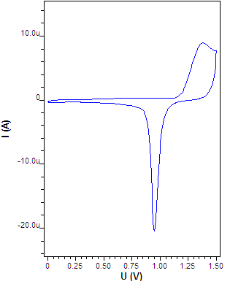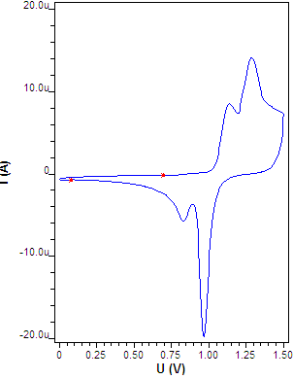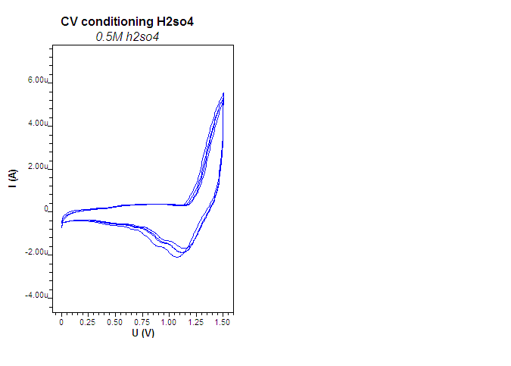
(c)
(b)
(a)

Figure 1. Voltammograms of electrochemical behavior for gold electrode by cyclic voltammetry in 0.5 M H₂SO₄; (a) clean surface, (b) presence of multilayer of oxides at the surface and (c) the passivating layer covered the electrode surface

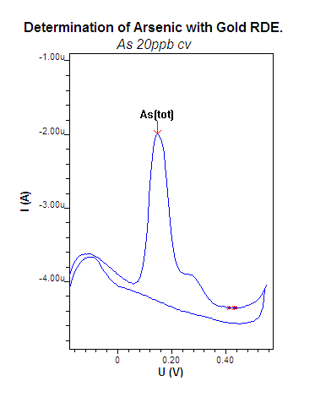
Figure 2. Cyclic voltammogram of 20 ppb As(V) in 2 M HCl at a sweep rate of 0.018 V/s

Figure 3. DPASV voltammogram and linear curve of Ip against concentration of As(V) standard additions: 0.4 mL of As(V) 50 ppb in 2 M HCl at 1: first addition, 2: second addition, 3: third addition, 4: fourth addition and 5: fifth addition (n = 6)

Table 2. Previous studies on detection of As species in different kind of samples using gold based electrodes with different voltametric techniques
Electrode/Substrate | As Species | Sample type | Technique(s) | LOD  (µg/L) | LOQ  (µg/L) | Reference
gold-disk electrode | As(III) | Natural waters and biomaterials | DPASV,  Linear sweep anodic stripping voltammetry  (LS ASV) | 0.15 | 0.5 | [32]
gold microelectrode | As(III) As(V) | Sea water | Square wave anodic stripping voltammetry  (SW ASV) | 0.3 | 1.0 | [30]
gold nanowires | As(III)  As(V) | River water | ASV | 0.08 | 0.24 | [33]
GC, modified gold-Pt nanoparticles | As(III) | Natural waters | LS ASV | 0.20 | 0.93 | [34]
GC, modified with gold film | As(III)  As(V) | Drinking water and Natural water | ASV | 0.55 | 1.7 | [35]

Table 2 (cont’d). Previous studies on detection of As species in different kind of samples using gold based electrodes with different voltametric techniques
Electrode/Substrate | As Species | Sample type | Technique(s) | LOD  (µg/L) | LOQ  (µg/L) | Reference
gold microelectrode | As(III)  As(V) | Drinking water and groundwater | SW ASV | 0.39 | 13.0 | [36]
gold electrode | As(III) | Environmental waters | ASV | 0.7 | 2.54 | [37]

Table 3. Physical changes of climacteric fruits before and after treated with CaC₂
Sample | Before Treatment | After Five  Days of Treatment | Treatment No. | Sample | Before Treatment | After Three Days of Treatment
M1 | 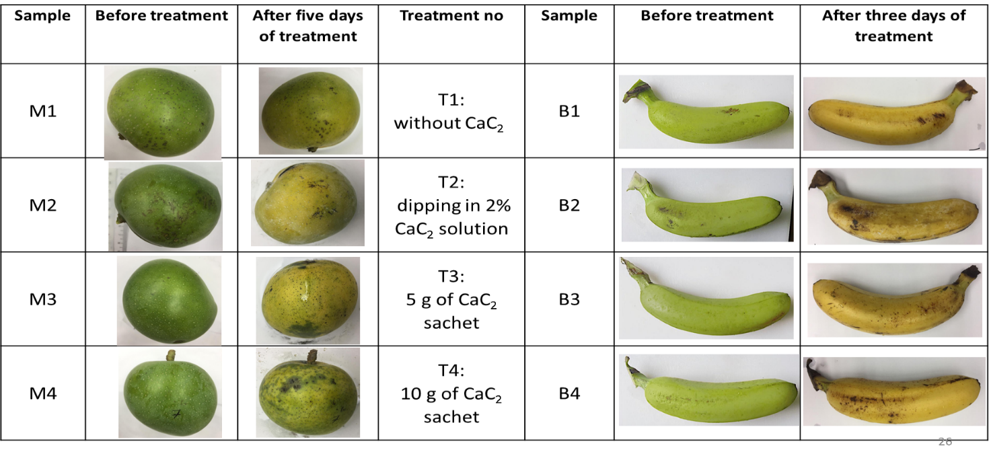 | 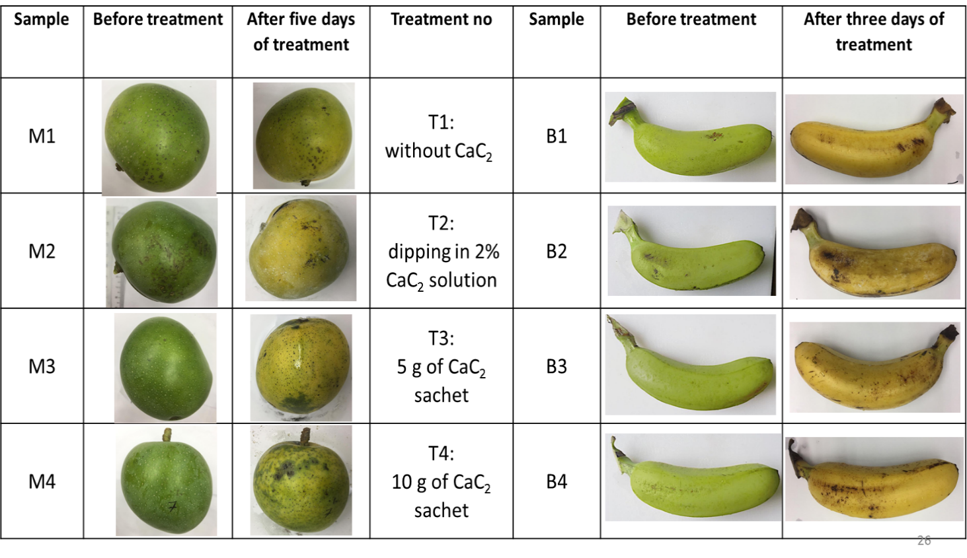 | T1:  Without CaC₂ | B1 | 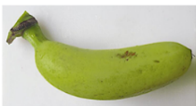 | 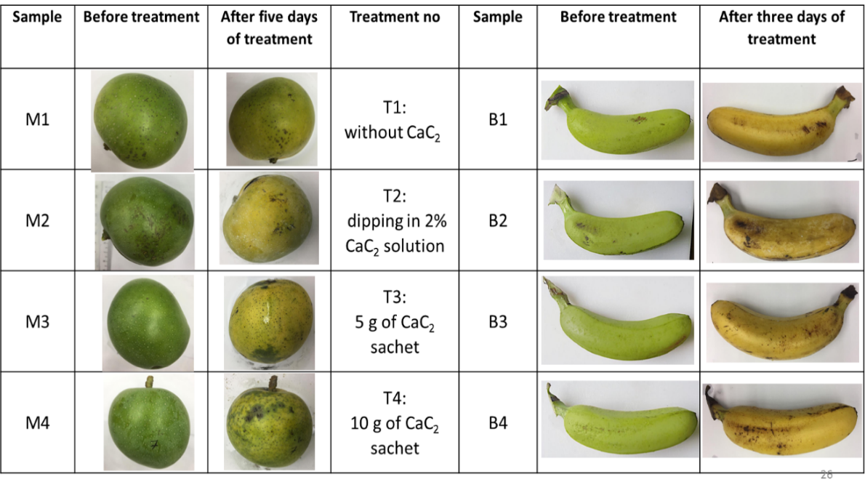
M2 | 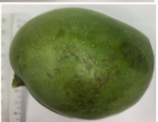 | 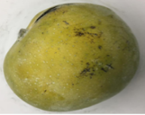 | T2:  Dipping in 2% CaC₂ solution | B2 | 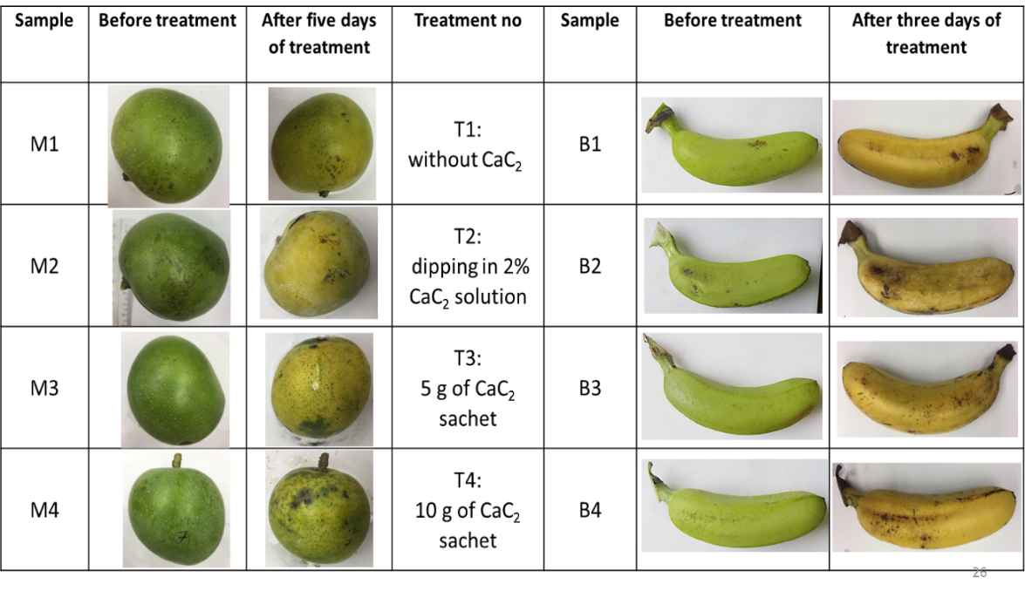
M3 | 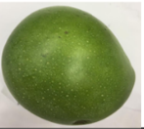 |  | T3:  5g of CaC₂ sachet | B3 | 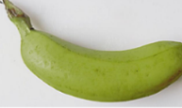 | 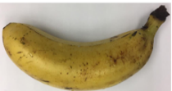
M4 |  |  | T4:  10g of CaC₂ sachet | B4

Voltammetry determination of washed water fruit samples
The data related to the residual arsenic presence on mango surface by applying different treatments of ripening fruits using CaC₂ are presented in Table 4. After five days of treatment with CaC₂, the ripened mango fruits were analyzed to detect the presence of As residues. The residual effect on the fruit surface was determined by analyzing the digested wash water of the fruits. 10 mL of wash water sample was added with 10 mL of HCl (supporting electrolyte) and taken for interpretation to represent the digested sample. Total As on fruit surface was calculated by multiplying the dilution factor of five with the represented sample concentration. Amount of As by weight in 500 mL of wash water was also calculated in Table 4.

From the data above, the average value of the total concentration of As residues in mangoes ripened by different treatments of CaC₂ varied from 6.5 to 10.32 ppb. The peak of As in voltammogram for fruit matured without using CaC₂ (T1) was not detected, it might
indicate that there was no As presence or perhaps the arsenic content was too small to be detected. Among the treatments, mangoes ripened by dipping in 2% CaC₂ solution (T2) recorded the maximum average value of total As residues in fruit surface which was 10.32 ppb followed by the fruits ripened by fruits ripened in 10 g of CaC₂ solution (T4) that gave a concentration of 8.89 ppb.

The lowest total average value of fruit treated with CaC₂ was observed in fruit ripened by using the lowest concentration of CaC₂, which was 5 g CaC₂ sachet (T3) that found to be 6.5 ppb. The data showed that higher As residues found in mangoes that dipped into CaC₂ solution as compared to sachet. It was believed that As residues were transferred to the fruit surface, which had the most contact with the CaC₂ solution.

For all market samples that were analyzed as in Table 5, the range concentration of As residues in fruit surface was between 4.42 to 10.81 ppb. Sample MS1, MS2, MS3 and MS5 did not show visual peak detected using DPASV. However, having the assumption of no As presence in the mango sample could not be deduced as the sample peak might be lowered than the LOD of As determination (0.7 ppb). Thus, this study considered the presumption of the minute amount of As that might be presented but could not be detected using DPASV in the mango sample. Further, the level of As residues found in the market sample was compared to other methods of CaC₂ ripening. Presence of high level of As residues in the market sample than the CaC₂ treated fruit indicated that traders use a much higher level of CaC₂ for the maturation of the mangoes.

The highest concentration of As residues found in mango fruits collected from the market was MS6 with a value of 10.81 ppb indicated that mangoes are ripened by traders using a very high concentration of CaC₂, for example, more than 10 g CaC₂ sachet or the traders might dip it into more than 2% of CaC₂ solution (10 g/ 0.5 L). Market sample for MS4, MS7 and MS8 showed the total concentration As residue presence at the fruit surface with 9.87, 6.96 and 7.27 ppb, respectively. From this data, it could be estimated that fruit traders utilized some amount of CaC₂ as their fruit ripening agent for instances more than 5 to 10 g of CaC₂ sachet for sample MS4, MS7 and MS8. While the lowest concentration of As found in the local market was MS9 with a concentration of 4.42 ppb.

Among the mango samples bought at the market, it showed that most of the imported mangoes had detected the presence of As except for MS5. This observation implied that imported mangoes had utilized the application of CaC₂ in their fruit ripening process. A harsh condition during road transportation and long hour of the journey might cause deterioration to the fruit. In contrast, green ripened mangoes using CaC₂ during the transport and reached the market was fully matured and ready to be sold [3]. On the other hand, As in local mangoes (MS1, MS2 and MS3) was not detected. The application of CaC₂ on local mangoes was seemed unpopular, as the local fruit sellers preferred to let their fruit ripened naturally or they used other fruit ripening method.

The same treatment of CaC₂ application on mango was done for banana samples. The ripened bananas were analyzed for the presence of As(V) residues after three days of treatment with CaC₂ using the DPASV. The results of the residual arsenic from different treatments of ripening fruits using CaC₂ present on banana fruit are presented in Table 6.

Among the different ripening treatments using CaC₂, the most As residues amount recorded on the banana surface in 500 mL of wash water was sample B4 (9.96 ppb of As concentration) which undergone T1, followed by T2 for sample B3 which As concentration obtained was 7.16 ppb and sample B4 (6.10 ppb of As) for T3. Similar treatment with mango (T1), no peak of As(V) presence for sample B1 was detected as well. Hence, the treatment on control fruit without CaC₂ which absence of arsenic residues in comparison with fruits ripened with CaC₂ suggested that As(V) detected might exist as impurities in commercial CaC₂.

The results for the highest As residues found on the banana surface was contradictory with the mango sample as 10 g of CaC₂ sachet measured as the highest amount of As found at the fruit surface than dipping in CaC₂ solution. Chandel et al. [11] believed that the As present in CaC₂ solution settles down at the bottom because of the properties of As which has a molecular weight (74.92 g/mol) heavier than water (18 g/mol) [11]. Besides, the size of container used to dip the fruit might correspond to this result, as the larger surface area of the box which spread the As at the bottom of the container and caused the lesser surface area of the fruit in contact with the As. Hence, the fruit dipped in CaC₂ solution has less transfer of As on to the surface of the banana.

Furthermore, as mentioned in the literature, arsine gas released when the CaC₂ reacts with water and combined with oxygen to form inorganic arsenic [11]. With the molecular weight of arsine gas (77.95 g/mol) higher than average dry air (28.97 g/mol), the As released from the sachet settles at the bottom layer of air in the container and kept covered to the fullest of fruit surface area for five days treatment, unlike when dipped in the CaC₂ solution, where the probability of contact reduces when the banana was only treated for one hour before being removed and kept in the container. Plus, during the mixture with water, most of the arsine gas had evaporated thus lesser As residues in fruits ripened by using CaC₂ solution.
For all banana samples bought from the market, there was no peak could be detected using DPASV. The inference of these results probably due to the concentration of As residues were smaller than the LOD concentration, or there might be no CaC₂ used by the trader to ripen the banana. Perhaps, the traders used another method of ripening such as smoke in the ethylene gas chamber, methyl jasmonate or ethephon, which proven by another study not to contain arsenic residues [4].

It is worth noting that, voltammetry analysis on different fruit parts such as peel and pulp of the fruit were not successfully being measured as there was broad peak interfered which masked the arsenic peak so it cannot be detected. This phenomenon happened due to voltammetry determination is sensitive towards the organic matter. The matrix effect from the organic matter has interfered the deposition of the analyte of interest at the gold electrode.

Table 4. Concentration of As residues found on the surface of mangoes by different treatments of CaC₂ application
Treatments | Samples No. | Average As Residues in Mango’s Wash Water  ± SD (ppb)
Treatments | Samples No. | Represented Sample Concentration, X  (10 mL) | Total Concentration,  5X  (50 mL)
T1: without CaC₂ | M1 | ND | ND
T2: dipping in 2% CaC₂ solution | M2 | 2.06 ± 0.12 | 10.32 ± 0.62
T3: 5 g of CaC₂ sachet | M3 | 1.30 ± 0.08 | 6.50 ± 0.25
T4: 10 g of CaC₂ sachet | M4 | 1.78 ± 0.05 | 8.89 ± 0.38
* ND refers to no peak detected; (n = 3)

Table 5. Concentration of As residues detected on the surface of mango bought at the market
Market Samples No. | Average Residual Arsenic in Mango’s Wash Water ± SD (ppb)
Market Samples No. | Represented Sample  Concentration (10 mL) | Total Concentration  (50 mL)
MS1 | ND | ND
MS2 | ND | ND
MS3 | ND | ND
MS4 | 1.97 ± 0.08 | 9.87 ± 0.38
MS5 | ND | ND
MS6 | 2.16 ± 0.05 | 10.81 ± 0.25
MS7 | 1.39 ± 0.11 | 6.96 ± 0.53
MS8 | 1.45 ± 0.06 | 7.27 ± 0.32
MS9 | 0.88 ± 0.02 | 4.42 ± 0.09
* ND refers to no peak detected; (n = 3)

Table 6. Concentration of arsenic residues found at the fruit surface of bananas by different treatments of CaC₂ application
Treatments | Samples No. | Average Residual Arsenic in Bananas’ Wash Water ± SD (ppb)
Treatments | Samples No. | Represented Sample Concentration (10 mL) | Total Concentration  (50 mL)
T1: without CaC₂ | B1 | ND | ND
T2: dipping in 2% CaC₂ solution | B2 | 1.43 ± 0.02 | 7.16 ± 0.11
T3: 5 g of CaC₂ sachet | B3 | 1.22 ±0.07 | 6.10 ± 0.34
T4: 10 g of CaC₂ sachet | B4 | 1.99 ± 0.05 | 9.96 ± 0.26
* ND refers to no peak detected; (n = 3)

Conclusion
CV and DPASV method of electrochemical behaviour and quantitative determination of As(V) standards and samples have been successfully studied in this research. The electrode pre-treatment was required to be employed every day before any electrochemical measurement of As(V) standard and fruit samples (mango and banana), to maintain the gold electrode surface reproducibility and appropriate state. The CV analysis of 20 ppb As(V) standard at gold electrode proved that in acidic medium (2 M HCl), redox process of As(V) has irreversible nature which possessed one oxidation peak potential at +0.15 V.

Physical changes of fruit ripened using CaC₂ was also recorded and compared between fruits of different CaC₂ treatment. The fruits surface color changed from green to yellow upon ripening. It was observed that fruits with CaC₂ ripened faster and have a shorter shelf life. The DPASV technique for As(V) in fruit wash water samples has been successfully applied after sample preparation in wet acid digestion.

Based on the observation of determination of As(V) on different treatments of CaC₂ using DPASV, the presence of As(V) in the samples could be used as an indicator for application of CaC₂ in fruit ripening. The concentration of As in fruit for different treatments of CaC₂ could be used to estimate the amount of CaC₂ applied on the sample bought from the market. The concentration of As(V) found in fruit purchased from the market (range between 4.42 to 10.81 ppb) below the maximum limit of As level in Food Act 1983 and FDA/WHO which is 1 ppm.

Acknowledgement
The authors greatly appreciate the instrumental and financial supports received from School of Health Sciences, Universiti Sains Malaysia (USM).

References
- Islam, Md. N., Imtiaz, M. Y., Alam, S. S., Nowshad, F., Shadman, S. A. and Khan, M. S. (2018). Artificial ripening on banana (Musa Spp.) samples: Analyzing ripening agents and change in nutritional parameters Yildizlez, F., (Ed.). Cogent Food & Agriculture, 4: 1–16.
- Bouzayen, M., Latché, A., Nath, P. and Pech, J.C. (2010). Mechanism of fruit ripening. In: Pua, E.C. And Davey, M.R., (Eds.) Plant developmental biology - biotechnological perspectives. Springer Berlin Heidelberg. Berlin, Heidelberg: pp. 319-339.
- Prasanna, V., Prabha, T. N. and Tharanathan, R. N. (2007). Fruit ripening phenomena–an overview. Critical Reviews in Food Science and Nutrition, 47: 1-19.
- Dhembare, A.J. (2013). Bitter truth about fruit with reference to artificial ripener. Archives of Applied Science Research, 5: 45-54.
- Siddiqui, W. and Dhua, R. S. (2010). Eating artificially ripened fruits is harmful. Current Science, 99: 1664-1668.
- Mondal, P., Balo Majumder, C. and Mohanty, B. (2007). Removal of trivalent arsenic (As(III)) from contaminated water by calcium chloride (CaCl₂)-impregnated rice husk carbon. Industrial & Engineering Chemistry Research, 46: 2550-2557.
- Kjuus, H., Andersen, A. and Langard, S. (1986). Incidence of cancer among workers producing calcium carbide. Occupational and Environmental Medicine, 43: 237-242.
- Rohani, M., (1999). Proses pemasakan dan penyahhijauan. In: pengendalian lepas tuai buah-buahan dan sayur-sayuran tropika. Institut Penyelidikan dan Kemajuan Pertanian Malaysia (Mardi): pp. 70-76.
- Consumers Association of Penang (2011). Ban the Use of Carbide Gas to Ripen Fruits. Access from http://www.consumer.org.my/index.php/food/safety/502-ban-the-use-of-carbide-gas-to-ripen-fruits.
- Ur-Rahman, A., Chowdhury, F. R. and Alam, M. B. (2008). Artificial ripening: What we are eating. Journal of Medicine, 9(1): 42-44.
- Chandel, R., Sharma, P. C. and Gupta, A. (2018). Method for detection and removal of arsenic residues in calcium carbide ripened mangoes. Journal of Food Processing and Preservation, 42: 1-6.
- Benhadria, N., Attar, T. and Messaoudi, B. (2020). Understanding the link between the detection limit and the energy stability of two quercetin–antimony complexes by means of conceptual DFT. South African Journal of Chemical, 73: 120-124.
- Behadria, N., Messaoudi, B. and Attar, T. (2020). The study of the correlation between the detection limit and the energy stability of two antimony complexes by means of conceptual DFT. Malaysian Journal of Chemistry, 22: 111-120.
- Attar, T., Messaoudi, B. and Benhadria, N. (2020). DFT theoretical study of some thiosemicarbazide derivatives with copper. Chemistry & Chemical Technology, 14: 20-25.
- Metrohm, (2019). Determination of arsenic by stripping voltammetry at the rotating gold electrode. https://www.metrohm.com/sv-se/applications/ab-226 [Accessed online 16 April 2019].
- Miller, J. N. and Miller, J. C. (2000). Statistics and chemometrics for analytical chemistry. 4th Edition, Pearson Education.

- Garlaschelli, F., Alberti, G., Fiol, N. and Villaescusa, I. (2017) Application of anodic stripping voltammetry to assess sorption performance of an industrial waste entrapped in alginate beads to remove As(V). Arabian Journal of Chemistry, 10: 1014-1021.
- Association of Official Analytical Chemists (1990). AOAC: Official Methods of Analysis (Volume 1). In: Official Methods of Analysis of The Association Of Official Analytical Chemists. Association of Official Analytical Chemists, Inc, Virginia, USA: pp. 1-771.
- Izumi, T., Yokohama, Y. and Watanabe, I. (1991). Activation of a gold electrode by electrochemical oxidation-reduction pretreatment in hydrochloric acid. Journal of Electroanalytical Chemistry and Interfacial Electrochemistry, 303: 151-160.
- Fischer, L. M., Tenje, M., Heiskanen, A., Masuda, N., Castillo, J., Bentien, J., Emneus, J., Jakobsen M. H. and Boisen, A. (2009). Gold cleaning methods for electrochemical detection applications. Microelectronic Engineering, 86: 1282-1285.
- Giacomino, A., Abollino, A., Lazzara M., Malandrino, M. and Mentasti, E. (2011). Determination of As(III) by anodic stripping voltammetry using a lateral gold electrode: Experimental conditions, electron transfer and monitoring of electrode surface. Talanta, 83: 1428-1435.
- Susteric, M. G., Almeida, N. V., Von Mengershausen, A. E. and Esquenoni, S. M. (2012). Hydrogen oxidation on gold electrode in sulphuric acid solution. International Journal of Hydrogen Energy, 37: 14747-14752.
- Zhang, W., Bas, A.D., Ghali, E. and Choi, Y., (2015). Passive behavior of gold in sulfuric acid medium. Transactions of Nonferrous Metals Society of China, 25: 2037-2046.
- Burke, L. D., Moran, J. M. and Nugent, P. F. (2003). Cyclic voltammetry responses of metastable gold electrodes in aqueous media. Journal of Solid State Electrochemistry, 7: 529-538.
- Elgrishi, N., Rountree, K. J., McCharty, B. D., Rountree, Eisenhart, T. S. and Dempsey, J. R. (2018). A practical beginner’s guide to cyclic voltammetry. Journal of Chemical Education, 95: 197-206.
- Yilmaz, S., Baba, B., Baba, A., Yagmur, S. and Citak, M. (2009). Direct quantitative determination of total arsenic in natural hotwaters by anodic stripping voltammetry at the rotating lateral gold electrode. Current Analytical Chemistry, 5: 29-34.
- Cavicchioli, A., La-Scalea, M. A. and Gutz, I. G. R. (2004). Analysis and speciation of traces of arsenic in environmental, food and industrial samples by voltammetry: A review. Electroanalysis, 16: 697-711.
- United State Environmental Protection Agency (1996). Arsenic in aqueous samples and extracts by anodic stripping voltammetry: pp. 1-9.
- Wei, Z. and Somasundaran, P. (2004). Cyclic voltammetric study of arsenic reduction and oxidation in hydrochloric acid using a Pt RDE. Journal of Applied Electrochemistry, 34: 241-244.
- Salaün, P., Planer-Friedrich, B. and Van Den Berg, C. M. G. (2007). Inorganic arsenic speciation in water and seawater by anodic stripping voltammetry with a gold microelectrode. Analytica Chimica Acta, 585: 312-322.
- Taşdemir, İ. H. (2014). Electrochemistry and determination of cefdinir by voltammetric and computational approaches. Journal of Food and Drug Analysis, 22: 527-536.
- Kopanica, M. and Novotný, L. (1998). Determination of traces of arsenic(III) by anodic stripping voltammetry in solutions, natural waters and biological material. Analytica Chimica Acta, 368(3): 211-218.
- Mardegan, A., Scopece, P., Ugo, P. and Moretto, L. M. (2015). Ensembles of gold nanowires for the anodic stripping voltammetric determination of inorganic arsenic. Journal of Nanoscience and Nanotechnology, 15(5): 3417–3422.
- Bu, L., Liu, J., Xie, Q. and Yao, S. (2015). Anodic stripping voltammetric analysis of trace arsenic(III) enhanced by mild hydrogen-evolution at a bimetallic Au-Pt nanoparticle modified glassy carbon electrode. Electrochemistry Communications, 59: 28-31.

- Jedryczko, D., Pohl, P. and Welna, M. (2016). Inorganic arsenic speciation in natural mineral drinking waters by flow-through anodic stripping chronopotentiometry. Talanta, 150: 265-271.
- Zhou, C., Yang, M., Li, S. S., Jiang, T. J., Liu, J. H., Huang, X. J. and Chen, X. (2017). Electrochemically etched gold wire microelectrode for the determination of inorganic arsenic. Electrochimica Acta, 231: 238-246.
- Tupiti, W., Chandra, S. and Prasad, S. (2018). Sensitive inorganic arsenic speciation on a voltammetric platform in environmental water samples. Microchemical Journal, 139: 301-305.
- Caseiro, A. Bauer, H., Schmidl, C., Pio, C. A. and Puxbaum, H. (2009). Wood burning impact on PM₁₀ in three Austrian regions. Atmospheric Environment, 43: 2186-2195.
- Unsworth, J. (2010). Guidance on residue analytical methods. Access from http://agrochemicals.iupac.org/.
- Noor Shaeda, I., Irniza, R., Sarva, M. P. and Emilia, Z.A. (2018). Calcium carbide (CaC₂) exposure from fruit ripening process and health effects among fruit farmers: A research review. International Journal of Public Health and Clinical Sciences, 5: 91-101.
- Asif, M. (2012). Physico-chemical properties and toxic effect of fruit-ripening agent calcium carbide. Annals of Tropical Medicine and Public Health, 5: 150-156.

