
DETERMINATION OF METSULFURON METHYL IN CRUDE PALM OIL USING LIQUID CHROMATOGRAPHY TRIPLE QUADRUPOLE MASS SPECTROMETER

(Penentuan Metsulfuron Metil dalam Minyak Sawit Mentah Menggunakan Kromatografi Cecair Spektrometri Jisim Caturkutub Ganda Tiga)

Nik Sasha Khatrina Khairuddin¹*, Chee Beng Yeoh¹, Najwa Sulaiman¹, Farah Khuwailah Ahmad Bustamam¹, Halimah Muhamad¹, Ismail Sahid²

¹Malaysian Palm Oil Board,
No. 6, Persiaran Institusi, Bandar Baru Bangi, 43000 Kajang, Selangor, Malaysia
²School of Environmental Science and Natural Resources, Faculty Science and Technology,
Universiti Kebangsaan Malaysia, 43600 Bangi, Selangor, Malaysia.

*Corresponding author: sashakhatrina@mpob.gov.my

Received: 23 December 2020 ; Accepted: 16 February 2021; Published: xx April 2021

Abstract
A simple and fast method for the determination of metsulfuron methyl (MSM) in crude palm oil (CPO) was developed and validated in-house. The analytical method developed involved a liquid-liquid extraction of MSM with the incorporation of a heating step that has been found to enhance the extraction efficiency and stability. This is followed by clean-up using solid phase extraction (SPE), concentration and reconstitution of the analyte prior to injection into the liquid chromatography triple quadrupole mass spectrometer (LC/MS/MS). Using this method, good linearity with good coefficient correlation (r²) of >0.999 was obtained for matrix-matched calibration. Results showed that the average recoveries obtained for MSM in CPO samples at different levels of concentration (ultra-low, low, and high) are in the range between 84-98% with a relative standard deviation (RSD) of less than 5% for all samples. The limit of detection (LOD) and limit of quantification (LOQ) for analysis of residual MSM in CPO was estimated to be 1.0 and 5.0 ng/g, respectively. An experiment determining the repeatability resulted in an RSD of less than 5% for all samples and intermediate precision at spiking level at 10 ng/g and 50 ng/g showed RSD of 6.93% and 4.07%, respectively. A very low % RSD indicates good precision and suitability of this method for use in the analysis of residual MSM in CPO. Quick monitoring of Malaysian CPO was also carried out by analyzing 10 samples obtained from various mills throughout Malaysia. Results from the CPO monitoring showed that all samples were free from residual MSM.

Keywords: method development, metsulfuron methyl, pesticides, crude palm oil, liquid chromatography triple quadrupole mass spectrometer

Abstrak
Satu kaedah yang mudah dan pantas bagi penentuan kandungan metsulfuron metil (MSM) dalam minyak sawit mentah telah dibangunkan dan telah ditentusahkan. Kaedah analitikal yang telah dibangunkan melibatkan kaedah pengekstrakan MSM jenis cecair-cecair, dengan tambahan langkah pemanasan yang didapati dapat meningkatkan kecekapan dan kestabilan pengekstrakan, diikuti dengan langkah pembersihan menggunakan pengekstrakan jenis fasa pepejal (SPE), serta pemekatan dan pelarutan semula analit sebelum disuntik ke dalam instrumen kromatografi cecair spektrometri jisim caturkutub ganda tiga (LC/MS/MS). Melalui kaedah ini, kelinearan dan korelasi pekali penentuan yang baik, dengan nilai (r²) >0.999 bagi kalibrasi padanan matriks telah diperolehi. Keputusan menunjukkan purata perolehan semula yang diperolehi bagi MSM dalam sampel minyak sawit mentah pada kepekatan yang berbeza (sangat rendah, rendah dan tinggi) adalah pada julat antara 84-98% dengan nilai sisihan piawai relatif (RSD) kurang daripada 5% bagi kesemua sampel. Had pengesanan (LOD) dan had pengkuantitian (LOQ) bagi analisis sisabaki MSM dalam minyak sawit mentah masing-masing adalah 1.0 dan 5.0 ng/g. Eksperimen bagi penentuan kebolehulangan menunjukkan nilai RSD yang kurang daripada 5% untuk kesemua sampel dan kejituan pertengahan pada kepekatan 10 ng/g dan 50 ng/g menunjukkan nilai RSD masing-masing 6.93% and 4.07%. Nilai RSD yang sangat rendah menunjukkan kejituan yang baik dan kesesuaian penggunaan kaedah ini untuk analisis sisabaki MSM dalam minyak sawit mentah. Satu kajian pemantauan kandungan MSM dalam minyak sawit mentah di Malaysia juga telah dijalankan terhadap 10 sampel minyak sawit mentah yang diperolehi daripada beberapa kilang pemprosesan minyak sawit di Malaysia. Hasil keputusan pemantauan ini menunjukkan bahawa semua sampel minyak sawit mentah yang dianalisa adalah bebas dari sisabaki MSM.

Kata kunci: pembangunan kaedah, metsulfuron metil, pestisid, minyak sawit mentah, kromatografi cecair spektrometri jisim caturkutub ganda tiga

Introduction
Oil palm is one of the most important crops in the global market and Malaysia is the world’s second largest producer and exporter [1]. In 2019, the total of Malaysian palm oil and the exported products was 27.98 million tonnes [2]. Like any other crops, oil palm is also threatened by various types of weeds such as Asystasia gangetica, Chromolaena odorata, Mikania micrantha, Hedyotis verticillate, and Peperomia pellucida. These threats have caused a fair amount of losses to the production of palm oil, which led to an increase in maintenance cost. There are a large number of herbicides registered globally to be used for weeds management. The chemical and physical properties of these chemical compounds vary considerably. It is noted that continuous and extensive application of herbicides or any type of pesticides contaminates the water, soil, and food, and this leads to compromising human health and polluting the environment. The growing number of pesticides usage has increased the demands for the development of new laboratory methods applicable to their effective detection and control [3]. Therefore, the development of methods for all registered pesticides to be used in oil palm plantations is important to monitor residual pesticides to ensure that the trade and market of palm oil can be sustained.

MSM is one of the herbicides currently used in Malaysian oil palm plantation for weed management (Figure 1). It is a residual sulfonylurea compound used as a selective pre- and post-emergence herbicide. It has a high herbicidal activity even at low application rate and is widely used including Malaysia for effective control of a wide range of weeds such as annual grasses, pasture, and plantation crops. It is a systemic compound with foliar and soil activity that inhibits cell division in shoots and roots through the inhibition of acetolactate synthase (ALS), which is a key enzyme in the biosynthesis of branched amino acids (valine, isoleucine, and leucine) in plant and micro-organisms. ALS, however, is not present in animals [4]. MSM can be applied alone or in tank mixture with other herbicides for weed control such as glyphosate, paraquat, and others [5]. It is common to add MSM to increase the efficacy of mix herbicides [6].

Figure 1. Molecular structure of MSM

Various methods have been described for the determination of MSM herbicide residue in soil and water [7-10]. However, there are only a few reports on its determination in oil or fatty matrices despite the various analytical methods described for the determination of various pesticides in oil crops such as olive oil, palm oil, sunflower oil and other oils [11-17].

Nageswara Rao et al. [18] reported a dispersive extraction method for the determination of MSM in groundnut oil. In the developed method, the author homogeneously dispersed (1:1, (w/w)) groundnut oil in C18 adsorbent prior to the elution using (1:1, v/v) 20 mL of ethyl acetate-dichloromethane. This resulted in average recoveries ranging from 90–97% and RSD of less than 3%. In another study by Maldaner [19], matrix solid phase dispersion extraction followed by C₈ co-column clean-up for the determination of MSM in soybeans was reported. For oil palm application, research on MSM in soil has been carried out [20, 21], however, lack of research was performed for CPO. Although there are several studies reported on pesticide multiresidue analysis in oil matrices including palm oil, MSM residue was not included [16, 22-23]. Therefore, the applicability of the method for residual MSM analysis is unknown. In another study by Kostelac and Anastassiades [24], residual analysis of MSM was included in the multiresidue analysis using the Quick, Easy, Cheap, Effective, Rugged and Safe (QuEChERS) technique. The method described is only limited to be used for non-fatty matrices such as cucumber, lemon, raisins, and wheat flour. Due to the lack of literature concerning residues of MSM in palm oil, there is a need to carry out a study on the development of an analytical method for MSM in palm oil matrix. In this study, the method was developed based on a paper published by Yeoh et al. [25] and Yeoh and Chong [16]. However, in that method, the chlorinated solvent was used as a diluent in sample extraction. Reported in this study is a modified method for MSM residue determination in palm oil matrix that omits the use of halogenated solvent but maintaining the effectiveness of the method.

Materials and Methods
Chemicals, materials and apparatus
All chemicals and reagents used in this study were of analytical or liquid chromatographic grade. Methanol (MeOH) was obtained from Merck whereas acetic acid (LC/MS grade) was obtained from Sigma Aldrich. Deionized water used in this experiment was from a Milli-Q water purification system (Millipore Corp., USA). Both MSM (99% purity) and ethametsulfuron methyl (EMSM, 98% purity) standard materials were purchased from Dr. Ehrenstorfer (Ausburg, Germany). Carbograph SPE columns (500 mg/8 mL) used for sample clean-up were obtained from AlltechTM. Nitrogen evaporator (Horizon Technology, USA) was used for samples drying.

Preparation of stock and working standard solution
A stock solution of MSM with a concentration of 100 µg/mL was prepared by dissolving 10.1 mg of the MSM standard in 100 mL of MeOH. A similar procedure was carried out for the preparation of the EMSM stock solution (100 µg/mL). Working standard solutions for MSM (5, 10, 20, 30, 50 and 70 µg/mL) were then prepared by dilution with the appropriate MeOH volume. The prepared standard solutions were stored at -20ºC. For EMSM, a suitable amount of stock solution was used to prepare EMSM working standard solution (500 µg/mL) in order to spike in the final extract as an internal standard before injecting into the LC/MS/MS system.

Spiking sample preparation
200 g of blank CPO obtained from a nearby palm oil mill was melted in a 500 ml beaker (tall form) using water bath controlled at 60ºC. Before conducting the experiment, the oil samples were analyzed to ensure the absence of any MSM residual. For the preparation of spiked CPO samples at 10 ng/g, 20 µL of MSM stock solution (100 µg/mL) was spiked into the blank CPO followed by stirring using a magnetic bar for 30 minutes. This is important to ensure that the spiking of MSM into the oil sample is well distributed and homogenized. While ensuring the stirring using the magnetic bar is continuous, 5 g each of CPO samples spiked with MSM at 10 ng/g level were weighed. A total of 30 spiked samples were obtained and stored in a freezer controlled at -20ºC. These samples were taken out for analysis when required. The same procedure was repeated for the preparation of spiked CPO samples at 5 and 50 ng/g level.

Liquid-liquid extraction and SPE Clean-up
As shown in Figure 2, 5.0 g of CPO sample and 5 mL of MeOH extraction solvent were mixed in a 30 mL self-standing Falcon tube. The sample was shaken using a vortex mixer for 2 minutes and was left in the water bath (60ºC) for a subsequent 2 minutes. The same process (shaking and heating) was repeated until a total of 10 minutes shaking time was achieved. Then, the samples were tilted at approximately 45-60º in the freezer (-20ºC) for 1 hour prior to centrifugation at 2655 x g for 5 minutes to allow phase separation. The placement of samples in a tilted position was found to give better phase separation [17].

For SPE clean-up (Figure 3), the carbograph SPE cartridge was first conditioned using 8 mL of MeOH. Then, 1 mL aliquot of the extracted sample (from the liquid-liquid extraction section) was transferred into the SPE cartridge. Elution of MSM was carried out using 6 mL of MeOH solvent under gravity flow. The collected SPE eluate was dried using nitrogen evaporator followed by reconstitution with 1 mL of MeOH, and the addition of 25 μL internal standard. The sample was shaken with a vortex mixer for a few seconds prior to LC/MS/MS injection.

LC/MS/MS analysis
LC/MS/MS analysis was conducted using AB Sciex QTRAP® 4500 (Foster City, CA, USA) triple quadrupole MS/MS with ESI in the positive ion mode. The system was equipped with Analyst® Instrument Control and Data Processing version 1.6.2 software. Kinetex C18 100A capillary column (50 mm x 2.1 mm x 2.6 µm) attached to the guard column (SecurityGuardTM ULTRA cartridges for UHPLC C₁₈, with an internal diameter of 2.1 mm) were both provided by PhenomenexTM. The column compartment temperature was set at 40ºC. Mobile phase A and B were 10mM aqueous acetic acid solution and 100% MeOH, respectively at the flow rate of 0.2 mL/min using a gradient elution profile depicted in Table 1. A volume of 10 µL of the sample was injected into the LC/MS/MS system with a total analysis time of 15 min for each sample. The determination of the respective compounds (MSM and EMSM) was carried out according to the multiple reaction monitoring experiment parameters as shown in Table 2.

In-house validation
In-house method validation was carried out and the parameters tested were linearity, LOD, LOQ, and method precision.

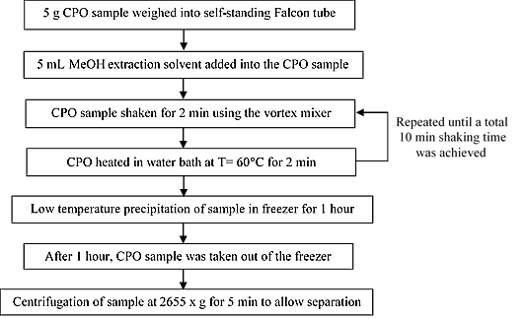
Figure 2. Liquid-liquid extraction steps for residual analysis of MSM in CPO using LC/MS/MS

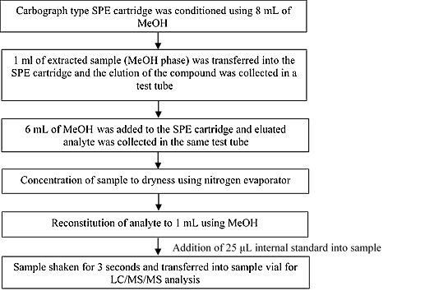
Figure 3. SPE clean-up steps for residual analysis of MSM in CPO using LC/MS/MS

Table 1. Mobile phase gradient system used in the residual MSM analysis using LC/MS/MS
Time  (min) | Flow Rate  (mL/min) | A  (%) | B  (%)
0.00 | 0.20 | 95 | 5
5.00 | 0.20 | 5 | 95
10.00 | 0.20 | 5 | 95
10.50 | 0.20 | 95 | 5
15.00 | 0.20 | 95 | 5

Table 2. Optimum parameter for MSM and EMSM obtained by manual tuning
Term Used | Transition  (m/z) | DP | EP | CE | CXP
MSM 1 | 382/167 | 91 | 10 | 19 | 8
MSM 2 | 382/199 | 91 | 10 | 32 | 8
EMSM 1 | 411/196 | 86 | 10 | 24 | 10
EMSM 2 | 411/168 | 86 | 10 | 42 | 10
DP=Declustering Potential, EP=Entrance Potential, CE=Collision Energy, CXP=Collision Cell Exit Potential

Results and Discussion
Heating technique versus no heating technique
It is known that palm oil contains approximately 1:1 ratio of saturated and unsaturated fatty acids in its composition. Palm oil tends to solidify at room temperature. In this experiment, cloudiness was observed during the extraction process (Figure 4). It was believed that the formation of crystals during the extraction process may reduce the extraction efficiency. In order to optimize the extraction of MSM residue in this experiment, the extraction was carried out with an addition of intermittent heating step at constant and consistent intervals (every one-minute interval for five minutes). The intermittent heating step was found to yield better and consistent recovery compared to without heating (Figure 5). This observation is in agreement with the observation reported by Yeoh et al. [26]. In that paper, it was noted that there was an increase of ~20% recovery when a heating step was included possibly due to the melting of micro crystals in palm oil matrix with the presence of heat. Thus, increases the extraction efficiency that leads to improving the recovery percentage.

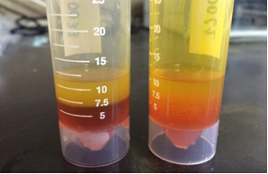
Figure 4. Comparison of physical condition of CPO sample with the addition of intermittent heating step (left) versus CPO sample without intermittent heating step which resulted cloudiness (right)

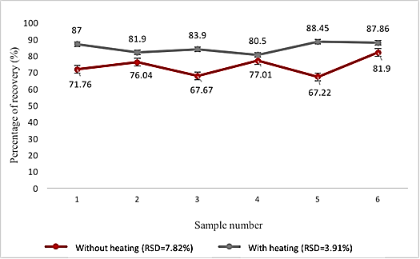
Figure 5. Comparison of recovery percentage for samples that underwent heating step versus samples without the addition of heating step

Linearity and matrix effect
From Figure 6, it was noted that the signals obtained for MSM are linear in the concentration ranging from 5-70 ng/g. This is true for both calibration curves plotted for MSM prepared in both pure solvent and blank CPO extract (matrix-matched). It could also be observed that the MSM signal suffers from serious suppression effect due to the matrix. Determination of this matrix effect was carried out by comparing the slope of both calibration curves according to Pano-Farias et al. [27] in which the matrix effect was found to be approximately -1956% (matrix suppression effect). Therefore, it was decided that further work on method development of residual MSM in CPO would be based on the matrix-matched calibration curve.

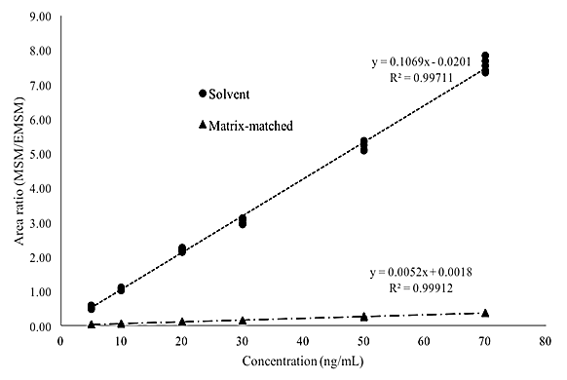
Figure 6. Comparison of MSM calibration curve prepared in pure solvent versus blank CPO extract (matrix-matched)

LOD and LOQ
The LOD value was estimated based on 3 times the y-residual standard deviation of the calibration curve. The LOQ value was estimated based on 10 times the y-residual standard deviation [28]. In this study, both the LOD and LOQ were estimated to be 1.0 and 5.0 ng/g, respectively.

Method recovery
The method recovery was examined by analyzing six replicates of spiked samples at ultra-low (5 ng/g), low (10 ng/g), and high (50 ng/g) spiking levels. Based on the results, the range of recoveries obtained was within 84-98% with RSD <5% for all levels. Results for the recovery analysis of residual MSM in CPO is summarized in Table 3. Low RSD % obtained from this recovery study also indicated that the method has good repeatability. Figure 7 shows a typical chromatogram of blank CPO sample, MSM working standard solution at 10 ng/mL concentration, and CPO sample spiked at 10 ng/g of MSM.

Method precision study: Repeatability
Repeatability of the analysis was verified through recovery experiment using the method that was developed for the analysis of residual MSM in CPO (n=6) at low and high spiking level (10.0 and 50 ng/g) carried out by two different analysts (Analyst 1 and Analyst 2). It could be observed from Table 4 that the average recovery for all sample replicates on each day (Day 1 and Day 2) by Analyst 1 and Day 2 for Analyst 2 were between 84-108%. Despite the lack of experience in performing the analysis using this newly developed analytical method, method repeatability study performed by Analyst 2 was comparable to those by Analyst 1. The method RSD % calculated from recovery experiment datasets were all below 5% and were considered to be excellent according to the literature [29, 30].

Method precision study: Intermediate precision
Intermediate precision is the measurement of method repeatability over a short period with possible minor variations in the experimental conditions such as different batches of reagents used, different analyst, different column efficiency and others. Therefore, a comparison study of method recovery was conducted by two different analysts in two days for CPO samples analysis (n=6) spiked at 10 and 50 ng/g of MSM, respectively. From Table 4, the calculation of RSD % for both 10 ng/g and 50 ng/g spiking levels taking into account variations in terms of analyst’s skill and time of analysis resulted in 6.93% and 4.07% of RSD, respectively. These values confirm that the method precision (repeatability and intermediate precision) is within the acceptable levels [29, 30].

Monitoring of CPO samples
10 CPO samples obtained from selected licensed palm oil mills with incoming fresh fruit bunches (FFB) from plantations with known MSM usage history in Peninsular Malaysia, Sabah and Sarawak were analyzed for possible residual MSM using the developed method (liquid-liquid extraction followed by SPE clean-up) in three replicates. Based on the monitoring, no residual MSM was detected in any of the CPO samples. This gives a preliminary indication that the usage of MSM in oil palm plantations was based on the recommended dosage by the manufacturer and also follow the good agricultural practice. However, more CPO samples need to be analyzed in the future to obtain more comprehensive data for the production of palm oil in Malaysia.

Table 3. studies for analysis of MSM in CPO at the concentration of 5, 10 and 50 ng/g
Sample Replication | Spiking Level
Sample Replication | 5 ng/g | 10 ng/g | 50 ng/g
1 | 93.02 | 92.40 | 91.02
2 | 86.86 | 94.78 | 90.23
3 | 93.84 | 96.17 | 98.00
4 | 84.11 | 96.43 | 89.06
5 | 88.37 | 96.83 | 88.19
6 | 85.52 | 92.01 | 87.06
Average | 88.62 | 94.77 | 90.59
Standard Deviation | 4.00 | 2.11 | 3.55
RSD % | 4.51 | 2.22 | 3.92
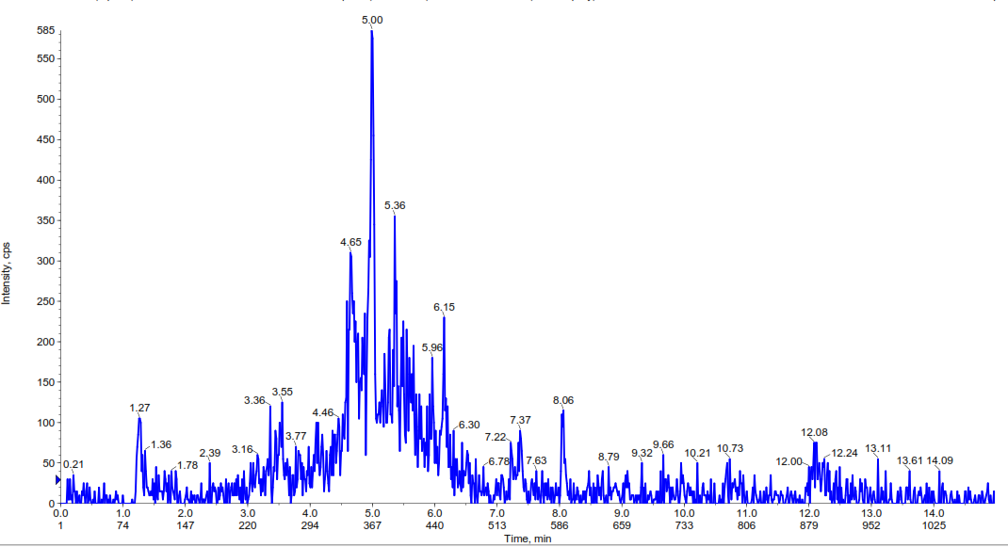
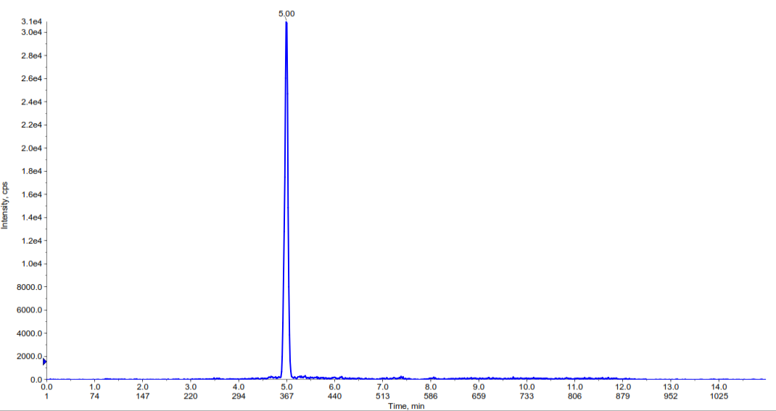
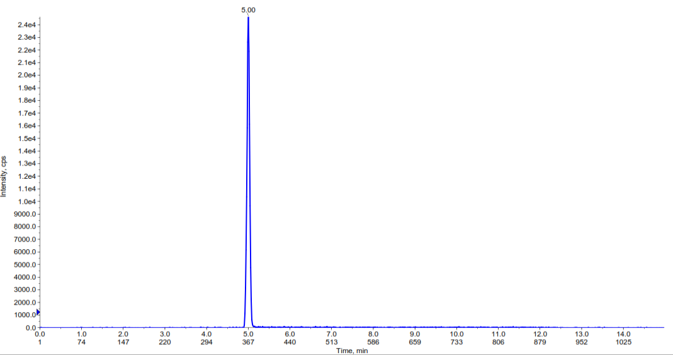
(a)
(b)
(c)
Figure 7. Representative chromatogram of (A) blank CPO sample, (B) MSM working standard solution (in MeOH) at the concentration of 10 ng/mL and (C) CPO sample spiked at 10 ng/g of MSM

Table 4. Intermediate precision study of residual MSM determination in CPO at 10 and 50 ng/g spiking levels
Sample Replication | 10 ng/g Spiking Level |  |  | 50 ng/g Spiking Level
Sample Replication | Analyst 1 |  | Analyst 2 | Analyst 1 |  | Analyst 2
Sample Replication | Day 1 | Day 2 | Day 2 | Day 1 | Day 2 | Day 2
1 | 92.40 | 99.83 | 105.16 | 91.02 | 84.68 | 84.16
2 | 94.78 | 95.52 | 117.29 | 90.23 | 83.89 | 89.23
3 | 96.17 | 97.16 | 108.27 | 98.00 | 85.13 | 86.08
4 | 96.43 | 91.57 | 107.50 | 89.06 | 85.74 | 84.74
5 | 96.83 | 97.10 | 101.19 | 88.19 | 84.34 | 87.22
6 | 92.01 | 100.34 | 108.26 | 87.06 | 83.17 | 88.08
Average | 94.77 | 96.92 | 107.95 | 90.59 | 84.49 | 86.59
Standard Deviation | 2.11 | 3.19 | 5.31 | 3.55 | 0.83 | 1.96
RSD % | 2.22 | 3.29 | 4.92 | 3.92 | 0.98 | 2.26

Conclusion
A new method was developed and optimized for the analysis of residual MSM in CPO matrix. Results from the experiment showed that the extraction technique using MeOH followed by heating of the samples, low temperature precipitation technique, and sample clean-up using SPE (carbograph) gave good recovery rates (84-98%) with RSD of less than 5% for all samples. The method was also in-house validated and passed the important validation parameters such as linearity, recovery, and precision (repeatability and intermediate precision). LOD and LOQ for the developed method were estimated to be 1.0 and 5.0 ng/g, respectively.

Acknowledgement
The authors would like to thank the Director-General of MPOB for granting permission to publish the findings from this study. Special thanks also go to the Analytical Research laboratory assistants for their continuous technical support.

References
- Kushairi, A., Loh, S. K., Azman, I., Elina, H., Meilina, O.-A., Mohd Noor Izudin, Z. B., Razmah, G., Shamala, S. and Ahmad Parveez, G. K. (2018). Journal of Oil Palm Research, 30: 163-195.
- Parveez, G. K. A., Elina, H., Loh, S. K., Ong-Abdullah, M., Kamalrudin, M. S., Zanal Bidin, M. N. I., Sundram, S., Hasan, Z. A. A. and Zainab, I. (2020). Oil palm economic performance in Malaysia and R&D progress in 2019. Journal of Oil Palm Research, 32(2): 159-190.
- Lacina, O., Zachariasova, M., Urbanova, J., Vaclavikova, M., Cajka, T. and Hajslova, J. (2012). Critical assessment of extraction methods for the simultaneous determination of pesticide residues and mycotoxins in fruits, cereals, spices and oil seeds employing ultra-high performance liquid chromatography-tandem mass spectrometry. Journal of Chromatography A, 1262: 8-18.
- Zanardini, E., Negri, M., Boschin, G., D'Agostina, A., Valle, A., Arnoldi, A. and Sorlini, C. (2002). Biodegradation of chlorsulfuron and metsulfuron-methyl by Aspergillus niger. The Scientific World Journal, 2: 1369-1374.
- Bazzigalupi, O. and Cepeda, S. (2005). Relations between soil moisture and the metsulfuron methyl effects on the seedling growth of soybean (Glycine max L. Merr.) Revista de Investigaciones Agropecuarias, 34(1): 101-110.
- Wibawa, W. and Sugandi, D. (2013). The effectiveness of three herbicides mixed with metsulfuron methyl in controlling weeds on two types of soil in smallholders oil palm plantation. International Journal of Current Research, 5(9): 2487-2493.
- Ghani, A. and Wardle, D. A. (2001) Fate of ¹⁴C from glucose and the herbicide metsulfuron–methyl in a plant–soil microcosm system. Soil Biology and Biochemistry, 33: 777-785.
- Pons, N. and Barriuso, E. (1998). Fate of metsulfuron‐methyl in soils in relation to pedo‐climatic conditions. Pesticide Science, 53: 311-323.
- Sondhia, S. (2008). Persistence of metsulfuron-methyl in wheat crop and soil. Environmental Monitoring and Assessment, 147: 463-469.
- Sondhia, S. (2009). Persistence of metsulfuron-methyl in paddy field and detection of its residues in crop produce. Bulletin of Environmental Contamination and Toxicology, 83: 799-802.
- Ferrer, C., Gómez, M. J., García-Reyes, J. F., Ferrer, I., Thurman, E. M. and Fernández-Alba, A. R. (2005). Determination of pesticide residues in olives and olive oil by matrix solid-phase dispersion followed by gas chromatography/mass spectrometry and liquid chromatography/tandem mass spectrometry. Journal of Chromatography A, 1069: 183-194.
- Muhamad, H., Tan, Y. A. and Ismail, B. S. (2008). Determination of the herbicide fluroxypyr in oil matrices. Journal of Environmental Science and Health B, 43: 134-140.
- Li, L., Zhou, Z., Pan, C., Qian, C., Jiang, S. and Liu, F. (2007) Determination of organophosphorus pesticides in soybean oil, peanut oil and sesame oil by low-temperature extraction and GC-FPD. Chromatographia, 66: 625-629.
- Nageswara Rao, T., Ramasubbih A.V. and Parvathi, T. (2012). Development and validation of a HPLC-UV method for simultaneous determination of five sulfonylurea herbicide residues in soybean oil followed by matrix solid-phase dispersion. International Journal of Chemical, Environmental and Pharmaceutical Research, 3(2): 117-121.
- Ramli, M. I., Zakaria, Z., Sahid, I., Tan, Y. A. and Muhamad, H. (2012). Determination of herbicide diuron levels in palm oil matrices using HPLC-UV. Sains Malaysiana, 41: 1451-1459.
- Yeoh, C. B. and Chong, C. L. (2012). LC–MSMS analysis of acetamiprid residue in crude palm oil. European Journal of Lipid Science and Technology, 114(12): 1358-1361.
- Zainudin, B. H., Bakar, N. K. A. and Muhamad, H. (2009). Determination of cypermethrin in palm oil matrices. European Journal of Lipid Science and Technology, 111: 1014-1019.
- Nageswara Rao, T., Ramesh, A. and Parvathamma, T. (2012). Development and validation of a HPLC-UV method for simultaneous determination of five sulfonylurea herbicide residues in groundnut oil followed by matrix solid-phase dispersion. ISRN Analytical Chemistry, 2012: 1-5.
- Maldaner, L., Santana, C. C. and Jardim, I. C. S. F. (2008). HPLC determination of pesticides in soybeans using matrix solid phase dispersion. Journal of Liquid Chromatography and Related Technologies, 31(7): 972-983.
- Ismail, B. S. and Ooi, K. E. (2012). Adsorption, desorption and mobility of metsulfuron-methyl in soils of the oil palm agroecosystem in Malaysia. Journal Environmental Biology, 33(3): 573-577.
- Mohd Tahir, N. and Jee Sing, N. Y. (2006). Adsorption of metsulfuron-methyl on soils under oil palm plantation: A case study, 1st International Conference on Natural Resources Engineering & Technology, Putrajaya, Malaysia. p.591-596.
- Lászlo Polgár, Béla Kmellár, Juan F. García-Reyes and Péter Fodor. (2012). Comprehensive evaluation of the clean-up step in the QuEChERS procedure for the multi-residue determination of pesticides in different vegetable oils using LC-MS/MS. Analytical Methods, 4(4): 1142-1148.
- Sobhanzadeh, E., Bakar, N. K. A., Abas, M. R. B., & Nemati, K. (2012). A simple and efficient multi-residue method based on QuEChERS for pesticides determination in palm oil by liquid chromatography time-of-flight mass spectrometry. Environmental Monitoring and Assessment, 184(9): 5821-5828.
- Kostelac, D. and Anastassiades. (2007). Access from QuEChERS validation method for acidic pesticides. https://www.eurl-pesticides.eu/library/ docs/fv/2ndtr2007_AcidicKostelac.pdf [accessed October 2019].

- Yeoh, C. B., Kuntom, A., Dorasamy, S., Omar, M. R., Nor, M.Y. M., and Noh, M. R. M. (2006). Determination of acephate, methamidophos, and monocrotophos in crude palm oil. European Journal of Lipid Science and Technology, 108: 960-964.
- Yeoh, C. B., Ahmad Bustamam, F. K., Sulaiman, N., Khairuddin, N. S. K., Tay, M. G. and Saw, M. H. (2019). Development of analytical method for determination of thiosultap-disodium residue in palm oil matrix. Journal of Oil Palm Research, 3: 634-640.
- Pano-Farias, N. S., Ceballos-Magaña, S. G., Muñiz-Valencia, R. and Gonzalez, J. (2017). Validation and assessment of matrix effect and uncertainty of a gas chromatography coupled to mass spectrometry method for pesticides in papaya and avocado samples. Journal Food Drug Analysis, 25: 501-509.
- Vial, J. and Jardy, A. (1999). Experimental comparison of the different approaches to estimate LOD and LOQ of an HPLC method. Analytical Chemistry,71: 2672-2677.
- European Commission, Sante/11813/2017-Guidance document on analytical quality control and validation procedures for pesticide residues and analysis in food and feed, 2017: pp 1-46.
- Huber, L. (2007). Validation and qualification in analytical laboratories. 2nd Edition. CRC Press, Boca Raton: pp 1-288.

