

OILY SAND CLEANING OPTIMIZATION BY SURFACTANTS INTERFACIAL TENSION SCREENING AND HYDROCYCLONE SEPARATION

(Pengoptimuman Pembersihan Pasir Berminyak oleh Saringan Ketegangan

antara Muka Surfaktan dan Pemisahan Hidrosiklon)

Akhmal Sidek¹*, Ahmad Faiq Omar¹, Aizuddin Supee², Amni Haslinda Alpandi³, Hazlina Husin³,

Dewandra Bagus Ekaputra⁴, Shaziera Omar¹

¹Petroleum Engineering Department, SCEE, Faculty of Engineering
²Energy Management Group, SCEE, Faculty of Engineering
Universiti Teknologi Malaysia, 81310 Skudai, Johor, Malaysia
³Petroleum Engineering Department,
Universiti Teknologi PETRONAS, 32610 Seri Iskandar, Perak, Malaysia
⁴Department of Geological Engineering, Faculty of Engineering,
Universitas Islam Riau, Riau 28284, Indonesia

*Corresponding author: akhmalsidek@utm.my

Received: 30 December 2020; Accepted: 10 February 2021; Published: 25 April 2021

Abstract

The oily sand cleaning process should pass the standard discharge requirements so that its impact on the environment can be minimized. This work has used integrated surfactants which includes sodium dodecyl sulfate (SDS, anionic), saponin (plant-based, nonionic), and cetyl trimethylammonium bromide (CTAB, cationic) with hydrocyclone method, for washing oily sand (41 wt.% of paraffin) with fixed cleaning time of 150 minutes. The interfacial tension (IFT) of the surfactants as a cleaning agent was screened based on the critical micelle concentration (CMC) so that the desirable surfactant concentration can be used. Field Emission Scanning Electron Microscopy-Energy Dispersive X-ray (FESEM-EDX) was used to characterize the sand for before and after the cleaning process. As compared to without hydrocyclone, the application of hydrocyclone caused in increasing oil removal efficiency with CTAB exhibits 91%, followed by SDS (87%), and saponin (79%). Based on the FESEM-EDX characterization, besides its primary function of oil removal from the sand, saponin is also capable to remove heavy metal elements. It can be deduced that the integration of hydrocyclone with the surfactants can cause in synergized effects which could then improve the oily sand cleaning efficiency.

Keywords: interfacial tension screening, critical micelle concentration, hydrocyclone, oily sand cleaning, efficiency

Abstrak

Proses pembersihan pasir berminyak perlu melepasi syarat-syarat piawai pelepasan supaya kesannya terhadap alam sekitar boleh dikurangkan. Kajian ini telah menggunakan integrasi surfaktan yang merangkumi sodium dodekil sulfat (SDS, anionik), saponin (sumber tumbuhan, non-ionik) dan cetyl trimetilammonium bromida (CTAB, kationik) dengan kaedah hidrosiklon, bagi pembersihan pasir berminyak (kandungan paraffin 41 wt.%) dengan masa pembersihan tetap 150 minutes. Ketegangan antara muka (IFT) surfaktan sebagai agen pembersihan telah disaring berdasarkan kepekatan misel kritikal (CMC) supaya kepekatan surfaktan yang diingini dapat digunakan. Mikroskopi Imbasan Electron Pelepasan Medan-Tenaga Serakan sinar-X (FESEM-EDX) telah digunakan untuk mencirikan pasir sebelum dan selepas proses pembersihan. Berbanding dengan tanpa hidrosiklon, penggunaan hidrosiklon telah menyebabkan peningkatan kecekapan penyingkiran minyak dengan CTAB menunjukkan 91%, diikuti oleh SDS (87%), dan saponin (79%). Berdasarkan ciri FESEM-EDX, selain fungsi utama penyingkiran minyak dari pasir, saponin juga mampu menyingkirkan unsur logam berat. Dapat disimpulkan bahawa integrasi hidrosiklon dengan surfaktan menyebabkan kesan sinergi yang kemudian membawa kepada peningkatan kecekapan pembersihan pasir berminyak.

Kata kunci: saringan ketegangan antara muka, kepekatan misel kritikal, hidrosiklon, pembersihan pasir berminyak, kecekapan

Introduction

Sand is commonly produced along with hydrocarbons into the separator. Sand production can severely affect well productivity, damage equipment and surface facilities as well as lead to the risk of a catastrophic failure of the production system [1, 2]. In addition, produced sand may contain hydrocarbons, wax, water, clay, silt, and corrosion products [3]. The production of sand and other reservoir solids can cause major impediment to hydrocarbon production and facility operations [4].

Oily sand (oil-on-sand) discharge rules may limit disposal options and compel storage of some or all of the sand [5]. It may be accumulated in separator vessel and needs to be flushed out at regular intervals with a strict maximum limit discharged of oil content of 10g/1kg (0.01 wt.%) from contaminated materials as stated by the Department of Environment, Malaysia [6]. Despite decades of research, successful bioremediation of hydrocarbon contaminated sand remains a challenge particularly its limited application in the field [7, 8, 9]. The sand cleaning aims to reduce volume of solid wastes by applying several approaches to clean oily sand such as thermo-chemical cleaning [10], electrochemical [11], and ultrasonic washing [12]. Surfactant-enhanced sand de-oiling has long been used as a technique for removing oil from sand as it has a relatively high removal ratio while being cost-effective [13].

The mechanism involves the surfactant ability to enhance the solubility of hydrophobic organic compounds by partitioning them into the hydrophobic cores of surfactant micelles. High solubility of micelles has better efficiency to remove hydrocarbon contaminants [14]. The concentration when the micelle formed is known as the critical micelle concentration (CMC) while simultaneously the decrease in interfacial tension (IFT) influenced by the surfactant concentration which must be higher than or equal to the CMC [15]. The right concentration of surfactant can improve oil recovery by IFT screening which are no further effect when below and under the CMC [16, 17]. Sodium dodecyl sulfate (SDS) is anionic surfactant which is commonly used in the oil and gas industry with characterization of hydrophilic properties derived from the presence of ionic groups in large numbers, such as sulfate or sulfonate groups [18]. In addition, the hydrophobic group is bonded to the hydrophilic portion with an unstable C-O-S bond which can be easily hydrolyzed. The alternatives of the chemical surfactants related plant-based natural surfactants are called as saponin [19]. Saponin is non-ionic surfactant in nature due to the presence of ether or hydroxyl groups. This is the possible reason for the hydrophilic characteristics existence in this surfactant (saponin) [20]. Saponin can be used in heavy metal contaminated material cleaning as it contains hydroxyl or carboxyl [21, 22]. On the other side, cetyl trimethylammonium bromide (CTAB) is one of cationic surfactants types that is widely used particularly to enhance oil recovery [23]. This cationic surfactant contains the hydrophilic group with a positive charge which is generally caused by the presence of natrium sulfates [24].

In the oil and gas industry, cationic surfactants were used with respect to facilitate the wettability of wet oil-water to water-wet which subsequently increase the oil production rate in carbonate reservoir [25]. Additionally, cationic surfactants have the ability to be used in high temperature environment (up to 100 °C) and salinity up to 200,000 ppm [26]. The concentration of SDS, saponin, CTAB, contaminants, and removal efficiency of oil-sand particles from previous scholars is summarized in Table 1.

The hydrocyclones has been used in numerous separation applications especially for liquid-solid systems (LSS), overcoming conventional technical, mechanical material dispersion by fluid stream that applied centrifugal force [39], and reducing economic operating constraints [40]. This technology is dominantly applied in de-oiling facilities especially in offshore for water treatment with standard rotation speed of 3000 rpm [41, 42]. Although various scholars have applied the surfactants for their oily sand cleaning, none of them have performed the oily sand cleaning process via the integration of surfactants interfacial tension screening and LSS hydrocyclone assistance. Thus, this present work attempts to determine the optimum surfactant concentration with the application of LSS hydrocyclone separator in oily sand cleaning process.

Table 1. Types of surfactants with their concentration and oil-based removal from previous scholars
Surfactant | Concentration  (wt.%) | Contaminants | Removal  (wt.%) | References
SDS  (anionic) | 0.04 | Crude oil | 63.0 | [27]
SDS  (anionic) | 0.08 | Diesel | 73.7 | [28]
SDS  (anionic) | 0.5 | Pesticide | 86.0 | [29]
SDS  (anionic) | 0.1 | Toluene | 62.1 | [30]
Saponin  (non-ionic) | 0.028 | Diesel | 45.0 | [31]
Saponin  (non-ionic) | 0.14 | Paraffin | 76.8 | [32]
Saponin  (non-ionic) | 0.01 | Pyrene | 52.7 | [33]
Saponin  (non-ionic) | 0.5 | Phenanthrene | 87.4 | [34]
CTAB (cationic) | 0.3 | Crude oil | 82.5 | [35]
 | 0.02 | Cooking oil | 64.4 | [36]
 | 0.008 | Crude oil | 36.9 | [37]
 | 0.3 | Paraffin | 79.1 | [38]

Materials and Methods

Oily sand

The sand was collected from Desaru, Johor and sieved to standardize the sand grain size to the range of 0.1mm to 0.25mm (200/400 mesh) by following the ASTM E11 standard [43], with their total weight set to 1000g. Synthetic paraffin oil (Sigma-Aldrich) was used to represent crude oil with density of 0.83 g/cm³ and viscosity of 30 cp. Paraffin was mixed with black dye for virtual observation of paraffin movement in compacted sand (Figure 1). After that, the oily sand was prepared by pouring 720g of paraffin oil into the containers to achieve a contamination level of 41 wt.% refer to Zheng et al. [32] and pH of 7.5. The saturated oily sand was obtained after the oily sand undergone mixing process using the FANN multi-mixer for approximately 1 hour and left for stabilize in 3 days.

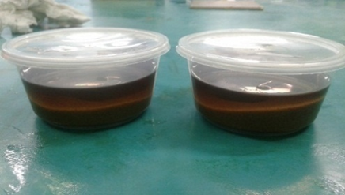

Figure 1. Oily sand preparation

Surfactants

The non-ionic biosurfactant used from saponin (Sigma-Aldrich) is in powder form. This plant based saponin acts as a surface-agent as a solute with various amounts to prepare the surfactant solution. The molecular weight of saponin is 1.5 g/mol with density of 1.02 g/cm³ and composition of sapogenin of 25%. Meanwhile for the SDS (Sigma-Aldrich), it is a white powder form which possess 85% of active content with anionic charge. For the CTAB (cationic), it was also purchased from Sigma-Aldrich, with 99% purity. All of them were used in the oil removal process.

Solid characterization

The characterization of sand particles for the before and after cleaning process were performed using the Field Emission Scanning Electron Microscopy-Energy Dispersive X-ray (FESEM-EDX):JSM-6701F located at CSNano Laboratory, Ibnu Sina Institute, Universiti Teknologi Malaysia.

IFT of surfactants

The Krüss Tensiometer-K6 (Du Noüy ring method) which is available at the Reservoir Laboratory, School of Chemical and Energy Engineering, Universiti Teknologi Malaysia was used to determine the IFT in liquid-liquid interface. With this equipment, the CMC of surfactants was able to be determined and then used as a mechanism in oily sand cleaning.

Hydrocyclone washing machine

The hydrocyclone Separator-Pilot cyclone EPC100P for LSS was designed and fabricated-in-house by the Environment Laboratory, Universiti Teknologi Malaysia. The machine has 150 cm thickness with diameter of 100 cm together with 50 cm nozzle at discharge valve line. The hydrocyclone was equipped with the pump that can speed up to 6000 rpm. This centrifugal effect (cyclone) was used to wash the oily sand by adding the distilled water and surfactants in the system. After the washing process has been accomplished, the sand was discharged through the discharge valve at the bottom of the container.

Oily sand cleaning process

The concentration for each surfactant which consists of 0.05 wt.%, 0.1 wt.%, 0.3 wt.%, 0.5 wt.%, 0.8 wt.%, and 1.0 wt.% was prepared based on equation 1. Their CMC value can be determined by measuring the IFT between those surfactant concentration and paraffin oil followed by the graph plotting of IFT versus surfactant concentration [17]. After the IFT screening, optimum surfactant concentration at CMC point was opted to clean the oily sand.

$C_{su} \left(wt\%\right)=\frac{W_{su}}{W_{H2O}+W_{sand}+W_{oil}+W_{su}}$ x 100% (1)

where C_{su} is surfactant concentration in wt.%, W_{su} is weight of surfactant, W_{H20} is weight of water, W_{sand} is weight of sand particles and W_{oil} is weight of paraffin oil.

The method used for this work is summarized in Figure 2. To investigate the effects of surfactant addition and hydrocyclone application, the cleaning process was also performed with the absence of surfactant (only use distilled water) and hydrocyclone. Basically, with the surfactants and hydrocyclone application, the oily sand (with recorded weight) was poured together with 1000 mL of distilled water into hydrocyclone system. After that, the contaminated sand was washed for 60, 90, 120, and 150 min with 3000 rpm and then left for 10 min [44]. Next, the sand was flushed out from the hydrocyclone to the sand collector. Then, the collected sand was filtered, cleansed with distilled water, and heated at 100 °C for 1.5 hour to remove the moisture and the surfactants [45]. After the heating process completed, the clean sand was left for 3 hours in the ambience temperature (27 °C) and then weighted in order to calculate the percentage of oil removed.

The experiment was performed with different CMC surfactant concentration (different type of surfactant) with washing time up to 150 minutes and fixed 3000 rpm centrifugal rotation. The micrographs and elemental analysis obtained from the Field Emission Scanning Electron Microscopy-Energy Dispersive X-ray (FESEM-EDX) was used to describe the sand (before and after the cleaning process). Once the cleaning process has completed, the effluent was filtered and discharged. The efficiency of this cleaning system was referred to different value of samples weighed before and after experiment using a gravimetric method [46]. It can be obtained by comparing the percentage of oil removal on sample weight by using Equation 2.

$Oil removed \left(\%\right)=\frac{W_{b}-W_{a}}{W_{oil}}×100\%$ (2)

where W_{b} is total weight of contaminated sand before washing (g), W_{a} is total weight of contaminated sand after washing (g) and W_{oil} is initial oil in sand (g).

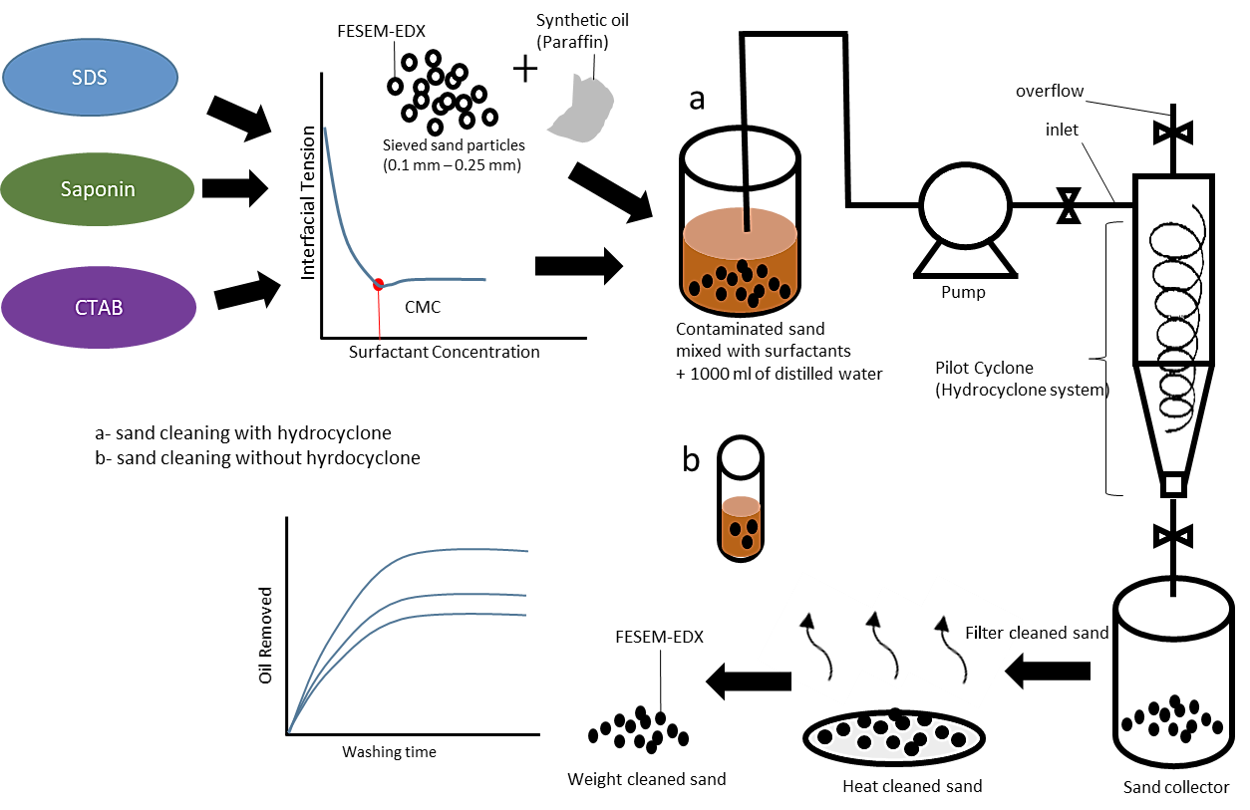

Figure 2. Method used for oily sand cleaning process

Results and Discussion

IFT screening

Surfactant was normally used in cleaning job especially for oil removal in which it can improve the mobility of contaminants from contaminated particles [13]. Thus, it is vital to screen the optimum surfactant concentration so that the cleaning process efficiency become better. The optimum surfactant concentration can be obtained by determining the CMC point of the surfactant. Figure 3 depicts the plot of IFT versus surfactant concentration for different type of surfactant used in this work. The CMC point which denoted by the vertical red line was determined using the meeting-point between two slopes (black line) from the graph. In other word, the CMC point is denoted by the optimum surfactant concentration in which the reduction in IFT is insignificant for the surfactant concentration beyond that point. This concept of selecting the optimum surfactant concentration for oily solid particles cleaning also corresponded with previous scholars [28, 30, 38]. Based on Figure 3(a-c), the optimum surfactant concentration for SDS, saponin, and CTAB are 0.34 wt.%, 0.58 wt.%, 0.13 wt.%, respectively. These optimum concentrations were then further adopted in our oily sand cleaning process.

Effect of surfactants and hydrocyclone on cleaning process efficiency

Figure 4 summarizes the cleaning process efficiency (oil removal, %) with assistance of hydrocyclone with the surfactants’ presence (optimum surfactant concentration) and absence (only use distilled water) at different washing time. Generally, the percentage of oil removal increased with the increase of washing time. Without surfactants, the maximum percentage of oil removal that can be obtained only limited to 46% with total washing time of 150 min. With surfactants, the oil removal percentage increased to greater than 75% with CTAB exhibits the highest percentage (90%), followed by SDS (87%), and saponin (79%). There were two possible mechanisms involved in removing the oil from the sand with the surfactant presence which are the micellar solubilization and mobilization of surfactants by centrifugal force (cyclone) [29, 39]. Based on our work, the cationic CTAB results in the highest performance for sand cleaning and this finding is also parallel with Gu et al. [25] and Nandwani et al. [38], respectively. Even though the distilled water is ineffective in oil removal as compared to the surfactants’ application, however, it is recommended to apply the distilled water first before proceeding with the surfactant. By doing this, the consumption of surfactants in the cleaning process can be reduced significantly or in other words, reduce the cost effectively.

The effects of hydrocyclone on cleaning process efficiency has been investigated. The same cleaning solution (distilled water and optimum surfactant concentration) has also been applied to the system without the hydrocyclone. The comparison between them (with and without the hydrocyclone) is shown in Figure 5. Obviously, the percentage of oil removal from the sand was decreased (19-22%) with no hydrocyclone in the cleaning system regardless of the surfactants presence or not. Therefore, it can be concluded that the synergized effects of optimum surfactant concentration and hydrocyclone applications at 150 min washing time results in higher cleaning process efficiency.

Further analysis on the effects of using hydrocyclone on effluent produced from the cleaning process is depicted in Figure 6. Without the hydrocyclone (Figure 6a), the effluent behavior exhibited two separate layers which composed of oil and surfactant solution. Meanwhile with the hydrocyclone (Figure 6b), three distinct layers existed which consist of foam and turbidity (wash layer). All the effluents from the surfactants used in this work exhibit similar layer formation as in Figure 6b with CTAB results in the highest foam and turbidity formation, while the saponin exhibit the least. The least formation of foam for saponin (non-ionic) is due to no surface charge on the foam films and larger surface area of molecules [34]. As the CTAB is a cationic surfactant, it resulted in higher adsorption of oil which then cause in more turbidity as compared to SDS and saponin [23].

Sand analysis for before and after cleaning process with hydrocyclone assistance

The EDX results of the sand for the before and after cleaning process are shown in Table 2. Before the cleaning process, the sand consists of dominance Si-O (quartz-sand) with small traces of Al, Fe, Ca and K which typically found in sandy beaches. The traces of Fe element are possibly due to nature occurrences caused by sedimentation from weathered volcanic rock that precipitate which then influence the composition of the used sand [22]. After the cleaning process, the sand has shown the presence of saponin at optimum surfactant concentration which results in significant reduction of heavy metal elements (Fe, Al, Mg). Thus, in addition to remove oil from the sand, saponin is also capable to reduce heavy metal elements and the results obtained resemble the works by previous scholars [21]. As compared to the sand before the cleaning process, higher C content was found for those three surfactants after the cleaning process. This might be due to the unsettled paraffin component on the sand [31].

Figure 7a shows a FESEM micrograph for the sand before the cleaning process. Obviously, it can be seen that a relatively small particles attached on sand which possibly due to the clay and iron oxide particles formation. After three cleaning process with the SDS (Figure 7b) and saponin (Figure 7c), white materials on sand were detected and this might be an organic compound that absorbed and precipitate on sand during the cleaning. There are no white materials detected on the sand for the CTAB surfactant in Figure 7d. This might be due to the hydrophilic nature of CTAB which effectively enhance the oil compound absorption on sand and oil removal process.

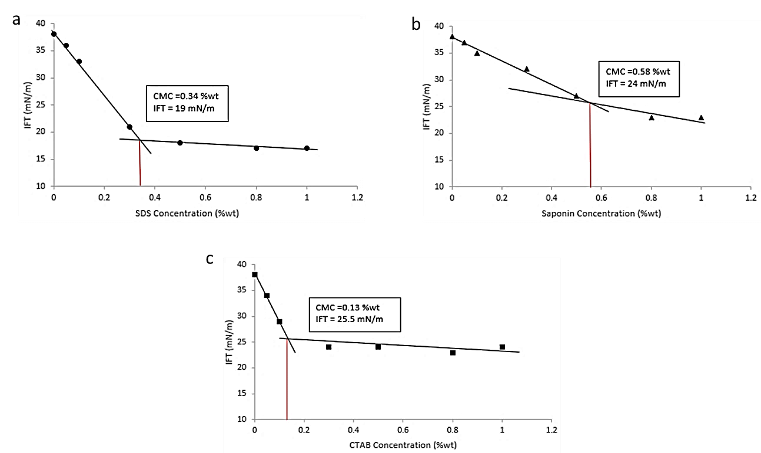

Figure 3. IFT versus surfactant concentration, (a) SDS, (b) Saponin and (c) CTAB

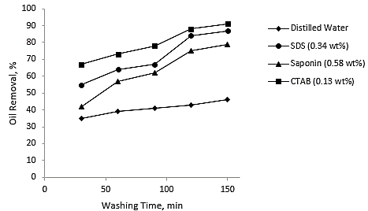

Figure 4. Oil removal percentage versus washing time.

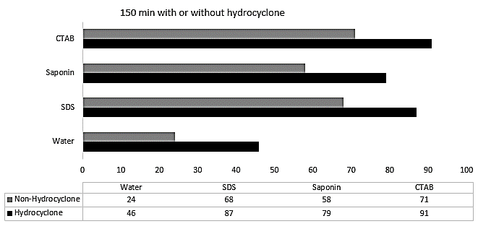

Figure 5. Oil removal percentage with and without LSS hydrocyclone separator for 150 min washing time

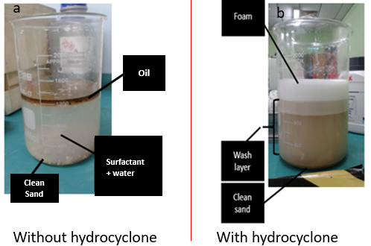

Figure 6. Effluent behaviour from the cleaning process, (a) without hydrocyclone and (b) with hydrocyclone

Table 2. EDX elemental analysis on sand for before and after cleaning process
Element, wt.% | C | O | Na | Mg | Al | Si | K | Ca | Fe
Before | 0.1 | 37.1 | 1.2 | 1.2 | 5.7 | 28.2 | 2.2 | 2.3 | 4.3
After (SDS) | 1.2 | 35.0 | 1.0 | 1.2 | 5.0 | 28.0 | 2.0 | 2.3 | 3.2
After (Saponin) | 1.3 | 35.3 | 0.5 | 0.7 | 2.1 | 28.1 | 1.2 | 1.8 | 1.7
After (CTAB) | 0.7 | 36.0 | 1.1 | 1.2 | 5.2 | 28.2 | 2.2 | 2.2 | 2.2

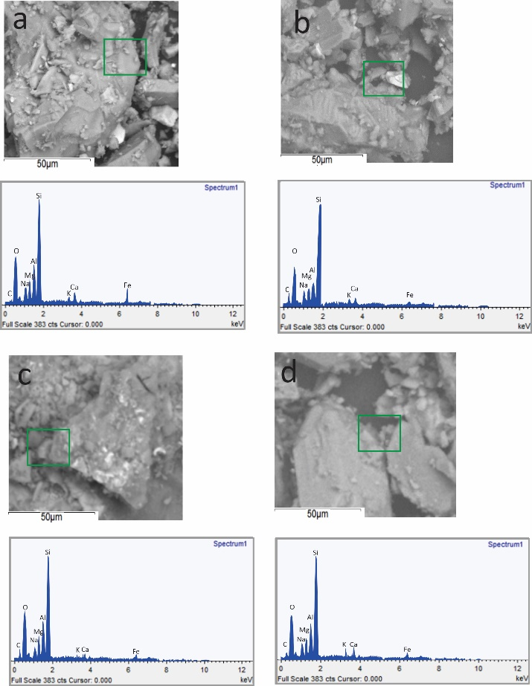

Figure 7. FESEM-EDX micrographs sand particles, (a) before cleaned, and after cleaned by (b) SDS, (c) saponin and (d) CTAB

Conclusion

The IFT screening on surfactants (SDS, saponin, and CTAB) and the oily sand washing through LSS hydrocyclone has been determined systematically. Based on the findings from this work, it can be concluded that the IFT values decreased significantly for the surfactant concentration below the CMC point. Increased in surfactant concentration exceeding the CMC point only results in insignificant IFT reduction. The CTAB at optimum surfactant concentration resulted in higher cleaning process efficiency (greater amount of oil removal) as compared to SDS and saponin. With the hydrocyclone assistance, the efficiency became greater and the improvement was due to the synergized effects (surfactant-IFT and centrifugal force). Saponin surfactant has a binary function whereby it can remove the oil from the sand and reduce heavy metal elements. These binary functions are possibly able to avoid the secondary pollution and reduce the washing time so that the oil sand disposal requirements set by the authority can be fulfilled.

Acknowledgement

We would like to thank the Ibnu Sina Institute and the School of Chemical and Energy Engineering, Universiti Teknologi Malaysia for the laboratory equipment and sample characterization and this work is funded by UTM Transdiciplinary Research Grant (Q. J130000.3551.07G12).

References
- Rawlins, H. (2013). Sand management methodologies for sustained facilities operations. Oil and Gas Facilities, 2(05): 27-34.
- Ikporo, B. and Sylvester, O. (2015). Effect of sand invasion on oil well production: a case study of Garon field in the Niger Delta. The International Journal of Engineering and Science, 4(5): 64-72.
- Pichtel, J. (2016). Oil and gas production wastewater: Soil contamination and pollution prevention. Applied and Environmental Soil Science, 2016: 1-25.
- Khamehchi, E., Ameri, O. and Alizadeh, A. (2015). Choosing an optimum sand control method. Egyptian Journal of Petroleum, 24(2): 193-202.
- Jiuxing, Z. H. Y. Y. W. and Dongping, W. (2010). A study on oily sludge (sand) treatment technology. Environmental Protection of Oil & Gas Fields, 3: 1-20.
- Zali, M. A., Ahmad, W. K. W., Retnam, A. and Catrina, N. (2015). Concentration of heavy metals in virgin, used, recovered and waste oil: a spectroscopic study. Procedia Environmental Sciences, 30: 201-204.
- AlSofi, A. M., AlKhatib, A. M., Al-Ajwad, H. A., Wang, Q. and Zahrani, B. H. (2019). Assessment of enhanced-oil-recovery-chemicals production and its potential effect on upstream facilities. SPE Journal, 24(3): 1-037.
- Bahmani, F., Ataei, S. A. and Mikaili, M. A. (2018). The effect of moisture content variation on the bioremediation of hydrocarbon contaminated soils: modeling and experimental investigation. Journal of Environmental Analytical Chemistry, 5(2): 236.
- Liu, P. W. G., Chang, T. C., Whang, L. M., Kao, C. H., Pan, P. T. and Cheng, S. S. (2011). Bioremediation of petroleum hydrocarbon contaminated soil: Effects of strategies and microbial community shift. International Biodeterioration & Biodegradation, 65(8): 1119-1127.
- Jing, G., Chen, T. and Luan, M. (2016). Studying oily sludge treatment by thermo chemistry. Arabian Journal of Chemistry, 9: S457-S460.
- Muñoz-Morales, M., Braojos, M., Sáez, C., Cañizares, P. and Rodrigo, M. A. (2017). Remediation of soils polluted with lindane using surfactant-aided soil washing and electrochemical oxidation. Journal of Hazardous Materials, 339: 232-238.
- Gao, Y. X., Ding, R., Chen, X., Gong, Z. B., Zhang, Y. and Yang, M. (2018). Ultrasonic washing for oily sludge treatment in pilot scale. Ultrasonics, 90: 1-4.
- Arelli, A., Nuzzo, A., Sabia, C., Banat, I. M., Zanaroli, G. and Fava, F. (2018). Optimization of washing conditions with biogenic mobilizing agents for marine fuel-contaminated beach sands. New Biotechnology, 43: 13-22.
- Singh, A. K. and Cameotra, S. S. (2013). Efficiency of lipopeptide biosurfactants in removal of petroleum hydrocarbons and heavy metals from contaminated soil. Environmental Science and Pollution Research, 20(10): 7367-7376.
- Belhaj, A. F., Elraies, K. A., Alnarabiji, M. S., Shuhli, J. A., Mahmood, S. M. and Ern, L. W. (2019). Experimental investigation of surfactant partitioning in pre-CMC and post-CMC regimes for enhanced oil recovery application. Energies, 12(12): 2319.
- Manshad, A. K., Rezaei, M., Moradi, S., Nowrouzi, I. and Mohammadi, A. H. (2017). Wettability alteration and interfacial tension (IFT) reduction in enhanced oil recovery (EOR) process by ionic liquid flooding. Journal of Molecular Liquids, 248: 153-162.
- Duan, M., Wang, X., Fang, S., Zhao, B., Li, C. and Xiong, Y. (2018). Treatment of Daqing oily sludge by thermochemical cleaning method. Colloids and Surfaces A: Physicochemical and Engineering Aspects, 554: 272-278.
- Bahadori, A. (2018). Fundamentals of enhanced oil and gas recovery from conventional and unconventional reservoirs. Gulf Professional Publishing.

- Saidy, A. R., Smernik, R. J., Baldock, J. A., Kaiser, K. and Sanderman, J. (2013). The sorption of organic carbon onto differing clay minerals in the presence and absence of hydrous iron oxide. Geoderma, 209: 15-21.
- Ferreira, T. M., Bernin, D. and Topgaard, D. (2013). NMR studies of nonionic surfactants. In Annual Reports on NMR Spectroscopy. Academic Press, 79: pp. 73-127.
- Tang, J., He, J., Xin, X., Hu, H. and Liu, T. (2018). Biosurfactants enhanced heavy metals removal from sludge in the electrokinetic treatment. Chemical Engineering Journal, 334: 2579-2592.
- Borghi, C. C., Fabbri, M., Fiorini, M., Mancini, M. and Ribani, P. L. (2011). Magnetic removal of surfactants from wastewater using micrometric iron oxide powders. Separation and Purification Technology, 83: 180-188.
- Dehaghani, A. H. S. and Badizad, M. H. (2018). Effect of magnetic field treatment on interfacial tension of CTAB nano-emulsion: Developing a novel agent for enhanced oil recovery. Journal of Molecular Liquids, 261: 107-114.
- Para, G., Hamerska-Dudra, A., Wilk, K. A. and Warszyński, P. (2010). Surface activity of cationic surfactants, influence of molecular structure. Colloids and Surfaces A: Physicochemical and Engineering Aspects, 365(1-3): 215-221.
- Gu, X., Zhang, F., Li, Y., Zhang, J., Chen, S., Qu, C. and Chen, G. (2018). Investigation of cationic surfactants as clean flow improvers for crude oil and a mechanism study. Journal of Petroleum Science and Engineering, 164: 87-90.
- Negin, C., Ali, S. and Xie, Q. (2017). Most common surfactants employed in chemical enhanced oil recovery. Petroleum, 3(2): 197-211.
- Urum, K., Pekdemir, T. and Gopur, M. (2003). Optimum conditions for washing of crude oil-contaminated soil with biosurfactant solutions. Process Safety and Environmental Protection, 81(3): 203-209.
- Khalladi, R., Benhabiles, O., Bentahar, F. and Moulai-Mostefa, N. (2009). Surfactant remediation of diesel fuel polluted soil. Journal of Hazardous Materials, 164(2-3): 1179-1184.
- Bandala, E. R., Aguilar, F. and Torres, L. G. (2010). Surfactant-enhanced soil washing for the remediation of sites contaminated with pesticides. Land Contamination & Reclamation, 18(2): 2.
- Long, A., Zhang, H. and Lei, Y. (2013). Surfactant flushing remediation of toluene contaminated soil: Optimization with response surface methodology and surfactant recovery by selective oxidation with sulfate radicals. Separation and Purification Technology, 118: 612-619.
- Huang, Z., Wang, D., Befkadu, A. A., Zhou, J., Srivastava, I., Pan, D. and Chen, Q. (2020). Enhancement of auxiliary agent for washing efficiency of diesel contaminated soil with surfactants. Chemosphere, 252: 126494.
- Zheng, C., Wang, M., Wang, Y. and Huang, Z. (2012). Optimization of biosurfactant-mediated oil extraction from oil sludge. Bioresource Technology, 110: 338-342.
- Kobayashi, T., Kaminaga, H., Navarro, R. R. and Iimura, Y. (2012). Application of aqueous saponin on the remediation of polycyclic aromatic hydrocarbons-contaminated soil. Journal of Environmental Science and Health, Part A, 47(8), 1138-1145.
- Zhou, W., Wang, X., Chen, C. and Zhu, L. (2013). Enhanced soil washing of phenanthrene by a plant-derived natural biosurfactant, Sapindus saponin. Colloids and Surfaces A: Physicochemical and Engineering Aspects, 425: 122-128.
- Li, G., Guo, S. and Hu, J. (2016). The influence of clay minerals and surfactants on hydrocarbon removal during the washing of petroleum-contaminated soil. Chemical Engineering Journal, 286: 191-197.
- Trisunaryanti, W., Larasati, S., Bahri, S., lailun Ni’mah, Y., Efiyanti, L., Amri, K. and Sumbogo, S. D. (2020). Performance comparison of Ni-Fe loaded on NH₂-functionalized mesoporous silica and beach sand in the hydrotreatment of waste palm cooking oil. Journal of Environmental Chemical Engineering, 8(6): 104477.
- Zhu, Z., Zhang, B., Chen, B., Cai, Q. and Lin, W. (2016). Biosurfactant production by marine-originated bacteria Bacillus Subtilis and its application for crude oil removal. Water, Air, & Soil Pollution, 227(9): 328.
- Nandwani, S. K., Malek, N. I., Lad, V. N., Chakraborty, M. and Gupta, S. (2017). Study on interfacial properties of Imidazolium ionic liquids as surfactant and their application in enhanced oil recovery. Colloids and Surfaces A: Physicochemical and Engineering Aspects, 516: 383-393.
- Saad, M. A., Kamil, M., Abdurahman, N. H., Yunus, R. M. and Awad, O. I. (2019). An overview of recent advances in state-of-the-art techniques in the demulsification of crude oil emulsions. Processes, 7(7): 470.
- Yurdem, H., Demir, V. and Degirmencioglu, A. (2010). Development of a mathematical model to predict clean water head losses in hydrocyclone filters in drip irrigation systems using dimensional analysis. Biosystems Engineering, 105(4): 495-506.
- Durdevic, P., Pedersen, S., Bram, M., Hansen, D., Hassan, A. and Yang, Z. (2015). Control oriented modeling of a de-oiling hydrocyclone. IFAC-PapersOnLine, 48(28): 291-296.
- Shi, Y., Zhu, H., Zhang, J., Yin, B., Xu, R. and Zhao, J. (2017). Investigation of condition parameters in each stage of a three-stage helico-axial multiphase pump via numerical simulation. In the 27th International Ocean and Polar Engineering Conference. International Society of Offshore and Polar Engineers.
- ASTM E11 (2013). Standard specification for woven wire test sieve cloth and test sieves. West Conshohocken: ASTM
- Arpornpong, N., Padungpol, R., Khondee, N., Tongcumpou, C., Soonglerdsongpha, S., Suttiponparnit, K. and Luepromchai, E. (2020). Formulation of bio-based washing agent and its application for removal of petroleum hydrocarbons from drill cuttings before bioremediation. Frontiers in Bioengineering and Biotechnology, 8: 961.
- Falciglia, P. P., Giustra, M. G. and Vagliasindi, F. G. A. (2011). Low-temperature thermal desorption of diesel polluted soil: Influence of temperature and soil texture on contaminant removal kinetics. Journal of Hazardous Materials, 185(1): 392-400.
- Villalobos, M., Avila-Forcada, A. P. and Gutierrez-Ruiz, M. E. (2008). An improved gravimetric method to determine total petroleum hydrocarbons in contaminated soils. Water, Air, and Soil Pollution, 194(1-4): 151-161.

