Natural radioactivity of ²¹⁰Pb in mussels at the semi-enclosed water of the Johor Strait, Malaysia

through statistical approach

(Radioaktiviti Semulajadi ²¹⁰Pb dalam Kupang di Perairan Separa-Tertutup Selat Johor, Malaysia Melalui Pendekatan Statistik)

Noor Affizah Bujang Saili and Che Abd Rahim Mohamed*

Department of Earth Sciences and Environment,

Faculty of Science and Technology

Universiti Kebangsaan Malaysia, 43600 UKM Bangi, Selangor, Malaysia

*Corresponding author: carmohd@ukm.edu.my

Abstract
Mussel and seawater samples were collected along the Johor Strait during the northeast monsoon, inter-monsoon, and southwest monsoon. The aim of this study is to determine the allometric relationship of ²¹⁰Pb and investigate the ²¹⁰Pb content in mussel tissues where there is semi-enclosed water flow. The statistical tests (varian ANOVA) indicate an insignificant relationship between mussel condition indexes (Ci) related to seasons and geography. A high level of ²¹⁰Pb in mussels (mean: 29.33±6.65 Bq kg⁻¹ dry weight) was measured during inter-monsoon with less dissolved oxygen content (< 3.0 mg L⁻¹). The causeway structure disrupts water quality and conditions in the Johor Strait and causes almost hypoxic conditions in its vicinity. That dissolved oxygen in the water column is inversely proportional to ²¹⁰Pb in mussels proves that oxygen deficiency is influenced the bioaccumulation of ²¹⁰Pb in mussels.

Keywords: Johor Strait, dissolved oxygen, hypoxia, monsoon, ²¹⁰Pb

Abstrak
Sampel kupang dan air laut diambil di sepanjang Selat Johor pada musim monsun timur laut, inter-monsun dan monsun barat daya. Matlamat kajian ini adalah untuk menentukan hubungan allometrik ²¹⁰Pb dan mengkaji kandungan ²¹⁰Pb dalam tisu kupang khususnya di perairan separa-tertutup. Ujian statistik (varian ANOVA) menunjukkan hubungan yang tidak signifikan di antara indeks keadaan kupang (C_{i}) terhadap perubahan musim dan keadaan geografi. Kandungan ²¹⁰Pb yang tertinggi dalam kupang (min: 29.33±6.65 Bq kg⁻¹ berat kering) diperolehi pada musin inter-monsun di mana kandungan oksigen terlarut adalah pada paras yang rendah (< 3.0 mg L⁻¹). Struktur tambak telah menyekat aliran air dan menyebabkan kualiti air di perairan Selat Johor menghampiri keadaan hipoksik. Kandungan oksigen terlarut dalam turus air berkadar sonsang terhadap kandungan ²¹⁰Pb dalam kupang dan ini membuktikan kekurangan oksigen teralarut mempengaruhi bioakumulasi ²¹⁰Pb dalam kupang.

Kata kunci: Selat Johor, oksigen terlarut, hipoksia, monsun, ²¹⁰Pb

Introduction
Lead-210 (²¹⁰Pb, half-life, t_{1/2}: 22.3 years) is well known as a particle reactive radionuclide that is widely utilized as a tracer in marine geochemistry to determine sedimentation rate and particle scavenging in the water column. However, there are limited studies on ²¹⁰Pb especially on radiological risk to aquatic organisms compared to its progeny ²¹⁰Po. The ²¹⁰Pb radionuclide is presumed to be less significant in terms of radiation hazard to aquatic organism health as well as in its effect on humans. The concern arises through the improvement of the established method of chemical speciation which contributed to new findings on ²¹⁰Pb binding capacity in marine sediments. In anoxic sediments, about 5 to 33% of ²¹⁰Pb is bound to organic matter [1] and it is reported that more than 50% of organic matter preserved in surface sediments are exposed to hypoxic conditions [2]. These findings trigger the question of ²¹⁰Pb bioavailability in an oxygen deficient environment.

Recently, anoxic, and hypoxic conditions in aquatic environments worldwide have been on the increase due to urbanization. Coastal development activities such as land reclamation are potential pathways and sediment sources which may contribute to anthropogenic support of ²¹⁰Pb in aquatic environments instead of that which is naturally produced from the in-situ decay of radium-226 (²²⁶Ra, half-life =1600 years). In addition, the source of unsupported ²¹⁰Pb in shallow water regions originates largely from the atmospheric deposition results in the exclusive decay of radon-222 (²²²Rn, half-life =3.82 days). The ²¹⁰Pb radionuclide is thus introduced into aquatic environments via rainfall into rivers, estuaries, and seas. However, ²¹⁰Pb is more particle-reactive and eliminated by suspended particulate matters [3]. The distribution of ²¹⁰Pb in an aquatic environment is subject to the interaction between dissolved and small particulate phases via sorption/ desorption as well as reversible ²¹⁰Pb exchange by small and large particulate phases by aggregation/ disaggregation [4]. Finally, the particulate matter will fall to the seabed and become part of surface sediment.

According to previous studies, radionuclide concentration in mussels significantly decreases with size [5, 6]. However, other factors e.g. local environmental conditions, hypoxia and season changes might also influence the variation of radionuclides in mussels [6]. The Johor Strait has undergone extensive development and has been established as an important site for aquaculture production of marine fishes and mussels as a local source of protein. Unfortunately, the causeway structure and industrial discharge along the Johor Straits are significantly interrupts the status marine water quality [7]. In addition, the strait is located in the tropics, which is affected by seasonal monsoons. Therefore, this study may contribute to new insight on 210Pb behavior in mussels in the tropics in semi-enclosed marine areas and hypoxic conditions which not published by the previous researchers and will be also useful as a comparison with other subtropical regions. The purpose of this study is to investigate the behaviors and level of 210Pb in mussels with the geography of shallow straits through the statistical approach.

Materials and Methods

Study area and sample collection

The Johor Strait is located between Malaysia and Singapore as established as the largest mussel’s production in Malaysia [7]. Therefore, the Johor Strait was selected as a study area to understand the behavior of ²¹⁰Pb in the aquatic organisms. Green mussels (Perna viridis) have been established as a good bioindicator due to its sessile and filter feeding habits as well as its abundance in the Johor Strait [8, 9].

Sampling was conducted three times in the periods between 29th to 30th November 2017, 28th to 29th March 2018 and 1st to 2nd August 2018 during the northeast monsoon, inter-monsoon and southwest monsoon, respectively. Sampling stations were identified along the Johor Strait by considering the causeway structure which separates the water body into two regions (Figure 1). On the western half of the Johor Strait (WJS) there were three sample collection stations and six sampling stations on the eastern side of the Causeway (EJS).

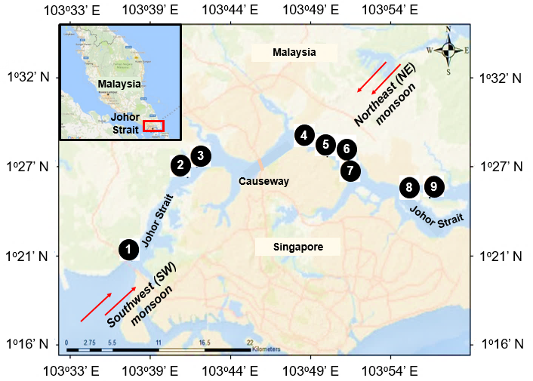
Figure 1. Map of Johor Strait which is separated by a causeway structure that links Malaysia and Singapore with monsoon wind directions. The western part of the Johor Strait (WJS) consists of Station 1 until Station 3, meanwhile the eastern part of the Johor Strait (EJS) region consists of Station 4 until Station 9

Mussels were collected from each station by hand and were usually found attached on vertical ropes tied to floating rafts at 0.5 to 2 m depth in the water column. Samples were washed and separated based on their length as follows: small (< 5 cm), medium (between 5 to 7 cm) and large (> 7 cm). The weight, length and gonad condition of the mussels were recorded individually before the soft tissues were detached from the shell. Female gonad maturation was observed based on > 50% orange gonadal tissues covering the mantle (Figure 2). The soft tissue samples from each size interval were pooled and dried at 60 °C in the oven to constant weight. The soft tissue samples were then homogenized and 3 replicates from the pooled samples were proceeding for acid digestion. The results of the three replicates were averaged for reporting (dry weight) and the standard deviation is based on the replicates.

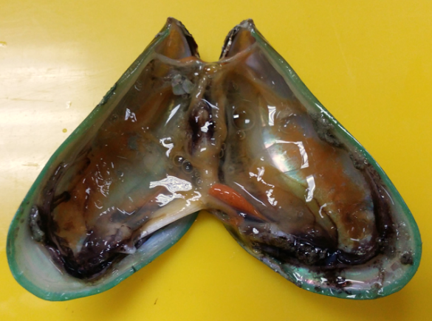

Figure 2. Female gonad maturation with > 50% orange gonadal tissues covering the mantle

In-situ surface water quality parameters were recorded using a calibrated YSI (Professional Plus) at 1.0 m depth near the mussel rafts. About 20 L of seawater was taken using a Niskin water sampler at the same point where the water quality measurement was taken. All the samples were brought to the laboratory and filtered before proceeding to chemical extraction. Meanwhile, another 3 L of seawater were kept in opaque PE bottle and immediately filtered within 24 hours upon sampling time for chlorophyll-a analysis.

Chemical extraction
Published analytical procedures were applied [10, 11] where about 0.3 g of homogenized mussel powder was spiked with 20 mg mL⁻¹ of lead nitrate, Pb(NO₃)₂ as chemical yield. Closed digestion was then performed by mixing 9 mL of nitric acid, HNO₃ and 3 mL of hydrogen peroxide, H₂O₂ (3:1) for 3 hours on a hotplate at 80 °C. The solution was thereafter filtered using 0.45 µm pore size glass fiber filter paper (Advantec), dried and dissolved with 50 mL of 0.5 M HNO₃ for purification. About 20 L of filtered seawater samples were filtered again through 0.45 µm pore size pre-weighted membrane filters following published analytical procedures for purification [12, 13].

Finally, ²¹⁰Pb was measured using the Gross Alpha-beta Spectrometry (Canberra Tennelec Model Series 5 XLB with Eclipse software) based on the growth of its immediate daughter 210Bi which established equilibrium greater than 98% after 30 days. Analytical quality control was also applied with three replicates of Certified Reference Material IAEA-437 with yield recovery mean value of 72±18%.

Statistical analysis
Statistical Package for the Social Sciences (SPSS) Version 16.0 was used to perform statistical operations. Analysis of Variance (ANOVA) is a parametric test that determines whether there is any statistical significance between the means of 210Pb relative to stations, regions, and sampling periods. In order to perform the ANOVA test, all the pre-requisite protocols are certified with parametric statistics. The deviated data processed under Kruskal-Wallis ANOVA with a statistically significant value of p < 0.05.

Follow-up analyses for ANOVA effect size were estimated manually by calculating the eta-square (ɳ²) which is easily interpreted as the proportion of variance in the dependent variable that can be attributed to the independent variable. The ɳ² for omnibus ANOVA effect size was calculated as described in Eq. (1):

$ɳ^{2}=\frac{{SS}_{Between}}{{SS}_{Total}}$ | (1)

where the SS_{Between} is the between-group sum of squares, and the SS_{Total} is the total sum of squares, with both values obtained from the ANOVA summary table. Cohen [14] suggested that the ɳ² values of 0.10, 0.59 and 1.38 could be considered as small, medium, and large effect sizes, respectively.

The ɳ² was also calculated using the Kruskal-Wallis ANOVA effect size as shown in Eq. (2):

ɳ² = [ ꭓ²] / (N – 1) | (2)

where, the chi-square (ꭓ²) value can be read from the statistic output and N is the total sample size. In this study, the effect size of Kruskal-Wallis ANOVA is represented as Cohen’s f in Eq. (3):
$f=\sqrt{\frac{ɳ^{2}}{1-ɳ^{2}}}$ | (3)

The f values could be considered as small, medium, and large effect sizes respectively, and were 0.10, 0.25 and 0.40 [14].

Paleontological Statistics (PAST3.26) software was used to perform a Linear Discriminant Analysis (LDA). LDA is a multivariate analysis that can best separate group data and provides more information about underlying dimensions. All the data were log-transformed in order to get normal distribution data (p > 0.05) before proceeding to the LDA analysis. A convex hull was selected instead of 95% ellipses to display clear discrimination in a scatter plot.

Mussels allometric
Each mussel’s physiological status was determined using the Mussel Condition Index (Ci) as described by Lucas & Beniger [15] in Eq. (4):

(Ci) = W.L⁻³ × 10⁶ | (4)

where W is the average of soft tissues in dry weight (g) and L is the average of shell maximum length (mm). Normally, a mussel’s higher body weight and shell length corresponds to its age.

Concentration Factor
The concentration factor (CF) is derived in terms of unit volume and is expressed in L kg⁻¹ as described in Eq. (5) at a steady state IAEA [16]:

CF (L kg⁻¹) = | Concentration per unit mass of organism (Bq kg⁻¹) |  | (5)
CF (L kg⁻¹) = | Concentration per unit volume of seawater (Bq L⁻¹) |  | (5)

where, ²¹⁰Pb activities in mussels from each station were the average of small, medium, and large sizes in dry weight as there was no significant difference between sizes. The CF value is a rapid observation to investigate the ability of mussels in the Johor Strait to concentrate 210Pb from their surroundings.

Results and Discussion
Allometric relationships of ²¹⁰Pb in mussels
In order to investigate the effect of mussel sizes on ²¹⁰Pb activities, the mean biometric parameters of mussels at different time of sampling sessions, regions, and sizes are displayed in Table 1. An analysis of variance (ANOVA) showed significant differences in physiological C_{i} with regards to different mussel sizes (F(2,54) = 27.330, p = 0.000, ɳ² = 0.503) which constantly decreases throughout their lifespan with a of mean 4.497 ± 0.789 (small), 3.377 ± 0.682 (medium) and 2.746 ± 0.553 (large). According to previous studies, the physiological C_{i} was sensitive to reproductive development [17, 18] and the depletion of glycogen as well as a cycle of lipid storage during gonad maturation, which then contributes to low physiological C_{i} [19]. In general, reproduction was very sensitive to temperature changes and food availability as well discussed by previous researcher [20].

Table 1. Mean biometric parameters and ²¹⁰Pb activities in mussel soft tissues at different sampling times, regions, and sizes
Sampling |  | Region |  | Station |  | Size |  | N | Shell  Length  (mm) | Dry Weight Soft Tissues  (g) | Condition  Index  (Ci) | ²¹⁰Pb in Mussels  (Bq kg⁻¹) d.w.
Northeast monsoon  (29th -30th November 2017) | WJS |  | 1 |  | S |  | 12 |  | 45.47 | 0.378 | 4.02 | 16.41 | ± | 5.06
Northeast monsoon  (29th -30th November 2017) |  |  |  |  | M |  | 12 |  | 55.51 | 0.545 | 3.14 | 5.59 | ± | 5.28
Northeast monsoon  (29th -30th November 2017) |  |  |  |  | L |  | 3 |  | 79.47 | 1.239 | 2.37 | 13.66 | ± | 4.26
Northeast monsoon  (29th -30th November 2017) |  |  | 2 |  | S |  | 6 |  | 38.67 | 0.246 | 4.30 | 14.91 | ± | 4.97
Northeast monsoon  (29th -30th November 2017) |  |  |  |  | M |  | 7 |  | 57.96 | 0.505 | 2.63 | 8.72 | ± | 3.02
Northeast monsoon  (29th -30th November 2017) |  |  |  |  | L |  | 4 |  | 79.09 | 1.523 | 3.00 | 12.07 | ± | 3.82
Northeast monsoon  (29th -30th November 2017) |  |  | 3 |  | S |  | - |  | - | - | - |  | -
Northeast monsoon  (29th -30th November 2017) |  |  |  |  | M |  | 15 |  | 60.46 | 0.465 | 2.12 | 15.61 | ± | 7.95
Northeast monsoon  (29th -30th November 2017) |  |  |  |  | L |  | 16 |  | 74.12 | 0.772 | 1.91 | 12.14 | ± | 0.61
Northeast monsoon  (29th -30th November 2017) | EJS |  | 6 |  | S |  | 10 |  | 42.77 | 0.254 | 3.19 | 14.87 | ± | 7.16
Northeast monsoon  (29th -30th November 2017) |  |  |  |  | M |  | 7 |  | 57.93 | 0.468 | 2.43 | 18.77 | ± | 4.20
Northeast monsoon  (29th -30th November 2017) |  |  |  |  | L |  | - |  | - | - | - |  | -
Northeast monsoon  (29th -30th November 2017) |  |  | 8 |  | S |  | - |  | - | - | - |  | -
Northeast monsoon  (29th -30th November 2017) |  |  |  |  | M |  | 14 |  | 62.44 | 1.076 | 4.39 | 10.81 | ± | 5.46
Northeast monsoon  (29th -30th November 2017) |  |  |  |  | L |  | 14 |  | 84.35 | 2.196 | 3.76 | 16.45 | ± | 7.11
Northeast monsoon  (29th -30th November 2017) |  |  | 9 |  | S |  | - |  | - | - | - |  | -
Northeast monsoon  (29th -30th November 2017) |  |  |  |  | M |  | 15 |  | 63.74 | 1.061 | 4.05 | 14.66 | ± | 9.78
Northeast monsoon  (29th -30th November 2017) |  |  |  |  | L |  | 15 |  | 79.46 | 2.072 | 3.67 | 15.15 | ± | 6.12
inter-monsoon  (28th -29th March 2018) | WJS |  | 1 |  | S |  | 10 |  | 42.29 | 0.381 | 4.79 | 30.23 | ± | 14.35
inter-monsoon  (28th -29th March 2018) |  |  |  |  | M |  | 16 |  | 63.34 | 1.057 | 4.14 | 16.85 | ± | 12.23
inter-monsoon  (28th -29th March 2018) |  |  |  |  | L |  | 16 |  | 79.78 | 1.742 | 3.42 | 25.07 | ± | 10.05
inter-monsoon  (28th -29th March 2018) |  |  | 2 |  | S |  | 15 |  | 38.60 | 0.269 | 4.61 | 24.83 | ± | 10.52
inter-monsoon  (28th -29th March 2018) |  |  |  |  | M |  | 20 |  | 61.07 | 0.803 | 3.53 | 33.63 | ± | 12.30
inter-monsoon  (28th -29th March 2018) |  |  |  |  | L |  | 18 |  | 76.41 | 1.319 | 2.92 | 9.86 | ± | 9.08
inter-monsoon  (28th -29th March 2018) |  |  | 3 |  | S |  | - |  | - | - | - |  | -
inter-monsoon  (28th -29th March 2018) |  |  |  |  | M |  | 18 |  | 66.24 | 0.882 | 3.07 | 18.14 | ± | 8.50
inter-monsoon  (28th -29th March 2018) |  |  |  |  | L |  | 22 |  | 77.79 | 1.123 | 2.40 | 25.57 | ± | 10.58
inter-monsoon  (28th -29th March 2018) | EJS |  | 4 |  | S |  | - |  | - | - | - |  | -
inter-monsoon  (28th -29th March 2018) |  |  |  |  | M |  | 10 |  | 63.99 | 0.975 | 3.80 | 36.88 | ± | 14.26
inter-monsoon  (28th -29th March 2018) |  |  |  |  | L |  | 20 |  | 83.08 | 1.836 | 3.16 | 25.14 | ± | 18.33
inter-monsoon  (28th -29th March 2018) |  |  | 5 |  | S |  | - |  | - | - | - |  | -
inter-monsoon  (28th -29th March 2018) |  |  |  |  | M |  | 20 |  | 60.06 | 0.786 | 3.65 | 36.45 | ± | 14.55
inter-monsoon  (28th -29th March 2018) |  |  |  |  | L |  | 20 |  | 78.92 | 1.413 | 2.86 | 29.21 | ± | 27.46
inter-monsoon  (28th -29th March 2018) |  |  | 6 |  | S |  | - |  | - | - | - |  | -
inter-monsoon  (28th -29th March 2018) |  |  |  |  | M |  | 20 |  | 64.00 | 0.516 | 1.98 | 49.85 | ± | 43.84
inter-monsoon  (28th -29th March 2018) |  |  |  |  | L |  | 20 |  | 74.32 | 0.755 | 1.84 | 23.05 | ± | 15.82
inter-monsoon  (28th -29th March 2018) |  |  | 7 |  | S |  | 17 |  | 45.24 | 0.356 | 3.80 | 58.58 | ± | 3.83
inter-monsoon  (28th -29th March 2018) |  |  |  |  | M |  | 20 |  | 57.41 | 0.576 | 3.09 | 34.37 | ± | 8.07
inter-monsoon  (28th -29th March 2018) |  |  |  |  | L |  | 20 |  | 78.50 | 1.040 | 2.16 | 30.36 | ± | 25.18
inter-monsoon  (28th -29th March 2018) |  |  | 8 |  | S |  | - |  | - | - | - |  | -
inter-monsoon  (28th -29th March 2018) |  |  |  |  | M |  | 20 |  | 63.22 | 0.821 | 3.25 | 23.91 | ± | 21.90
inter-monsoon  (28th -29th March 2018) |  |  |  |  | L |  | 20 |  | 79.53 | 1.263 | 2.55 | 34.72 | ± | 12.75
inter-monsoon  (28th -29th March 2018) |  |  | 9 |  | S |  | 12 |  | 45.09 | 0.372 | 4.02 | 21.85 | ± | 0.60
inter-monsoon  (28th -29th March 2018) |  |  |  |  | M |  | 20 |  | 58.32 | 0.719 | 3.62 | 31.27 | ± | 24.04
inter-monsoon  (28th -29th March 2018) |  |  |  |  | L |  | 20 |  | 80.36 | 1.241 | 2.35 | 20.57 | ± | 23.04
 |  |  |  |  |  |  |  |  |  |  |  | continue…

…continue
Southwest monsoon  (1st-2nd August 2018) | WJS | 1 | S | - |  | - |  | - |  | - |  | -
Southwest monsoon  (1st-2nd August 2018) | WJS |  | M | 30 |  | 57.00 |  | 0.701 |  | 3.66 | 13.47 | ± | 4.58
Southwest monsoon  (1st-2nd August 2018) | WJS |  | L | 15 |  | 75.56 |  | 1.419 |  | 3.24 | 12.42 | ± | 4.03
Southwest monsoon  (1st-2nd August 2018) | WJS | 2 | S | 20 |  | 31.66 |  | 0.176 |  | 5.38 | 12.18 | ± | 5.56
Southwest monsoon  (1st-2nd August 2018) | WJS |  | M | 30 |  | 58.36 |  | 0.894 |  | 4.39 | 29.32 | ± | 15.15
Southwest monsoon  (1st-2nd August 2018) | WJS |  | L | 24 |  | 75.24 |  | 1.461 |  | 3.39 | 12.28 | ± | 7.28
Southwest monsoon  (1st-2nd August 2018) | WJS | 3 | S | 20 |  | 31.09 |  | 0.188 |  | 5.77 | 12.75 | ± | 1.73
Southwest monsoon  (1st-2nd August 2018) | WJS |  | M | 30 |  | 56.19 |  | 0.781 |  | 4.35 | 10.68 | ± | 8.89
Southwest monsoon  (1st-2nd August 2018) | WJS |  | L | 13 |  | 83.81 |  | 1.501 |  | 2.60 | 35.47 | ± | 6.11
Southwest monsoon  (1st-2nd August 2018) | EJS | 5 | S | - |  | - |  | - |  | - |  | -
Southwest monsoon  (1st-2nd August 2018) | EJS |  | M | 29 |  | 58.61 |  | 0.637 |  | 3.14 | 12.34 | ± | 5.64
Southwest monsoon  (1st-2nd August 2018) | EJS |  | L | 10 |  | 83.12 |  | 1.511 |  | 2.62 | 25.02 | ± | 12.42
Southwest monsoon  (1st-2nd August 2018) | EJS | 6 | S | - |  | - |  | - |  | - |  | -
Southwest monsoon  (1st-2nd August 2018) | EJS |  | M | 30 |  | 60.94 |  | 0.871 |  | 3.78 | 15.77 | ± | 0.74
Southwest monsoon  (1st-2nd August 2018) | EJS |  | L | 19 |  | 80.71 |  | 1.534 |  | 2.97 | 20.64 | ± | 7.85
Southwest monsoon  (1st-2nd August 2018) | EJS | 7 | S | 20 |  | 36.40 |  | 0.266 |  | 5.50 | 12.72 | ± | 8.02
Southwest monsoon  (1st-2nd August 2018) | EJS |  | M | 20 |  | 61.57 |  | 0.699 |  | 3.02 | 23.50 | ± | 8.84
Southwest monsoon  (1st-2nd August 2018) | EJS |  | L | 19 |  | 79.85 |  | 0.949 |  | 1.94 | 23.33 | ± | 10.64
Southwest monsoon  (1st-2nd August 2018) | EJS | 8 | S | 20 |  | 36.17 |  | 0.234 |  | 4.82 | 8.87 | ± | 5.65
Southwest monsoon  (1st-2nd August 2018) | EJS |  | M | 20 |  | 61.51 |  | 0.818 |  | 3.49 | 7.88 | ± | 0.66
Southwest monsoon  (1st-2nd August 2018) | EJS |  | L | 13 |  | 74.82 |  | 1.050 |  | 2.45 | 22.94 | ± | 7.62
Southwest monsoon  (1st-2nd August 2018) | EJS | 9 | S | 20 |  | 36.29 |  | 0.181 |  | 3.76 | 9.65 | ± | 4.84
Southwest monsoon  (1st-2nd August 2018) | EJS |  | M | 20 |  | 64.52 |  | 0.801 |  | 2.94 | 15.97 | ± | 8.15
Southwest monsoon  (1st-2nd August 2018) | EJS |  | L | 15 |  | 80.00 |  | 1.464 |  | 2.84 | 18.15 | ± | 8.68
S (small): <5 cm; M (medium): 5-7 cm; L (large): >7 cm

However, this study revealed that there was no significant relationship between physiological C_{i} and temperature (Pearson’s Correlation, r = −0.131, N = 57, p = 0.330 as well as chlorophyll-a content as a food availability indicator (Pearson’s Correlation, r = 0.136, N = 57, p = 0.312). This insignificant relationship was also shown in the one-way ANOVA test (95% confident level) which proved that there was no significant physiological C_{i} changes at different sampling times (F(2,54) = 1.477, p = 0.237, ɳ² = 0.052) and regions (F(1,55) = 1.586, p = 0.213, ɳ² = 0.028) and stations (F(8,48) = 0.818, p = 0.591, ɳ² = 0.120). Both statistical models demonstrate that growth and gonad maturation of mussels did not correspond to the fluctuation of stations and time. Female gonad maturation seems to be all-year-round in the tropical region with 14% to 15% for small sizes, 24% to 42% for medium sizes and 33% to 45% for large sizes (Figure 3). The spawning was similarly reported for Perna viridis [21, 22].

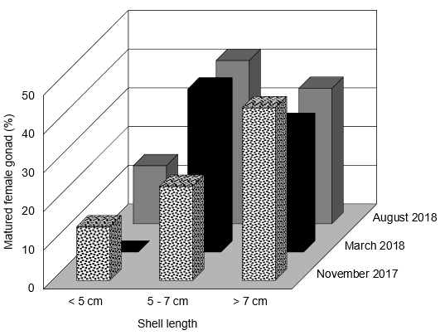

Figure 3. Percentage of matured female gonad at different size intervals and sampling periods

Figure 4 displays mussel growth as a function of (a) the maximum shell length and (b) tissue dry weight. Both dependent variables were best expressed as a power function of maximum shell length with high determination of coefficients for shell, wet and dry weight of tissues with R² value 0.913, 0.844 and 0.845, respectively. Those variables as a power function of tissue dry weight fit the data of shell and wet weight with R² value 0.884 and 0.964, respectively. All these statistics indicated that mussel growth is significantly related to size, where the weight increases proportionately with length throughout their lifespan. In general, mussels gain more energy for growth and gonad development when in its juvenile stages as the metabolism rate is higher than during its adult stages [22]. This is due to the greater energy needed for muscle development and growth than gonad development for reproduction. It is thus believed that small mussels have the potential to accumulate more contaminants such as radionuclides from the environment [23].
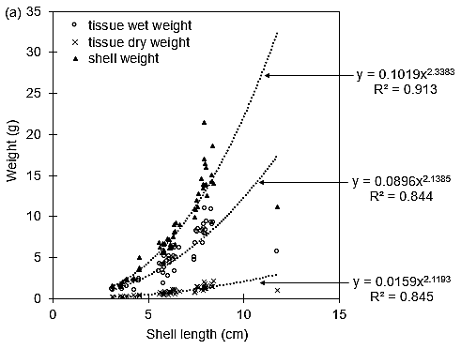

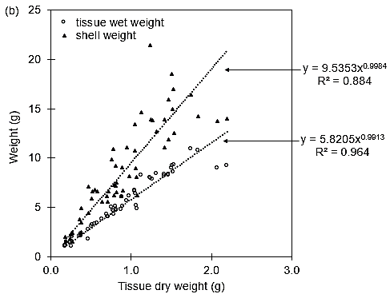
Figure 4. (a) Mussel growth based on shell and tissue weights (d.w. and w.w.) as a function of the maximum shell length and (b) Mussel growth based on shell and tissue weight (w.w.) as a function of tissue weight (d.w.). Each data plot is the average of individual biometric value of N samples as display in Table 1.
The level of 210Pb activities in mussels varied between small, medium and large sizes ranging from 8.87 to 58.58 Bq kg⁻¹ (mean = 19.82 ± 3.76 Bq kg⁻¹), 5.59 to 49.85 Bq kg⁻¹ (mean = 21.06 ± 11.49 Bq kg⁻¹) and 9.86 to 35.47 Bq kg⁻¹ (mean = 21.06 ± 7.51 Bq kg⁻¹), respectively. According to Vives I Battlle et al. [23] and Carvalho et al. [24], the allometric relationship between radionuclide contents with mussel size demonstrated high radionuclide content found in smaller mussels than in large ones. However, as far as the sizes were concerned, the Kruskal-Wallis ANOVA indicated that there was no significant difference in 210Pb activities in mussels related to small (Mean Rank = 24.67), medium (Mean Rank = 29.04) and large sizes (Mean Rank = 31.32), (ꭓ²(2) = 1.247, N = 57, p = 0.536, Cohen’s f = 0.150). Therefore, ²¹⁰Pb activities in mussel soft tissues in the Johor Strait might be dominated by other factors than the physiological.

By comparison, ²¹⁰Pb activities in mussel soft tissues (5.59 to 58.58 Bq kg⁻¹, d.w. with mean 20.65 ± 7.59 Bq kg⁻¹) at the Johor Strait were higher than the Tejo Estuary in Portugal (10 ± 4 Bq kg⁻¹ d.w.) [25] and the Vernice Lagoon, Italy (3 to 16 Bq kg⁻¹ d.w.) [26]. However, our findings are still lower than that reported from the Turkish Coast of the Aegean Sea (6 to 135 Bq kg⁻¹, d.w.), which is affected by local pollutants e.g., domestic sewage, industries, etc. [6]. Other studies have also used bivalves for heavy metal and radionuclide pollution monitoring in the temperate region [27] as well as published by on ²¹⁰Pb [6, 25]. They also found [6, 25, 27] the level activities of ²¹⁰Pb in bivalves were high during winter season and assuming the unsupported of ²¹⁰Pb came from the atmospheric deposition. In contrast, the temperature (Table 2) in the tropical region shows no significant difference due to the hot and wet climate all the year (F(2,24) = 1.375, p = 0.273, ɳ² = 0.103).
Table 2. Water parameter, ²¹⁰Pb in seawater and mussels along the Johor Strait at different sampling times

 | Region | Station |  | Water Parameter |  |  |  | ²¹⁰Pb Activity
 | Region | Station | N | Depth | Temp. | DO | Chl-a | ²¹⁰Pb in Sea Water |  |  | ²¹⁰Pb in Mussel*
 |  |  |  | (m) | (ºC) | (mg L⁻¹) | (µg L⁻¹) | (mBq L⁻¹) |  |  | (Bq kg⁻¹) d.w.
Northeast monsoon  (29th -30th Nov 2017) | WJS | 1 | 27 | 10.13 | 29.9 | 7.32 | 21.99 | 4.58 | ± | 1.99 | 11.89 | ± | 5.62
Northeast monsoon  (29th -30th Nov 2017) | WJS | 2 | 17 | 6.33 | 29.8 | 5.39 | 25.69 | 4.61 | ± | 1.58 | 11.90 | ± | 3.10
Northeast monsoon  (29th -30th Nov 2017) | WJS | 3 | 31 | 8.33 | 29.8 | 7.66 | 30.81 | 3.71 | ± | 1.81 | 13.87 | ± | 2.45
Northeast monsoon  (29th -30th Nov 2017) | EJS | 4 | - | 11.67 | 29.8 | 2.14 | - | 3.46 | ± | 1.33 |  | -
Northeast monsoon  (29th -30th Nov 2017) | EJS | 5 | - | 11.47 | 29.5 | 2.16 | - | 4.10 | ± | 1.71 |  | -
Northeast monsoon  (29th -30th Nov 2017) | EJS | 6 | 17 | 11.07 | 29.6 | 3.75 | 10.49 | 5.13 | ± | 2.34 | 16.82 | ± | 2.76
Northeast monsoon  (29th -30th Nov 2017) | EJS | 7 | - | 15.67 | 29.6 | 3.65 | - | 5.25 | ± | 2.44 |  | -
Northeast monsoon  (29th -30th Nov 2017) | EJS | 8 | 28 | 10.10 | 29.1 | 6.02 | 16.73 | 5.34 | ± | 2.32 | 13.63 | ± | 3.99
Northeast monsoon  (29th -30th Nov 2017) | EJS | 9 | 30 | 6.70 | 29.1 | 5.96 | 8.21 | 4.82 | ± | 1.87 | 14.90 | ± | 0.35
inter-monsoon  (28th -29th March 2018) | WJS | 1 | 42 | 9.70 | 29.3 | 4.75 | 0.53 | 3.49 | ± | 1.20 | 24.05 | ± | 6.75
inter-monsoon  (28th -29th March 2018) | WJS | 2 | 53 | 3.53 | 29.3 | 2.78 | 2.41 | 3.76 | ± | 1.66 | 22.77 | ± | 12.02
inter-monsoon  (28th -29th March 2018) | WJS | 3 | 40 | 4.07 | 29.9 | 2.13 | 0.82 | 2.83 | ± | 1.15 | 21.86 | ± | 5.25
inter-monsoon  (28th -29th March 2018) | EJS | 4 | 30 | 9.97 | 29.9 | 2.10 | 14.91 | 3.95 | ± | 1.62 | 31.01 | ± | 8.30
inter-monsoon  (28th -29th March 2018) | EJS | 5 | 40 | 15.00 | 29.9 | 2.10 | 4.98 | 3.74 | ± | 1.37 | 32.83 | ± | 5.12
inter-monsoon  (28th -29th March 2018) | EJS | 6 | 40 | 15.70 | 29.5 | 2.69 | 6.82 | 3.06 | ± | 1.40 | 36.45 | ± | 18.95
inter-monsoon  (28th -29th March 2018) | EJS | 7 | 57 | 16.50 | 29.4 | 2.96 | 1.47 | 3.48 | ± | 1.60 | 41.10 | ± | 15.27
inter-monsoon  (28th -29th March 2018) | EJS | 8 | 40 | 6.93 | 29.1 | 5.05 | 11.73 | 3.07 | ± | 1.31 | 29.31 | ± | 7.64
inter-monsoon  (28th -29th March 2018) | EJS | 9 | 52 | 7.53 | 29.1 | 6.26 | 10.20 | 3.69 | ± | 1.63 | 24.56 | ± | 5.84
Southwest monsoon  (1st-2nd Aug 2018) | WJS | 1 | 45 | 9.40 | 29.4 | 4.61 | 4.57 | 4.96 | ± | 2.27 | 12.95 | ± | 0.74
Southwest monsoon  (1st-2nd Aug 2018) | WJS | 2 | 74 | 4.50 | 29.7 | 3.55 | 11.30 | 3.79 | ± | 1.68 | 17.93 | ± | 9.87
Southwest monsoon  (1st-2nd Aug 2018) | WJS | 3 | 63 | 4.70 | 29.7 | 3.13 | 11.13 | 3.86 | ± | 1.55 | 19.63 | ± | 13.75
Southwest monsoon  (1st-2nd Aug 2018) | EJS | 4 | - | 5.40 | 30.0 | 1.63 | - | 3.25 | ± | 1.44 |  | -
Southwest monsoon  (1st-2nd Aug 2018) | EJS | 5 | 39 | 15.30 | 30.2 | 4.17 | 15.05 | 3.84 | ± | 1.74 | 18.68 | ± | 8.97
Southwest monsoon  (1st-2nd Aug 2018) | EJS | 6 | 49 | 16.70 | 30.0 | 3.29 | 5.43 | 3.38 | ± | 1.59 | 18.20 | ± | 3.44
Southwest monsoon  (1st-2nd Aug 2018) | EJS | 7 | 59 | 15.40 | 29.9 | 4.01 | 5.06 | 5.28 | ± | 2.81 | 19.85 | ± | 6.18
Southwest monsoon  (1st-2nd Aug 2018) | EJS | 8 | 53 | 8.70 | 29.4 | 4.52 | 1.68 | 5.23 | ± | 2.10 | 13.23 | ± | 8.42
Southwest monsoon  (1st-2nd Aug 2018) | EJS | 9 | 55 | 5.90 | 29.3 | 4.64 | 0.59 | 3.41 | ± | 1.67 | 14.59 | ± | 4.41
* ²¹⁰Pb in mussel are in average of all sizes.
November 2017 – Mussel cages at Stations 4, 5 and 7, the line was covered by unidentified mussels which believed as an invasive species.
August 2018 – Mussel cages at Station 4 have been removed due to reclamations activities

Discrimination of ²¹⁰Pb in mussels by monsoon season
Since the univariate analysis obtained revealed insignificance in the variation of ²¹⁰Pb activities in mussel tissues at different sizes, a Linear Discriminant Analysis (LDA) was utilized to get a better picture of the data and predict the best discrimination component effect of ²¹⁰Pb activities in mussels. The LDA will provide the best set of variables into group within the minimum error, where Figure 5 shows the scatter plotted contents of ²¹⁰Pb in mussels which 87% of data have been classified correctly according to the sampling periods. The highest accuracy of 210Pb activities in mussels was 89% in March 2018 followed by 88% in August 2018 and 83% in November 2017. The Kruskal-Wallis ANOVA test indicated that there was significance in the correlation between ²¹⁰Pb activities in mussels and time of sampling with the highest mean rank score of about 42.59 in March 2018, followed by 22.76 in August 2018 and 17.00 in November 2017, (ꭓ²(2) = 25.034, N = 57, p = 0.000, Cohen’s f = 0.899).

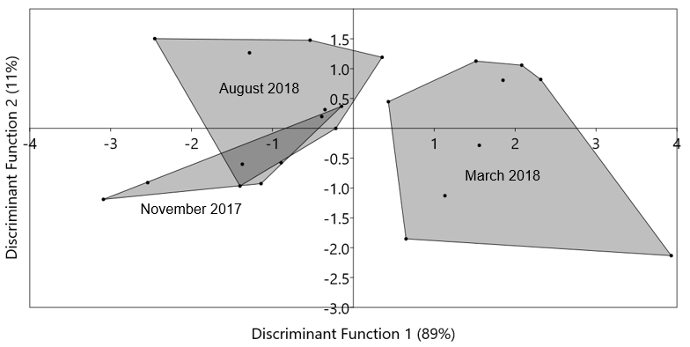

Figure 5. LDA scatter plot of ²¹⁰Pb activities in mussels’ samples (N=23) classified with convex hulls by different time of sampling

The convex hulls clearly showed that ²¹⁰Pb activities in March 2018 significantly discriminated from November 2017 and August 2018. Figure 6 illustrates the distribution of ²¹⁰Pb in mussels, which is consistently higher in March 2018 than November 2017 and August 2018 for all size intervals.

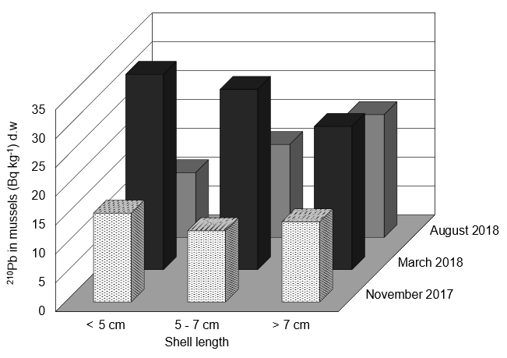

Figure 6. ²¹⁰Pb in mussels (Bq kg⁻¹) at different size intervals and sampling periods

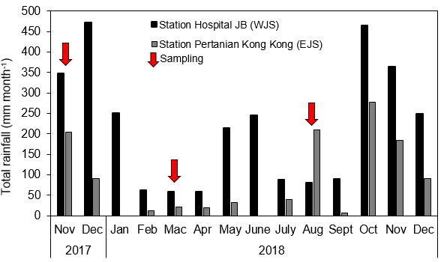
In the Johor Straits, the NE monsoon usually occurs from October to March (sampling conducting in November 2017 represents the effects of the NE monsoon), meanwhile March 2018 represents the inter-monsoon season since sampling was conducted at the end of March. The SW monsoon begins in April and lasts until September (sampling in August 2018 represents the SW monsoon). The NE and SW monsoon seasons experience abundant rainfall from different wind directions compared to the inter-monsoon which has less precipitation (Figure 7). Therefore, the mean activities of ²¹⁰Pb in seawater during the NE (4.56 ± 0.67 mBq L⁻¹) and SW (4.11 ± 0.27 mBq L⁻¹) monsoons were higher than during the inter-monsoon (3.45 ± 0.38 mBq L⁻¹) (Table 2).

Figure 7. Distribution of total rainfall at the WJS and EJS from November 2017 to December 2018 [28]

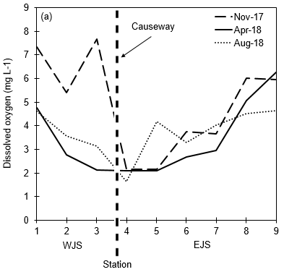
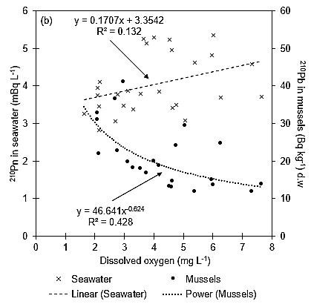
The ²¹⁰Pb activity in mussels related to seawater demonstrated an inverse relationship significant at 99% confidence level (Pearson’s correlation, r = −0.573, N = 23, p = 0.004) which contradicts the nature of mussels as a bioindicator. In general, high pollutants in mussels indicate a high level of pollution in its environment e.g., the Turkish coast of the Aegean Sea established high ²¹⁰Pb activities in mussels during winter where high precipitation is believed to be the source of unsupported ²¹⁰Pb [6]. In contrast to this scenario, we suggest that the lower dissolved oxygen content given the hypoxic environment in the Johor Strait is indirectly related to the inter-monsoon season. Figure 8a shows the distribution of DO along the Johor Strait which decreases constantly towards the causeway during the inter-monsoon season where less rainfall potentially limited water flow resulted from the causeway connecting Johor and Singapore. During the inter-monsoon, ²¹⁰Pb activity in seawater increases proportionally with DO while ²¹⁰Pb activities in mussels’ increases with a decrease in DO level content (Figure 8b). In the water column, Fe and Mn hydroxide cause the preferential removal of ²¹⁰Pb to suspended particulate matter via unselective co-precipitation [29, 30] which is associated with the changes in physicochemical properties of the water column during the inter-monsoon [31]. Meanwhile the high tolerance mussels established the lowest percentage of gonad maturation during inter-monsoon and contribute to high ²¹⁰Pb uptake via unselective ingestion to restore their energy [21, 22]. These clearly indicate that the distribution content of ²¹⁰Pb in seawater and mussels in the Johor Straits correspond to a hypoxic environment.

Figure 8. (a) Distribution of Dissolved Oxygen (DO) in water column in the western (WJS) and eastern (EJS) of the Johor Strait, (b) ²¹⁰Pb in seawater (dissolved phase) proportionate with DO in the water column which contradicts the inverse relationship of ²¹⁰Pb in mussels as a function of DO

About 87% is true using the LDA statistical test analysis for a classified scatter plot (Table 3) with a misclassified value of only about 13%. Table 3 summarizes the confusion matrix of ²¹⁰Pb activities in mussels assigned by sampling period. The misclassified values for November 2017, March 2018 and August 2018 were 17%, 11% and 13%, respectively. Specifically, the misclassified values came from Station 6 (Pasir Gudang port), Station 3 (west coast near the Causeway) and Station 1 (close to Tanjung Pelepas port). These misclassified values might due to geographic elements (e.g., industry, harbour, and causeway) and other similar factors at these specific locations which subsequently influence the ²¹⁰Pb activities in mussels and the water column. According to Ugur et al. [6], the source of ²¹⁰Pb could be from local pollution and rivers as well as rainfall input. In this case, we found that all the misclassified stations located near the causeway structure caused hypoxic conditions associated with the status of in-situ water parameters (e.g., pH, dissolved oxygen, and total suspended particles).

Table 3. Confusion matrix of ²¹⁰Pb activities in mussels assigned by sampling period
Sampling Time | November 2017 | March 2018 | August 2018 | Total
November 2017 | 5 | 0 | ^{c}1 | 6
March 2018 | 0 | 8 | ^{b}1 | 9
August 2018 | ª1 | 0 | 7 | 8
Total | 6 | 8 | 9 | 23
Row: given groups, Column: predicted groups, ªStation 1, ^{b}Station 3, ^{c}Station 6

Environmental effect to bioconcentration of ²¹⁰Pb in mussels
In order to understand the relationship between ²¹⁰Pb in mussels related to ambient water in the Johor Straits, the concentration factor (CF) has been utilized as a simple indicator for contaminant substance uptake in mussels from water exposure. Generally, the CF value in this study ranged from 103 to 104 which exceeds the ²¹⁰Pb CF recommendation value, 1 × 103 L kg⁻¹ [31]. The highest mean of CF values obtained was found during the March 2018 (8.6 ± 2.1×103 L kg⁻¹) sampling, followed by August 2018 (4.2 ± 1.1 × 103 L kg⁻¹) and November 2018 (3.0 ± 0.5 × 103 L kg⁻¹). A positive and strong relationship between CF values and ²¹⁰Pb in mussels at 99% confidence level (Pearson’s Correlation, r = 0.9625, N = 23, p = 0.000) was determined (Figure 8). The inter-monsoon season in the Johor Straits caused less water flow, lower levels of dissolved oxygen content and the high decomposition process of suspended particles will affect the water quality and organisms living there. Therefore, high ²¹⁰Pb activities in mussels during the inter-monsoon is influenced by metabolic transformation, which then increases the uptake of ²¹⁰Pb via ingested food as well as by respiratory uptake via gills [24]. Metabolic transformation is a mechanism which is developed by organisms to survive under thermal stress and oxygen deprivation at low tide and is used by most bivalves that inhabit the intertidal zone [32]. However instead of its use to survive under natural environmental changes, these mussels were exposed to anthropogenic activities as well.

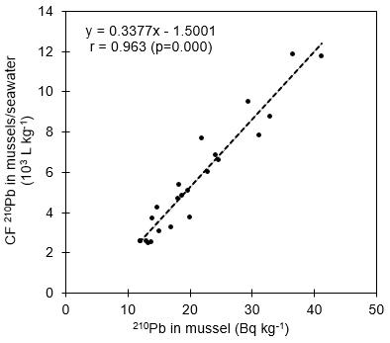
Figure 8. Relationship between concentration factors (CF) of ²¹⁰Pb in mussels related to seawater and ²¹⁰Pb in mussels

Table 2 shows the water parameters along the Johor Strait at different sampling times. There were dramatic changes in dissolved oxygen (DO) content between stations along the Johor Strait (Kruskal-Wallis ANOVA, ꭓ²(8) = 16.214, N = 27, p = 0.039, Cohen’s f = 1.238). This study revealed that the causeway structure interrupts water quality where DO concentrations decrease on both sides of the Straits and becomes almost hypoxic adjacent to the causeway. Figure 7a shows the distribution of DO content in the water column along the Johor Strait and how it decreases toward the causeway structure in both halves of the EJS and WJS. The lowest DO value was recorded at Station 4 which decreases from 2.14 mg L⁻¹ > 2.10 mg L⁻¹ > 1.63 mg L⁻¹ (hypoxic, O₂ < 2 mg L⁻¹) from the November 2017 to the August 2018 sampling. Figure 7b proved that the deficiency of dissolved oxygen content in the water column potentially affects the level of ²¹⁰Pb in mussels with R² value 0.428. The deficiency of oxygen content in the water column potentially influences the bioavailability of ²¹⁰Pb in mussels and metabolic transformation might be relevant in a build-up of CF values due to environmental changes [33].

In this study, the causeway structure was believed to be an obstruction of the water flow in the Johor Strait. Fig. 9a shows the whisker plot of ²¹⁰Pb in mussels at the WJS and EJS with an outlier of case number 37. The Kruskal-Wallis ANOVA (ꭓ²(1) = 3.952, N = 57, p = 0.0.047, Cohen’s f = 0.2754) proved that, there was significant differences between the two regions where the ²¹⁰Pb in mussels at the EJS (Mean Rank = 32.73) was much higher than WJS (Mean Rank = 23.88). The outlier of case number 37 with score 58.58 occurred at Station 7 (Kuala Masai) during the inter-monsoon. This outlier was not neglected because the authors found that the Masai River has a 10year history of pollution issues that is frequently reported in Malaysian mainstream media [34].

Figure 9b illustrates the distribution of ²¹⁰Pb in mussels and seawater at different stations along the Johor Strait. Besides Station 7, Station 4 is also exposed to higher ²¹⁰Pb activity. The causeway structure limits water spreading especially at the EJS and thus potentially accumulates more ²¹⁰Pb as well as other contaminants. Water quality is shown to be poor, especially adjacent to the causeway, which is almost hypoxic, thus significantly contributing to higher ²¹⁰Pb in mussels (Figure 7). However, the experiment done by Wang et al. [35] indicated that the reduction of DO content reduced absorption efficiency and respiration rates of the mussels.

We presume that, the higher accumulation of ²¹⁰Pb in mussels at the hypoxic zone is probably due to its high tolerance to the reduction of DO content and exposes them longer to the ambient water. Furthermore, the behavior of ²¹⁰Pb in hypoxic environments should be considered instead of the mussel’s physiological responses. In marine environments, hypoxic bottom water conditions potentially preserve more than 50% of the organic matter (OM) in surface sediments than oxic conditions, contributing 5 to 33% of total 210Pb bound to OM [2, 36]. Consequently, the authors suggest that the causeway structure potentially exposes the Johor Strait to higher bioavailability of ²¹⁰Pb due to the hypoxic conditions where organic particle suspension in the water column seems to be a major pathway for ²¹⁰Pb absorption by mussels [37].

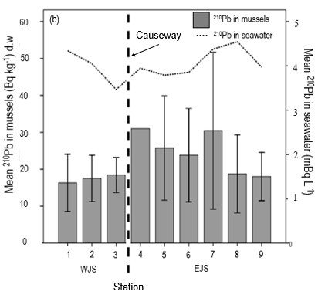
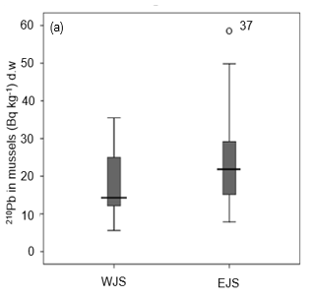

Figure 9. (a) The whisker plot of ²¹⁰Pb in mussels at the WJS and EJS with an outlier of case number 37 (station 7), and (b) The mean distribution of ²¹⁰Pb in mussels and seawater along the Johor Strait

Conclusion
The highest ²¹⁰Pb activity in mussels occurred during the inter-monsoon during which there is less precipitation and water flushing. The causeway structure limits water flow and causes the environment to be almost hypoxic especially adjacent to the causeway. The extent of oxygen deficiency was expanded during the inter-monsoon. The inverse relationship between ²¹⁰Pb in mussels as a function of dissolved oxygen in the water column indicates that the oxygen deficiency potentially influences the bioavailability of ²¹⁰Pb in mussels. The metabolic transformation as well as unselective ingestion might be relevant in the build-up of CF due to environmental changes. Further works are required to identify the species of ²¹⁰Pb in order to confirm the percentage of the bioavailability ²¹⁰Pb in the Johor Strait and comprehensive dose assessment of ²¹⁰Pb to human via mussel consumption.

Acknowledgement
This research is supported by Universiti Kebangsaan Malaysia grant (code: DPK-2017-010). The authors would like to thank all the members of Land-Atmospheric-Ocean Interaction Research (LAOI) group, Faculty of Science and Technology, Universiti Kebangsaan Malaysia for their help during sampling and sample analysis.

References
- Connan, O., Boust, D., Billon, G., Solier, L., Rozet, M. and Bouderbala, S. (2009). Solid partitioning and solid-liquid distribution of ²¹⁰Po and ²¹⁰Pb in marine anoxic sediments: roads of Cherbourg at the northern France. Journal of Environmental Radioactivity, 100: 905-913.
- Jessen, G. L., Lichtschlag, A., Ramette, A., Pantoja, S., Rossel, P. E., Schubert, C. J., Struck, U. and Boetius, A. (2017). Hypoxia causes preservation of labile organic matter and changes seafloor microbial community composition (Black Sea). Science Advances, 3: 1-14.
- Bacon, M. P., Spencer, D. W. and Brewer, P. G. (1976). ²¹⁰Pb/²²⁶Ra and ²¹⁰Po/²¹⁰Pb disequilibria in seawater and suspended particulate matter. Earth Planetary Science Letters, 32: 277-296.
- Rigaud, S., Stewart, G., Baskaran, M. and Marsan, D. (2015). ²¹⁰Po and ²¹⁰Pb distribution, dissolved-particulate exchange rate, and particulate export along the North Atlantic US GEOTRACES GA03 section. Deep Sea Research Part II, 116: 60-78.
- Carvalho, F. P., Oliveira, J. M., Alberto, G. and Vives I Batlle, J. (2010). Allometric relationship of ²¹⁰Po and ²¹⁰Pb in mussels and their application to environmental monitoring. Marine Pollution Bulletin, 60: 1734-1742.
- Ugur, A., Ozden, B. and Filizok, I. (2011). Spatial and temporal variability of ²¹⁰Po and ²¹⁰Pb in mussel (Mytilus galloprovincialis) at the Turkish of the Aegean Sea. Chemosphere, 83: 1102-1107.
- Ismail, M., Hashim, N. N. and Kazemi, Z. (2016). Estimating dissolved oxygen depletion in inner western Johor Strat, Malaysia using a three dimensional water quality model. Malaysian Journal of Civil Engineering, 28(3): 240-251.
- Yap, C. K., Ismail, A., and Tan, S. G. (2004). Biomonitoring of heavy metal in the west water of Peninsular Malaysia using the green-lipped mussel Perna viridis: Present Status and What Next?. Journal of Tropical Agriculture Science, 27(2):151-161.
- Othman, Z., Wahid, M. A., Lee, W. K. and Mohamed Basri, Z. D. (2015). Water quality observation on Johor River Estuary and East Tebrau Strait, Malaysia. Jurnal Teknolologi, 72(1): 1-4.
- Mohamed, C.A.R., Tee, L.T., Zal, U.M., Zaharuddin, A. and Masni, M.A. (2006). Activity concentrations of ²¹⁰Po and ²¹⁰Pb in edible tissue of fish caught at Kuala Selangor, Malaysia. Malaysian Applied Biology Journal 35(2): 67-73.
- Zakaria, N., Sarimin, A.S., Sabuti, A.S. and Mohamed, C.A.R. (2013). Assessment activity of ²¹⁰Po and ²¹⁰Pb in the edible tissues of cultured seabass (Lates calcarifer) at Peninsular Malaysia. Environmental Asia 6(1): 66-73.
- Theng, T. L. and Mohamed, C. A. R. (2005). Activities ²¹⁰Po and ²¹⁰Pb in the water column at Kuala Selangor, Malaysia. Journal of Environmental Radioactivity, 80(3): 273-286.
- Sabuti, A. A. and Mohamed, C. A. R. (2010). Lead. In: Radionuclides in the environment (Ed: Atmood DA). John Wiley and Sons Co, Ltd: pp. 139-147.
- Cohen, J. (1988). Statistical power analysis for the behavioural science (2nd edition) Hillsdale, N.J: Erlbaum
- Lucas, A. and Beniger, P. G. (1985). The use of physiological condition indices in marine bivalve aquaculture. Aquaculture, 44: 187-200.
- IAEA (2001). Generic models for use in assessing the impact of discharges of radioactive substances to the environment. Vienna, International Atomic Energy Agency.
- Ojea, J., Pazos, A. J., Martinez, D., Novoa, S. and Sanchez, J. L. (2004). Seasonal variation in weight and biochemical composition of tissue of Ruditapes decussatus in relation to the gametogenic cycle. Aquaculture, 238: 451-469.
- Peharda, M., Mladineo, I., Bolotin, J., Kekez, L. and Skaramuca, B. (2006). The reproductive cycle and potential protandic development of the Noah’s Arc shell, Arca noae L.: Implications for aquaculture. Aquaculture, 252: 317-327.
- Orban, E., Di Lena, G., Nevigato, T., Casini, I., Marzetti, A. and Caproni, R. (2002). Seasonal changes in meat content, condition index and chemical composition of mussels (Mytilus galloprovincialis) cultured in two different Italian sites. Food Chemistry, 77: 57-65.
- Gosling, E. (2003). Bivalve molluscs-biology, ecology and culture. Fishing New Books, Oxford Press.
- Laxmilatha, P. (2013). A review of the green mussel, Perna viridis fishery of South West Coast of India. International Journal of Marine Science, 3: 408-416.
- Soon, T. K. and Ransangan, J. (2014). A review of feeding behaviour, growth, reproduction, and aquaculture site selection for green-lipped mussel, Perna viridis. Advances in Bioscience and Biotechnology, 5: 462-469.
- Vives I Battlle, J., Wilson, R. C., Watts, S. J., McDOnald, P. and Craze, A. (2009). Derivation of allometric relationships for radionuclides in marine phyla. Radioprotection, 44: 47-52.
- Carvalho, F. P. (2018). Radionuclide concentration process in marine organism: A comprehensive review. Journal of Environmental Radioactivity, 186: 124-130.
- Carvalho, F. P., Oliveira, J. M. and Alberto, G. (2010). Factors affecting ²¹⁰Po and ²¹⁰Pb activity concentrations in mussels and implications for environment bio-monitoring programmes. Journal of Environmental Radioactivity, 102: 128-137.
- Jia, G., Belli, M., Sansone, U., Rosamilia, S. and Blasi, M. (2003). ²¹⁰Pb and ²¹⁰Po concentration in the Vernice lagoon ecosystem (Italy) and the potential radiological impact to the public and environment. Journal of Radioanalytical and Nuclear Chemistry, 256(3): 513-528.
- Fonolosa, E., Penalver, A., Aguilar, C. and Borrull. (2017). Bioaccumulation of natural radionuclides in molluscs from the Ebro Delta area. Environmental Science Pollution Research, 24: 28-214.
- Malaysian Meteorological Department (2018). Taburan hujan di Stesen Hospital JB dan Stesen Pertanian Kong Kong Johor 2017-2018.
- Carvalho, F. P. (1995). ²¹⁰Pb and ²¹⁰Po in sediment and suspended matter in Targus Estuary. Local enhancement of natural levels by wastes from phosphate ore processing industry. Science Total Environment Journal, 159: 201-161.
- Benoit, G. and Rozan, T. F. (1999). The influence of size distribution on the particle concentration effect and trace metal partitioning in rivers. Geochemica et Cosmochimica Acta, 63(1): 113-127.
- Sanudo-wilhelmy, S. A., Rivera-Duarte, I. and Flegal, A. R. (1996). Distribution of colloidal trace elements in San Fransisco Bay estuary. Geochemica et Cosmochimica Acta, 60: 4933-4944.
- Anestis, A., Portner, H.O. and Michaelidis, B. (2010). Anaerobic metabolic patterns related to stress responses in hypoxia exposed mussels Mytilus galloprovincialis. Journal of Experimental Marine Biology and Ecology, 394: 123-133.
- Giannetto, A., Maisano, M., Cappello, T., Olivia, S., Parrino, V., Natalotto, A., Marco, G. D. and Fasulo, S. (2017). Effect of oxygen availability on oxidative stress biomarkers in the Mediterranean mussels Mytilus galloprovincialis. Marine Biotechnology, 2017: 1-13.
- Kosmo Online (2018). Sungai Masai Besar tercemar 10 tahun, nelayan minta pembelaan, access from http://www.kosmo.com.my/negara/sungai-masai-besar-tercemar⁻¹0-tahun-nelayan-minta-pembelaan1.627 512.[ Accessed date 5 September 2019].
- Wang, Y., Hu, M., Wong, W. H., Shin, P. K. S. and Chueng, S. G. (2011). The combined effects of oxygen availability and salinity on physiological responses and scope for growth in the green-lipped mussel Perna viridis. Marine Pollution Bulletin, 63: 255-261.
- Ontiveros-Cuadras, J. F., Ruiz-Ferna´ndez, A. C., Sanchez-Cabeza, J. A., Wee-Kwong, L. L. and Pe´rez-Bernal L. H. (2012). Geochemical fractionation of ²¹⁰Pb in oxic estuarine sediments of Coatzacoalcos River, Gulf of Mexico. Journal of Radioanalytical and Nuclear Chemistry, 292: 947-956.
- Pan, J. F. and Wang, W. X. (2004). Differential uptake of dissolved and particulate organic carbon by the marine mussel Perna viridis. Limnology and Oceanography, 49: 1980-1991.

