PREPARATION AND CHEMICAL COMPOSITION OF ALKALINE WATER FROM PLANT COMBUSTION ASH

(Penyediaan dan Komposisi Kimia Air Beralkali dari Abu Loji Pembakaran)

Pairin Pongsa and Napa Tangtreamjitmun*

Department of Chemistry,

Faculty of Science,

Burapha University, Bangsaen, Chonburi, 20131 Thailand

*Corresponding author email address: napa@buu.ac.th

Abstract

The alkaline water prepared from burning natural materials into ash and submersing the ash in water was studied. The combustion time and the percentage of ash obtained for each material were different. The major chemical components of the ash were identified by Fourier transform infrared spectroscopy. The main functional groups found were carbonate and hydroxide. The alkaline water which had a pH of 11-12 was filtered and studied for its chemical composition. The alkalinity in terms of hydroxide, carbonate and bicarbonate species was determined by acid titration. The sodium, potassium, calcium and magnesium content were determined by inductively coupled plasma optical emission spectrophotometer. The major cations found were potassium and sodium. The concentrations and pH of the alkaline water that would be obtained after dilution should be suitable for human consumption although further medical testing is required.

Keywords: alkaline water, lye water, ash, alkalinity

Abstrak

Air beralkali telah disediakan dari pembakaran bahan semulajadi kepada abu dan kebolehan tenggelan abu di dalam air telah dikaji. Masa pembakaran dan peratus abu yang diperolehi bagi setiap bahan adalah berbeza. Komponen kimia utama bagi abu telah dikenalpasti menggunakan spektroskopi inframerah transformasi Fourier. Kumpulan berfungsi utama yang ditemui adalah karbonat dan hidroksida. Air beralkali yang mempunyai nilai pH 11-12 telah dituras dan dikaji komposisinya. Sifat kealkalian seperti spesis hidroksida, karbonat dan bikarbonat telah ditentukan melalui pentitratan asid. Kandungan sodium, kaliam, kalsium and magnesium telah di analisis menggunakan spektrofotometer sebaran optikal – plasma gandingan aruhan. Kation utama yang dijumpai adalah kalium dan sodium. Kepekatan dan nilai pH air beralkali diperolehi selepas pencairan sesuai bagi penggunaan manusia meskipun ujian perubatan lanjutan masih diperlukan.

Kata kunci: air beralkali, air abu, abu, kealkalian

Introduction

Alkaline water or lye water is made by submersing plant ash in water for a length of time. The soluble salts in the ash dissolve, resulting in basic water. This is how people in the past used to produce alkaline water for their own consumption in the household. This process has been known since ancient times. The alkaline water was called “Kan Sui” in Cantonese [1]. Kan Sui has been used for making noodles turn into yellow color with a firm and elastic texture. It is also used to refresh dry squid and sea cucumber. In Eastern European region, lye water is used to make a brown surface of breads, such as bagels and pretzels.

Currently, alkaline water can also be produced by electrolysis process. The produced alkaline ionized water (AIW) or alkaline reduced water (ARW) was reported to have clinical effects due to its antioxidant properties in treatment and prevention of diseases [2, 3]. Drinking alkaline water is popular among people, who are concerned about their health. Most consumers believe that the basic properties of alkaline water will help balance the acid-base equilibrium in the body caused by some acidic foods.

Food grade lye water produced from potassium carbonate is commercially available nowadays. But the preferred method of naturally alkaline water making from plant ash is still used in some parts of the world. In Thailand, the bottled alkaline water is sold in the form of concentrated alkaline water produced from coconut husk ash. There is usually a label indicating “Concentrated alkaline water” and the recommended dilution ratio for drinking. Therefore, this research has studied the factors that affect the preparation of alkaline water from different plant ash and its chemical composition which should be useful information for consumers.

Materials and Methods

Ash production and its chemical composition

The leaf samples from six edible trees and coconut husk (shown in Figure 1) were sun dried for 5 days. 50 grams of each dried sample was then combusted in a basin on a gas stove in the fume hood. The time spent in combustion until the leaves turn to ash was recorded. The ash was weighed and the percentage of ash obtained from the dry weight of the leaf sample was calculated. The ash was analyzed for chemical composition by Fourier Transform Infrared Spectrophotometer (System 2000, Perkin Elmer, USA).
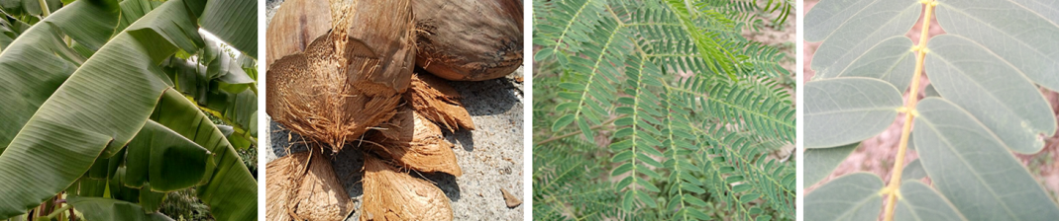
A1 A2 A3 A4
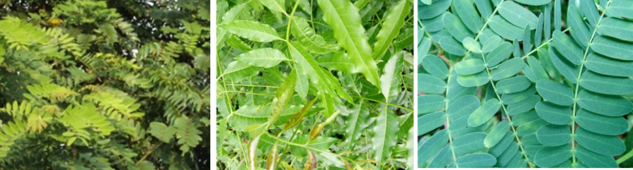
A5 A6 A7

Figure 1. Fresh plant leaves and dry coconut husk used in combustion to produce ash; A1: Banana leaf (Musa sapientum Linn.) A2: Coconut husk (Cocos nucifera Linn.) A3: Acacia leaf (Leucaena leucocephala (Lamk.) de Wit) A4: Sesbania grandiflora leaf (Sesbania grandiflora (L.) Pres.) A5: Cassia leaf (Cassia siamea Britt.) A6: Neem leaf (Azadirachta indica var. siamensis Valeton) A7: Tamarind leaf (Tamarindus indica Linn.)

Preparation and pH measurement of alkaline water

Deionized water (E-Pure Barnstead 3 column Model D4632, Thermo Fisher Scientific, USA) was used to extract the ash. The ash and water were mixed at ratios of 1:5 and 1:100 (g:mL) and submersed for 12 hours. The suspension was filtered and the pH of the alkaline water was measured.

The ash was mixed with water at a ratio 1:5 and the pH of the suspension was measured at 10, 30, 60, 120 and 720 minutes. The ash was mixed with water at a ratio 1:5. The pH of the suspension was measured after 10 minutes. The suspension was then filtered and the same volume of fresh water was added to the solids. The pH was measured after 10 minutes. This was repeated until the pH value was constant for 3 consecutive times.

The chemical composition of alkaline water

The alkaline water set 1 was obtained from submersion of ash at a ratio 1:5 for 12 hours. After the alkaline water was removed, fresh water was added to re-submerse the ash at the same conditions. The process was repeated twice, in order to obtain alkaline water set 2 and set 3. Then the three sets of prepared alkaline water samples and alkaline water samples sold in health stores were titrated with acid to determine alkalinity using the procedure in Standard Methods for the Examination of Water and Wastewater [4].

Sodium, potassium, calcium, and magnesium were analyzed in purchased alkaline water samples. The samples were digested with 10% HCl in an ultrasonic bath (690D, Crest Ultrasonics Corp., USA) for 20 min. A mixed standard solution of sodium, potassium, calcium, and magnesium (Mono-element standard Solution for AAS, Loba Chemie, India) was prepared to make a calibration curve. All solutions were analyzed by Inductively Coupled Plasma Optical Emission Spectrophotometer (ICP-OES) (PlasmaQuant® PQ 9000, Analytik Jena AG, Germany).

Results and Discussion

Ash production

During the combustion process, the dry sample first turned into a black ash. Then, after a period of time, the black ash turned white to grayish white or light brown depending on the type of plant (as shown in Figure 2).

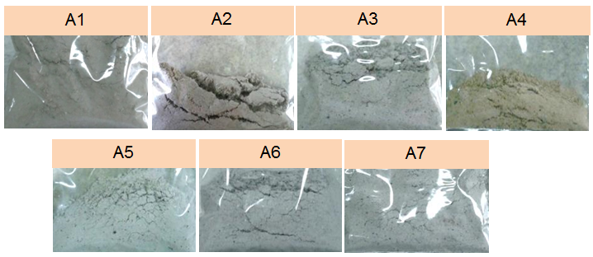

Figure 2. The combustion ash obtained from various leaves and coconut husk

All leaf samples took less time for combustion than coconut husk. The coconut husk took almost 6 hours for combustion and gave the lowest percentage of ash (4.5%) as shown in Figure 3. The other samples gave a percentage ash between 6.8-10.3. Sesbania grandiflora leaf, cassia leaf, banana leaf and acacia leaf had the lowest combustion time about 1 hour. Sesbania grandiflora leaf gave the highest percentage of ash 10.3. Tamarind and neem leaves took about 1.5 hours to complete combustion. Tamarind leaves gave 10.1% ash, but takes about half an hour more combustion time than Sesbania grandiflora leaves. It can be seen that leaves yield more ash than the stem. Stem combustion yields about 0.2-1% ash but occasionally gave 3-4% [5]. According to past research, bark and leaves produce more ashes than the core of the stem [6].

Figure 3. Combustion time (left) and percentage of ash (right) produced from different plant combustion. A1: Banana leaf, A2: Coconut husk, A3: Acacia leaf, A4: Sesbania grandiflora leaf, A5: Cassia leaf, A6: Neem leaf, A7: Tamarind leaf

Chemical composition of ash

Ash was analyzed by FTIR for functional groups. The IR spectra in Figure 4 showed a fairly wide peak of -OH- at about 3400 cm⁻¹ and a peak of Si-O at about 1100 cm⁻¹[7]. The 1400 cm⁻¹ peak was the C-O stretching and bending bond in the CO₃²⁻ group of calcium carbonate [8]. In addition, the spectrum of all ash, except banana leaves and coconut husk contained a sharp peak at about 900 cm⁻¹ due to SO₄²⁻ [7].

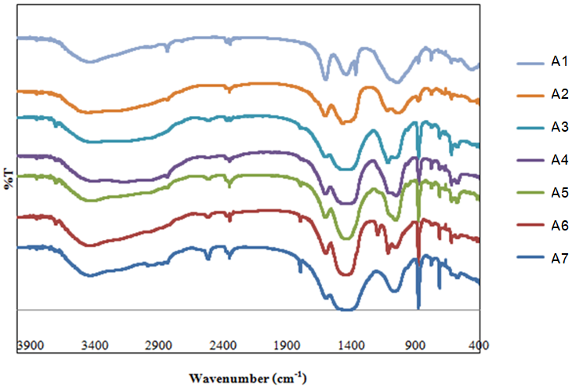

Figure 4. Infrared spectrum of different ash samples. From top to bottom; A1: Banana leaf, A2: Coconut husk, A3: Acacia leaf, A4: Sesbania grandiflora leaf, A5: Cassia leaf, A6: Neem leaf, A7: Tamarind leaf

Ash from hardwood normally contains 80% of water insoluble constituents. The remaining soluble inorganic compounds are potassium carbonate (K₂CO₃), soda ash (Na₂CO₃), arcanite (K₂SO₄), and calcium hydroxide Ca(OH)₂. However, if the temperature is above 600 °C potassium carbonate decomposes to potassium oxide (K₂O) [9]. The gas stove used in this study could only provide a temperature of about 250 °C thus potassium oxide should not be produced in this combustion process.

These soluble compounds are important in the uses of alkaline water from ash. Based on the spectra shown in Figure 4, all ash contains carbonate (CO₃²⁻) and hydroxide (OH⁻) groups as the anion of soluble inorganic components in the ash. It is apparent that ash from the leaves and coconut husk will have an ash component that is similar to that of hardwood ash.

Factors affecting alkaline water preparation: Mixing ratio of ash to water

The pH of alkaline water produced from mixing ratios of 1:5 and 1:100 were between 11.2-12.5 and 10.1-11.3, respectively. Alkaline water is generally sold in concentrated form in bottles with pH 10-12. Therefore, ratios between 1:5 and 1:100 could be used for alkaline water preparation. The consumer would have to dilute concentrated alkaline water about 50-100 times as specified on label typical to prepare it for drinking. The pH of the diluted alkaline water for drinking would be about 8.5 as this is the upper limit of pH for standard drinking water (Ministry of Public Health, Thailand (No. 256; 2000). The 1:5 ratio was used for alkaline water preparation in all experiments in this work.

Optimum submersion time

The pH of alkaline water obtained by ash submersion in water at various times did not vary by more than 0.5 over 12 hours as shown in Figure 5.

Figure 5. pH of alkaline water using a submersion ratio 1:5 at various submersion time. The alkaline water from different ash samples: A1: Banana leaf, A2: Coconut husk, A3: Acacia leaf, A4: Sesbania grandiflora leaf, A5: Cassia leaf, A6: Neem leaf, A7: Tamarind leaf

However, long submersion times provided good settling of non-soluble ash and resulted in clearer alkaline water, which would be more pleasant to drink. In addition, it was found that alkaline water produced from neem leaf (A6) ash gave the highest pH value of 12.5. The coconut husk (A2) ash produced alkaline water with the lowest pH of 11.2.

Re-submersion of ash

The pH of alkaline water from re-submersion of the ash every 10 minutes gradually decreases. Once the ash has been re-submersed for 35 times, the pH stayed almost constant about 8.6-9.0. Thus the ash can be re-submersed for about 35 times in the production of alkaline water. However, the pH value alone does not indicate the water capacity of alkaline water to neutralize acid. Therefore, the alkalinity of water, which was defined as water capacity to neutralize acid [10] was studied in the next section. The capacity of water in this context indicates the “buffering capacity”.

Chemical composition of alkaline water: Alkalinity
The alkalinity titration for three sets of alkaline water is shown as mg L⁻¹ CaCO₃ in Table 1. According to the high pH of all alkaline water samples (pH>11), no hydrogen carbonate were found as alkalinity species in these seven samples. Carbonate (CO₃²⁻) was the main alkalinity species for all samples except A1 (banana leaf) in set 1 (obtained from the first submersion). For the banana leaf ash, hydroxide was the only alkalinity species found in the set 1alkaline water. The alkaline water from Sesbania grandiflora leaf ash (A4) contained only the weak base carbonate (CO₃²⁻) in every set, which is a good buffering system for acid neutralization. Therefore, Sesbania grandiflora leaf ash produces the best alkaline water in terms of acid neutralization. The total alkalinity was also high (32,578 mg L⁻¹ CaCO₃).

Table 1. Alkalinity values of alkaline water samples prepared from different ash samples (n=3)

Alkaline Water | Alkalinity (±sd) (mg L⁻¹ CaCO₃) |  |  |  |  |  |  | Total alkalinity  (mg L⁻¹ CaCO₃)
Alkaline Water | Set 1 |  |  | Set 2 |  | Set 3 |  | (±sd)
Alkaline Water | OH⁻ | CO₃²⁻ | OH⁻ |  | CO₃²⁻ | OH⁻ | CO₃²⁻ | (mg L⁻¹ CaCO₃)
A1 | 987  (±21) | - | 104  (±4.9) |  | 1002  (±0) | 430  (±87) | 568  (±87) | 3,091  (±108)
A2 | - | 25010  (±206) | 2527  (±125) |  | 5365  (±170) | 982  (±7) | 4252  (±27) | 38136  (±296)
A3 | - | 25461  (±2398) | 604  (±31) |  | 9671  (±490 | 572  (±112) | 3109  (±151) | 39417  (±2454)
A4 | - | 20040  (±71) | - |  | 6804  (±125) | - | 5734  (±23) | 32578  (±146)
A5 | - | 20302  (±1573) | 662  (±70) |  | 9625  (±20) | 253  (±14) | 4252  (±48) | 35094  (±1575)
A6 | 1,474  (±41) | 21848  (±418) | 835  (±47) |  | 13954  (±599) | 994  (±45) | 4483  (±457) | 43588  (±865)
A7 | - | 15453  (±337) | 979  (±101) |  | 5837  (±151) | 606  (±13) | 2287  (±13) | 25162  (±383)

For the other leaves, the strong base hydroxide ion (OH⁻) was found in alkaline water obtained in the second and third submersion (set 2 and set 3). It can be concluded that, re-submersion of ash should be avoided, in order to exclude hydroxide ions from the alkaline water produced. Because Ca(OH)₂ found in ash is a sparingly soluble salt and it will dissolve less in basic solutions of the first submersion. But in re-submersion solution, fresh water (pH 7) will dissolve Ca(OH)₂ resulting in release of hydroxide ions. Therefore, hydroxide ions can be found only in A1 and A6 for set 1. For the first submersion, K₂CO₃ or Na₂CO₃ will dissolve first to release carbonate ion. Hydrogen carbonate ion cannot be found in chemical equilibrium with the carbonate ion in high pH solutions.

Banana leaf (A1) is different from the other leaves. The composition of the ash may therefore differ from the other ashes. The strong base hydroxide ion was found in three sets of alkaline water. The carbonate ion was obtained only in the second and third submersion. The total alkalinity obtained from banana leaves were the lowest quantity among all leaves. The hydroxide ion is not a buffer, thus the neutralization reaction was very strong, resulting in a large change of pH. Thus, ash from banana leaf is considered not to be suitable for making alkaline water.

Coconut husk is commonly used in making ash for alkaline water because it can be easily found as a waste in the community. The obtained alkaline water has a very high alkalinity and carbonate concentration. But it is recommended that ash should not be reused to make alkaline water because hydroxide ions will be released.

The alkalinity of alkaline water samples bought from stores is shown in Table 2. Sample B1 and B2 contained hydroxide and carbonate species similar to the re-submersion alkaline water; set 2 and 3 in Table 1 (except A4; Sesbania grandiflora leaf). Sample B3 contained only carbonate. For sample B4, which is a diluted ready to drink alkaline water produced from an electrolysis machine, contained only hydrogen carbonate in a very low amount.

Table 2. Alkalinity of alkaline water bought from stores (n=3)
Sample | Alkalinity (±sd) (mg L⁻¹ CaCO₃) |  |  | Total alkalinity (±sd)
Sample | OH⁻ | CO₃²⁻ | HCO₃⁻ | (mg L⁻¹ CaCO₃)
B1 | 561  (±51) | 803  (±65) | - | 1364  (±82)
B2 | 91  (±6) | 750  (±24) | - | 841  (±25)
B3 | - | 1576  (±21) | - | 1,576  (±21)
B4* | - | - | 70  (±9.7) | 70  (±9.7)
*B4 is a ready to drink alkaline water

Cation analysis by ICP-OES
The alkaline water samples bought from stores (B1, B2, B3) were labeled “made from coconut husk ash” and thus should be similar to alkaline water prepared in the laboratory. The amount of cations in alkaline water B1, B2, B3 were determined and compared to alkaline water produced by the electrolysis machine (B4). The results are shown in Table 3.

Table 3. The amount of cation (mg L⁻¹) found in alkaline water samples determined by ICP-OES

Sample | Na | K | Ca | Mg
B1 | 396±13 | 1367±16 | 72±8 | nd*
B2 | 494±7 | 2152±12 | 19±6 | 0.064±0.00
B3 | 693±3 | 1993±14 | 64±2 | nd*
B4 | 26±2 | 90±0.4 | 163±5 | 4.07±0.06
* nd = not detected (LOD = 0.30 μg L⁻¹)

The highest amount of potassium was detected in concentrated alkaline water samples bought from stores. The potassium ion possibly came from K₂CO₃ and K₂SO₄, the water-soluble salts in ash. Sodium and calcium were also detected but magnesium was present at much lower concentrations. This result agrees to the solubility product constant of Ca(OH)₂ (5.0 x 10⁻⁶) compared to Mg(OH)₂ (5.6 x 10⁻¹²). The alkaline water produced from an electrolysis machine (sample B4) contained very low levels of Na and K. However, Ca and Mg were found in higher amount than other alkaline samples made from ash. They could have been added during production.

Conclusion
Analysis of cations and anions detected in alkaline water made from ash confirmed that potash (K₂CO₃) was the major component of soluble salts found in ash. The exception was ash from banana leaves that could contain Ca(OH)₂ and K₂CO₃/Na₂CO₃ in similar amounts. Ash from different plants yielded slightly different alkaline species in alkaline water. Re-submersion of ash or boiling ash should not be done, in order to avoid hydroxide ion formation. We concluded that ashes obtained from the different plants studied should be suitable as alkaline water for human consumption or in the production of various food products although further medical testing is required.

Acknowledgement

We would like to thank Analytik Jena Far East (Thailand) Ltd. for their support of the use of ICP-OES instrument. We thank Dr. Ron Beckett for helpful proofreading and suggestions concerning the manuscript.

References
- Fu, B. X. (2008). Asian noodles: History, classification, raw materials, and processing. Food Research International, 41: 888-902.
- Ignacio, R. M., Joo, K. B., and Lee, K. J. (2012). Clinical effect and mechanism of alkaline reduced water. Journal of Food and Drug Analysis, 20(1): 394-397.
- Shirahata, S., Hamasaki, T. and Yeruya, K. (2012). Advanced research on the health benefit of reduced water. Trends in Food Science & Technology, 23: 124-131.
- APHA. (2012). No. 2320 B: Titration Method. Standard Methods for the Examination of Water and Wastewater. 22nd ed. American Public Health Association, Washington, D.C.
- Berg, M.G. Fertilizer guide. (1982). Using Wood Ashes in the Home Garden. Oregon state university extension service. https://ir.library.oregonstate.edu/downloads/2j62s561s [Access online 15 May 2019].
- Rafat, S. (2012). Utilization of wood ash in concrete manufacturing. Resources Conservation and Recycling, 67: 27-33.
- Martins, F. M., Martins J. M., Ferracin L. C. and Cunha, C. J. (2007). Mineral phases of green liquor dregs, slaker grits, lime mud and wood ash of a Kraft pulp and paper mill. Journal of Hazardous Materials, 147: 610-617.
- Adler, H. H. and Kerr, P. F. (1963). Infrared absorption frequency trends for anhydrous normal carbonates. The American Mineralogist, 48: 124-137.
- Misra, M. K., Ragland, K.W. and Baker, A. J. (1993). Wood ash composition as a function of furnace temperature. Biomass and Bioenergy, 4(2): 103-116.
- US-EPA. (1994). EPA's drinking water glossary: A dictionary of technical and legal terms related to drinking water, EPA810-B-94-006, Environmental Protection Agency, Washington, DC. USA.

