

MEFENAMIC ACID DETERMINATION IN TABLET FORMULATIONS USING A SELECTIVE AND ACCURATE SPECTROPHOTOMETRIC METHOD BASED ON PRUSSIAN BLUE FORMATION

(Penentuan Asid Mefenamik dalam Formulasi Tablet Menggunakan Kaedah Spektrofotometri yang Selektif dan Tepat Berdasarkan Pembentukan Biru Prusian)

Hendri Wasito^{1,2}*, Desi Purnamasari², Muhamad Salman Fareza¹

¹Department of Pharmacy,

Faculty of Health Sciences, Jenderal Soedirman University, Purwokerto 53123, Indonesia

²Analytical Chemistry for Pharmaceutical and Health Research Group, Department of Pharmacy, Faculty of Health Sciences,

Jenderal Soedirman University, Purwokerto 53123, Indonesia

*Corresponding author: hendri.wasito@unsoed.ac.id

Received: 10 November 2020; Accepted: 6 January 2021; Published: xx February 2021

Abstract

Selective and accurate visible spectrophotometric methods based on Prussian blue formation were successfully developed for the quantitative analysis of mefenamic acid in a tablet. The proposed method showed that visible spectrophotometric measurement at 715 nm under the optimized condition of 15 mmol/L potassium ferricyanide and 2.5 mmol/L ferric chlorides in 0.5 mol/L acetic acids after 15 minutes incubation time. The analytical performance demonstrated good linearity with the squares of correlation coefficient (r²) more than 0.99 in the concentration ranges of 3.0-14.0 mg/L with a limit of detection and quantification (LOD and LOQ) were found to be 0.31 mg/L and 1.04 mg/L, respectively. The method also seemed to be selective that proven by small interference with various excipients added. The developed and validated method was suitable for routine analysis of mefenamic acid in real samples of the tablet.

Keywords: quantification, mefenamic acid, spectrophotometry, validation

Abstrak

Kaedah spektrofotometri kelihatan selektif dan tepat berdasarkan pembentukan biru Prusian berjaya dibangunkan untuk analisis kuantitatif asid mefenamik dalam penyediaan tablet. Kaedah yang dicadangkan menunjukkan bahawa pengukuran optimum spektrofotometri yang dapat dilihat pada 715 nm di bawah keadaan 15 mmol/L kalium feriksianida dan 2.5 mmol/L ferik klorida dalam 0.5 mol/L asid asetik setelah 15 minit masa inkubasi. Prestasi analitikal menunjukkan kelinearan yang baik dengan pekali korelasi (r²) lebih besar daripada 0.99 dalam julat kepekatan 3.0-14.0 mg/L dengan had pengesanan dan kuantifikasi (LOD dan LOQ) masing-masing didapati 0.31 mg/L dan 1.04 mg/L. Kaedah ini juga nampaknya selektif yang terbukti dengan campur tangan kecil dengan pelbagai eksipien yang ditambahkan. Kaedah yang dibangunkan dan disahkan sesuai untuk analisis rutin asid mefenamik pada sampel sebenar tablet.

Kata kunci: kuantifikasi, asid mefenamik, spektrofotometri, pengesahan

Introduction

Mefenamic acid (Figure 1) is a non-steroidal anti-inflammatory drug (NSAID) that is pharmaceutically used to reduce mild and moderate pain such as headaches, tooth pain, pain after surgery, dysmenorrhea, osteoarthritis, and rheumatoid arthritis. In higher doses, this compound decreases inflammation [1]. On the other hand, mefenamic acid is formulated in a tablet dosage form for oral administration. Quality control and determination of active substances in pharmaceutical dosage forms must be met the requirement to ensure the quality of drug formulations and support the achievement of expected therapeutic effects. One of the quality requirements is the active compound concentration in the pharmaceutical dosage form that must meet the requirements, as stated in the pharmacopeia or other compendia [2].

Numerous analytical methods were performed to determine mefenamic acid in pharmaceutical dosage forms, such as high-performance liquid chromatography (HPLC), titration method, voltammetry, and potentiometry [3-6]. Spectrophotometric methods were also developed in UV and visible measurements, as well as derivative and flow injection analysis strategies. This spectrophotometric method was proven to be inexpensive, accurate, and fast in determining active compounds in pharmaceutical products [7-12].

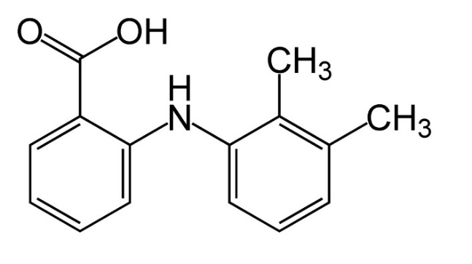

Figure 1. Chemical structure of mefenamic acid

Spectrophotometry is a simple analytical method for the determination of mefenamic acid in pharmaceutical dosage forms. Determination of active ingredient compounds in tablet formulation that contains other excipients that can absorb energy in ultraviolet (UV) became challenging. For instance, sunset yellow dyes can be detected in both UV and visible areas. In the UV region, this excipient gives absorption at wavelengths of 230 nm and 315 nm. At the same time, absorption at wavelengths of 480 nm in the visible area is observed [13]. Therefore, a selective spectrophotometric method is needed to overcome this problem by measuring the absorption in a visible area that not interfering with other excipients.

Selective strategies that can be developed for determining active compounds in complex matrix samples using spectrophotometric methods are based on the formation of colors that can be analyzed in visible regions. Visible spectrophotometric methods based on the formation of red complexes through the reduction of ferric (Fe³⁺) ions to ferrous (Fe²⁺) ions by mefenamic acid followed by complex formation with o-phenanthroline was developed for quantification in pharmaceutical products [8]. Another method for mefenamic acid analysis was based on the formation of N-chlorosuccinimide color through the oxidative coupling reaction of mefenamic acid and 4-amminoantipyrine in the acidic medium [14]. However, visible spectrophotometry methods based on Prussian blue formation have not to be reported previously. This approach is not performed yet because other studies use other chemicals to form colored complex compounds and make it more promising to be developed and investigated.

The development of an analytical method for mefenamic acid determination in tablets based on Prussian blue formation is significantly promising because mefenamic acid has the ability to reduce Fe³⁺ to Fe²⁺ ions [8]. The presence of Fe²⁺ ions can be used to form Prussian blue complexes with potassium ferricyanide. The intense blue colored complex afterward analyzed by visible spectrophotometry method at a visible wavelength [15, 16]. This study aimed to develop and validate a visible spectrophotometric method for mefenamic acid determination in tablet formulations based on Prussian blue formation. Optimization of various parameters in terms of reaction conditions and other spectrophotometric parameters was observed. Comprehensive analytical performances were evaluated based on the guideline for the validation of analytical procedures [17]. Additionally, the proposed method was implemented for the quantitative analysis of mefenamic acid in the real samples. The proposed method was easy to handle due to using simple chemicals and instruments and a fast reaction time of 35 minutes. On the other hand, selectivity for other compounds contributing to the redox reaction may be more challenging. However, the application for the determination of mefenamic acid in tablets showed minor interference. The interference of some excipients that were commonly used in the tablet was evaluated in this study.

Materials and Methods

Chemicals

The analytical grade of mefenamic acid standards (purity ≥ 98.5%), ferric chloride (FeCl₃) (purity 99.0%-102.0%), potassium ferricyanide (K₃(FeCN6)) (purity ≥ 99.0%), acetic acid (purity ≥ 96.0%), and ethanol (purity ≥ 99.5%) were purchased from Merck (Darmstadt, Germany). The technical grade of distilled water and some excipients, such as talc, starch, and polyvinyl pyrrolidone (PVP), were purchased from Bratachem (Purwokerto, Indonesia). All other chemicals were of analytical grade. Mefenamic acid tablet samples were obtained from the pharmacies in the Purwokerto area.

Instruments

UV-Vis 3000 single-beam spectrophotometer (Cecil CE 3021, Cambridge, England) was used for measurements. Analytical balance, shaker incubator Memmert EN 60529 (Schwabach, Germany), pH meter, and micropipette (Socorex, Switzerland) were used for sample preparations.

Spectrophotometric determination

Mefenamic acid standard solutions and potassium ferricyanide solutions were prepared by accurately weighing each compound, dissolving, and serial dilution into ethanol to obtain appropriate concentration. For instance, 50.0 mg mefenamic acid was dissolved in 50 mL ethanol in a volumetric flask, and then serial dilution was carried out by transferring 1.0 mL solutions into 25 mL volumetric flask, and ethanol was added to obtain 40.0 mg/L mefenamic acid standard solutions. The optimized conditions were performed for measuring mefenamic acid concentration using a spectrophotometer based on Prussian blue formation. In brief, 2.0 mL of mefenamic acid solution was reacted with two mL of 15 mmol/L potassium ferricyanide and two mL of 2.5 mmol/L ferric chlorides in 0.5 mol/L acetic acids in a 10.0 mL volumetric flask. Afterward, 50% ethanol was added to make up the mark. The maximum wavelength was determined using a solution without mefenamic acid to confirm other chemicals and solvents' interference in the measurement. The absorbance of the mixture solution was measured using a spectrophotometer after 35 min incubation at room temperature. The wavelength of 715 nm was used for measuring the absorbance against a reagent blank that contained distilled water.

Analytical method validation

Analytical parameters in terms of linearity, detection limits, quantification limits, accuracy, precision, and selectivity were evaluated for method validation, according to ICH (Q2) R1 guideline [17]. Linearity study was carried out using five series concentrations of mefenamic acid standard solutions in the range of 3.0 mg/L to 14.0 mg/L. Each concentration was prepared in three replicated and then reacted with ferric chloride in acetic acid solution and potassium ferricyanide under optimized conditions. The absorbance was measured with a spectrophotometer at 715 nm. Subsequently, the calibration curve was prepared based on mefenamic acid concentration and their absorbance value. Detection and quantitation limits were calculated based on the residual standard deviation value and the calibration curve slope.

The standard addition method was carried out for accuracy and precision assessments in three concentration levels replicate. Three concentration levels of spiked samples, namely 75%, 100%, and 125%, were processed using 6.0 mg/L, 8.0 mg/L, and 10.0 mg/L of a mefenamic acid standard added to 0.11 mL of the mefenamic acid tablet sample solution, respectively. These levels were selected to cover lower and higher concentrations from the defined concentration. Preparation of the mefenamic acid tablet sample solution was carried out by grinding 20 mefenamic acid tablets, followed by weighed accurately 50.0 mg of homogenized powder and transferred it into a 50 mL volumetric flask. To made up the mark, 50% ethanol was added and mixing until homogeneous, then filtered. An unspiked sample solution that contained only the mefenamic acid tablet sample was prepared with 50% ethanol.

The absorbance values were measured using a visible spectrophotometer after reaction with ferric chloride in acetic acid solution and potassium ferricyanide under optimized conditions. Repeatability (intra-day) and intermediate (inter-day) precision were evaluated from three measurements on the same day and three different days, respectively. Selectivity performance was done by adding separately 8.0 mg/L mefenamic acid standard solutions into common excipients that might be added during formulations, such as talc, starch, and PVP with a concentration of 1000 mg/L for each solution. The absorbance then measured using a spectrophotometer at 715 nm in the optimized condition.

Mefenamic acid determination in tablet

Quantitative determination of mefenamic acid concentrations in the tablet was carried out using three different mefenamic acid tablet brands. First, 20 tablets were pulverized and accurately weighed 50.0 mg of homogenized powder and then dissolved in 25 mL ethanol in a volumetric flask. Following this, the sample solutions were filtered, and afterward, an appropriate sample was transferred into a 25 mL volumetric flask and added 50% ethanol to make the mark. Then, 2.0 mL samples were mixed with ferric chloride in acetic acid solution and potassium ferricyanide under optimized conditions. Finally, the absorbance values were measured using a spectrophotometer at 715 nm.

Data analysis
The concentration of mefenamic acid samples was calculated by interpolating the absorbance value with the mefenamic acid standard calibration curve. The analytical method's linearity was given in the square of the correlation coefficient (r²), indicating the relationship between the mefenamic acid concentration and their absorbance values. The detection limit and the quantification limit were expressed as the concentration level (mg/L) calculated from three times and ten times the standard residual deviation in the method, respectively. The accuracy was evaluated from the recovery percentage, and the precision was observed from the relative standard deviation (% RSD) of measurements. Also, selectivity assessment was recognized from the percentage of mefenamic acid concentration recovery after adding some excipients tablet samples. Regarding the determination of the real sample tablet, the data were presented descriptively in the form of the percentage of the claimed label for each identified tablet brand.

Results and Discussion

Method development for mefenamic acid determination using visible spectrophotometry

Determination of the spectrophotometric detection wavelength was carried out by measuring the absorption of Prussian blue solutions formed from the reaction of mefenamic acid with ferric chloride in acetic acid solution and potassium ferricyanide in the region wavelength between 500 nm to 800 nm. Figure 2 illustrated the findings of optimized wavelength at 715 nm that shown the higher concentration of mefenamic acid as a reducing agent, the higher intensity of Prussian blue formed. These findings suggested that the reduced agent's increased capacity contributed to the increasing Prussian blue formed, and afterward, the absorbance level gradually increases [18]. The optimized wavelength measurement was obtained at 715 nm. This wavelength region corresponded to the wavelength for a bluish-green color solution in the range of 610 nm to 750 nm [20]. On the other hand, according to Teepoo et al. [15], the Prussian blue wavelength was 700 nm. Another study reported that the slight difference of the optimized wavelength was obtained probably due to the different conditions of the Prussian blue formation such as temperature, pH, differences in solvents, and differences in reaction conditions [21].

To optimize the measurement and reaction conditions for Prussian blue formation, various parameters in terms of operating time measurement and concentration of potassium ferricyanide, ferric chloride, and acetic acid solutions were investigated using a spectrophotometer at 715 nm. The stable measurement time for Prussian blue formation was observed over 75 minutes after reaction

to mefenamic acid with ferric chloride and potassium ferricyanide solutions. The suitable time for measurement was obtained at 35 minutes (Figure 3a) under the conditions of 40.0 mg/L mefenamic acid, 15.0 mmol/L potassium ferricyanide, and 0.5 mmol/L ferric chlorides in 0.5 mol/L acetic acids after 35 min incubation. This finding seemed different from the other research, which reported the operating time for Prussian blue formation derived from reducing Fe³⁺ to Fe²⁺ ions using ascorbic acid as a reducing agent followed by reaction with potassium ferricyanide was 10 minutes [15]. It is reasonable because ascorbic acid is a strong reducing agent that the reaction time needed for the reduction process occurs faster due to the formation of Prussian blue only needs in less time [22].

Various concentration solutions to form optimum Prussian blue was observed using potassium ferricyanide, ferric chloride, and acetic acid. The investigated results obtained that the higher potassium ferricyanide concentration influenced the higher intensity absorbance to 15 mmol/L and became remained constant (Figure 3b). This finding shows that 15 mmol/L potassium ferricyanide was a suitable condition for optimum concentration to form Prussian blue. The measurement was performed using 40.0 mg/L mefenamic acid and 0.5 mmol/L ferric chloride in 0.5 mol/L acetic acids after 35 minutes incubation. This finding was in accordance with the other studies that the addition of potassium ferricyanide in higher concentration increased the absorbance of Prussian blue formed [15, 23]. Evaluation from ferric chloride concentration also gave the same trend. An increase of ferric chloride concentration was gradually followed by increasing the absorbance at 715 nm (Figure 3c). The absorbance remained stable after a concentration value of 2.5 mmol/L, indicated that the optimum concentration of ferric chloride for this measurement was carried out using 0.5 mol/L acetic acid, 40.0 mg/L mefenamic acids, and 15.0 mmol/L potassium ferricyanide, with incubation time 35 minutes.

On the other hand, the optimum concentration of acetic acid was 0.5 mol/L (Figure 3d). Acetic acid was used for dissolving ferric chloride. Increasing acetic acid concentration causes an increase in Prussian blue, which was formed due to acidic conditions that can increase Prussian blue's solubility. In addition, Prussian blue was unstable under alkaline conditions where Prussian blue will form deposits of iron oxide (Fe(OH)₃) [24]. In summarize, these results showed that optimum Prussian blue formed using 40 mg/L mefenamic acids under the condition of 15 mmol/L potassium ferricyanide and 2.5 mmol/L ferric chlorides in 0.5 mol/L acetic acids.

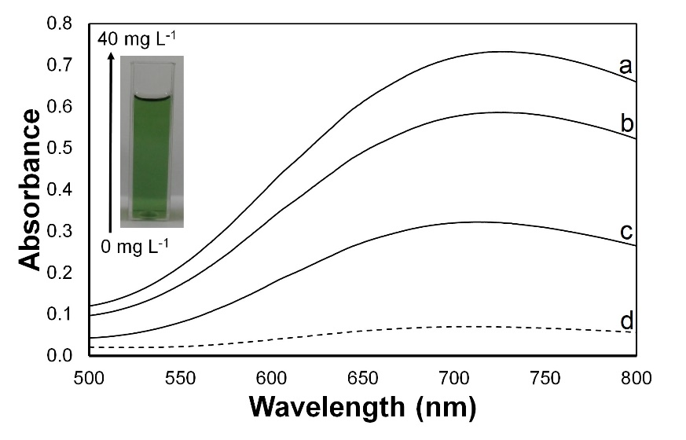

Figure 2. Absorption spectra of soluble Prussian blue formation. Condition: 3.0 mmol/L potassium ferricyanide and 0.5 mmol/L ferric chloride in 0.5 mol/L acetic acid with (a) 40.0 mg/L, (b) 24.0 mg/L, (c) 6.0 mg/L, and (d) 0.0 mg/L mefenamic acid

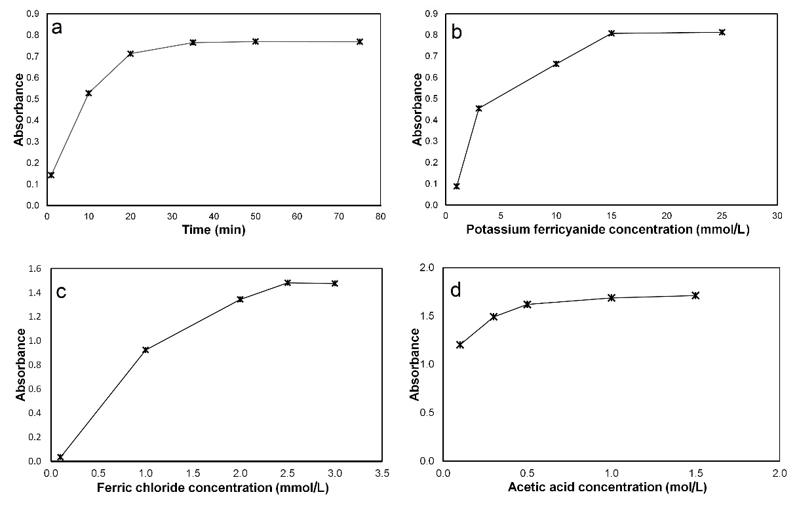

Figure 3. Optimization of Prussian blue color formation measured using spectrophotometry at 715 nm. The effect of (a) incubation time, (b) potassium ferricyanide, (c) ferric chloride, and (d) acetic acid concentrations on color development

Method validation performance

Linearity measurement was performed using five different mefenamic acid concentrations, which gave absorbance in the range of between 0.2 and 0.8 absorbance units with three replicates. The measurement results are presented in Figure 4. It can be seen that the value of the square correlation coefficient (r²) obtained was 0.9954 in the concentration range of 3.0 mg/L to 14.0 mg/L, which means that there was a good correlation between the concentration and the absorbance measurement. In addition, the high degree of correlation coefficient value of the regression equation showed good linearity following Lambert Beer's law [25, 26]. In other studies, Ahmed and Mufty, who developed an analytical method for determining the concentration of mefenamic acid through oxidation of mefenamic acid by Fe³⁺ and reacted with phenanthroline, gave the degree of correlation coefficient was 0.9993 [8]. Whereas in the research of Raza et al., who developed the method of determining mefenamic acid through the reaction of mefenamic acid with chloranil, which produced violet color, the degree of correlation coefficient was 0.9996 [9].

On the other hand, measuring mefenamic acid based on N-bromosuccinimide's oxidation reaction produced a yellow color with a linear degree of correlation coefficient of 0.9999 [27]. Additionally, the LOD and LOQ calculated based on mefenamic acid standard calibration curves were 0.31 mg/L and 1.04 mg/L, respectively. This result seemed to be better than another report from Raza et al. that obtained the value of 2.16 mg/L for LOD and 7.5 mg/L for LOQ [9].

Accuracy and precision evaluation were done using the standard addition method using three standard concentration levels with three replicate measurements (Table 1). Accuracy performance was obtained from the recovery value of the mefenamic acid added into the sample. The results of the average recovery for each level of concentration was between 90.00% and 93.79%. On the other hand, this method's precision was less than 1.60% and 3.03% for intra-day and inter-day measurements, respectively. Finally, selectivity performance was obtained by adding 1000 mg/L of talk, starch, and PVP solution to the standard solution of mefenamic acid with a concentration of 8.0 mg/L. The selectivity value was observed from the recovery value. The recovery value obtained was between 99.94% and 102.76% (Table 2). This result indicated an appropriate selectivity of the proposed method in the presence of excipient in the matrix sample commonly used in the tablet dosage form.

Application of mefenamic acid level measurement in tablet

The proposed visible spectrophotometric method was used to determine the concentration of mefenamic acid in the pharmaceutical tablet. Three different samples of commercially mefenamic acid tablets, namely PNT, GMA, and MFL, with the same batch number were determined. The mefenamic acid concentration in the sample was determined by measuring absorbance at 715 nm using external calibration approaches. Relative average concentration comparing with claim labeled measurement for mefenamic acid tablet labels were between 99% and 103% (Table 3). These results suggested that each sample measured using the proposed method was under the requirements. The Indonesian Pharmacopoeia and British Pharmacopeia stated that mefenamic acid tablets should contain mefenamic acid in the range of 95.0% to 105.0% of the amount stated on the label [28, 29].

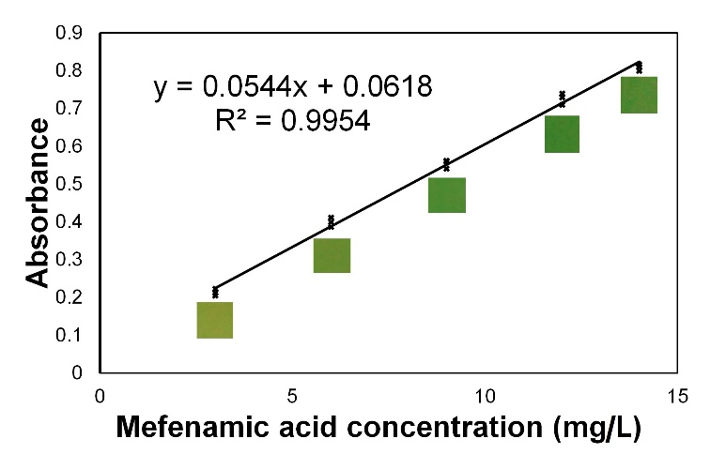

Figure 4. Linear regression calibration curve for mefenamic acid's standard solution in the concentration range of 3.0 mg/L to 14.0 mg/L (n = 3)

Table 1. Accuracy and precision of mefenamic acid spectrophotometric measurement using
standard addition method (n = 3)
Level  (%) | Sample | Mefenamic acid added | Intra-day |  | Inter-day
Level  (%) | Sample | Mefenamic acid added | Mefenamic acid found | Recovery | Mefenamic acid found | Recovery
Level  (%) | Sample | (mg/L) | (mg/L) | (%) | (mg/L) | (%)
75 | 1 | 6.00 | 5.63 | 93.83 | 5.41 | 90.17
75 | 2 | 6.00 | 5.59 | 93.17 | 5.33 | 88.83
75 | 3 | 6.00 | 5.46 | 91.00 | 5.46 | 91.00
75 | Average |  |  | 92.67 |  | 90.00
75 | % RSD |  |  | 1.60 |  | 1.22
100 | 1 | 8.00 | 7.44 | 93.00 | 7.16 | 89.50
100 | 2 | 8.00 | 7.50 | 93.75 | 7.15 | 89.34
100 | 3 | 8.00 | 7.57 | 94.63 | 7.44 | 93.00
100 | Average |  |  | 93.79 |  | 90.61
100 | %RSD |  |  | 0.87 |  | 2.28
125 | 1 | 10.00 | 9.25 | 92.50 | 8.79 | 87.90
125 | 2 | 10.00 | 9.46 | 94.60 | 9.31 | 93.10
125 | 3 | 10.00 | 9.21 | 92.10 | 9.21 | 92.10
125 | Average |  |  | 93.07 |  | 91.03
125 | % RSD |  |  | 1.44 |  | 3.03

Table 2. Method selectivity evaluation in the presence of various excipients in tablet formulations (n = 3)
Excipients | Amount Taken  (mg/L) | Mefenamic Acid Added  (mg/L) | Recovery  (%) | RSD  (%)
PVP | 1000 | 8.00 | 98.38 | 2.33
Talc | 1000 | 8.00 | 108.12 | 3.15
Starch | 1000 | 8.00 | 104.20 | 1.38

Table 3. Application of the proposed method for analysis of commercial mefenamic acid formulations
in tablet dosage form (n =3)
Sample | Label Claimed in Each Tablet  (mg) | Weight of Sample for Each Tablet  (Mg) | Mefenamic Acid Found in Each Tablet  ( ± SD Mg) | Mefenamic Acid Found in Each Tablet  ( ± SD%) | Percentage of Label Claimed Found in Each Tablet  ( ± SD %)
PNT | 500 | 728 | 499.72 ± 1.15 | 68.68 ± 0.16 | 99.94 ± 0.23
GMA | 500 | 654 | 513.78 ± 6.01 | 78.53 ± 0.92 | 102.76 ± 1.20
MFL | 500 | 910 | 507.83 ± 9.99 | 55.78 ± 6.13 | 101.57 ± 2.00

Conclusion

A selective and accurate visible spectrophotometric method was successfully developed for mefenamic acid determination in the tablet formulations based on Prussian blue formation. The proposed method can be applied as an alternative method for the routine analysis of mefenamic acid in pharmaceutical raw and dosage forms with a good analytical performance.

Acknowledgment

The authors would like to thank the Jenderal Soedirman University for financial support and the Department of Pharmacy, Faculty of Health Sciences, Jenderal Soedirman University for research facilities.

References
- Sweetman, S. C. (2009). Martindale The complete drug reference, Pharmaceutical Press, London: pp. 80.
- Council of Experts and Its Expert Committees (2014). United States Pharmacopeia 37, United States Pharmacopoeial Convention, Rockville: pp. 3672-3673.
- Ibrahim, H., Boyer, A., Bouajila, J., Couderc, F. and Nepveu, F. (2007). Determination of non-steroidal anti-inflammatory drugs in pharmaceuticals and human serum by dual-mode gradient HPLC and fluorescence detection. Journal of Chromatography B, 857(1): 59-66.
- Kormosh, Z. and Matviychuk, O. (2013). Potentiometric determination of mefenamic acid in pharmaceutical formulation by membrane sensor based on ion-pair with basic dye. Chinese Chemical Letters, 24(4): 315-317.
- Malode, S. J., Shetti, N. P. and Kulkarni, R. M. (2019). Voltammetric detection and determination of mefenamic acid at silver-doped TiO₂ nanoparticles modified electrode. Materials Today: Proceedings, 18: 671-678.
- Poerwono, H., Widyowati, R., Kubo, H., Higashiyama, K. and Indrayanto, G. (2005). Mefenamic acid: analytical profile, profiles of drug substances, excipients and related methodology, Academic Press, Brittain: pp. 281-336.
- Dinç, E., Yücesoy, C. and Onur, F. (2002). Simultaneous spectrophotometric determination of mefenamic acid and paracetamol in a pharmaceutical preparation using ratio spectra derivative spectrophotometry and chemometric methods. Journal of Pharmaceutical and Biomedical Analysis, 28(6): 1091-1100.
- Al-mufty, M. Z. and Ahmed, N. R. (2009). Indirect spectrophotometric method for the determination of mefenamic acid in pharmaceutical formulations. Rafidain Journal of Science, 20(6): 39-47.
- Raza, A. (2008). Spectrophotometric determination of mefenamic acid in pharmaceutical preparations. Journal of Analytical Chemistry, 63(3): 244-247.
- Zisimopoulos, E. G., Tsogas, G. Z., Giokas, D. L., Kapakoglou, N. I. and Vlessidis, A. G. (2009). Indirect chemiluminescence-based detection of mefenamic acid in pharmaceutical formulations by flow injection analysis and effect of gold nanocatalysts. Talanta, 79(3): 893-899.
- Mofavvaz, S., Sohrabi, M. R. and Heydari, A. (2020). Application of UV/vis spectrophotometry based on using least squares support vector machine and continuous wavelet transform methods for the simultaneous analysis of antibiotics drugs in tablet formulation: Comparison with HPLC method. Optik, 220: 165246.
- Darbandi, A., Sohrabi, M. R. and Bahmaei, M. (2020). Development of a chemometric-assisted spectrophotometric method for quantitative simultaneous determination of Amlodipine and Valsartan in commercial tablet. Optik, 218: 165110.
- Pavanelli, S. P., Bispo, G. L., Nascentes, C. C. and Augusti, R. (2011). Degradation of food dyes by zero-valent metals exposed to ultrasonic irradiation in water medium: Optimization and electrospray ionization mass spectrometry monitoring. Journal of the Brazilian Chemical Society, 22(1): 111-119.
- Othman, N. S. and Awades, L. S. (2008). Spectrophotometric determination of mefenamic acid via oxidative coupling reaction with 4-amminoantipyrine in presence of N-chlorosuccinimide. Pakistan Journal Analytical Environmental Chemistry, 9(2): 64-68.
- Teepoo, S., Chumsaeng, P., Jongjinakool, S., Chantu, K. and Nolykad, W. (2012). A new simple and rapid colorimetric screening test for semi-qualitative analysis of vitamin C in fruit juices based on Prussian blue. Journal of Applied Sciences, 12(6): 568-574.
- Wasito, H., Fatoni, A., Hermawan, D. and Susilowati, S. S. (2019). Immobilized bacterial biosensor for rapid and effective monitoring of acute toxicity in water. Ecotoxicology and Environmental Safety, 170: 205-209.
- Borman, P. and Elder, D. (2017). Q2 (R1) validation of analytical procedures. ICH Quality Guidelines, 5: 127-166.
- Jayanthi, P. and Lalitha, P. (2011). Reducing power of the solvent extracts of Eichhornia crassipes (Mart.) Solms. International Journal of Pharmacy and Pharmaceutical Sciences, 3(3): 126-128.
- Grandjean, F., Samain, L. and Long, G. J. (2016). Characterization and utilization of Prussian blue and its pigments. Dalton Transactions, 45(45): 18018-18044.
- Malacara, D. (2011). Color vision and colorimetry: Theory and applications. SPIE Press, Bellingham: pp. 1-20.
- Giovannetti, R. (2012). The use of spectrophotometry UV-Vis for the study of porphyrins macro to nano spectroscopy. InTech, China: pp. 87-108.
- Rao, G. G. and Rao, V. N. (1955). Ascorbic acid as a reducing agent in quantitative analysis. Fresenius’ Zeitschrift Für Analytische Chemie, 147(5): 338-347.
- Samain, L., Grandjean, F., Long, G. J., Martinetto, P., Bordet, P. and Strivay, D. (2013). Relationship between the synthesis of Prussian Blue pigments, their color, physical properties, and their behavior in paint layers. The Journal of Physical Chemistry C, 117(19): 9693-9712.
- Adhikamsetty, R. and Jonnalagadda, S. (2009). Kinetics and mechanism of prussian blue formation. Bulletin of the Chemical Society of Ethiopia, 23(1): 47-54.
- El-Didamony, A. M., Saad, M. Z. and Saleem, N. O. (2013). Kinetic spectrophotometry method for the determination of morphine, nalbuphine and naltrexone drugs in bilk and pharmaceutical formulation. Journal of the Chilean Chemical Society, 58(3): 1907-1913.
- Hu, W.-H., Zhai, Q.-Z. and Zhang, X.-M. (2014). Determination of trace amount of IO₃−with KIO₃-KBr-(DBS-arsenazo) system by spectrophotometry. Journal of Analytical Chemistry, 69(5): 438-441.
- Alarfaj, N., Altamimi, S. and Almarshady, L. (2009). Spectrophotometric determination of mefenamic acid in pharmaceutical preparations. Asian Journal of Chemistry, 21(1): 217-226.
- Panitia Farmakope Indonesia, R. (1995). Farmakope Indonesia Edisi Keempat, Depkes, Jakarta: pp. 1107-1110.
- British Pharmacopoeia Commission Office (2009). British Pharmacopoeia, Volume I & II, Medicines and Healthcare Products Regulatory Agency (MHRA), London: pp. 4788.

