

COPOLYMERISATION OF METHYL METHACRYLATE AND HYDROXYPROPYL METHYLCELLULOSE VIA EMULSION POLYMERISATION TECHNIQUE

(Pengkopolimeran Metil Metakrilat dan Hidroksipropil Metilselulosa Melalui Teknik Pempolimeran Emulsi)

Noor Aniza Harun^{1,2}*, Liew Pei Chen¹, Anis Arina Zainudin¹, Tan Yea Tzy¹, Farhanini Yusoff¹

¹Faculty of Science and Marine Environment,

²Advanced Nano Materials (ANOMA) Research Group, Faculty of Science and Marine Environment,

Universiti Malaysia Terengganu, 21030 Kuala Nerus, Terengganu, Malaysia

*Corresponding author: nooraniza@umt.edu.my

Received: 22 September 2020; Accepted: 29 November 2020; Published: xx February 2021

Abstract
Copolymerisation between methyl methacrylate (MMA) and hydroxypropyl methylcellulose (HPMC) to produce poly(methyl methacrylate-co-hydroxypropyl methylcellulose) P(MMA-co-HPMC) nanoparticles was successfully prepared via an emulsion polymerisation technique. The effects of different molar ratios of MMA and HPMC monomers towards the copolymer formation, morphology, thermal stability and solubility were thoroughly discussed. Homopolymerisation of poly(methyl methacrylate) (P(MMA)) and poly(hydroxylpropyl methylcellulose) (P(HPMC)) was also carried out as control via emulsion polymerisation. Sodium dodecyl sulphate (SDS) and potassium persulfate (KPS) were used as anionic surfactant and water-soluble initiator, respectively, throughout the emulsion polymerisation process. The formation of copolymer P(MMA-co-HPMC) and homopolymers of P(MMA) and P(HPMC) nanoparticles was confirmed by Fourier transform infrared spectroscopy (FTIR). The morphology of copolymer and homopolymer nanoparticles was determined using scanning electron microscopy (SEM). The decomposition rate of homopolymer and copolymer nanoparticles was verified using thermogravimetric analysis (TGA) technique. Meanwhile, the hydrophilicity of homopolymer and copolymer nanoparticles was determined by a simple solubility test to obtain their degree of solubility in aqueous medium. It was found that the copolymers formed with higher molar ratios of MMA monomers were less thermally stable and possessed lower rates of solubility than that of the higher molar ratios of HPMC monomers.

Keywords: methyl methacrylate, hydroxypropyl methylcellulose, copolymerization, emulsion polymerization, hydrophilic nanoparticles

Abstrak

Pengkopolimeran di antara metil metakrilat (MMA) dan hidroksilpropil metilselulosa (HPMC) untuk menghasilkan nanopartikel poli(metil metakrilat-ko-hidroksilpropil metilselulosa) (P(MMA-ko-HPMC)) berjaya disediakan melalui teknik pempolimeran emulsi. Kesan nisbah molar yang berlainan daripada monomer MMA dan HPMC terhadap pembentukan kopolimer, morfologi, kestabilan haba dan kelarutan telah dibincangkan dengan jelas. Penghomopolimeran poli(metil metakrilat) (P(MMA)) dan poli(hidroksilpropil metilselulosa) (P(HPMC)) juga dijalankan sebagai kawalan melalui pempolimeran emulsi. Sodium dodesil sulfat dan kalium persulfat digunakan sebagai surfaktan anionik dan agen pemula di sepanjang tindak balas pempolimeran emulsi. Pembentukan nanopartikel kopolimer P(MMA-ko-HPMC) dan homopolimer P(MMA) dan P(HPMC) telah disahkan oleh puncak penyerapan spektroskopi infra-merah Fourier (FTIR). Morfologi nanopartikel kopolimer dan homopolimer ditentukan dengan menggunakan mikroskopi pengimbasan elektron (SEM). Kadar penguraian nanopartikel homopolimer dan kopolimer ditentukan dengan menggunakan teknik termogravimetrik (TGA). Manakala keterlarutan homopolimer dan kopolimer nanopartikel ditentukan oleh ujian kelarutan mudah bagi menentukan tahap keterlarutan di dalam medium akues. Ianya didapati bahawa kopolimer yang terbentuk dengan nisbah molar monomer MMA yang lebih tinggi mempunyai kestabilan haba yang lebih rendah dan mempunyai kadar kelarutan yang lebih rendah daripada nisbah molar monomer HPMC yang tinggi.

Kata kunci: metil metakrilat, hidroksilpropil metilselulosa, pengkopolimeran, pempolimeran emulsi, nanopartikel hidrofilik

Introduction
The increase in nano-medicine components in the field of nanotechnology has induced the development of nano-scale materials for drug delivery applications. Amongst the materials, synthetic polymeric nanoparticles (PNPs), which are synthesised from biocompatible and biodegradable monomers, have become favourable. Polymer-based nanoparticles within the size range of 10-500 nm can effectively carry drugs, proteins, and DNA to target cells and organs. This is because their nanometer size can promote effective permeation through cell membranes and stability in the blood stream [1]. Due to the grand bioavailability, better encapsulation, control release, and less toxic properties, biodegradable polymeric nanoparticles are often used to increase the therapeutic value of many water soluble or insoluble medicinal drugs and bioactive molecules by improving bioavailability, solubility, and retention time [2].

PNPs can be easily prepared by several methods, namely preformed polymers and direct polymerisation of monomers. In the preparation of PNPs from preformed polymers, several techniques such as solvent evaporation, salting out, dialysis, and supercritical fluid technology can be utilised. PNPs can also be directly synthesised via polymerisation techniques such as microemulsion [3, 4], miniemulsion [5, 6], emulsion [7, 8], and interfacial polymerisation [9]. The selection of preparation method is based on several factors, such as the type of polymeric system, area of application, and size requirement [10]. Amongst the various methods, emulsion polymerisation is known as the fastest method for nanoparticle preparation because it is readily scalable. In general, emulsion polymerisation is defined as a heterogeneous reaction that consists of dispersed and continuous phases initiated by free radical to prepare dispersions of polymers [11]. The advantage of this technique includes the production of high molecular weight polymers via rapid polymerisation with narrow molecular weight distribution.

Emulsion polymerisation is a common technique used for producing biodegradable polymer that has been utilised in many industries for synthesising large quantities of latex in various applications such as surface coating in paints and adhesives [12]. Several research have been performed on the synthesis of biodegradable polymer by using the emulsion polymerisation technique. Poly(methacrylic acid)-polysorbate 80-grafted starch (PMAA-PS 80-g-St) nanoparticles are synthesised by using a one-pot emulsion polymerisation method. This technique enables simultaneous grafting of PMAA and polysorbate 80 onto starch and composite nanoparticles are formed in an aqueous medium. This research is focused on the design of new pH-responsive nanoparticles for controlled delivery of anticancer drug doxorubicin (Dox) [13].

Several studies have been carried out on the preparation and characterisation of HPMC copolymer and MMA monomers via the emulsion polymerisation technique. For example, Baek et al. prepared hydroxypropyl methylcellulose graft poly(ethylacrylate-co-methylacrylate) [HPMC-g-poly(EA-co-MMA)] nano- particles via resin-fortified emulsion polymerisation using ceric ammonium nitrate (CAN) as the redox initiator in determining the solubility behaviour of aspirin tablet [14]. In another study, copolymers of methyl methacrylate and butyl acrylate were synthesised by varying concentrations of methacrylic acid and 2-hydroxy ethyl methacrylate via the emulsion polymerisation technique. The copolymers showed good thermal stability on the TGA characterisation and could be applied for coating of textiles without any thickening agent [15].

Biodegradable polymers can be defined as polymers that are able to degrade within the body as a result of natural biological processes due to enzyme-catalysed hydrolysis reactions to produce biocompatible by-products. These polymers can be metabolised and excreted via normal physiological pathways. Biodegradable polymers can be classified as natural or synthetic polymers. Natural biodegradable polymers that are commonly used are gelatine and alginate [16]. However, synthetic biodegradable polymers are found to be more versatile and possess diverse biomedical applications through modifications in the polymer structures. Synthetic biodegradable polymers have been widely used in the development of biomedical fields due to their biocompatibility and biodegradability [17].

Methyl methacrylate (MMA) monomer is considered as a hydrophobic monomer since it is only partially soluble in water [18]. Emulsion polymerisation of MMA will produce poly(methyl methacrylate) (P(MMA)) that has the characteristic of partial solubility in water, which is not completely biodegradable [19]. Therefore, to improve the hydrophilicity and biocompability of P(MMA) nanoparticles, it is desirable to combine MMA monomer with another monomer via the copolymerisation method. Hydroxypropyl methylcellulose (HPMC) is a hydrophilic swelling polymer that provides water permeability and solubility [20]. Therefore, this study highlights the synthesis of homopolymer and copolymer of MMA and HPMC monomers and examines the ability of HPMC monomer to improve the hydrophilicity of P(MMA) nanoparticles at different molar ratios. The development of copolymer MMA-HPMC is expected to be further utilised in medical and biological applications. In this particular research, the hydrophilic homopolymer and copolymer nanoparticles are synthesised via the emulsion polymerisation technique by using methyl methacrylate (MMA) and hydroxypropylmethyl cellulose (HPMC) monomers. The PNPs obtained are characterised using Fourier transform infrared spectroscopy (FTIR), scanning electron microscopy (SEM), and thermogravimetric analysis (TGA).

Materials and Methods

Materials
Methyl methacrylate (MMA) and hydroxypropylmethyl cellulose (HPMC) monomers, sodium dodecyl sulphate (SDS) as the anionic surfactant, and potassium persulfate (KPS) as the initiator were all commercially obtained from Sigma Aldrich. Distilled water was used throughout the experiment.

Emulsion polymerization of homopolymer P(MMA) and P(HPMC) nanoparticles
Emulsion polymerisation was conducted in a 250 mL two-neck round bottom flask equipped with a magnetic stirrer, reflux-condenser, nitrogen gas inlet, and thermometer. Distilled water (50 mL) and methyl methacrylate (MMA) (0.05 g) were mixed with the anionic surfactant, i.e. sodium dodecyl sulfate (SDS) (8.2 mM), and added into a reactor at room temperature. The solution mixture was purged with $N_{2}$ for 15 minutes to remove any dissolved oxygen. The $N_{2}$ inlet was removed and the neck of the round bottomed flask was sealed with parafilm. The polymerisation was initiated by adding aqueous potassium persulfate (KPS) (6.95 mM) and the reaction was performed in an oil bath at 80 °C for 2 hours with constant stirring at 400 rpm. The product was cooled for 30 minutes and the remaining solvent was removed by a rotary evaporator. The process was repeated by homopolymerisation of HPMC via a similar procedure, whereby the starting amount of HPMC monomer was 0.65 g. Table 1 summarises the ingredients used.

Emulsion polymerization of copolymer P(MMA-co-HPMC) nanoparticles
Emulsion copolymerisation between MMA and HPMC was prepared using the similar method as described above. Different molar ratios of MMA and HPMC monomers (1:4) were mixed with the anionic surfactant (SDS) and added into the reactor at room temperature prior to initiation with aqueous KPS solution. The procedure for the preparation of homopolymer P(MMA) and P(HPMC) nanoparticles and copolymer of P(MMA-co-HPMC) nanoparticles is summarised in Table 1.

Fourier transform infrared spectroscopy
The solid samples of polymer nanoparticles were prepared in the form of potassium bromide (KBr) pellet. The polymer nanoparticles were mixed and crushed together with KBr powder in a ratio of 1:7. The KBr powder was heated for 1 hour or more to avoid any moisture that can affect the IR spectra. The pellet was placed on a plate and clamped in the right position. The FTIR spectra was recorded using Perkin-Elmer 100 series Fourier transform instrument covering a scan range between 4000–450 cm⁻¹.

Scanning electron microscopy
The coating of polymer nanoparticles was prepared using JFC-1600 Auto Fine Coater. The particle sizes and morphology polymer nanoparticles were observed using Oxford Instrument attached to JSM-6360 LA Analytical Transmission Electron Microscope at a magnification observation of 5000x, with 50 nm scale bar and acceleration voltage of 15 kV.

Thermogravimetric analyzer
TGA characterisation was performed using Q500 (TA Instrument) with a heating rate of 10 °C/min under nitrogen condition at temperature up to 600 °C. About 10 mg of polymer samples were placed in a TGA pan and utilised in this analysis.

Solubility test
A simple solubility test was conducted to compare the hydrophilicity of homopolymer and copolymer of P(MMA), P(HPMC) and P(MMA-co-HPMC) nano- particles, respectively. About 0.05 g of polymer nanoparticles were weighed and dissolved with 6 mL of distilled water at room temperature. The ability of homopolymer and copolymer nanoparticles to dissolve in aqueous medium was observed.

Results and Discussion
Emulsion Polymerization of Copolymer Poly(MMA-co-HPMC) via Emulsion Polymerization Technique
Copolymerisation of methyl methacrylate (MMA) and hydroxypropyl methylcellulose (HPMC) monomers to produce poly(methyl methacrylate-co-hydroxypropyl methylcellulose) P(MMA-co-HPMC) nanoparticles at different molar ratios was successfully synthesised via the emulsion polymerisation technique in the presence of sodium dodecyl sulphate (SDS), potassium persulfate (KPS), and water as dispersion medium (Table 1).

Homopolymer P(MMA) and P(HPMC) nanoparticles were also synthesised via emulsion polymerisation and acted as the control for comparison in this research. P(MMA) nanoparticles were obtained in white powder form (Figure 1a), whereas P(HPMC) nanoparticles were attained as gel-like form (Figure 1b). P(MMA-co-HPMC) nanoparticles with molar ratios of MMA and HPMC 1:1 (Figure 1c) and 1:4 (Figure 1d), respectively, appeared as soft white powder. The chemical structures of the synthesised polymeric nanoparticles are shown in Scheme 1 and the proposed mechanism for the copolymerisation of P(MMA-co-HPMC) is depicted in Scheme 2.

Fourier transform infrared spectroscopy
Fourier transform infrared spectroscopy (FTIR) was measured to identify the functional group present within the samples. The FTIR spectra were recorded using Perkin-Elmer 100 series Fourier transform instrument, covering a scan range between 4000 - 450 cm⁻¹.

According to the FTIR graph in Figure 2, the large and broad peak at wavenumber around 3200 - 3500${cm}^{-1}$ was present in P(HPMC), and a series of copolymer P(MMA-co-HPMC) nanoparticles referred to the v(OH) functional group. It can be seen that as the molar ratios of MMA monomer increased, the v(OH) group peak became less intense. In comparison, when the molar ratios of HPMC monomer increased, the v(OH) group peak became more significant as the HPMC structure itself consisted many v(OH) groups (Scheme 1b). This can clearly be seen in P(MMA-co-HPMC)_{1:2} that showed an intense large broad v(OH) peak. However, the v(OH) peak in P(MMA-co-HPMC)_{1:3} and P(MMA-co-HPMC)_{1:4} were slightly diminished, which justified the expected product at which one of the v(OH) group in HPMC was attacked by radical from the v(C=C) bond in MMA to form a new bond of v(C-O-C). Furthermore, the IR peaks around 1665-1760 cm⁻¹ corresponded to
v(C=O) stretching within P(MMA) polymer nanoparticles, which became less sharp in copolymer nanoparticles of P(MMA-co-HPMC)_{1:2,} P(MMA-co-HPMC)_{1:3}, and P(MMA-co-HPMC)_{1:4}. Additionally, the consistent existence of the v(C-O-C) peak at 1000–1320 cm⁻¹ eventually suggested that methyl methacrylate (MMA) monomers were successfully copolymerised with hydroxypropyl methylcellulose (HPMC) monomers to form P(MMA-co-HPMC). Overall, the most suitable molar ratio for the copolymerisation between MMA and HPMC was observed at 1:4 (MMA:HPMC) with no presence of v(C=O) bond.

Scanning electron microscopy
Scanning electron microscopy (SEM) was performed to determine the size and morphology of P(MMA), P(HPMC), and P(MMA-co-HPMC) nanoparticles (Figure 3). The SEM images of P(MMA), P(HPMC), and P(MMA-co-HPMC) nanoparticles were viewed at 50 nm scale bar under magnification observation of 5000x with acceleration rate of 15 kV. Figure 3a shows that the P(MMA) nanoparticles appeared as spherical-like shape, whereas the P(HPMC) nanoparticles (Figure 3b) appeared as a three-dimensional network. The morphology of P(MMA-co-HPMC)_{1:1} (Figure 3c) was observed as an irregular shape with small particles, whereas P(MMA-co-HPMC)_{2:1} showed a group of larger particles (Figure 3d). This observation could be due to the increase of molar concentration of MMA monomers. The structure of P(MMA-co-HPMC)_{3:1} (Figure 3e) resulted in spherical-like shapes, which could be the effect of high concentration of MMA monomers dominating the polymerisation. In addition, the morphology of P(MMA-co-HPMC)_{4:1} (Figure 3f) illustrated the existence of polymer nanoparticle aggregation. P(MMA-co-HPMC)_{1:2} (Figure 3g) showed a cluster of large lumps of particles that clumped together, which might be caused by moisture traces within the particles. Meanwhile, P(MMA-co-HPMC)_{1:3} (Figure 3h) depicted that the particles were dispersed in polymer matrix. P(MMA-co-HPMC)_{1:4} (Figure 3i) showed the existence of particles but with some blurry view. This observation might be due to the drying process of the sample during SEM preparation and the limitation of SEM, which could not observe the particles in nanoscale regimes.

The average particle sizes of P(MMA) and P(HPMC), P(MMA-co-HPMC) nanoparticles of varying MMA and HPMC concentrations were determined by randomly measuring the polymer particles obtained from the SEM images. The average particle size of P(MMA) was 455 nm, whereas P(HPMC) had an average particle size of 483 nm. P(MMA-co-HPMC)_{2:1} and P(MMA-co-HPMC)_{3:1} had average particle sizes of 690 nm and 759 nm, respectively. This finding indicated that the average particle size of copolymer increased as the concentration of MMA increased. As for P(MMA-co-HPMC)_{1:1}, it was hard to determine its particle size due to the aggregation of particles and the blurry view of the image, caused by the limitation of SEM magnification, which could not focus further to view the morphology of polymer particles. P(MMA-co-HPMC)_{1:2} and P(MMA-co-HPMC)_{1:3} had average particle sizes of 700 nm and 586 nm, respectively, which depicted that the average particle size of copolymers obtained was smaller when the concentration of HPMC increased.

Table 1. The formulation of P(MMA-co-HPMC) nanoparticles prepared via emulsion polymerization by varying molar ratios of MMA and HPMC monomers
Polymer  Nanoparticles (PNPs) | Molar Ratios of (MMA:HPMC) | SDS  (mM) | KPS  (mM)
P(MMA) | - | 8.2 | 6.95
P(HPMC) | - | 8.2 | 6.95
P(MMA-co-HPMC)_{1:1} | 1 (0.01 M) :1 (0.01 M) | 8.2 | 6.95
P(MMA-co-HPMC)_{2:1} | 2 (0.02 M) :1 (0.01 M) | 8.2 | 6.95
P(MMA-co-HPMC)_{3:1} | 3 (0.03 M) :1 (0.01 M) | 8.2 | 6.95
P(MMA-co-HPMC)_{4:1} | 4 (0.04 M) :1 (0.01 M) | 8.2 | 6.95
P(MMA-co-HPMC)_{1:2} | 1 (0.01 M) :2 (0.02 M) | 8.2 | 6.95
P(MMA-co-HPMC)_{1:3} | 1 (0.01 M) :3 (0.03 M) | 8.2 | 6.95
P(MMA-co-HPMC)_{1:4} | 1 (0.01 M) :4 (0.04 M) | 8.2 | 6.95

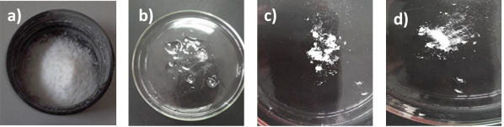
Figure 1. Physical appearances of (a) P(MMA), (b) P(HPMC), (c) P(MMA-co-HPMC)_{1:1} and (d) P(MMA-co-HPMC)_{1:4}

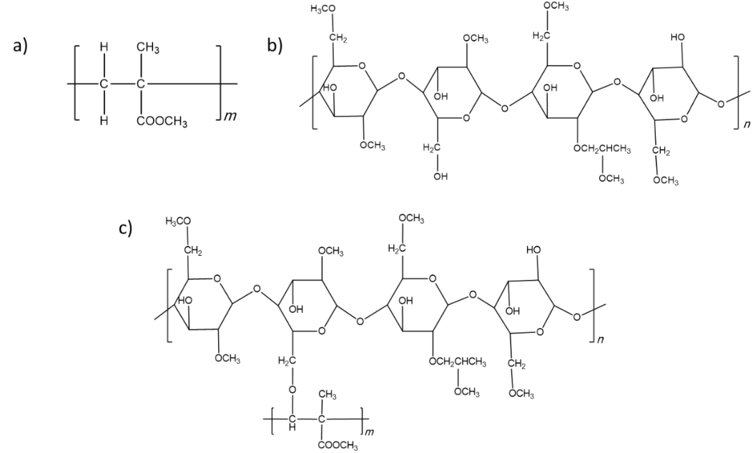
Scheme 1. The chemical structures of (a) P(MMA), (b) P(HPMC) and c) P(MMA-co-HPMC)
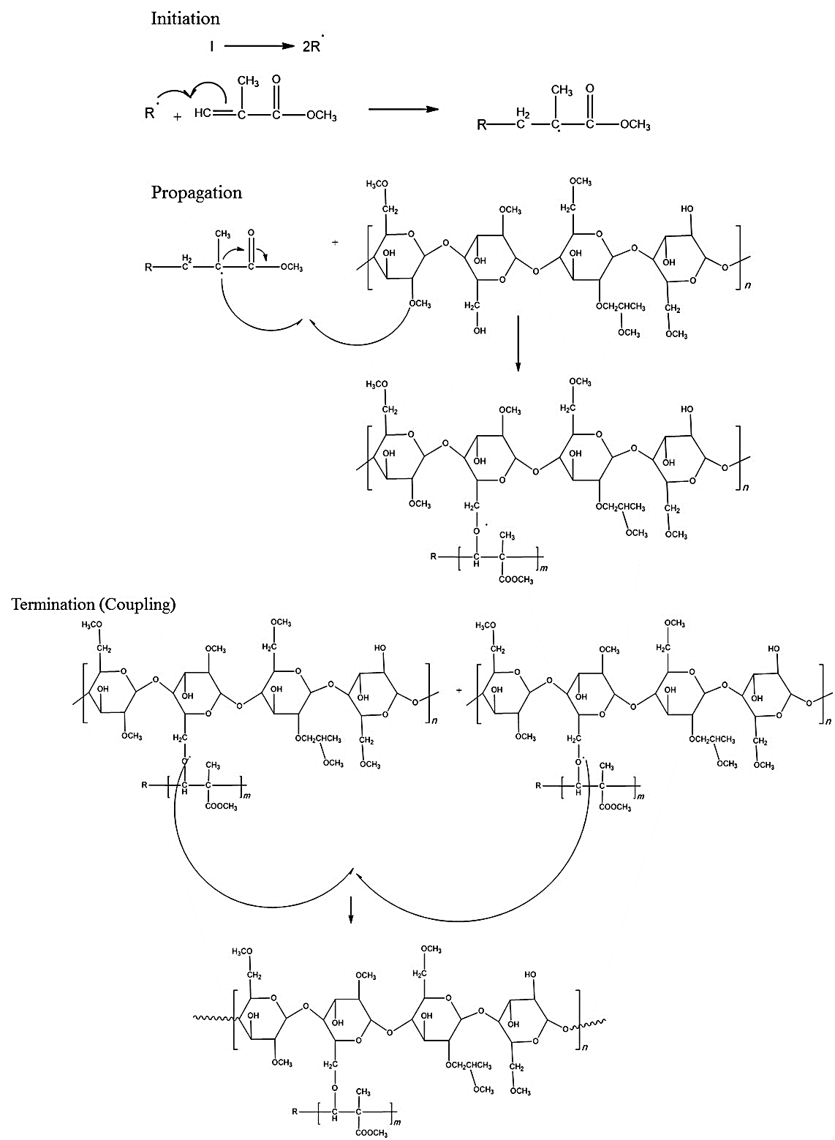
Scheme 2. The proposed mechanism for copolymerization of P(MMA-co-HPMC)

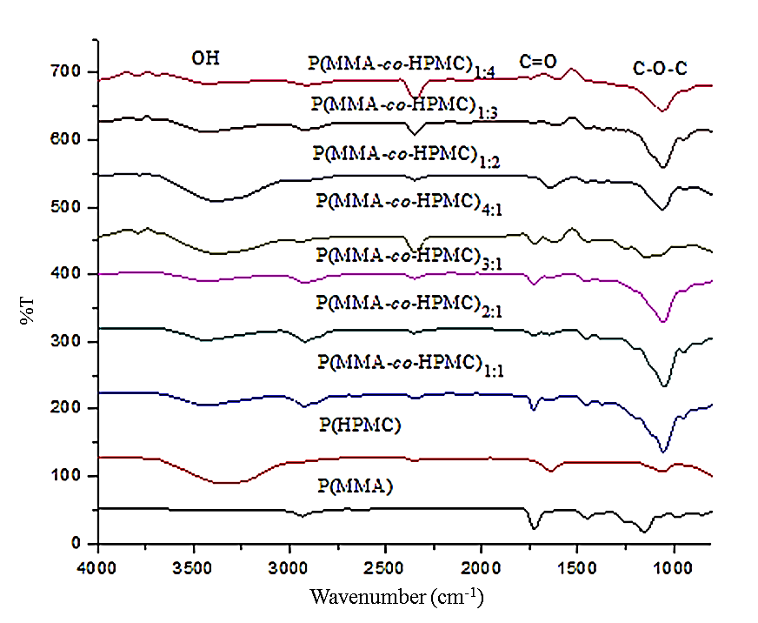
Figure 2. IR spectra of P(MMA), P(HPMC) and P(MMA-co-HPMC) nanoparticle

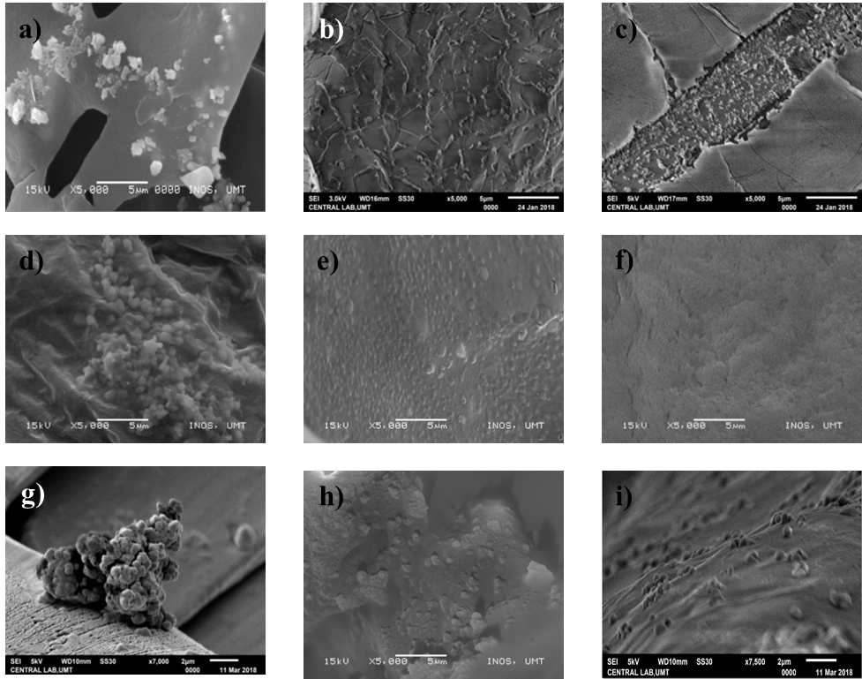
Figure 3. SEM images of (a) P(MMA), (b) P(HPMC), (c) P(MMA-co-HPMC)_{1:1}, (d) P(MMA-co-HPMC)_{2:1}, (e) P(MMA-co-HPMC)_{3:1}, (f) P(MMA-co-HPMC)_{4:1}, (g) P(MMA-co-HPMC)_{1:2}, (h) P(MMA-co-HPMC)_{1:3}, (i) P(MMA-co-HPMC)_{1:4} nanoparticles by varying the concentration of MMA and HPMC

Thermogravimetric analysis
Thermogravimetric analysis (TGA) measures the amount of change in a sample mass as a function of temperature and is used to determine thermal stability [21]. The decomposition rates of P(MMA), P(HPMC), and P(MMA-co-HPMC) polymer nanoparticles at different molar ratios of MMA and HPMC were investigated. The TGA plots (Figure 4) showed the percentage of mass as a function of sample temperature for P(MMA), P(HPMC) and P(MMA-co-HPMC) nanoparticles, which was determined under inert (N₂) conditions. Approximately 10 mg of sample were heated at a rate of 20 °C/min using the PerkinElmer TGA.

P(MMA) nanoparticle samples showed a two-step weight loss in a temperature range of 75 - 350 °C. The first weight loss of around 75 °C might be due to the moisture traces within the samples and the second weight loss of around 350 °C was the result of polymer degradation. P(HPMC) sample also showed a two-step weight loss, whereby the first weight loss was around 110 °C, which was due to moisture traces within the sample. Meanwhile, the second weight loss of P(HPMC) started at a lower temperature of 210 °C, which displayed that P(HPMC) sample possesses less thermal stability than that of P(MMA).

It can be clearly seen that the TGA curves for copolymer nanoparticles of P(MMA-co-HPMC) showed the existence of a combination peak between P(MMA) and P(HPMC) nanoparticles, confirming the successful synthesis of copolymer nanoparticles (Figures 4 and 5). There were two distinctive weight loss curves observed for copolymer samples at around 170 °C and 370 °C. For the copolymer samples with high molar ratios of MMA monomer (P(MMA-co-HPMC)_{1:1}, P(MMA-co-HPMC)_{2:1}, P(MMA-co-HPMC)_{3:1}), (Figure 4), the first degradations were observed around 165 °C, while the second degradation happened around 365 °C. P(MMA-co-HPMC)_{4:1} (Figure 4) that was prepared using the highest molar concentration of MMA demonstrated a very broad peak in which the degradation temperature was almost similar to the P(MMA) nanoparticles. This observation indicated that at a high concentration of MMA monomer, the MMA segments were significant than HPMC and the degradation according to MMA became dominant.

Moreover, copolymer samples that were prepared using high molar concentrations of HPMC showed a slight difference in terms of degradation temperature. P(MMA-co-HPMC)_{1:2}, P(MMA-co-HPMC)_{1:3}, and P(MMA-co-HPMC)_{1:4} samples (Figure 5) indicated that the first degradation temperature occurred approximately at 200 °C, which was higher than copolymer nanoparticles prepared using high molar concentration of MMA monomers. On the other hand, the second degradation slope for copolymer nanoparticles prepared using high molar ratios of HPMC monomer was observed at around 370 °C. This observation strongly suggested that the copolymers formed by varying concentrations of HPMC were more thermally stable than that of the varying concentrations of MMA. As the concentration of HPMC increased, the thermal degradation temperature also increased.

Table 2 shows P(MMA) undergoing a significant weight loss of 60%, which might due to the diffusion of water uptake in glassy polymer (P(MMA)). Upon heating, this changed the glassy state to rubbery (soft state), increasing the mobility of the polymer chains [22]. In contrast, P(HPMC) accounted for only 15% of weight loss due to the water retention properties of HPMC. P(MMA-co-HPMC)_{1:1}, P(MMA-co-HPMC)_{1:2}, P(MMA-co-HPMC)_{1:3}, P(MMA-co-HPMC)_{1:4}, P(MMA-co-HPMC)_{2:1}, P(MMA-co-HPMC)_{3:1}, and P(MMA-co-HPMC)_{4:1} depicted 35% of weight loss, except for P(MMA-co-HPMC)_{4:1}, which took up to 70% of weight loss possibly due to the highest molar ratios of MMA monomer. From the observations of percentage weight loss, it could be summarised that copolymer nanoparticles of P(MMA-co-HPMC) were more stable than the homopolymer nanoparticles of P(MMA).

Solubility test
A simple solubility test was conducted to confirm the hydrophilicity of P(MMA), P(HPMC), and P(MMA-co-HPMC) nanoparticles. Approximately 0.05 g of polymer samples were weighed and dissolved in 6 mL of distilled water at room temperature. The ability of P(MMA), P(HPMC), and P(MMA-co-HPMC) nanoparticles to dissolve in aqueous solution was observed. Figure 6 shows the images of P(MMA), P(HPMC), and P(MMA-co-HPMC) at molar concentrations of 1:1 and 1:4 (MMA:HPMC), respectively, which were obtained before and after the solubility test. It was observed that P(MMA) nanoparticles (Figure 6a) were partially soluble after being dissolved in aqueous solution on account of P(MMA) itself is partially soluble in water [23].

As for P(HPMC) nanoparticles, they were soluble after being dissolved in aqueous solution but took 2 to 3 minutes to become completely soluble (Figure 6b). This was because hydroxypropyl methylcellulose is a water-soluble monomer and allows diffusion of water to take place easily in a dispersion medium [24]. Meanwhile, P(MMA-co-HPMC)_{1:1} nanoparticle that had a similar monomer ratio of MMA and HPMC was partially soluble in aqueous medium (Figure 6c). Interestingly, copolymer P(MMA-co-HPMC)_{1:4} nanoparticles were immediately soluble after being dissolved in water, which proved that the hydrophilicity of P(MMA) nanoparticles increased by the copolymerisation with HPMC monomer (Figure 6d). It was worth to note that the different molar ratios of MMA and HPMC had different rates of solubility. For example, P(MMA-co-HPMC) nanoparticles obtained by varying concentrations of MMA with constant concentration of HPMC took a longer duration (after two days) to dissolve as the concentration of MMA was increased in the ratio of 4:1 (Figure 7). On the other hand, P(MMA-co-HPMC) nanoparticles obtained by varying concentrations of HPMC with constant concentration of MMA took a shorter time for the copolymer nanoparticles to be dissolved in water when the concentration of HPMC was increased in the ratio of 1:4.

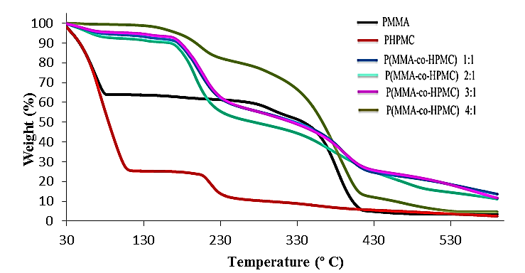
Figure 4. TGA curves obtained for P(MMA), P(HPMC), P(MMA-co-HPMC)_{1:1}, P(MMA-co-HPMC)_{2:1}, P(MMA-co-HPMC)_{3:1}, P(MMA-co-HPMC)_{4:1} nanoparticles by varying the concentration of MMA

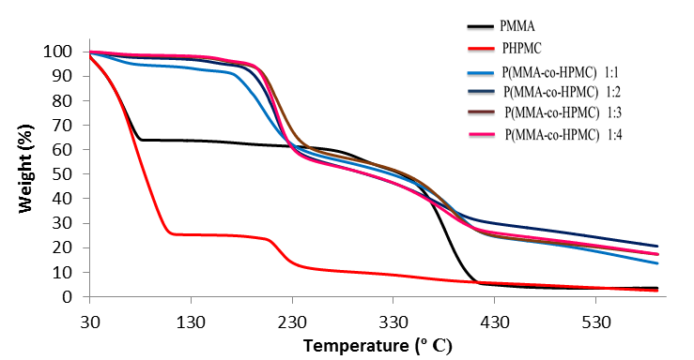
Figure 5. TGA curves obtained for P(MMA), P(HPMC), P(MMA-co-HPMC)_{1:1}, P(MMA-co-HPMC)_{1:2}, P(MMA-co-HPMC)_{1:3,} P(MMA-co-HPMC)_{4:1} nanoparticles by varying the concentration of HPMC

Table 2. The percentage weight loss of P(MMA-co-HPMC) of nanoparticles prepared via emulsion polymerization by varying molar ratios of MMA and HPMC monomer
PNPs | Percentage of Weight Loss (%)
P(MMA) | 60
P(HPMC) | 15
P(MMA-co-HPMC)_{1:1} | 35
P(MMA-co-HPMC)_{2:1} | 35
P(MMA-co-HPMC)_{3:1} | 35
P(MMA-co-HPMC)_{4:1} | 70
P(MMA-co-HPMC)_{1:2} | 35
P(MMA-co-HPMC)_{1:3} | 35
P(MMA-co-HPMC)_{1:4} | 35

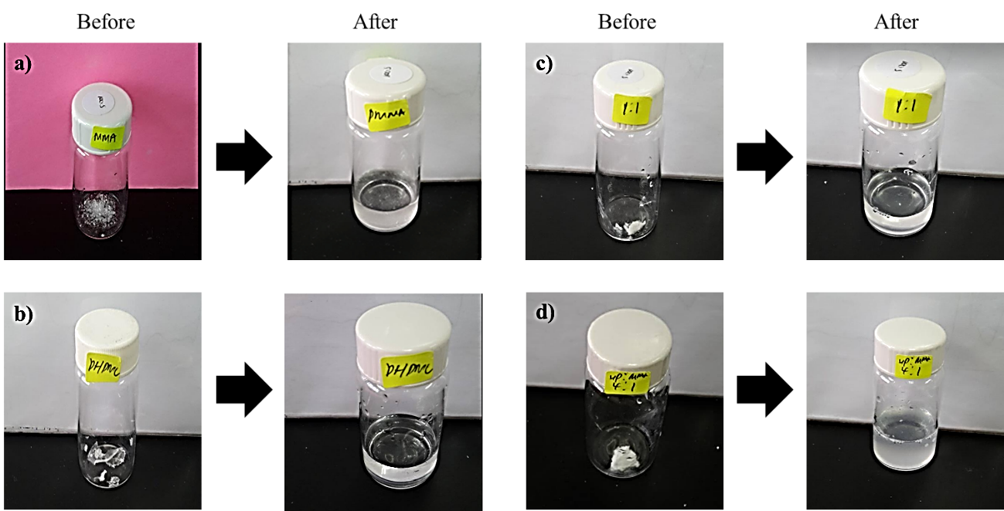
Figure 6. The solubility test of (a) P(MMA), (b) P(HPMC), (c) P(MMA-co-HPMC)_{1:1} and (d) P(MMA-co-HPMC)_{1:4}

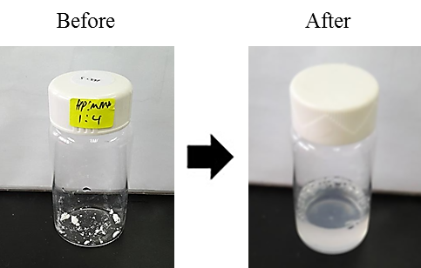
Figure 7. The solubility test of P(MMA-co-HPMC)_{4:1} after two days observation

Conclusion
Emulsion copolymerisation of methyl methacrylate (MMA) with hydroxypropyl methylcellulose (HPMC) to produce poly(methyl methacrylate-co-hydroxypropyl methylcellulose) (P(MMA-co-HPMC)) was obtained successfully, and the formation of P(MMA-co-HPMC) nanoparticles was confirmed by FTIR analysis, in which v(C=O) diminished when PMMA lost its double bonds. Despite the limitation of SEM that was unable to clearly observe the morphology and structure of the polymer nanoparticles, it showed the existence of aggregation of P(MMA-co-HPMC) nanoparticles. Thermograms obtained from the TGA analysis determined that P(MMA-co-HPMC) nanoparticles prepared by increasing the molar ratios of HPMC monomers were more thermally stable. This was because copolymer of higher molar ratios of HPMC monomers degraded at higher temperature than that of higher molar ratios of MMA. The effect of different molar ratios of MMA and HPMC concentration could affect the morphology and size of the P(MMA-co-HPMC) nanoparticles. When the amount of MMA increased, the average particles size of P(MMA-co-HPMC) nanoparticles tend to become larger. In contrast, an increase in HPMC concentration led to the decrease in the average particle size of P(MMA-co-HPMC) nanoparticles. The simple solubility test was carried out to confirm the hydrophilicity of P(MMA-co-HPMC) nanoparticles in which the copolymer samples of higher concentrations of MMA took a longer time to be dissolved. In comparison, the copolymer samples of higher concentrations of HPMC took a shorter time to be fully dissolved.

Acknowledgement
We thanked the Ministry of Higher Education, Malaysia for the funding (FRGS/1/2020/STG02/UMT/02/1/ 59633) and Universiti Malaysia Terengganu for the generous support.

References
- Nagavarma, B. V. N., Hemant, K. S. Y., Ayaz, A., Vasudha, L. S. and Shivakumar, H. G. (2012). Different technique for preparation of polymeric nanoparticles – a review. Asian Journal of Pharmaceutical and Clinical Research, 5(3): 16-23.
- Kumari, A., Yadav, S. K. and Yadav, S. C. (2010). Biodegradable polymeric nanoparticles based drug delivery system. Colloids and Surfaces B: Biointerfaces, 75(1): 1-18.
- Liang, Y., Yun, W., Maozhi, P., Garry, L. R. and Qinmin, P. (2013). Synthesis of poly(methyl methacrylate) nanoparticles via differential microemulsion polymerization. European Polymer Journal, 49(1): 41-48.
- Dusadee, T., Garry, L. R. and Pattarapan, P. (2017) Preparation of poly(methyl methacrylate)-silica nanoparticles via differential microemulsion polymerization and physical properties of NR/PMMA-SiO₂ hybrid membranes. Polymer Engineering & Science, 58(5): 759-766.
- Ismail, Z. and Harun, N. A. (2019). Synthesis and characterizations of hydrophilic PHEMA nanoparticles via inverse miniemulsion polymerization. Sains Malaysiana, 48(8): 1753-1759.
- Kamaruddin, N. N., Kassim, S. and Harun, N. A. (2017). Volume effect of non-polar solvent towards the synthesis of hydrophilic polymer nanoparticles prepares via inverse miniemulsion polymerization. AIP Conference Proceedings, 1885: 020056.
- Harun, N. A., Md Tahier, N., Kamaruddin, N. N., Mamat, M. and Kassim, S. (2018). Emulsion polymerization of poly(methacrylic acid) nanoparticles: Effects of different cationic surfactants. Asian Journal of Chemistry, 30 (10): 2299-2304.
- Harun, N. A., Tzy, T. Y., Chen, L. P. Zainuddin, A. A. and Kassim, S. (2019). Copolymerization of methacrylic acid (MAA) and butyl acrylate (BuA) via emulsion polymerization technique. Malaysian Journal of Chemistry, 21(3): 20-28
- Nopparat, V. and Panya, S. (2020). Synthesis of crosslinked poly(methacrylic acid) shell/ lipid core colloidal nanoparticles via L-in-L_{m} interfacial polymerization and their pH responsiveness. Colloids and Surfaces A; Physicochemical and Engineering Aspects, 603: 125180.
- Rao, J. P. and Geckeler, K. E. (2011). Polymer nanoparticles: Preparation techniques and size-control parameters. Progress in Polymer Science, 36(7): 887-913.
- José, M. A. (2004). Emulsion polymerization: From fundamental mechanisms to process developments. Journal of Polymer Science Part A: Polymer Chemistry 42(5): 1025-1042.
- Thickett, S. C. and Gilbert, R. G. (2007) Emulsion polymerization: State of the art in
kinetics and mechanisms. Polymer, 48(24): 6965-6991.
- Shalviri, A., Raval, G., Prasad, P., Chan, C., Liu, Q., Herrklotz, H., Rauth, A. M. and Wu, X. Y. (2012). pH-dependent doxorubicin release from terpolymer of starch, polymethacrylic acid and polysorbate 80 nanoparticles for overcoming multidrug resistance in human breast cancer cells. European Journal of Pharmaceutics and Biopharmaceutics, 82(3): 587-597.

- Baek, H. H., Lee, J. M., Cho, J. E., Kim, J. H. and Cheong, I. W. (2010). Hydroxypropyl methylcellulose-graft-poly(ethyl acrylate-co-methyl methacrylate) particles by resin emulsion polymerization. Macromolecule Research, 18(1): 53-58.
- Mondal, S., Gupta, B. and Sing, H. (2005). Acrylic monomers based emulsion copolymer for coating application. Indian Journal of Fibre and Textile Research, 30: 184-189.
- Joshi, J. R. and Patel, R. P. (2012). Role of biodegradable polymers in drug delivery.
International Journal of Current Pharmaceutical Research, 4(4): 74.
- Tian, H. Y., Tang, Z. H., Zhuang, X. L., Chen, X. S. and Jing, X. B. (2012). Biodegradable synthetic polymers: preparation, functionalization and biomedical application. Progress in Polymer Science, 37(2): 237-280.
- Lu, T., Liu, X. Y., Qi, D. M. and Zhao, H. T. (2015). Effect of hydrophobic monomer on the aqueous dispersion polymerization of acrylamide with quaternary ammonium cationic monomer. Iranian Polymer Journal, 24(3): 219-227.
- Wu, B., Lenz, R. W. and Hazer, B. (1999). Polymerization of methyl methacrylate and its copolymerization with ε-caprolactone catalyzed by isobutylalumoxane catalyst. Macromolecules, 32(20): 6856-6859.
- Miranda, A., Mill, M. and Caraballo, I. (2006). Study of the critical points of HPMC
hydrophilic matrices for controlled drug delivery. International Journal of Pharmaceutics, 311(1-2): 75-81.

- Ding, C. C., Li, G. Y. and Zhang, M. (2015). Preparation and characterization of
collagen/hydroxypropyl methylcellulose (HPMC) blend film. Carbohydrate Polymer, 119: 194-201.
- Wayne, N. A., Stephen, P. D. and Samual, L. E. (2014). Ageing and moisture uptake in polymethyl methacrylate (PMMA) bone cements. Journal of the Mechanical Behavior of Biomedical Materials, 32(100): 76-88.
- Fatimah, A., Amir, H. N. and Francesco, P. (2019). Material encapsulation in poly(methyl methacrylate) shell: A review. Journal of Applied Polymer, 136(41): 48039.
- Wu, H. C., Du, S. Y., Lu, Y., Li, Y. and Wang, D. (2014). The application of biomedical polymer material hydroxy propyl methyl cellulose (HPMC) in pharmaceutical preparations. Journal of Chemical and Pharmaceutical Research, 6(5): 155-160.

