STABILITY AND ANTIBACTERIAL PROPERTIES OF GREEN SYNTHESIS SILVER NANOPARTICLES USING

Nephelium lappaceum PEEL EXTRACT

(Kestabilan dan Ciri Antibakteria bagi Sintesis Hijau Nanopartikel Perak

Menggunakan Ekstrak Kulit Nephelium lappaceum)

Nur Syazwanie Mohd Saidi¹, Hanis Mohd Yusoff^{1,2*}, Irshad Ul Haq Bhat^{1,2}, Suganthi Appalasamy^{3,4},

Alia Diyana Mohamed Hassim³, Farhanini Yusoff¹, Asnuzilawati Asari^{1,2}, Nurul Huda Abdul Wahab^{1,2}

¹Faculty of Science and Marine Environment,

²Advanced Nano Materials (ANoMa) Research Group,

Faculty of Science and Marine Environment

Universiti Malaysia Terengganu, 21030 Kuala Nerus, Terengganu, Malaysia

³Institute of Food Security and sustainable Agriculture,

⁴Faculty of Earth Science,

Universiti Malaysia Kelantan, 17600 Jeli Campus, Kelantan, Malaysia

*Corresponding author: hanismy@umt.edu.my

Abstract

Silver nanoparticles (AgNPs) are known for its easy production with wide range of applications. The production can involve chemical, physical, biological and photochemical methods. For production of AgNPs using biological method, the synthesis normally involves plants, bacteria or other potential reducing agents that can control the size of AgNPs. In this study, Nephelium lappaceum or also known as rambutan peel was used as a reducing agent. Nephelium lappaceum extract was added to AgNO₃ (1 mM) solution and stirred for 1 hour. Three sets of synthesis were carried out to see the reproducibility and stability of the AgNPs. The solution obtained was analyzed by using Fourier transform-infrared spectroscopy (FTIR), UV-Vis spectrophotometer and scanning electron microscope (SEM). The stability of the obtained AgNPs was observed and compared with AgNPs synthesized by using the chemical method. FTIR spectra showed O-H, C-H, C=O and C=C stretching at 3361 cm⁻¹, 2090 cm⁻¹, 1637 cm⁻¹ and 1367 cm⁻¹, respectively. The wavelength of UV-Vis obtained for the 3 sets of green synthesis is at 452 nm. The appearance of the peak around 452 nm due to the surface plasmon resonance band confirmed the formation of AgNPs. SEM images showed a mixture of spherical shapes that were agglomerated with size range of about 40 to 200 nm. The antibacterial study performed on AgNPs produced from Nephelium lappaceum peel extract was found to exhibited antibacterial activity on both Gram-positive and Gram-negative bacteria.

Keywords: green synthesis, reducing agent, green AgNPs, antibacterial, rambutan peel

Abstrak

Nanopartikel perak (AgNPs) dikenali dengan penghasilannya yang mudah dan aplikasi yang meluas. Kaedah penghasilan tersebut merangkumi kimia, fizikal, biologi dan fotokimia. Bagi penghasilan AgNPs menggunakan kaedah biologi, sintesis ini kebiasaannya melibatkan tumbuhan, bakteria atau agen penurunan lain yang berpotensi mengawal saiz AgNPs. Dalam kajian ini, Nephelium lappaceum atau dikenali juga sebagai kulit rambutan telah digunakan sebagai agen penurunan. Ekstrak Nephelium lappaceum telah ditambah kepada larutan AgNO₃ (1 mM) dan dikacau selama 1 jam. Tiga set sintesis telah dijalankan untuk melihat kebolehterbitan dan kestabilan AgNPs. Larutan yang diperolehi telah dianalisa menggunakan spektrometer infra merah transformasi Fourier (FTIR), spektrofotometer tampak UV (UV-Vis) dan mikroskop imbasan elektron (SEM). Kestabilan larutan AgNPs yang diperolehi telah dikaji dan dibandingkan dengan AgNPs yang disintesis menggunakan teknik kimia. Spektra FTIR telah menunjukkan kewujudan regangan O-H, C-H, C=O dan C=C masing-masing adalah pada 3361 cm⁻¹, 2090 cm⁻¹, 1637 cm⁻¹ dan 1367 cm⁻¹. Panjang gelombang UV-Vis bagi ketiga-tiga set adalah pada 452 nm. Kewujudan puncak sekitar 452 nm adalah disebabkan oleh jalur resonansi plasmon permukaan yang membuktikan pembentukan AgNPs. Imej SEM menunjukkan campuran bentuk sfera dan aglomerasi dengan anggaran saiz sekitar 40 hingga 200 nm. Kajian antibakteria telah dilakukan terhadap AgNPs yang dihasilkan daripada ekstrak kulit Nephelium lappaceum didapati menunjukkan aktiviti antibakteria pada kedua-dua bakteria Gram-positif dan Gram-negatif.

Kata kunci: sintesis hijau, agen penurun, AgNPs hijau, antibakteria, kulit rambutan

Introduction
Nanomaterials are materials that have structural compounds smaller than 1 µm in minimum of one dimension [1-2]. Metal oxide nanoparticles and metal nanoparticles are widely studied in top down approach due to various preparation methods that are considered as simple and can be modified to produce various sizes and morphologies [3-6]. Metal nanoparticles exhibit different properties compared to bulk materials even if they are made of the same atoms [2]. The physical and chemical properties of metal nanoparticles are different compared to bulk materials. Metal nanoparticles have lower melting points, higher specific surface areas, specific optical properties, mechanical strengths and specific magnetizations [7-10]. AgNPs have been widely studied and synthesized due to its wide applications in the fields of medicine, chemistry, pharmacy, industry, environment, surface modification and biology [4-11]. There are two major synthesis routes for AgNPs which are top to bottom approach and bottom up approach. Top to bottom approach involves physical methods while bottom up approach involves biological and chemical methods. The simplest and the most frequently used bulk-solution synthetic method for metal nanoparticles is by reducing the metal salts. The chemical synthetic method of AgNPs involves the ionic salt reduction in an appropriate medium with the presence of a surfactant while using different reducing agents such as sodium citrate or sodium borohydride, followed by the addition of capping agents including alkylamines and alkanethiols or any polymeric materials like gelatin and polyvinyl alcohol [7]. The function of capping agent is to stabilize the AgNPs from aggregation. The use of this capping agent and the reduction by using these chemicals can result in hazardous by-products formation which will certainly affect the use of AgNPs in biomedical fields and chemical application. Alternatively, green and cheaper methods can be used to synthesize AgNPs in order to overcome these problems [7-9].

Currently, there are green synthesis methods available involving bacteria, fungi, and plant extracts. Most of the methods involve oxidation-reduction reactions [12-15]. Green synthesis using plant extracts are the best compared to other biological methods [14]. Many plants have been used in the green synthesis of AgNPs and have the reducing agent to reduce Ag⁺ to Ag⁰ from silver nitrate solution [13-16]. Some examples of plant leaf extracts that have been used are from carob leaves, pine leaves, persimmon leaves, gingko leaves, and magnolia leaves [13]. The use of fruit peels was also used in the previous studies such as peel waste from pomegranates, oranges, bananas and apples [14-17]. Nephelium lappaceum or rambutan peel was used as the reducing agent. Phytochemical properties were determined to know the reducing compounds in rambutan peel and further applied to produce AgNPs. Many studies revolving fruit peels lack information regarding stability of AgNPs and the effect of various concentrations towards antibacterial studies. Rambutan peels are also known as waste and the full utilization of this waste could be merited in synthesizing AgNPs. This study aimed to synthesize and characterize AgNPs by using rambutan peel. The designed AgNPs were compared with AgNPs generated from a conventional chemical method. The stability and antibacterial activity of AgNPs were carried out to determine the structural changes and their potential as antibacterial agents, respectively.

Materials and Methods

Materials and Instrumentation
Silver nitrate (AgNO₃) and sodium borohydride (NaBH₄) were purchased from Sigma Aldrich and used without further purification. Rambutan was purchased from local market in Kuala Nerus, Terengganu. Distilled water was used to prepare all the solution and Whatman No 1 filter paper was used to filter AgNPs solution.

Both green and chemically synthesized AgNPs were characterized using UV-Vis spectroscopy (UV-Vis), Fourier Transform Infrared (FTIR) and scanning electron microscope (SEM). The UV-Vis spectrophotometer model used was Shimadzu UV-1800. The wavelength used was within the range of 200-800 nm. The FTIR spectra were recorded between 4000 until 400 cm⁻¹ using Perkin Elmer Spectrum 100. The sample for SEM was sonicated three times (3 minutes each) before it was mounted on a stub of metal with adhesive. Then, the sample was coated with metal gold.

Synthesis of Silver Nanoparticles (AgNPs): Preparation of rambutan peel extract
A total of 20 g of rambutan peels was washed thoroughly and finely cut into smaller pieces. The finely cut pieces were added in the Erlenmeyer flask with 200 mL of distilled water. The solution was heated at 70-80 °C for 1 hour. The extract was then filtered with Whatman No. 1 filter paper.

Phytochemical tests of rambutan peel extract

To investigate the compounds presence in the rambutan peel extract, several phytochemical tests were carried out which included alkaloid test, flavonoid test, tannin test, saponin test, steroid test, phlobatanin test, and carbohydrate test. Table 1 shows a list of methods for each test. Every test was carried out at least three times and only tests which appeared positive in two or more tests that were considered to confirm the presence of the investigated compounds in rambutan peel extract.

Table 1. Phytochemical tests methods

Tests | Methods
Alkaloid | 0.5 mL of peel extract were treated with a few drops of Wagner’s reagent (iodine in potassium iodide). The colour changes were observed, and a brown precipitate formed to indicates the presence of alkaloid.
Flavonoid | 0.5 mL of peel extract were treated with few drops of concentrated sulphuric acid. The colour changes were observed, and a formation of orange colour indicates the presence of flavonoid.
Saponin | 1 mL of peel extract was added with 2 mL of distilled water in a test tube. The solution was shaken vigorously and was observed for a stable persistent froth for 10 min.
Carbohydrate | 0.5 mL of peel extract was added with few drops of iodine solution. Purple or dark blue shows the presence of carbohydrates.
Phlobatanin | 0.5 mL of peel extract was boiled with 1% aqueous hydrochloric acid. Formation of red precipitate shows the presence of phlobatanin.
Steroid/Sterols | 0.5 mL of peel extract were treated with few drops of acetic anhydride, boiled and cooled to room temperature. A few drops of concentrated sulphuric acid, H₂SO₄ were added to the test tube and formation of brown ring at the junction of two layers were observed. Green coloration of upper layer indicates a positive test for steroids.
Phenolic | 0.5 mL of peel extract was put into test tube and 2 mL of distilled water was added followed with 2 to 3 drops of 10% iron (III) chloride solution. The presence of green or blue colour indicates the presence of phenolic compound.
Tannin | 0.5 mL of each crude extract was added with distilled water followed by 1 to 2 drops of diluted ferric chloride solution. A dark green or blue-green coloration indicates the presence of tannins.

Green synthesis of silver nanoparticles (AgNPs)

For green synthesis, 5 mL of rambutan peel extract was added to 50 mL of AgNO₃ (1 mM) aqueous solution. The solution was stirred for 1 hour. Any changes in the color of the solution was observed and recorded. The temperature for the synthesis was kept at room temperature and pH 7. To study the stability of green AgNPs, three sets of synthesis were done with similar condition.

Chemical synthesis of silver nanoparticles (AgNPs)
An amount 10 mL of AgNO₃ (1 mM) was added dropwise for 20 drops per minute into 30 mL of sodium borohydride (2 mM). This solution was then put into an ice bath at about 4 °C and was stirred continuously [18]. The solution was centrifuged with 5000 rpm for 15 minutes and then filtered with Whatman No. 1 filter paper.

Antibacterial Study

Tests were done by the disc diffusion method. Sterile 6.0 mm diameter blank disc were used to impregnate with five different concentrations of green synthesis and chemical synthesis silver nanoparticles. The concentrations were 0.2, 0.4, 0.6, 0.8 and 1.0 mM for both syntheses. The culture of Escherichia coli and Bacillus subtillis was spread on the plates with nutrient agar uniformly using sterile hockey stick. AgNPs impregnated discs with different concentration were placed on an agar plate. Sterile distilled water was used as negative control and 10 µg Gentamicin disc (Oxoid ™, United Kingdom) was used as positive control. The plates were incubated at 37 °C for 24 hours. Triplicates were done for every concentration and different bacteria. Antibacterial activities were then measured by the clear zones of inhibition.

Results and Discussion

Green and chemical synthesis of AgNPs
Phytochemical tests were carried out towards the rambutan peel extract to confirm the bioactive compounds and the functional groups responsible for the reduction and the stabilization of AgNPs [20, 21]. From Table 2, the presence of alkaloid, flavonoid, saponin, phenolic and tannin in rambutan peel extract. Tests were carried out three times and labeled as A, B and C for each desired active compound to confirm the consistency of the results. Only two or more positive results were considered to confirm the presence of the investigated compounds in the rambutan peel extract. Phytochemical tests findings of flavonoid and alkaloids in this study are similar with the study by Ashok et al. [23]. The presence of phenolic compound and tannin strengthen the suggested fact that O-H group is the biomolecule responsible in the reducing and stabilizing the AgNPs produced [20].

Table 2. Phytochemical tests result towards rambutan peel extract

Tests | Set A | Set B | Set C
Alkaloid | + | + | +
Flavonoid | + | + | +
Saponin | + | + | +
Carbohydrate | - | + | +
Phlobatanin | - | - | -
Steroid/Sterols | - | - | -
Phenolic | + | + | +
Tannin | + | + | +

(+) = presence of active compounds in rambutan peel, (-) = no active compounds in rambutan peel

For chemical synthesis, 1 mM of 10 mL AgNO₃ was added drop wise into 2 mM of 30 mL NaBH₄ and stirred continuously until the color in the mixture changed from pale yellow to light brown. According to Badi’ah et al., AgNPs are formed when the colorless solution turned to pale yellow [19]. The reaction stopped when the pale-yellow change to light brown as shown in Figure 1.

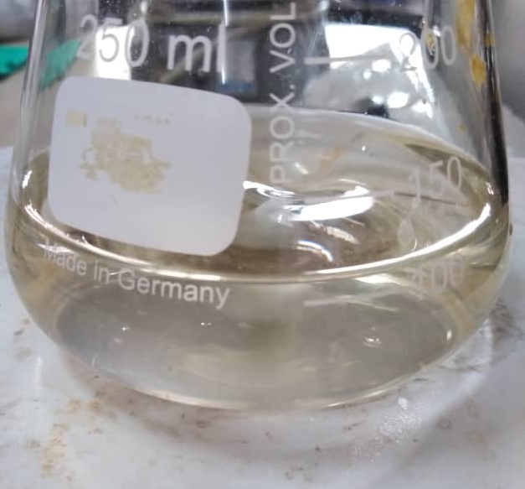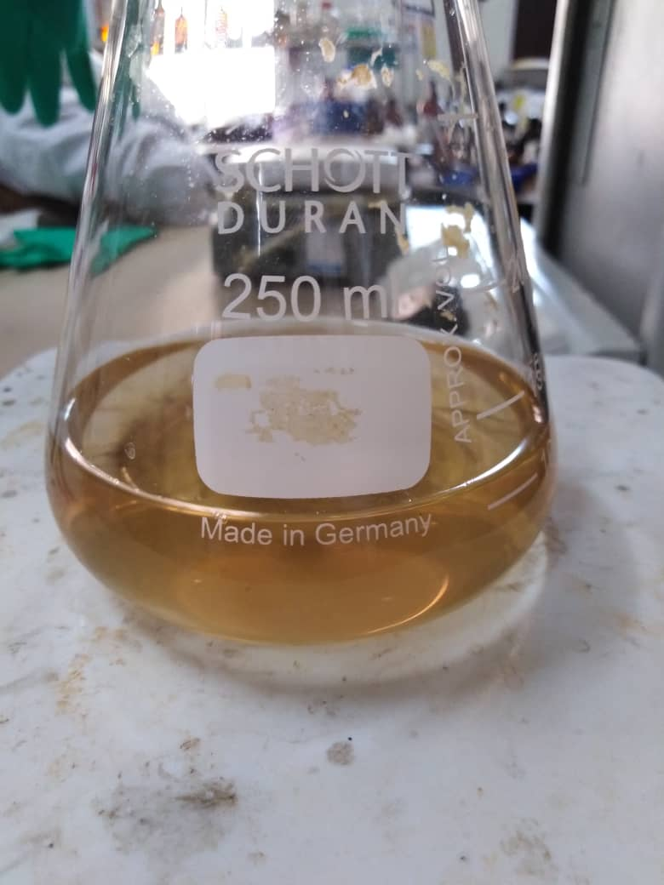

Figure 1. Colour change in chemical synthesis of AgNPs from pale-yellow to light brown

AgNPs have been successfully synthesized chemically and also using the rambutan peel extract. In the green synthesis, 5 mL rambutan peel extract was added into 1 mM 50 mL silver nitrate and stirred continuously. The AgNPs were formed when light brown solution turned to dark brown which was after 10 minutes of stirring. The reaction was complete after 1 hour of stirring which the solution turned to darker brown (Figure 2). This observation is similar to the previous study by Gudikandula & Maringanti, which also mentioned that dark brownish color indicated the complete formation of AgNPs [10].

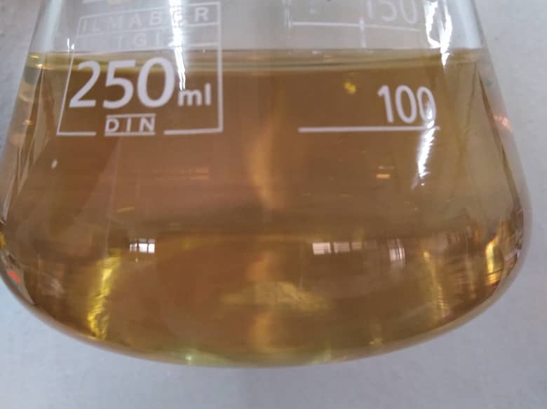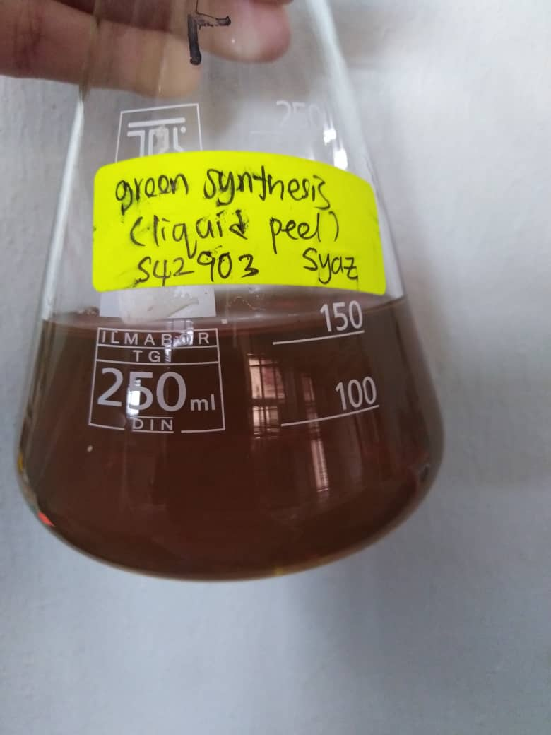

Figure 2. Color change in green synthesis of AgNPs from pale-yellow to dark brown

Ultraviolet-visible spectroscopy
Both chemically and green synthesized AGNPs were characterized using UV-Vis spectroscopy to confirm the formation of the particles. In Figure 3, a peak appeared at 415 nm for the AgNPs synthesized by NaBH₄. This peak appeared due to surface plasmon resonance which confirmed the formation of AgNPs. Surface plasmon resonance (SPR) is a common phenomenon in metal nanoparticles where electrons in the metal surface layer are excited by photons of incident light with a certain angle of incidence which then propagates parallel to the metal surface [13, 20]. As shown in Figure 4, a prominent peak also appeared at the wavelength of 452 nm with AgNPs synthesized by rambutan peel extract.

Figure 3. UV-Vis spectrum of chemically synthesized AgNPs

Figure 4. UV-Vis spectrum of green synthesized AgNPs

The SPR band for spherical AgNPs was normally in the range of 390-450 nm [13-24]. It has been found in a study of AgNPs synthesized using Argemone Mexican leaves as reducing agent that the SPR band was at 440 nm. They also stated that the broadening of the peak indicated that the AgNPs synthesized were polydisperse [19]. Awwad et al. stated that their AgNPs gave the highest peak at 420 nm in UV-Vis [14]. The SPR band obtained in this study which indicated the formation of AgNPs in both chemically and green synthesis method are similar with the previous studies.

In the green synthesis method, three sets of reaction with similar condition were done to check the stability of the AgNPs. The stability comparison can be seen in Table 3. The UV-Vis of the synthesized AgNPs were carried out every day until there was a shift in the wavelength of the spectra. For Set A, the color changed from light brown to dark brown after 1 hour of synthesis. After one day, the color changed to grey and the solution became cloudy. After 5 days, it could be seen that the grey color changed to brown and agglomeration of brown particles occurred. The wavelength of UV-Vis spectrum for Set A (Figure 5) also shifted after 4 days. For Set B and Set C, the color change was consistent after 1 hour and one day. But after 8 days, the solution became cloudy and agglomeration also occurred. Like Set A, the grey color also changed to brown. The wavelength of the UV-Vis spectra of both Set B (Figure 6) and Set C (Figure 7) shifted after 8 days.

Figure 5. UV-Vis spectra of green synthesized AgNPs (Set A)

Figure 6. UV-Vis spectra of green synthesized AgNPs (Set B)

Figure 7. UV-Vis spectra of green synthesized AgNPs (Set C)

Table 3. Stability of green synthesis of AgNPs
Sets | Stability
A | 5 days
B | 8 days
C | 8 days

To date, there is no stability study of green synthesized using rambutan peel. 7 days are considered a short-term stability and in some modified condition by considering the stabilizer agent such as citrine, stability of AgNPs could last longer [25]. These findings indicated that the AgNPs synthesized using rambutan peel extract as the reducing agent is considered having short stability. Another condition to be improved for longer stability is by modifying the pH of the solution since the phenolic functional group in the extract can act as a good reducing and stabilizing agent that can releases electrons to reduce Ag⁺ to become Ag⁰ under an alkaline condition instead of acidic or neutral [20].

Fourier transform infrared spectroscopy
The assignment of the bands in the synthesized AgNPs from both methods are tabulated in Table 4. Figure 8 represents FTIR spectrum for green synthesized AgNPs. Strong intensity at 3361.93 cm⁻¹ corresponds to the O-H stretching of the phenolic compounds in the extract [13-16, 20]. The medium intensity at 2090.84 cm⁻¹ corresponds with the aliphatic C-H stretching and C-H stretching of aldehyde group [16]. The C=O stretching in the phenolic group can be found at 1637.53 cm⁻¹ [13-16, 20]. The medium intensity at 1367.53 cm⁻¹shows the C=C stretching vibrations. The peak at 1242.16 cm⁻¹ indicated the finger print region of C-O-C stretch [14]. The broad band at 466.77 cm⁻¹ indicates the presence of Ag vibration properties in the AgNPs [13-16].

Table 4. FTIR spectra peak assignments
Peak Assignment | Wavenumber (cm⁻¹)
 | Chemically Synthesized AgNPs | Green Synthesized AgNPs
O-H stretching | 3346.50 | 3361.93
C-H stretching | 2086.98 | 2090.84
C=O stretching | 1635.64 | 1637.56
C=C stretching  C-O | 1369.46  1249.87 | 1367.53  1242.16
Ag metal | 466.77 | 439.77

For chemical synthesis, the band and the intensity for the AgNPs were similar with green synthesis AgNPs. In green synthesis, the rambutan peel extract was used as the reducing agent due to the presence of –OH group from phenolic and –CHO from aldehyde in the extract. These groups were said to interact with Ag⁺ that was oxidized to –COOH and simultaneously Ag⁺ was reduced to Ag⁰ [7, 14, 16].

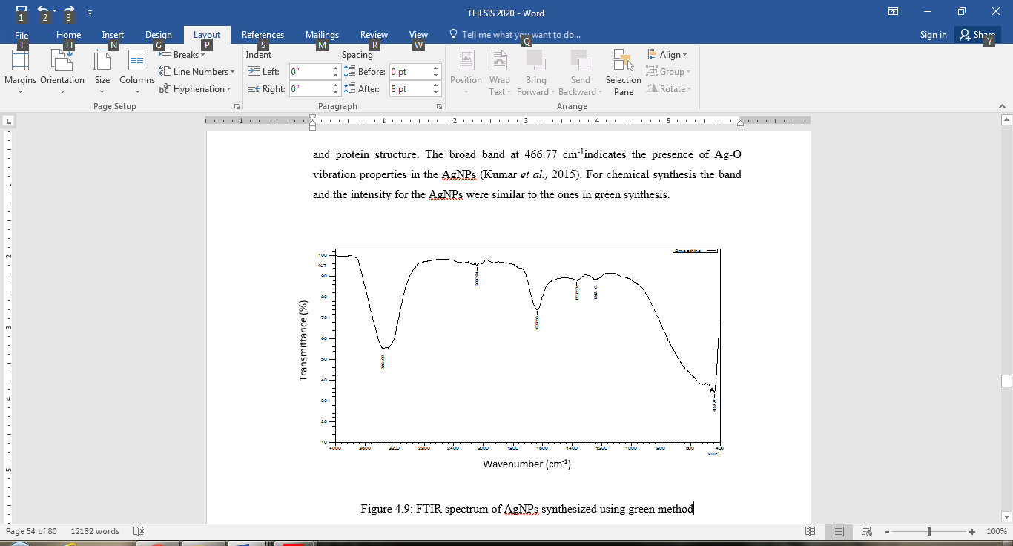

Figure 8. FTIR spectrum of green synthesized AgNPs

Scanning electron microscope

The AgNPs were observed under SEM to see the morphology and the size of the nanoparticles formed. The magnification used were 15000X and 30000X. Based on SEM images, the size of AgNPs produced for green synthesis ranged from 40 nm to 200 nm and seem to be correlated with previous studies [18-20]. The AgNPs seem to be in spherical shape and agglomerated (Figure 9).

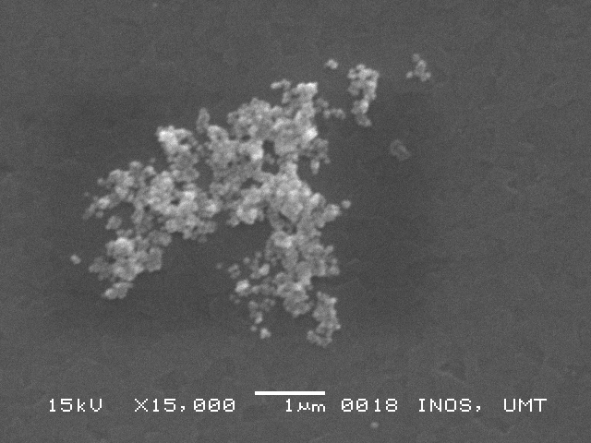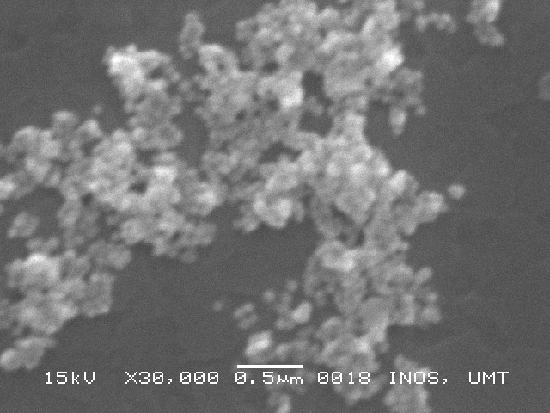
(b)
(a)

Figure 9. SEM images of green synthesis AgNPs at different magnification of (a) 15000X and (b) 30000X

Antibacterial Study
The antibacterial study was done using disk-diffusion method. Different concentrations of chemically and green synthesized nanoparticles were used in the study. Two types of bacteria namely Escherichia coli (gram-negative) and Bacillus subtillis (gram-positive) bacteria were used in this study. The result was tabulated and shown in Table 5 and Table 6 respectively.

The concentrations of AgNPs used in this study were 1.0, 0.8, 0.6, 0.4 and 0.2 mM for both synthesized AgNPs. The results show that both chemical and green synthesized AgNPs have weak and moderate activity towards bacteria. For gram-negative bacteria (Table 5), the concentration of 1.0 mM chemically synthesized AgNPs shows the highest inhibition zone at 9.0 mm in the first two trials and 10.0 mm for the third trial. There was no inhibition show for the concentration of 0.4 mM and 0.2 mM. The green synthesized AgNPs showed inhibition towards bacteria for all concentrations used. Like chemical synthesis, the concentration of 1.0 mM green synthesized AgNPs showed the highest inhibition at 8.0 mm in the first two trials and 9.0 mm for the third trial. The concentration of 0.2 mM shows the weakest activity towards bacteria at 5.5 mm in all trials. To compare both, chemical synthesized AgNPs had more inhibition towards gram-negative bacteria, Escherichia coli. The inhibition zone are as shown in Figure 10.

Table 5. Antibacterial inhibition of green synthesis AgNPs towards Escherichia coli

Escherichia coli
 | Chemically Synthesized AgNPs |  |  | Green Synthesized AgNPs
Concentration  (mM) | Measurement of Inhibition Zone  (mm) |  |  | Measurement of Inhibition Zone  (mm)
1.0 | 9.0 | 9.0 | 10.0 | 8.0 | 8.0 | 9.0
0.8 | 8.0 | 8.0 | 8.5 | 7.0 | 7.0 | 7.0
0.6 | 8.0 | 6.5 | 7.0 | 6.0 | 6.0 | 6.0
0.4 | - | - | - | 5.8 | 6.0 | 5.8
0.2 | - | - | - | 5.5 | 5.5 | 5.5
Positive control | 25.0 | 26.0 | 25.0 | 25.0 | 25.0 | 25.0

Table 6. Antibacterial inhibition of green synthesis AgNPs towards Bacillus subtillis

Bacillus subtillis
 | Chemically Synthesized AgNPs |  |  | Green Synthesized AgNPs
Concentration  (mM) | Measurement of Inhibition Zone (mm) |  |  | Measurement of Inhibition Zone (mm)
1.0 | 8.0 | 11.0 | 17.0 | 9.0 | 9.0 | 9.0
0.8 | 15.0 | 15.0 | 15.0 | 10.0 | 9.0 | 10.0
0.6 | 8.0 | 9.0 | 9.0 | 8.0 | 9.0 | 9.0
0.4 | 7.0 | 7.0 | 7.0 | 6.6 | 6.6 | 6.6
0.2 | 7.0 | 6.5 | 6.5 | 5.5 | 5.5 | 5.5
Positive control | 25.0 | 25.0 | 25.0 | 25.0 | 25.0 | 25.0

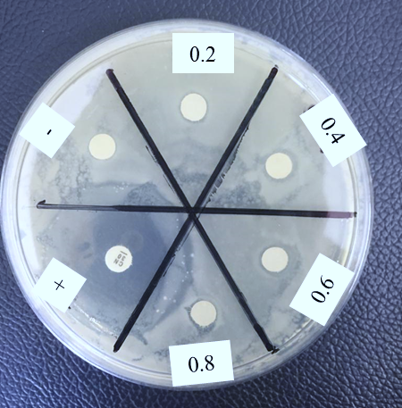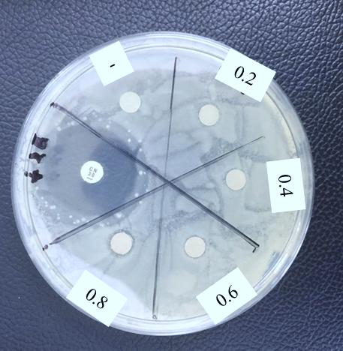
(b)
(a)

Figure 10. Inhibition zone of antibacterial study using different concentrations of (a) chemically synthesized AgNPs and (b) green synthesized AgNPs against Escherichia coli

For gram-positive bacteria (Table 6), the inhibition shown by 0.8 mM chemically synthesized AgNPs is the highest and consistent at 15.0 mm in all trials while the weakest is shown by 0.2 M AgNPs at 7.0 mm inhibition zone for the first trials and 6.5 mm for the other two trials. Unlike Escherichia coli, the concentration of 0.2 mM and 0.4 mM show inhibition zone towards Bacillus subtillis. For green synthesis AgNPs, the concentration of 0.8 mM also shows the highest inhibition zone at 10.0 mm in two trials and 9.0 mm in another. The lowest inhibition is shown by the concentration of 0.2 mM at 5.5 mm for all trials. Comparing chemically and green synthesized AgNPs, chemically synthesized still has better inhibition zone towards gram-positive bacteria, Bacillus subtillis. The inhibition zone is shown in Figure 11. The inhibition zones recorded in this study are comparable with previous findings where the inhibition ranges from 7 to 15 mm [24, 26, 27].

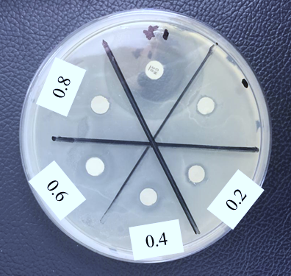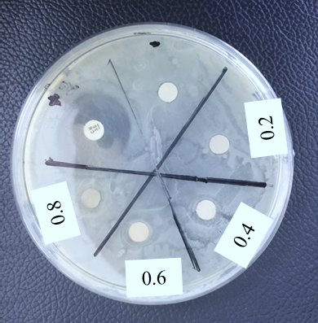
(b)
(a)

Figure 11. Inhibition zone of antibacterial study using different concentrations of (a) chemically synthesized AgNPs and (b) green synthesized AgNPs against Bacillus subtillis

Conclusion
In this study, AgNPs were successfully synthesized by chemical and green method. UV-Vis spectroscopy confirmed the formation of silver nanoparticles in both chemical and green synthesis by exhibiting the SPR band at 415 nm and 452 nm respectively. FTIR shows that the functional groups of -OH, C-H, C-O-C, C=C and C=O responsible in capping and stabilising of AgNPs. Green synthesized AgNPs produced are within 40 to 200 nm. The antibacterial study shows that the green synthesized AgNPs produced have moderate activity against Escherichia coli within the range of 5.5 to 9 mm while against Bacillus subtillis the inhibition zones were within 5.5 to 10 mm.

Acknowledgement

We would like to thank Universiti Malaysia Terengganu, Universiti Malaysia Kelantan and Ministry of Higher Education (MOHE) for research grant FRGS vot number 59383 (FRGS/1/2015/SG01/UMT/02/3) for some financial support in completing this research.

References
- Buzea, C., Pacheco, I. I. and Robbie, K. (2007). Nanomaterials and nanoparticles. Biointerphases, 2(4): MR17-71.
- Solomon, S. D., Mulfinger, L., Bahadory, M., Jeyarajasingam, A. V., Rutkowsky, S. A. and Boritz, C. (2007). Synthesis and study of silver nanoparticles. Journal of Chemical Education, 84(2): 322-325.
- Yusoff, H. M., Hazwani, N. U., Hassan, N. and Izwani, F. (2015). Comparison of sol gel and dehydration magnesium oxide (MgO) as a catalyst in Michael addition reaction. International Journal of Integrated Engineering, 7(3):43-50.
- Yusoff, H. M., Idris, N. H., Hipul, N. F., Yusoff, N. F. M., Izham, N. Z. M. and Bhat, I. U. H. (2020). Green synthesis of zinc oxide nanoaparticles using black tea extract and its potential as anode material in sodium ion batteries. Malaysian Journal of Chemistry, 22(2): 43-51.
- Mazli, S. R. A., Yusoff, H. M. and Idris N. H. (2020). Synthesis of zinc oxide nanoparticles by using aloe vera leaf extract as potential anode material in lithium ion battery. Universiti Malaysia Terengganu Journal of Undergraduate Research, 2(2): 1-8.
- Yusoff, H. M., Rafit, F. A., Mohamad, F. I., Hassan, N. and Daud, A. I. (2017). The effect of calcination temperatures in the synthesis of nanocrystalline magnesium oxide via sol-gel technique. Applied Mechanics and Materials, 865: 36-42.
- Lestari, P., Pratiwi I. and Juliani A. (2018). Green synthesis of silver nanoparticles using rambutan (Nephelium lappaceum L.) peel extract and its antibacterial activity against Salmonella parathypi A. MATEC Web of Conferences, 154: 1-4.
- Maribel, G., Guzmán, J. D. and Stephan, G. (2009). Synthesis of silver nanoparticles by chemical reduction and their antibacterial activity. International Journal of Chemical and Biomolecular Engineering, 2(3): 104-111.
- Liu, H., Wang, D., Song, Z. and Shang S. (2011). Preparation of silver nanoparticles and the application in electrochemical detection of DNA hybridization. Cellulose, 18: 67-74.
- Gudikandula, K. and Maringanti, S., C. (2016). Synthesis of silver nanoparticles by chemical and biological methods and their antimicrobial properties. Journal of Experimental Nanoscience, 11(9): 714-721.
- Yusoff, H. M., Rzeznicka, I. I., Hoshi, H., Kajimoto, S., Horimoto, N. N., Sogawa, K., & Fukumura, H. (2013). Excitation energy migration in yellow fluorescent protein (Citrine) layers adsorbed on modified gold surfaces. Applied Surface Science, 280: 776-782.
- Zhu, X. and Gao, T. (2019). Nano-inspired biosensors for protein assay with clinical applications. Elsevier, Amsterdam: pp. 237-264.
- Ahmed, S., Ahmad, M., Swami, B. L. and Ikram S. (2016). A review on plants extract mediated synthesis of silver nanoparticles for antimicrobial applications: A green expertise. Journal of Advanced Research, 7: 17-28.
- Awwad, A. M., Salem, N. M. and Abdeen, A. O. (2013). Green synthesis of silver nanoparticles using carob leaf extract and its antibacterial activity. International Journal of Industrial Chemistry, 4(29): 1–6.
- Naganathan, S. and Thirunavukkarasu, S. (2017). green way genesis of silver nanoparticles using multiple fuit peels waste and its antimicrobial, antioxidant and anti-tumor cell line studies. 2nd International Conference on Mining, Material and Metallurgical Engineering, 191: pp. 1-7.
- Mousa A. A., Moosa, A. A. and Allawi, M. (2015). Green synthesis of silver nanoparticles using spent tea leaves extract with atomic force microscopy. International Journal of Current Engineering and Technology, 5(5): 3233-3241.
- Loo, Y. Y., Chieng, B. W., Nishibuchi, M. and Radu, S. (2012). Synthesis of silver nanoparticles by using tea leaf extract from Camellia sinesis. International Journal of Nanomedicine, 7: 4263-4267.
- Narayanamma, A. (2016). Natural synthesis of silver nanoparticles by banana peel extract and as antibacterial agent. IOSR Journal of Polymer and Textile Engineering, 3(1): 17-25.
- Badi’ah, H. I., Seedeh, F., Supriyanto, G. and Zaidan A. H. (2019). Synthesis of silver nanoparticles and the development in analysis method. IOP Conference Series: Earth and Environmental Science, 217: 1-8.
- Kumar, B., Smita, K., Cymbal, L. and Angulo Y. (2020). Photosynthesis of silver nanoparticles using andean cabbage: Structural characterization and its application. Materials Today: Proceedings, 21: 2079-2086.
- Singh, A., Jain, D., Upadhyay, M. K., Khandelwal, N. and Verma, H. N. (2010). Green synthesis of silver nanoparticles using agremone mexicana leaf extract and evaluation of their antimicrobial activities. Digest Journal of Nanomaterials and Biostructures, 5(2): 483-489.
- Babu, S., Claville, M. O. and Ghebreyessus, K. (2015). Rapid synthesis of highly stable silver nanoparticles and its application for colourimetric sensing of cysteine. Journal of Experimental Nanoscience, 10(16): 1242–1255.
- Ashok, K., Nethaji, R., Thooyavan, G. and Mullai N. K. (2015). Phytochemical profiling, antioxidant and antimicrobial activity of methanol extract in rambutan fruit (Nephelium lappaceum) epicarp against the human pathogens. International Journal of Current Innovation Research, 1(9): 201-206.
- Reenaa, M. and Menon, A. S. (2017). Synthesis of silver nanoparticles from different citrus fruit peel extract and a comparative analysis on its antibacterial activity. International Journal of Current Microbiology and Applied Sciences, 6(7): 2358–2365.
- Kavulicova, J., Mrazikova, A., Velgosova, O., Ivanova, D. and Kubovcikova, M. (2018). Stability of synthesized silver nanoparticles in citrate and mixed gelatin/citrate solution. Acta Polytechnica, 58(2): 104-108.
- Peiris, M. M. K., Fernando, S. S. N., Jayaweera, P. M., Arachchi, N. D. H. and Guansekara, T. D. C. P. (2018). Comparison of antimicrobial properties of silver nanoparticles synthesized from selected bacteria. Indian Journal Microbiology, 58(3): 301-211.
- Maruthai, K., Vallayyachari, K., Ravibalan, T., Phillip, A. A., Samrot, A. V. and Muthuraj, M. (2017). Antibacterial activity of the silver nanoparticles against Escherichia coli and Enterobacter sp. Progress in Bioscience and Bioengineering, 1(1): 29-35.

