FIELD-AMPLIFIED SAMPLE INJECTION-CAPILLARY ZONE ELECTROPHORESIS METHOD FOR THE ANALYSIS OF 5-FLUOROURACIL ANTICANCER DRUG

(Kaedah Suntikan Sampel Medan Dipertingkat-Elektroforesis Zon Kapilari

untuk Analisa Ubat Antikanser 5-Fluorouracil)

Nur Shahz Ereena Zulkifli¹, Khairil Juhanni Abdul Karim¹, Noorfatimah Yahaya³, Wan Aini Wan Ibrahim^{1, 2}, Sazlinda Kamaruzaman⁴, Nur Idayu Mat Ghani¹, Aemi Syazwani Abdul Keyon ^{1, 2*}

¹Department of Chemistry,

Faculty of Science,

²Centre for Sustainable Nanomaterials,

Ibnu Sina Institute for Scientific and Industrial Research,

Universiti Teknologi Malaysia, 81310 UTM, Johor, Malaysia

³Integrative Medicine Clusters, Advanced Medical and Dental Institute (AMDI),

Universiti Sains Malaysia, 13200 Kepala Batas, Penang, Malaysia

⁴Department of Chemistry,

Faculty of Science,

Universiti Putra Malaysia, 43400 UPM Serdang, Selangor, Malaysia

*Corresponding author: aemi@kimia.fs.utm.my

Abstract
Field-amplified sample injection-capillary zone electrophoresis (FASI-CZE) method was developed to enhance the detection sensitivity of anticancer drug 5-fluorouracil (5-FU). The analyte was introduced electrokinetically for 5 s into a capillary loaded with highly conductive background electrolyte (BGE). The injected analyte migrated in negative polarity, reducing separation time to 5 minutes as compared to positive polarity in hydrodynamic injection-CZE (18 minutes). FASI-CZE was optimized based on three parameters: Sample injection time (5 s, 10 s, and 40 s), BGE concentration in sample (3 mM, 5 mM, and 10 mM) and BGE concentration (15 mM and 25 mM). Optimization of FASI-CZE was conducted to achieve optimal conditions as followed: 15 mM borate BGE containing 0.1% w/v hexadimethrine bromide (HDMB), 5-FU and 5-BrU (IS) prepared in 5 mM diluted BGE, 20% v/v organic modifier in mixture sample was injected at -5 kV for 5 s. The separation was conducted using -25 kV and detected at the wavelength of 234 nm in diode array detection (DAD). The precision was reasonable; %RSD 4.43% at low concentration levels (5 mg/L). The LOD value was 0.24 mg/L when applied with FASI as compared to 0.58 mg/L using HDI-CZE. The sensitivity enhancement factor (SEF) was almost 3 times higher than HDI-CZE at positive polarity, showing that the proposed of FASI-CZE approach is appropriate for the study of 5-FU at trace level.

Keywords: 5-fluorouracil, field-amplified sample injection, capillary electrophoresis, anticancer drug

Abstrak

Kaedah suntikan sampel medan dipertingkat-elektroforesis zon kapilari (FASI-CZE) dibangunkan untuk pertama kalinya bagi meningkatkan kepekaan pengesanan ubat antikanser 5-fluorouracil (5-FU). Analit diperkenal secara elektrokinetik selama 5 s ke dalam kapilari yang dimuatkan dengan elektrolit latar belakang yang sangat konduktif (BGE). Analit yang disuntik berpindah dalam medan kutub negatif, mengurangkan masa pemisahan kepada 5 minit berbanding dengan medan kutub positif dalam suntikan hidrodinamik-CZE (18 minit). FASI-CZE dioptimumkan berdasarkan tiga parameter: masa suntikan sampel (5s, 10s, dan 40s), kepekatan BGE dalam sampel (3 mM, 5 mM, dan 10 mM), dan kepekatan BGE (15 mM dan 25 mM). Pengoptimuman FASI-CZE dilakukan untuk mencapai keadaan yang optimum. Keadaan optimum untuk FASI-CZE adalah seperti berikut: 15 mM BGE borat yang mengandungi 0.1% w/v heksadimetrin bromida (HDMB), 5-FU dan 5-BrU (IS) yang disiapkan dalam 5 mM BGE cair, 20% v/v pengubah organik dalam campuran sampel disuntik pada voltan -5 kV selama 5 s. Pemisahan dilakukan dengan menggunakan -25 kV voltan dan dikesan pada panjang gelombang 234 nm dalam pengesanan susunan diod (DAD). Ketepatannya wajar; %RSD 4.43% pada tahap kepekatan rendah (5 mg/L). Nilai LOD adalah 0.24 mg/L ketika diterapkan dengan FASI berbanding 0.58 mg/L menggunakan HDI-CZE. Faktor peningkatan kepekaan (SEF) hampir 3 kali lebih tinggi daripada HDI-CZE pada medan kutub positif, menunjukkan bahawa pendekatan FASI-CZE yang dicadangkan sesuai untuk kajian 5-FU pada tahap kepekatan surih.

Kata kunci: 5-fluorouracil, suntikan sampel medan dipertingkat, elektroforesis zon kapilari, elektroforesis kapilari, ubat antikanser

Introduction

Cancer is considered as one of the world’s most serious causes of death. Different types of chemotherapy drugs are used to effectively treat various cancers [1]. But patients are more likely to receive chemotherapy along with surgery, radiotherapy, targeted therapy or immunotherapy [2]. There are about 178 drugs used to combat various types of human cancers [3]. The most widely prescribed cancer treatment includes 5-fluorouracil (5-FU), cyclophosphamide, and hydroxyurea [4]. Fluoropyrimidine 5-FU drug has been used for almost 50 years in routine clinical oncology [5]. 5-FU primarily acts as an inhibitor of thymidylate synthase, disrupting the action of enzyme, that is a nucleoside required for DNA replication [6]. The durability and the effectiveness of the drug in cancer chemotherapy is due to the fact that 5-FU is the only anticancer agent on the market that demonstrates compatibility with most combinations of anticancer drugs [7]. Most anticancer drugs contain compounds that are highly toxic due to low therapeutic index and may have strong pharmacological properties from their degradation products that can often lead to an increase in toxicity [8]. Therefore, reliable and sensitive analytical approaches are certainly necessary for determination of 5-FU.

Since capillary electrophoresis (CE) works with any form of ionizable material regardless of polarity, CE-ultraviolet (CE-UV) method has been developed for the analysis of 5-FU [9] and cytarabine [10]. CE is a highly efficient separation technique that provides rapid, inexpensive, low detection limits. Therefore, CE might be a strong alternative for anticancer drugs determination. It was found that due to the above advantages, CE is becoming more common among oncologists [3]. Given the high performance of CE approaches, the issue of relatively low sensitivity cannot be avoided due to limited volume of sample injected (2-10 nL) and short optical pathlength (25-100 um) in spectroscopy-based detectors [11]. The use of sensitive detection techniques such as laser-induced fluorescence, mass spectrometry, and electrochemical detection. is able to improve CE sensitivity [12, 13]. Besides, sensitivity improvement of CE can be achieved by employing a special design of detection cells such as bubble cells [14] and Z-shaped cells [15], due to the extended optical path. The applicability of such approaches is however constrained by time-consuming or expensive setups. Most CE systems; on-line sample preconcentration or stacking techniques, have been commonly employed for the enhancement of concentration sensitivity in CE [13]. These techniques are focused on specific mechanism of preconcentration, which depends on variations in the properties of sample solution and a running buffer [11], and developed dependent on the physico-chemical characteristics of electrophoresis [16]. The three mechanisms that are frequently used are field-amplified sample injection, transient isotachophoresis (t-ITP) [17], and dynamic pH junction stacking and sweeping [16]. FASI-CZE is the simplest and most effective preconcentration technique[18].

FASI, which is established based on the difference in conductivity between the sample and buffer zones, remains as one of the most sought-after stacking techniques due to its simplicity. The analyte from the sample solution (prepared in a diluted BGE) electrokinetically enters the capillary filled with high conductivity BGE. Theoretically, the stacking occurs in the boundary region between high resistivity solvent and BGE, and the separation was performed [19]. Hence, at the point when the sample ions cross the boundary between the analyte and the BGE with high voltage, the ions may undergo a large decrease in velocity owing to a drastic drop in the local electric field, thus causes stacking at the boundary [16]. FASI offers a simpler process and relatively short enrichment time, as well as allows for a greater amount of analyte addition. The present paper reports the development and validation of FASI-CZE for 5-FU. The optimization of the experimental conditions was conducted and the validity of FASI was assessed. FASI-CZE was optimized based on three parameters: Sample injection time (5 s, 10 s, and 40 s), BGE concentration in sample (3 mM, 5 mM, and 10 mM) and BGE concentration (15 mM and 25 mM). The optimal conditions were as follow: -5 kV for 5 s, 20 mg/L standard mixture prepared in 5 mM diluted BGE containing 20% v/v organic solvent and 15 mM borate BGE only (pH 9.3).

Materials and Methods

All chemical materials such as 5-fluorouracil (5-FU $≥$ 99% HPLC), and 5-bromouracil (5-BrU, 98%) were purchased with highest grade of purity from Nano Life Quest Sdn Bhd and supplied by Sigma Aldrich from Shah Alam, Selangor. Boric acid and hexadimethrine bromide (HDMB) were also purchased from Sigma Aldrich, while sodium hydroxide pellets were purchased from Qrec (ASIA) Sdn Bhd. Other chemicals such as methanol (MeOH) of HPLC grade and di-sodium tetraborate decahydrate were obtained from Merck from Masai, Johor by VNK Supply and Service company.

HDI-CZE and FASI-CZE experiments were conducted using Agilent CE (7100, Agilent Technologies, Waldbronn, Germany) coupled with diode array detector (DAD). Electrophoretic separations were accomplished using 64.5 cm polyimide coated fused-silica capillary with an effective length of 56.0 cm. The capillary was placed at a temperature of 25 °C. For normal polarity HDI-CZE, pressure–assisted hydrodynamic injection (HDI) was used to load the sample (10 s, 3.5 kPa) with +25 kV separation voltage. BGE consisted of a buffer solution with 25 mM of di-sodium tetraborate decahydrate (pH 9.3). Two wavelengths of 234 nm and 270 nm were performed on the analytes for the detection of UV absorption using UV-DAD. From the two wavelengths, the 234 nm wavelength was the best detection wavelength for the analytes. On the other hand, FASI was performed by introducing the sample into the capillary using electrokinetic injection (EKI) at -5 kV for 5 s, using -25 kV separation voltage and BGE (borate buffer with pH 9.3). The standard solutions were prepared in a 10x diluted borate BGE buffer solution containing 20% v/v of organic modifier used as a sample matrix to ensure the ionization of 5-FU (the chemical structure of 5-FU as in Figure 1) and its internal standard of 5-bromouracil (5-BrU). For instrumental quality parameters, 5-fluorouracil was prepared in five different concentrations (0.5 ppm, 5 ppm, 10 ppm, 20 ppm, and 25 ppm) and each concentration were mixed constantly with 20 ppm of internal standard (IS) 5-BrU.

Intra-day (all concentrations) and inter-day (three consecutive days with two different concentrations) analyses were fully validated by performing external calibration curve, calculating LODs and LOQs, precision and %RSD. Prior to use, the new capillary was pretreated with 1 M NaOH at 950 mbar for 60 minutes, Milli-Q water for 20 minutes, and borate buffer (pH 9.3) only as BGE for 10 minutes. The capillary was conditioned with Milli-Q water for 5 minutes at the start of the day to ensure the electrodes for both inlet and outlet were clean. The capillary was further conditioned with NaOH (0.1M) for 10 minutes, again with water (10 minutes), with 1% w/v HDMB (20 minutes), and lastly with 20 minutes BGE (added with diluted HDMB [0.1% w/v]). Between each run, the capillary was rinsed with BGE (added with 0.1% w/v HDMB) for 5 minutes to ensure that the capillary wall was still coated with HDMB surfactant before sample injection. The electropherograms were controlled by Agilent ChemStation software.

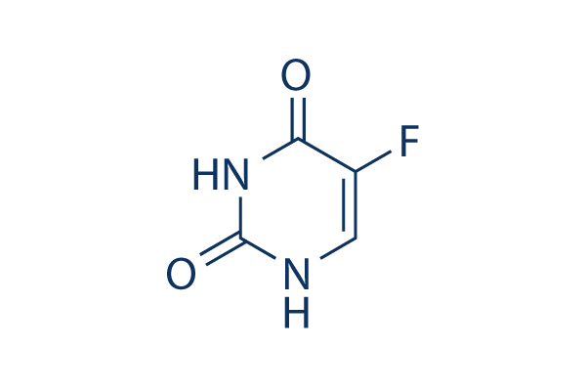
Figure 1. Chemical structure of 5-FU

Results and Discussion
Separation of analytes using CZE

5-FU is an acidic compound (with pKa= 7.93) that can be negatively charged when in an alkaline medium [20, 21]. Separation at positive (normal) polarity +25 kV voltage using di-sodium tetraborate decahydrate buffer at pH 9.3 as BGE was able to separate 5-FU and 5-BrU, having resolution (Rs) just above 1.5. Even though both negatively charged compounds could arrive at the detector end due to the electroosmotic flow (EOF), they were also strongly attracted towards the anode, resulting in poor peak shape (wide and tailing) and long analysis time (18 minutes), as shown in Figure 2. In this case, effective separation was accomplished by conducting the separation in negative polarity with the aid of HDMB, which is a polycationic polymer that acts as a cationic surfactant for EOF reversal. The positively charged HDMB attached to the negatively charged double layer within the fused silica capillary, was attracted towards the anode, thus reversing the EOF. The separation in negative polarity HDI-CZE condition gave a good resolution (Rs > 1.5) and shorter analysis time (< 5 minutes) as compared to the separation using positive polarity HDI-CZE (< 18 minutes) (Figure 2).

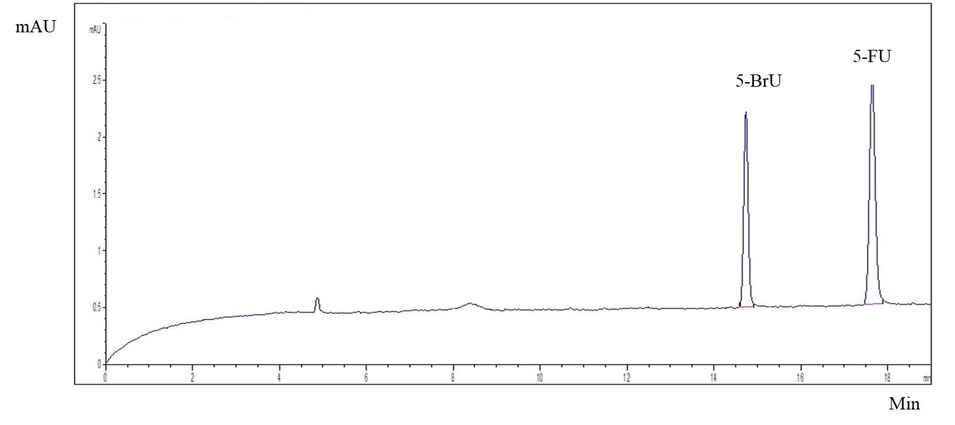

Figure 2. Electropherogram showing separation of 5-BrU and 5-FU using positive polarity HDI-CZE at 25 kV CE conditions: polyimide coated fused-silica capillary (i.d.= 50 𝜇m, l= 56 cm, L= 64.5 cm); 25 mM borate BGE (pH 9.3); separation at 25 ºC. Experiment was performed on standards mixture (20 mg/L); UV detection at 234 nm.

Field-amplified sample injection-CZE (FASI-CZE)
Having the optimized criteria for the separation, the sensitivity enhancement is important for analyte trace analysis. FASI was chosen as a quick online preconcentration method prior to CZE. The analytes entered the capillary through EKI, and they stacked up between low conductive sample (analyte prepared in low concentration BGE) and BGE in the boundary region dependent on the velocity changes of the analytes, and then separation started to occur. FASI helps improve sensitivity by introducing more ions from the sample vial. Moreover, FASI has been reported to enhance sensitivity up to 1000x [22]. FASI-CZE of 5-FU and 5-BrU were optimized systematically to enhance sensitivity as well as to reduce analysis time.

Effect of sample injection time
Electrokinetic sample injection times of 5 s, 10 s, and 40 s were tested. Theoretically, the higher the injection time, the greater the signal. Increasing the injection time improved the signal but caused some loss in resolution and peak symmetry. It was found to be more acceptable when sample injected for 5 s even though signal gradually increased from 5 s to 40 s (as electropherograms depicted in Figure 3), where 40 s injection time showed highest signal. This was because of the difference in conductivity between the injected sample plug and separation BGE inside capillary. Nevertheless, the peaks became less symmetrical and peak width increased (dispersion effect). Better repeatability was observed for 5 s injection time (RSD 0.62%), and the resolution between 5-FU and the IS was much higher. Therefore, 5 s injection time was selected in subsequent FASI optimization.

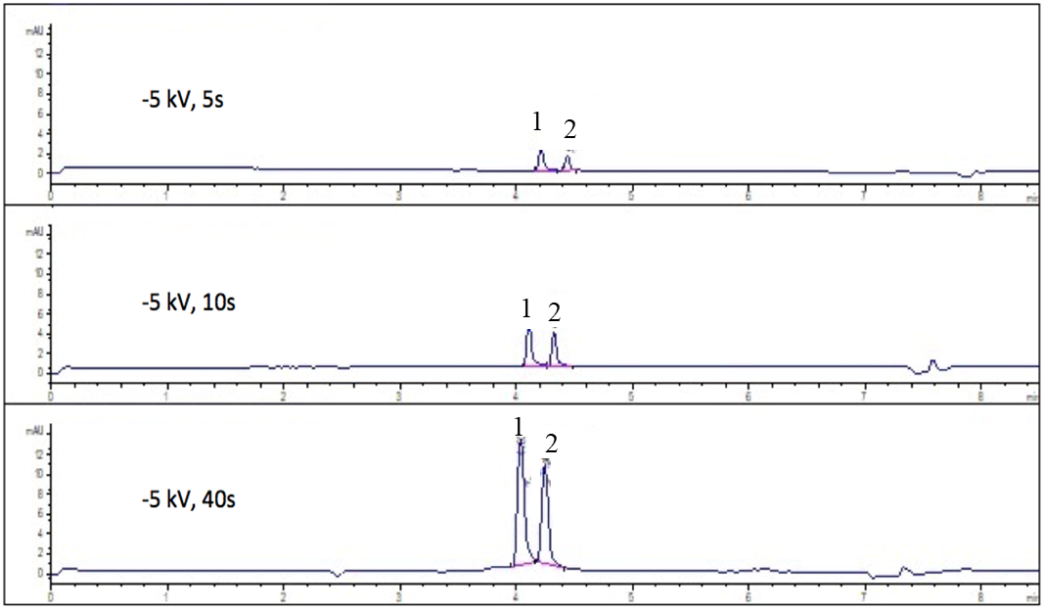

Figure 3. Electropherograms showing separation of 5-FU and 5-BrU using negative polarity FASI-CZE. Effect of the sample injection time. CE conditions: polyimide coated fused-silica capillary (i.d.= 50 𝜇m, l= 56 cm, L= 64.5 cm); 25 mM borate BGE (pH 9.3) (added with 0.1% HDMB); separation at 25 ºC and -25 kV. Peak 1 = 5-FU, peak 2 = 5-BrU. Experiment was performed on standards mixture (20 mg/L); UV detection at 234 nm.

Effect of concentration of BGE in sample
The rationale to optimize BGE concentration in sample was to enhance the sensitivity of the analyte, as FASI helps to stack the analyte (increasing the peak signal). Borate buffer in BGE was diluted and added with 20% v/v MeOH as an organic modifier in the sample. The organic solvent was used to increase solubilization, minimize conductivity, and enhance FASI [22]. For this study, the conductivity of the sample must be at least ten times less than the electrolyte, which is one of the stacking criteria. The sample was prepared by diluting in a diluted buffer (at least 10 times dilution) to allow stacking due to extreme difference in conductance. Three different concentrations (3 mM, 5 mM, and 10 mM) of diluted BGE were tested. The signals increased when the concentration of diluted BGE decreased (as shown in Figure 4). The resolutions for the three different diluted BGE concentrations were observed with Rs values of 2.67, 2.64, and 2.56, respectively. Therefore, 5 mM was chosen as the optimum concentration.

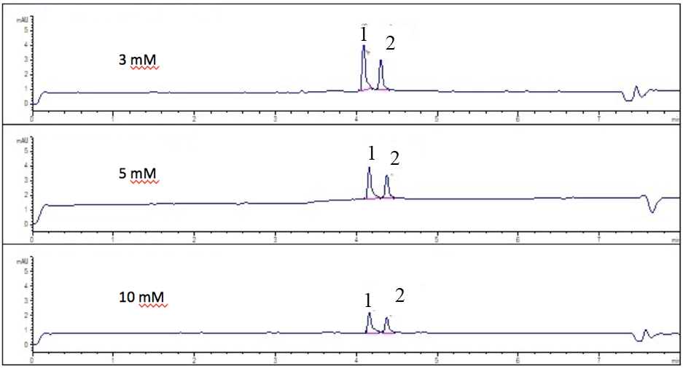

Figure 4. Electropherograms showing separation of 5-FU and 5-BrU using negative polarity FASI-CZE. Effect of BGE concentration in sample. CE conditions: polyimide coated fused-silica capillary (i.d.= 50 𝜇m, l= 56 cm, L= 64.5 cm); 25 mM borate BGE (pH 9.3) (added with 0.1% HDMB); separation at 25 ºC and -25 kV. Other experimental conditions as in Figure 3.

Effect of separation of BGE concentration
The effect of increasing the electrolyte concentration will increase the current and the migration of EOF, and sometimes the current will suddenly drop due to instability of the buffer system. Thus, inorganic electrolytes such as borate and phosphate must be optimized appropriately and used in low concentrations because of their high conductivities. The separation BGE concentrations (15 mM and 25 mM) were tested, while the other conditions were made constant; sample injection at -5 kV for 5 s (sample injection voltage × time: -25 kV.s), and the standard mixture (20 mg/L) contained 5 mM BGE. Although the signal for 25 mM concentration was better, 15 mM was still preferred for separation BGE. This was because the peak tailing and width were minimized, which gave the peak width ratio value 1.25 using 15 mM borate BGE as compared to 25 mM borate BGE (1.32), giving a better separation of the compounds.

Accordingly, FASI-CZE optimum conditions were 15 mM separation BGE concentration, 5 s sample injection time, and sample should contain 5 mM diluted BGE with 20% MeOH as the organic modifier. The electropherogram of 5-FU and 5-BrU at optimum conditions is shown in Figure 5.

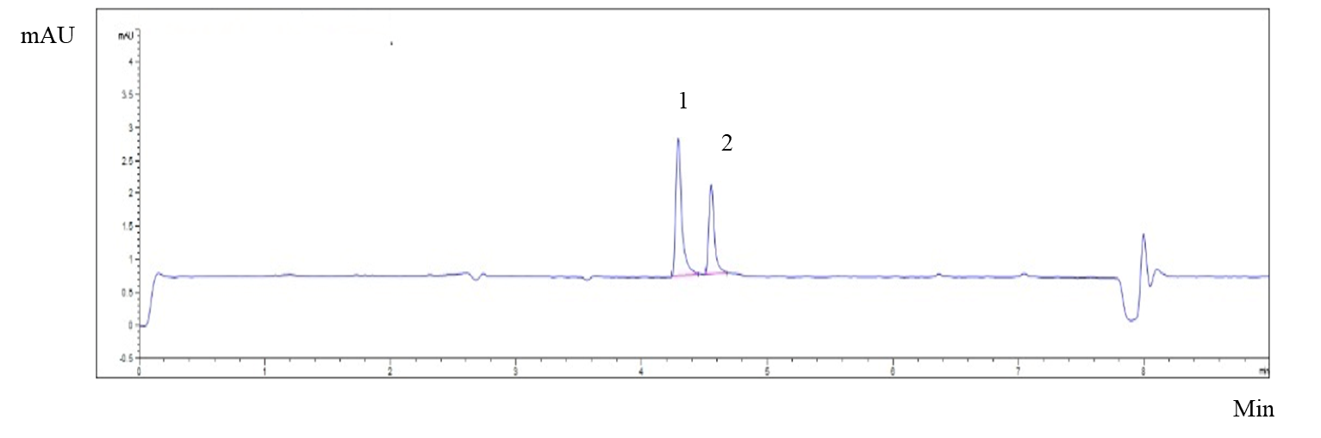

Figure 5. Electropherogram showing separation of 5-FU and 5-BrU using optimized negative polarity FASI-CZE conditions. CE conditions: polyimide coated fused-silica capillary (i.d.= 50 $μ$m, l= 56 cm, L= 64.5 cm); 15 mM borate BGE (pH 9.3) (added with 0.1% HDMB); separation at 25 ºC and -25 kV; Experiment was performed on standards mixture (20 mg/L) prepared in diluted BGE (5 mM) containing 20% v/v of MeOH; standards mixture was injected by EKI at -5 kV for 5 s. Other experimental conditions as in Figure 3.

Method validation
The method validation for HDI-CZE and FASI-CZE were conducted under optimum conditions. An external calibration curve was plotted from 0.5 mg/L to 25 mg/L, whereby good coefficient of regression was achieved with R² > 0.997. The limit of detection (LOD) for both methods were obtained based on a signal to noise ratio (S/N) of 3. As summarized in Table 1, HDI-CZE method provided a LOD value of 0.58 mg/L. With the pre-concentration technique of FASI, the LOD value reduced to a value of 0.24 mg/L, indicating improvement of sensitivity. The limit of quantification values (LOQ) obtained based on S/N of 10; 1.97 mg/L and 0.82 mg/L for HDI-CZE and FASI-CZE methods, respectively. The SEF obtained was almost 3 times higher than HDI-CZE method at positive polarity. Intraday and interday precisions were calculated for the signal (peak to height ratio, PHR). The RSD% values obtained for intraday and interday were 6.69% (5 mg/L) and 4.43% (5 mg/L), respectively. Table 2 summarizes current FASI-CZE method performance with other reported methods. Table 2 summarizes comparative data from our work against other reported CZE methods. The negative polarity FASI-CZE method compares well with other methods. The present LOD value for 5-FU was comparable or superior with most of the other methods. Most importantly, the total separation time achieved in our work was the shortest among all (due to the negative polarity used during separation of anionic analytes in a coated capillary).

Table 1. The analytical figure of merits for both analytes using HDI-CZE and FASI-CZE methods
Compound | Method | LODs  (mg/L) | (SEF_{c})ª | Intraday  %RSD (n = 3) |  | Interday  %RSD (n = 3)
 |  |  |  | Signal (PHR)^{b} |  | Signal  (PHR)^{b}
5-FU | HDI-CZE | 0.58 | -
5-FU | FASI-CZE | 0.24 | 3 | 6.69 |  | 4.43
ª SEF_{c} = LOD (HDI-CZE)/ LOD (FASI-CZE)
^{b} Peak height ratio (PHR) = Height (5-FU)/ Height (IS)

Table 2. FASI-CZE method performance with other reported methods

Analyte | Separation Mode |  | Total Separation Time | LODs | Regression Coefficient |  | Intraday  %RSD | Interday  %RSD | Ref.
5-FU | HDI-CZE | <6 min |  | 1.72 $μ$g/mL | 0.999 | <7.6% |  | <8.8% | [23]
5-FU | HDI-CZE | 10 min |  | 2.60 mg/L | 0.994 | NA |  | NA | [24]
5-FU | HDI-CZE | <15 min |  | NA | 0.999 | <2.9% |  | <2.9% | [25]
5-FU | HDI-CZE | 15 min |  | 1.04 $μ$M | 0.999 | 2.0% |  | 3.3% | [26]
5-FU | HDI-CZE | 21 min |  | 1.7 $μ$g/L | 0.9992 | 0.7-8.9% |  | 2.2-9.5% | [27]
5-FU | FASI-CZE | 4.4 min |  | 0.24 mg/L | 0.997 | 6.69% |  | 4.43% | Current work
NA = Not available

Conclusion

A new negative polarity FASI-CZE method was developed for the analysis of 5-FU. With FASI, LOD of 0.24 mg/L was obtained as compared to positive polarity HDI-CZE with 0.58 mg/L, indicating that FASI could be an effective alternative method to increase sensitivity. A BGE solution of 15 mM sodium tetraborate buffer was recommended as the optimal solution for CZE separation of 5-FU. HDMB surfactant was used as co-EOF to reverse the EOF, giving the capillary wall a net positive charge. The migration time of analytes was significantly reduced by the assistance of FASI, thus allowed the analytes to be separated within 5 min using 15 mM borate BGE at pH 9.3 added with 0.1% w/v HDMB. Further application of this online sample preconcentration system through increased speed and sensitivity will render CE a great instrument in the routine monitoring in healthcare and pharmaceutical industry, as well as environmental analysis (soil and water bodies polluted with 5-FU residuals).

Acknowledgement

A.S.A.K is grateful for the financial support of the work by the Ministry of Higher Education Malaysia (MOHE) and Universiti Teknologi Malaysia via Fundamental Research Grant Scheme (R.J130000.7854.5F010) and Universiti Teknologi Malaysia Fundamental Research grant (UTMFR, Q.J130000.2554.20H98). N.Y thanked financial support from Universiti Sains Malaysia through Research University Grant (1001.CIPPT.8011052).

References
- Abdollahi, Z., Taheri-Kafrani, A., Bahrani, S. A. and Kajani, A. A. (2019). Pegaylated graphene oxide/superparamagnetic nanocomposite as a high-efficiency loading nanocarrier for controlled delivery of methotrexate. Journal of Biotechnology, 298: 88-97.
- National Cancer Institute (2018). Chemotherapy and you. National Cancer Institute, U.S.: pp. 1-55.
- Ali, I., Haque, A., Wani, W. A., Saleem, K., and Al Za'abi, M. (2013). Analyses of anticancer drugs by capillary electrophoresis: A review. Biomedical Chromatography, 27(10): 1296-1311.
- Usawanuwat, J., Boontanon, N. and Boontanon, S. K. (2014). Analysis of three anticancer drugs (5-fluorouracil, cyclophosphamide and hydroxyurea) in water samples by HPLC-MS/MS. International Journal of Advances in Agricultural & Environmental Engineering, 1: 72-76.
- Saif, M. W., Choma, A., Salamone, S. J. and Chu, E. (2009). Pharmacokinetically guided dose adjustment of 5-fluorouracil: A rational approach to improving therapeutic outcomes. JNCI: Journal of the National Cancer Institute, 101(22): 1543-1552.
- Kosjek, T. and Heath, E. (2011). Occurrence, fate and determination of cytostatic pharmaceuticals in the environment. TrAC Trends in Analytical Chemistry, 30(7): 1065-1087.
- Cirillo, G., Iemma, F., Puoci, F., Parisi, O. I., Curcio, M., Spizzirri, U. G. and Picci, N. (2009). Imprinted hydrophilic nanospheres as drug delivery systems for 5-fluorouracil sustained release. Journal of Drug Targeting, 17(1): 72-77.
- Zalewska, M., Wilk, K., and Milnerowicz, H. (2013). Capillary electrophoresis application in the analysis of the anti-cancer drugs impurities. Acta Poloniae Pharmaceutica, 70(2): 17180.
- Sun, H., Wu, Y., He, P., Zuo, Y. and Lv, Y. (2012). Characterization of interaction between antitumor drug 5-fluorouracil and human serum albumin by affinity capillary electrophoresis. Asian Journal of Pharmaceutical Sciences, 7(1): 75-79.
- Guichard, N., Guillarme, D., Bonnabry, P. and Fleury-Souverain, S. (2017). Antineoplastic drugs and their analysis: A state of the art review. Analyst, 142(13): 2273-2321.
- Forough, M., Farhadi, K., Molaei, R., Khalili, H., Shakeri, R., Zamani, A. and Matin, A. A. (2017). Capillary electrophoresis with online stacking in combination with AgNPs@ MCM-41 reinforced hollow fiber solid-liquid phase microextraction for quantitative analysis of capecitabine and its main metabolite 5-fluorouracil in plasma samples isolated from cancer patients. Journal of Chromatography B, 1040: 22- 37.
- Zhang, Z., Zhang, F. and Liu, Y. (2013). Recent advances in enhancing the sensitivity and resolution of capillary electrophoresis. Journal of Chromatographic Science, 51(7): 666-683.
- Kitagawa, F. and Otsuka, K. (2014). Recent applications of on-line sample preconcentration techniques in capillary electrophoresis. Journal of Chromatography A, 1335: 43-60.
- Xue, Y. and Yeung, E. S. (1994). Characterization of band broadening in capillary electrophoresis due to nonuniform capillary geometries. Analytical Chemistry, 66(21): 3575-3580.
- Bruin, G. J. M., Stegeman, G., Van Asten, A. C., Xu, X., Kraak, J. C. and Poppe, H. (1991). Optimization and evaluation of the performance of arrangements for uv detection in high-resolution separations using fused-silica capillaries. Journal of Chromatography A, 559(1-2): 163-181.
- Chen, X., Tang, Y., Wang, S., Song, Y., Tang, F. and Wu, X. (2015). Field‐amplified sample injection in capillary electrophoresis with amperometric detection for the ultratrace analysis of diastereomeric ephedrine alkaloids. Electrophoresis, 36(16): 1953-1961.
- Rabanes, H. R., Aranas, A. T., Benbow, N. L. and Quirino, J. P. (2012). Synergistic effect of field enhanced sample injection on micelle to solvent stacking in capillary electrophoresis. Journal of Chromatography A, 1267: 74-79.
- Purrà, M., Cinca, R., Legaz, J. and Núñez, O. (2014). Solid-phase extraction and field-amplified sample injection–capillary zone electrophoresis for the analysis of benzophenone UV filters in environmental water samples. Analytical and Bioanalytical Chemistry, 406(25): 6189-6202.
- Hou, X., Deng, D., Wu, X., Lv, Y. and Zhang, J. (2010). Simultaneous stacking of cationic and anionic compounds in single run capillary zone electrophoresis by two-end field amplified sample injection. Journal of Chromatography A, 1217(35): 5622-5627.
- Diasio, R. B. and Harris, B. E. (1989). Clinical pharmacology of 5-fluorouracil. Clinical Pharmacokinetics, 16(4): 215-237.
- Wielińska, J., Nowacki, A. and Liberek, B. (2019). 5-fluorouracil—complete insight into its neutral and ionised forms. Molecules, 24(20): 3683.
- Breadmore, M. C. (2007). Recent advances in enhancing the sensitivity of electrophoresis and electrochromatography in capillaries and microchips. Electrophoresis, 28(1‐2): 254-281.
- Prochazkova, A., Liu, S., Friess, H., Aebi, S., and Thormann, W. (2001). Determination of 5-fluorouracil and 5-fluoro-2’-deoxyuridine-5’-monophosphate in pancreatic cancer cell line and other biological materials using capillary electrophoresis. Journal of Chromatography A, 916: 215-224.
- Flores, J. R., Nevado, J. J. B., Penalvo, G. C., and Caceres, M. I. R. (2003). Direct capillary electrophoretic determination of three chemotherapeutic drugs in human urine. Journal of Chromatographia, 57: 493-496.
- Lu, H.-j., Guo., Y.-l., Zhang, H. and Ou, Q.-y. (2003). Rapid determination of 5-fluorouracil in plasma using capillary electrophoresis. Journal of Chromatography B, 788(2): 291-296.
- Liu, Y., Zhu, P., Huang, Z., Zhou, Li. and Shi, P. (2018). Simultaneous detection of 5-fluorocytosine and 5-fluorouracil in human cells carrying CD/5-FC suicide gene system by using capillary zone electrophoresis. Journal of Chromatography B, 1076: 1-7.
- Mahnik, S. N., Rizovski, B., Fuerhacker, M., and Mader, R. M. (2004). Determination of 5-fluorouracil in hospital effluents. Analytical and Bioanalytical Chemistry, 380(1): 31-35.

