

CELLULOSE ACETATE-TiO₂ PHOTOCATALYTIC HOLLOW FIBRE MEMBRANE FOR DEGRADATION OF METHYLENE BLUE

(Membran Fiber Berongga Fotomangkin Selulosa Asetat-TiO₂ bagi Degradasi Metilena Biru)

Siti Wafiroh*, Miriam R. Prananda, Linda Yuliana, Pratiwi Pudjiastuti, Abdulloh

Department of Chemistry, Faculty of Science and Technology,
Airlangga University, Surabaya, Indonesia

*Corresponding author: sitiwafiroh@fst.unair.ac.id

Received: 18 July 2019; Accepted: 20 July 2020; Published: xx December 2020

Abstract
Methylene blue (MB) used in the textile industry can cause environmental damage. Photocatalytic hollow fibre membrane (PHFM) was employed in the degradation of synthetic MB dye. This research aimed to determine the optimum concentration of TiO₂ addition on the characteristic and performance of cellulose acetate-TiO₂ PHFM for the degradation of synthetic MB dye. Hollow fibre membrane was prepared from the phase inversion method using a dope solution with the ratio of CA, formamide, and acetone of 22%:27%:51%, and TiO₂ was then added with various concentrations of 0.10%, 0.15%, 0.20%, 0.25%, and 0.30% (w/w). The results showed that the optimum concentration of TiO₂ addition to the hollow fibre membrane was 0.25% (w/w). The characterisation of PHFM involved strain, stress, Young’s modulus, flux, rejection, SEM, FTIR, and efficiency degradation for MB, while the characterisation of CA-TiO₂ PHFM involved thickness, stress, strain and Young’s Modulus, i.e., 0.15 mm, 5.5 × 10² kN/mm², 0.13, and 4.2 × 10³ kN/mm², respectively. The flux and rejection performance of PHFM with MB feed were 25.66 L/m².h and 94.8%, respectively. The total efficiency of CA-TiO₂ PHFM application for MB degradation was 98.9%, and waste textile dye was 82.6%. PHFM was capable of degrading the synthetic MB.

Keywords: photocatalytic, hollow fibre membrane, cellulose acetate, TiO₂, methylene blue

Abstrak
Metilena biru (MB) yang digunakan dalam industri tekstil boleh menyebabkan kerosakan alam sekitar. Membran fiber berongga fotomangkin (PHFM) digunakan dalam pemerosotan pewarna MB sintetik. Kajian ini bertujuan untuk menentukan kepekatan optimum penambahan TiO₂ terhadap ciri dan prestasi PHFM selulosa asetat–TiO₂ untuk pemerosotan pewarna MB sintetik. Membran fiber berongga dihasilkan melalui kaedah songsangan fasa menggunakan larutan dop dengan nisbah CA, formamida, dan aseton pada 22%:27%:51%, dan TiO₂ kemudiannya ditambah pada pelbagai kepekatan sebanyak 0.10%, 0.15%, 0.20%, 0.25%, dan 0.30% (w/w). Keputusan menunjukkan kepekatan optimum penambahan TiO₂ kepada membran gentian geronggang pada 0.25% (w/w). Pencirian PHFM melibatkan terikan, tegasan, modulus Young, fluks, penyingkiran, SEM, FTIR, dan kecekapan pemerosotan MB, manakala pencirian CA-TiO₂ PHFM melibatkan ketebalan, tegasan, terikan, dan modulus Young, masing-masing pada 0.15 mm, 5.5 × 10² kN/mm², 0.13, and 4.2 × 10³ kN/mm². Prestasi fluks dan penyingkiran PHFM dengan suapan MB masing-masing ialah 25.66 L/m².h and 94.8%. Kecekapan aplikasi CA–TiO₂ PHFM bagi pemerosotan MB ialah 98.9%, dan sisa pewarna tekstil ialah 82.6%. PHFM mampu degradasi MB sintetik.

Kata kunci: fotomangkin, membrane fiber berongga, selulosa asetat, TiO₂, metilena biru

Introduction
Dyes are one of the major pollutants in wastewater from the textile industry. The textile dyeing industry produces by-products in the form of wastewater in large quantities and contains various types of chemicals. The textile industry produces the largest amount of synthetic dye waste and produces around 50-200 mg/L dyes that could not be degraded entirely [1]. The type of dye that is widely used in the textile industry in Indonesia is methylene blue (MB) because it is a basic dye and has excellent solubility [2]. In the industry, only 5% of MB is bound, while the remaining 95% becomes waste; hence, its distribution in the aquatic environment is extensive. This phenomenon can cause disturbances in the ecosystem; e.g. it can disrupt the aesthetics of the waters and can block the penetration of sunlight into the waters. This kind of dye wastes may interfere with the photosynthesis process of aquatic plants, consequently decreasing the oxygen content in the water and eventually reduce water quality and can be fatal, especially to aquatic organisms [3, 4].

In this research, the photocatalytic method uses the concept of electron/hole pair generation in semiconductor particles because it requires the right energy (e.g., for TiO₂, λ <380 nm and similarity of band gap energy greater than 3.2 eV) [5]. The study reported the effect of plasma surfaces and triarylmethane dyes in textiles using the photocatalytic method of performance of TiO₂-chitosan [6]. Adsorption is another promising alternative method developed to treat textile synthetic dye wastes because the process is relatively simple, inexpensive, and it can work at low concentrations. This type of adsorbent has been used to reduce the concentration of aquatic dyes. MnO-activated carbon can be synthesised hydrothermally from coconut shell. This adsorption can absorb azo dyes by 99.1%. However, this process requires relatively large energy, causing the price of activated carbon to be expensive and difficult to apply in the industry [7].

Another method besides the use of photocatalytic methods and adsorption to treat textile dye waste is membrane technology, which is widely used in the industry. Various types of membranes are available, one of which is hollow fibre membranes. The geometry of this hollow fibre membrane provides greater membrane effectiveness. Excellent mechanical properties and the ease of handling during fabrication and operational processes renders hollow fibre membranes as the chosen method in the industry [8]. The manufacture of membranes is said to be optimum if the membrane has many small pores, which causes large flux values and high reproduction. Furthermore, it has high mechanical properties and low fouling. Therefore, the right combination of materials is needed. The membrane requires composites with other compounds for the production of membranes with optimum specifications [9]. One of the composites that are often used in membrane modification is the inorganic compound, TiO₂. TiO₂ is a semiconductor material that has been widely applied in the environment due to abundant resources, excellent photocatalytic performance, high refractive index, low cost, non-toxic, and high photodegradation chemical stability. TiO₂ is proven to be a promising catalyst in the management of water and air pollution [10].

Cheng et al. [11] have produced a hollow CA membrane nanofiltration to increase perm selectivity through hydrolysis reactions followed by carboxymethylation. Nanofiltration of CA hollow fibre membrane produces a flux value of about 5.2 L/m²h, the value of NaCl rejection of 66.4%, and Na₂SO₄ rejection value of 95.4%. The modification of pure semi-permeable CA membrane yielded a flux value of 2.3 L/m²h, NaCl rejection value of 90.8%, and Na₂SO₄ rejection value of 91.5%. In addition, the modification of CA membranes in diluted solutions of Congo red and MB increased the dye degradation rate and the value of flux in water more than twice compared to pure membranes [11]. Mozia et al. [12] reported the performance of two photocatalytic membrane reactors (PMRs), utilising ultraﬁltration (UF) - PMR1, or direct contact membrane distillation (DCMD) – PMR2, in the treatment of primary (PE) and secondary (SE) efﬂuents of municipal wastewater treatment plant. Additionally, single UF and DCMD were also examined. TiO₂ Aeroxide® P25 (0.5–1.5 g/dm3) was applied as a photocatalyst. Photocatalysis contributed to an improved permeate ﬂux in PMR1 compared to UF alone for 25-38% in the case of PE and 33% when SE was used [12].

Sarasidis et al. [13] have reported a laboratory pilot photocatalytic membrane reactor (PMR), employing a hybrid TiO₂/UV-A catalysis-ultrafiltration process, which was evaluated for the degradation of diclofenac (DCF), a typical micro-pollutant frequently encountered in source waters. The combination of membrane ultrafiltration with photocatalysis allows TiO₂ separation and reuse, whereas the automatic periodic membrane backwashing, combined with moderate permeate flux, effectively control membrane fouling; thus, permitting stable continuous operation with no wastewater stream [13]. Zhao et al. [14] have structured the design and observed the performance of braid-reinforced cellulose acetate (BR CA) fibre membranes that have anti-fouling properties with an average rejection value of more than 80%. The tensile strength of BR CA membranes varied from 16.0 MPa to 62.9 MPa by adjusting the braid composition [14].

Based on the description above, this research employed a membrane using CA-TiO₂ as a base material for PHFM. The CA-TiO₂ PHFM was applied for the degradation of MB. The composition of the mixture was 51% acetone, 27% formamide, and 22% CA with variations in TiO₂ concentrations of 0.10%, 0.15%, 0.20%, 0.25%, and 0.30%. The CA-TiO₂ PHFM was characterized by the determination of membrane mechanics and membrane performance. Determination of membrane mechanics was performed to specify the thickness, stress value, strain value, and Young’s modulus, while the performance determination was performed to specify the value of flux and rejection. The morphological determination was performed using SEM, and the determination of functional groups by Fourier-transform infrared (FTIR). The CA-TiO₂ PHFM with mechanical properties and optimum performance was applied to the degradation of MB, waste textile dye using membrane modules for the filtration process, and photocatalytic reactors for waste textile dye degradation.

Materials and Methods
Raw materials
All materials used in this research were analytical grade chemicals and used as it is without further purification. Cellulose acetate (Mv = 50.000 g/mol), TiO₂, H₂SO₄, formamide, acetone, and phenolphthalein indicator were obtained from Merck.

Production of CA-TiO₂ PHFM
The dope solution was made with a composition of 22% CA, 51% acetone, and 27% formamide, which was slowly dissolved with acetone at room temperature in a closed Erlenmeyer flask to avoid solvent evaporation. The composition of TiO₂ solution varied in concentration; 0.10%, 0.15%, 0.20%, 0.25%, and 0.30%. Formamide was added after all CA was dissolved in acetone. The dope solution, which has been mixed, was then stirred with a magnetic stirrer at 30 °C until homogeneous. During stirring, TiO₂ was added according to the variations for several hours. The homogeneous dope solution was left overnight to eliminate air bubbles to allow the dope solutions to be moulded into hollow fibre membranes using phase inversion techniques. The hollow fibre membrane printing device was assembled first and the preparation of a coagulant tub with at 5 °C using ice just below the spinneret at 25 cm. Tube 1 was used to place a dope solution, while tube 2 is used for aquadest. The compressor is connected using a hose on tube 1. When the dope solution passes through the needle, tube valve 2 was opened. After going through the spinneret, the hollow fibre membrane formed from the dope solution enters the tub of the coagulant so that the hollow fibre membrane became solid. Then, the hollow fibre membrane was washed using water flowing to eliminate excess solvent. For the final step, the PHFM was transferred to a tube containing sodium azide solution to inhibit bacterial growth in the membrane so that it can be characterised [15]

Characterization of CA-TiO₂ PHFM
The thickness measurement was performed using micrometre screw with an accuracy of 0.01 mm. Determination of the mechanical properties of CA-TiO₂ PHFM can be carried out using tensile test, where the membrane is clamped on a tensile test tool and the puller mounted to a load unit of kN. The CA-TiO₂ PHFM was then pulled at a speed of 1 cm/min until it broke. The magnitude of the force (F) to break the membrane and the change in length (Δl) until the sample exactly broken was recorded in the monitor of the tensile tester. From these data we can determine the stress$(σ)$ value (Equation 1), strain ($ε;$ Equation 2), and the Young’s modulus (E; Equation 3).

$σ=\frac{F}{A}$ (1)

$ε=\frac{l-lo}{lo}=\frac{∆l}{lo}$ (2)

$E=\frac{σ}{ε}$ (3)

The membrane performance test was determined by calculating flux value and rejection or perm selectivity value. PHFM module performance was tested using crossflow cells. Flux (J) was deﬁned as the quantity permeated per unit of area (A) and per unit of time (t), as reported in Equation 4. The flux of water or sample passing through the membrane was determined directly by measuring flow infiltration in volume (L) per square meter per hour (L.m⁻²h⁻¹) and calculated using Eq. 4. [11].

$J=\frac{v}{A×t}$ (4)

Perm selectivity or rejection value is expressed as a membrane’s ability to hold or pass through a species. The coefficient of rejection can be calculated using Eq. 5.

R=1-Cp/Cf×100% (5)

where Cp is the concentration of permeate and Cf is the concentration of feed. Feed is MB and waste textile dye.

Application of CA-TiO₂ PHFM for MB degradation
The application is performed by comparing two methods, i.e., the filtration method using a hollow CA fibre membrane and CA-TiO₂ PHFM. Filtration using a hollow CA fibre membrane was carried out by filtering MB feed solution into the membrane. CA-TiO₂ PHFM was carried out in the same way. The resulting permeate was measured by using a UV-Vis spectrophotometer [11].

Qualitative test of CA-TiO₂ PHFM for degradation of MB
Qualitative tests of the results of MB degradation can be performed using five qualitative tests, including analysis of CO₂, NH₄⁺, Cl⁻, NO⁻, and SO₄²⁻ with the results of the degradation of MB. The CO₂ gas test was performed using a U pipe, which allows the flow of air formed by the vacuum resulted from the degradation of MB in Ba(OH)₂ solution. The CO₂ formed will react with Ba(OH)₂ to form white sediment. The NH₄⁺ ion test was performed by adding excessive NaOH to the solution resulting from the MB degradation, which was then heated. A spatula dipped in concentrated HCl was also placed in the solution. The spatula that has been dipped with concentrated HCl will form white steam on the tube wall. The SO₄²⁻ ion test was carried out with the addition of Ba²⁺ [16].

Results and Discussion
Production of CA-TiO₂ PHFM
CA hollow fibre membranes were produced using a phase inversion method, which is a process of forming polymers from a solution form into solids in a controlled manner [1]. When making a dope solution, the CA powder was dissolved with acetone using a magnetic stirrer; then, the formamide was added as an additive to form the pores of the hollow fibre membrane. An additive may be used in the production of membranes if it meets the requirements of being soluble in polymer solvents and must also be soluble in non-solvents [14]. A thick dope solution requires a push force to come out of spinneret with the compressor. The dope solution was then applied to the coagulant tub, which contains water at 5 °C. Low-temperature during moulding functions to produce asymmetrical (different pore size) membrane. The morphology of the membrane was affected by the
evaporation of solvents during the moulding process affected; therefore, an air gap of 25 cm was used. Five variations of dope solution were used in this study, with a composition of 22% CA, 51% acetone, 27% formamide, and variations in the concentration of TiO₂ additions, i.e., 0.10%, 0.15%, 0.20%, 0.25%, and 0.30%. The result of CA-TiO₂ photocatalytic membrane dope solution was in the form of a thick, white solution. PHFM that have been formed are stored in sodium azide solution to prevent bacterial membrane degradation.

Characterisation of CA-TiO₂ PHFM
The average thickness of the CA-TiO₂ PHFM was 0.13 µm. The characteristics of an excellent quality membrane are thin, transparent, and strong against pressure [15]. This will affect the permeability properties because the thicker the membrane, the further distance the bait need to take, thereby increasing the flow rate of the feed fluid, and potentially increase the occurrence of fouling due to the accumulation of feed material above the membrane surface [17].

Membranes with strong mechanical properties are characterised by high stress values, a good performance that can be seen from high flux values and significant rejection can be considered as the optimum membrane. The results of stress measurements on each variation of TiO₂ concentration are shown in Figure 1.

In each variation of TiO₂ concentration on hollow fibre membranes, the results of stress measurements decreased as the concentration of TiO₂ increasing, which lead to decreased tensile strength at the time of breaking. Deviations occur at 0.3% TiO₂ concentration because the concentration of TiO₂ in the membrane reached the maximum value at a concentration of 0.25% with the stress value of 5.5 × 10² kN/mm². High stress value indicates that the material has excellent strength in resisting deformation, as strong membranes are not easily broken. Increased concentration can increase stress due to the presence of more molecules from the membranes, causing the distance between molecules to become denser. The density of membrane composing molecules can reduce pore size. If the concentration of TiO₂ addition reaches the maximum limit, many TiO₂ molecules are still insoluble in the dope solution; thus, reducing the bond strength of the membrane and caused small stress value.

The strain value indicates the material’s ability to increase the length before the material is broken or often called elasticity. The increasing strain values also indicate the addition of pore size when deformed by pressure. The graph of the relationship between the concentration of TiO₂ and strain is shown in Figure 2. Strain value of hollow fibre membranes tends to decrease from the concentrations of 0.1% to 0.2%. The decreasing plasticity value is due to the increasing number of particles that lead to an increasing number of intermolecular bonds [18]. At the concentration of 0.25%, the concentration increases due to the lack of homogeneous dope solution, causing the pores to be distributed less evenly, making membrane plasticity not constant [19].

Young’s modulus is a comparison between stress and strain. Young’s modulus is often referred to as selectivity modulus or stretch modulus. If Young’s modulus value gets bigger, the strain value of the membrane gets smaller; hence, the membrane can maintain its pore size when considerable pressures are applied [20]. The graph of Young’s modulus value of the CA-TiO₂ PHFM is shown in Figure 3. In general, hollow fibre membranes have a large Young’s modulus value and small strain value. Conversely, if the stress value is large, Young’s modulus will be higher.

In this research, the optimum concentration of TiO₂ was 0.25% with stress value of 555.88 kN/mm², strain value of 0.13, and Young’s modulus value of 4270.50 kN/mm². The performance of the CA-TiO₂ PHFM was determined by the value of flux and rejection. Flux values indicate the permeate flow rate when passing through the membrane and the rejection coefficient shows the ability of the membrane to hold solute molecules [19]. Flux measurement was carried out by compacting the CA-TiO₂ PHFM in the module tested by flowing water through the membrane to obtain a constant water flux. Compaction was aimed to make the membrane pore more even, where the membrane becomes stiff, and the constant value of water flux was obtained at the given pressure [17]. The module was then connected to the pump by applying pressure to the water flow, and water flux was measured using the volume of water collected during a specified time interval. Measurements were performed until a constant water flux was obtained and then replaced with MB solution. The flux value of the data can be identified with equation 4. The flux value of hollow fibre membranes showed the permeate flow rate to pass through the membrane by passing 100 mL of the feed solution then measuring the volume of the permeate during a specific time interval with 60-min intervals [21]. Flux value generated from the research with methylene blue feed was 25.66 L/m².h and rejection of 94.8%.

In the FTIR spectrum results, not many changes in the CA-TiO₂ functional group were observed compared to the standard CA (Figure 4). It is noted that the OH group in the wavenumber range of 3600–2800 cm⁻¹ showed a board ribbon at 3445.78 cm⁻¹, the stretched CH group showed a little board ribbon at 2959.13 cm⁻¹, CO group in the wavenumber range of 1400–1000 cm⁻¹ showed the ribbon at 1397.79 cm⁻¹, and the C=O group in the wavenumber range of 1950–1600 cm⁻¹ showed two ribbons at 1631.20 cm⁻¹ and 1698.94 cm⁻¹. This indicates an interaction between the C=O group and TiO₂, that is a covalent bond; therefore, two ribbons appear in the wavenumber range of 1950–1600 cm⁻¹. The absorption of TiO₂ is usually seen at wavenumbers 700–550 cm⁻¹ [22]. In the research, Ti-O absorption was in wavenumber 646.80 cm⁻¹.

The purpose of morphology assessment was to know the surface structure and cross-section of the membrane obtained. The morphological results of the asymmetric cellulose acetate hollow fibre membrane at the magnification of 5000× showed membrane pores. Figure 5 shows that the hollow fibre membrane cross-section has a porous structure. The dispersion of these tightly dense membrane pores is one of the causes of the optimum strain, stress, and modulus of the optimum membrane [23, 24, 25]. The pore size of CA-TiO₂ PHFM on the outer surface was 300.5 nm, with an inner surface of 581.2 nm. Membrane surface photos show an even distribution of the pores of the CA-TiO₂ PHFM, as seen in Figure 5.

Figure 1. Graph of the relationship between stress and the concentration of TiO₂

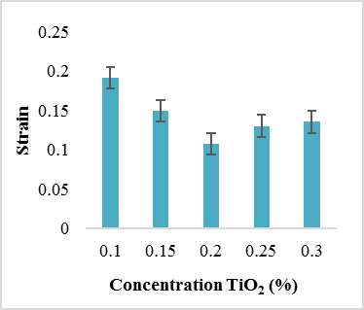
Figure 2. Graph the relationship between strain and the concentration of TiO₂

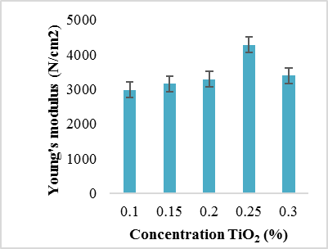
Young’s modulus (N/cm²)
Figure 3. Graph between the concentration of TiO₂ and Young’s modulus

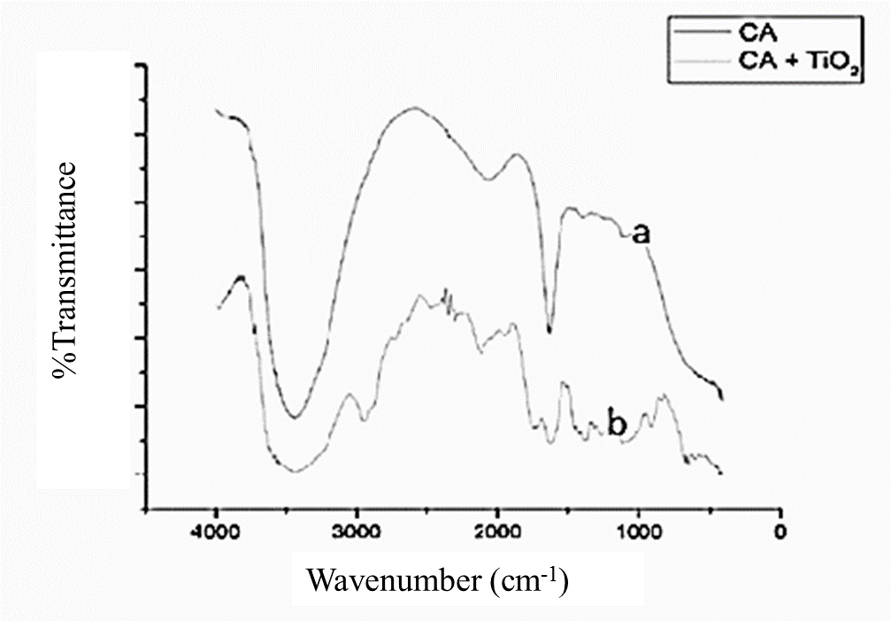

Figure 4. FTIR spectrum of (a) CA-TiO₂ PHFM, CA membrane (b)
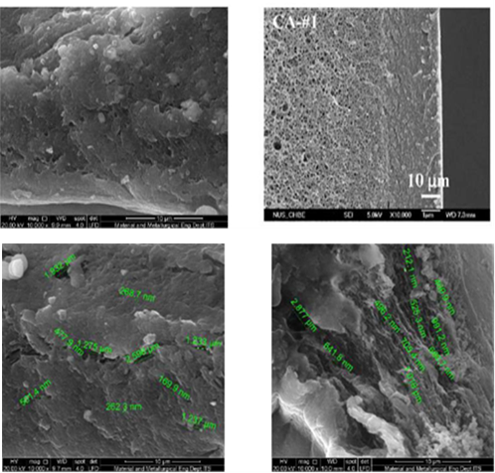
Figure 5. SEM of CA-TiO₂ PHFM

Application of CA-TiO₂ PHFM for MB Degradation
MB textile waste was taken from the textile industry in the Pakal area, Surabaya with dark brown colour due to the acidic condition of the textile waste solution. Textile waste was prepared in advance using Whatman 41 filter paper to remove large particles that were dissolved in the waste to avoid damaging the pores of the hollow fibre membrane. The initial absorbance was measured using a UV-Vis spectrophotometer with 100 times dilution as it was too concentrated, and absorbance was obtained with a concentration of 2.586 ppm. The source of energy used to start the degradation process was UV light. When UV rays provide energy to TiO₂, OH free radicals were formed to degrade the waste and MB. The photocatalytic degradation waste concentration decreased to 0.793 ppm, with a photocatalytic degradation efficiency of 82.6%. PHFM The PHFM significantly affected the use of CA and TiO₂ in the membrane on MB wastewater treatment and MB solutions, as shown in Figures 6 and 7.

CA-TiO₂ PMFC has a significant impact on the flux, rejection, and efficiency of degradation of MB and textile dye waste. Besides that, TiO₂ added to the hollow fibre membrane will also reduce membrane fouling.

Qualitative test of CA-TiO₂ PHFM for MB degradation
The qualitative test was performed based on the results of the photocatalytic degradation of MB to determine the analysis of NH⁺, Cl⁻, SO²⁻ ions, and CO₂ gas. The NH⁴⁺ ion test was completed by adding excessive NaOH in the solution resulted from degradation, which was then heated, and the spatula dipped in concentrated HCl was inserted to test for NH₄⁺ compounds. The NH₄⁺ test was positive because white steam was formed on the tube wall. The test to determine the existence of Cl⁻ ions was carried out by adding AgNO₃ to the degradation solution of MB, which formed white deposits of AgCl. The SO₄²⁻ ion test was carried out by adding Ba(NO₃)₂ to test the SO₄²⁻ compound. SO₄²⁻ tests were positive with the formation of BaSO₄ white deposits. CO₂ gas test was carried out using a U pipe that was flowed with the vacuumed air formed from the degradation of MB in Ba(OH)₂ solution. The test result was positive as BaCO₃ white deposits were formed. The reaction equation that occurs in each test can be written as follows [16].
NH₄⁺ + OH⁻ → NH_{3(g)} + H₂O (6)

Cl⁻ + AgNO₃ → AgCl_{(s)} + NO₃⁻ (7)

SO₄²⁻ + Ba(NO₃)₂ → BaSO_{4(s)} + 2 NO₃ (8)

Ba(OH)_{2(aq)} + CO₂ → BaCO_{3(s)} + H₂O (9)

The optimum CA-TiO₂ PHFM has a composition of 21.75% CA, 51% acetone, 27% formamide, and 0.25% (w/w) TiO₂ with a stress value of 5.5×10² kN/mm², strain value of 0.13, and Young’s modulus value of 4.2×10³ kN/mm². Performance of CA-TiO₂ PHFM with MB feed of flux and rejection were 25.66 L/m².h and a rejection coefficient of 94.8%. The effectiveness of the CA-TiO₂ PHFM for the degradation of MB can be seen from the efficiency of the degradation of MB, which was 98.9% and the efficiency of textile waste of 82.6%. The CA-TiO₂ PHFM can process MB textile dye waste because TiO₂ in the membrane have the photocatalytic activity and the ability of the membrane itself to be able to filter MB and waste textile dye.

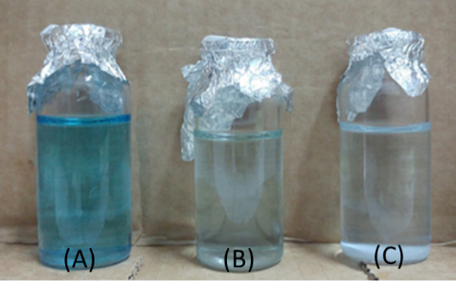
Figure 6. MB solution (a) before filtration, (b) after filtration with CA hollow fibre membrane and (c) after filtration with CA-TiO₂ PHFM
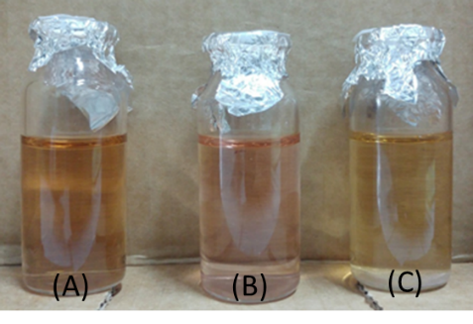
Figure 7. Waste textile dye solution (a) before filtration, (b) after filtration with CA hollow fibre membrane and (c) after filtration with CA-TiO₂ PHFM

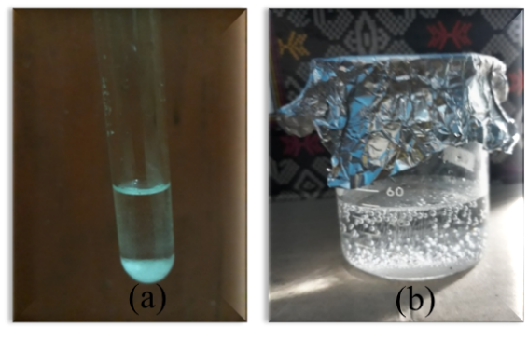
Figure 8. (a) The SO₄²⁻ ion test was carried out by adding Ba(NO₃)₂ produces a white precipitate BaSO₄ (b). The Cl⁻ ions was carried out by adding AgNO₃ formed white deposits of AgCl

Conclusion
The optimum CA-TiO₂ PHFM has a composition of 21.75% CA, 51% acetone, 27% formamide, and 0.25% (w/w) TiO₂ with a stress value of 5.5×10² kN/mm², strain value of 0.13, and Young’s modulus value of 4.2×10³ kN/mm². Performance of CA-TiO₂ PHFM with MB feed of flux and rejection were 25.66 L/m².h and a rejection coefficient of 94.8%. The effectiveness of the CA-TiO₂ PHFM for the degradation of MB can be seen from the efficiency of the degradation of MB, which was 98.9% and the efficiency of textile waste of 82.6%. The CA-TiO₂ PHFM can process MB textile dye waste because TiO₂ in the membrane have the photocatalytic activity and the ability of the membrane itself to be able to filter MB and waste textile dye.

Acknowledgement
This research was supported by the funding of the Ministry of Research and Technology, Republic of Indonesia.

References
- Mondal, M. and De, S. (2016). Treatment of textile plant effluent by hollow fibre nanofiltration membrane and multi-component steady state modeling. Chemical Engineering Journal, 285: 304-318.
- You, L., Ai, L. and Jiang. J. (2011). Removal of methylene blue from aqueous by montmorillonite/CoFe₂O₄ composite with magnetic separation performance. Desalination, 266: 72-77.
- Chin, S., Park, E., Kim, M. and Jurng, J. (2010). Photocatalytic degradation of methylene blue with TiO₂ nanoparticles prepared by a thermal decomposition process. Powder Technology, 201: 171-176.
- Dariani, R. S., Esmaeili, A., Mortezaali, A. and Dehghanpour, S. (2016). Photocatalytic reaction and degradation of methylene blue on TiO₂ nano-sized particles. Optik, 127:7143-7154
- Nosaka, Y. and Zhang, Y. (2014). Mechanism of the OH radical generation in photocatalysis with TiO₂ of different crystalline types. Journal of Physical Chemistry, 118:10824-10832.
- Erjavec, B., Grcic, I., Vrsaljko, D., Guyon, C. and Tatoulian, M. (2017). Influence of plasma surface pretreatment and tryarylmethane dye on the photocatalytic performance of TiO₂-chitosan coating on textile. Progress in Organic Coatings, 105: 277-285.
- Rahman, Arifur, M., Amin, Ruhul, S, M., Alam and Shafiqul, A. M. (2012). Removal of methylene blue from waste water using activated carbon prepared from rice husk. Dhaka University Journal of Science, 60(2):185-189.
- Jiangfeng, Y., Wang, K., Ren, M., Jefferson, Z, L. and Wang, H. (2012). Phase inversion spinning of ultrafine hollow fibre membrane through a single orifice spinneret. Journal of Membrane Science, 421: 8-14.
- Jayakumar, R., Ramachandran, R., Divyarani, V. V., Chennazhi, K. P., Tamura, H. and Nair, S. V. (2011). Fabrication of chitin–chitosan/nano TiO₂-composite scaffolds for tissue engineering applications. International Journal of Biological Macromolecules, 48(2): 336-344.
- Yang, X., Xiong, L., Hu, X., He, B. and Chu. G., (2012). Photocatalytic reaction and degradation of methylene blue on TiO₂ films in vacuum, an X-ray spectroscopy study. Research Chemistry Intermediate, 38: 67-75.
- Cheng, Q., Yu, S., Huang, C., Liu, J., Peng, X. and Liu, M. (2013). Cellulose acetate hollow fibre nanofiltration membrane with improved perm selectivity prepared through hydrolysis followed by carboxymethylation. Journal Membrane Science, 434: 44-54.
- Mozia, S., Darowna, D., Szymański, K., Grondzewska, S., Borchert, K., Wróbel, R. and Morawski, A. W. (2014). Performance of two photocatalytic membrane reactors for treatment of primary and secondary effluents. Catalysis Today, 236: 135-145.
- Sarasidis, V. C., Plakas, K. V., Patsios, S. I. and Karabelas, A. J. (2014). Investigation of diclofenac degradation in a continuous photo-catalytic membrane reactor. Influence of operating parameters. Chemical Engineering Journal, 239: 299-311.
- Fan, Z., Xiao, C., Liu, H., Huang, Q. and Zhao, J. (2015). Structure design and performance study on braid-reinforced cellulose acetate hollow fiber membranes. Journal of Membrane Science, 486: 248-256.
- Zhang, X., Wang, D. K., Lopez, D. R. S. and da Costa, J. C. D. (2014). Fabrication of nanostructured TiO₂ hollow fibre photocatalytic membrane and application for wastewater treatment. Journal of Chemical Engineering, 236: 314-322.
- Svehla, G. (2000). Textbook of macro and semimicro qualitative inorganic analysis, Wiley. New York: pp: 108-114.
- Chen, S, C., Su, J., Fu, F, J., Mi, B. and Chung, T. S. (2013). Gypsum (CaSO₄.2H₂O) scaling on polybenzimidazole and cellulose acetate hollow fibre membranes under forward osmosis. Membrane, 4: 354-374.
- Kopek, K, K., Ditczak S, M. and Wessling, M. (2011). Chemistry in a spinneret on the interplay of crosslink and phase inversion during spinning of novel hollow fibre membranes. Journal of Membrane Sciences, 18: 308-359.
- Baker, W. R. (2012). Membrane technology and applications. 3rd edition, John Wiley & Sons, New York, pp: 265-266.
- Dzinun, H., Othman, M. H. D., Ismail, A, F., Puteh, M, H., Rahman, M, A. and Jaafar, J. (2015). Photocatalytic degradation of nonyphenol by immobilized TiO₂ in dual layer hollow fibre membranes. Chemical Engineering Journal, 269: 255-261.
- Dzinun, H., Othman, M. H. D., Ismail, A. F., Puteh, M. H., Rahman, M. A. and Jaafar, J. (2014). Morfological study of co-extruded dual-layer hollow fibre membranes incorporated with different TiO₂ loadings. Journal of Membrane Science, 134: 62.
- Wessling, M., Culfaz, P. Z. and Lammertink, R. G. H. (2011). Hollow fibre ultrafiltration membranes with microstructured inner skin. Journal Membrane Science, 7:221-369.
- Fan, Z. W., Xiao, C. F. and Huang, X. Y. (2015). Preparation and performance of homogeneous braid reinforced cellulose acetate hollow fibre membranes. Cellulose, 22: 695-707.
- Su, J., Yang, Q., Teo, J. F. and Chung, T. S. (2010). Cellulose acetate nanofiltration hollow fibre membranes for forward osmosis processes. Journal Membrane Science, 355: 36-44.
- Yao, J., Wang, J., Ren, M., Liu, J. Z. and Wang. H. (2012). Phase inversion spinning of ultrafine hollow fibre membranes through a single orifice spinneret. Journal Membrane Science, 421-422: 8-14.

