
SYNTHESIS OF ORDERED NANOARRAYS ACTIVATED CARBON USING SBA-15 AS HARD TEMPLATE FOR ADSORPTION OF IBUPROFEN

(Sintesis Karbon Aktif Nano Berketeraturan Menggunakan SBA-15 Sebagai Templat Keras untuk Penjerapan Ibuprofen)

Maria Ulfa¹*, Didik Prasetyoko², Hasliza Bahruji³

¹Chemistry Education Study Program, Faculty of Teacher Training and Education,
Sebelas Maret University, Jl. Ir. Sutami 36A, Surakarta 57126, Central Java Indonesia.
²Department of Chemistry, Faculty of Mathematics and Natural Sciences,
Institute of Technology Sepuluh Nopember, Jl Keputih, Surabaya, 61115, East Java Indonesia
³Centre of Advanced Material and Energy Sciences,
Universiti Brunei Darussalam, Jalan Tungku Link, BE 1410, Brunei Darussalam

*Corresponding author: ulfa.maria2015@gmail.com

Received: 18 July 2019; Accepted: 20 July 2020; Published: xx December 2020

Abstract
Ibuprofen is an anti-inflammatory drug primarily found as a pharmaceutical residue in water and can be removed using adsorption method. Activated carbon with nanoarrays structure was produced using SBA-15 as a hard template and further utilised as an adsorbent for ibuprofen removal. SBA-15 was synthesised using TEOS and Pluronic-F123 as a mesoporous template, followed by deposition with sucrose as a carbon precursor. Carbonisation was carried out under N₂ flow at 180 °C followed by pyrolysis at 900 °C to form carbon nanoarrays. The effect of activation using KOH solution on activated carbon nanoarrays was investigated for ibuprofen removal. Characterisation using XRD, FTIR, TEM, and N₂ adsorption-desorption revealed that the carbon adapted the highly ordered structure of SBA-15 with the diameter of nanoarrays of ~ 5 nm and surface area of ~646 m²/g. Investigation of the adsorption of ibuprofen on activated carbon nanoarrays showed that the adsorption followed the pseudo-second-order kinetic model with the adsorption capacity of ~ 24.5 mg/g. Prolonged treatment of carbon with KOH has been shown to affect the adsorption capacity of ibuprofen due to a decrease in the surface functionality of carbon.

Keywords: activated ordered nanoarrays carbon, activated, adsorption, ibuprofen, pore

Abstrak
Ibuprofen adalah ubat anti-radang yang banyak dijumpai sebagai residu farmasi di dalam air dan dapat disingkirkan dengan kaedah penjerapan. Karbon aktif dengan struktur susunan-nano dihasilkan menggunakan SBA-15 sebagai templat keras dan selanjutnya digunakan sebagai penjerap untuk penyingkiran ibuprofen. SBA-15 disintesis menggunakan TEOS dan Pluronic-F123 sebagai templat liang-meso diikuti dengan pemendapan menggunakan sukrosa sebagai sumber karbon. Karbonisasi dilakukan di bawah aliran N₂ pada suhu 180 °C diikuti oleh pirolisis pada suhu 900 °C untuk membentuk karbon susunan-nano. Kesan pengaktifan menggunakan larutan KOH pada susunan-nano karbon aktif dikaji dalam penyingkiran ibuprofen. Pencirian menggunakan XRD, FTIR, TEM dan N₂ penjerapan-penyerapan menunjukkan karbon menyesuaikan struktur SBA-15 yang sangat teratur dengan diameter susunan-nano ~ 5 nm dan luas permukaan ~ 646 m²/g. Kajian penjerapan ibuprofen pada susunan-nano karbon aktif menunjukkan penjerapan diikuti model kinetik pseudo-urutan-kedua dengan kapasiti penjerapan ~ 24.5 mg/g. Rawatan karbon yang berpanjangan dengan KOH terbukti memberi kesan kapasiti penjerapan ibuprofen yang disebabkan oleh penurunan fungsi permukaan karbon.
Kata kunci: karbon aktif susunan-nano, pengaktifan, penjerapan, ibuprofen, liang

Introduction
Activated carbon is a non-toxic substance with high surface area and often utilised as an adsorbent for removal of contaminants from wastewater. Activated carbon can be synthesised using a hard carbon template with an ordered structure, high thermal stability with regulated pore size distribution [1-5]. Depending on the average diameter of the pores, porous carbon may be classified into macropore, mesopore, and micropore structures. Activated carbon typically contained micropores within the structure and its application as an adsorbent was limited to the removal of small molecule substrates [5]. Pharmaceutical residues from hospital discharge often involved bulk organic molecules such as ibuprofen. Ibuprofen is a non-steroidal anti-inflammatory drug with the molecular size of ~1.3 × 0.6 nm [6, 7]; therefore, carbon adsorbent with mesoporous structure would be beneficial to accommodate the adsorbed ibuprofen [8].

Synthesis of carbon with ordered structure and large surface area has been the main interest to enhance the adsorption capacity of carbon [9-14]. Mesoporous carbon with ordered structure was used in drug delivery systems [1], energy storage [2], catalyst [3], and as adsorbent [4]. The activation process was performed using acidic solutions such as HCl [15] and H₃PO₄ [16], and also alkaline solutions such as KOH [11] and NH₄OH [17]. The alkaline solution has a high affinity to carbon surface in comparison to acid solution due to the interaction between the OH⁻and the double bond of the sp² carbon [16]. Activation using potassium hydroxide enhanced the surface area of carbon from 300 to 1022 m²/g [11]. Activation of carbon by KOH also showed significant improvement in the pore volume and specific surface area of carbon, the formation of uniform pore size, and enhanced surface functional group of carbon [18]. The activation process also influenced the formation of microporous and mesoporous structures, and the use of strong base KOH eliminated the tar deposits and volatile impurities on carbon [11].

Ordered carbon nanoarrays were synthesised using reverse microemulsion, solvothermal synthesis [12], hard templating [13], and soft templating methods [18-20]. The hard-templating method employed solid silica as mould and produced carbon with controlled morphology [18]. The structure and the morphology of carbon produced from hard templating method were significantly affected by the acidity of the synthesis mixtures, the temperature and the pressure used during the synthesis, and the duration of the synthesis [19]. As activation has generally enhanced the surface functionality of carbon, the effect of activation using KOH for ibuprofen removal using carbon nanoarrays was investigated in this study. The formation of activated carbon nanoarrays was carried out using SBA-15 as a template that was synthesised and deposited with sucrose as a carbon source. Activated carbon nanoarrays were obtained following carbonisation, pyrolysis, and activation steps. Morphological and structural properties of carbon nanoarrays were characterised using transmission electron microscopy (TEM), N₂ adsorption, and Fourier-transform infrared spectroscopy (FTIR) analysis. The effect of the activation of carbon using KOH was investigated for the adsorption of ibuprofen.

Materials and Methods
Material
Materials used were absolute ethanol (Sigma Aldrich), distilled water, sucrose ≥ 99.00% (HIMEDIA Laboratories Pvt. Ltd.), triblock poly(ethylene oxide)-b-poly (propylene oxide)-b-poly (ethylene oxide) copolymer Pluronic P123 from (Sigma), H₂SO₄ 95-97% (Merck), n-hexane (Sigma Aldrich), KOH (Merck Millipore, Sigma Aldrich).

SBA-15 synthesis
Mesoporous SBA-15 was synthesised by mixing 15% of P123 with 92% ethanol and 39% water (w/w). The mixture was agitated for 2 hours in a sealed flask to avoid evaporation. Then, 4% tetraethyl orthosilicate was added to the solution containing Pluronic P123 and stirred for another 2 hours. The resulting mixture was placed in Teflon-lined autoclave and placed in at 100 °C for 24 hours. The resulting white powder was filtered, washed, and calcined at 550 °C for 5 hours.

Synthesis of carbon
The SBA-15 was mixed with sucrose solution at 4% SBA-15, 9% sucrose, 45% water, and 4% H₂SO₄ ratios and stirred for 24 hours. Carbonisation was carried out at 100 °C for 18 hours. The resulting brown powder was annealed at 160 °C for 18 hours to form black carbon. Black carbon was crushed and sieved to produce a powder with 250 mesh size. The final step involved pyrolysis of black powder under the flow of nitrogen for 5 hours at 900 °C to produce ordered nanoarrays carbon (ONC). The removal of SBA-15 on the composite carbon was carried out by HF 5%. After washing, filtering, and evaporating, carbon was activated by potassium hydroxide. The activation process was conducted by mixing ONC with KOH and stirred for 60 minutes at 29 °C. The activation times were varied at 1, 2, and 3 hours. The mixture was aged for 12 hours, washed with water, and filtered using Whatman filter paper. The resulting powder was dried in an oven at 100 °C for 24 hours. The carbon was labelled as AONC-1h, AONC-2h, and AONC-3h.

Ibuprofen adsorption
The adsorption process was carried out by mixing 100 ppm of ibuprofen with 20 mg carbon and stirred at room temperature. The aliquot was sampled every 5 min and immediately separated from carbon using a membrane filter. The adsorption was analysed using UV-Vis spectrophotometer, and the concentration was determined using the calibration curve of absorbance against the concentration of ibuprofen. The amount of absorbed ibuprofen was calculated according to the following Equation 1:

q_{t} = $\frac{C_{O}-C_{t}}{W}×V$ (1)

where q_{t} is the amount (mg g⁻¹) of ibuprofen absorbed, C_{O} is the initial concentration of ibuprofen (ppm), C_{t} is the concentration of ibuprofen at given time (ppm), V is the volume (litres) of ibuprofen, and W is the mass (g) of activated carbon. The q_{mak} was calculated using the following Equation 2, where q_{mak} is the maximum amount of ibuprofen adsorbed.

$\frac{Ce}{qe}$ = + $\frac{1}{qmaks.KL}\frac{Ce}{qmaks}$ (2)

Kinetics studies of ibuprofen adsorption on activated ordered nanoarrays carbon (AONC) were plotted against the pseudo-second-order model following linear regression analysis, where the pseudo-second-order equation was expressed as the following Equation 3:

$d_{q}= K_{2} (q_{e}$-$q_{t}$) $d_{t}$ (3)

K₂ indicates the adsorption rate (g/mg/min), q_{e} represented the mass of ibuprofen adsorbed on AONC at equilibrium (mg/g), and q_{t} is the mass of ibuprofen adsorbed at time t (mg/g).

Characterisation
The morphology of activated carbon microspheres was characterised using scanning electron microscopy (SEM) JEOL JSM-700 at a speed of 15.0 kV voltages. The functional groups of the activated carbon were characterised using FTIR Bruker Vertex 70 at the wavelength of 500-4000 cm⁻¹. The ibuprofen adsorption was measured using UV-Vis spectroscopy (model U-2000, Hitachi, Japan) at the wavelength of 272 nm.

Results and Discussion
XRD analysis was carried out on SBA-15 and activated carbon synthesis using SBA-15 template (Figure 1). The diffraction pattern showed that the broad peak centred at 25° corresponded to the amorphous structure of SBA-15. There were no significant changes on the diffraction pattern of carbon; however, a small peak was observed at 44°. The diffraction peaks for carbon that appeared at 2θ = 25.5° corresponded to the diffraction of (002) plane and 41.7° for (100) plane [20].

Figure 2a shows the N₂ adsorption isotherm of AONC and SBA-15. The specific surface area of the carbon was analysed at ~646 m²/g, while the SBA-15 was ~520 m²/g. The N₂ adsorption isotherm of carbon showed similar features as SBA-15, which corresponded to the type IV isotherm adsorption associated with the presence of mesoporous structure [21]. The N₂ adsorption/desorption isotherm of carbon was divided into three stages with the first stage corresponded to the adsorption at P/Po < 0.5. N₂ filled the small pore of carbon and formed monolayer adsorption on the microporous surface. The volume of N₂ adsorption showed a linear increase with the pressure. The second stage involved the N₂ adsorption on the mesoporous carbon pores, as the relative pressure P/Po increased from 0.4 to 0.8. At this stage, a sharp increase in N₂ adsorption was observed due to N₂ capillary condensation in the mesopore, which was the characteristic features of the uniformed pores [22]. The sharp increase of N₂ adsorption with the relative pressure also indicated the beginning of the interconnection of pores within the structure. Two types of pores existed in the carbon, which consisted of large primary pores interconnecting with small pores known as secondary pore. The presence of small pores in carbon also recognized as pore-neck or pore-bridge [21-22]. The third stage of N₂ adsorption occurred on the microporous surface of carbon at P/P_{o} above 0.8 with the vertical direction features. The N₂ desorption from carbon surfaced showed a similar pattern but with hysteresis loop due to the capillary condensation. The pore distribution of carbon and SBA-15 are shown in Figure 2b. The synthesised carbon nanoarrays showed similar pore distribution as SBA-15, which are in the mesopore region. However, the pore volume showed a slight reduction. The average pore diameter of the carbon was analysed within the range of 3–6 nm.

Infrared spectra of the SBA-15 in Figure 3 shows the characteristic bands associated with the SBA-15 ribbon character at 1000-1300 cm⁻¹ and 800-900 cm⁻¹, which represent the asymmetric and cyclic strain vibration of Si-O-Si [20, 21]. The wide adsorption band centred at 3600 cm⁻¹ corresponded to the presence of hydrogen bonds or adsorbed water. The presence of C-H vibrational peak at 2930 cm⁻¹ is also observed on SBA-15, which presumably originated from the remaining carbon from the P123 precursor. The infrared spectra of carbon also show a wide absorption peak at 3600-3100 cm⁻¹ that corresponded to the presence of hydroxyl groups and adsorbed water on the surface. The broadening of the band following activation with KOH suggested the enhancement of surface hydroxyl on the carbon. The characteristics absorption band of SBA-15 at 809 cm⁻¹ and 1080 cm⁻¹ are absent in the carbon profile, indicating complete removal of the SBA-15 template. The absorption band appeared at 1300 cm⁻¹ that corresponded with the presence of vibration strain stretch of C-H in carbon. Meanwhile, the absorption band at 1567 cm⁻¹ with relatively small intensity, indicating the characteristic of sp2 carbon double bond vibration presumably from the aromatic structure in the carbon. Several vibrations bands are also observed corresponding to the presence of functional group on carbon, such as the vibration of C=O at 2347 cm⁻¹ at 2072 cm⁻¹ and the vibration of the CH₃ and CH₂ clusters appeared between 3000–2800 cm⁻¹ [21]. KOH treatment at 1 h significantly enhanced the intensity of CH₃ and CH₂ clusters within 3000–2800 cm⁻¹ region, which suggested that the treatment enhanced surface functionality of carbon. However, when the activation of carbon with KOH was extended to 2 hours and 3 hours, the C-H vibration peak at 2936 cm⁻¹ disappeared, indicating the detrimental effect of prolonged treatment on the functionality of carbon.

TEM analysis shown in Figure 4 confirmed the morphology of carbon nanoarrays obtained using SBA-15 as a hard template. The micrograph of carbon shows an identical ordered nanoarray structure as SBA-15, which implied the carbon could retain the ordered structure following the removal of SBA-15 (Figure 4a, 4b, red box). Carbon micrograph also shows that the spacing between the nanoarrays is ~ 8.0 nm, while the cross-sectioned nanoarrays indicated the pore diameter of 6.3 nm (Figure 4, red circle). However, the TEM analysis of SBA-15 revealed that the spacing between the nanoarrays of SBA-15 is ~ 8.9 nm and the diameter of the cross-sectioned of the nanoarrays is ~ 9.3 nm. The structural stability and regularity of the activated carbon nanoarrays can be identified due to the absence of TEM image defects. The regularity of the structure and
microscopic features of the material in this study were observed with the TEM. The TEM carbon micrograph shows a hexagonal structure with 6 mm spaces. The regularity of carbon after activation and SBA-15 can also be seen in SAED (Selected area electron diffraction) which was obtained in TEM image by reverse space in lattice plane. TEM image of carbon also exhibits the arrangement of carbon bars when observed from the horizontal direction. TEM analysis shows that the synthesised carbon has a similar morphology to SBA-15 silica, which implies a successful replication process. In general, TEM SBA-15 and carbon nanoarray data have the same regularity as previous studies [20-21]. EDX analysis of the activated carbon following KOH treatment for 1 h (Fig. 5) indicated that the ordered nanoarrays activated carbon contained 61% of carbon with 36% oxygen. P, Mo, and K were also observed as impurities at traces level. The EDX result confirmed the removal of SBA-15 template.

Figure 6 shows the adsorption of ibuprofen on carbon following activation using KOH. The carbon was alkaline treated with KOH for 1, 2, and 3 hours prior to the ibuprofen adsorption. The adsorption isotherms showed high adsorption capacity of ibuprofen on carbon following 1 hours KOH activation. However, extending the activation period to 2 and 3 hours exhibited a reduction in the adsorption capacity of ibuprofen. For carbon produced by 1 hour of KOH treatment, the adsorption reached equilibrium within 10 minutes of the adsorption. The rate of ibuprofen adsorption is relatively fast within the first 5 minutes and continued to reach steady states at 10 minutes. Increasing the immersion time of carbon in KOH showed a detrimental effect on the adsorption of ibuprofen. The resulting carbon after 2 and 3 hours of immersion reached equilibrium at 20 minutes with the adsorption capacity of ~19 mg/g. The adsorption of ibuprofen on carbon occurred via monolayer adsorption due to the repulsion between the adsorbed ibuprofen molecules on the carbon surface with the ibuprofen in the solution, which prevented multi-layer adsorption. Understanding the mechanism of ibuprofen adsorption on carbon surface [23], it was expected that ibuprofen molecules initially adsorbed in the mesopores and experienced rapid saturation during the initial state of adsorption. Consequently, further adsorption requires ibuprofen molecules to move along the occupied sites to achieve adsorption into a deeper pore of carbon. Due to the bulky structure of ibuprofen and the repulsion with the adsorbed molecules, the rate of adsorption was significantly reduced following the initial saturation stage [24]. Infrared analysis on activated carbon indicated the disappearance of C-H surface functionality of carbon following KOH treatment at 2 and 3 hours. Meanwhile, although activation with KOH was essential to enhance surface functionality and consequently increased the adsorption, prolonged activation was proven detrimental, as it removed the required active sites for ibuprofen adsorption.

Kinetic analysis of ibuprofen adsorption on carbon was carried out using linear regression analysis pseudo-second-order kinetics model, as shown in Figure 7 [25]. The model was previously used to describe the kinetic adsorption of ibuprofen on mesoporous carbon microspheres and activated carbon [8, 23-26]. The ibuprofen adsorption kinetic data on pseudo-second-order approached the two-Semitic order model with a correlation coefficient of R² = 0.999. The ibuprofen adsorption followed the pseudo-second-order kinetic model, which suggested that ibuprofen adsorption occurred at two different carbon surface sites.

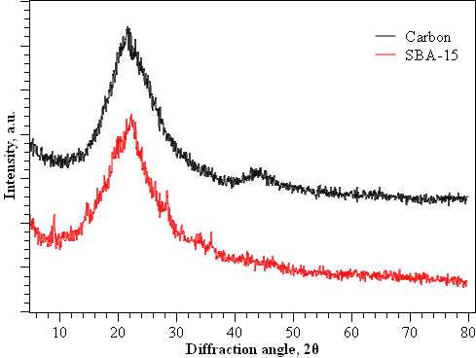
Figure 1. XRD analysis of SBA-15 and activated nanoarrays carbon

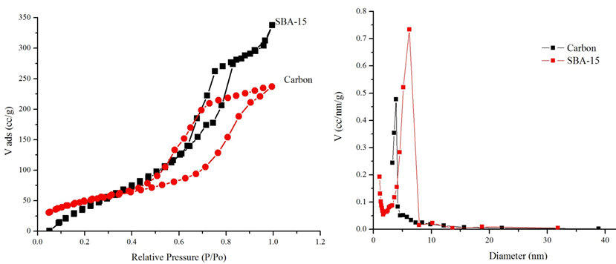
(b)
(a)
Figure 2. N₂ adsorption-desorption isotherm (a) and pore size distribution (b) of activated nanoarrays carbon (AONC-1h) and SBA-15

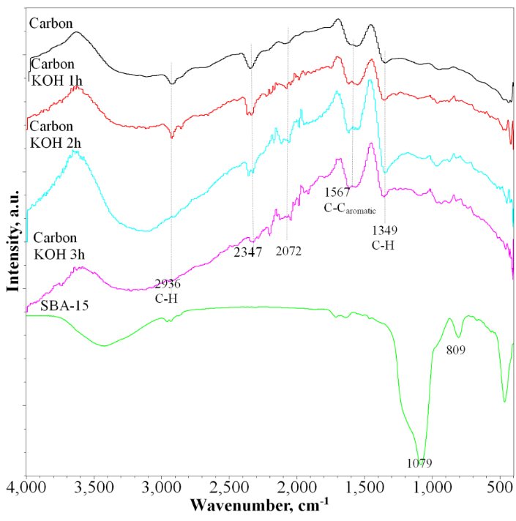
Figure 3. Infrared spectra of SBA-15 and carbon after activation with KOH

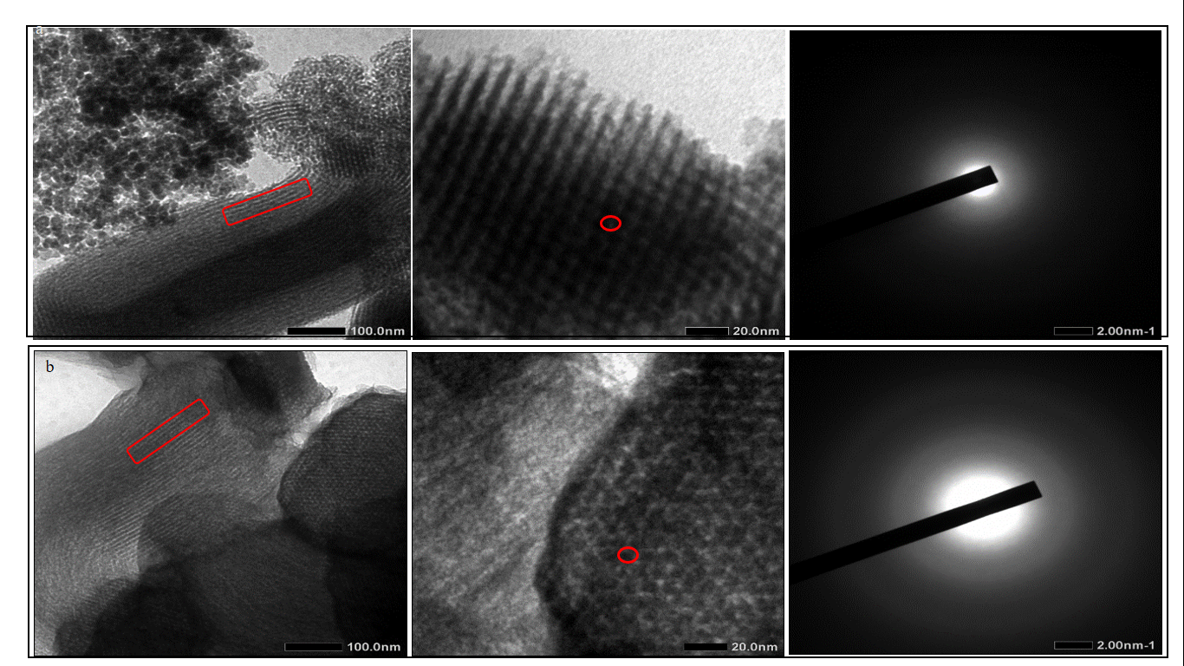
Figure 4. TEM analysis of a) SBA-15, and b) ordered nanoarrays activated carbon

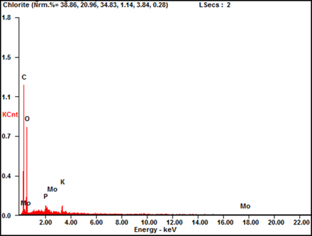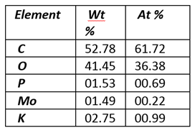
Figure 5. EDX analysis of ordered nanoarrays activated carbon

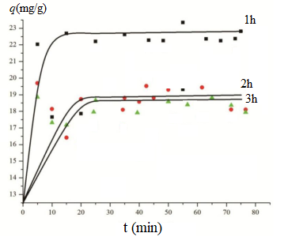
Figure 6. The adsorption of ibuprofen on carbon following activation process at 1, 2, and 3 hours

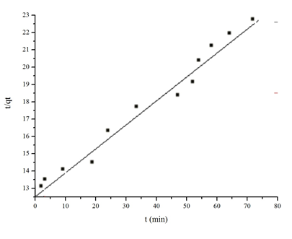
Figure 7. The pseudo-second-order linear kinetic model of ibuprofen adsorption on activated nanoarrays carbon

Conclusion
Activated ordered carbon nanoarrays (AONC) have been successfully synthesised using SBA-15 as a hard template and showed potential as an adsorbent for ibuprofen. AONC was characterised by FTIR, TEM, and nitrogen adsorption-desorption analysis that showed the replication of the SBA-15 ordered structure on the activated carbon. Adsorption studies of ibuprofen on the carbon showed the maximum adsorption capacity of ibuprofen at 24.5 mg/g with the adsorption kinetics following the pseudo-second-order kinetic model. The detrimental effect of prolonged KOH activation was observed on the decrease of ibuprofen adsorption capacity on the carbon that was due to the decrease of surface functionality, as indicated by infrared analysis.

Acknowledgments
Our research was financially supported by the Program Penelitian Kolaborasi Indonesia 2020 (Indonesia Collaboration Research Program 2020) collaborated by Sebelas Maret University (UNS), Gadjah Mada University (UGM), Sepuluh Nopember Institute of Technology (ITS), and University Brunei Darussalam (UBD).

References
- Zhou, M. Z., Peng, S., Liao, P., Li, M. and Li, S. (2014). Design of a microencapsulated carbon nanotube-based microspheres and its application in the colon targeted drug delivery. Drug Delivery, 21(2): 101-109
- Liu, M. L., Kong, C., Lu, X., Li, Y., Luo, K. and Kang, L. (2012). Close-packed mesoporous carbon polyhedrons derived from colloidal carbon microspheres for electrochemical energy storage applications. RSC Advances, 2(27): 10310-10315.
- Wang., F. (2015). Simple synthesis of novel hierarchical porous carbon microspheres and their application to a rechargeable lithium-ion batteries. Carbon NY, 81(1): 314-321.
- Meer, S., Kausar, A. and Iqbal, T. (2016). Synthesis of multi-walled carbon nanotube/silica nanoparticle/ polystyrene microsphere /polyaniline-based hybrids for EMI shielding application. Fullerenes, Nanotube, and Carbon Nanostructures, 24(8): 507-519.
- Wang, J. and Kaskel, S. (2012). KOH activation of carbon-based materials for energy storage. Journal of Materials Chemistry, 22(45): 23710-23725
- Mestre, J., Pires, J. M. F., Nogueira, Y. and Carvalho, A. P. (2007). Activated carbons for the adsorption of ibuprofen. Carbon NY, 45(10): 1979-1988.
- Kumaresan, S. (2010). S+ Ibuprofen (Dexibuprofen): The superior conventional non-steroidal antiinflammatory agents for development of pharmaceuticals. International Journal of Current Pharmaceutical Research, 2(3): 66-75.
- Ulfa, M., Didik, P., Mahadi, A. and Hasliza, B. (2019). Size tunable mesoporous carbon microspheres using Pluronic F127 and gelatin as co-template for removal of ibuprofen. Science of the Total Environment, 56 (3): 24-32
- Nieto-Márquez, A., Valverde, J. L. and Keane, M. A. (2009). Selective low temperature synthesis of carbon nanospheres via the catalytic decomposition of trichlorethylene. Applied Catalytic Agent, 352(2): 159-170.
- Zhang, D. (2017). Scalable synthesis of hierarchical macropore of activated carbon-rich microspheres assembled by carbon nanoparticles for high-rate performance supercapacitors, Journal Power Sources, 342 (1): 363-370.
- Lua, A. C and Yang, T. (2004). Effect of activation temperature on the textural and chemical properties of potassium hydroxide activated carbon prepared from pistachio-nut-shell. Journal of Colloid and Interface Science, 274 (2): 594-601.
- Mi, Y. Z. and Liu, Y. L. (2009). A simple solvothermal route to synthesize carbon microspheres. Xinxing Tan Cailiao/New Carbon Materials, 24(4): 375-378.
- Li, J., Zhong, X. Z., Yang, G. J., Lan, H. D., Tang and Liu H. Z. (2011). Simple synthesis of semi-graphitized ordered mesoporous carbons with tunable pore sizes. Xinxing Tan Cailiao/New Carbon Materials, 26(2): 123-129

- Gorka, C., Fenning, K. and Jaroniec, M. (2009). Influence of temperature, carbon precursor/ copolymer ratio and acid concentration on adsorption and structural properties of mesoporous carbons prepared by soft-templating. Colloids and Surfaces A Physicochemical and Engineering Aspects, 352(1-3): 113-117.
- Guo, J., Zhang, H. and Liu H. (2016). Ultra-high Rhodamine B adsorption capacities from an aqueous solution by activated carbon derived from: Phragmites australis doped with organic acid by phosphoric acid activation. RSC Advances, 6(47): 40818-40827.
- Heidari, H., Younesi, A., Rashidi, A. and Ghoreyshi. A. A. (2014). Evaluation of CO₂ adsorption with eucalyptus wood-based activated carbon modified by ammonia solution through heat treatment. Chemical Engineering Journal, 254(3): 503-513.
- Pflitsch, C. (2014). Chemical vapor infiltration of activated carbon with tetramethylsilane. Carbon NY, 79 (1): 28-35.
- Ulfa, M., Wega, T., Iif, I. and Indriana, K. (2018). Wormhole-like mesoporous carbons from gelatine as multistep infiltration effect. Indonesian Journal of Chemistry, 16(3): 239-242.
- Xie, D., Kocaefe, C., Chen, T. and Kocaefe, Y. (2016). Review of research on template methods in preparation of nanomaterials. Journal of Nanomaterial, 2016(23): 025-035.
- Ma, Z., Kyotani, T., Liu, Z., Terasaki, O. and Tomita, A. (2001). Very high surface area microporous carbon with a three-dimensional nano-array structure: Synthesis and its molecular structure. Chemistry of Materials, 13(12): 4413-4415.
- María E. A., Marisa, P., Magali, B., Bénédicte, L., Verónica, B. and Loreana, G. (2020). Synthesis and characterization of mesoporous SBA-15 and SBA-16 as carriers to improve albendazole dissolution rate. Saudi Pharmaceutical Journal, 28(1): 15-24.
- Belmoujahid, Y. M., Bonne, Y., Scudeller, D., Schleich, Y., Grohens, B. and Lebeau, A. (2015). SBA-15 mesoporous silica as a super insulating material.
- Fröhlich, A. C. R., Ocampo-Pérez, V. Diaz-Blancas, N. P. G., Salau, G. L. and Dotto. (2018). Three-dimensional mass transfer modeling of ibuprofen adsorption on activated carbon prepared by sonication. Chemical Engineering Journal, 341(1): 65-74.
- Michel O., Laurence R., Sylvie G., Stéphane B., Sandrine D., Jean-Marc, L. and Laurent D. (2018). Improving the adsorption kinetics of ibuprofen on an activated carbon fabric through ultrasound irradiation: Simulation and experimental studies. Chemical Engineering Journal, 343(1): 163-172.
- Syeda N. F., Ali, E. I., El-Shafey, F., Saleh Al-Busafi, Haider, A. J. and Al-Lawati. (2019). Adsorption of chlorpheniramine and ibuprofen on surface functionalized activated carbons from deionized water and spiked hospital wastewater. Journal of Environmental Chemical Engineering, 7(1): 28-38.
- Hanen, G., Imadeddine, L., Laurence R., Jean-Marc, L., Nizar, B. and Laurent, D. (2020). Removal of ionic liquids and ibuprofen by adsorption on a microporous activated carbon: Kinetics, isotherms, and pore sites. Arabian Journal of Chemistry, 13(3): 258-270.

