

DETERMINATION OF PHENANTHRENE AND FLUORANTHENE IN RICE SAMPLES BY ACTIVATED CARBON-BASED DISPERSIVE SOLID PHASE MICRO-EXTRACTION COUPLED WITH GAS CHROMATOGRAPHY-FLAME IONIZATION DETECTOR ANALYSIS

(Penentuan Phenantrena dan Fluorantena dalam Sampel Beras Menggunakan Pengekstrakan Mikro Fasa Pepejal Berserak Berasaskan Karbon Diaktifkan Bersama Analisis Pengesan Pengionan Nyalaan-Kromatografi Gas)

Nurul Nadjwa Nahrowi¹, Boon Yih Hui², Mohamad Shariff Shahriman¹, Noorfatimah Yahaya², Nur Nadhirah Mohd Zain², Saliza Asman³, Md Firoz Khan¹, Kavirajaa Pandian Sambasevam⁴, Vuanghao Lim², Muggundha Raoov^{1,5}*

¹Department of Chemistry, Faculty of Science,

Universiti Malaya, 50603 Kuala Lumpur, Malaysia

²Integrative Medicine Cluster, Advanced Medical & Dental Institute,

Universiti Sains Malaysia, 13200 Pulau Pinang, Malaysia

³Department of Physics and Chemistry, Faculty of Applied Sciences and Technology, Pagoh Education Hub,

Universiti Tun Hussein Onn Malaysia, 84000 Pagoh, Muar, Johor, Malaysia

⁴School of Chemistry and Environment, Faculty of Applied Sciences,

Universiti Teknologi MARA, Negeri Sembilan Branch, Kuala Pilah Campus, 72000 Kuala Pilah, Negeri Sembilan, Malaysia

⁵Universiti Malaya Centre for Ionic Liquids (UMCIL), Department of Chemistry, Faculty of Science,

Universiti Malaya, 50603 Kuala Lumpur, Malaysia

*Corresponding author: muggundha@um.edu.my

Received: 12 August 2020; Accepted: 20 October 2020; Published: xx December 2020

Abstract

A simple dispersive solid phase micro-extraction (DSPME) based on activated carbon (AC) was performed for the determination and separation of carcinogenic polycyclic aromatic hydrocarbons (PAHs), namely phenanthrene and fluoranthene, in selected white, brown and parboiled rice samples. The extraction was coupled with gas chromatography-flame ionization detector (GC-FID) for analysis. Under the optimized conditions [amount of adsorbent (5 mg), sample volume (40 mL), type (dichloromethane), and volume of desorption solvent (300 µL)], calibration curves were found to be linear for the concentration between 10 and 1000 µg kg⁻¹ with coefficient of determination (R²) from 0.9938 to 0.9955. The limit of detection (LOD) and limit of quantification (LOQ) were in the range of 0.11 - 0.15 µg kg⁻¹ and 0.33 - 0.46 µg kg⁻¹, respectively. Relative standard deviation (RSD) was less than 8.02% and 5.48% for intra-day (n = 5) and inter-day (n = 5) for the present method, respectively. High pre-concentration factor (2587 - 2866) and satisfactory recoveries (90.23 - 115.63%) were also achieved. The proposed method was found to be simple, rapid and reliable for the monitoring of PAHs in rice samples.

Keywords: dispersive solid phase micro-extraction, activated carbon, polycyclic aromatic hydrocarbons, rice samples

Abstrak

Pengekstrakan mikro fasa pepejal berserak (DSPME) yang mudah berasaskan karbon diaktifkan (AC) telah dijalankan untuk penentuan dan pengasingan hidrokarbon polisiklik aromatik (PAHs) yang boleh menyebabkan barah iaitu phenantrena dan fluorantena dalam sampel beras putih, perang dan pra-rebus yang terpilih. Pengekstrakan dijalankan bersama dengan - kromatografi gas - pengesan pengionan nyalaan (GC-FID) untuk analisis. Dalam keadaan optimum [jumlah penyerapan (5 mg), jumlah isipadu sampel (40 mL) dan jenis serta jumlah isipadu pelarut penyerapan (diklorometana, 300 µL)], keluk penentukuran didapati bergerak lurus untuk kepekatan antara 10 dan 1000 µg kg⁻¹ dengan pekali penentuan (R²) daripada 0.9938 hingga 0.9955. Had pengesanan (LOD) dan had kuantifikasi (LOQ), masing-masing dalam julat 0.11 - 0.15 µg kg⁻¹ dan 0.33 - 0.46 µg kg⁻¹. Berdasarkan kaedah yang sekarang, sisihan piawai relatif (RSD) menunjukkan masing-masing kurang daripada 8.02% dan 5.48% untuk hari yang sama (n=5) dan antara hari (n=5). Faktor prakepekatan tinggi (2587 - 2866) dan pemulihan yang memuaskan (90.23 - 115.63%) juga dapat dicapai. Kaedah yang dicadangkan didapati mudah, cepat dan boleh dipercayai untuk pemantauan PAH dalam sampel beras.

Kata kunci: pergekstrakan mikro fasa pepejal dispersif, karbon diaktifkan, hidrokarbon polisiklik aromatik, sampel beras

Introduction

Rice is an important food source for the world population. It is harvested seasonally and stored prior to distribution [1]. Rice plants flourish in humid environment and warm temperatures. However, rice processing operation may introduce carcinogenic compounds into the food. Recent studies found that, through the planting and manufacturing process, rice can be contaminated by carcinogenic mixtures such as polycyclic aromatic hydrocarbons (PAHs) [2-4]. PAHs are chemical compounds characterized by the presence of multiple aromatic rings in their structure with reasonably elevated desorption activation energy [5]. The bigger the molecular weight of a PAH, the more carcinogenic it will be [6]. Examples of the low molecular weight PAHs are phenanthrene and fluoranthene whereas high molecular weight PAHs include chrysene and benzo[a]pyrene.

PAHs are released from scorching coal, oil, gasoline, trash, tobacco and wood. Food processing techniques that use high temperatures, such as smoking and grilling, are common causes for the formation of PAHs in foods. PAHs are known as a cancer-causing agent that are widespread in the environment as pollutant; they mostly contaminate the soils and sediments due to anthropogenic activities [7, 8]. PAHs can accumulate at the different structures of plants, most likely in the root and husk. The accumulation usually happens in the manufacturing process of rice at the stage where the factory needs to dry the rice before removing the husk.

Although the determination of PAHs has been studied extensively in various matrices [4, 9], the need for reliable and sensitive method for the determination of PAHs in food samples is in high demand due to their potential carcinogenicity i.e. their ability to cause cancer [10]. Herein, sample preparation techniques play an important role in the development of sensitive detection method prior to instrument analysis. Previous literatures have reported numerous sample preparation techniques in determining PAHs such as liquid-liquid extraction (LLE), solid phase extraction (SPE), dispersive solid-phase extraction (DSPE) and solid phase micro-extraction (SPME). However, there are some drawbacks to these techniques which limit their performance. For example, LLE uses a large amount of organic solvent and is time-consuming to extract the analytes [11].SPE sorbents could cause low recoveries due to the sorbent bed breakthrough effect, while SPME fibres are fragile and have limited lifetime usage on organic solvents. Dispersive solid phase micro-extraction (DSPME) method, on the other hand, is a method known to be simple and use less solvent, an initiative towards green chemistry. DSPME method uses dispersive solid-phase type of adsorbents to extract and facilitate the mass transfer of analytes from samples towards adsorbents [11]. The concept of DSPME is similar to DSPE, that the difference being DSMPE only employs a small quantity of sorbent or small volume of solvent in micro scale [12].

In this study, commercial activated carbon (AC) was chosen as an extraction material for the DSPME method because AC provides larger surface area for adsorption and can be used in small amount to extract PAHs prior to instrument detection. AC can be dispersed in solution with the help of shaker thus making it suitable to be used in DSPME. In addition, a good industrial adsorbent such as activated carbon can be used without any modification on the surface. In a previous study, an application of charcoal on soils caused the concentrations of PAHs to be decreased remarkably by using corn straw-derived biochar in old polluted soil under swamped conditions [13]. Furthermore, a small dosage of AC can adsorb high concentration of PAHs [14]. In addition, a recent study proved that AC has high affinity towards PAHs as compared to heavy metals analytes [15]. Thus, the present method (AC-DSPME-GC-FID) is deemed to be reliable and sensitive.

Materials and Methods

Material and solutions

Activated carbon (charcoal based, powdered form for analysis) was purchased from Merck (Kennilworth, NJ, USA) PAHs standards (phenanthrene and fluoranthene) were obtained from Sigma Aldrich (St. Louis, MO, USA). Acetonitrile HPLC-grade was supplied by R&M Chemicals (Essex, United Kingdom) and dichloromethane HPLC-grade by Fisher Scientific (United Kingdom). All other chemicals and reagents were analytical grade. Deionized water was produced from Milli-Q Elix Technology Inside. Acetonitrile was used to prepare standard stock solutions (1000 mg L⁻¹) and stored at -4 $℃$to avoid the degradation process.Ultrapure water was used to prepare the working standard solution to desired concentrations by dilution of the stock solutions.

Instrumentation

A mechanical shaker, Harmony Mixer Uzusio VTX-3000L was used during the extraction step to disperse the activated carbon. Agilent Technologies 7890A, Gas Chromatography equipped with –a split/splitless inlet and Flame Ionization Detector (FID) was used for the PAH quantification in this study. The carrier gas was N₂ (99.999%) with a constant flow rate of 30 mL min⁻¹. The separation was accomplished using Agilent HP5-MS (30 m × 25 mm ID × 0.25 μm film thickness, 5% phenyl-methylpolysiloxane) column. The injector and detector temperature were set at 280 ℃ with splitless mode. The GC oven was set as: 90 °C for five minutes and increased to 290 °C at 10.0 °C min⁻¹ and the injection volume was 1 µL. The chromatographic data were analysed using the Chemstation software.

Samples preparation

Selected three types of rice samples were purchased from a local supermarket located in Kuala Lumpur namely white rice, brown rice and parboiled rice. The rice samples were pre-treated following the standard procedure with minor modifications [16]. In brief, the rice was ground and screened through a sieve. The rice was then dried in an oven to remove moisture before being analysed. The target analytes were spiked into 0.1 g of rice sample in a 15 mL of centrifuge tube. Thereafter, 0.6 mL of acetonitrile was added into the centrifuge tube. The rice sample was mixed under vortex for a minute before being centrifuged for three minutes at 4000 rpm. The supernatant was then collected and transferred into a 40 mL glass vial before being topped up to 15 mL of sample volume.

Dispersive solid phase micro-extraction (DSPME) procedure

An amount 15 mg of activated carbon was dispersed well in 15 mL of sample solution and mixed under vortex for three minutes to reach the equilibrium phase between the adsorbent and analytes. Then, the sample solution was transferred into 3 mL syringe that was connected to 0.45 µm nylon membrane filter. The analyte-adsorbed activated carbon was trapped in the nylon filter while the water was removed. After that, acetonitrile (1 mL) was passed through the syringe and the plunger was pressed slowly to desorb the analytes from activated carbon. The resulting desorption solution was collected into a 1.5 mL vial and 1 µL of the sample was then injected into the GC-FID system for further analysis. The graphical diagram of dispersive solid phase micro-extraction (DSPME) procedure in full was shown in Figure 1.

Method validation

The mean and standard deviation of peak area from intra-day and inter-day were obtained and relative standard deviation (RSD) was calculated by Equation (1):

RSD = $\frac{\text{standard deviation}}{\text{mean}}×100\%$ (1)

Limit of detection (LOD) and limit of quantification (LOQ) were obtained by running blank solvent (dichloromethane) for ten times and peak area on the retention time same with target analytes were obtained. Then, the standard deviation for the peak areas were obtained. LOD, LOQ and pre-concentration factor (PF) were calculated by the following Equations (2), (3) and (4), respectively [7, 17]:

LOD = $\frac{\text{standard deviation}}{\text{slope}}×3.3$ (2)

LOQ = $\frac{\text{standard deviation}}{\text{slope }}×10$ (3)

PF = $\frac{{\text{P}}_{\text{f}}}{{\text{P}}_{\text{i}}}\text{×}\frac{{\text{V}}_{\text{f}}}{{\text{V}}_{\text{i}}}$ (4)

The value for the slope was obtained from the matrix match calibration curve. P_{f} is peak area obtained from the spiked sample after extraction, while P_{i} is peak area obtained from the spiked solvent. V_{i} represents the initial sample volume and V_{f} is the final desorption solvent volume. The recovery studies that reflect the accuracy of the proposed DSPME method was carried out by spiking blank rice samples with three different concentration levels in triplicates (n=3). The recovery percent was calculated by using the following equation (5):

Recovery (%) = $\frac{{\text{C}}_{\text{spiked }}\text{- }{\text{C}}_{\text{unspiked}}}{{\text{C}}_{\text{o}} }×100\%$ (5)
where C_{spiked} is the concentration of PAHs in the spiked sample, while C_{unspiked} is the concentration of PAHs in the unspiked sample. C_{o} represents the initial spiking concentration.

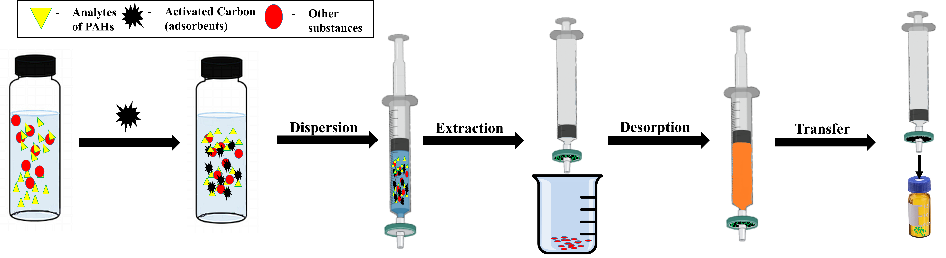

Figure 1. Graphical diagram of dispersive solid phase micro-extraction (DSPME) procedure

Results and Discussion

Optimization of AC-DSPME-GC-FID

Four important parameters that influence the extraction performance of activated carbon towards the targeted PAHs were evaluated: amount of adsorbent, sample volume, type and volume of desorption solvent. The experiment was performed in triplicate (n = 3) at spiked concentration level of 500 µg kg⁻¹ for each (PAH) in blank rice samples.

Amount of adsorbent

The effect of sorbent dosage was carried out by varying the mass of activated carbon from 5 to 25 mg. As shown in Figure 2 a), the highest extraction performance was achieved at 5 mg. Lower amount (<5 mg) of adsorbent was avoided to prevent the activated carbon from sticking on the wall which will greatly affect the reproducibility of the method, and thus reduce the analytical signals. Theoretically, the higher the amount of adsorbent used, the better the extraction efficiency will be until the extraction reaches plateau. However, the increment of the sorbent amount gives negative results, probably due to larger amount of sorbents not being dispersed and separated well in the same extraction time and sample volume, which reduce the surface area that affects the efficiency of the elution process [17]. These data indicate a small amount of activated carbon is sufficient to adsorb the analytes [14] due to its high surface area and excellent adsorbing capacity [18]. Therefore, 5 mg of sorbent was selected for subsequent analysis.

Effect of sample volume

The volume of sample is one of the determining factors to obtain high enrichment factor [17]. To study this effect, the sample volume was varied from 15 to 100 mL. Based on Figure 2 b), it was observed that the higher the sample volume, the greater the extraction efficiency. This phenomenon can be explained by the fact that activated carbon achieved well dispersion in the high volume of samples, thus facilitating the mass transfer process from the water phase towards adsorbents [19]. Therefore, 40 mL of sample solutions volume was selected for further analysis due to its appropriate volume for extraction and the size of vial used in this study.

Effect of desorption solvent

Three solvents with different polarity (dichloromethane: 3.1, acetonitrile: 5.8, and methanol: 5.1) were examined for their desorption efficiency. This is an important parameter to be considered as the selection of solvent reflects the solubility of analyte (polarity of phenanthrene: 4.5, fluoranthene: 5.2) in the extracted phase [20]. Figure 2 c) depicted that dichloromethane has higher eluting capability towards PAHs followed by acetonitrile and methanol. This probably is due to different range of polarity of desorption solvent with targeted analytes. Dichloromethane, acetonitrile and methanol are non-polar, mid-polar and polar solvent respectively. [21]. Thus, dichloromethane was chosen as a desorption solvent because of its properties: it is slightly miscible with water thus good interaction with non-polar analytes and have high capability to lose the bond between analytes and adsorbents compared to other studied solvents [22].

Effect of desorption volume

The influence of desorption volume was examined in the range of 300 to 1000 µL. As seen in Figure 2 d), 300 µL shows the highest elution efficiency compared to others. This was attributable to the fact that higher concentration of targeted analytes was obtained in lower volume of desorption solvent [23]. Hence, 300 µL was selected as optimum value of the desorption solvent for the developed method.

Analytical figures of the method

A series of method validation parameters such as linearity range, precision, limit of detection (LOD), limit of quantification (LOQ) were conducted to access the performance of the developed method under optimal conditions.

Based on Table 1, the developed DSPME exhibited a dynamic linearity range between 10 and 1000 µg kg⁻¹ with satisfactory coefficient of determination (R²) ranging from 0.9955 to 0.9938 for both analytes phenanthrene (PHE) and fluoranthene (FLU). Meanwhile, the LODs were found to be at 0.11 - 0.15 µg kg⁻¹, and LOQs ranged at 0.33 - 0.46 µg kg⁻¹, indicating that at concentration as low as 0.33 µg kg⁻¹, PAHs can be accurately detected with some predefined goals for bias and imprecision are met. The precision of the developed method was examined in spiked rice at a concentration of 100 µg kg⁻¹. The intra- and inter-day precision (n=5) were evaluated and expressed in RSDs ranging from 6.16 to 8.02% and 3.56% to 5.48%.

The pre-concentration factor (PF) was determined as the ratio of the extracted analyte concentration time’s sample-to-desorb solvent volume ratio. The PF values for PHE and FLU were 2587 and 2866, respectively at 1 mg kg⁻¹. The typical GC-FID chromatogram of PAHs in blank rice samples is illustrated in Figure 3.

Real sample analysis

Three different concentrations (100 µg kg⁻¹, 300 µg kg⁻¹ and 1000 µg kg⁻¹) were spiked into the blank rice samples to evaluate the sample matrix effect. The results are summarized in Table 2, in which phenanthrene had recovery values within the range of 90.41% to 115.63% while fluoranthene was within the range of 90.23% to 96.58%. The recovery values observed for these two analytes are within the acceptable range as a previous study [17]. The findings revealed that sample matrix effect was negligible in this study, signifying the clean-up and enrichment ability of the present method.

The developed method was then applied for real sample analysis to assess the safety content of PAHs in various rice samples, and the quantitative results were listed in Table 2. The results demonstrated that brown rice contained high concentration of phenanthrene that exceeded the permitted limit of PAHs in foodstuffs based on Authority of Ireland specification that the lowest limit of PAHs to be allowed in food is below 30 µg kg⁻¹ for heavy molecular of PAHs [24]. Figure 4 shows the chromatograms of detected phenanthrene and fluoranthene in the tested rice samples, respectively.

Comparison study

The present method was compared with previous works on the determination of PAHs in food samples. The characteristic data and figures of merits were summarized in Table 3. Overall, the present method provides lower limits of detection and quantification. The recovery of the present method is also comparable in term of analysis parameter such as amount of dosage and extraction time. The current method also utilizes activated carbon, which is commercially available, thus a great advantage and simplifies the extraction procedure.

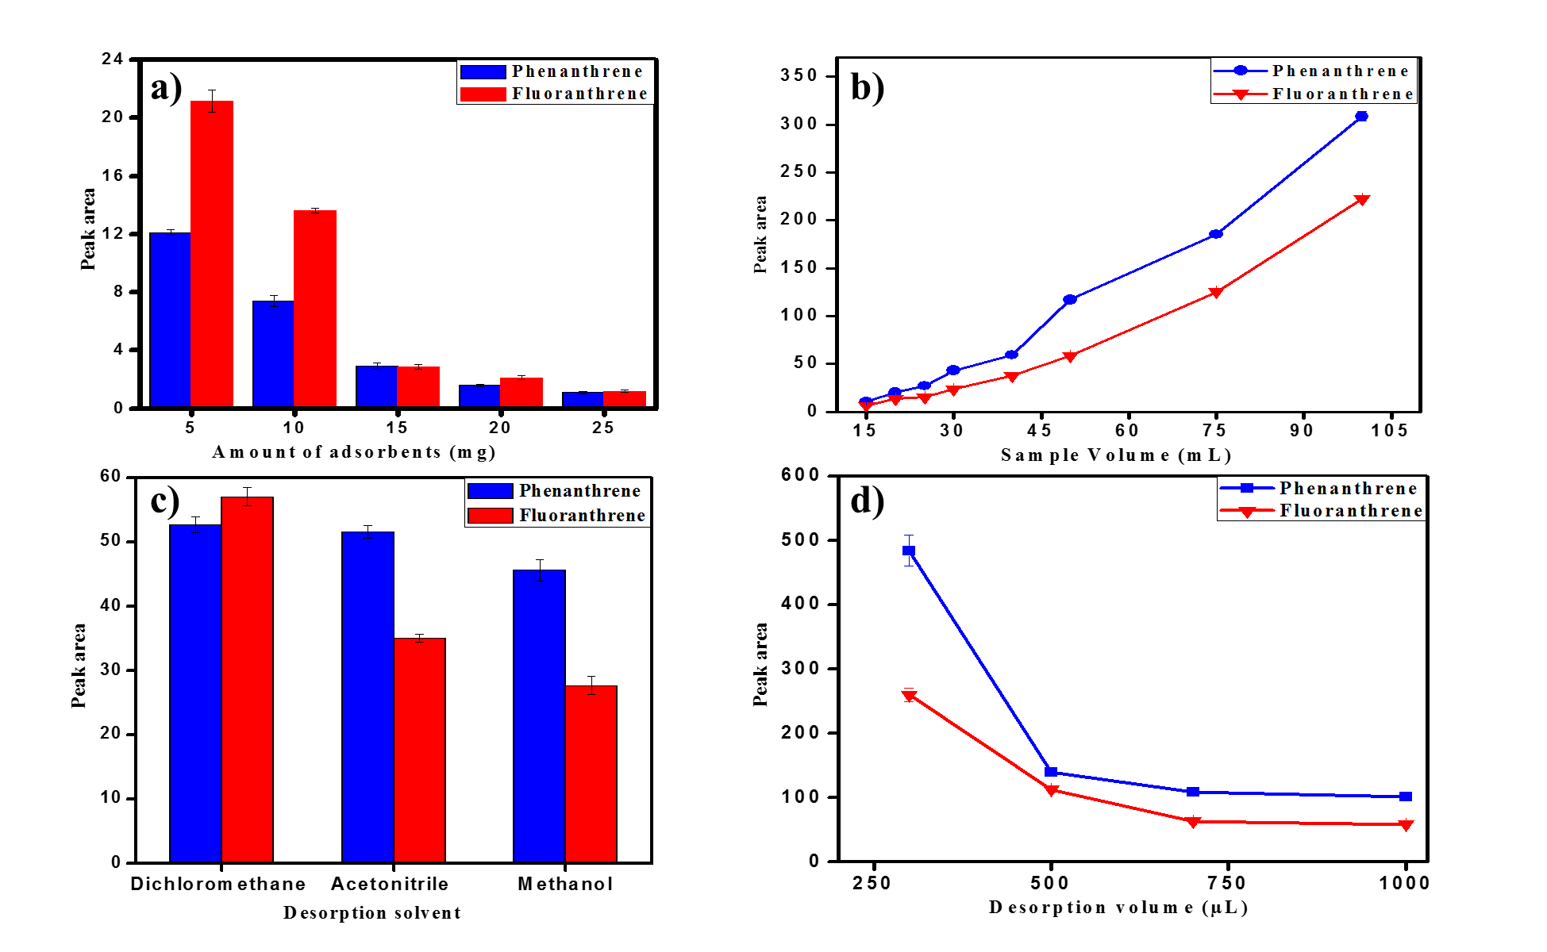

Figure 2. a) Effect of amount adsorbent on the extraction performance of PAHs (extraction conditions: 500 µg kg⁻¹ of PAHs compounds, 15 mL of sample volume, 1 mL acetonitrile as desorption solvent) b) Effect of sample volume on the extraction performance of PAHs (extraction conditions: 500 μg kg⁻¹ of PAHs compounds, 5 mg of amount adsorbent and 1 mL acetonitrile of desorption solvent) c) Effect of desorption solvent on the extraction performance (extraction conditions: 500 µg kg⁻¹ of PAHs, 5 mg of amount adsorbent, 40 mL of sample volume and 1 mL of desorption volume) and d) Effect of desorption volume on the extraction performance (extraction conditions: 500 µg kg⁻¹ of PAHs compounds, 5 mg of amount of adsorbent, 40 mL of sample volume and dichloromethane as desorption solvent)

Table 1. Analytical performance data of the proposed method
Analytes | Linear Range  (μg kg⁻¹) | RSDª  (%)  (n=3) | RSDª (%) |  | (R²)^{b} | LOD^{c} (μg kg⁻¹) | LOQ^{d} (μg kg⁻¹) | PF^{e}
Analytes | Linear Range  (μg kg⁻¹) | RSDª  (%)  (n=3) | Intra-day (n=5) | Inter-day (n=5)
PHE | 10-1000 | 1.22 | 6.16 | 5.48 | 0.9955 | 0.15 | 0.46 | 2587
FLU | 10-1000 | 4.29 | 8.02 | 3.56 | 0.9938 | 0.11 | 0.33 | 2866

ªRSD=relative standard deviation, ^{b}Coefficient of determination, ^{c}Limit of detection, ^{d}Limit of quantification and ^{e}Pre-concentraction factor at 1 mg kg⁻¹

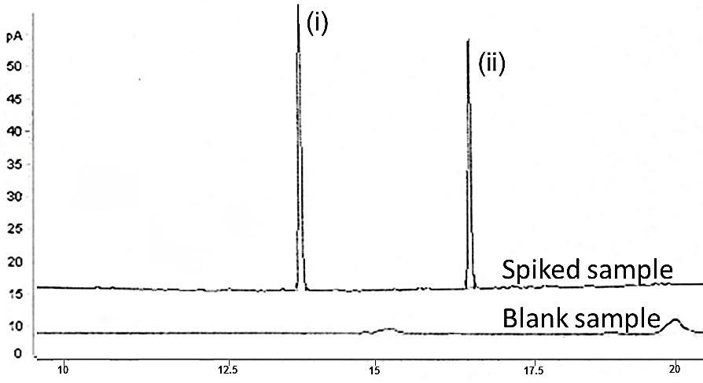

Figure 3. GC-FID chromatogram of blank sample and spiked sample with 1 mg kg⁻¹ (i) Phenanthrene at retention time 12.9 minutes (ii) Fluoranthene at retention time 15.7 minutes

Table 2. The relative recoveries and concentration found in the selected rice sample of each analytes
PAHs | Spiked  (μg kg⁻¹) | Relative Recovery (%) ±% RSDª (n=3) | Concentration of Analytes Found in Real Samples  (µg kg⁻¹) ± %RSD (n = 3)
PAHs | Spiked  (μg kg⁻¹) | Relative Recovery (%) ±% RSDª (n=3) | White Rice | Brown Rice | Parboiled Rice
PHE | 100 | 90.41(1.3) | ND^{b} | 171.79 ± 2.8 | ND
PHE | 300 | 103.25(2.1) | ND^{b} | 171.79 ± 2.8 | ND
PHE | 1000 | 115.63(4.0) | ND^{b} | 171.79 ± 2.8 | ND
FLU | 100 | 92.16(3.2) | 13.5 ± 0.3 | ND | 2.41 ± 5.3
FLU | 300 | 96.58(2.0) | 13.5 ± 0.3 | ND | 2.41 ± 5.3
FLU | 1000 | 90.23(5.4) | 13.5 ± 0.3 | ND | 2.41 ± 5.3

ªRSD = relative standard deviation, ^{b}ND = not detected

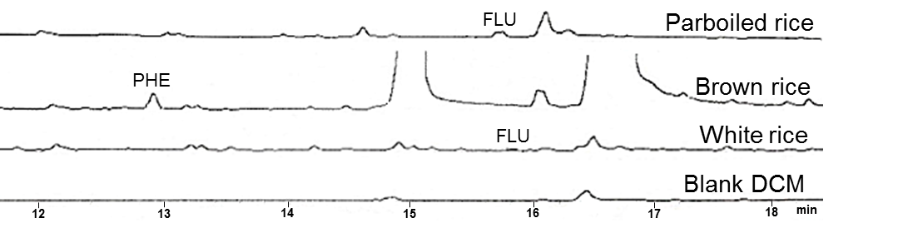

Figure 4. DSPME-GC-FID chromatogram of blank DCM solvent, white rice, brown rice and parboiled rice samples extract using the optimum extraction procedure. (i) Phenanthrene at retention time 12.9 minutes. (ii) Fluoranthene at retention time 15.7 minutes

Table 3. Comparison of the proposed method with other adsorbents for extraction of PAHs in food samples
Adsorbent | Samples | Extraction | Technique | Sample Volume (mL) | Dosage Amount (mg) | Extraction Time (min) | RSD (%) | LOD | ER (%) | Ref.
MWCNTsª | Water and smoked rice | SPME | GC-FID | 10 | 20 | 15 | 0.1-4.2 | 0.009 -0.013  (µg L⁻¹)  40.0 -150.0  (µg kg⁻¹) | - | [4]
- | Rice | QuEChERS | GC-MS | 10 | 10 | 3 | - | 0.11 -0.57  (µg kg⁻¹) | 75.3 - 90.7 | [9]
PMS^{b} | Water, sugarcane juice and tea infusion | DLLME-DSPE | GC-MS | 35 | 15 | 1.33 | 1.0-8.2 | 0.003 -0.016  (µg L⁻¹) | 86.3-109.1 | [25]
- | Meat | SPE | GC-FID | 30 | 1 | - | 1.82 -12.87 | 0.1 - 1.5  (µg kg⁻¹) | 83.69 - 94.25 | [26]
Activated carbon | white rice, brown rice and parboiled rice | DSPME | GC-FID | 40 | 5 | 3 | 1.3 -5.4 | 0.11 -0.15  (µg kg⁻¹) | 90.23 -115.63 | Current study

ªMWCNTs -Multiwalled carbon nanotubes ^{, b}PMS -Phenyl functionalized magnetic sorbent

Conclusion

In this study, the activated carbon-based DSPME coupled with GC-FID method was successfully developed as a simple, cheap, miniaturized, and reliable technique for the detection of trace levels of PAHs in rice samples. The applicability of the proposed method was tested on real rice samples and the quantitative results revealed that the target analytes were present in different samples. The study herein demonstrates the feasibility of using activated carbon coupled with this mode of microextraction technique for rice samples analysis.

Acknowledgments

The authors wish to thank the Department of Chemistry, Faculty of Science, University of Malaya for the facilities provided; and University Malaya Faculty Research Grant, for their financial supports through research vote (GPF058B-2018).

References
- Mohanty, S. (2013) Trends in global rice consumption. Rice Today, 12: 44-45.
- McGrath, T. E., Chan, W. G. and Hajaligol, M. R. (2003). Low temperature mechanism for the formation of polycyclic aromatic hydrocarbons from the pyrolysis of cellulose. Journal of Analytical and Applied Pyrolysis., 66: 51-70.
- Escarrone, A., Caldas, S., Furlong, E., Meneghetti, V., Fagundes, C., Arias, J. and Primel, E. (2014). Polycyclic aromatic hydrocarbons in rice grain dried by different processes: Evaluation of a quick, easy, cheap, effective, rugged and safe extraction method. Food Chemistry, 146: 597-602.
- Matin, A. A., Biparva, P. and Gheshlaghi, M. (2014). Gas chromatographic determination of polycyclic aromatic hydrocarbons in water and smoked rice samples after solid-phase microextraction using multiwalled carbon nanotube loaded hollow fiber. Journal Chromatography A, 1374: 50-57.
- Johnsen, A. R. and Karlson, U. (2005). PAH degradation capacity of soil microbial communities; does it depend on PAH exposure?. Microbial Ecology, 50: 488-495.
- Eisler, R. (1987). Polycyclic aromatic hydrocarbon hazards to fish, wildlife, and invertebrates: A synoptic review. Contaminant Hazard Reviews Report, 11: 55.
- Shahriman, M. S., Ramachandran, M. R., Zain, N. N. M., Mohamad, S., Manan, N. S. A. and Yaman, S. M. (2018). Polyaniline-dicationic ionic liquid coated with magnetic nanoparticles composite for magnetic solid phase extraction of polycyclic aromatic hydrocarbons in environmental samples. Talanta, 178: 211-221.
- Yang, R., Zhou, R., Xie, T. and Jing, C. (2018). Historical record of anthropogenic polycyclic aromatic hydrocarbons in a lake sediment from the southern Tibetan plateau. Environmental Geochemistry Health., 40: 1899-1906.
- Bertinetti, I. A., Ferreira, C. D., Monks, J. L. F., Sanches-Filho, P. J. and Elias, M. C. (2018). Accumulation of polycyclic aromatic hydrocarbons (PAHs) in rice subjected to drying with different fuels plus temperature, industrial processes and cooking. Journal Food Composition Analysis, 66: 109-115.
- Sarafraz-Yazdi, A., Ghaemi, F. and Amiri, A. (2012). Comparative study of the sol–gel based solid phase microextraction fibers in extraction of naphthalene, fluorene, anthracene and phenanthrene from saffron samples extractants. Microchimica Acta, 176: 317-325.
- Tsai, W. H., Huang, T. C., Huang, J. J., Hsue, Y. H. and Chuang, H. Y. (2009). Dispersive solid-phase microextraction method for sample extraction in the analysis of four tetracyclines in water and milk samples by high-performance liquid chromatography with diode-array detection. Journal of Chromatography. A, 1216: 2263-2269.
- Anastassiades, M., Lehotay, S. J., Štajnbaher, D. and Schenck, F. J. (2003). Fast and easy multiresidue method employing acetonitrile extraction/partitioning and dispersive solid-phase extraction for the determination of pesticide residues in produce. Journal of AOAC International, 86: 412-431.
- Ni, N., Wang, F., Song, Y., Bian, Y., Shi, R., Yang, X., Gu, C. and Jiang, X. (2018). Mechanisms of biochar reducing the bioaccumulation of PAHs in rice from soil: Degradation stimulation vs immobilization. Chemosphere, 196: 288-296.
- Gong, Z., Alef, K., Wilke, B. M. and Li, P. (2007). Activated carbon adsorption of PAHs from vegetable oil used in soil remediation. Journal Hazardous Materials, 143: 372-378.
- Eeshwarasinghe, D., Loganathan, P. and Vigneswaran, S. (2019). Simultaneous removal of polycyclic aromatic hydrocarbons and heavy metals from water using granular activated carbon. Chemosphere, 223: 616-627.
- Li, X., Wei, S., Sun, Y., Sun, Q., Liang, L., Zhang, B., Piao, H., Song, D. and Wang, X. (2016). Glass slides functionalized by 1‐carboxyethyl‐3‐methylimidazolium chloride for the determination of triazine herbicides in rice using high‐performance liquid chromatography. Journal of Separation Sciences, 39: 4585-4591.
- Boon, Y. H., Zain, N. N. M., Mohamad, S., Osman, H. and Raoov, M. (2019). Magnetic poly (β-cyclodextrin-ionic liquid) nanocomposites for micro-solid phase extraction of selected polycyclic aromatic hydrocarbons in rice samples prior to GC-FID analysis. Food Chemistry, 278: 322-332.
- Huang, X., Lu, Q., Hao, H., Wei, Q., Shi, B., Yu, J., Wang, C. and Wang, Y. (2019). Evaluation of the treatability of various odor compounds by powdered activated carbon. Water Research, 156: 414-424.

- Saraji, M., Boroujeni, M. K., Bidgoli, A. A. H. (2011). Comparison of dispersive liquid–liquid microextraction and hollow fiber liquid–liquid–liquid microextraction for the determination of fentanyl, alfentanil, and sufentanil in water and biological fluids by high-performance liquid chromatography. Analytical and Bioanalytical Chemistry, 400: 2149.
- Galan-Cano, F., Alcudia-Leon, M. C., Lucena, R., Cardenas, S. and Valcarcel, M. (2013). Ionic liquid coated magnetic nanoparticles for the gas chromatography/mass spectrometric determination of polycyclic aromatic hydrocarbons in waters. Journal of Chromatography A, 1300: 134-140.
- Acree, Jr. W. E. (2013). IUPAC-NIST solubility data series. 98. Solubility of polycyclic aromatic hydrocarbons in pure and organic solvent mixtures revised and updated. Part 3. Neat organic solvents. Journal of Physical and Chemical Reference Data, 42: 013105.
- Lehotay, S., Schenck, F. (2000). Multi-residue methods: Extraction encyclopaedia of separation science: pp. 3409-3415.
- Zhao, G., Song, S., Wang, C., Wu, Q. and Wang, Z. (2011). Determination of triazine herbicides in environmental water samples by high-performance liquid chromatography using graphene-coated magnetic nanoparticles as adsorbent. Analitica Chimica Acta, 708: 155-159.
- Food Safety Authority of Ireland (2015). Polycyclic aromatic hydrocarbons (PAHs) in food. Food Safety Authority of Ireland, 2: 1-10.
- Mohd Hassan, F. W., Raoov, M., Kamaruzaman, S., Sanagi, M. M., Yoshida, N., Hirota, Y., Nishiyama, N. and Yahaya, N. (2018). Dispersive liquid–liquid microextraction combined with dispersive solid‐phase extraction for gas chromatography with mass spectrometry determination of polycyclic aromatic hydrocarbons in aqueous matrices. Journal of Separation Sciences, 41: 3751-3763.
- Olatunji, O. S., Fatoki, O. S., Opeolu, B. O. and Ximba, B. J. (2014). Determination of polycyclic aromatic hydrocarbons [PAHs] in processed meat products using gas chromatography flame ionization detector. Food Chemistry, 156: 296-300.

