
STUDY ON THE OXIDATION AND PROPERTIES OF DIHYDROXYL CELLULOSE USING DIFFERENT AMOUNTS OF SODIUM PERIODATE

(Kajian ke atas Pengoksidaan dan Pencirian bagi Dihidroksil Selulosa Menggunakan Kuatiti Natrium Periodat yang Berbeza)

Nur Nadia Dzulkifli*, Nur Wahibah Mohd Zaki, Ahmad Husaini Mohamed, Nor Monica Ahmad,
Sheikh Ahmad Izaddin Sheikh Mohd Ghazali

School of Chemistry and Environment, Faculty of Applied Sciences,
Universiti Teknologi MARA Negeri Sembilan Branch, Kuala Pilah Campus,
Pekan Parit Tinggi 72000 Kuala Pilah, Negeri Sembilan

*Corresponding author: nurnadia@uitm.edu.my

Received: 23 July 2020; Accepted: 23 September; Published: xx December 2020

Abstract
Sodium periodate is as an oxidizing agent that breaks the cellulose ring at the C2-C3 bond of the anhydroglucose units (AGU) by creating two vicinal hydroxyl groups which have the potential to form a Schiff base for further reactions. The objective of this study was to evaluate the effects of different amounts of sodium periodate on the formation and arrangement of hydroxyl groups at the C2-C3 bond of the anhydroglucose units (AGU), which is so-called dihydroxyl cellulose (DHC). Firstly, microcrystalline cellulose (MCC) was sonicated to break down the intermolecular and intramolecular interactions. Then, MCC was oxidized with 3 g and 5 g of sodium periodate to prepare the DHC compounds. The DHC and MCC were characterized by FTIR-ATR, FESEM, TGA, and XRD techniques. The numbers of hydroxyl group of DHC increased with the addition of sodium periodate. Besides, the thermal stability and crystallinity of DHC was found to be higher with the increasing amount of sodium periodate. Lastly, the morphology of DHC was found to be smooth, needle- (1:3) and leaf-like (1:5) structure as compared to the irregular forms of MCC. Difference of thermal stability, crystallinity, and morphological structure of DHC compounds concluded that different amounts of sodium periodate could modify the physicochemical properties of MCC.

Keywords: microcrystalline cellulose, dihydroxyl cellulose, sodium periodate, oxidation

Abstrak
Sodium periodat adalah agen pengoksidaan yang membuka gegelang selulosa di ikatan C2-C3 pada unit anhidroglukosa (AGU) dengan mewujudkan dua kumpulan visinal hidroksi yang berpotensi untuk membentuk Bes Schiff bagi tindak balas selanjutnya. Objektif kajian ini ialah untuk menilai kesan perbezaan kuantiti natrium periodat ke atas pembentukan dan susunan kumpulan hidroksil di ikatan C2-C3 pada unit anhidroglukosa (AGU), yang dikenali sebagai dihidroksi selulosa (DHC). Pertamanya, mikrohablur selulosa (MCC) telah disonikasi untuk memutuskan interaksi intermolekul dan intramolekul, Kemudian, MCC dioksidakan dengan 3g dan 5g natrium periodat untuk menyediakan sebatian DHC. DHC dan MCC dicirikan dengan teknik FTIR-ATR, FESEM, TGA, dan XRD. Bilangan kumpulan hidroksil bagi DHC meningkat dengan penambahan kuantiti natrium periodat. Disamping itu, kestabilan haba dan kehabluran DHC dikenalpasti adalah tinggi dengan peningkatan kuantiti natrium periodat. Terakhir, morfologi DHC dikenalpasti adalah licin, struktur yang menyerupai jejarum (1:3) dan dedaun (1:5) berbanding dengan bentuk yang tidak teratur bagi MCC. Perbezaan kestabilan haba, kehabluran dan struktur morfologi sebatian DHC dapat disimpulkan bahawa perbezaan kuantiti natrium periodat berupaya mengubah sifat fizik-kimia MCC.

Kata kunci: mikrohablur selulosa, dihidroksi selulosa, natrium periodat, pengoksidaan

Introduction
Cellulose is categorized as a biopolymer which is biocompatible, hydrophilic, and biodegradable by nature [1]. Each cellulose moiety is composed of multiple (1,4)-linked ß-D-glucan linear chains [2]. Hydrogen bonds are formed between hydroxyl (OH) groups from a chain with a nearby oxygen atom to build up stable and rigid cellulose structures, protecting them from being dissolved by common solvents. Various processes have been suggested to improve the solubility of cellulose as well as to expand its application in the industry [3,4]. The process can be made by introducing functional groups, particularly carboxylic acid and aldehyde at C2-C3 bond in the position of anhydroglucose units (AGU), as shown in Figure 1. On the other hand, in this study, hydroxyl groups have been produced at C2-C3 of AGU by opening the ring structure of the compound using sodium periodate as an oxidizing agent [5]. The sodium periodate oxidation of cellulose has the potential to break down the C2-C3 bond and form dialdehyde groups [6]. Then, dialdehyde compounds can be further oxidized to form a new functional group, carboxylic acid, or imine after it reacts with the amine group [7]. The effects of different amounts of sodium periodate added into the MCC was investigated under controlled conditions of pH, temperature, and time of reaction. Fourier-transform infrared-attenuated total reflectance spectroscopy (FTIR-ATR), power X-ray diffraction (PXRD), thermogravimetric analysis (TGA), and field-emission scanning electron microscopy (FESEM) techniques were applied to characterize and investigate the effects of oxidation on the chemical structure of MCC and its crystallinity. Figure 2 shows the proposed mechanism on the formation of DHC.

Material and Methods
The chemical reagents used to prepare DHC are MCC, sodium periodate, and ethylene glycol, which were purchased from Aldrich. All the reagents were used without purification. The MCC is light brown microcrystalline powder. The particle size and density of MCC were 51 μm and 0.6 g mL⁻¹, respectively. The samples were analyzed using FTIR-ATR Perkin Elmer GX spectrophotometer. The transmittance of the samples was detected with a resolution of 4 cm⁻¹ in the range of 4000–650 cm⁻¹. The morphology of the samples was observed using a ZEISS MERLIN compact microscope equipped with a field emission gun. The samples were mounted in aluminium stubs on double-sided carbon tape and coated with iridium to reduce the effects of charging. Powder X-ray Diffraction pattern (PXRD) of the samples was recorded on Shidmazu D600 diffractometer (Shidmazu Kyoto Jaya, Japan) in the 2θ range of 5º to 70º using Cu-Kα radiation (λ = 0.15415) at 40 kV and 20 mA with 0.17˚min⁻¹. Powder X-ray diffraction analysis was performed on the sample to determine the phase of MCC and DHC crystallinity.

The ultrasonication of MCC
One hundred mL of deionized water and 2 g of MCC were added into a flask. The ultrasonication was performed for 30 minutes to break the intermolecular and intramolecular interactions of chemicals in MCC. Then, the treated MCC was filtered and washed with deionized water. The MCC was dried in the oven at 45 ºC for 24 hours.

The oxidation of MCC by using sodium periodate
Firstly, 30 mL of deionized water was added into a 100 mL flask. Then, 1 g of sonicated MCC and 3 g of sodium periodate were added into the flask and continuously stirred in water bath at 48 ºC for 4 hours. The flask was kept in dark condition by wrapping it using aluminium foil. After 4 hours of incubation, the ethylene glycol was added into the mixture and left for 1 hour. The oxidized product was filtered and washed with methanol. The product was dried in the oven at 45 °C for 24 hours. The process was repeated using 5 g of sodium periodate to study the effects of different amounts of sodium periodate on the oxidation of MCC.

Figure 1. The structure of the AGU in cellulose

Figure 2. The mechanism of DHC formation

Results and Discussion
FTIR-ATR
FTIR-ATR spectroscopy is an important and easy technique to obtain a detailed information on the changes of chemical structure of cellulose after it was treated with different amounts of sodium periodate, as shown in Figure 4. The wide range of absorption band was attributed to the hydroxyl group, ʋ(OH) that was displayed at 3341 cm⁻¹ (MCC), 3468 cm⁻¹ (DHC 1:3), and 3338 cm⁻¹ (DHC 1:5), respectively. The intensity of ʋ(OH) increased when the amount of sodium periodate was increased. It can be inferred that the DHC consisted of more OH in its structure as compared to that of MCC, as shown in Figure 3. The stretching bond of ʋ(C-H) was displayed at 2900 cm⁻¹ (MCC), 2945 cm⁻¹ (DHC 1:3), and 2939 cmˉ¹ (DHC 1:5). This finding was contradicted with those performed by Liming et. al, which has reported that the stretching bond of CH and CH₂ groups were found to be at the range of 2800-2900 cmˉ¹ [8]. Furthermore, the absorption band ranging from 1633 to 1649 cm⁻¹ might be attributed to the deformation of OH vibration induced by absorbing the moisture of samples [9]. The vibration band at 897 cm⁻¹ was correlated with ʋ(C-O-C) vibration, portraying the β-glycosidic linkages ring presented in MCC. Meanwhile, the vibration bands of DHC (1:3) and DHC (1:5) at 883 cm⁻¹ and 880 cm⁻¹, respectively could be due to the presence of ʋ(C-OH) structure in the compound [10].

TGA
The TGA analysis can be used to figure out the thermal stability of MCC, DHC (1:3), and DHC (1:5). The initial degradation process at 100-130 ºC was attributed to the deterioration of intermolecular and intramolecular hydrogen bonding as well as the evaporation of a small amount of moisture from the sample [11]. Mahendra et al. proclaimed that a pyrolysis process will occur during the degradation process of cellulose and oxidation of cellulose in the range of 200-400 ºC [12]. In this study, it was found that the pyrolysis process of DHC celluloses was lower than MCC, as shown in Figure 5. Meanwhile, Sofla et al. reported that the reduction of DHC dimension after oxidation will reduce the pyrolysis process temperature [13]. Besides, it was suggested that the hemicellulose and cellulose were decomposed between 200-400 ºC, which will decrease the thermal stability of DHC after the oxidation process [14]. It was reported that the temperature in the range of 200-400ºC facilitated the decomposition of volatile and dehydrated compounds as well as the breakdown of glycosidic in compounds [15]. In this study, the decomposition of DHC compounds could only be detected when the temperature exceeded 400 ºC. This phenomenon could be attributed to the carbonization process, resulting in complete degradation and decomposition process. The finding suggests that the thermal stability of DHC was higher than MCC after surface modification with sodium periodate. It is conceivably due to the increase in number of hydroxyl groups in the cellulose ring after the cleavage of C2-C3 bond of the AGU, which promotes the crystallinity of DHC.

PXRD
The PXRD findings on the patterns of MCC and DHC are presented in Figure 6. It was found that DHC (1:3) and DHC (1:5) possessed different patterns from MCC, whereby the degree of crystallinity of DHC increased from 50.1% (MCC) to 99.8% (DHC 1:3) and 99.5% (DHC 1:5) after the oxidation process. Anuj et al. proclaimed that the cellulose structure displayed three main peaks close to 16º (110), 23º (200), and 35º (004) in MCC [16]. After the oxidation process, the crystallinity of MCC increased when the amount of sodium periodate had increased. It is deduced that the lignin and hemicelluloses, which are amorphous, were successfully removed with the addition of sodium periodate. This process facilitated the formation of hydroxyl groups in DHC which led to the rearrangements of crystalline cellulose structure. This was due to the development of intermolecular and intramolecular H bonding in DHC. The finding obtained from the PXRD analysis on MCC, DHC (1:3) and DHC (1:5) was further supported by the analysis on the surface morphological characteristics of the compound using field-emission scanning electron microscopy (FESEM) techniques.

FESEM
The photomicrograph of FESEM analysis showed the changes on surface morphology of MCC (A), DHC (1:3) (B) and DHC (1:5) (C) following the reaction with different amounts of sodium periodate (Figure 7). The surface roughness of the MCC seems uneven and irregular, indicating the absence of cementing materials such as lignin and hemicellulose components in MCC as shown in Figure 7(a) [17-19]. DHC (1:3) showed a clear, smooth, and needle-shaped like morphology of the cellulose after 3 g of sodium periodate was added. The findings demonstrated a complete defibrillation of MCC structure, which promotes the micronization of fibers into its constituent due to the increment of repulsion between the structure of fibers [20]. With the addition of 5 g of sodium periodate, the cellulose staked up or clustered together and the texture became more compact, resembling a thick leaf-like shape, in which the amorphous area was obviously destroyed as shown in Figure 7(c) [2]. The surface morphology of DHC (1:3) and DHC (1:5) were found to be smooth as compared to MCC, whereby it showed that the crystallinity of DHC increased with the increasing amount of sodium periodate added. It can be deduced that the cellulose chain exfoliation process was developed during the oxidation of sodium periodate. However, further addition of sodium periodate concentration will reduce the structure diameter and cause aggregation of the structure by hydrogen bonding and less steric hindrance between the neighboring hydroxyl group of DHC [22-23].

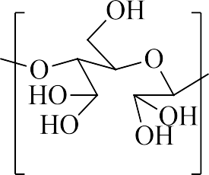

Figure 3. The structure of hydrated aldehyde (DHC) that was proposed in this study

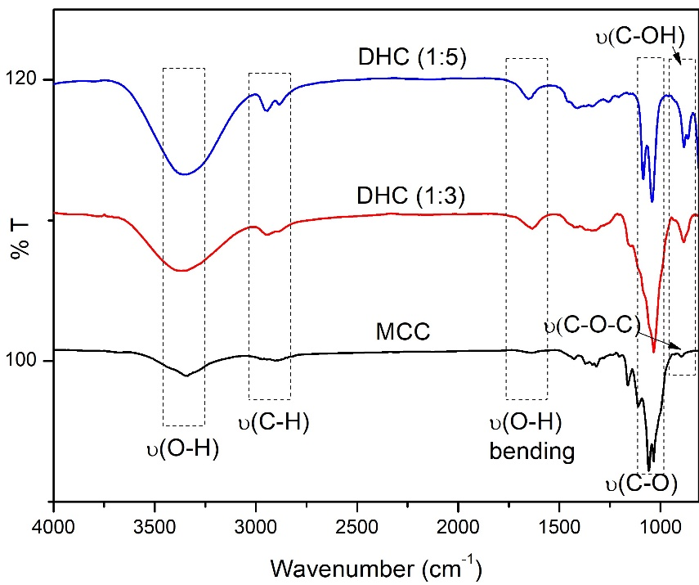
Figure 4. The FTIR-ATR spectra of MCC, DHC (1:3) and DHC (1:5)

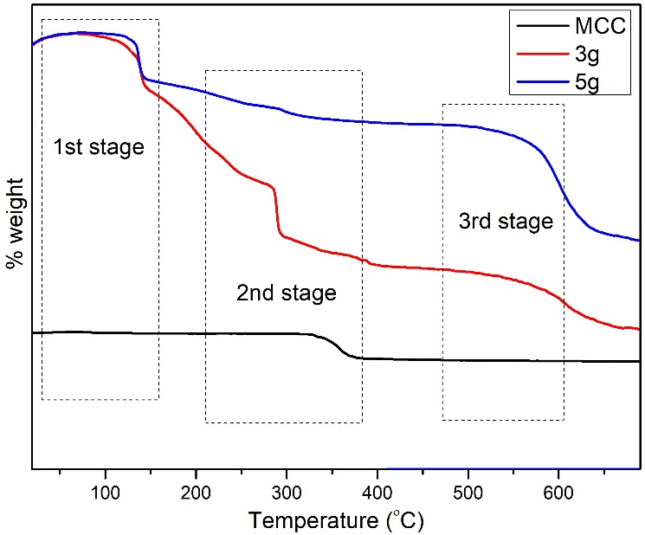
Figure 5. The TGA curves of MCC and DHC compounds

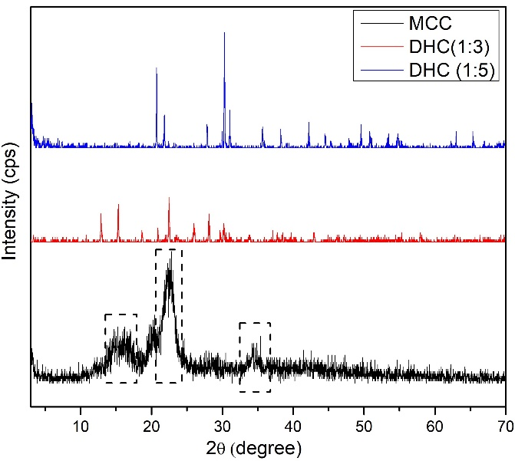
Figure 6. The PXRD diffractograms of MCC, DHC (1:3), and DHC (1:5)

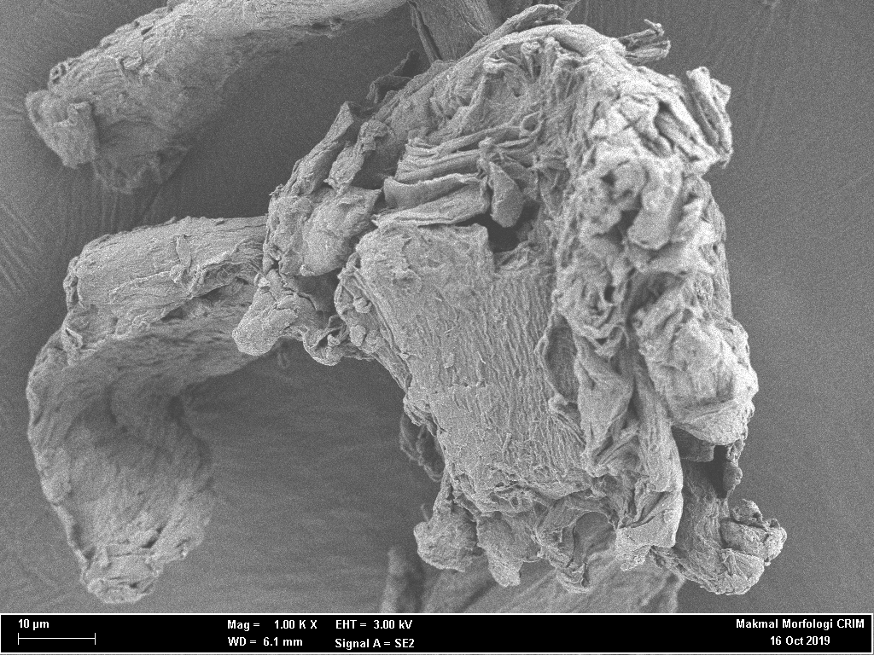  (a) | 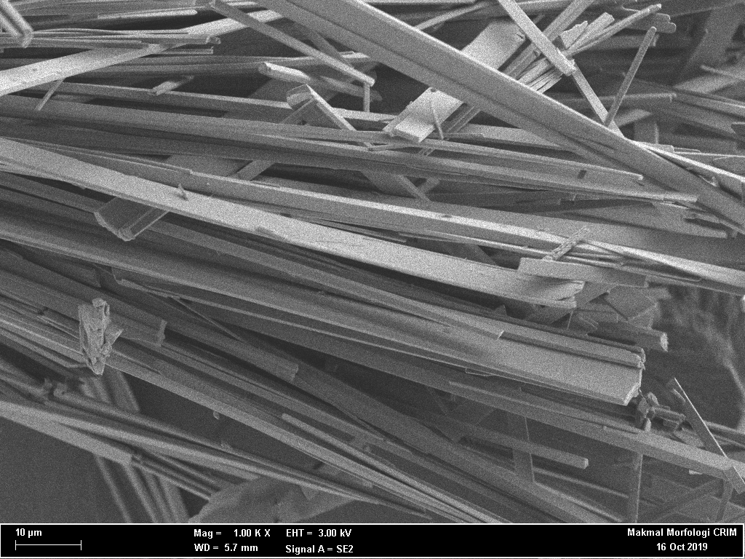  (b)
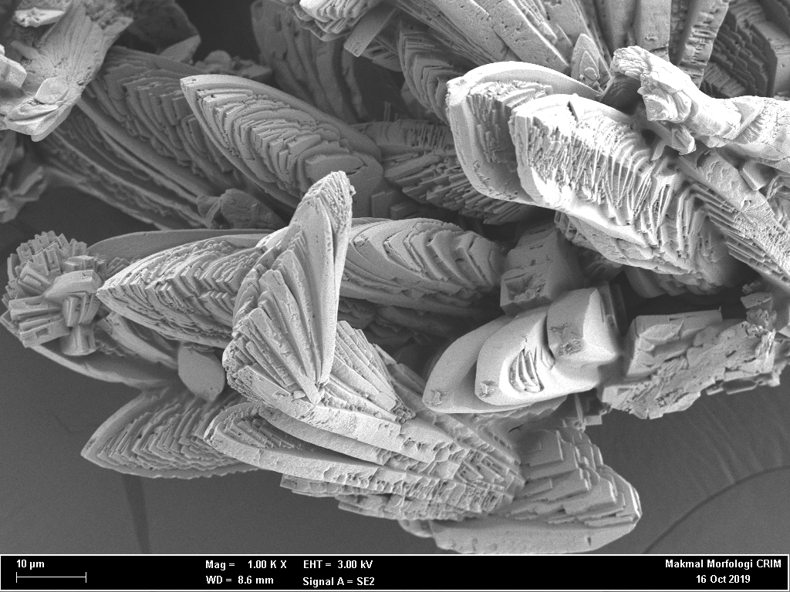
(c)
Figure 7. The morphology screening of MCC (a), DHC (1:3) (b), and DHC (1:5) (c)

Conclusion
In this study, DHC was successfully oxidized with different amount of sodium periodate on MCC in a concentration-dependent manner. The addition of sodium periodate on MCC increased the intensity of ʋ(OH) stretching band and the stability of DHC. The DHC also showed crystal-like structure with the increasing amount of sodium periodate, suggesting the possible occurrence of crystallinity of DHC during the oxidation process. The recent findings concluded that the DHC possessed more OH groups compared to that of MCC.

Acknowledgement
The authors would like to thank the Faculty of Applied Sciences, Universiti Teknologi MARA (UiTM), Negeri Sembilan Branch, Kuala Pilah Campus and the Centre of Research and Instrumentation Management (CRIM), Universiti Kebangsaan Malaysia for providing the facilities and instrumentation in this study.

References
- Cunzhen, G., Zhihui, Z., Zhixin, X., Peilong, X. and Yanzhi, Xia. (2019). Preparation of ion-exchanged TEMPO-oxidized celluloses as flame retardant products. Molecules, 24:1-10.
- Zuwu, T.,Wenyan, L., Xinxing, L., He, X., Qingxian, M., Liulian, H., Lihui, C. and Hui, W. (2017). TEMPO-oxidized cellulose with high degree of oxidation. Polymers, 9(9): 421.
- Lin, X., Ma, W., Wu, H., Huang, L., Chen, L. and Takahara, A. (2017). Fabrication of cellulose based super hydrophobic microspheres for the production of magnetically actuatable smart liquid marbles. Journal of Bioresources and Bioproducts, 2:110-115.
- Weng, R., Chen, L., Lin, S., Zhang, H., Wu, H., Liu, K., Cao, S. and Huang, L. (2017). Preparation and characterization of antibacterial cellulose/chitosan nanoﬁltration membranes. Polymers, 9(116):1-13.
- Luo, C. C.,Wang, H. and Chen, Y. (2015). Progress in modiﬁcation of cellulose and application. Chemical Industry and Engineering Progress, 34(3):767-773.

- Liu, P., Pang, B., Tian, L., Schafer, T., Gutmann, T., Liu, H., Volkert, C. A., Buntkowsky, G. and Zhang, K. (2018). Efﬁcient, self-terminating isolation of cellulose nanocrystals through periodate oxidation in pickering emulsions. ChemSusChem, 11(20): 3581-3585.
- Ruan, C. Q., Stromme, M. and Lindh, J. (2018). Preparation of porous 2,3-dialdehyde cellulose beads crosslinked with chitosan and their application in adsorption of Congo red dye. Carbohydrate Polymers, 181:200-207.
- Liming, Z., Huanhuan, G., Meng, X., Jie, C. and Yujie, D. (2017). Physicochemical properties, antioxidant and antibacterial activities of dialdehyde microcrystalline cellulose. Cellulose, 24: 2287-2298.
- Zaman, M., Xiao, H., Chibante, F. and Ni, Y. (2012). Synthesis and characterization of cationically modiﬁed nanocrystalline cellulose. Carbohydrate Polymers, 89:163-170.
- Anjali, T. (2012). Modification of carboxymethyl cellulose through oxidation Carbohydrate polymers, 87(1): 457-460.
- Xiuzhi, T. and Xue, J. (2017). Preparing water-soluble 2,3-dialdehyde cellulose as a bio-origin cross-linker of chitosan. Cellulose, 25:987-998.
- Mahendra, I. P., Wirjosentono, B., Tamrin, I. H. and Mendez, J. A. (2019). Thermal and morphology properties of cellulose nanofiber from TEMPO-oxidized lower part of empty fruit bunches (LEFB). Open Chemistry, 17: 526-536.
- Sofla, M. R. K., Brown, R. J., Tsuzuki, T. and Rainey, T. J. (2016). A comparison of cellulose nanocrystals and cellulose nanofibres extracted from bagasse using acid and ball milling methods. Advances in Natural Sciences: Nanoscience and Nanotechnology, 7(3):1-9.
- Horseman, T., Tajvidi, M., Diop, C. I. K. and Gardner, D. J. (2017). Preparation and property assessment of neat lignocellulose nanofibrils (LCNF) and their composite films. Cellulose, 24(6): 2455-2468.

- Marina, D. C. E. P., Demetrius, D. D. S., Ana, L. A. G., Victor, D. S. A. L., Allan, R. F., Moraes, R. F. D. N., Jairo, T. and Frederico, G. P. (2019). Film based on magnesium impregnated biochar/ cellulose acetate for phosphorus adsorption from aqueous solution. The Royal Society of Chemistry, 9: 5620-5627.
- Anuj, K., Yuvraj, S. N., Veena, C. and Nishi, K. B. (2014). Characterization of cellulose nanocrystals produced by acid-hydrolysis from sugarcane bagasse as agro-waste. Journal of Materials Physics and Chemistry, 2(1): 1-8.
- Lindh, J., Ruan, C., Stromme, M. and Mihranyan, A. (2016). Preparation of porous cellulose beads via introduction of diamine spacers. Langmuir, 32(22): 5600-5607.
- Julie, C. C. S., Neena, G. and Sunil, K. N. (2016). Isolation and characterization of cellulose nanofibrils from arecanut husk fiber. Carbohydrate Polymers, 142: 158-166.
- Ahmed, A. O. and Jong-Whan, R. (2016). Characterization of nanocelluloses isolated from Ushar (Calotropis procera) seed fiber: Effect of isolation method. Materials Letters, 168: 146-150.

- Juho, S., Henrikki, L., Jouko, N. and Osmo, H. (2011). Dialdehyde cellulose microfibers generated from wood pulp by milling-induced periodate oxidation. Carbohydrate Polymers, 86: 260-265.
- Chao, L., Li, B., Du, H., Lv, D., Zhang, Y. and Yu, G. (2016). Properties of nanocellulose isolated from corncob residue using sulfuric acid, formic acid, oxidative and mechanical methods. Carbohydrate polymers, 151:716-724.
- Lopez-Sanchez, P., Martinez-Sanz, M., Bonilla, M. R., Wang, D., Gilbert, E. P., Stokes, J. R. and Gidley, M. J. (2017). Cellulose-pectin composite hydrogels: Intermolecular interactions and material properties depend on order of assembly. Carbohydrate Polymers, 162:71-81.
- David, J. M., Christine, B., Vikram, S. R., George, P. S. and Gil, G. (2019). One-shot TEMPO-periodate oxidation of native cellulose. Carbohydrate Polymers, 226: 1-10.

