

A USE OF AN EVERYDAY LIFE CAMERA WITH IMAGE PROCESSING AS ALTERNATIVE DETECTION FOR A FLAME PHOTOMETER

(Penggunaan Kamera Harian Dengan Pemprosesan Imej Sebagai Alternatif Pengesanan Fotometer Nyalaan)

Narong Kotchabhakdi^{1,2} and Kate Grudpan^{1,2}*

¹Department of Chemistry and Graduate programs in Chemistry, Faculty of Science

²Center of Excellence for Innovation in Analytical Science and Technology

Chiang Mai University, Chiang Mai, 50200, Thailand

*Corresponding author: kgrudpan@gmail.com

Received: 27 August 2020; Accepted: 26 October 2020; Published: xx December 2020

Abstract

As alternative detector, everyday life cameras: Digital Single Lens Reflect (DSLR) and smartphone, are proposed for a Flame Atomic Emission Spectrometer (FAES) for the assays of Na, K, Ca, Ba, and Li. Image processing with Region of Interest (ROI) approach for DSLR employs imageJ while for smartphone, various available applications (Color Grab, Linear Regression, and Calculator) are used. It was found that linear correlations for calibration graphs could be obtained by a particular ratio of Red, Green, Blue (R, G, B) color intensity and concentration for each of the above metal ions in the range of 0.2-1.0 mg L⁻¹. Applications to real samples were demonstrated.

Keywords: flame photometry, digital single lens reflect camera, smartphone, image processing

Abstrak

Kamera harian: Refleksi Lensa Digital Tunggal (DLSR) dan telefon pintar, telah dicadang sebagai pengesan alternatif bagi spektrometer nyalaan pancaran atom (FAES) untuk analisis terhadap Na, K, Ca, Ba, dan Li. Pemprosesan imej dengan pendekatan Kawasan terpilih (ROI) pada imageJ DSLR manakala bagi telefon pintar, pelbagai aplikasi (Grab warna, regresi linear dan kalkulator) telah digunakan. Hasil mendapati korelasi linear diperolehi bagi graf kalibrasi berdasarkan nisbah keamatan warna merah, hijau, biru (R, G, B) dan kepekatan bagi setiap logam yang dinyatakan pada julat 0.2-1.0 mg L⁻¹. Aplikasi terhadap sampel sebenar telah berjaya dilakukan.

Kata kunci: fotometri nyalaan, kamera refleksi lensa digital tunggal, telefon pintar, pemprosesan imej

Introduction

The assays of the alkaline metal ions, including potassium, lithium, sodium, barium, and calcium, are needed applications in the fields of medicine, agriculture, industry and food [1-6]. There are some available color reagents such as: Alizarin, crown Reagents, and o-Cresolphthalein Complexone, for calcium and barium determination [7,8]. Lithium, sodium, and potassium are not usually colorimetrically assayed [9]. Due to the dominance of the spectral lines according to electronic configurations, taking advantage when excitation can be possible with low energy, the alkaline metal ions are assayed by flame photometry.

There have been some reports using a Charge Coupled Device (CCD) as a photo-sensor in a flame emission-based spectrometer [10, 11]. Using CCD, collecting video frames can be subjected to a multivariate image procedure based on Multivariate Curve Resolution – Alternating Least Squares (MCR-ALS) in connection to the Region of Interest (ROI) used to create the univariate regression model [12]. A webcam camera was also introduced as a detector for a flame photometer [13, 14]. Using recorded videos of the flame during the experiment and subsequent image treatments with an R statistics platform, flame photometry was reported for quantifying sodium in coconut water and seawater [15].

In this work, an everyday life camera (digital camera and smartphone) with image processing is proposed as a simple alternative detection system for a flame spectrometer. The developed system was demonstrated for the assays of real samples of water, fish sauce, milk, fertilizer and lithium battery for barium, sodium, calcium, potassium and lithium, respectively.

Materials and Methods

Solutions

Working solutions were prepared from the purchased standard solutions (1000 mg L⁻¹) for Atomic Absorption Spectrophotometry (AAS) (Merck, Germany) of Na, K, Ca, Ba, and Li in nitric acid (65%, Merck, Germany), and ultrapure water (Milli-Q, Merck) was used throughout the work.

Sample

Five different types of samples were selected to demonstrate in real application analysis using the proposed instrumentation and procedure. Samples of fish sauces, fertilizers, milks, water leaching batteries, and laboratory water wastes were model samples for Na, K, Ca, Ba, and Li assays, respectively. Five different brands/sources of samples were collected. Samples of fish sauces, fertilizers and milks were prepared by acid digestion with HNO₃.

Instrumentation

The setup is illustrated in Figure 1. It consists of parts A and B. For Part A: flame compartment having burner and flame (a1), a window (a2) for conventional photometric detector (B) and another window (a3) for alternative detector (Digital Single Lens Reflect (DSLR) camera positioned at B1, or smartphone positioned at B2). In the compartment A, at a4, a white ceramic plate mounted behind the flame for reducing the background of flame serving as a screen giving a background for taking a photo by the camera detector B1or B2 and having a white future board as protective shelter ,as a box of dimension with 20 cm x 10 cm x 10 cm (a5) around the flame. For the conventional photometric detector (B), lens (b1), monochromator/grating (b2), and Photomultiplier tube (PMT) (b3) collected and measured the light. The three detectors were not in simultaneous operation but at one at a time for each.

Flame Atomic Absorption and Emission Spectrophotometer (AA-6200, Shimazu, Japan) was used and followed its Manual Instruction for operating conditions. A standard premix- burner (titanium 10 cm slot) was used. The ratios of oxidant and fuel (Air/C₂H₂) for Na, K and Li were used at 1.8: 8.0 L/min, for Ca at 2.0: 8.0 L/min, and for Ba at 3.0: 8.0 L/min, with an aspiration flow rate at 5 mL/min. The conditions of the conventional photometric detection system used for the Shimazu model AA-6200 refers to double beam (chopper mirror) operation, with a monochromator of holographic grating (1,600 lines/mm) for wavelength range: 190 to 900 nm; automated wavelength selection, having slit: 0.2nm, or 0.7nm manual setting, with background correction: Duterium (D₂)-Lamp method, with PMT.

DSLR camera (EOS 600D, Canon, Taiwan) (focus 22 nm, a rate of 3 images/sec and 5184 × 3456 pixels resolution) was used. Evaluation was made through ImageJ (a public image processing software (NIH, USA)). The conditions of flame photography by the DSLR camera include: 24 mm focusing distance, image resolution of 5184 x 3456 pixels, high-quality Joint Photographic Experts Group (JPEG) Image, flash off, light control, self-timer, continuous shutting, 3shots/10 seconds, manual mode, manual exposure, aperture size (F5.6) and speed shutter 1/8. The camera was situated at 80 cm from the flame (as shown as B1 in Figure 1).

A smartphone (Samsung Galaxy Note II, Korea) with 8-megapixel camera was used in this study. Color Grab application for RGB color capture was used. For plotting of the analytical graph, a linear regression application in Android was employed. The RGB ratio and concentration values were evaluated with a Calculator application that was already available for a smartphone.

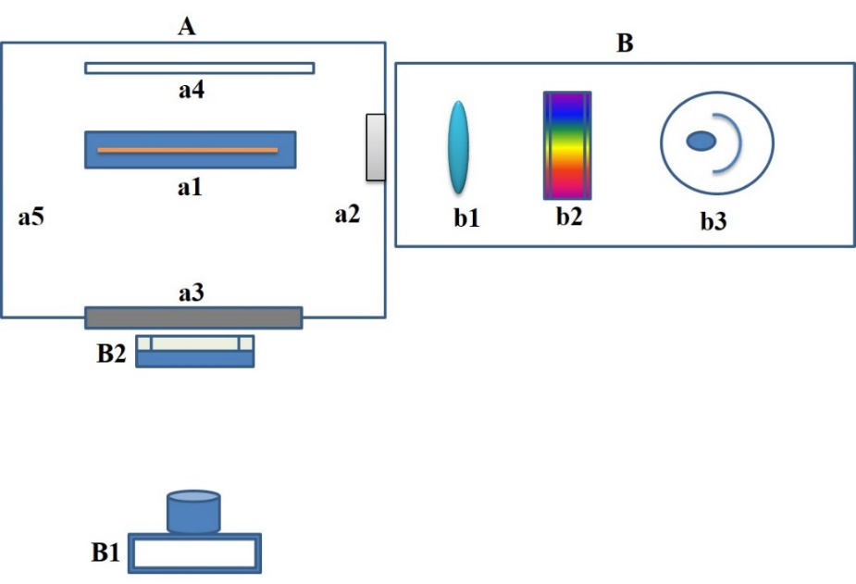

Figure 1. Top view; flame instrument set up: A) Flame compartment: Flame/Burner(a1), window for conventional photometric detector(a2), window for alternative detector (a3), screen for alternative detector
(a4), pprotective shelter (a5), B) conventional photometric detection system: lens (b1), grating(b2),
PMT(b3), B1; DSLR camera, B2; smartphone

Results and Discussion

Region of Interest (ROI) in the image processing

Region of Interest (ROI) was introduced for photographing and image processing for the flame. Image analysis requires an appropriate ROI to be representative of all images which should be acquired as high-resolution image and uncompressed file. RGB Image, as a True Color Photo Image, was stored using a 3D array M x N x 3, where M is the length and N is the width of the image in pixels. In the final dimension, each has its own color: red, green and blue.

Figure 2A illustrates the structure of the flame, which can be classified into three regions: the primary combustion zone, the interzonal region, and the secondary combustion zone. The appearance and relative size of these regions vary considerably with the oxidant-to-fuel ratio as well as with the type of oxidant and fuel. The primary combustion zone in a hydrocarbon flame exhibits blue luminescence and is seldom used for flame photometry.

Employing the DSLR camera for flame photographing with the ROI approach by capturing and recording images with storing in Tagged Image File Format (TIFF) files, the images were then pre-processed via ImageJ program. The criteria to select ROI are that reproducible signal with low background is obtained. This can be obtained via a histogram, as demonstrated in Figure 2B. The ROI2 would offer the lowest variation and the intensity of the grayscale indicated low background and higher sensitivity than that of ROI1 and ROI3. Figure 2C indicates that by considering threshold, ROI2 is the least affected by the lightness distribution which affected to the variation of a signal for low concentrations range.

DSLR camera as a detector

Under the conditions, the solutions of Na⁺, K⁺, Ca²⁺, Ba²⁺, and Li⁺ produce flames with the colors of yellow, violet, orange, lime green, and red, respectively, as shown in Figure 3.

Instead of using the individual R, G or B intensity value for plotting a calibration graph, the ratios of R/B, B/R, R/B, G/R and R/B are used for Na, K, Ca, Ba and Li, respectively. It was found that the relationship of the ratios of color intensities and concentrations was linear for each element, as represented in Table 1.

A smartphone as a detector

The previous DSLR camera as a detector was replaced by a smartphone as it is not only more commonly available but also offers various applications that are contained in the smartphone device itself. The applications include Color Grab, Linear Regression and Calculator, while information regarding photos taken by the DSLR camera has to be transferred to computer. Applying the previous ROI approach, using the smartphone as detector, it is arranged to focus to ROI2. RGB values can be obtained. This results in linear calibrations for the metal ions with a lower concentration range (Figure 4 and Table 2) (0.2-1.0 mg L⁻¹ for smartphone, while 2-8 mg L⁻¹ for DSLR camera).

The Limits of Detection (LODs) (3σ)[16] were found to be 0.13, 0.06, 0.16, 0.21, and 0.13 mg L⁻¹, while the Limit of Quantitation (LOQs) (10σ) )[16] were 0.33, 0.14, 0.45, 0.55, and 0.33 mg L⁻¹ for Na, K, Ca, Ba, and Li, which were comparable to that of the conventional photometer: LODs being 0.05, 0.05, 0.04, 0.15, and 0.11 mg L⁻¹ , and LOQs being 0.13, 0.13, 0.15, 0.37, 0.30 mg L⁻¹, respectively. It should be noted that: (1) when using another camera brand, the conditions would be re-optimized, and (2) after every 60 minutes, 3 points calibration would be checked to ensure the experimental conditions are still valid.

Application for real samples

The camera cannot differentiate interferent species, but using the ratios of R, G, B values may overcome the color interferent to some extent. To use a camera as a detector, a sample with a specific matrix should be investigated for suitable conditions. In this work, the ions of interest in a specific matrix sample have been demonstrated, namely, Na in fish sauce, Ba in wastewater, Li in leaching battery solution, K in fertilizer, and Ca in milk. The results agreed with the conventional detector (Table 3 and Figure 5) by applying t-test where the values of t_{observed} are less than t_{critical} [16](see Table 3), and it indicates no observed interference in the proposed method using smartphone.

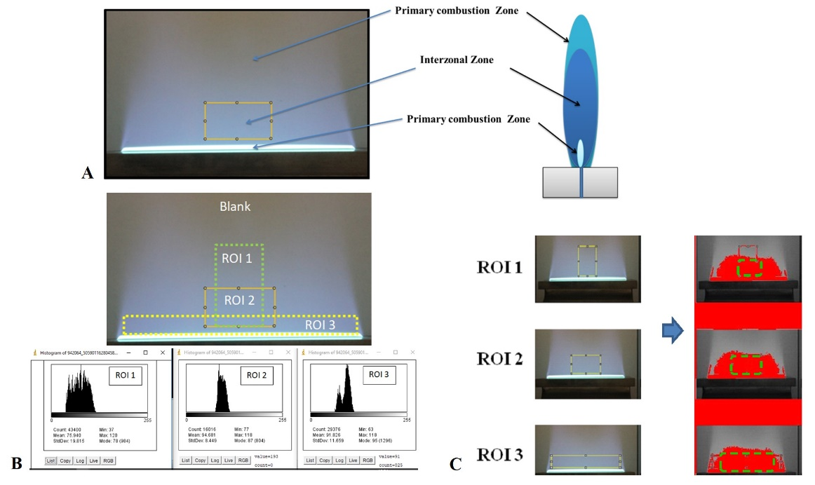

Figure 2. ROI for image processing: A; flame zones, B; the three ROIs with histogram, C; ROI with threshold

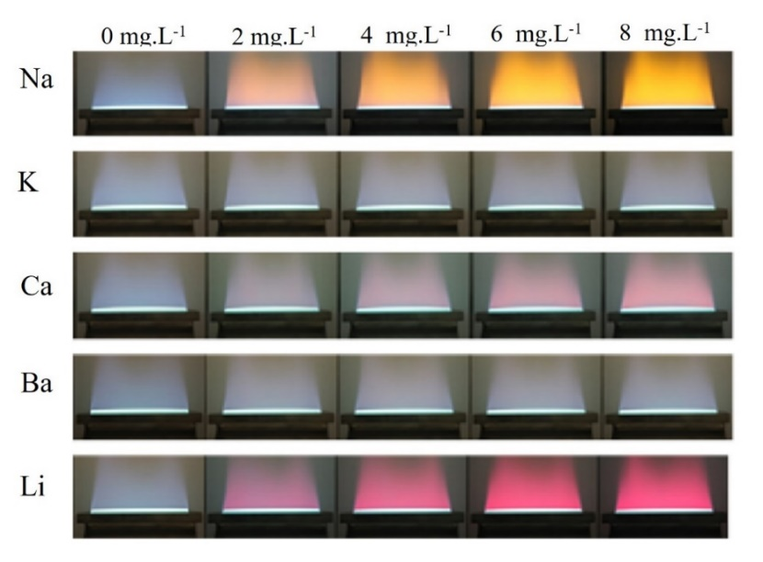

Figure 3. Illustration of photos of the flame colors due to the solutions of Na⁺, K⁺, Ca^{2+,} Ba^{2+,} and Li⁺ under the experimental conditions taken by the DSLR camera

Table 1. Calibration equations obtained by the ratio of color intensity value vs concentration using DSLR camera
Element (Color) | Color Intensity Ratio | Linear Equation | R²
Na (yellow) | R/B | y = 0.38x + 0.72 | 0.996
K (violet) | B/R | y = 0.0046x + 1.3 | 0.998
Ca (orange) | R/B | y = 0.064x + 0.84 | 0.999
Ba (lime green) | G/R | y = 0.043x + 0.96 | 0.995
Li (red) | R/B | y = 0.12x + 0.91 | 0.998

*Concentration range: 2.0- 8.0 mg L⁻¹

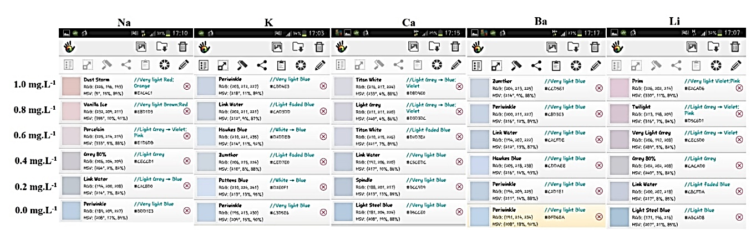

Figure 4. Information of color intensity under ROI approach using Color Grab application in the smartphone

Table 2. Calibration equations obtained by the ratio of color intensity value vs concentration using smartphone
Element (Color) | Color Intensity Ratio | Linear Equation | R²
Na (yellow) | R/B | y = 0.32x + 0.85 | 0.997
K (violet) | B/R | y = 0.11x + 0.85 | 0.995
Ca (orange) | R/B | y = 0.16x + 0.83 | 0.999
Ba (lime green) | G/R | y = 0.090x + 0.51 | 0.998
Li (red) | R/B | y = 0.18x + 0.88 | 0.996

*Concentration range: 0.2-1.0 mg L⁻¹

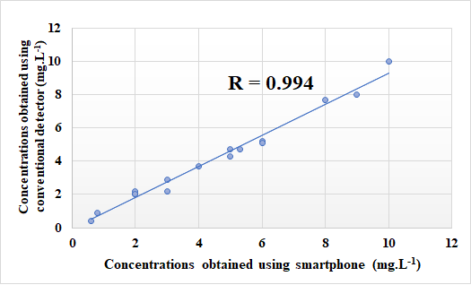

Figure 5. Correlation of the results obtained by using smartphone and conventional detector

Table 3. Determination of elements of interest in real samples using flame photometer with smartphone and conventional detectors
Element/Sample | Sample Code | Content in Solution Sample (mg L⁻¹) |  | t valueª
 |  | Smartphone | Conventional Detector | t_{observed} | t_{critical}
Na/fish sauce | FS1 | 5.3(±0.3)* | 4.7(±0.1)* | 0.59 | 4.30
 | FS2 | 2.0(±0.2)** | 2.0(±0.2)**
 | FS3 | 6.0(±0.2)* | 5.2(±0.2)*
Ba/wastewater | WT1 | 0.6(±0.1) | 0.4(±0.1) | 0.85 | 12.7
 | WT2 | 0.8(±0.1) | 0.9(±0.1)
Li/leaching battery solution | LBW1 | 2.0(±0.2)** | 2.2(±0.1)** | 0.35 | 3.15
 | LBW2 | 2.0(±0.1)** | 2.0(±0.1)**
 | LBW3 | 3.0(±0.2)** | 2.2(±0.1)**
 | LBW4 | 3.0(±0.1)** | 2.9(±0.1)**
K/fertilizer | FZ1 | 10.0(±0.3)* | 10.0(±0.1)* | 0.42 | 12.7
 | FZ2 | 9.0(±0.5)* | 8.0(±0.5)*
Ca/milk | MK1 | 8.0(±0.3)* | 7.7(±0.3)* | 0.38 | 2.78
 | MK2 | 5.0(±0.1)* | 4.7(±0.2)*
 | MK3 | 5.0(±0.2)* | 4.3(±0.2)*
 | MK4 | 6.0(±0.5)* | 5.1(±0.3)*
 | MK5 | 4.0(±0.1)* | 3.7(±0.1)*

ª95% confidence limit, With dilution: *10-folds, **5-folds

Conclusion

The use of an everyday life camera with image processing as alternative of detection in a flame photometer has been investigated for the assays of Na, K, Ca, Ba, and Li. The cameras were DSLR and smartphone. Using a smartphone which is commonly available together with available applications offers all operations to be done within the smartphone device, including evaluation and report. Application to real samples has been demonstrated.

Acknowledgement

The TRF Distinguished Research Professor Award Grant (DPG6080002 to Kate Grudpan), Chiang Mai University (through the Center of Excellence for Innovation in Analytical Science and Technology (I-ANALY-ST) and the Graduate School) and Lampang Rajabhat University are acknowledged. Thanks are due to Dr. Kanokwan Kiwfo for her help in manuscript preparation, and Prof. Gary Christian for editing the manuscript.

References
- Almeida, M. I. G. S., Segundo, M. A., Lima, J. L. F. C. and Rangel, A. O. S. S. (2008). Direct introduction of slurry samples in multi-syringe flow injection analysis: Determination of potassium in plant samples. Analytical Sciences, 24: 601-606.
- Rangel, A. O. S. S., and Toth, I. V. (1996). Flow injection sequential speciation of free and total potassium in fortified wines. Analytical Sciences, 12: 887-891.
- Lima, J. L. F. C. A., Rangel, O. S. S. and Souto, M. R. S. (1996). Simultaneous determination of potassium and sodium in vegetables by flame emission spectrometry using a flow-injection system with two dialysis units. Analytical Sciences, 12: 81-85.
- Barros, A. I., Oliveira, A. P. M., Magalhaes, R. L., and Villa, R. D. (2012). Determination of sodium and potassium in biodiesel by flame atomic emission spectrometry. Fuel, 93: 381-384.
- Castanheira, I., Figueiredo, C., Andre, C., Coelho, I., Silva, A. T., Santiago, S., Fontes, T., Mota, C., and Calhau, M. A. (2009). Sampling of bread for added sodium as determined by flame photometry. Food Chemistry, 113: 621-628.
- Ferreira, I. M. P. L. V. O., Lima, J. L. F. C. and Rangel, A.O. S. S. (1994). Flow injection sequential determination of chloride by potentiometry and sodium by flame emission spectrometry in instant soups. Analytical Sciences, 10: 801-805.
- Wen, G. H., (2002). Spectrophotometric determination of trace amounts of calcium using the calcium complex with alizarin. Journal of the Brazilian Chemical Society, 13:78-81.
- Nakashima, K., Muraki K., Nakatsuji, S. and Akiyama, S. (1989). Coloration reaction of a crowned 2,4-dinitrophenylazophenol-barium(II) complex with amines and its application to flow injection spectrophotometry. Analyst, 114: 501-504.
- Wu, Y. P. and Pacey, G. E. (1984). Spectrophotometric determination of lithium ion with the chromogenic crown ether, 2”,4”-dinitro-6”-triﬂuoromethylphenyl-4-0-aminobenzo-14-crown-4. Analytica Chimica Acta, 162: 285-291.
- Nazarenko, A. Y. (2004). Educational multiwavelength atomic emission spectrometer. Spectrocscopy. Letters, 37(3): 235-243.
- Bright, R. M., Momoh, P. O., Bozeman, A. D., Seney, C. S. and Sinclair, K. V. (2005). Development of a multiple-element flame emission spectrometer using CCD detection. Journal of Chemical Education, 82(12): 1826-1830.
- Debus, B., Kirsanov, D., Yaroshenkoab, I., and Leginab, A., (2017). A simple design atomic emission spectrometer combined with multivariate image analysis for the determination of sodium content in urine. Analytical Methods, 9: 3237-3243.
- Lyra, W. S., Santos, V. B., Dionízio, A. G. G., Martins, V. L., Almeida, L.F., Gaião, E. N. P., Dias Diniz, E. H. G., Silva, C. and Araújo, M. C. U., (2009). Digital image-based flame emission spectrometry. Talanta, 77: 1584-1589.

- Lyra, W. S., Sanches, F. A. C., Cunha, F. A. S., Diniz, P. H. G. D., Lemos, S.G., Silva, E. C. and Araujo, M.C.U. (2011). Indirect determination of sodium 224 diclofenac, sodium dipyrone and calcium gluconate in injection drugs using digital image-based (webcam) flame emission. Analytical Methods, 3: 1975-1980.
- Moraes, E. P., Silva, N. S. A., Morais, C. L. M., Neves, L. S. and Lima, K. M. G. J. (2014). Low-cost method for quantifying sodium in coconut water and seawater for the undergraduate analytical chemistry laboratory: Flame test, a mobile phone camera, and image processing. Journal of Chemical Education, 91(11): 1958-1960.
- Christian, G. D., Dasgupta, P. K. and Schug, K. A. (2014). Analytical Chemistry. Wiley, New York: pp. 84-105.

