

ROLE OF VANADIA AND TITANIA PHASES IN THE REMOVAL OF METHYLENE BLUE BY ADSORPTION AND PHOTOCATALYTIC DEGRADATION

(Peranan Fasa Vanadia dan Titania dalam Penyingkiran Metilena Biru Melalui Penjerapan dan Degradasi Fotokatalisis)

Pei Wen Koh^{1,2}, Cheng Yee Leong², Leny Yuliati^{2,3}, Hadi Nur², Siew Ling Lee²*

¹Department of Chemistry, Faculty of Science
²Centre for Sustainable Nanomaterials, Ibnu Sina Institute for Scientific and Industrial Research
Universiti Teknologi Malaysia, 81300 Johor Bahru, Malaysia
³Ma Chung Center for Photosynthetic Pigments,
Universitas Ma Chung, Malang 65151, Indonesia

*Corresponding author: sllee@ibnusina.utm.my

Received: 18 July 2019; Accepted: 20 July 2020; Published: xx December 2020

Abstract
Total removal of methylene blue (MB) over vanadia (V₂O₅) -modified titania (TiO₂) composite demonstrated that the V₂O₅ and TiO₂ phases played a vital role in the adsorption and photodegradation of MB, respectively. The 10 mol% of V₂O₅- modified TiO₂ (10V-TiO₂) showed the highest removal of MB, i.e., 26- and 2-folds better adsorption capacity than that of undoped TiO₂ and V₂O₅, respectively. The presence of surface hydroxyl, pores, and the highest amount of V⁵⁺ species in 10V-TiO₂ could be responsible for the high adsorption of MB. V₂O₅ induced anatase to rutile phase transformation and shifted absorption properties of TiO₂ to the visible light region. Considering the rutile phase has lower bandgap energy (3.0 eV), its presence in the sample has enhanced the photodegradation of MB. The photodegradation of MB followed pseudo-second-order reaction. The reusability test elucidated that the photodegradation performance of 10V-TiO₂ was improved by 30-folds after the second cycle, with total MB removal due to the exposure of more TiO₂ to MB.

Keywords: vanadia, titania, methylene blue, adsorption, photocatalyst, photodegradation

Abstrak
Penyingkiran metilena biru (MB) secara keseluruhan oleh komposit titania (TiO₂) yang diubahsuai dengan vanadia (V₂O₅) menunjukkan bahawa fasa V₂O₅ dan TiO₂ masing-masing memainkan peranan penting dalam penjerapan dan fotodegradasi MB. TiO₂ yang diubahsuai dengan 10 mol% V₂O₅ (10V-TiO₂) menunjukkan penyingkiran MB yang tertinggi, iaitu 26- dan 2-kali ganda kapasiti penjerapan yang lebih baik daripada TiO₂ dan V₂O₅ yang tidak didopkan. Kewujudan hidrosil di permukaan, liang, dan jumlah spesis V⁵⁺ tertinggi dalam 10V-TiO₂ menyumbang kepada penjerapan MB yang tinggi. V₂O₅ mendorong transformasi fasa anatase ke rutil dan sifat-sifat penyerapan TiO₂ beralih ke rantau cahaya nampak. Memandangkan fasa rutil mempunyai tenaga jurang jalur yang lebih rendah (3.0 eV), kewujudannya dalam sampel telah meningkatkan prestasi fotodegradasi MB. Fotodegradasi MB mengikuti tindak balas tertib pseudo-kedua. Ujian kebolehgunaan tersebut membuktikan bahawa prestasi fotodegradasi 10V-TiO₂ telah ditingkatkan sebanyak 30-kali ganda selepas kitaran kedua kerana lebih banyak TiO₂ terdedah kepada MB.

Kata kunci: vanadia, titania, metilena biru, penjerapan, fotokatalis, fotodegradasi

Introduction
Soil and water contamination by dye-containing effluents are serious environmental issues. The release of these coloured compounds into the drainage system has significantly impacted human and aquatic lives due to their toxicity. Although many technologies have been developed to treat dye-containing effluent at an acceptable level before drainage, there is no single process capable of adequately treating these dye-containing wastewaters. It was suggested that a combination of different techniques would be a better solution to remove the dyes [1, 2]. Compared to the conventional biological physicochemical method, it is undeniable that adsorption is a superior method established for the removal of dye due to its simplicity in design, efficiency, and ability to treat dye in larger quantities [3]. A good adsorbent should have high selectivity and adsorption capacity for the targeted adsorbate. However, in many cases, surface modification using an expensive surfactant, chemical, or heat treatment is always applied to solve the limitations of the surface functional group of adsorbents [4]. Another shortcoming of the adsorption method is associated with the formation of secondary pollution following the adsorption process. Photocatalysis appears to be a promising green technology approach to address this problem compared to conventional treatments such as flocculation, coagulation, and adsorption, which often result in secondary pollution [5, 6]. Photocatalysis is capable of fully mineralising toxic dye to non-toxic anionic compounds. However, its usage is only applicable to trace amount of dye-containing wastewater.

Among many semiconductor photocatalysts, titanium dioxide (TiO₂) has gained considerable attention due to its high activity, high light-illumination stability, non-toxic properties, and low price [7]. However, its low surface area has limited its adsorption and photocatalytic degradation efficiency under ultraviolet (UV) light. Recently, comprehensive review and studies on the effectiveness of incorporating TiO₂ on porous adsorbents had been reported [8-10]. The catalytic performance of TiO₂ can be improved by loading TiO₂ onto various supporting adsorbents. Other drawbacks of TiO₂ photocatalyst include high recombination rate of the electron-hole, high bandgap energy, and inactivity under visible light that affected its application under sunlight. A standard method used to solve the problems above is the modification of TiO₂ via transition metal doping. Transition metal doping appears to be one of the most effective approaches to reduce the rate of electrons and holes recombination [1, 11-13]. Visible light-driven vanadia-doped titania photocatalysts in pure anatase phase have been reported [14, 15]. Their enhanced photocatalytic behaviour was attributed to the highly dispersed vanadia in the TiO₂ crystallite, which successfully reduced the bandgap energy and increased the ability to absorb visible light.

Nguyen et al. reported that 10% vanadia-doped TiO₂ (V-TiO₂) is an excellent adsorbent for decolourisation of methylene blue (MB) [16]. This material possessed anatase and a negligible percentage of brookite phases. It was claimed that the good interaction between vanadia-doped TiO₂ and the dye molecules as well as the increased oxidation states of Ti, V, and O have contributed to the excellent adsorption ability of the material, resulting in the removal of 91.6% MB after 2 hours reaction time [16]. The usage of V-TiO₂ as a photocatalyst has been widely reported. In the current study, we present new insight into the role of the respective vanadia and titania in the V-TiO₂ composite through adsorption and photocatalysis of MB. MB was selected as a model reaction because it is widely used for dyeing in many industries such as silk, paper, ink and used as cotton mordant with tannin [2].

Materials and Methods

Materials
The materials used for this study include titanium tetraisopropoxide (TTIP; 97%, Aldrich), absolute ethanol (99.98%, HmBG), acetylacetone (≥ 99%, Aldrich), and vanadyl acetylacetonate (98%, Aldrich).

Synthesis of vanadia modified titania
Vanadia-modified titania (V-TiO₂) materials were prepared through the sol-gel method. The experimental procedures were reported in previous studies [2, 17]. In a typical synthesis, titanium tetraisopropoxide (TTIP; 97%, Aldrich) was mixed with absolute ethanol (99.98%, HmBG) and acetylacetone (≥ 99%, Aldrich) according to the molar ratio of 1:100:2. The mixture was then stirred for 60 min at room temperature. Vanadia precursor was prepared separately by dissolving a pre-calculated amount of vanadyl acetylacetonate (98%, Aldrich) in acetylacetone. The two solutions were mixed and stirred for 30 minutes at room temperature, followed by evaporation at 353 K. The obtained solid material was calcined at 773 K for 5 hours. The molar ratio of vanadia in TiO₂ was varied from 1 to 10 mol%. The resulted materials were denoted as xV-TiO₂, where x represents mol% of V. Undoped TiO₂ was prepared with the same procedures without the addition of vanadyl acetylacetonate for comparison. Bulk V₂O₅ was prepared by evaporating vanadyl acetylacetonate (98%, Aldrich) in acetylacetone at 273 K, followed by calcination at 773 K for 5 hours.

Characterisation
Phase purity and crystallinity of the synthesised undoped TiO₂, vanadium oxide-modified titania, and bulk V₂O₅ samples were examined using Powder X-ray diffraction (XRD) analyser. The XRD measurements were conducted on Bruker Advance D8 X-ray diffractometer with Cu Kα radiation (λ = 0.15418 nm, 40 KV, 40 mA, scan rate 0.1˚/s). The Diffuse reflectance UV-visible (DR UV-Vis) spectra were recorded on Perkin Elmer Ultraviolet-visible Spectrometer Lambda 900 with BaSO₄ as reference. Bandgap energy of the samples was calculated from the extrapolation of the Tauc plot. Surface morphology of the prepared samples was investigated using Field Emission Scanning Electron Microscopy (FESEM). The samples were coated with platinum using Auto Fine Coater (JEOL JFC-1600), prior to analysis using a FESEM instrument (JSM-6701F). The surface area and pore size distribution of the samples were confirmed using Brunauer-Emmett-Teller (BET) and Barrett-Joyner-Halenda (BJH) equations from adsorption-desorption isotherms at 77 K obtained by using 3Flex Surface Characterisation Analyser (Micromeritics). Before analysis, all the samples were degassed at 573 K for 4 hours. Temperature programmed reduction (TPR) was conducted to investigate the reducible species of surface vanadia on TiO₂. Selected samples were analysed in the temperature range of 573–973 K on Micromeritics AutoChem II 2920 chemisorption analyser. Prior to measurement, the samples were pre-treated under N₂ gas flowing at 473 K for 15 minutes. Argon gas, which contained 5.1% H₂, was passed through the sample tube during measurement with the flow rate of 25 cm³/min. Zeta potential of the samples was recorded on Malvern Zetasizer Nano ZSP.

Adsorption and photocatalytic degradation
Adsorption and photocatalytic testing were carried out on all synthesised materials. Aqueous solution of 50 mL 100 ppm MB solution and 0.1 g of the prepared material were placed in a beaker. Adsorption test was conducted prior to photocatalytic evaluation. The mixture was stirred in the dark at a constant temperature for 24 hours for the determination of adsorption capacity. Aliquots of 2 mL were withdrawn at different times within 24 hours and were put through a syringe filter. For the photocatalytic activity evaluation, the sample and MB solution were irradiated by a halogen fibre optic light illuminator (Dolan-Jenner MI 157, 150 W) as the visible light source for 24 hours, straight after the adsorption test of 24 hours. A UV cut-off filter (400 nm, Edmund Optics) was used to filter the UV light. The photocatalytic activity of the samples was assessed using UV-Vis spectrophotometer (Thermo Fisher, Genesys 10S) to measure the concentration of MB solution before and after the photodegradation. Adsorption and photocatalytic activities of undoped TiO₂ and bulk V₂O₅ were also included for comparison.

Results and Discussion
Phases formation
As evidenced by XRD analysis (Figure 1), the undoped TiO₂ was in pure anatase phase, as its XRD pattern was well-matched with that reported in JCPDS 21-1272. The anatase phase remained after doping of 1 mol% V in 1V-TiO₂, but the peak becomes slightly broader. The crystallite sizes of the samples were calculated using the Scherrer equation, and the results are shown in Table 1. The crystallite size decreased with an increasing amount of V oxide modifier, suggesting the addition V oxide inhibited the crystal growth of TiO₂. As observed, the rutile phase was detected when 2 mol% and above of V oxide was added into TiO₂, indicating the presence of an adequate amount of V has induced transformation of anatase to rutile phase. It was documented that due to the similar ionic radii of V⁴⁺ (0.580 Å) and V⁵⁺(0.540 Å) to that of Ti⁴⁺ (0.605 Å) [18], making substitution of Ti by V at substitutional position possible. Therefore, it resulted in rutile phase formation [19]. The result was in good agreement with the previous study, which stated that the formation of the rutile phase upon V doping [20]. The detection of rutile phase was a good indication of successful V incorporated in the TiO₂ lattice, even though peaks assigned to V oxides were not detected in all the V-doped TiO₂ samples.

The undetectable V peaks could be attributed to a little amount of the V dopant (at low concentration of V dopant), or the dopant was highly dispersed on the TiO₂ surface. Alternatively, the undetectable vanadia peak was ascribed to amorphous nature of vanadia [21]. XRD pattern of the bulk V₂O₅ was in agreement with the reported pattern (JCPDS 01-0359), indicating it crystallised in orthorhombic structure. The current study indicated that the vanadium oxide present in the current sample was crystalline, not amorphous.

The percentage of anatase phase in the synthesized V-doped TiO₂ samples was calculated using the Spurr equation [22]:

A (%) = 100 / (1+1.265 I_{R}/I_{A}) (1)

where I_{R} is intensity of rutile peak at 2θ = 27.5° (110) and I_{A} is intensity of anatase peak at 2θ = 25.5° (101). The percentage of rutile phase was obtained via subtraction of 100% on the calculated anatase percentage, assuming that the materials were totally crystallised.

Table 1 lists the anatase and rutile percentages in the synthesised samples. It was found that the percentage of rutile phase was independent to the amount of V dopant and remained constant in the range of 20.0% to 23.6%. The anatase to rutile transformation can be explained in terms of the valency state of the ion. Every four doping of V⁵⁺ in the Ti⁴⁺ octahedral cationic site led to one Ti⁴⁺ cation vacancy, which promotes the rutile phase formation. However, as the V amount increased, the accommodation of excess cation vacancy seems unfavourable in the anatase structure [23]. Hence, further addition of V oxide modifier did not promote more anatase-rutile transformation.

Optical properties
The prepared TiO₂ was a white powdered material, while the bulk V₂O₅ was an orange powder. All the V-TiO₂ samples were brownish. The colour of the V-TiO₂ samples was more intense, with the increase of the V content. A similar observation was reported previously [15]. As depicted in Figure 2, the undoped TiO₂ has absorption bands in the UV region ranged from 200-400 nm. The dominant peak found at 330 nm was identified as octahedral Ti species, while the shoulder at 230 nm was associated with tetrahedral coordinated Ti species [24]. Redshifts and new peaks of absorption within a range of 400-800 nm was observed after the modification with V oxides. In the resulting products, the extension in the absorption spectrum was demonstrated by the colour changes. The tailing of absorption curves revealed that all the V-TiO₂ materials absorbed the photon energy in the visible light region ranged 380-780 nm. The broadened peaks at 570 and 770 nm were due to V⁵⁺ and V⁴⁺, respectively [25]. As can be seen, the intensity of the V⁵⁺ absorption peak increased with the increase of V content in the samples. The 10V-TiO₂ sample possessed the highest amount of V⁵⁺, followed by 4V-TiO₂, 3V-TiO₂, 2V-TiO₂, and 1V-TiO₂. For bulk V₂O₅, the presence of a shoulder at 242 nm and two peaks at 380 and 480 nm were due to transitions in ligand-metal charge transfer (LMCT)
involving the charge transfer from oxygen ligands to the V⁵⁺ metal cation [26].

The bandgap energy of the samples was calculated from the Tauc plot. The following equation was used: αhv = A(hv-E_{g})^{n/2}, where α, hv, A, E_{g} are absorption coefficient, photon energy, a constant, and an optical bandgap, respectively. In this equation, n is determined by the transition type; n value is 1 and 4, for direct and indirect bandgap transitions. The value of n and E_{g} were first determined by plotting the graph In(αhv) vs. In(hv-E_{g}), using an appropriate value of E_{g}. The value of n was determined from the slope of the straight line near the band edge. After that, (αhv)^{2/n} vs. hv was formed, and a tangential line was plotted along the band edge, with the tangent line x-intercept corresponding to the optical bandgap. The obtained results are tabulated in Table 1. The findings showed that the bandgap energy of TiO₂ (3.25 eV) dropped significantly after doping of 1 mol% V into TiO₂ (2.15 eV). The bandgap energy of TiO₂ was further decreased with increasing of V amount. It was believed that the 3d orbital of vanadia had reduced the bandgap energy of TiO₂. The lowest bandgap energy of 1.50 eV was achieved in 10V-TiO₂.

Morphology
FESEM images of undoped TiO₂ and selected V-TiO₂ samples are illustrated in Figure 3. Undoped TiO₂ (Figure 3(a)) appeared to be large blocks of coarse material. The addition of 1 mol% V dopant also displayed similar features to undoped TiO₂, but with the formation of more small particles on the large material. Also, holes are formed between the particles, as shown in Figure 3(b).

Sample 4V-TiO₂ showed more small particles agglomerated with reduced holes between the small particles on the surface of the larger particle course. The surface of 10V-TiO₂ sample was smoother and more homogeneous, with small spherical particles agglomerated on the surface of TiO₂. The current results revealed that the addition of V oxide modifier could alter the morphology of undoped TiO₂ powder to be smoother. The FESEM images of V-TiO₂ supported the XRD results whereby the addition of excess V dopants (> 2 mol%) was not favourable in the anatase structure and could have resided on the surface of TiO₂ to form V₂O₅.

Textural analysis
The nitrogen adsorption-desorption isotherms of samples are presented in Figure 4. All synthesised samples possessed type IV isotherm, which is the characteristic of a mesoporous material. From the isotherm curve, it was observed that undoped TiO₂, 1V-TiO₂, and 2V-TiO₂ have H3 hysteresis loops, indicating the samples have slit-shaped pores. As the amount of V dopant increased, the hysteresis loops changed from H3 to H2 for samples 3V-TiO₂ and 4V-TiO₂, indicating these samples have bottleneck shape pore. Meanwhile, 10V-TiO₂ has hysteresis loop of H1, denoting the pore shape was cylinder-shaped. It was observed that the closing of the hysteresis loop of samples 1 to 4 mol% V-TiO₂ was approximately at 0.45 P/P_{o}, while the closing loop of 10V-TiO₂ was at 0.75 P/P_{o}. The results suggested that former samples had smaller mesopores while the latter sample had larger mesopores. In addition, 10V-TiO₂ possessed macropores since it showed a slight increase in adsorption in 0.95–1.00 P/P_{o}.

The specific surface area, total pore volume, and average pore diameter of samples are tabulated in Table 2. The increasing amount of V oxide modifier increased the surface area of TiO₂ by 2-fold from 17 to 34 m² g⁻¹. The increase of the surface area could be ascribed to the presence of V, which inhibited the crystalline growth, leading to an enlarged surface area. However, the addition of 10 mol% V reduced the surface area to 23 m² g⁻¹. This was due to the excess modifier covering the surface of TiO₂, as demonstrated by Figure 3(d). It is evident from Figure 3(d) that the surface of 10V-TiO₂ had been covered up by the modifier compared to Figure 3(a), which depicts the TiO₂ without a modifier.

Addition of 1 to 3 mol% V has a negligible effect on the total pore volume. The increase of pore volume for 4V-TiO₂ and 10V-TiO₂ samples was in agreement with the changing of the hysteresis loop, whereby the hysteresis loop H2 of 4V-TiO₂ was larger as compared to 3V-TiO₂ sample. Meanwhile, 10V-TiO₂ has the most significant total pore volume among the samples because it possessed macropores as evidenced by the isotherm plot.

The BJH pore size distribution is shown in Figure 5. The pore size was tuneable with the addition of V oxide modifier. The pore size distribution of samples with less than 4 mol% V became more homogenous and shifted to smaller pore size.

The current result is supported by the FESEM images where the pores between particles (textural) were reduced. The average pore diameter of 10V-TiO₂ was the largest among the samples. Figure 5 shows that 10V-TiO₂ has pores larger than 50 nm, confirming that this sample consisted of a mixture of meso and macropores, leading to the largest average pore diameter.

Figure 1. XRD patterns of (a) TiO₂, (b) 1V-TiO₂, (c) 2V-TiO₂, (d) 3V-TiO₂, (e) 4V-TiO₂, (f) 10V-TiO₂, and (g) V₂O₅

Table 1. Phases composition, crystallite size and bandgap energy of TiO₂, V₂O₅ and V-TiO₂ samples
Sample | Anatase (%)ª | Rutile (%)^{b} | Crystallite size (nm) | Bandgap (eV)^{c}
TiO₂ | 100.0 | n.a. | 20.1 | 3.25
1V-TiO₂ | 100.0 | n.a. | 16.2 | 2.75
2V-TiO₂ | 80.0 | 20.0 | 16.5 | 2.00
3V-TiO₂ | 77.4 | 22.6 | 14.7 | 1.95
4V-TiO₂ | 76.4 | 23.6 | 14.8 | 1.80
10V-TiO₂ | 78.2 | 21.8 | 14.5 | 1.50
V₂O₅ | n.a | n.a | n.a | 2.30
ª Calculated from Spurr equation, ^{b} Calculated from 100%- anatase phase%, ^{c} Calculated from extrapolation of Tauc plot and n.a. – not available

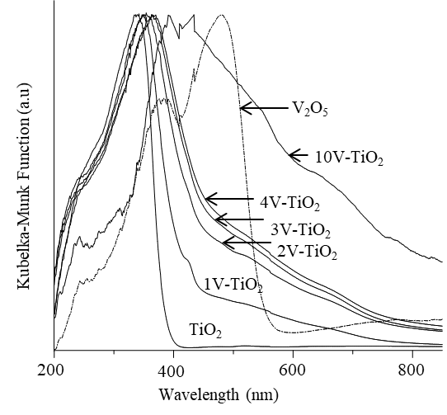
Figure 2. DR-UV-Vis spectra of TiO₂, V₂O₅, and V-doped TiO₂ samples
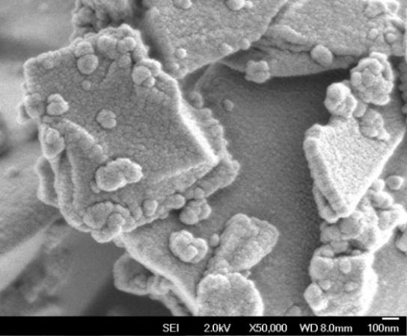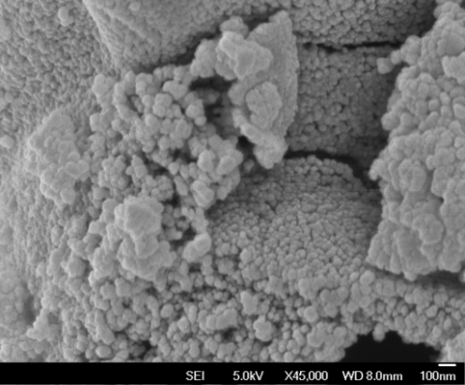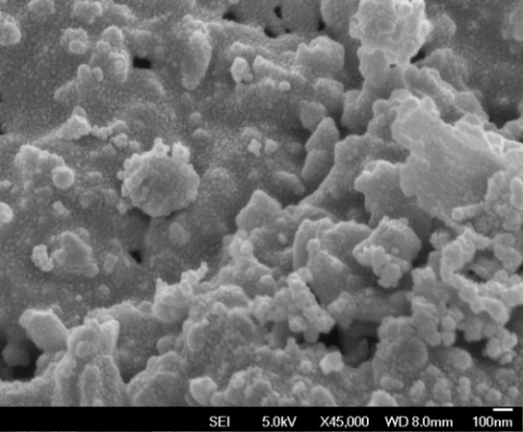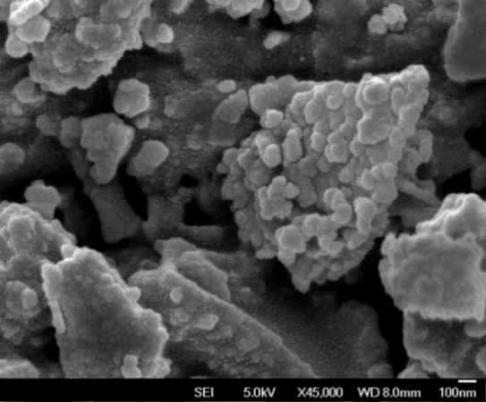
(a)
(b)
(c)
(d)
Figure 3. FESEM images of (a) TiO₂ (magnification ×50,000), (b) 1V-TiO₂ (magnification ×45,000), (c) 4V-TiO₂ (magnification ×45,000), and (d) 10V-TiO₂ (magnification ×45,000)

0
0.2
0.4
0.6
0.8
1.0
Relative Pressure (P/P_{o})
Amount of N₂ adsorbed (cm³/g)
(f)
(e)
(d)
(c)
(b)
(a)
0
100
200
Figure 4. N₂ adsorption-desorption isotherms of (a) TiO₂, (b) 1V-TiO₂, (c) 2V-TiO₂, (d) 3V-TiO₂, (e) 4V-TiO₂, and (f) 10V-TiO₂. (Remarks: filled points are adsorption isotherms, empty points are desorption isotherms. Figures (b)–(f) are marginally moved upwards for 20, 40, 60, 80, and 120 cm³/g, respectively for clearer presentation).

Table 2. Surface area, total pore volume and average pore diameter of TiO₂ and V-TiO₂ samples
Sample | Surface Area  (m² g⁻¹) | Total Pore Volume  (cm³ g⁻¹) | Average Pore Diameter  (Å)
TiO₂ | 17 | 0.0677 | 164.27
1V-TiO₂ | 21 | 0.0659 | 125.94
2V-TiO₂ | 25 | 0.0649 | 105.38
3V-TiO₂ | 29 | 0.0660 | 90.12
4V-TiO₂ | 34 | 0.0794 | 94.78
10V-TiO₂ | 23 | 0.1218 | 212.00

0
0.2
0.1
500
1000
1500
0
dV/dD (cm³/g)
(f)
(e)
(d)
(c)
(b)
(a)
Relative Pressure (P/P_{o})
Figure 5. BJH pore size distributions of (a) TiO₂, (b) 1V-TiO₂, (c) 2V-TiO₂, (d) 3V-TiO₂, (e) 4V-TiO₂, and (f) 10V-TiO₂

Surface oxidation state analysis
Temperature program reduction (TPR) was performed on selected samples to analyse vanadium surface oxidation states in the samples. H₂-TPR spectra of V- TiO₂ samples and V₂O₅ are shown in Figure 6. The 1 mol% V gave only one reduction peak at 814.3 K, which corresponded to the reduction of V₆O₁₃ to V₂O₄ [27], indicating that V⁴⁺ existed dominantly in 1V-TiO₂. The higher amount of V oxide modifier (4 mol%) resulted in a lower reduction peak at 647.4 K in 4V-TiO₂. This peak was associated with the reduction of V₂O₅ to V₆O₁₃ [27]; hence, it was a good indication of V⁵⁺ species existence. The detection of this peak is always linked to the formation of the strong interaction between V species and the H₂ gas due to V-O-Ti bonds of higher reducibility. Besides, a hump at 765.1 K was also observed in 4V-TiO₂, implying the presence of trace V⁴⁺ species.

Similarly, 10V-TiO₂ exhibited two reduction peaks at 684.5 and 841.3 K. Figure 6 shows that the intensity of
the reduction peak at 684.5 K is remarkably higher than that of 4V-TiO₂, strongly indicating the existence of more V⁵⁺ in 10V-TiO₂ compared to the latter sample. The maximum reduction temperature and the corresponded hydrogen consumption of each sample are tabulated in Table 3. As observed, the amount of V⁵⁺ in the 10V-TiO₂ was 5-fold of that in 4V-TiO₂. The bulk V₂O₅ showed only one reduction peak at 867.6 K, which corresponded to bulk vanadate. It was reported that more bulk vanadate was formed with increasing of vanadia content in vanadia-titania catalyst [27].

The contradiction could be due to different synthetic method and calcination temperature applied in the studies. The authors had synthesised vanadia-titania via the impregnation method at 673 K. Unlike the impregnation method, the sol-gel method applied in the current work was believed to enable the loading of vanadia not only on the TiO₂’s surface but also in the TiO₂ lattice. Meanwhile, the higher calcination temperature of 773 K had resulted in more interaction between vanadia and TiO₂ that facilitated the formation of more reducible V⁵⁺ species in the materials [28]. In the present work, the decrease of reduction temperature in V₂O₅ in the presence of TiO₂ can be explained by the structure distortion in V₂O₅ due to the extensive interaction with the TiO₂ support. A similar phenomenon was found for 12-molybdophosphoric acid supported on V₂O₅ dispersed γ-Al₂O₃ catalyst [29]. Therefore, we conclude that the presence of TiO₂ phase is essential as support for V⁵⁺ species formation.

Adsorption and photocatalytic performance
Adsorption and photocatalytic activity of the resulting V-TiO₂ samples were assessed over decolourisation of MB. As illustrated in Figure 7, the adsorption of MB on undoped TiO₂ is only 3% after 24 hours. Doping of 1 mol% V into TiO₂ allows 1V-TiO₂ to adsorb 9% MB after 2 hours. The increased V dopant amount of 2, 3, 4, and 10 mol% V had further enhanced the MB adsorption to 18%, 25%, 31%, and 68% after 2 hours. The adsorption of MB increased significantly by the increasing amount of V in V-TiO₂. The results demonstrated that the adsorption capacity of 10V-TiO₂ was 26-folds higher than that of undoped TiO₂. This material adsorbed 95% MB after 24 hours, confirming it was an excellent adsorbent for MB.

Zeta potential was conducted to analyse the surface charge of the samples. It was found that the increased amount of V oxide modifier to 10 mol% decreases the isoelectric point (IEP) continuously from 4.23 to 2.01 (Table 3). This could be the reason for the tremendous increase of MB adsorption, a cationic dye, up to 68% after 2 hours when TiO₂ was modified with 10 mol% V oxide. In addition, MB has a high affinity for V⁵⁺ [30]. This further enhanced the adsorption capacity of MB on 10V-TiO₂, which possessed the highest amount of V⁵⁺ among the samples. Comparatively, the adsorption ability of the bulk V₂O₅ was poorer as it adsorbed only 40% of MB after 2 hours. The lower activity of bulk V₂O₅ could be attributed to its massive structure which makes the accessibility of MB on V⁵⁺ more difficult. Besides, the superior adsorption capability of 10V-TiO₂ as compared to bulk V₂O₅ could be due to the existence of more surface OH⁻ in 10V-TiO₂ to interact with the π-electron of MB [16, 31].

The photocatalytic activity evaluation was carried out straight after the adsorption test with the samples. Figure 7 displays that the undoped TiO₂ gave an activity of 14.4% of MB photodegradation even with the utilisation of UV cut-off filter (400 nm, Edmund Optics). This can be rationalised by the photosensitisation effect [32]. Usage of MB as a model reaction in photocatalysis has been highlighted by Ohtani and co-worker [33]. The authors claimed that MB was not an acceptable pollutant for the target study, particularly when it was degraded under visible light. However, Matos et al. [34] argued that the decolourisation of MB is suitable for assessing the photocatalytic behaviour of semiconductors under steady-state conditions of the effect of photon flux upon the first-order rate constant.

Among the V-TiO₂ samples, only the 4V-TiO₂ sample has photodegraded 13.5% of MB after 24 hours under visible light irradiation. The other V-TiO₂ samples have negligible photocatalytic activity under visible light irradiation. In contrast, it had been documented that photocatalytic activity TiO₂ in dye degradation was significantly enhanced after V doping [35]. The photocatalytic improvement was always associated with the extended optical absorption of TiO₂ to the visible light, reduction in bandgap energy and the presence of anatase/rutile mixing phase. In the present study, the MB molecules were preferably adsorbed at the V site due to the high affinity of V⁵⁺. The strong interaction between V⁵⁺ and the MB molecules was believed to hinder the diffusion of the dye molecules to the active site for photodegradation at Ti; hence, retard the photocatalytic activity of the V-doped TiO₂ samples. In 4V-TiO₂, only limited MB molecules that adsorbed at Ti site would be further photodegraded after irradiated under visible light. The schematic diagram showing roles of the vanadia and titania phases in the dye removal is illustrated in Figure 8.

Even though the photocatalytic activity of the V-TiO₂ was not comparable to its adsorption ability, the total removal of MB of V-TiO₂ significantly increased as compared to TiO₂ and V₂O₅. As mentioned, the photocatalytic enhancement of TiO₂ was always related to the extension of optical absorption to the visible light region. By comparing the adsorption and photocatalytic testing of V-TiO₂ samples to the XRD results as represented in Figure 1 and Table 1, it can be seen that part of the anatase to rutile phase transformation induced by the doping of V into TiO₂ might have enhanced the photodegradation of MB to visible light region, attributed by the lower bandgap energy (3.0 eV) of the rutile phase as compared to the anatase phase (3.2 eV). It is suggested in this study that the vanadia and titania played a different role in the adsorption-photocatalytic activity. The vanadia responsible for the anatase to rutile phase transformation as well as the shifting of the absorption properties of TiO₂ to visible light region, and at the same time, acted as an adsorbent, while the titania acted as the photocatalyst, responsible for the photodegradation activity.

Reusability test
Since 10V-TiO₂ has the highest removal of MB, it was chosen for the reusability test. The used 10V-TiO₂ was washed with distilled water several times and dried at 333 K. The reusability test was conducted for four successive cycles under the same conditions. It was found out that the adsorption capacity of the used-10V-TiO₂ decreased significantly to 28%, 26%, and 27% for second, third, and fourth cycles, respectively. The decrease of the adsorption capacity could be attributed to the leaching problem of vanadium oxide from the material. It was believed that the loss of the vanadium oxide could have decreased the hydroxyl surface group and hence leading to less adsorption of MB [36]. It was noted that after the adsorption for the first cycle, the adsorption for the rest of the cycles was almost constant, indicating that the material has become stable. It is worth to highlight that the photocatalytic performance of 10V-TiO₂ increased to approximately 30% for the second, third, and fourth cycles (Figure 9). The improvement in photocatalytic performance could be attributed to more TiO₂ were exposed to MB, leading to a more significant degradation of MB. The study indicated that 10V-TiO₂ was a good photocatalyst for MB photodegradation after second cycles onwards.

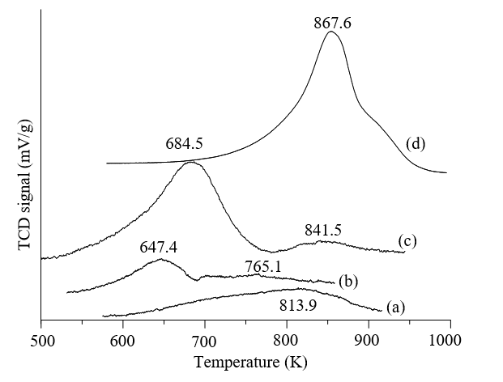
Figure 6. TPR profiles of (a)1V-TiO₂, (b) 4V-TiO₂, (c) 10V-TiO₂, (d) V₂O₅ (Intensity of V₂O₅ is multiplied with 0.1)

Dark
Visible Light
(a)
(b)
(c)
(d)
(e)
(f)
100
80
60
40
20
0
0
10
20
30
40
50
Time (hour)
Concentration (ppm)
(g)
Figure 7. The adsorption and photodegradation of MB using (a) TiO₂, (b) 1V-TiO₂, (c) 2V-TiO₂, (d) 3V-TiO_{2,} (e) 4V-TiO₂, (f) 10V-TiO₂, (g) V₂O₅

Table 3. Isoelectric point of prepared samples and its corresponded adsorption efficiency after 2 hours
Entry | Sample | IEP/pH | Adsorption Efficiency  After 2 hours /%
1 | TiO₂ | 4.23 | 3
2 | 1V-TiO₂ | 4.14 | 9
3 | 2V-TiO₂ | 4.13 | 18
4 | 3V-TiO₂ | 4.12 | 25
5 | 4V-TiO₂ | 2.22 | 31
6 | 10V-TiO₂ | 2.01 | 68

Figure 8. Schematic diagram showing the roles of vanadia and titania

% Photodegradation
Figure 9. Reusability test of 10V-TiO₂. (Conditions: concentration of MB = 100 ppm, mass of sample used = 0.1 g)

Conclusion
A series of V modified TiO₂ was successfully synthesised via the sol-gel method. Roles of vanadia and titania phases in the removal of MB were examined. The results demonstrated that the presence of vanadia phase was responsible for the rutile phase generation, bandgap reduction, and wavelength extension in the V-TiO₂ samples. On the other hand, the titania phase played a crucial role as support for the formation of more V⁵⁺ species. In the V oxide modified TiO₂ materials, vanadia phase was an excellent adsorbent attributed to the presence of V⁵⁺ species is abundant, which has a high affinity towards MB. Meanwhile, the titania phase acted as the photocatalyst in degrading MB. 10V-TiO₂ showed high photostability and reusability in photodegrading MB in second cycles and onward, attributed to more exposed of TiO₂ to MB.

Acknowledgement
Authors are grateful to financial support from Ministry of Higher Education Malaysia (MOHE) and Universiti Teknologi Malaysia through UTM Transdisciplinary Research Grant (Cost Centre No. Q.J130000.3554.07G57) and Professional Development Research University (Cost Centre No. Q.J.130000.21A2.03E61).

References
- Koh, P. W., Yuliati, L. and Lee, S. L. (2019). Kinetics and optimization studies of photocatalytic degradation of methylene blue over Cr-doped TiO₂ using response surface methodology. Iranian Journal of Science and Technology, Transactions A: Science, 43(1): 95-103.
- Koh, P. W., Hatta, M. H. M., Ong, S. T., Yuliati, L. and Lee, S. L. (2017). Photocatalytic degradation of photosensitizing and non-photosensitizing dyes over chromium doped titania photocatalysts under visible light. Journal of Photochemistry and Photobiology A: Chemistry, 332: 215-223.
- Kumar, P. S., Ramalingam, S. and Sathishkumar, K. (2011). Removal of methylene blue dye from aqueous solution by activated carbon prepared from cashew nut shell as a new low-cost adsorbent. Korean Journal of Chemical Engineering, 28(1): 149-155.
- Roosta, M., Ghaedi, M., Daneshfar, A., Sahraei, R. and Asghari, A. (2014). Optimization of the ultrasonic assisted removal of methylene blue by gold nanoparticles loaded on activated carbon using experimental design methodology. Ultrasonics Sonochemistry, 21(1): 242-252.
- Keng, P. S., Lee, S. L., Ha, S. T., Hung, Y. T. and Ong, S. T. (2013). Cheap materials to clean heavy metal polluted waters. In Green Materials for Energy, Products and Depollution Springer, Dordrecht: pp. 335-414.
- Leong, C.Y., Koh, P.W., Lo, Y.S., Lee, S.L. (2020). Hydrothermal synthesis of titanium dioxide nanotube with methylamine for photodegradation of Congo red. IOP Conf. Series: Materials Science and Engineering, 833, 012075.
- Pirkanniemi, K. and Sillanpää, M. (2002). Heterogeneous water phase catalysis as an environmental application: a review Chemosphere, 48(10): 1047-1060.
- MiarAlipour, S., Friedmann, D., Scott, J. and Amal, R. (2018). TiO₂/porous adsorbents: Recent advances and novel applications. Journal of Hazardous Materials, 341: 404-423.
- Ooi, Y. K., Hussin, F., Yuliati, L. and Lee, S. L. (2019). Comparison study on molybdena-titania supported on TUD-1 and TUD-C synthesized via sol-gel templating method: Properties and catalytic performance in olefins epoxidation. Materials Research Express, 6(7): 074001.
- Ooi, Y. K., Yuliati, L., Hartanto, D., Nur, H. and Lee, S. L. (2016). Mesostructured TUD-C supported molybdena doped titania as high selective oxidative catalyst for olefins epoxidation at ambient condition. Microporous and Mesoporous Materials, 225: 411-420.
- Wang, N., Zhu, L. H., Li, J., and Tang, H. Q. (2007). A novel Fe(OH)₃/TiO₂ nanoparticles and its high photocatalytic activity. Chinese Chemical Letters, 18(10): 1261-1264.
- Hamdan, H., Muhid, M. N. M., Lee, S. L., and Tan, Y. Y. (2009). Visible light enabled V and Cr doped titania-silica aerogel photocatalyst. International Journal of Chemical Reactor Engineering, 7(1).
- Ooi, Y. K., Yuliati, L., and Lee, S. L. (2016). Phenol photocatalytic degradation over mesoporous TUD-1-supported chromium oxide-doped titania photocatalyst. Chinese Journal of Catalysis, 37(11): 1871-1881.
- Wu, J. C. S. and Chen, C. H. (2004). A visible-light response vanadium-doped titania nanocatalyst by sol–gel method. Journal of Photochemistry and Photobiology A: Chemistry, 163(3): 509-515.

- Li, H., Zhao, G., Chen, Z., Han, G. and Song, B. (2010). Low temperature synthesis of visible light-driven vanadium doped titania photocatalyst. Journal of Colloid and Interface Science, 344(2): 247-250.
- Nguyen, T. B., Hwang, M. J., and Ryu, K. S. (2012). High adsorption capacity of V-doped TiO₂ for decolorization of methylene blue. Applied Surface Science, 258(19): 7299-7305.
- Koh, P. W., Yuliati, L., and Lee, S. L. (2014). Effect of transition metal oxide doping (Cr, Co, V) in the photocatalytic activity of TiO₂ for congo red degradation under visible light. Jurnal Teknologi (Sciences & Engineering), 69(5): 45-50.
- Shannon, R. D. (1976). Revised effective ionic radii and systematic studies of interatomic distances in halides and chalcogenides. Acta Crystallographica Section A: Crystal Physics, Diffraction, Theoretical and General Crystallography, 32(5): 751-767.
- Choi, J., Park, H. and Hoffmann, M. R. (2009). Effects of single metal-ion doping on the visible-light photoreactivity of TiO₂. The Journal of Physical Chemistry C, 114(2): 783-792.
- Martin, S. T., Morrison, C. L., and Hoffmann, M. R. (1994). Photochemical mechanism of size-quantized vanadium-doped TiO₂ particles. The Journal of Physical Chemistry, 98(51): 13695-13704.
- Pena, D. A., Uphade, B. S., and Smirniotis, P. G. (2004). TiO₂-supported metal oxide catalysts for low-temperature selective catalytic reduction of NO with NH₃: I. Evaluation and characterization of first row transition metals. Journal of Catalysis, 221(2), 421-431.
- Spurr, R. A. and Myers, H. (1957). Quantitative analysis of anatase-rutile mixtures with an X-ray diffractometer. Analytical Chemistry, 29(5): 760-762.
- Nagaveni, K., Hegde, M. S. and Madras, G. (2004). Structure and photocatalytic activity of Ti_{1-x}M_{x}O_{2±δ} (M= W, V, Ce, Zr, Fe, and Cu) synthesized by solution combustion method. The Journal of Physical Chemistry B, 108(52): 20204-20212.
- Astorino, E., John, B. Peri, R. J. Willey, and Guido B. (1995). Spectroscopic characterization of silicalite-1 and titanium silicalite-1. Journal of Catalysis, 157(2): 482-500.
- Bhattacharyya, K., Varma, S., Tripathi, A. K., Bharadwaj, S. R., and Tyagi, A. K. (2008). Effect of vanadia doping and its oxidation state on the photocatalytic activity of TiO₂ for gas-phase oxidation of ethene. The Journal of Physical Chemistry C, 112(48): 19102-19112.
- Lewandowska, A. E., Banares, M. A., Khabibulin, D. F. and Lapina, O. B. (2009). Precursor effect on the molecular structure, reactivity, and stability of alumina-supported vanadia. The Journal of Physical Chemistry C, 113(48): 20648-20656.
- Shekar, S. C., Soni, K., Bunkar, R., Sharma, M., Singh, B., Suryanarayana, M. V. S., and Vijayaraghavan, R. (2011). Vapor phase catalytic degradation of bis (2-chloroethyl) ether on supported vanadia–titania catalyst. Applied Catalysis B: Environmental, 103(1-2): 11-20.
- Olthof, B., Khodakov, A., Bell, A. T. and Iglesia, E. (2000). Effects of support composition and pretreatment conditions on the structure of vanadia dispersed on SiO₂, Al₂O₃, TiO₂, ZrO₂, and HfO₂. The Journal of Physical Chemistry B, 104(7): 1516-1528.
- Rao, P. S. N., Rao, K. T. V., Prasad, P. S. S. and Lingaiah, N. (2011). The role of vanadia for the selective oxidation of benzyl alcohol over heteropolymolybdate supported on alumina. Chinese Journal of Catalysis, 32(11-12): 1719-1726.
- Zhao, L., Zhu, X., Feng, K., and Wang, B. (2006). Speciation analysis of inorganic vanadium (V(IV)/V (V)) by graphite furnace atomic absorption spectrometry following ion-exchange separation. International Journal of Environmental and Analytical Chemistry, 86(12): 931-939.
- Dong, Y., Liu, Y., Lu, D., Zheng, F., Fang, P. and Zhang, H. (2017). Unpredictable adsorption and visible light induced decolorization of nano rutile for the treatment of crystal violet. Solid State Sciences, 66: 1-6.

- Yu, L., Yuan, S., Shi, L., Zhao, Y. and Fang, J. (2010). Synthesis of Cu²⁺ doped mesoporous titania and investigation of its photocatalytic ability under visible light. Microporous and Mesoporous Materials, 134(1-3): 108-114.
- Yan, X., Ohno, T., Nishijima, K., Abe, R. and Ohtani, B. (2006). Is methylene blue an appropriate substrate for a photocatalytic activity test? A study with visible-light responsive titania. Chemical Physics Letters, 429(4-6): 606-610.
- Matos, J., Hofman, M. and Pietrzak, R. (2013). Synergy effect in the photocatalytic degradation of methylene blue on a suspended mixture of TiO₂ and N-containing carbons. Carbon, 54: 460-471.
- Nair, R. G., Roy, J. K., Samdarshi, S. K. and Mukherjee, A. K. (2012). Mixed phase V doped titania shows high photoactivity for disinfection of Escherichia coli and detoxification of phenol. Solar Energy Materials and Solar Cells, 105: 103-108.
- Wu, H-X, Wang, T-J, Chen, L., Jin, Y., Zhang, Y. and Dou, X-M. (2009). The roles of the surface charge and hydroxyl group on a Fe−Al−Ce adsorbent in fluoride adsorption. Industrial & Engineering Chemistry Research, 48(9): 4530-4534.

