
EFFECT OF AUXIN AND METHYL JASMONATE ON TOTAL PHENOLIC CONTENT AND TOTAL FLAVONOID CONTENT IN ADVENTITIOUS ROOTS OF Justicia gendarussa

(Kesan Auksin dan Metil Jasmonat ke atas Jumlah Kandungan Fenolik dan Flavonoid dalam Akar Adventitius Justicia gendarussa)

Noor Khaleeda Arsad and Azman Abd Samad*

Department of Biosciences, Faculty of Science
Universiti Teknologi Malaysia, 81310 Johor Bahru, Johor, Malaysia

*Corresponding author: azmansamad@utm.my

Received: 18 July 2019; Accepted: 20 July 2020; Published: xx December 2020

Abstract
Justicia gendarussa or known as gandarusa, a member of the Acanthaceae family, is recognised for its medicinal properties. To date, the optimisation of total phenolic and total flavonoid contents in adventitious root biomass of J. gendarussa has not been reported. Therefore, in this study, the effects of auxins and methyl jasmonate (MeJa) on adventitious root biomass, total phenolic content (TPC), and total flavonoid content (TFC) of J. gendarussa were investigated. Adventitious root induction from leaf explant was studied when treated with different concentrations of indole butyric acid (IBA), indole acetic acid (IAA), and naphthalene acetic acid (NAA). The total phenolic content (TPC) and total flavonoid content (TFC) were recorded after 7 weeks of cultures. Results demonstrated that the maximum root biomass was obtained when treated with 2 mg/L IAA (1591.40 ± 14.14 mg). Analysis of TPC and TFC revealed that the combination of 2 mg/L IAA + 0.5 mg/L NAA had an optimum value of 0.30 ± 0.02 mg gallic acid equivalent/g dry roots and 0.24 ± 0.01 mg of (+) catechin equivalent/g dry roots, respectively. However, the addition of MeJa had reduced the root biomass, TPC, and TFC. In conclusion, a combination of IAA and NAA had a positive effect on root biomass, TPC, and TFC values.

Keywords: adventitious root, Justicia gendarussa, methyl jasmonate, flavonoid, phenolic

Abstrak
Justicia gendarussa atau juga dikenali sebagai gandarusa, adalah ahli keluarga Acanthaceae yang terkenal dengan ciri-ciri perubatan. Sehingga kini, pengoptimuman jumlah kandungan fenolik dan kandungan flavonoid di dalam akar adventitius masih belum dilaporkan. Oleh sebab itu, kajian ini dijalankan untuk menentukan kesan auksin dan metil jasmonat (MeJa) terhadap biojisim akar, jumlah kandungan fenolik (TPC), dan jumlah kandungan flavonoid (TFC) dalam akar adventitius J. gendarussa. Pengaruhan akar adventitius daripada eksplan daun yang dirawat telah dikaji dengan pelbagai kepekatan asid indol butirik (IBA), asid indol asetik (IAA), dan asid naftalena asetik (NAA). Analisa kandungan TPC dan TFC telah direkodkan selepas 7 minggu rawatan. Keputusan menunjukkan bahawa biojisim akar yang maksimum diperolehi pada rawatan 2 mg/L IAA (1591.40 ± 14.14) mg. Analisa TPC dan TFC pula menunjukkan bahawa gabungan rawatan 2 mg/L IAA + 0.5 mg/L NAA mencapai nilai optimum TPC (0.30 ± 0.02 mg asid galik yang setara per gram akar kering) dan TFC (0.24 ± 0.01 mg (+) katekin yang setara per gram akar kering). Walau bagaimanapun, penambahan MeJa telah mengurangkan biojisim akar, TPC dan TFC. Kesimpulannya, kombinasi IAA dan NAA memberikan kesan positif kepada penambahan biojisim akar, nilai TPC dan TFC.

Kata kunci: akar adventitius, Justicia gendarussa, metil jasmonat, flavonoid, fenolik

Introduction
Justicia gendarussa or locally known as gandarusa is a member of the Acanthaceae family. It is a shade-loving, quick-growing, evergreen plant and grown in moist areas [1]. It is distributed in Malaysia, China, Indonesia, India, Philippines, Sri Lanka, and Bangladesh. The J. gendarussa sp. has been demonstrated to exhibit bioactivities such as antioxidant, anticancer, anti-inflammatory, antibacterial, and anti-microbial activities [2]. Adventitious roots are natural, inducible, vigorously grown in supplementary medium plant growth regulators and have an excellent potential for the accumulation of valuable secondary metabolites [3]. The formation and development of adventitious roots are stimulated by wounding, hormonal application, or in response to certain stimuli from stems, leaves, and other parts of the plant [4]. Justicia gendarussa is found to contain lignans and naturally occurring phenolic dimers [5]. Plant phenolic is the most common and widely distributed group of flavonoids. Flavonoids play an essential role in plant pigmentation, nitrogen fixation, UV protection, and defence mechanism against predators and pathogens. Gandarusa also contains flavonoids that possess biological activities such as antioxidants and cytotoxic components [6]. Besides that, methyl jasmonate (MeJa) that acts as an elicitor, is a volatile organic compound used in the signal transduction process that regulates plant defence responses and enhances the production of various secondary metabolites. However, the effect of auxins and MeJa in root induction on TPC and TFC remains unknown. Therefore, in this study, the effects of indole acetic acid (IAA), indole butyric acid (IBA), and naphthalene acetic acid (NAA) concentrations on adventitious root biomass, total phenolic content (TPC), and total flavonoid content (TFC) from leaf explant of J. gendarussa were investigated. In addition, the effects of the combination of MeJa and auxins concentrations on adventitious root biomass, TPC, and TFC was also assessed.

Materials and Methods
Plant materials
The in vitro J. gendarussa plants were grown and maintained in the tissue culture room at the Plant Biotechnology Laboratory, Faculty of Science, Universiti Teknologi Malaysia. The young leaves (second leaves from the shoot) of four-month-old plants were used as explants.

Effect of auxins on adventitious root induction of J. gendarussa
For adventitious root induction, fresh leaves from four-month-old in vitro plants (0.5 cm × 0.5 cm) were placed on Murashige and Skoog (MS) [7] plates supplemented with different concentrations of IBA (1.0, 1.5, and 2.0 mg/L), IAA (1.0, 1.5, 2.0, and 2.5 mg/L), and NAA (1.0, 1.5, 2.0, and 2.5 mg/L). The steps were conducted in a strict sterile condition, and each of the plates contained five explants. Then, the cultured plates were double-sealed with parafilm and placed in the culture room for incubation, with five replicates for each treatment. All cultures were incubated at the growth conditions of 25 ± 2 °C; 16-h photoperiod, and light intensity of 17 mol m⁻² s⁻². Data were collected and analysed after 49 days of culture.

Analysis of adventitious roots
Fresh adventitious roots of J. gendarussa were harvested and weighed. Then, the root biomass was placed in the Petri dish and dried in the oven at 40 °C for 48 hours. After that, the dried root biomass was subjected to two assays such as TPC and TFC.

Estimation of phenols and flavonoids
The ground dried root material (~ 0.5 g) was mixed with 10 mL 75% (v/v) ethanol in a 50 mL polypropylene conical tube and stirred for 15 minutes. The content was centrifuged at room temperature for 10 minutes. The filtrate was collected by filtering the supernatant under vacuum into a volumetric flask. The phenols and flavonoids were re-extracted to a final volume of up to 12 mL.

Total estimation of TPC
TPC in adventitious root extracts was analysed spectrophotometrically using Folin-Ciocalteu reagent [8]. A volume of 100 mL methanol was mixed well with 2.5 mL sterile distilled water and 0.1 mL of Folin-Ciocalteu reagent for 6 minutes. After that, 0.15 mL 20% (w/v) sodium carbonate solution was added to the mixture. The colour changed after incubation at room temperature for 30 minutes. Finally, the absorbances were detected at 760 nm by UV-Vis spectrophotometer. The measurements were compared to the standard curve for gallic acid. The result was expressed as mg of gallic acid equivalent per gram of dry roots.

Total Estimation of TFC
The total amount of flavonoid in adventitious root extracts was analysed spectrophotometrically using aluminium chloride colourimetric method [8]. About 0.25 mL methanol was mixed with (+) catechin standard solution, 1.25 mL sterile distilled water, and 75 mL 5% sodium nitrate solution. The mixtures were mixed well and left for 6 minutes at room temperature. After that, 0.15 mL 10% (w/v) aluminium chloride solution was added to the mixture and mixed for 5 minutes. Then, 0.5 mL 1 M sodium hydroxide was added and mixed well. Next, the absorbances were detected at 510 nm using UV-Vis spectrophotometer. The measurements were compared to the standard curve for (+) catechin. The result was expressed as mg of (+) catechin equivalent per gram of dry roots.

Effect of auxins combinations on root biomass, TPC, and TFC
The leaves (0.5cm × 0.5cm) were placed on MS media containing different sets of combination concentrations of IBA+NAA and IAA+NAA ranging from 0 to 1.0 mg/L. The steps were conducted in a strict sterile condition, and each of the plates contained five explants. Then, the cultured plates were double-sealed with parafilm and placed in the culture room for incubation, with five replicates for each treatment. All cultures were incubated at growth conditions of 25 ± 2 °C, 16-h photoperiod, and light intensity of 17 mol m⁻² s⁻². Data were collected and analysed after 49 days of culture. Then, TPC and TFC were measured using the same method [8].

Effect of methyl jasmonate (MeJa) on root biomass, TFC, and TFC
Adventitious root (0.1 g/L) was inoculated into MS liquid media supplemented with IAA 2.0 mg/L + NAA 0.5 mg/L and different concentrations of MeJa (50–150 µM). Adventitious roots were grown in the presence of MeJa at 30 days before subsequent phenolic and flavonoid analysis. Afterwards, root biomass was calculated. All cultures were incubated at the growth conditions of 25 ± 2 °C, 16-h photoperiod, and light intensity of 17 mol m⁻² s⁻². Data were collected and analysed after 49 days of culture.

Statistical analysis
The data were analysed using SPSS for Windows software (SPSS 23.0, SPSS Inc., USA). A comparison of means for more than two treatments was conducted using analysis of variance (one-way ANOVA) with post hoc multiple comparisons, i.e., Bonferroni. The differences were considered significant if the probability is less than 0.05 (p <0.05).

Results and Discussion
Induction of Adventitious Roots by Auxin
In this experiment, the effects of IAA, IBA, and NAA on adventitious roots biomass, TPC, and TFC were studied. The adventitious roots were first observed after seven days of culture. Figure 1 shows that the amount of root biomass produced from leaf explants of J. gendarussa was influenced by different concentrations of auxins. For adventitious roots induction, leaf explants were cultured with different IBA concentrations (1, 1.5, and 2 mg/L), IAA (1.0, 1.5, 2.0, and 2.5 mg/L), and NAA (1.0, 1.5, 2.0, and 2.5 mg/L). Since the IBA concentration above 2 mg/L did not enhance root induction, phenols, and flavonoid content [9], it was not tested in this experiment. Leaf explants treated with 2.0 mg/L IAA produced the highest root biomass (1591.40 ± 14.14 mg) compared to 1.5 mg/L IBA (168.07 ± 18.75 mg) and 2.0 mg/L NAA (13.95 ± 1.94 mg), as shown in Figure 1.

Figure 3 shows the adventitious root induction from leaves explant treated with plant growth regulators, i.e., 1.5 mg/L IBA, 2.0 mg/L IAA, and 2.0 mg/L NAA. Besides, 2.0 mg/L IAA produced higher the root biomass than 1.5 mg/L IBA. The IAA had achieved the optimum concentration when treated with IAA at 2.0 mg/L but decreased tremendously when treated with 2.5 mg/L IAA. This indicated that the root biomass production reached maximum biomass at 2.0 mg/L IAA. Auxins such as IAA, IBA, and NAA are widely used as root stimulators that act with various phytohormones through complex crosstalk, changing their levels and actions at every level, which include biosynthesis, metabolism, transport, and signalling [10]. Different plant growth regulators participate in various steps of adventitious root formation. For example, IAA is recognised as the major plant growth regulator that promotes adventitious root formation [4] and increase adventitious root biomass up to nearly 8-fold than that of the control [11]. Besides that, IBA also promotes root induction and root biomass. IBA at 1.5 mg/L was found suitable for root induction of Echinacea angustifolia, Orthosiphon prostrate, and Ophiorrhiza prostrate [11], and it is widely used in clonal propagation [10]. Figures 2 and 3 show the formation of the fishbone structure and adventitious roots induced when leaf explants were treated with different types of auxin, respectively. The fishbone structure indicated the high proliferation rate of adventitious roots. Besides that, the shoot was also induced from leaf explant treated with 2.0 mg/L IAA, as shown in Figure 4.

Effect of auxins on TPC and TFC
Figure 5 shows the total phenolic content in root biomass treated with different concentrations of IBA, IAA, and NAA from leaf explants of J. gendarussa. The highest TPC in root biomass was obtained when treated with 2.0 mg/L IAA (0.27 ± 0.03 mg gallic acid equivalent/g dry roots), followed by 2.0 mg/L NAA (0.12 ± 0.005 mg gallic acid equivalent/g dry roots) and 1.5 mg/L IBA (0.07 ± 0.01 mg gallic acid equivalent/g dry roots). Figure 6 reveals the total flavonoid content in root biomass treated with different concentrations of IBA, IAA, and NAA from leaf explants of J. gendarussa. The highest TFC in root biomass was attained when treated with 2.0 mg/L IAA (0.18 ± 0.02 mg (+) catechin equivalent/g dry roots), followed by 2.0 mg/L NAA (0.12 ± 0.012 mg (+) catechin equivalent/g dry roots) and 1.5 mg/L IBA (0.07 ± 0.004 mg (+) catechin equivalent/g dry roots). From both figures, 2.0 mg/L IAA had the highest TPC and TFC with the value of 0.27 ± 0.03 mg gallic acid equivalent/g dry roots and 0.18 ± 0.02 mg (+) catechin equivalent/g dry roots, respectively. The trends also revealed that the increment of the root biomass had a positive effect on TPC and TFC. Overall, IAA at 2.0 mg/L had optimised root biomass, TPC, and TFC. Results showed that IAA influenced adventitious root biomass, TPC, and TFC. Plant secondary metabolites began to accumulate during the stationary phase of cell growth kinetics and were successfully synthesised when the primary metabolites have an adequate amount of carbon [12]. Besides that, the phenolic and flavonoids play a role in the formation of adventitious roots, where auxin inhibits or promotes adventitious root by altering the secondary metabolites, especially phenolic content [11]. The phenolic compounds and flavonoids are affected by the presence of auxin, growth sites, and organ parts [10,12]. It suggests that the increase in root biomass is proportional to TPC and TFC. Therefore, the increment of root biomass will improve the TPC and TFC. In this study, 2.0 mg/L IAA achieved the optimum TPC and TFC values but significantly decreased when treated at 2.5 mg/L IAA. This phenomenon indicated that IAA concentration above 2.0 mg/L affected the phenolic and flavonoids content in the roots.

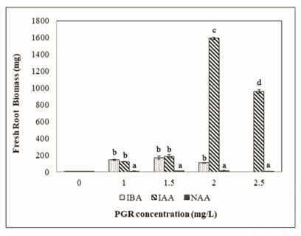
Figure 1. Root biomass produced when treated with different concentrations of IBA, IAA, and NAA from leaf explants of J. gendarussa

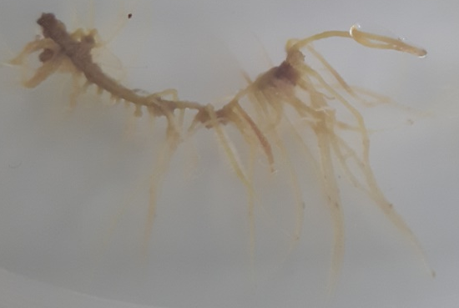
Figure 2. Fishbone structure of the adventitious root. Scale bar: 1 cm

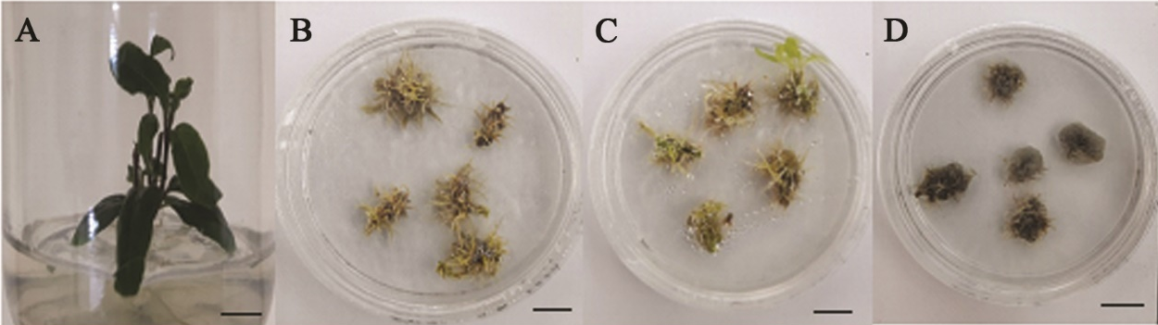
Figure 3. Adventitious root induction from leaves explant treated with auxins. (a): In vitro J. gendarussa plant, (b): 1.5 mg/L IBA, (c): 2.0 mg/L IAA and (d): 2.0 mg/L NAA. Scale bars: 1 cm

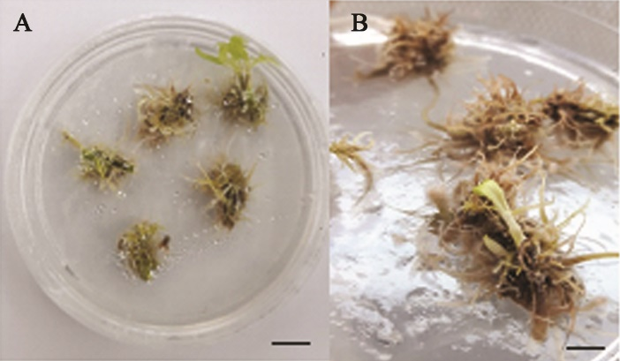
Figure 4. A: Shoot induced from leaf explant treated with 2.0 mg/L IAA. B: Close up. Scale bars: 1 cm

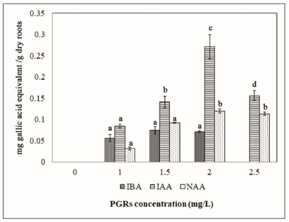
Figure 5. Total phenolic content obtained when treated with different auxin concentrations

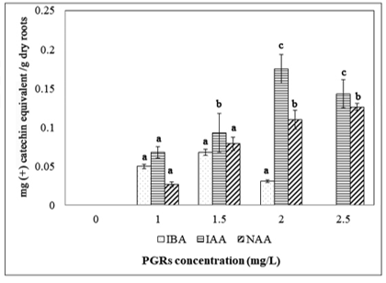
Figure 6. Total flavonoids content produced when treated with different auxin concentrations

Effect of auxin combination on root biomass, TPC, and TFC
In this experiment, the effects of the combinations of IAA, IBA, and NAA concentrations on root biomass, TPC, and TFC were studied. Adventitious roots were collected after seven weeks of culture. Figure 7 shows the amount of root biomass produced when root explants were treated with different combinations of IBA, IAA, and NAA concentrations. Total phenolic content and total flavonoid content in root biomass were also assessed, as shown in Figures 8 and 9. Two treatments, i.e., 1.5 mg/L IBA and 2.0 mg/L IAA, served as control. Results showed that the 2.0 mg/L IAA (1591.40 ± 14.14 mg) yielded the highest root biomass compared to other combinations (Figure 7). The combination of IBA 1.5 mg/L + NAA 0.1 mg/L (443.93 ± 14.68 mg) showed a significant higher root biomass than IBA 1.5 mg/L alone (168.07 ± 18.75 mg). This analysis indicated that the combination of IAA + NAA did not improve the production of root biomass. The combination of 1.5 mg/L IBA + 0.1 mg/L NAA produced optimal biomass, but the increment of NAA concentration above 0.1 mg/L reduced the production of fresh biomass. In another assessment, the combination of 2.0 mg/L IAA + NAA 0.5 mg/L showed the highest TPC (0.30 ± 0.02 mg gallic acid equivalent/g dry roots) and TFC (0.24 ± 0.01 mg (+) catechin equivalent/g dry roots) values as compared to the 2.0 mg/L IAA alone (Figures 8 and 9). This finding indicated that the combination of IAA+NAA had a positive effect on TPC and TFC but produced low root biomass. Besides, NAA has the potential to increase the amount of phenol and flavonoids in the roots [13]. It was suggested that IAA 2.0 mg/L gave the maximum root biomass and a combination of IAA 2.0 mg/L with NAA 0.5 mg/L enhanced TPC and TFC.

Effect of MeJa on root biomass, TPC, and TFC
In this experiment, the effects of combinations of auxins and MeJa on root biomass, TPC, and TFC were studied. Adventitious roots were observed after seven weeks of culture. Figure 10 shows the amount of fresh root biomass produced when treated with the combinations of auxins and MeJa. In the presence of MeJa, as for root biomass production, the combination of 2.0 mg/L IAA + 0.5 mg/L NAA + 75 μM MeJa produced the highest root biomass (470.1 ± 24.69 mg). The lowest root biomass was obtained when treated with 1.5 mg/L IBA + 0.1 mg/L NAA + 150 μM MeJa (104.95 ± 3.177 mg). However, in the absence of MeJa, 2.0 mg/L IAA alone (1591.40 ± 14.14 mg) resulted significantly higher than the addition of elicitor (490.8 ± 17.18 mg; Figures 7 and 10). This elicitor acts as an enhancer for root growth and physiological changes [11]. Besides, MeJa can trigger physiological and morphological responses and accumulation of secondary metabolites related to plant defence mechanisms [3].

Figures 11 and 12 show the TPC and TFC in root biomass treated with different combinations of auxins and MeJa concentrations. The combination of 2.0 mg/L IAA + 0.5 mg/L NAA + 100 μM MeJa recorded the highest TPC (0.27 ± 0.03 mg gallic acid equivalent/g dry roots) but no significant differences among all treatments tested. However, the combination of 2.0 mg/L IAA + 0.5 mg/L NAA had higher TPC (0.296 ± 0.02 mg gallic acid equivalent/g dry roots) and TFC (0.244 ± 0.01 mg (+) catechin equivalent/g dry roots) than the same combination with 1.0 μM MeJa. This demonstrated that the addition of MeJa elicitor reduced the production of root biomass, TPC and TFC. Elicitors could manipulate the secondary metabolites profile and improve the yield of secondary metabolites in the cultures of plant cells and organs [14]. Therefore, MeJa elicitor is not suitable to improve the yield of phenolic and flavonoid for J. gendarussa.

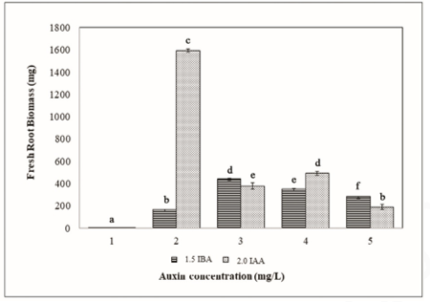
Figure 7. Amount of fresh root biomass produced after treated with different combinations of auxin concentrations. 1 = MS medium without auxin; 2 = control (1.5 IBA and 2.0 IAA); 3= 1.5 IBA + 0.1 NAA and 2.0 IAA + 0.1 NAA; 4 = 1.5 IBA + 0.5 NAA and 2.0 IAA + 0.5 NAA; 5 = 1.5 IBA + 1.0 NAA and 2.0 IAA + 1.0 NAA

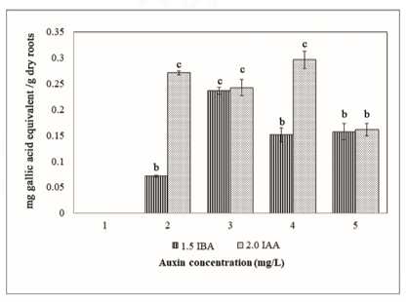
Figure 8. Total phenolic content in root biomass treated with different combinations of auxin concentrations. 1 = MS medium without auxin; 2 = control (1.5 IBA and 2.0 IAA); 3= 1.5 IBA + 0.1 NAA and 2.0 IAA + 0.1 NAA; 4 = 1.5 IBA + 0.5 NAA and 2.0 IAA + 0.5 NAA; 5 = 1.5 IBA + 1.0 NAA and 2.0 IAA + 1.0 NAA
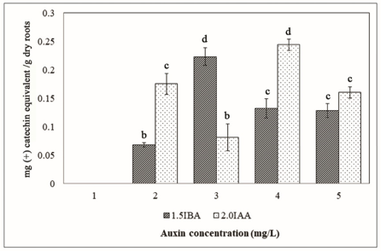
Figure 9. Total flavonoid content in root biomass treated with different combinations of auxin concentrations. 1 = MS medium without auxin; 2 = control (1.5 IBA and 2.0 IAA); 3 = 1.5 IBA + 0.1 NAA and 2.0 IAA + 0.1 NAA; 4 = 1.5 IBA + 0.5 NAA and 2.0 IAA + 0.5 NAA; 5=1.5 IBA + 1.0 NAA and 2.0 IAA + 1.0 NAA

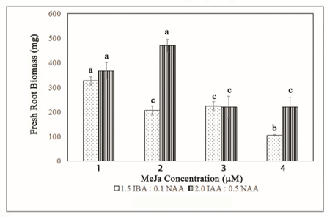
Figure 10. Fresh weight of root biomass obtained when treated with different combinations of auxin concentrations with addition of MeJa. 1 = 1.5 IBA + 0.1 NAA + 50 µM MeJa and 2.0 IAA + 0.5 NAA +50 µM MeJa ; 2 = 1.5 IBA + 0.1 NAA + 75 µM MeJa and 2.0 IAA + 0.5 NAA + 75 µM MeJa; 3 = 1.5 IBA + 0.1 NAA + 100 µM MeJa and 2.0 IAA + 0.5 NAA + 100 µM MeJa; 4= 1.5 IBA + 0.1 NAA + 150 µM MeJa and 2.0 IAA + 0.5 NAA + 150 µM MeJa

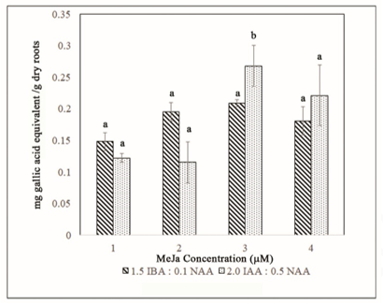
Figure 11. Total phenolic content in root biomass treated with different combinations of auxin concentrations with the addition of MeJa. 1 = 1.5 IBA + 0.1 NAA + 50 µM MeJa and 2.0 IAA + 0.5 NAA +50 µM MeJa ; 2 = 1.5 IBA + 0.1 NAA + 75 µM MeJa and 2.0 IAA + 0.5 NAA + 75 µM MeJa; 3 = 1.5 IBA + 0.1 NAA + 100 µM MeJa and 2.0 IAA + 0.5 NAA + 100 µM MeJa; 4 = 1.5 IBA + 0.1 NAA + 150 µM MeJa and 2.0 IAA + 0.5 NAA + 150 µM MeJa

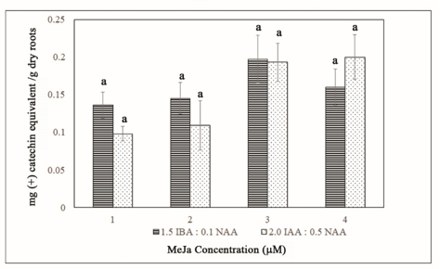
Figure 12. Total flavonoid content in root biomass treated with different combinations of auxin concentrations with addition of MeJa. 1 = 1.5 IBA + 0.1 NAA + 50 µM MeJa and 2.0 IAA + 0.5 NAA +50 µM MeJa ; 2 = 1.5 IBA + 0.1 NAA + 75 µM MeJa and 2.0 IAA + 0.5 NAA + 75 µM MeJa; 3 = 1.5 IBA + 0.1 NAA + 100 µM MeJa and 2.0 IAA + 0.5 NAA + 100 µM MeJa; 4 = 1.5 IBA + 0.1 NAA + 150 µM MeJa and 2.0 IAA + 0.5 NAA + 150 µM MeJa

Conclusion
Maximum root biomass was obtained in the treatment with IAA 2.0 mg/L. However, the combination of IAA 2.0 mg/L IAA + NAA 0.5 mg/L produced the highest TPC and TFC. As for IBA, a combination of 1.5 mg/L IBA + 0.1 mg/L NAA showed better root biomass than 1.5 mg/L IBA alone. IAA promoted root biomass production and combination IAA + NAA enhanced TPC and TFC in adventitious roots. The addition of MeJa up to 150 µM did not improve root biomass, TPC, and TFC of J. gendarussa.

Acknowledgment
The authors would like to thank Universiti Teknologi Malaysia (UTM; TDR Grant Vot No. 06G70), the Ministry of Education (MOE) for financial support and Plant Biotechnology Laboratory, Faculty of Science for laboratory facilities.

References
- Uddin, R., Sinha, S., Hossain, A., Kaisar, A., Hossain, K. and Rashid, M. A. (2011). Chemical and biological investigations of Justicia gendarussa (Burm. F). Dhaka University Journal of Pharmaceutical Sciences, 10(1): 53-57.
- Sugumaran, P., Kowsalya, N., Karthic, R. and Seshadri, S. (2013). Biomass production and antibacterial activity of Justicia Gendarussa : A valuable medicinal plant. Journal of Tropical Life Science, 3(1): 8-13.
- Murthy, H. N., Hahn, E. J. and Paek, K. Y. (2008). Adventitious roots and secondary metabolism. Chinese Journal of Biotechnology, 24(5): 711-716.
- Tesser, C., Remko, O. and Fett-neto, A. G. (2019). The role of auxin transporters and receptors in adventitious rooting of Arabidopsis thaliana pre-etiolated flooded seedlings. Plant Science, 290:110294.
- Ratnasooriya, W. D., Deraniyagala, S. A. and Dehigaspitiya, D. C. (2007). Antinociceptive activity and toxicological study of aqueous leaf extract of Justicia gendarussa Burm. F. in rats. Pharmacognosy Magazine, 3(11): 145-155.
- Ayob, Z., Bohari, S. P. M., Abd Samad, A. and Jamil, S. (2014) Cytotoxic activities against breast cancer cells of local Justicia gendarussa crude extracts. Evidence-Based Complementary and Alternative Medicine, 2014: 732980
- Murashige, T. and Skoog, F. (1962). A revised medium for rapid growth and bio assays with tobacco tissue cultures. Physiologia Plantarum, 15(3): 473-497.
- Lee, E. J., Park, S.Y. and Paek, K.Y. (2015). Enhancement strategies of bioactive compound production in adventitious root cultures of Eleutherococcus koreanum Nakai subjected to methyl jasmonate and salicylic acid elicitation through airlift bioreactors. Plant Cell, Tissue Organ Culture, 120: 1-10.
- Dewir, Y. H. and Paek, K. Y. (2006). Optimization of culturing conditions for the production of biomass and phenolics from adventitious roots of Echinacea angustifolia. Journal of Plant Biology, 49(3): 193-199.
- Wei, K., Ruan, L., Wang, L. and Cheng, H. (2019). Auxin-induced adventitious root formation in nodal cuttings of Camellia sinensis. International Journal of Molecular Sciences, 20(4817): 1-10.
- Guan, L., Tayengwa, R., Cheng, Z. M., Peer, W. A. and Murphy, A. S. (2019). Auxin regulates adventitious root formation in tomato cuttings. BMC Plant Biology, 9(1): 1-16.
- Ayob, Z., Abd Samad, A. and Bohari, S. P. M. (2013). Cytotoxicity activities in local Justicia gendarussa crude extracts against human cancer cell lines. Jurnal Teknologi, 2: 45-52.
- Fazal, H., Abbasi, B. H. and Ahmad, N. (2014). Optimization of adventitious root culture for production of biomass and secondary metabolites in Prunella vulgaris L. Applied Biochemistry and Biotechnology, 174(6): 2086-2095.
- Kim, Y., Hahn, E., Murthy, H. N. and Paek, K. (2004). Adventitious root growth and ginsenoside accumulation in Panax ginseng cultures as affected by methyl jasmonate. Biotechnology Letters, 26(21): 1619-1622.

