EFFECT OF TIME AND TEMPERATURE ON REDUCED GRAPHENE OXIDE (rGO) LAYER STABILITY AND CYCLIC VOLTAMMETRIC BEHAVIOUR OF MODIFIED SCREEN-PRINTED CARBON
ELECTRODE (mSPCE) FOR BIOSENSING PURPOSES

(Kesan Masa dan Suhu Pengeraman terhadap Kestabilan Lapisan rGO dan Perlakuan Voltametri Berkitar Elektrod Karbon Tercetak Terubahsuai (mSPCE) bagi
Tujuan Penderiaan Bio)

Ahmad Farid Mohd Azmi^{1*}, Vayithiswary Kannan^{2,3}, Nur Sabila Yasin², Jahwarhar Izuan Abdul Rashid¹, Ainsah Omar⁴, Emee Marina Salleh²

¹Centre for Defence Foundation Studies
²Centre for Research Management and Innovation
³Faculty of Defence Science and Technology
⁴Faculty of Medicine and Defence Health
Universiti Pertahanan Nasional Malaysia,
Sungai Besi Camp, 57000 Kuala Lumpur, Malaysia.

*Corresponding author: ahmad.farid@upnm.edu.my

Abstract
In recent times, electrochemical immunosensing has emerged as a promising technique for a simple, portable, cost-effective, and efficient detection of cortisol in biofluids. The 2D graphene nanosheet is widely considered as a ‘wonder material’, attributing to its numerous incredible qualities which are commonly used as nanomaterial in today’s biosensing technology. In this study, the working condition of biosensor for layer stability and cyclic voltammetric behaviour of modified screen-printed carbon electrode (mSPCE) integrated with reduced graphene oxide (rGO) was optimized. Two main parameters, i.e., incubation time and incubation temperature were investigated to assess the stability of rGO layer on the surface of modified electrode. After the modification of SPCE with rGO, the anodic and cathodic peak currents were remarkably enhanced at peak potentials 0.04 V and 0.22 V for incubation time and 0 V and 0.23 V for incubation temperature, respectively. The optimum condition of layer stability for the developed rGO-mSPCE was achieved by incubating the rGO on the electrode surface for 24 hours at 25 °C.

Keywords: biosensor, graphene oxide, electrochemical, screen printed carbon electrode, incubation

Abstrak
Sejak kebelakangan ini, teknik pengesanan penderiaan imuno elektrokimia telah muncul sebagai teknik yang berpotensi dalam mengesan kortisol secara ringkas, mudah alih dan cekap. Lapisan nano grafin 2D adalah terkenal sebagai bahan yang menakjubkan yang merujuk kepada kepelbagaian kualitinya yang luar biasa yang menjadikannya sebagai nanomaterial yang kini selalu digunakan dalam teknologi penderiaan bio. Dalam kajian ini, kestabilan lapisan grafin teroksida yang terturun (rGO) dan tindak balas voltametri berkitar di atas permukaan elektrod karbon tercetak terubahsuai (mSPCE) telah dioptimumkan. Dua parameter utama iaitu tempoh pengeraman masa dan tempoh pengeraman suhu telah dikaji untuk menilai kestabilan lapisan rGO di atas permukaan elektrod tersebut. Selepas pengubahsuaian SPCE dengan rGO, arus puncak katod dan anod telah dipertingkatkan pada potensi puncak bernilai 0.04 V dan 0.22 V bagi tempoh pengeraman masa serta pada potensi puncak 0 V dan 0.23 V bagi tempoh pengeraman suhu. Keadaan optimum untuk kestabilan lapisan rGO-mSPCE yang telah diubahsuai dicapai melalui pengeraman lapisan rGO pada permukaan elektrod selama 24 jam pada suhu 25 °C.

Kata kunci: biosensor, grafin oxida, elektrokimia, elektrod karbon tercetak terubahsuai, pengeraman

Introduction
The development of analytical devices to measure bodily analytes as a biomarker for certain health conditions has been reported to be challenging. In recent times, electrochemical immunosensing has emerged as a promising technique for a simple, portable, cost-effective, and efficient detection of cortisol in biofluids. It is according to the principle of measuring the changes in the electrical properties of a conductive substrate due to the adsorption of an analyte on the surface functionalized with antibodies, which is sensitive and selective to the analyte [1, 2, 3]. In enhancing the sensitivity and selectivity of analyte detection, numerous explorations of nanomaterials and metallic nanoparticles composites have shown great promises. Reduced graphene oxide- (rGO) modified electrodes are desirable due to the fact that they are the most economical way of obtaining graphene-like structures, and graphene is recognized for its unique conductivity due to its large surface area and high chemical stability [4, 5].

Towards the development of high performance, lightweight and reliable electronic devices, attention has been drawn to the production of flexible supercapacitors that possess high electrochemical capacitance even under high mechanical stretch. Owing to its two-dimensional (2D) monolayer of carbon nanosheet, graphene may offer fascinating characteristics, including a large specific surface area (up to 2675 m²/g), great electron mobility (230,000 cm²/Vs), high thermal conductivity (3000 W/mK), high electrical conductivity (10³–10⁴ S/m), high strength (130 GPa), and outstanding elasticity and stiffness, which have attracted attention for the application as a supercapacitor [6, 7, 8]. Graphene consists of a thin layer pure carbon that is tightly packed and bonded together in a hexagonal honeycomb lattice with sp² bonds. Graphene and its various derivatives are widely considered as a ‘wonder material’, attributing to its numerous incredible qualities which are commonly used as nanomaterial in today’s biosensing technology [9-13].

Physical parameters such as incubation time and temperature are one of the factors that would potentially influence the stability and integrity of a material or substance in biosensors or in this case; a self-assembled monolayer [14, 15, 16]. Therefore, this current work investigates the effect of incubation time and temperature of rGO layer (post electro-reduction), mainly on its electrical behaviour through cyclic voltammetric analysis.

Materials and Methods
The stock solution of graphene oxide dispersed in water (4 mg/mL) was purchased from Sigma Aldrich (St. Louis, MO) and further diluted in distilled water to a desired concentration of 2 mg/mL upon 10 minutes sonication. C110 Screen Printed Carbon Electrode (SPCE) consisting of a 4 mm diameter carbon working electrode, carbon auxiliary electrode, and silver reference electrode was purchased from Metrohm DropSens. The SPCE was drop-casted onto 10 µL of 2 mg/mL graphene oxide (GO) solution and electrochemically reduced at applied potentials of -1.5 V to 0 V by using Metrohm Autolab B.V. (PGSTAT204) (Netherlands).

Figure 1 shows the appearance of the SPCEs pre- and post-modifications. The functionalized rGO on the electrode is denoted as rGO-mSPCE and its physical appearance perceived by the naked eyes is shown in Figure 1b. After electro-reduction, the rGO-mSPCE were incubated according to their respective incubation period of 1, 8, 18, 24, and 48 hours initially at room temperature and to their respective temperatures -24, 4, 25, 37, and 45 °C at a selected incubation period. Cyclic voltammetry (CV) test was carried out in 100 µL of 5 mM potassium ferricyanide, K₃Fe(CN)₆ in 0.1 M of potassium chloride (KCl) at the potentials of -0.4 V to 0.6 V, and 0.05 V/s scan rate, as referred from Omar et al. [17]. Both tests were carried out in duplicates. The average cathodic peak current from the cyclic voltammogram was recorded for each set of data. The condition of rGO layer on each mSPCE is observed through electrode photography (naked eye view) and Field Emission Scanning Electron Microscope (FESEM).

Figure 1. (a) Bare SPCE and (b) rGO-modified SPCE (rGO-mSPCE)
Results and Discussion
Morphological characterization of rGO-mSPCE
The morphology of rGO layer on the modified electrode (rGO-mSPCE) was characterized by using Field Emission Scanning Electron Microscope (FESEM). Figure 2 shows the FESEM image of the layer, with a distinctive crumpled surface. This depicts a high surface area ratio of rGO. The rGO monolayer was also seen to be uniformly distributed across the working electrode surface.

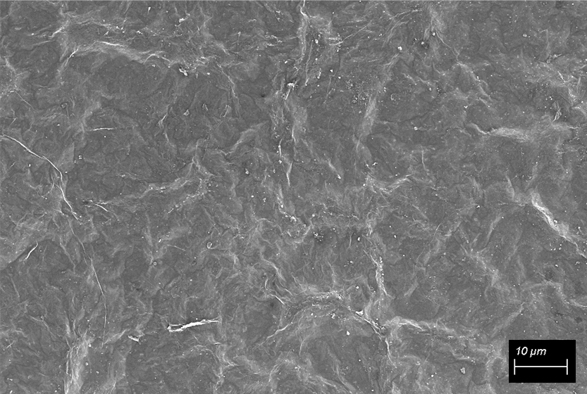

Figure 2. FESEM image of rGO-mSPCE at 1000X magnification

Effect of incubation time
Figure 3 shows the effect of incubation time on the average peak currents of the modified SPCE at room temperature. The peak current was reduced from 143 to 137.6 µA with the time increased from 1 to 18 hours. This shows that the incubation time was insufficient in enhancing the electrical sensitivity of the electrode within this duration of incubation. After 24 hours of incubation, the peak current was increased to 172.1 µA, but was then considerably reduced to 130.1 µA beyond 24 hours. This finding was also recorded as the highest peak current. However, prolonged duration of incubation up to 48 hours has resulted in a significant reduction of the peak current, as low as 130.1 µA. In brief, the optimum incubation time in enhancing the performance of rGO-mSPCE was achieved at 24 hours; being the adequate time for the freshly electro-reduced rGO layer to set on the working electrode of rGO-mSPCE prior to application with other chemicals or solutions. The readings obtained from this parameter study were significantly higher than the peak current recorded from a bare, unmodified SPCE with a peak current of 67.14 µA. From Table 1, the rGO layer appearance was seen to be intact and there was no noticeable difference from the pre-incubation and post-incubation time prior to the CV test, suggesting that the integrity of the layer remained unchanged.

Figure 3. Average peak currents of rGO-mSPCE for various incubation time

Table 1. rGO layer appearance on mSPCE at different incubation durations

Incubation Time (h) | Test 1 | Test 2
1 | 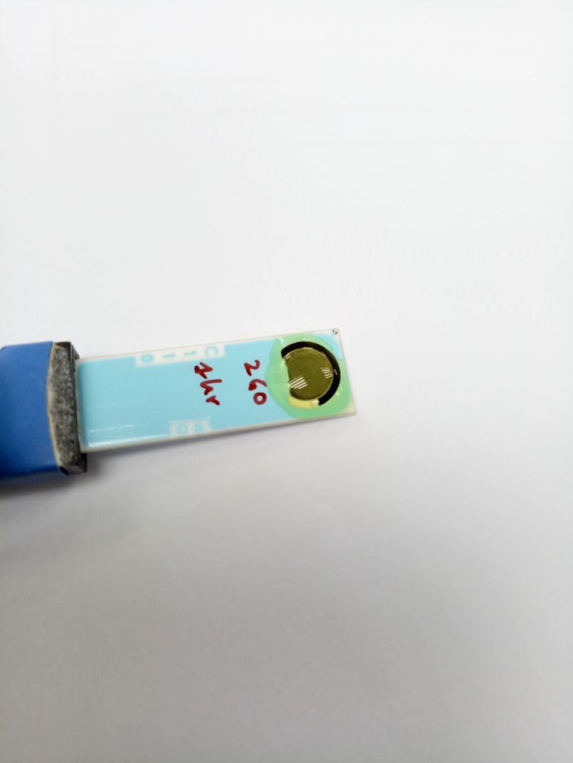 | 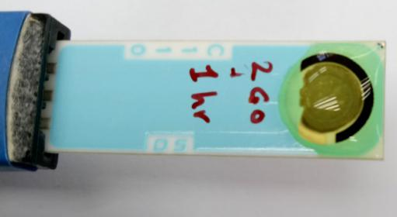
8 | 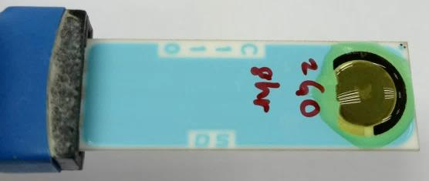 | 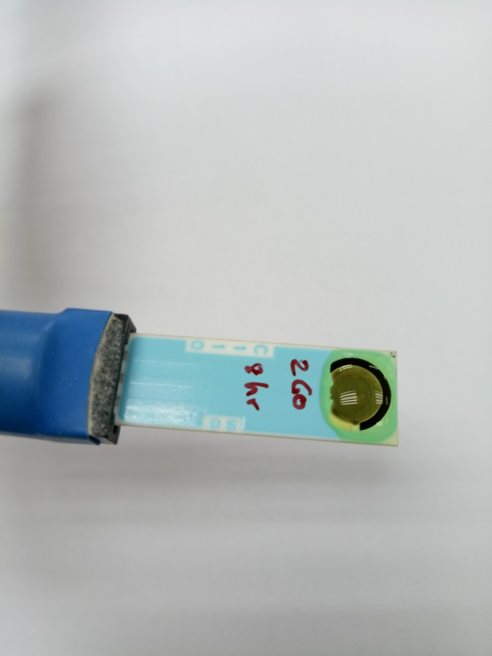
18 | 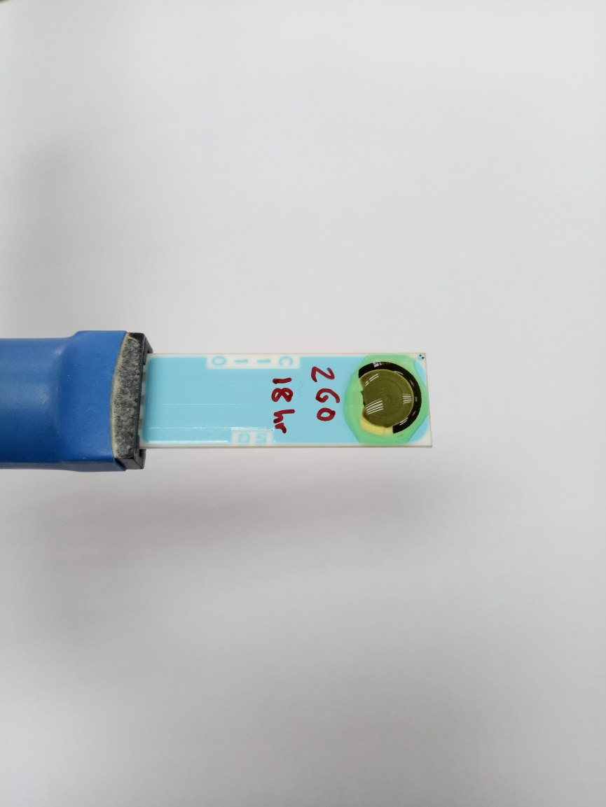 | 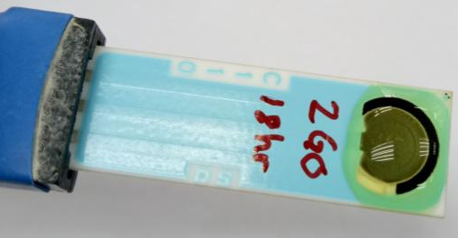
24 | 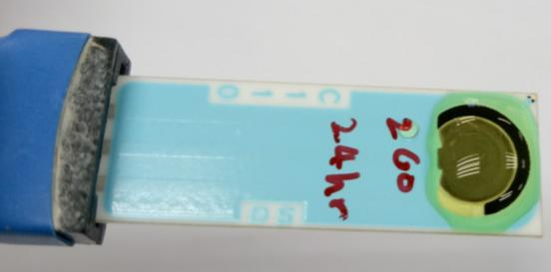 | 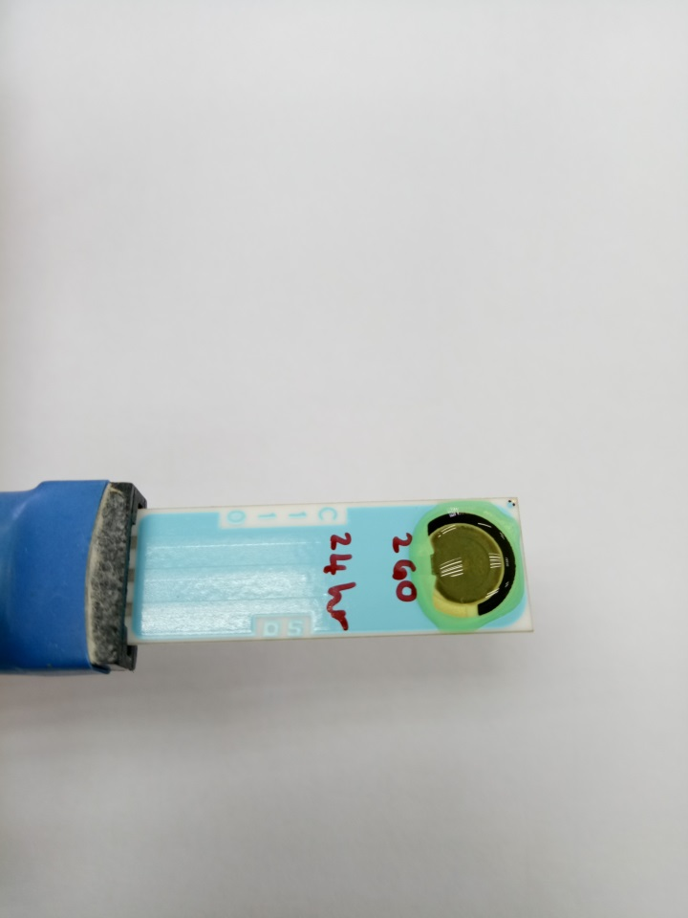
48 | 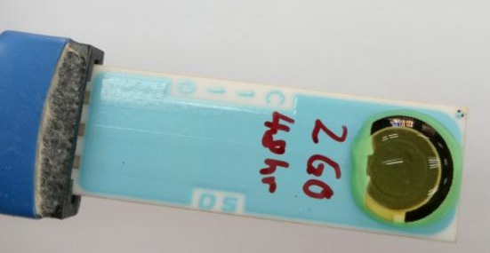 | 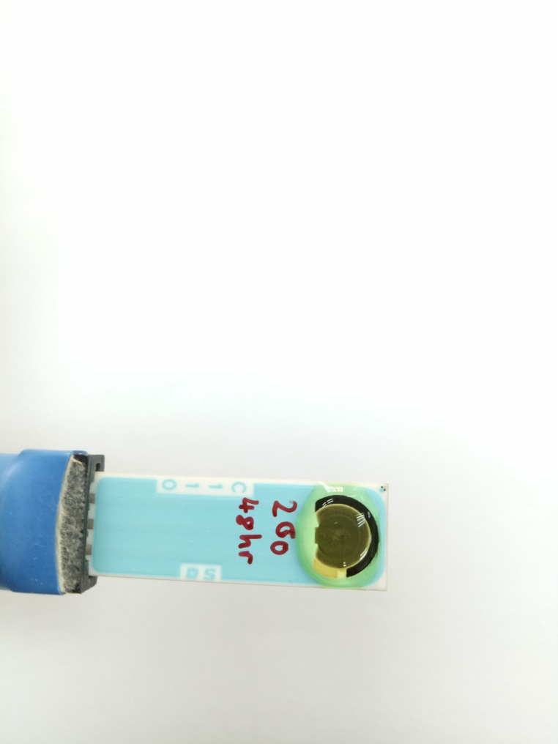

Effect of incubation temperature
The incubation was performed at various temperatures for 24 hours to determine the optimum condition for the electrochemical detection of analytes, apart from assessing the rGO layer stability and morphology on the mSPCE. Five sets of temperature were chosen, which signified a random storage temperature for the rGO-mSPCE whereby the lowest temperature was of a freezer (-24 °C), chiller (4 °C), room temperature at 25 °C, and incubator at 37 °C and 45 °C as the normal human body temperature and the highest ambient temperature, respectively. Figure 4 shows that the average peak current of rGO-mSPCE was decreased slightly from 127.5 µA at -24 °C to 124.6 µA at 4 °C. The current response was increased at 25 °C and 37 °C with the current difference of 1.34 µA at 139.86 µA and 138.52 µA, respectively. The increment of electrical current explained that the electrochemical activity of the modified electrode was affected by the temperature. However, the electrical current dropped to 127.14 µA when the temperature was increased to 45 °C, which was almost the same current range seen at lower temperature settings. The reduction in the electrochemical behaviour of the mSPCE might be due to the deterioration of rGO layer that has been exposed to a considerably high temperature, which affected the redox reaction.
This scenario advocated that the optimum incubation temperature in attaining a high electrical performance of the rGO-mSPCE for analyte detection was achieved at 25 °C and stable at 37 °C, which demonstrated a maximal current conductivity, thus providing an improved electrochemical activity of the carbon working electrode. Furthermore, through naked eye observation, small ‘bulge-like’ appearances are shown by the white arrows (Table 2) on the rGO layer incubated at lower and higher temperatures than 25 °C and 37 °C, which suggest that changes that occurred in the integrity of rGO layer might have affected its current conductivity [18]. The room temperature and normal human body temperature were seen to be ideal as a working environment and storage temperature for the rGO-mSPCE. Extreme temperature, however, is not ideal for analyte detection that uses rGO-mSPCE with certain heat-labile sensing materials, i.e., antibodies, as they are subjected to degradation [19].

-24 °C 4 °C 25 °C 37 °C 45 °C

Figure 4. Average peak currents of rGO-mSPCE for various incubation temperatures

Table 2. rGO layer appearance on mSPCE at different incubation temperatures

Incubation  Temperature (ºC) | Test 1 | Test 2
-24  (freezer) | 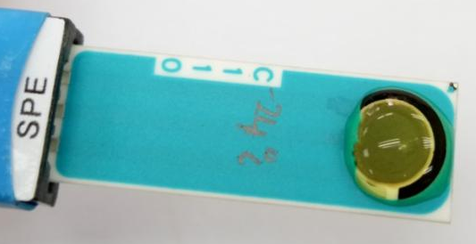 | 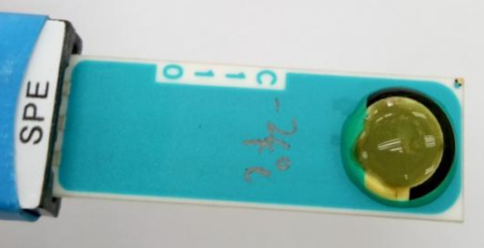
4  (chiller) | 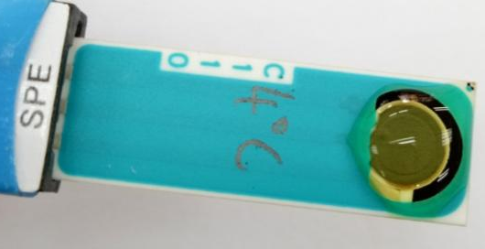 | 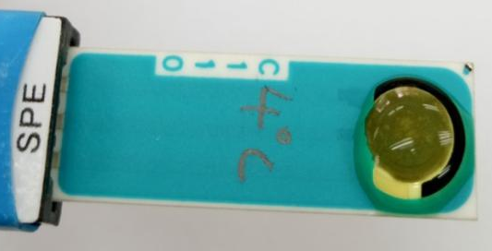
25  (room temperature) | 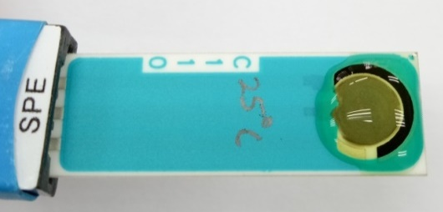 | 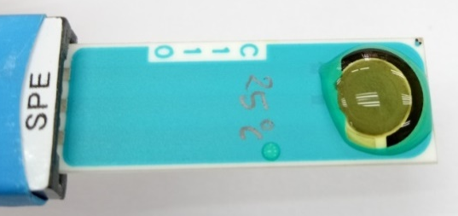
37  (human body temperature) | 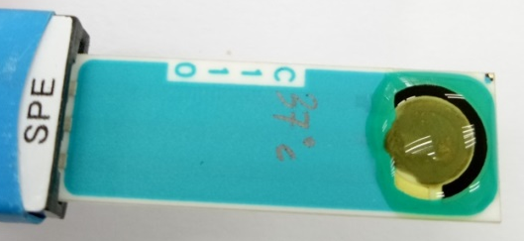 | 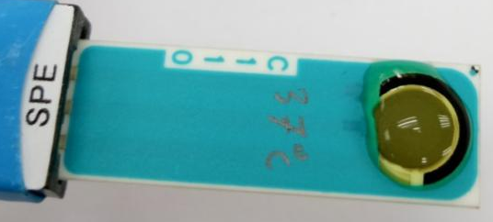
45  (highest ambient temperature) | 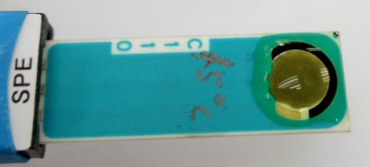 | 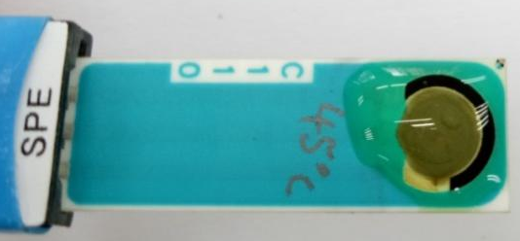

Cyclic voltammetric behaviour
Cyclic Voltammetry (CV) is a potentio-electrochemical technique for acquiring qualitative information about electrochemical reactions that take place within the electrode-electrolyte interface. CV was performed to study the electrochemical properties of an analyte in a solution, particularly to measure the current that develops in an electrochemical cell for a voltage range. Figure 5 and Figure 6 show that the cyclic voltammogram of incubation times and incubation temperatures were both consistent of which each was depicted by quasi-rectangular curve shape. This phenomenon implied that both studied parameters slightly affected the oxidation-reduction process of the rGO-mSPCE as there were only a slight difference of electrical conductivity in terms of their current responses towards time and temperature incubation [20, 21].

Figure 5 displays the large CV curve of mSPCE which was due to its relatively high redox activity. However, within the incubation duration of 1 to 18 hours, the electrochemical reactions decreased in their current responses. The eenhancement of peak currents was observed after 24 h of incubation whereby the anodic and cathodic peak currents were increased at peak potentials 0.04 V and 0.22 V, respectively. The increasing incubation time resulted in a smaller CV and the redox process was not very well defined, which might be attributed to low capacitive currents and surface area of the working electrode [11, 22].

Figure 6 shows the cyclic voltammograms generated at incubation temperatures -24, 4, 25, 37, and 45 °C. The CV curves of all temperature settings were almost similar to each other in terms of their shape, with two distinctive anodic and cathodic peaks. However, the CV curve of rGO-mSPCE incubated at 25 °C and 37 °C exhibited slightly higher anodic and cathodic peak currents at peak potentials 0 V and 0.23 V, respectively than other temperatures. Further increase in incubation temperatures resulted in a slight decrease of the current responses, which was almost to its initial range during the first two incubation temperatures. This phenomenon suggested that the redox reaction of the mSPCE was affected by the incubation temperature [20]. It was evident that at 25 °C and 37 °C, the rGO layer was seen to be stable, which correlated to the observations in Table 2, thus proving a suitable working temperature or condition for analyte detection using biosensor with the rGO-mSPCE.

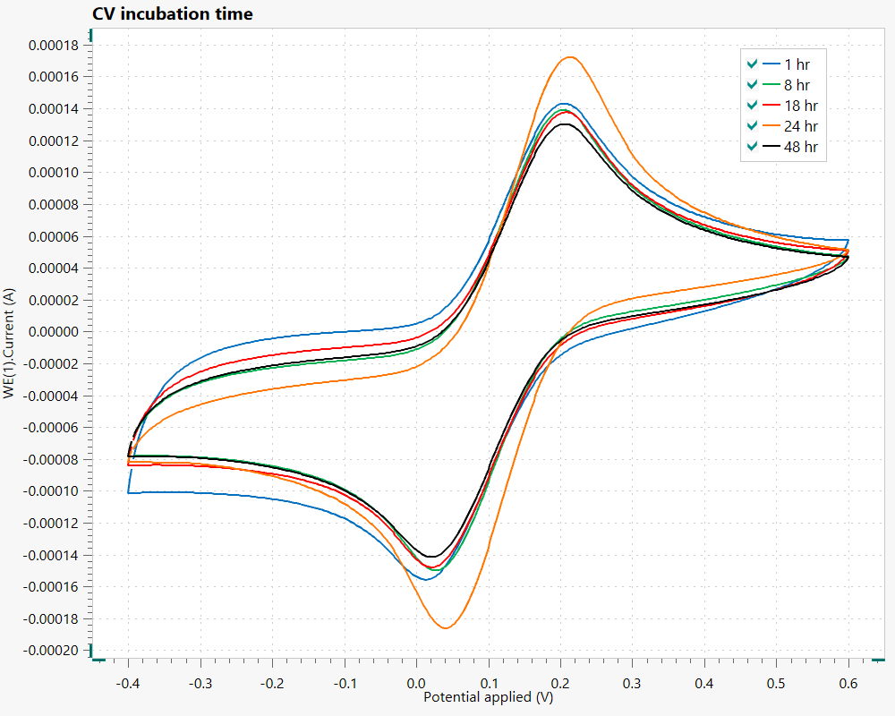

Figure 5. CV of rGO-mSPCE for various incubation time

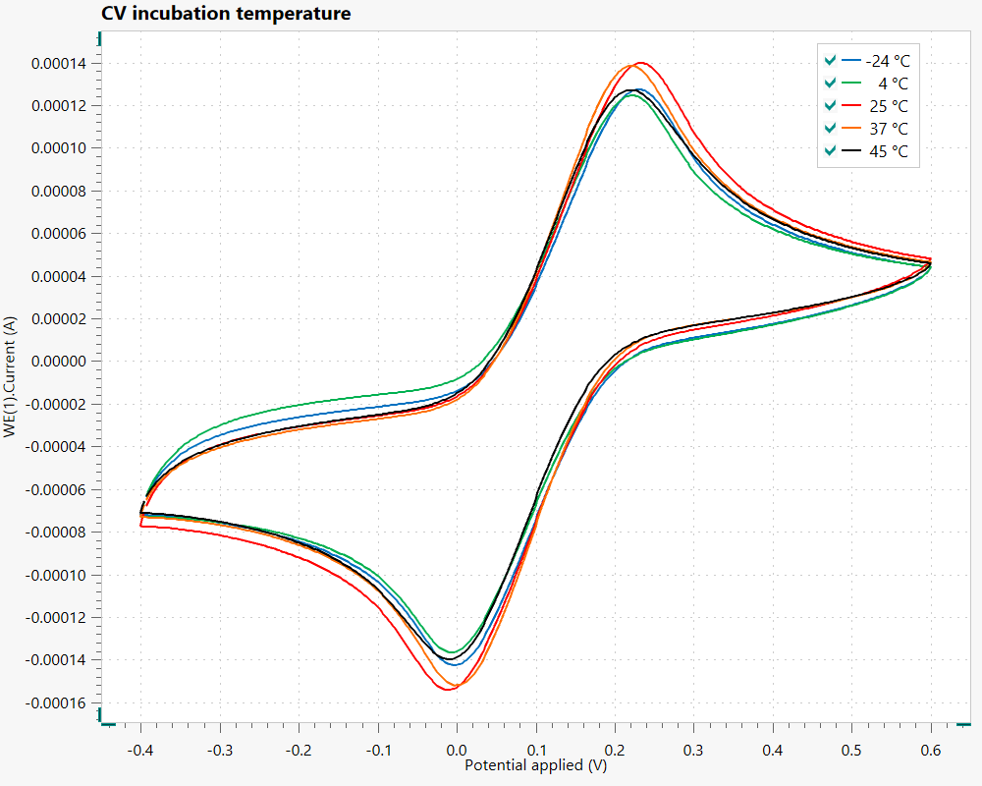

Figure 6. CV of rGO-mSPCE for various incubation temperatures

Conclusion
The optimum incubation time and temperature for the rGO-mSPCE were achieved after 24 hours at 25 °C, which exhibited an adequately high current conductivity, thus demonstrated an improved electrochemical activity of the carbon working electrode. The cyclic voltammogram of both studied parameters was in a consistent curved shape. At 24 hours of incubation, the anodic and cathodic peak currents were increased at the peak potentials 0.04 V and 0.22 V, respectively. The largest CV was obtained at 25 °C whereby the anodic and cathodic currents peaked at the peak potentials 0 V and 0.23 V, respectively. The optimum condition of layer stability for the developed rGO-mSPCE was achieved by incubating the rGO on the electrode surface for 24 hours at 25 °C.

Acknowledgement
The authors would like to acknowledge the financial support provided by the Ministry of Higher Education Malaysia under the Niche Research Grant Scheme (NRGS/2013/UPNM/PK/P4). The funding for the publication of this article was provided by the Centre for Defence Foundation Studies, Universiti Pertahanan Nasional Malaysia (UPNM).

References
1. Kidd, T., Carvalho, L. A. and Steptoe, A. (2014). The relationship between cortisol responses to laboratory stress and cortisol profiles in daily life. Biological Psychology, 99: 34-40.
2. Walter, E. E., Fernandez, F., Snelling, M. and Barkus, E. (2018). Stress induced cortisol release and schizotypy. Psychoneuroendocrinology, 89: 209-215.
3. Wichmann, S., Kirschbaum, C., Böhme, C. and Petrowski, K. (2017). Cortisol stress response in post-traumatic stress disorder, panic disorder, and major depressive disorder patients. Psychoneuroendocrinology, 83: 135-141.
4. Linninge, C., Jönsson, P., Bolinsson, H., Önning, G., Eriksson, J., Johansson, G. and Ahrné, S. (2018). Effects of acute stress provocation on cortisol levels, zonulin and inflammatory markers in low-and high-stressed men. Biological Psychology, 138: 48-55.
5. Wichmann, S., Kirschbaum, C., Lorenz, T. and Petrowski, K. (2017). Effects of the cortisol stress response on the psychotherapy outcome of panic disorder patients. Psychoneuroendocrinology, 77: 9-17.
6. Cruz, A. F. D., Norena, N., Kaushik, A. and Bhansali, S. (2014). A low-cost miniaturized potentiostat for point-of-care diagnosis. Biosensors and Bioelectronics, 62: 249-254.
7. Herrera, A. Y., Nielsen, S. E. and Mather, M. (2016). Stress-induced increases in progesterone and cortisol in naturally cycling women. Neurobiology of Stress, 3: 96-104.
8. Koh, W. C. A., Son, J. I., Choe, E. S. and Shim, Y.-B. (2010). Electrochemical detection of peroxynitrite using a biosensor based on a conducting polymer− manganese ion complex. Analytical Chemistry, 82(24): 10075-10082.
9. Malhotra, B. D., Chaubey, A. and Singh, S. (2006). Prospects of conducting polymers in biosensors. Analytica Chimica Acta, 578(1): 59-74.
10. Sun, W., Zhang, Y., Hu, A., Lu, Y., Shi, F., Lei, B. and Sun, Z. (2013). Electrochemical DNA biosensor based on partially reduced graphene oxide modified carbon ionic liquid electrode for the detection of transgenic soybean A2704‐12 gene sequence. Electroanalysis, 25(6): 1417-1424.
11. Bollella, P., Fusco, G., Tortolini, C., Sanzò, G., Favero, G., Gorton, L. and Antiochia, R. (2017). Beyond graphene: electrochemical sensors and biosensors for biomarkers detection. Biosensors and Bioelectronics, 89: 152-166.
12. Liu, C.-Y., Chou, Y.-C., Tsai, J.-H., Huang, T.-M., Chen, J.-Z. and Yeh, Y.-C. (2019). Tyrosinase/Chitosan/Reduced graphene oxide modified screen-printed carbon electrode for sensitive and interference-free detection of dopamine. Applied Sciences, 9(4): 622.
13. Patri, S. B., Adarakatti, P. S. and Malingappa, P. (2019). Silver nanoparticles-chitosan composite embedded graphite screen-printed electrodes as a novel electrochemical platform in the measurement of trace level nitrite: application to milk powder samples. Current Analytical Chemistry, 15(1): 56-65.
14. Hanifah, M. F. R., Jaafar, J., Aziz, M., Ismail, A., Othman, M. and Rahman, M. A. (2015). Effects of reduction time on the structural, electrical and thermal properties of synthesized reduced graphene oxide nanosheets. Bulletin of Materials Science, 38(6): 1569-1576.
15. Kimiagar, S., Rashidi, N. and Ghadim, E. E. (2015). Investigation of the effects of temperature and time on reduction of graphene oxide by microwave hydrothermal reactor. Bulletin of Materials Science, 38(7): 1699-1704.
16. Timofeeva, T., Evseev, Z., Vinokurov, P., Alexandrov, G. and Smagulova, S. (2018). The effect of temperature conditions during graphene oxide synthesis on humidity dependence of conductivity in thermally reduced graphene oxide. Journal of Structural Chemistry, 59(4): 799-805.
17. Omar, A., Rashid, J. I. A., Latif, A. A. A., Karim, K. A., Bakar, O. C., Bakar, M. A. and Yunus, W. (2017). Development of cortisol immunosensor based reduced graphene oxide (rGO) for future application in monitoring stress levels among military personnel. Science & Technology Research Institute for Defence (STRIDE), 10(2): 142-149.
18. Colonna, S., Monticelli, O., Gomez, J., Novara, C., Saracco, G. and Fina, A. (2016). Effect of morphology and defectiveness of graphene-related materials on the electrical and thermal conductivity of their polymer nanocomposites. Polymer, 102: 292-300.
19. Le Basle, Y., Chennell, P., Tokhadze, N., Astier, A. and Sautou, V. (2020). Physicochemical Stability of Monoclonal Antibodies: A Review. Journal of Pharmaceutical Sciences, 109(1): 169-190.
20. Rahman, M. S., Anower, M. S., Bashar, L. B. and Rikta, K. A. (2017). Sensitivity analysis of graphene coated surface plasmon resonance biosensors for biosensing applications. Sensing and Bio-Sensing Research, 16: 41-45.
21. Settu, K., Liu, J.-T., Chen, C.-J. and Tsai, J.-Z. (2017). Development of carbon-graphene-based aptamer biosensor for EN2 protein detection. Analytical Biochemistry, 534: 99-107.
22. Song, H. S., Kwon, O. S., Kim, J.-H., Conde, J. and Artzi, N. (2017). 3D hydrogel scaffold doped with 2D graphene materials for biosensors and bioelectronics. Biosensors and Bioelectronics, 89: 187-200.

