GREEN SYNTHESIS OF SILVER PARTICLES USING

Citrus microcarpa PEEL EXTRACT

(Sintesis Partikel Perak Menggunakan Ekstrak kulit Citrus Microcarpa)

Gong Wee Jie, Masrina Mohd Nadzir*, Kalaivani Rangasamy

School of Chemical Engineering, Engineering Campus

Universiti Sains Malaysia, 14300 Nibong Tebal, Penang, Malaysia

*Corresponding author: chmasrina@usm.my

Abstract

Green synthesis of particles involves the use of safe biological agents as an eco-friendly and cost-effective alternative to chemical synthesis. In this study, silver particles were biosynthesised by using silver nitrate and aqueous Citrus microcarpa peel extract as the reducing and stabilising agent. The synthesised silver particles were confirmed and characterised by UV-Vis spectroscopy, scanning electron microscopy (SEM), energy dispersive X-ray spectroscopy (EDX), and dynamic light scattering (DLS). The UV-Vis spectrum showed surface plasmon resonance (SPR) with maximum peak intensity around 450 nm. The DLS studies show that silver particles have an average Z-diameter value of 235 nm with a polydispersity index of 0.363, which indicates the presence of agglomeration. The reaction parameters have a significant effect on the formation of silver particles. The highest absorbance recorded was 1.42 obtained under conditions of 72 hours reaction time, using 5 wt.% peel extract that reacted with 8 mM silver nitrate solution, while the ratio of solution of peel extract to silver nitrate was fixed at 1:5. Silver particles were successfully synthesised by Citrus microcarpa peel extract, which has the potential to replace the chemical method.

Keywords: silver particles, Citrus microcarpa, green synthesis

Abstrak

Sintesis hijau partikel melibatkan penggunaan agen biologi yang selamat sebagai alternatif yang mesra alam dan keberkesanan kos dibandingkan dengan kaedah sintesis kimia. Dalam kajian ini, partikel perak disintesis dengan menggunakan nitrat perak dan ekstrak kulit Citrus microcarpa berair sebagai ejen penurunan dan penstabilan. Partikel perak yang disintesis telah dikaji dan dicirikan dengan menggunakan analisis spektoskopi UV-Vis, mikroskop imbasan elektron (SEM), spektroskopi tenaga sinar-X (EDX), dan penyerakan cahaya dinamik (DLS). Spektrum UV-Vis menunjukkan permukaan resonan plasma (SPR) pada panjang gelombang maksimum sekitar 450 nm. Kajian PCD menunjukkan bahawa purata saiz bagi partikel ialah 235 nm dan indeks poliserakan adalah 0.363 yang membuktikan pengaglomeratan partikel. Parameter reaksi mempunyai kesan yang signifikan terhadap pembentukan partikel perak. Panjang gelombang tertinggi yang direkodkan adalah 1.42 yang diperolehi dalam keadaan masa 72 jam dengan menggunakan ekstrak 5 wt.% yang bertindak balas dengan larutan perak nitrat 8 mM, manakala nisbah larutan kulit ekstrak ke nitrat perak ditetapkan pada 1:5. Partikel perak boleh disintesis dengan menggunakan ekstrak kulit Citrus microcarpa yang mempunyai potensi untuk menggantikan kaedah sintesis kimia.

Kata kunci: partikel perak, Citrus microcarpa, sintesis hijau

Introduction

Silver particles are among the most utilised particles in therapeutic gadgets, medicinal service items, and material coatings. Since silver particles can disrupt the membrane and enzymatic activities of pathogenic microorganisms, it is widely applied in numerous biomedical applications such as surgical instruments, wound dressings, and antiseptic sprays [1]. Various preparation techniques can be used for the synthesis of silver particles, notably the chemical reduction method, thermal decomposition, and laser ablation [2]. In most cases, these methods include the utilisation of toxic chemicals especially the use of organic solvents as stabilising and reducing agents that are hazardous to living organisms, not to mention cause environmental pollution [3].

Biological methods are suitable alternatives to overcome the drawbacks of the chemical methods as it is straightforward, cost-effective, dependable, and environmentally friendly. Much consideration has been given to the high yield production of silver particles obtained from different biological medium including bacteria, fungi, algae, plant extract, and waste materials [4]. Green synthesis of silver particles utilising plants has been widely reported in literature due to their wide range of applications [5].

The green synthesis method that uses plant extracts stems from green chemistry principles since the overall synthesis of particles is environmentally friendly [6]. This method is generally utilised for the synthesis of metallic particles such as silver, iron, platinum, and gold. This strategy is a practical method for producing particles and offers flexibility with regards to the morphology, size, and nature of the separated particles [7]. Green synthesis of silver particles is one of the viable alternatives for acquiring size-controlled silver particles with antibacterial activity [8]. Smaller-sized silver particles have a significantly larger surface area that is in contact with the bacteria, thus making them more effective as antibacterial agents [9].

It is believed that the genus Citrus originated from Southeast Asia. Advances in natural or artificial crossbreeding has produced several hundreds of varieties and different hybrids [10]. Citrus microcarpa (C. microcarpa) is a natural hybrid from the crossbreed of a mandarin and an oval kumquat. It has been cultivated throughout tropical countries such as Southeast Asia countries, India, Hawaii, and West Indies. The health benefits of this citrus fruit have been attributed to their high content of phenolic compounds, including coumarins, flavonoids, lignin’s, phenolic acids, and tannins [11]. Phenolic acids such as caffeic, p-coumaric, ferulic, and sinapic acids were found in C. microcarpa peel [12]. These acids were reported to exhibit high antioxidant activity [13].

In this paper, silver particles were synthesised by using C. microcarpa peel extract as a reducing and stabilising agent. The reduction of silver ion to silver particles was observed through colour change of samples during incubation. The peel extract concentration, silver nitrate concentration and incubation time were varied to determine the highest absorbance spectra. The silver particles formed were characterised by using UV-Vis spectrophotometer, SEM, EDX, and DLS. These characterisations were conducted to observe and study their formation, surface morphology, and size distribution of the silver particles.

Materials and Methods

Materials

Citrus Microcarpa fruits were purchased from Nibong Tebal, Pulau Pinang. Silver nitrate (AgNO₃, 99.8% purity) was purchased from Bendosen Laboratory Chemical. Distilled water was used for all preparations of aqueous solutions.

Preparation of C. microcarpa peel extract

Fresh C. microcarpa fruits were washed thoroughly with distilled water and the peel was separated from the flesh. Then, the peels were finely blended into powder and dried in the oven. The mass of the sample was weighed and the drying process was continued until a constant mass of the sample was reached whereby all moisture was removed. Aqueous extract of (2 wt.%) C. microcarpa peels were prepared by weighing 2 g of powdered peels and added to 100 mL of distilled water in a beaker. The beaker was then placed on a hot plate magnetic stirrer at 750 rpm and heated at a temperature of 80 °C for 10 minutes. The solution was then removed from the heat source and left at room temperature to be cooled down. The aqueous extract was filtered with muslin cloth followed by filtration using Whatman no.1 filter paper (Whatman Limited, England) and finally using a 0.45 µm syringe filter.

Synthesis of silver particles using C. microcarpa peel extract

Silver nitrate was weighed and then placed in a 250 ml volumetric flask filled with distilled water to obtain a concentration of 8 mM silver nitrate. Aqueous extract of 2 wt.% C. microcarpa peel was slowly added to the silver nitrate solution while stirring. The mixture was incubated at room temperature for 48 hours. A series of experiments were performed to investigate the effect of incubation time, concentration of plant extract and concentration of silver nitrate. The effect of incubation time (0, 1, 5, 24, 48 and 72 hours) was studied at room temperature. The amount of plant extract was varied at 2, 5, and 10 wt.% while maintaining the concentration of silver nitrate at 8 mM. The effect of silver nitrate was determined by varying the concentration at (2, 4, 6, and 8 mM). The ratio of solution of peel extract to silver nitrate was fixed at 1:5.

Characterisation of silver nanoparticles

UV-Vis absorption spectra were measured using Agilent Cary 60 UV-Vis spectrophotometer at different time intervals in the absorption wavelength of 400-800 nm. The average size of silver particles was determined by using Dynamic light scattering (DLS). For DLS analysis, the sample was dispersed in distilled water followed by ultrasonication for 5 minutes, then centrifuged for 40 minutes at 4,400 rpm. The supernatant was collected and diluted with distilled water and analysed by using a computer-controlled particle size analyser (Malvern Instrument, UK). The morphological features of synthesised silver particles from the peel extract were studied by using Quanta FEG 450 scanning electron microscopy (SEM). The sample was centrifuged, and the sample was placed on a stub and analysed at an accelerating voltage of 20 KV. Elemental composition of the sample was tested using energy dispersive X-ray spectroscopy, EDX (Quanta FEG 450).

Results and Discussion

Effect of peel extract concentration

As seen in Figure 1, the colour of the solutions changed from pale yellow to yellowish brown and deep brown for solution mixture containing 2, 5, and 10 wt.% peel extract respectively. The colour change is because of the excitation of SPR in the silver particles that indicates the formation of silver particles [14]. The increase in colour intensity of reaction mixture is caused by the increase in number of particles formed due to the reduction of silver ions in the aqueous solution. Solution containing silver particles will appear yellowish-brown in colour when the surface plasmon vibrations are excited [15].

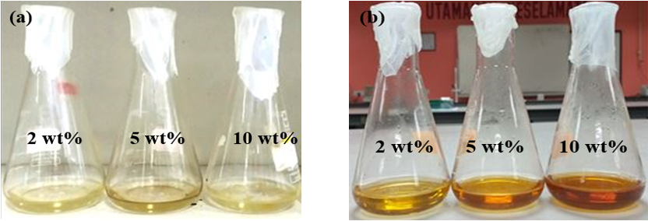

Figure 1. Silver particles prepared at different peel extract concentration for (a) 0 hour (b) 48 hours.

Figure 2 shows the maximum absorption that was obtained at 450 nm for 5 wt.% peel extract concentration. The SPR phenomenon occurs when metal particles emit strong electromagnetic fields on the particle surface, leading to strong absorption band in the range of 400-500 nm in UV-Vis spectra [16]. The absorption peak was more intense at around 450 nm with increasing concentration of the peel extract from 2 to 5 wt.%. When the concentration of biomolecules involved in the metal reductive process increases, more Ag⁺ are reduced to Ag⁰, thus resulting in higher peak absorbance [17]. However, the absorbance decreases significantly when the concentration was further increased to 10 wt.% peel extract. An excess in peel extract concentration will cause the silver particle size to agglomerate which leads to larger particle size. The absorbance decreases with increasing silver particle size due the decrease in particle density [18]. This phenomena has also been reported by Kokila et al. [19] for the green synthesis of silver nanoparticles from cavendish banana peel extract, where the absorbance of 50 wt.% cavendish banana peel extract decreases when the volume was increased from 4 to 5 mL.

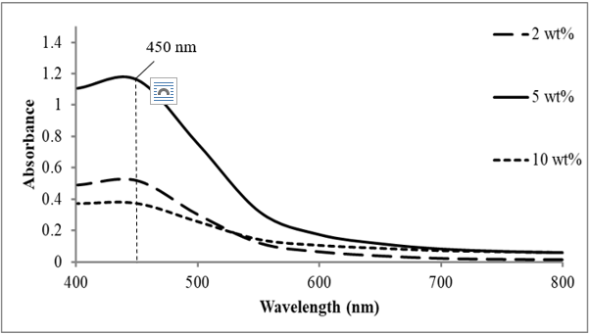

Figure 2. UV-Vis absorption spectra of silver particles observed for different peel extract concentration (wt.%) after 48 hours of incubation process

Effect of silver nitrate solution

Peel extract at 5 wt.% was chosen as a constant variable to evaluate the optimum concentration of the silver nitrate solution. Figure 3 shows that the sample colour with 2, 4, and 6 mM are yellowish brown while the sample with the highest concentration of silver nitrate solution at 8 mM is dark brown. As concentration of the silver nitrate solution increases, the intensity of colour changes will be more significant due to the presence of more silver particles than the reducing agent [20].

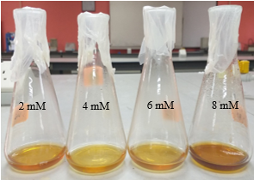

Figure 3. Silver particles prepared at different silver nitrate concentration at 48 hours

The highest peak of absorbance was recorded for 8 mM of silver nitrate solution at a wavelength around 450 nm (Figure 4). The graph depicts that as the concentration of the silver nitrate solution increases, the peak of absorbance also increases. Yang and Li [21] who synthesised silver particles from mango peels also reported that the peak of absorbance increases and shifts to higher wavelength with an increase of silver nitrate concentration. The slight increase in wavelength could be due to excess silver ions aggregates on the surface of preformed nuclei, by which the secondary reduction process occurs which leads to the formation of larger particles.

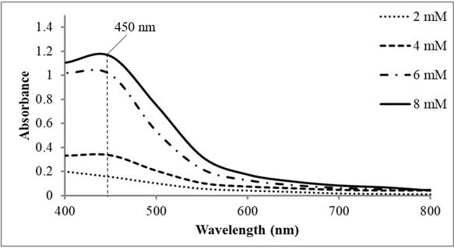

Figure 4. UV-Vis absorption spectra of silver particles observed using different silver nitrate concentration after 48 hours

Effect of incubation time

The effect of different reaction times was investigated for the synthesis of silver particles using 5 wt.% of peel extract and 8 mM of silver nitrate solution. Figure 5 shows the result of UV-Vis analysis at incubation time of 0, 1, 5, 24, 48, 72 hours. No absorbance peak was obtained during 0 and 1 h, indicating few or no particles formed in the solution. For the following hours, the absorbance intensity increases with time. The highest peak of absorbance was obtained after 72 hours of incubation time at a wavelength around 450 nm. Longer reaction time allows for more chemical interaction between the bio-reducing agents to reduce the silver ion into silver particles in the medium [20]. Based on previous literature, the incubation time required for the reduction of silver ions to silver particles varies significantly, from 90 minutes to [21] and up to one week [22].

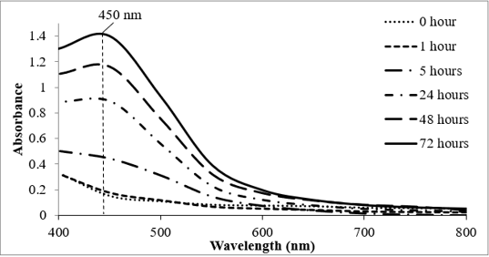

Figure 5. UV-Vis absorption spectra of silver particles observed for the incubation time of 0, 1, 5, 24, 48, and 72 hours

Scanning electron microscopy (SEM)

Scanning electron microscopy was conducted to observe the morphology of silver particles produced. The analysis was performed with proportions of 5 wt.% of plant extract concentration, 8 mM of AgNO₃ solution after incubation time of 72 hours. Figure 6 shows the image of the silver particles (white clusters) formed with different magnification scales. The silver particle observed are polydisperse. The morphology of the silver particles was observed to be dense silver particles which were highly aggregated.

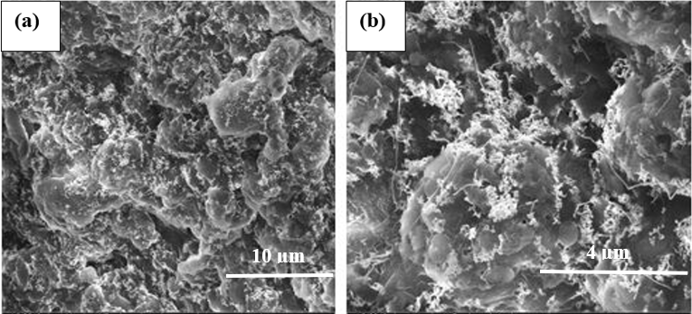

Figure 6. Scanning electron micrographs of the prepared silver particles of sample at (a) 10 000× magnification and (b) 30 000× magnification

Energy-disperse X-ray analysis

Energy-disperse X-ray (EDX) analysis was used to observe the chemical compositions of the silver particles produced at 5 wt.% of the plant extract concentration, 8 mM of AgNO₃ solution after incubation time of 72 hours. The analysis confirmed the presence of elemental silver signal of the silver particles. The result in Figure 7 revealed strong carbon signal along with a weaker oxygen and silver peak (silver element of 19.38% weight) that could have originated from silver particles with bound biomolecules on the surface of the silver particles [23]. The highest peak that was obtained from the EDX could have been from carbon that was released by the pectin that was present in the C. microcarpa peel. The intracellular layer of plant cells especially fruits contains high amounts of pectin which is a type of structural fibre. The peels of citrus fruits contain 0.5%-3.5% pectin [24]. Hence, weaker signal of silver is obtained as the carbon from the pectin is difficult to be separated from the peel extract because of its high gelling capacity. The strong signal for silver particles at 3.0 keV in the EDX profile corresponds to the absorption of metallic silver due to SPR of silver particles [25].

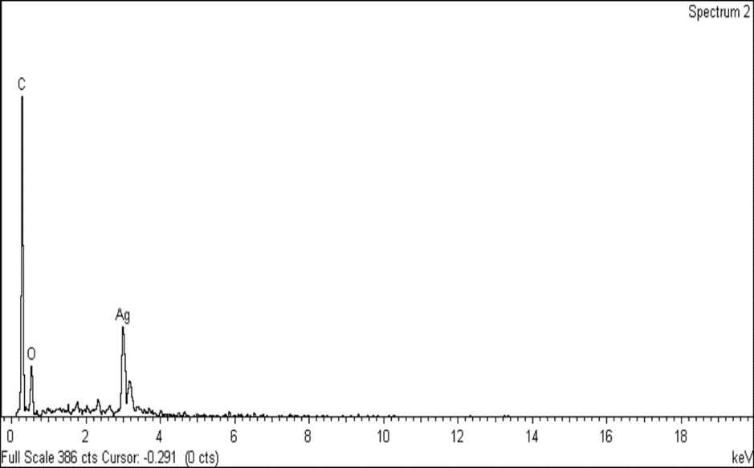

Figure 7. Energy disperse X-ray analysis spectra of silver particles

Size distribution of silver particles

The distribution of silver particle size in the solution was determined using the DLS method. Figure 8 shows the size range of synthesised silver particles was between 100 nm to 500 nm with low polydispersity index (PDI) of 0.363. Anandalakshmi et al. [26] who used Pedalium murex leaf extract to bio-synthesise silver particles found that the size distribution of silver particles ranges from 10 to 150 nm. The average diameter determined by DLS is approximately 235 nm. This could be due to the measured particles size which includes biomolecules that surrounds the surface of the silver particles. In addition, the large particle size could be explained by the different interactive forces in the solution such as Van der Waals forces that allows agglomeration of particles [27]. Kokila et al. [19] also reported large silver particle size of 297 nm obtained from DLS using cavendish banana peel extract to biosynthesise silver particles.

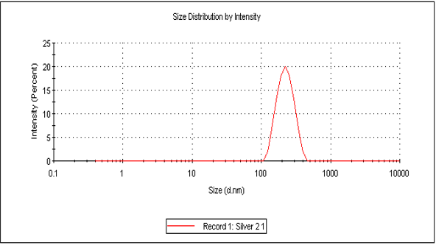

Figure 8. Size distribution of synthesised silver particles

Conclusion

The polydisperse silver particles with an average diameter of 235 nm were successfully synthesised using C. microcarpa peel extract as the reducing agent. The optimum condition to obtain the maximum peak absorbance is when the concentration of peel extract is 5 wt.% which reacts with 8 mM of silver nitrate solution for 72 hours. Citrus microcarpa peel extract provides an environmentally friendly and cost-effective method that could potentially be used for the biosynthesis of silver particles.

Acknowledgement

This study was funded by the Bridging-Insentif Grant (304/PJKIMIA/6316445) from Universiti Sains Malaysia and the Fundamental Research Grant Scheme (203/PJKIMIA/6071379) from the Ministry of Higher Education, Malaysia.

References
- Franci, G., Falanga, A., Galdiero, S., Palomba, L., Rai, M., Morelli, G. and Galdiero, M. (2005). Silver nanoparticles as potential antibacterial agents. Molecules, 20(5): 8856-8874.
- Ranoszek-Soliwoda, K., Tomaszewska, E., Socha, E., Krzyczmonik, P., Ignaczak, A., Orlowski, P., Krzyzowska, M., Celichowski, G. and Grobelny, J. (2017). The role of tannic acid and sodium citrate in the synthesis of silver nanoparticles. Journal of Nanoparticle Research, 19: 1-15.
- Bar, H., Bhui, D. K., Sahoo, G. P., Sarkar, P., De, S. P. and Misra, A. (2009). Green synthesis of silver nanoparticles using latex of Jatropha curcas. Colloids and Surfaces A, 339: 134-139.
- Zhang, X. F., Liu, Z. G., Shen, W. and Gurunathan, S. (2016). Silver nanoparticles: Synthesis, characterization, properties, applications, and therapeutic approaches. International Journal of Molecular Sciences, 17(2016): 1-34.
- Rafique, M., Sadaf, I., Rafique, M. S. and Tahir, M. B. (2017). A review on green synthesis of silver nanoparticles and their applications. Artificial cells. Nanomedicine and Biotechnology, 45(7): 1272-1291.
- Nakhjavani, M., Nikkhah, V., Sarafraz, M. M., Shoja, S. and Sarafraz, M. (2017). Green synthesis of silver nanoparticles using green tea leaves: Experimental study on the morphological, rheological and antibacterial behavior. Heat Mass Transfer, 53: 3201-3209.
- Thuc, D. T., Huy, T. Q., Hoang, L. H., Tien, B. C., Van Chung, P., Thuy, N. T. and Le, A. T. (2016). Green synthesis of colloidal silver nanoparticles through electrochemical method and their antibacterial activity. Materials Letters, 181: 173-177.
- Roy P., Das, B., Mohanty, A. and Mohapatra, S. (2017). Green synthesis of silver nanoparticles using Azadirachta indica leaf extract and its antimicrobial study. Applied Nanoscience, 7: 843-850.
- Raza, M. A., Kanwal, Z., Rauf, A., Sabri, A. N., Riaz, S. and Naseem, S. (2016). Size- and shape-dependent antibacterial studies of silver nanoparticles synthesized by wet chemical routes. Nanomaterials, 6(4): 1-15.
- Dugo, G. and Mondello, L. (2010). Citrus oils: Composition, advanced analytical techniques, contaminants, and biological activity. Illustrate CRC Press, pp. 60-61.
- Xu, G., Ye, X., Liu, D., Ma, Y. and Chen, J. (2008). Composition and distribution of phenolic acids in Ponkan and Huyou during maturity. Journal of Food Composition and Analysis, 21(5): 382-389.
- Cheong, M. W., Chong, Z. S, Liu, S. Q., Zhou, W., Curran, P. and Yu, B. (2012). Characterization of calamansi (Citrus microcarpa). Part I: Volatiles, aromatic profiles and phenolic acids in the peel. Food Chemistry, 134 (2): 686-695.
- Rice-Evans, C. A., Miller, N. J. and Paganga, G. (1997). Antioxidant properties of phenolic compounds. Trends in Plant Science, 2 (4): 152-159.
- Khalil, M. M. H., Ismail, E. H., El-Baghdady, K. Z. and Mohamed, D. (2014). Green synthesis of silver nanoparticles using olive leaf extract and its antibacterial activity. Arabian Journal of Chemistry, 7(6): 1131-1139.
- Vasireddy, R., Paul, R. and Krishna, A. (2012). Green synthesis of silver nanoparticles and the study of optical properties. Nanomaterials and Nanotechnology, 2: 1-6.
- Senthamilselvi, S., Kumar, P., Prabha, A. L. and Govindaraju, M. (2013). Green simplistic biosynthesis of anti-bacterial silver nanoparticles using Annona squamosa leaf extract. Nano Biomedicine and Engineering, 5(2): 102-106.
- Satishkumar, M., Sneha, K., Won, S., Cho, C., Kim, S. and Yun, Y. (2009). Cinnamon zeylanicum bark extract and powder mediated green synthesis of nano-crystalline silver particles and its antibacterial activity. Colloids and Surfaces B: Biointerfaces, 73(2): 332-338.
- Goh, E. G., Xu, X. and McCormick, P. G. (2014). Effect of particle size on the UV absorbance of zinc oxide nanoparticles. Scripta Materialia, 78-79: 49-52.
- Kokila, T., Ramesh, P. S. and Geetha, D. (2015). Biosynthesis of silver nanoparticles from Cavendish banana peel extract and its antibacterial and free radical scavenging assay: A novel biological approach. Applied Nanoscience, 5: 911-920.
- Veerasamy, R., Xin, T. Z., Gunasagaran, S., Xiang, T. F. W., Yang, E. F. C., Jeyakumar, N. and Dhanaraj, S. A. (2011). Biosynthesis of silver nanoparticles using mangosteen leaf extract and evaluation of their antimicrobial activities. Journal of Saudi Chemical Society, 15(2): 113-120.
- Yang, N. and Li, W. H. (2013). Mango peel extract mediated novel route for synthesis of silver nanoparticles and antibacterial application of silver nanoparticles loaded onto non-woven fabrics. Industrial Crops and Products, 48: 81-88.
- Dipankar, C. and Murugan, S. (2012). The green synthesis, characterization and evaluation of the biological activities of silver nanoparticles synthesized from Iresine herbstii leaf aqueous extracts. Colloids and Surfaces B: Biointerfaces, 98(1): 112-119.
- Subba Rao, Y., Kotakadi, V. S., Prasad, T. N., Reddy, A.V. and Sai Gopal, D.V. (2013). Green synthesis and spectral characterization of silver nanoparticles from Lakshmi tulasi (Ocimum sanctum) leaf extract. Spectrochimica Acta Part A: Molecular and Biomolecular Spectroscopy, 103:156-159.
- Mudgul, D. (2017). The interaction between insoluble and soluble fiber. dietary fiber for the prevention of cardiovascular disease. Academic press, pp. 35-39.
- Jagtap, U. B. and Bapat, V. A. (2013). Green synthesis of silver nanoparticles using Artocarpus heterophyllus Lam. seed extract and its antibacterial activity. Industrial Crops and Products, 46: 132-137.
- Anandalakshmi, K., Venugobal, J. and Ramasamy, V. (2016). Characterization of silver nanoparticles by green synthesis method using Pedalium murex leaf extract and their antibacterial activity. Applied Nanoscience, 6: 399-408.
- Prathna, T. C., Chandrasekaran, N., Raichur, M. and Mukherjee, A. (2011). Biomimetic synthesis of silver nanoparticles by Citrus limon (lemon) aqueous extract and theoretical prediction of particle size. Colloids and Surfaces B: Biointerfaces, 82(1): 152-159.

