
S

FOURIER TRANSFORM INFRARED SPECTROSCOPY AND OPTICAL PROPERTIES OF SAMARIUM DOPED ZINC BOROTELLURITE GLASSES

(Inframerah Transformasi Fourier dan Sifat Optik Kaca Samarium didop dengan Zink Borotelurit)

Siti Nasuha Mohd Rafien¹*, Azman Kasim², Azhan Hashim², Wan Aizuddin Wan Razali², Norihan Yahya²

¹Faculty of Applied Sciences,

Universiti Teknologi MARA, 40450 Shah Alam, Selangor, Malaysia

⁵Faculty of Applied Sciences,

Universiti Teknologi MARA Pahang, 26400 Jengka, Pahang, Malaysia

*Corresponding author: nasuharafien1@gmail.com

Received: 13 November 2019; Accepted: 3 September 2020; Published: 12 October 2020

Abstract

Zinc borotellurite glasses doped with Sm³⁺ ions of the (70-x)TeO₂-20B₂O₃-10ZnO-xSm₂O₃ system were prepared by a melt-quenching technique. The values of x varied from 0.0 mol% to 2.5 mol%. The studies on structural and optical characterisation of Sm³⁺ ions were carried out through Fourier transform infrared spectroscopy (FTIR), absorption spectra, optical band gap (E_{opt}) and Urbach energy (ΔE) analysis were presented for Sm³⁺ ions in zinc borotellurite glasses. From the FTIR analysis, the presence of BO₃, BO₄, TeO₃, TeO₄ and B – O ⁻ structural units in the prepared glasses was investigated. Three strong absorption peaks in the ultraviolet and visible regions were observed from absorption spectra due to transition between the ground state and various excited state of Sm³⁺ ions. The value of optical band gap, E_{opt} laid between 2.605 eV to 2.982 eV for the direct transition, and 2.768 eV to 3.198 eV for indirect transition, respectively. Meanwhile, the Urbach energy (ΔE) was observed in the range of 0.112 eV to 0.694 eV, respectively. Some other results were analysed and discussed in details.

Keywords: optical properties, zinc, borotellurite, absorption spectra

Abstrak

Kaca zink borotelurit didop dengan ion Sm³⁺ dalam sistem (70-x)TeO₂-20B₂O₃-10ZnO-xSm₂O₃ telah disediakan melalui kaedah konvensional sepuh lindap. Nilai x bervariasi dari 0.0 mol% hingga 2.5 mol%. Kajian terhadap pencirian struktur dan optik ion Sm ³⁺ telah dilakukan melalui analisis spektroskopi inframerah transformasi Fourier (FTIR), spektrum penyerapan, jurang jalur optik (E_{opt}) dan tenaga Urbach (ΔE) telah dibentangkan untuk ion Sm³⁺ dalam kaca zink borotelurit. Dari analisis FTIR, kehadiran struktur unit BO₃, BO₄, TeO₃, TeO₄ dan B - O- dalam kaca yang disediakan telah dikaji. Tiga puncak penyerapan yang kuat pada ultraungu dan rantau terlihat telah diamati dari spektra penyerapan kerana transisi antara keadaan dasar dan pelbagai keadaan teruja ion Sm³⁺. Nilai jurang jalur optik terletak antara 2,605 eV hingga 2,982 eV untuk transisi langsung dan 2,768 eV hingga 3,198 eV untuk transisi tidak langsung. Sementara itu, tenaga Urbach (ΔE) diperhatikan dalam lingkungan 0.112 eV hingga 0.694 eV, masing-masing. Beberapa keputusan lain telah dianalisis dan dibincang secara terperinci.

Kata kunci: sifat optik, zink, borotelurit, spektra penyerapan

Introduction

Rare earth (RE) ions incorporated with various glass oxides have attracted a great deal of interest due to their important role in the development of many optical devices, such as solid-state laser, light converters, sensor and optical communication fibres [1]. The RE ions doped in various glass hosts, such as zinc borotellurite [2], zinc tellurite [3], borotellurite [4] and zinc sodium phosphate [5] have received considerable attention. Amongst these glass hosts, zinc borotellurite glass systems are found suitable to be used as an excellent candidate for laser material due to their low phonon energy, high mechanical strength, high refractive index, large corrosion resistance, extended infrared transmittance (0.35 µm – 6.0 µm) and relatively high thermal stability [6,7]. Sailaja et al. reported that the RE ions, Sm³⁺, can be used as a dopant in different glass hosts and crystal hosts for their high intense fluorescence in the visible region [8] since the absorption and emission spectra possess broad band region from ultraviolet to infrared [9]. This glass host is very interesting to analyse since the energy transfer process has relatively high quantum efficiency by means of their large energy gap (less non-radiative decay) between the lowest emitting level and next lower lying energy level. However, this glass also shows different quenching mechanisms [10].

In this paper, the effects of Sm³⁺ ions on the structural and optical properties of zinc borotellurite glass were investigated. This study is done to provide more data on the effect of Sm³⁺ ions on zinc borotellurite glass, which are suitable to be used for laser and optical devices. It is expected that the addition of Sm³⁺ ions in the glass network will enhance the optical properties of glass by lowering the optical band gap [11]. Their structural properties by means of FTIR spectroscopy, as well as their optical properties will be analysed and presented.

Materials and Methods

Sm³⁺ ions doped zinc borotellurite glasses with the chemical composition of (70-x)TeO₂-20B₂O₃-10ZnO-xSm₂O₃ (0.0 ≤ x ≤ 2.5 mol%) were prepared by following the melt-quenching technique. Each batch had chemical composition of about 10 g. The chemical compositions were firstly milled together for about 1 hour by using a milling machine to obtain homogeneous mixtures. Then, the mixtures were transferred into an alumina crucible and melted in an electric box furnace at 1000 ℃ for 30 min. The molten mixture was poured onto a stainless-steel plate, followed by an annealing process at 400 ℃ for 5 hours before it was allowed to cool down to room temperature gradually. Then, glass sample was polished before being used for any structural and optical studies.

The FTIR spectra of the glass samples were recorded by using Perkin - Elmer Spectrum 100 FT-IR Spectrometer system in the wavelength region 650–4000 cm⁻¹ to identify the local structure and presence of fundamental functional groups. The absorption spectra were measured by using Perkin - Elmer Lambda 35 UV/VIS Spectroscopy in the range of 380-600 nm. By these absorption spectra, the optical absorption coefficient (α(ω)) can be calculated by using the equation as in [12]:

$α(ω)=2.303\frac{A}{d}$ (1)

where, A is the absorbance and d is the thickness of sample in cm⁻¹. The optical band gap, E_{opt}, of the glass samples can be calculated by using the known Mott – Davis equation [13]:

$α=\frac{B{(ħω-E_{opt})}^{r}}{ħω}$ (2)

where, B is the band tailing parameter, E_{opt} is the optical band gap, ħω is the incident photon energy while r is the index number used to decide the nature of the interband electronic transition causing the absorption (r=1/2 for direct allowed transition and r=2 for indirect allowed transition) [14]. Based on this equation, the graph of (αħω)² and (αħω)^{1/2} versus ħω can be plotted and the value of optical band gap is the extrapolation of the linear region in these two graphs.

In addition, Urbach energy is another optical parameter that can be attained from the absorption spectra. Referring to the equation from Urbach rule, it is obtained by calculating the reciprocal of slope in the graph of natural logarithm of α(ω) as a function of photon energy, ħω:

$α(ω)=α_{°}exp\left(\frac{ħω}{∆E}\right)$ (3)

where, ${}_{º}$ is a constant and ΔE is the Urbach energy [15].

Results and Discussion

Figure 1 shows the FTIR spectra of zinc borotellurite glasses with respect to Sm³⁺ ions content. The spectra band around 714-735 cm⁻¹ were assigned with the stretching vibrations of the Te-O bonds in trigonal bipyramid (TeO₄) with bridging oxygen and trigonal pyramid (TeO₃) with non-bridging oxygen (NBO) [16, 17]. The bands at 839-855 cm⁻¹ and 1215-1218 cm⁻¹ belonged to asymmetric stretching vibrations of B-O bonds in BO₄ tetrahedral and BO₃ trigonal units [18, 19]. Meanwhile, the peaks positioned at 1362-1367 cm⁻¹ were due to the asymmetric stretching vibrations in trigonal BO₃ and trigonal B – $0^{-}$ bond. Whereas the bands present at 2993-3003 cm⁻¹ were attributed to the characteristic of the hydrogen bond in the glasses [20]. Finally, the absorption bands located around 3618-3748 cm⁻¹ were due to fundamental stretching of molecular water groups, OH, as reported by Elbatal et al. [21].

Figure 2 shows the absorption intensity as a function of wavelength, normalised by the sample thickness of the glass with 0 mol% to 2.5 mol% Sm₂O₃. These were three absorption peaks centred at 403 nm, 422 nm and 480 nm, that corresponded to the ⁶H_{5/2} → ⁴L_{13/2}, ⁶H_{5/2} → ⁴M_{19/2} and ⁶H_{5/2} → ⁴I_{11/2} transitions observed. Similar trend of results was also reported by Yaru et al., Som & Karmakar and Selvaraju & Marimuthu in their works, respectively [22-24].

Figure 3(a) and Figure 3(b) show the graph of direct and indirect optical band gaps. The variations of indirect and direct optical band gaps are shown in Table 1. Indirect and direct optical band gaps of the glass samples were found to be varied with the Sm₂O₃ content. These changes may be due to the variations in the amount of bridging oxygen (BOs) and non-bridging oxygen (NBOs) in the glass system. According to Fares et al., the decrement of NBOs caused a reduction in glass polarizability and increment of the optical band gap [25]. This was due to the fact that NBOs bound an excited electron less tightly as compared to BOs. Therefore, NBOs tends to be more polarisable than the BOs. Decrement of E_{opt} might be caused by weaker bond strength of Sm₂O₃ as compared to other chemical oxide in the glass. As a result, it was easier for the electrons to jump into the conduction band. The existence of trivalent electrons, Sm³⁺ ions caused the increment in the number of free electrons in the glass network. This will cause electrons to localise in deep energy levels and contributed to the declining of E_{opt} [26]. Table 1 also shows the results of Urbach energy (ΔE). Urbach energy gives information regarding to defects and disorderness of the glass network [27]. As tabulated in Table 1 as well as in the plotted graph of ln α versus photon energy, ħω is shown in Figure 4, the values of the Urbach energy were found to lay between 0.112 eV to 0.694 eV for the glass samples which were in agreement with the results found with other oxide glass, such as P₂O₅-TeO₂, Bi₂O₃-P₂O₅-TeO₂ (0.17-0.67 eV) and TeO₂-MgO-Na₂O-Nd₂O₃ (0.12-0.21 eV), depending on glass composition [28, 29]. The Urbach energy, ΔE, was measured from the reciprocal of the linear region slope (in lower photon energy) of the curves.

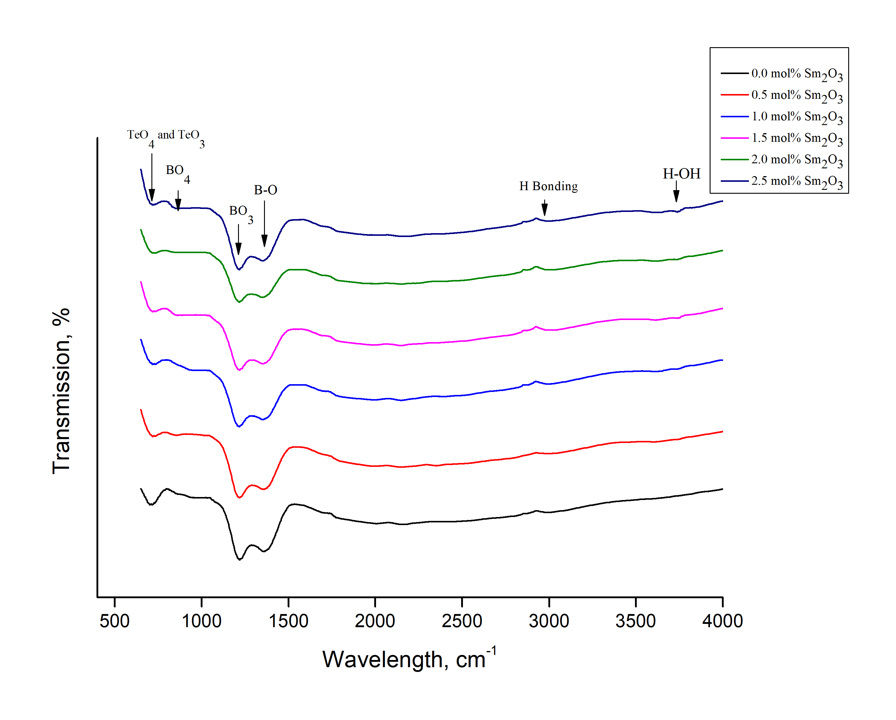

Figure 1. FTIR spectra of the Sm³⁺ doped zinc borotellurite glasses

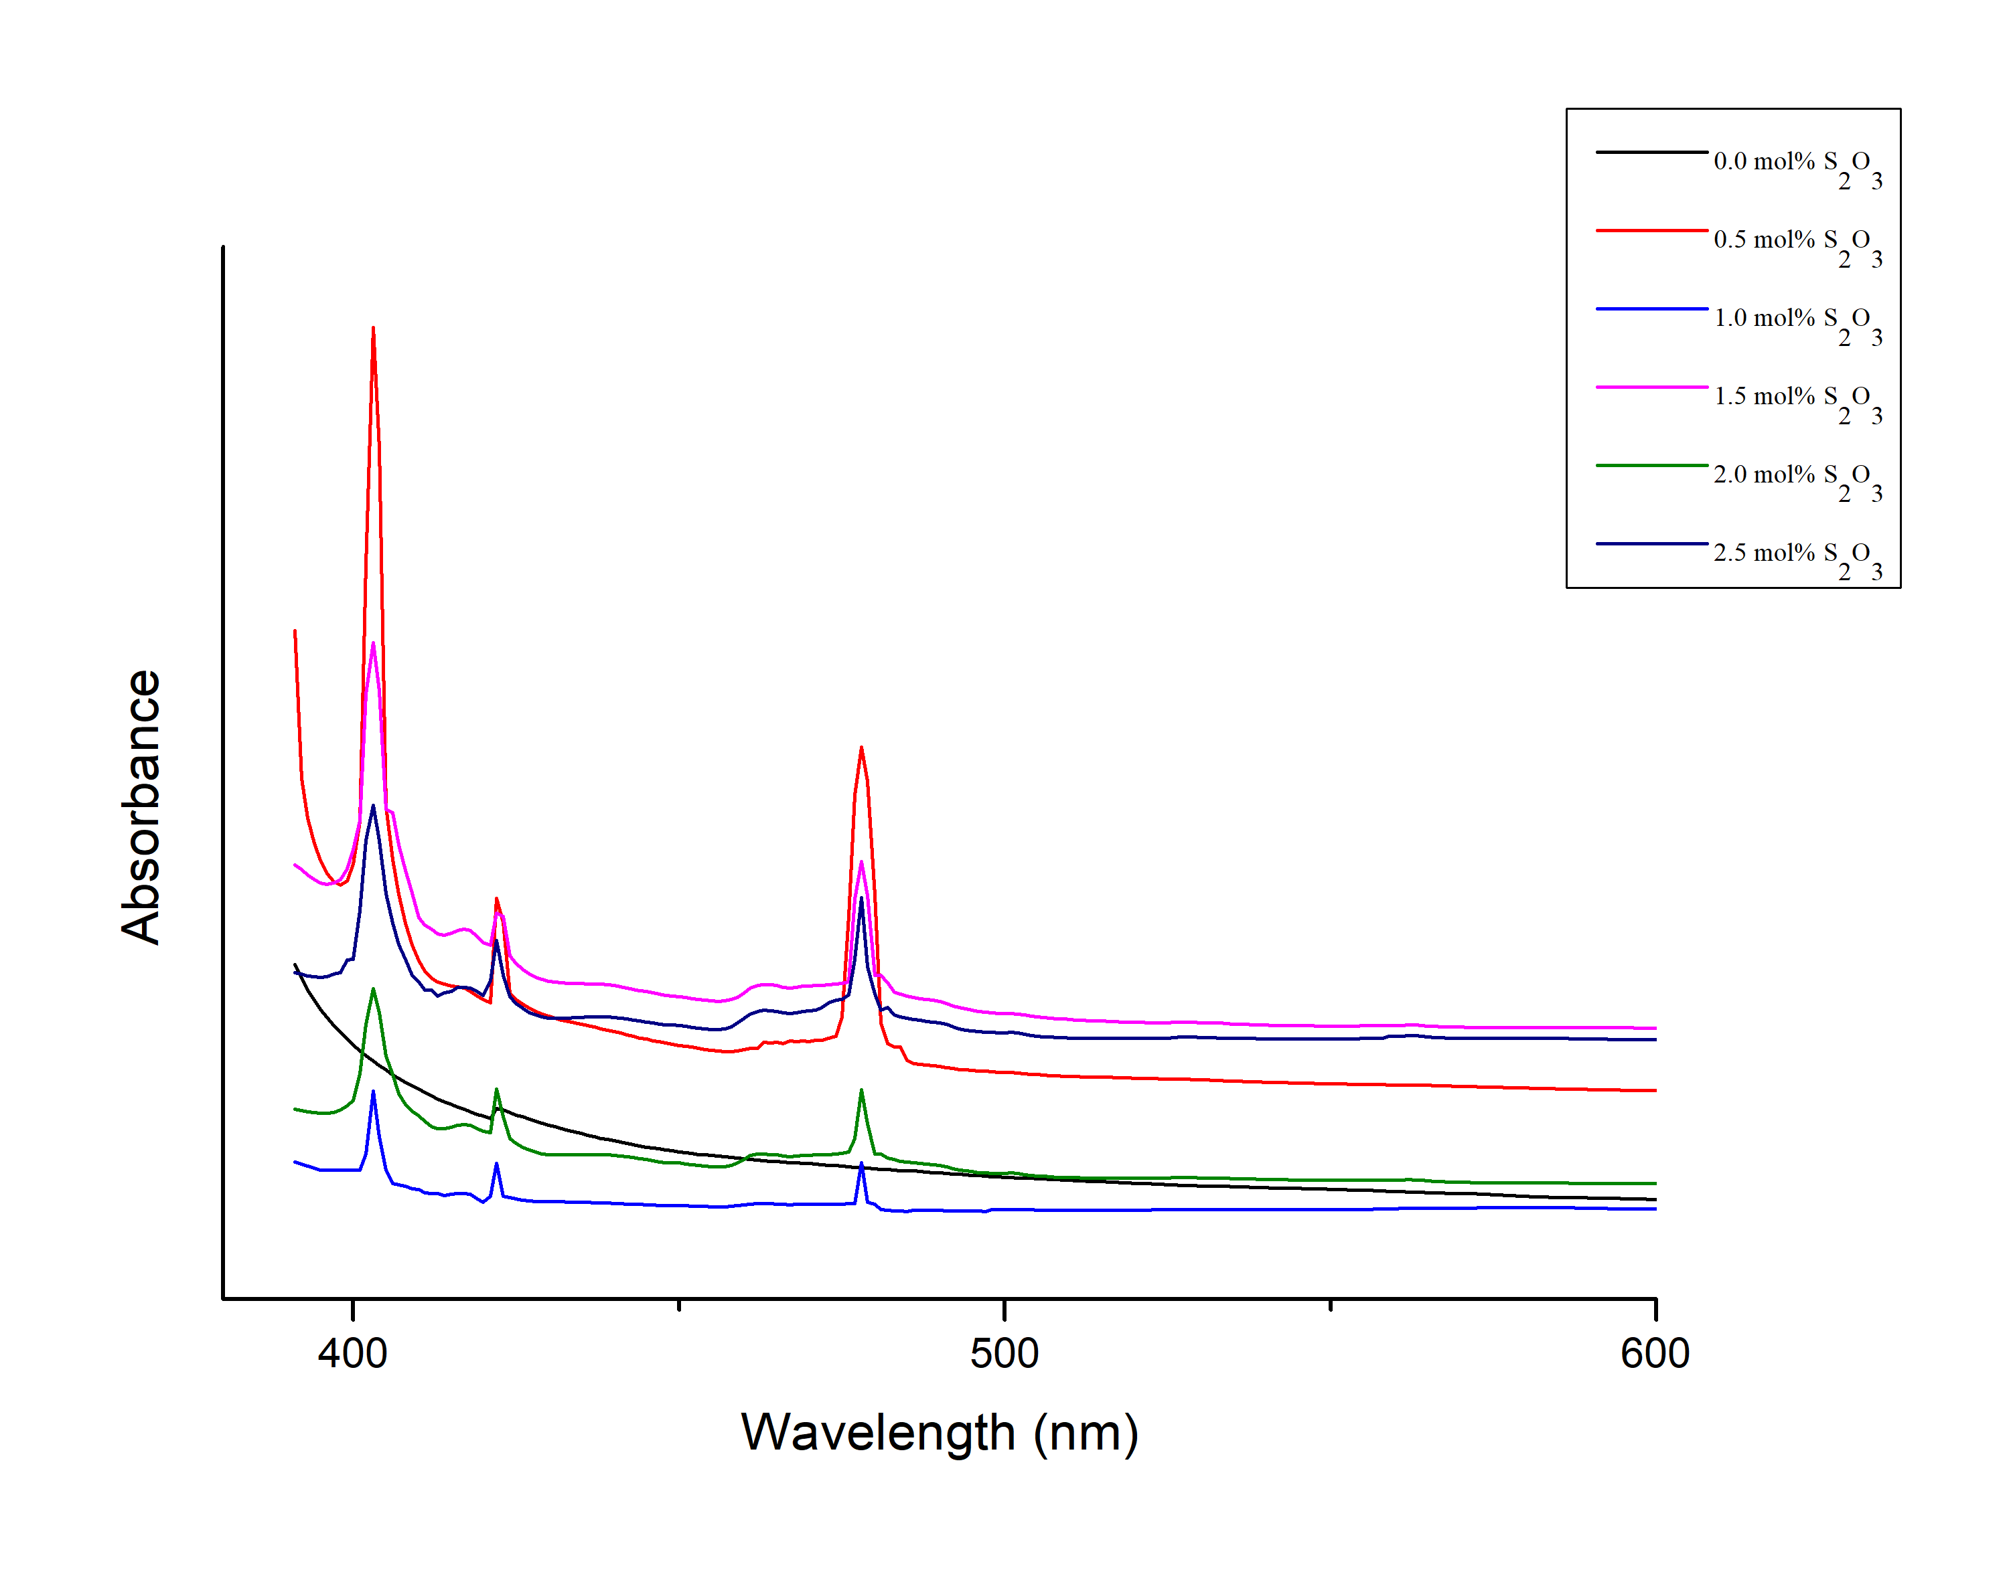
Figure 2. Normalised optical absorption spectra of glasses with different mol% Sm₂O₃

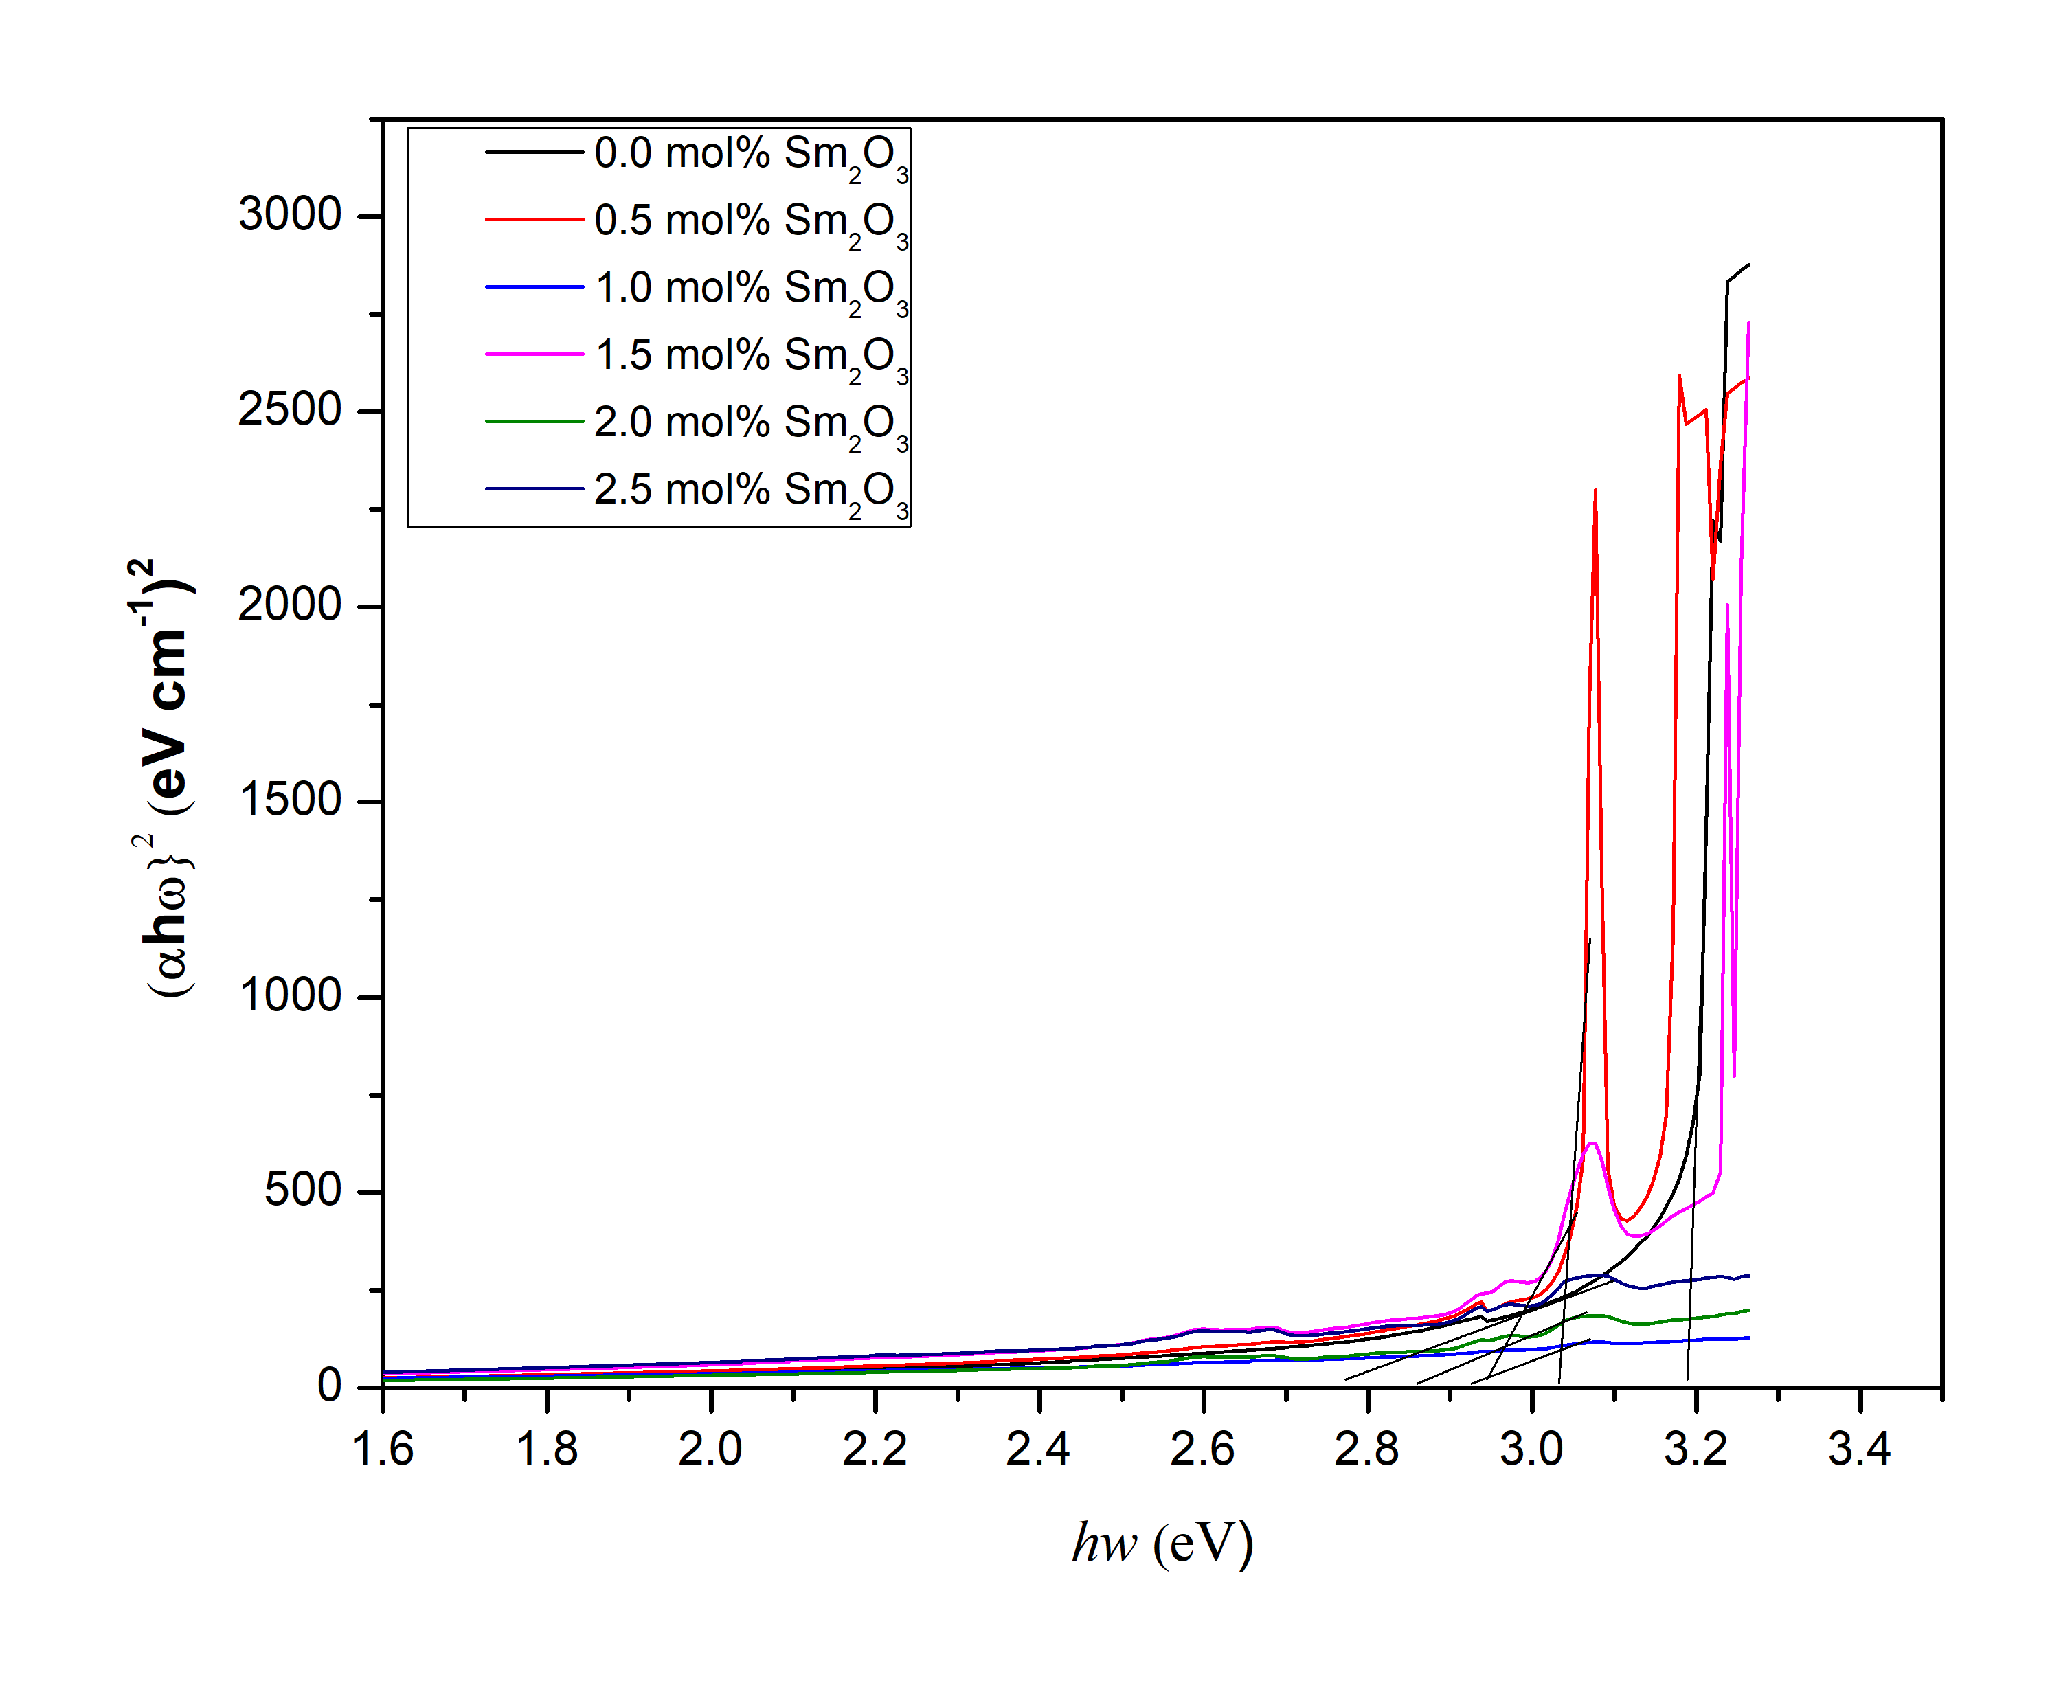

Figure 3(a). Plot of (αħω)² versus ħω for direct band gap of (70-x)TeO₂-20B₂O₃-10ZnO-xSm₂O₃ glass system

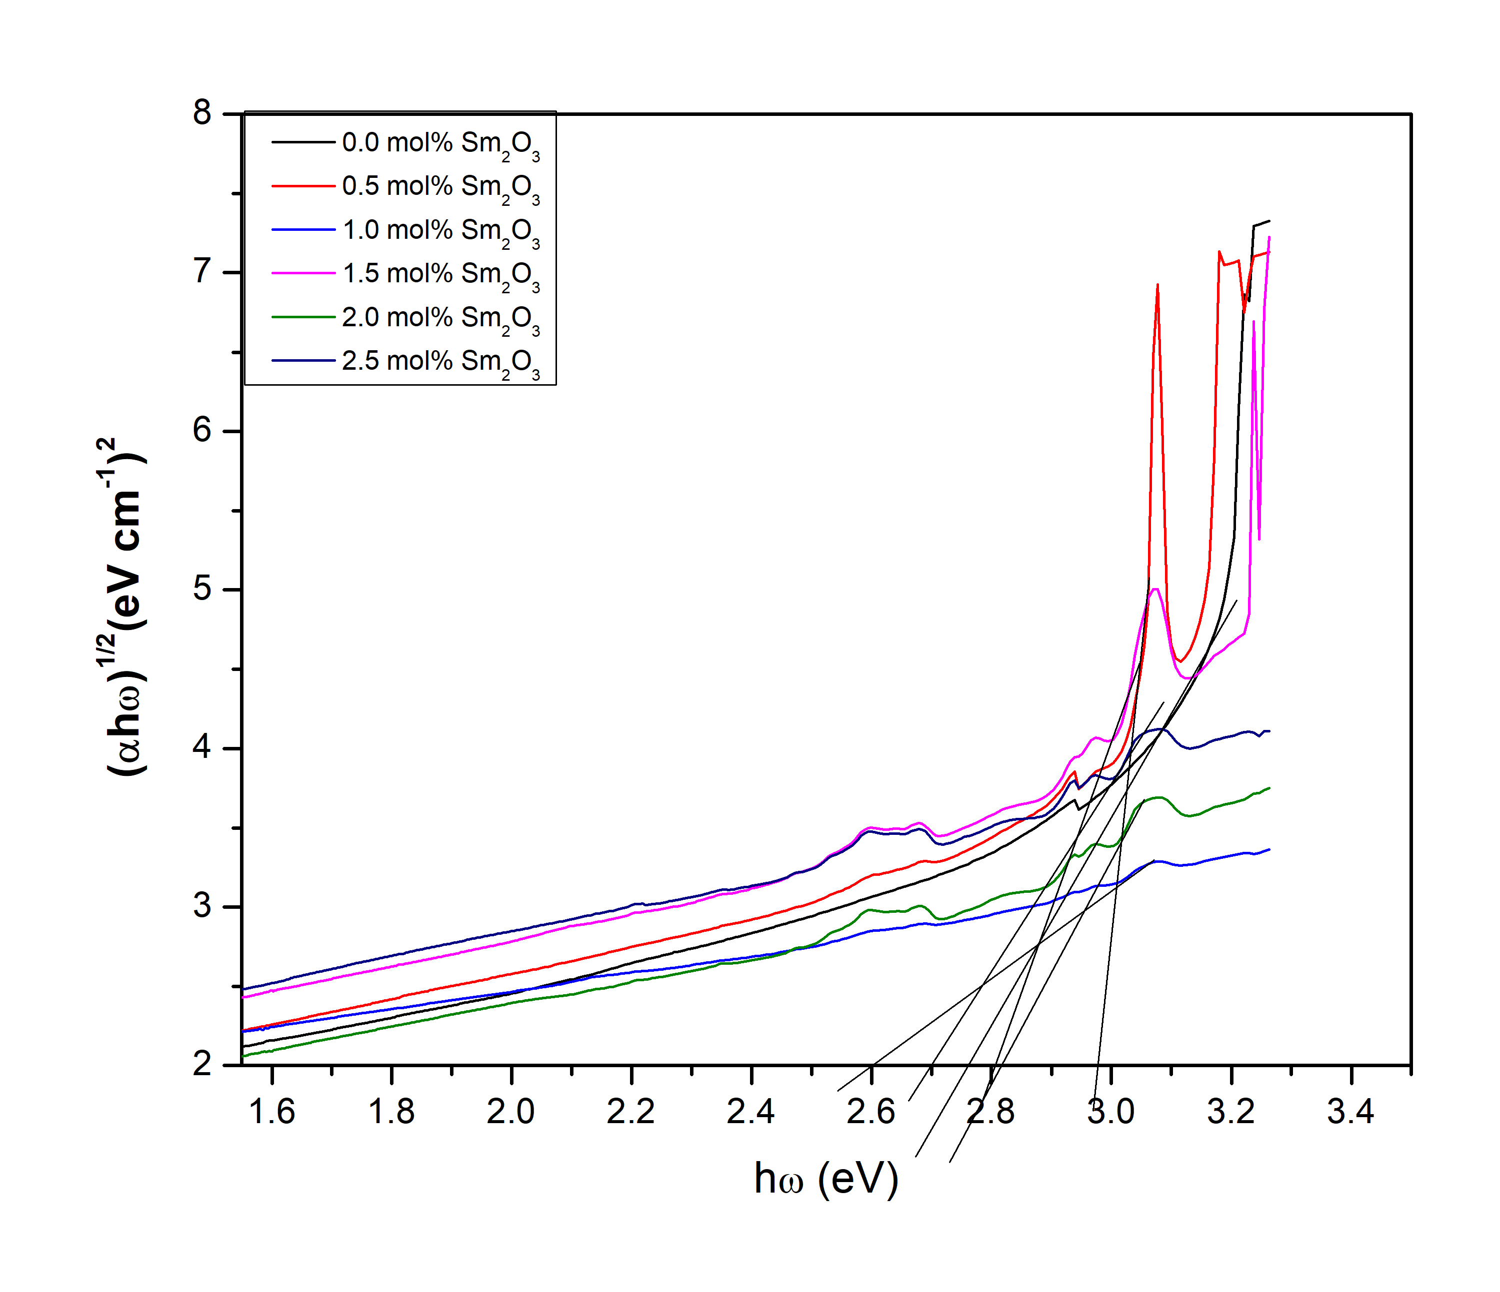

Figure 3(b). Plot of (αħω) ^{1/2} versus ħω for indirect band gap of (70-x)TeO₂-20B₂O₃-10ZnO-xSm₂O₃ glass system

Table 1. Indirect E_{opt}, direct E_{opt} and Urbach energy (ΔE) of the glass samples
Samples No. | Indirect E_{opt} | Direct E_{opt} | Urbach Energy, ΔE
 | (eV) | (eV) | (eV)
S1 | 3.198 | 2.815 | 0.644
S2 | 3.036 | 2.982 | 0.440
S3 | 2.768 | 2.605 | 0.112
S4 | 2.946 | 2.812 | 0.488
S5 | 2.868 | 2.755 | 0.694
S6 | 2.938 | 2.714 | 0.618

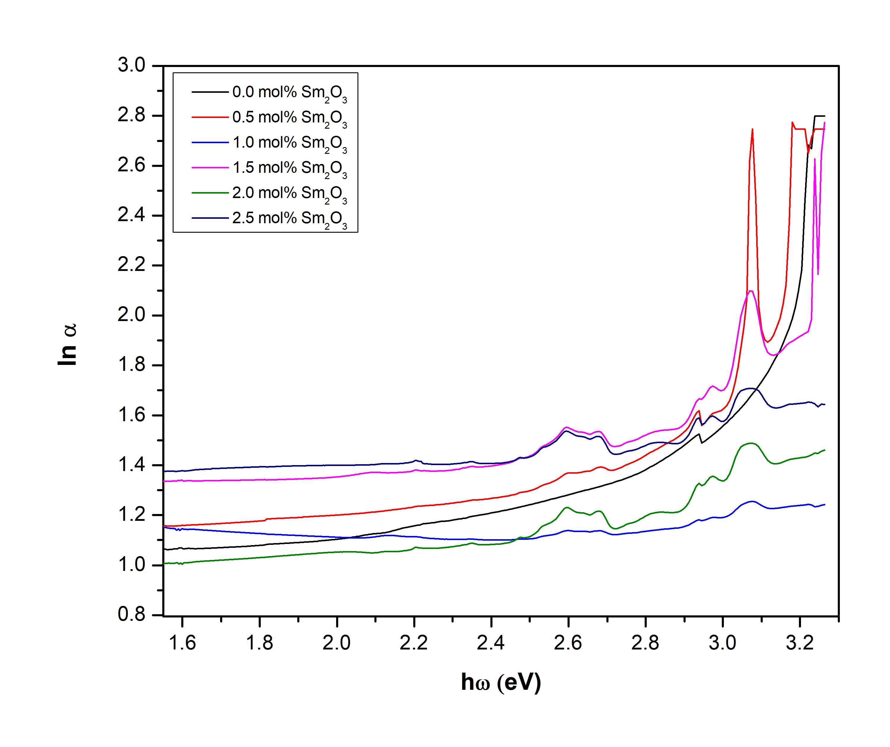

Figure 4. Plot of ln α versus ħω for Urbach energy of (70-x)TeO₂-20B₂O₃-10ZnO-xSm₂O₃ glass system

Conclusion

Sm³⁺ ions doped zinc borotellurite glasses were prepared and their structural and optical properties were studied and reported. The FTIR revealed the presence of asymmetric stretching vibrations of B-O bonds in BO₃ trigonal, BO₄ tetrahedral units and B – $0^{-}$ trigonal, Te-O bonds in trigonal pyramid (TeO₃) and trigonal bipyramid (TeO₄) units and the hydroxyl groups in the prepared glasses. The absorption spectra showed that the strongest absorption occurred at 480 nm. The direct and indirect optical band gaps were found to vary independently with Sm₂O₃ contents.

Acknowledgement

The author would like to thank UiTM for the encouragement and financial support.

References
- Selvi, S., Venkataiah, G., Arunkumar, S., Muralidharan, G. and Marimuthu, K. (2014). Structural and luminescence studies on Dy³⁺ doped lead boro- telluro-phosphate glasses. Physica B: Condensed Matter, 454: 72-8.
- Hasnimulyati, L., Halimah, M. K., Zakaria, V., Halim, S.A., Ishak, M. and Eevon, C. (2016). Structural and optical properties of Tm₂O₃-doped zinc borotellurite glass system. Journal of Ovonic Research, 12(6): 291-299.
- Dousti, M. R., Sahar, M. R., Ghoshal, S. K., Amjad, R. J. and. Samavati, A. R. (2013). Effect of AgCl on spectroscopic properties of erbium doped zinc tellurite glass. Journal of Molecular Structure, 1035: 6-12.
- Nasuha, M. R. S., Azman, K., Azhan, H., Senawi, S. A. and Mardhiah. A. (2016). The physical characteristic of Sm³⁺ doped borotellurite glass. Material Science Forum, 846: 69-74.
- Biju, P. R., Jose, G., Thomas, V., Nampoori, V. P. N. and Unnikrishnan, N. V. (2004). Energy transfer in Sm³⁺, Eu³⁺ system in zinc sodium phosphate glasses. Optical Materials, 24(4):671-677.
- Selvaraju, K. and Marimuthu, K. (2012). Structural and spectroscopic studies on Er³⁺ doped boro-tellurite glasses. Physica B: Condensed Matter, 407 (7): 1086-1093.
- Sasikala, T., Moorthy, L. R. and. Babu, A. M. (2013). Molecular and biomolecular spectroscopy optical and luminescent properties of Sm³⁺ doped tellurite glasses. Spectrochimica Acta Part A: Molecular and Biomolecular Spectroscopy, 104: 445-450.
- Sailaja, S., Raju, C. N., Reddy, C. A., Prasad, B. D., Jho, Y. and Reddy, B. S. (2013). Optical properties of Sm³⁺ doped cadmium bismuth borate glasses. Journal of Molecular Structure, 1038: 29-34.
- Ravi, O., Reddy, C. M., Manoj, L. and Prasad, B. D. (2012). Structural and optical studies of Sm³⁺ ions doped niobium borotellurite glasses. Journal of Molecular Structure, 1029: 53-59.
- Hager, I. Z., El-mallawany, R. and Bulou, A. (2011). Luminescence spectra and optical properties of TeO₂ – WO₃ – Li₂O glasses doped with Nd, Sm and Er rare earth ions. Physica B: Physics of Condensed Matter, 406(4): 972–980.
- Auwalu, I. A., Hotoro, M. A. Y., Jamo, U. H. and Diso, D.G. (2018). Effect of samarium oxide on structural and optical properties of zinc silicate glass ceramics from waste material. Nano Hybrids and Composites. 22: 35-46.
- Ghribi, N., Dutreilh-Colas, M., Duclere, J. R., Hayakawa, T., Carreaud, J., Karray, R., Kabadou, A. and Thomas, P. (2015). Thermal, optical and structural properties of glasses within the TeO₂TiO₂ZnO system. Journal of Alloys and Compounds, 622: 333-340.
- Eraiah, B. (2010). Optical properties of lead–tellurite glasses doped with samarium trioxide. Indian Academy of Sciences, 33(4): 391.
- Kundu, R. S., Dhankhar, S., Punia, R., Nanda, K. and Kishore, N. (2014). Bismuth modified physical, structural and optical properties of mid-IR transparent zinc boro-tellurite glasses. Journal of Alloys and Compounds, 587: 66-73.
- Halimah, M. K., Daud, W. M., Sidek, H. A. A., Zainal, A. S., Zainul, A. H. and Jumiah, H. (2007). Structural analysis of borotellurite glass. American Journal of Applied Sciences, 4(5):323-327.
- Maheshvaran, K., Veeran, P. K. and Marimuthu, K. (2013). Structural and optical studies on Eu³⁺ doped boro-tellurite glasses. Journal of Solis State Sciences, 17: 54-62.
- Ghribi, N., Hayakawa, T., Carreaud, J., Kabadou, A., Thomas, P. and Karray, R. (2014). Thermal, optical and structural properties of glasses within the TeO₂-TiO₂-ZnO system. Journal of Alloys and Compounds, 622: 333-340.
- Noorazlan, A. M., Kamari, H. M., Zulkefly, S. S. and Mohamad, D. W. (2013). Effect of erbium nanoparticles on optical properties of zinc borotellurite glass system. Journal of Nanomaterials, 2013: 1-8.
- Kaur, N. and Khanna, A. (2014). Structural characterization of borotellurite and alumino-borotellurite glasses. Journal of Non-Crystalline Solids, 404: 116-123.

- Nawaz, F., Sahar, M. R., Ghoshal, S. K., Awang, A. and Ahmed, I. (2014). Concentration dependent structural and spectroscopic properties of Sm³⁺/Yb³⁺ co-doped sodium tellurite glass. Physica B: Condensed Matter, 433: 89-95.
- ElBatal, H. A., Abdelghany, A. M. and Ali, I. S. (2012). Optical and FTIR studies of CuO-doped lead borate glasses and effect of gamma irradiation. Journal of Non-Crystalline Solids, 358(4): 820-825.
- Yaru N. and Chunhua, L. (2007). Study on optical properties and structure of Sm₂O₃ doped boron-aluminosilicate glass. Journal of Rare Earth, 25: 94-98.
- Som Tirtha, B. K. (2008). Infrared-to-red upconversion luminescence in samarium-doped antimony glasses. Journal of Luminescence, 128(12): 1989-1996.
- Selvaraju, K. and Marimuthu, K. (2013). Structural and spectroscopic studies on concentration dependent Sm³⁺ doped boro-tellurite glasses. Journal of Alloys and Compounds, 553: 273-281.
- Fares, H., Jlassi, I., Hraiech, S., Elhouichet H. and Férid, M. (2014). Radiative parameters of Nd³⁺ doped titanium and tungsten modified tellurite glasses for 1.06 µm laser materials. Journal of Quantitatives
Spectroscopy and Radiatice Transfer, 147: 224-232.
- Azlan, M. N., Halimah, M. K., Shafinas, S. Z. and Daud, W. M. (2014). Polarizability and optical basicity of Er³⁺ ions doped tellurite glass. National Institute of Materials Physics, 11(7): 319-335.
- Hajer, S. S., Halimah, M. K., Azmi, Z. and Azlan, M. N. (2014). Optical properties of zinc-borotellurite doped samarium. Chalcogenide Letter, 11(11): 553-566.
- Rajendran, V., Palanivelu, N., Chaudhuri, B. K. and Goswami, K. (2003). Characterisation of semiconducting V₂O₅-Bi₂O₃-TeO₂ glasses through ultrasonic measurements. Journal Non-Crystal Solids, 320(1): 195-209.
- Mat Jan, N. A., Sahar, M. R., Ghoshal, S. K., Ariffin, R., Rohani, M. S. and Hamzah, K. (2014). Absorption spectra of neodymium doped tellurite glass. Advanced Materials Research, 895: 395-399.

