
S
CARBOXYMETHYL CHITOSAN-BASED BIOPOLYMER ELECTROLYTE WITH IMIDAZOLIUM IONIC LIQUID

(Elektrolit Biopolimer Berasaskan Karboksimetil Kitosan Dengan Cecair Ionik Imidazolium)

Intan Juliana Shamsudin¹*, Norsyabila Shrgawi¹, Hussein Hanibah², Nur Hasyareeda Hassan³, Azizan Ahmad³

¹ Chemistry & Biology Department, Centre for Defence Foundation Studies,
National Defence University of Malaysia, 57000 Kuala Lumpur, Malaysia
² Centre of Foundation Studies,
Universiti Teknologi MARA, Selangor Branch, Dengkil Campus, 43800 Dengkil, Selangor Darul Ehsan, Malaysia
³ School of Chemical Sciences and Food Technology, Faculty of Science and Technology,
Universiti Kebangsaan Malaysia, 43600, Bangi, Selangor Darul Ehsan, Malaysia

* Corresponding author: intanjuliana@upnm.edu.my

Received: 13 November 2019; Accepted: 3 September 2020; Published: xx October 2020

Abstract
Solid biopolymer electrolyte based on carboxymethyl chitosan has been successfully prepared with ionic liquid 1-butyl-3-methylimidazolium acetate, [Bmim][OAc] as the charge carrier. The strong interactions of the ionic liquid with the biopolymer host were detected by several changes in the FTIR spectra. The decreased percentage of the crystallinity index derived from the XRD diffractograms suggested the amorphous nature of the film prepared. SEM observations showed formation of the linkages due to the plasticising effect of [Bmim][OAc]. Higher amount of [Bmim][OAc] led to the enhancement in the ionic conductivity, σ. The highest σ achieved was (3.05 ± 0.35) x 10⁻³ S cm⁻¹ measured at ambient temperature. The highest conducting electrolyte achieved high electrochemical stability up to ±2.8 V measured by linear sweep voltammetry (LSV). Transference number measurement confirmed that ions were the major contributor in the conduction of electrolyte with ±0.980 ion transference number.

Keywords: carboxymethyl chitosan, ionic liquid, imidazolium, biopolymer electrolytes, ionic conductivity

Abstrak
Elektrolit biopolimer pepejal berasaskan karboksimetil kitosan telah berjaya disediakan dengan cecair ionik 1-butil-3-metillimidazolium asetat, [Bmim][OAc] sebagai pembawa cas. Interaksi yang kuat di antara cecair ionik dengan perumah biopolimer dikesan oleh beberapa perubahan dalam spektrum FTIR. Peratusan penurunan indeks penghabluran yang diperolehi daripada difraktogram XRD mencadangkan sifat amorfus filem yang disediakan. Pemerhatian SEM menunjukkan pembentukan jaringan kerana kesan pemplastikan [Bmim][OAc]. Lebih banyak jumlah [Bmim][OAc] membawa kepada peningkatan dalam kekonduksian ionik, σ. Kadar tertinggi σ dicapai (3.05 ± 0.35) x 10⁻³ S cm⁻¹ yang diukur pada suhu ambien. Elektrolit berkonduksian tertinggi mencapai kestabilan elektrokimia yang tinggi sehingga ± 2.8 V diukur dengan voltammetri sapuan linear (LSV). Pengukuran nombor pemindahan mengesahkan bahawa ion adalah penyumbang utama dalam pengaliran elektrolit dengan nombor pemindahan ion sebanyak ± 0.980.

Kata kunci: karboksimetil kitosan, cecair ionik, imidazolium, elektrolit biopolimer, konduktiviti ionik

Introduction
Chitosan is the second most abundant polysaccharide after cellulose and has a wide number of applications due to its biocompatibility, biodegradability, and abundance in nature. However, chitosan has very low ionic conductivity, σ (⁓10⁻⁹ S cm⁻¹) due to the strong intermolecular and intramolecular hydrogen bonding in the chitosan matrix [1]. Previous studies have reported the chemical modification (carboxymethylation) on chitosan, where a carboxyl group (COO⁻) is substituted into the biopolymer matrix [2-4]. Based on the findings, carboxymethyl chitosan showed a lower degree of crystallinity due to the presence of carboxymethyl residue, which hindered the inter and intramolecular hydrogen bonding in the modified chitosan. The σ of carboxymethyl chitosan was also enhanced by three orders of magnitude to ⁓10⁻⁶ S cm⁻¹ compared to pristine chitosan. Figure 1 shows the chemical structure of carboxymethyl chitosan.

Ionic liquids are a group of organic salts in which the ions are poorly coordinated, which results in these solvents being liquid at relatively low temperatures (below 100 °C). Ionic liquids have attracted the interest of many researchers due to the green solvent properties such as low toxicity, thermal stability, and negligible vapour pressure [5]. 1-butyl-3-methylimidazolium acetate, [Bmim][OAc] have been extensively used as dissolution media for polysaccharide such as cellulose and chitosan. The dissolution mechanism of chitosan in [Bmim][OAc] were reported by Tian and co-workers, whereby a strong interaction between chitosan and [Bmim]OAc was identified, which interrupted the initial hydrogen bonds in chitosan due to the formation of new hydrogen bonds in the complexes. The high basicity value of the anion, CH₃COO⁻ reflected the strong tendency of the anion to accept hydrogen bond [6].

Our previous work discussed the bi-function effect of [Bmim][OAc] in solid polymer electrolyte based on chitosan [7]. Hence, this paper described the effects of [Bmim][OAc] on the biopolymer derivative, carboxymethyl chitosan. The chemical interactions, crystallinity, and electrochemical studies will be discussed, in order to investigate the ability and effectiveness of carboxymethyl chitosan as a polymer host in an electrolyte system.

Materials and Methods
The carboxymethylation of chitosan was done by employing Williamson’s ether synthesis process; a consecutive two-step reaction [2]. Chitosan was used as the starting material. 1-butyl-3-methylimidazolium acetate [Bmim][OAc] was purchased from Sigma-Aldrich. All materials were used without further purification.

Preparation of thin film
Mixtures of carboxymethyl chitosan with different concentrations of ionic liquid were prepared via the solution casting method. Carboxymethyl chitosan was dissolved in 1% solution of acetic acid and stirred overnight in order to obtain complete dissolution of carboxymethyl chitosan. Different concentrations of ionic liquid [Bmim][OAc] (10, 20, 20, 40, 50, and 60 wt.%) were dried under vacuum for 2 hours with vigorous stirring. The dissolved chitosan solution was then added to the dried [Bmim][OAc] under nitrogen gas. The mixed solution was further stirred for 24 hours under nitrogen gas. After complete dissolution, the solution was poured into a Teflon petri dish and left to dry for several days. The resulting thin film was then peeled and stored in a desiccator to prevent any moisture contact. Seven thin film samples have been successfully prepared which were CMChi-0 (pure carboxymethyl chitosan), CMChi-10 (added with 10 wt.% [Bmim][OAc]), CMChi-20 (added with 20 wt.% [Bmim][OAc]), CMChi-30 (added with 30 wt.% [Bmim][OAc]), CMChi-40 (added with 40 wt.% [Bmim][OAc]), CMChi-50 (added with 50 wt.% [Bmim][OAc]), and CMChi-60 (added with 60 wt.% [Bmim][OAc]).

Characterisation
ATR-FTIR analyses were performed using Perkin- Elmer Spectrum 2000, USA in the range of 4000-650 cm⁻¹. The scanning resolution was 4 cm⁻¹. The analyses were carried out to observe any changes and shifts of the characteristic band due to the chemical interactions of chitosan with the charge carrier. X-ray diffraction (XRD) measurements were performed using model D5000 Siemens, Germany. The data were collected from a range of diffraction angle 2θ from 3° to 60° at rate 0.05° s⁻¹ to determine whether the sample was crystalline, semi-crystalline, or amorphous. Investigation on the morphologies of the polymer electrolytes was examined by FESEM Supra 55VP, UK model at 10,000 magnifications. The measurement of the bulk resistance (R_{b}) of the sample was carried out by using Electrical impedance spectroscopy (EIS) model HIOKI 3522 LCR Hi-Tester, Japan, with the frequency range between 50 Hz to 5 MHz. The sample was sandwiched between the blocking stainless steel under spring pressure with a contact area of 5.13 cm². The conductivity values, (σ) of electrolyte have been calculated from equation (1):

$$\text{σ=t}{\text{R}}_{\text{b}}^{\text{-1}}{\text{A}}^{\text{-1}} \text{(1) }$$

where t is the thickness of the sample, R_{b} is the bulk resistance, and A is the contact area. A complex impedance plot was used to calculate the R_{b}. The effect of temperature on the conductivity was measured within the temperature range of 30 to 70 ºC at approximately 5 ºC intervals. Linear sweep voltammetry (LSV) technique was used to determine the electrochemical stability window of the polymer electrolyte. The sample was placed between two stainless steel blocking electrodes using 1 mVs⁻¹ scan rate from 0 to 5.0 V. Transference number measurement was carried out in order to investigate the main conducting element in the polymer electrolyte system using the dc polarisation method. The ions transference number t_{ion} in the electrolyte was determined by monitoring the current as a function of time. Fixed 1.0 V dc voltage was applied across the sample sandwiched between the two stainless steel electrodes. By applying Wagner's Polarisation technique, the value of t_{ion} was calculated from the normalised polarisation current versus time plot using equation (2) where i_{T} and i_{e} are the total and residual current, respectively.

${ \text{t}}_{\text{ion}}\text{= (}{\text{i}}_{\text{T}}\text{-}{\text{i}}_{\text{e}}\text{)/}{\text{i}}_{\text{T}}$ (2)

Figure 1. The chemical structure of carboxymethyl chitosan

Results and Discussion
ATR-FTIR
FTIR spectra of pure CMChi film (CMChi-0) and CMChi with various wt.% of [Bmim][OAc] (10-60 wt.%) in the wavenumber region 4000-2500 cm⁻¹ are depicted in Figure 2. This region shows the characteristic peaks for polar groups such as hydroxyl (-OH) and amino (-NH₂) which were anticipated to be altered with the inclusion of [Bmim][OAc]. Significant changes in the FTIR spectra with the addition of ionic liquid are observed in the figure. Upon the inclusion of [Bmim][OAc], the presence of a new peak at 2962 cm⁻¹ was observed which belonged to the -C-H stretching of methyl group in the ionic liquid [8]. Hence, the appearance of these new peaks and the increase in the intensities indicated the complexation between CMChi matrix with [Bmim][OAc].

The appearance of peaks at 3353 cm⁻¹ in the CMChi/[Bmim][OAc] films indicated the presence of NH₃⁺ that has been protonated by the acetic acid [4]. The O-H band in the CMChi/[Bmim][OAc] films was suggested to be protonated as well, as evidenced by the shift of the band towards lower wavenumber at 3292 cm⁻¹ to 3281 cm⁻¹. Thus, these protonated O-H suggested the formation of OH₂⁺. The broadening of the O-H stretching peaks also might be due to the presence of water molecules in the CMChi films as polysaccharide is hydrophilic in nature [9].

There are also several displacements in the wavenumbers of certain characteristic peaks in CMChi/[Bmim][OAc] films depicted in Figure 3(a). The peak at 1572 cm⁻¹ which belonged to the overlapping of amine (N-H) in the polymer chain was displaced to about 10 cm⁻¹ of wavenumbers to 1562 cm⁻¹ [10]. The C-O-C stretching bridge in CMChi at 1152 cm⁻¹ was observed to shift to higher wavenumbers to 1166 cm⁻¹ and peak at 1058 cm^{-1,} which attributed to the C-O-H stretching of CMChi and acetate ion was shifted to 1066 cm⁻¹ [11, 12]. The shift of the band toward lower wavenumber indicated the particular bonds have been lengthened and thus required less energy to vibrate the particular bond. Meanwhile, the shift towards higher wavenumbers showed that the particular bonds’ length has been shortened which resulted in more energy needed to vibrate the bonds [13]. Scheme 1 shows the proposed interaction mechanism between CMChi and [Bmim][Oac]. In addition, there were two interesting changes in terms of the intensity noted upon the inclusion of [Bmim][OAc] in the CMChi matrix in Figure 3(b). The intensity of C-C(=O)-C stretching in the carboxyl in CMChi at 1323 cm⁻¹ and the C-O stretching in the CMChi backbone around 1060-1025 cm⁻¹ was reduced with the increasing wt.% of [Bmim][OAc]. These changes suggested the strong interaction of the ionic liquid with the biopolymer hosts. Table 1 lists the assigned bands and wavelengths of the CMChi films at different wt.% of [Bmim][OAc].

Figure 2. FTIR spectra CMChi with various wt.% of [Bmim][OAc] in the wavenumber region 4000-2500 cm⁻¹

Figure 3. (a) FTIR spectra and (b) normalised absorbance of CMChi with various wt.% of [Bmim][OAc] in the wavenumber range 1850-800 cm⁻¹ and 1400-800 cm⁻¹ respectively.

Table 1. The assigned bands and wavelength of the CMChi films at different wt.% of [Bmim][OAc]
Assignments of Bands | Wavelength (cm⁻¹)
Assignments of Bands | CMChi-0 | CMChi-10 | CMChi-20 | CMChi-30 | CMChi-40 | CMChi-50 | CMChi-60
O-H | 3292 | 3280 | 3281 | 3282 | 3281 | 3281 | 3281
N-H | 1572 | 1563 | 1561 | 1560 | 1561 | 1561 | 1562
C-O | 1152 | 1156 | 1160 | 1167 | 1166 | 1167 | 1166
C-O | 1058 | 1061 | 1061 | 1064 | 1067 | 1071 | 1066

Scheme 1. Proposed interaction between CMChi and [Bmim][OAc]

X-ray diffraction (XRD)
XRD diffractogram in Figure 4 shows pure CMChi film (CMChi-0) and CMChi with various wt.% of [Bmim][OAc]. The pure CMChi film showed a semicrystalline peak at 2θ of 21.0º, comparable to the previous reports [14, 15]. The crystallinity peak of CMChi was lower than other polysaccharide such as pristine chitosan and cellulose, thus implying lower degree of crystallinity [16, 17]. It was noticeable that, as the wt.% of [Bmim][OAc] increased, the intensity of the peak reduced. At low loading of [Bmim][OAc], (CMChi-10), the intensity and broadness of the peak has not been greatly changed. However, at 20 wt.% of [Bmim][OAc], the intensity of the peak was observed to reduce which indicated that the addition of [Bmim][OAc] has taken impact on the crystalline nature of CMChi. Higher concentration of [Bmim][OAc] has further reduced the intensity, which indicated the development of amorphous phase in the biopolymer. It was noted that in the CMChi-50 and CMChi-60 diffractograms, only a very small peak appeared, reflecting the great disruption of the crystalline phase in CMChi. Moreover, although the amount of [Bmim[OAc] added was rather high, there was no sign of ion multiple peak formation observed, suggesting the miscibility of the ionic liquid in the biopolymer matrix. The plasticising effect of [Bmim][OAc] might have assisted in the reduction of the crystallinity as ionic liquid has been previously reported as an effective plasticiser for polysaccharide [18-20]. In this case, [Bmim][OAc] might have broken the inter and intra-molecular hydrogen bonds of CMChi and destroyed the original crystalline form. As a result, the polymer chain structures have been rearranged whereby the new arrangement has led to the formation of amorphous phase in CMChi [7]. Table 2 depicts the crystallinity index of CMChi/[Bmim][OAc] films. Decreased value in the crystallinity index was observed with higher inclusion of [Bmim][OAc] into the CMChi matrix.

Morphology
SEM micrographs of pure CMChi film (CMChi-0), and CMChi with 20 wt.%, 40 wt.% and 60 wt.% of [Bmim][OAc] (CMChi-20, CMChi-40 and CMChi-60) are depicted in Figure 5. The morphology of CMChi-0 in Fig. 5(a) shows a smooth and homogenous surface indicating the low degree of crystallinity of the pure film. Addition of 20 wt.% of [Bmim][OAc] as can be seen in Fig. 5(b) has slightly altered the morphology as the film showed signs of agglomeration. Nevertheless, no phase separation was observed, suggesting the miscibility of [Bmim][OAc] in the CMChi matrix and the persisted amorphousness of the film. Higher addition of ionic liquid in CMChi-40 film as can be observed in Fig. 5(c) has greatly changed the morphology as the appearance of linkage-like structures can be observed. A similar observation was previously reported whereby the formation of the linkages was identified due to the plasticising effect of glycerol in the blend of chitosan and starch [21]. The plasticiser was believed to act as a spacer between the polymer chains by creating links that functioned as an alternative pathway for ionic conduction. A similar explanation was proposed for the change in the morphology in CMChi-40 film. The [Bmim][OAc] was proposed to function as a plasticiser and form linkages in the CMChi matrix, thus favouring the ionic conduction in the film. However, at the maximum loading of ionic liquid in CMChi-60 film as depicted in Fig. 5(d), the linkages formation was reduced. The co-solvent function of [Bmim][OAc] might have enhanced the miscibility and compatibility of the CMChi matrix and the ionic liquid, which resulted in more homogenous structure in the film. Although the film appeared to agglomerate, no phase separation was observed, suggesting the miscibility of [Bmim][OAc] in the biopolymer. The permanent dark region in the surface micrograph indicates the amorphous phase of the film [21, 22] thus suggesting that the amorphousity of the film was not changed even at high loading of [Bmim][OAc].

Ionic conductivity
Figure 6 depicts the ionic conductivity of Chi and CMChi films as a function of [Bmim][OAc] wt.% at ambient temperature (298 K). Apparently, as reported in our previous work [7], the pure Chi exhibited very low σ, which was (2.93 ± 0.62) x 10⁻⁹ S cm⁻¹. However, the derivative of Chi, CMChi showed improvement in the σ. The σ enhanced by almost two orders of magnitude to (2.20 ± 0.45) x 10⁻⁷ S cm⁻¹. The low crystallinity phase of CMChi as has been identified in the XRD and SEM studies might have assisted the ion conduction and a low crystallinity phase favoured the movement of ions in the system thus resulting in more interactions with the polymer chain.

In the CMChi/[Bmim][OAc] system, the strong conducting effect of [Bmim][OAc] has been observed with only 10 wt.% addition of the ionic liquid. The σ was enhanced by two orders of magnitude to (4.66 ± 0.35) x 10⁻⁵ S cm⁻¹. Further inclusion of [Bmim][OAc] has improved the σ to (2.50 ± 0.30) x 10⁻⁵ S cm⁻¹. The maximum addition at 60 wt.% of [Bmim][OAc] has resulted in the highest σ of (3.05 ± 0.35) x 10⁻³ S cm⁻¹. This has resulted in the total enhancement of four orders of magnitude compared to the σ of the pure CMChi film. A few investigations have been reported that utilised carboxymethyl chitosan as a polymer host in an electrolyte system. However, Mobarak reported that the addition of 20 wt.% of ammonium triflate salt has improved the σ of CMChi to 8.90 × 10⁻⁶ S cm⁻¹. Further addition of ammonium triflate has reduced the σ and was attributed to the formation of ion pairs and ion aggregates, which reduced the number of mobile charge carriers [4]. Thus, this has also shown that [Bmim][OAc] is an efficient charge carrier and suitable to be applied in the CMChi matrix.

The significant σ increase in the systems might also be due to the strong plasticising effect of the ionic liquid. [Bmim][OAc] might have broken the inter and intramolecular hydrogen bonding in CMChi matrixes and thus softened the polymer backbone and enhanced the flexibility of the polymer chains [23]. This is supported by the XRD data. As the flexibility increased, the free volume of the polymer system increased as well. Thus, greater dissociation of the charge carriers was experienced. The increase in number of charge carriers then contributed to higher ionic conductivity in the systems. In addition, the amorphous phase with the higher content of [Bmim][OAc] as shown by the SEM in the CMChi/[Bmim][OAc] system contributed to higher flexibility of the electrolyte chain. As a result, the movement of the conducting ions was easier in the electrolyte and thus increased the ions mobility [24]. Since ionic conductivity is proportional to ion mobility, the enhancement in the ionic conductivity was perceived.

Linear sweep voltammetry analysis
Linear sweep voltammetry analysis has been performed in order to investigate the stability of the polymer electrolyte by measuring the electrochemical stability window. The working cell potential range of electrolytes is an essential factor to be evaluated as it shows the ability of the electrolyte to endure operating voltage of electrochemical devices such as batteries or other electrochemical devices. In this regard, the electrochemical stability window of pure biopolymer film (CMChi-0) and the highest conducting polymer electrolytes CMChi-60 have been studied and the corresponding voltammograms are shown in Figure 7. Based on Figure 7(a), the pure CMChi films showed no electrochemical stability as it underwent immediate oxidation as the cell potential exceeded 0 V. On the other hand, the films with the inclusion of [Bmim][OAc], depicted in Figure 7(b), showed improved electrochemical stability up to ± 2.0 V, and experienced oxidation above the potential. The decomposition voltage of the electrolyte was detected at ±2.8 V. The results revealed that the presence of ionic liquid [Bmim][OAc] in the CMChi biopolymer matrix has increased the electrochemical stability. An investigation reported that addition of ionic liquid improved the oxidative stability of electrolyte, which made the tighter polymer electrolyte [25]. Thus, this result showed that CMChi/[Bmim][OAc] has potential to be applied in electrochemical devices.
Transference number study
The information about the contribution of the particular charge species, whether ions or electrons present in the polymer electrolyte to the overall charge transport can be determined by measuring the transference number. The plots of polarised current versus time for the highest conducting films CMChi-60 are shown in Figure 8. The depletion of the charge carriers or ionic species in the electrolyte caused the initial total current to decrease with time. In the completely depleted condition, the current became constant. Based on Figure 8, high ionic transference number ±0.980 was observed in CMChi-60 film. The high ion transference number in CMChi-60 might be due to the low crystallinity phase of CMChi-60 which eased the mobility of ions in the polymer matrix. The electron transference number in CMChi-60 was only ±0.02 and can be neglected [26]. Thus, this suggested that ions were predominantly responsible in the conduction of CMChi-60 electrolytes film.

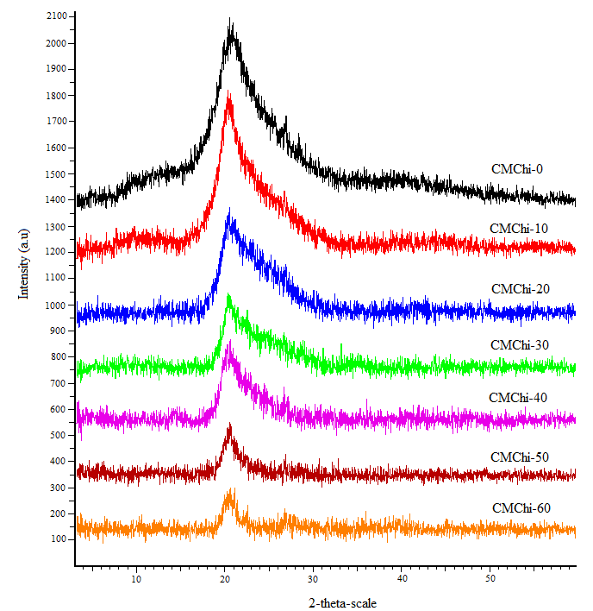
Figure 4. XRD diffractograms of CMChi with various wt.% of [Bmim][OAc]

Table 2. Crystallinity index of pure CMChi film (CMChi-0) and CMChi with 10-60 wt.%
of [Bmim][OAc] films
Sample | Crystallinity index, X_{CI} (%)
CMChi-0 | 34.2
CMChi-10 | 32.3
CMChi-20 | 30.0
CMChi-30 | 28.5
CMChi-40 | 25.2
CMChi-50 | 22.5
CMChi-60 | 18.3

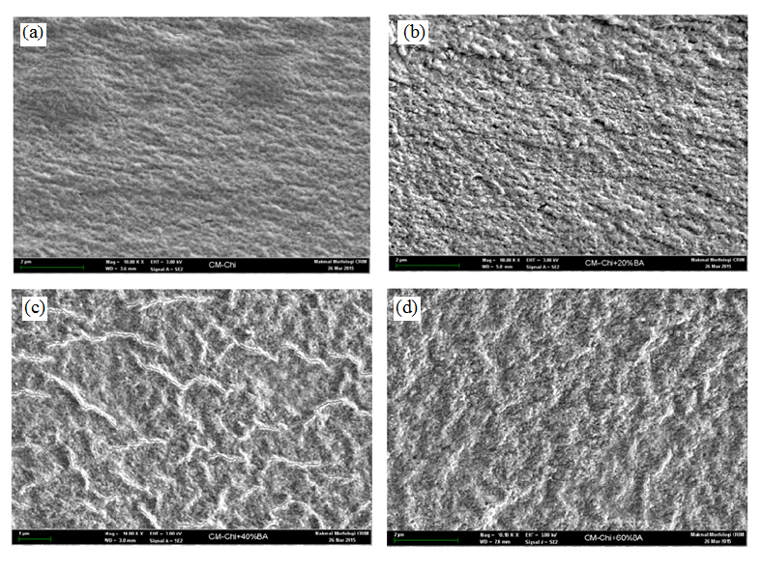
Figure 5. SEM micrographs of (a) CMChi-0, (b) CMChi-20, (c) CMChi-40 and (d) CMChi-60

Figure 6. Ionic conductivity (σ) of Chi and CMChi films as a function of [Bmim][OAc]

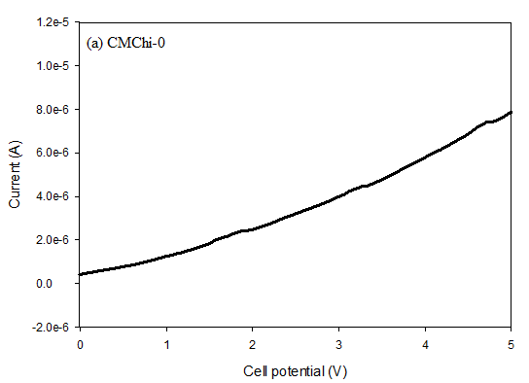

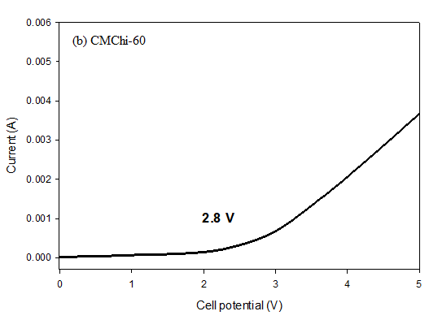

Figure 7. Linear sweep voltammetry of (a) CMChi-0 and (b) CMChi-60 electrolyte films

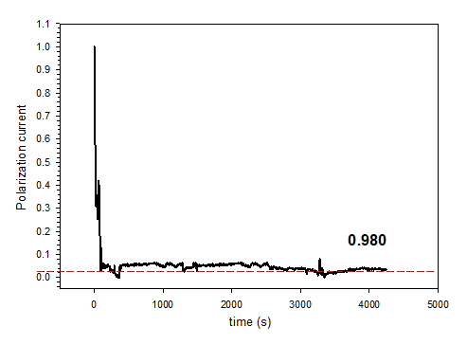
Figure 8. Polarisation current versus time of CMChi-60 films

Conclusion
Solid biopolymer electrolytes based on CM-chitosan with ionic liquid [Bmim][OAc] were prepared and characterised. ATR-FTIR analysis has proven the complexation and interaction between CM-chitosan and ionic liquid while XRD analysis has confirmed the plasticising effect of ionic liquid in the polymer matrix by the disruption of the crystalline phase of the polymer matrix. The SEM morphologies of the biopolymer electrolytes showed a smoother surface as the quantity of ionic liquid increased, thus reinforcing the function of [Bmim][OAc] as a plasticiser in the system. EIS results revealed that the ionic liquid enhanced the ionic conductivity of the electrolyte up to (3.05 ± 0.35) x 10⁻³ S cm⁻¹. The ion transference number was found to be ±0.980 and electrochemical stability up to ±2.8 V was achieved. These results verified that CMChi/[Bmim][OAc] electrolyte system shows potential to be applied in electrochemical devices.

Acknowledgement
The authors are pleased to acknowledge UPNM for the provision of grant RACER/1/2019/STG01/UPNM//2.

References
- Zhang, M., Li, X. H., Gong, Y. D., Zhao, N. M. and Zhang, X. F. (2002). Properties and biocompatibility of chitosan films modified by blending with PEG. Biomaterials, 23(13): 2641-2648.
- Sun, G. Z., Chen, X. G., Li, Y. Y., Zheng, B., Gong, Z. H., Sun, J. J., and Lin, W. X. (2008). Preparation of H-oleoyl-carboxymethyl-chitosan and the function as a coagulation agent for residual oil in aqueous system. Frontiers of Materials Science in China, 2(1): 105-112.
- Ge, H. C., and Luo, D. K. (2005). Preparation of carboxymethyl chitosan in aqueous solution under microwave irradiation. Carbohydrate Research, 340(7): 1351-1356.
- Mobarak, N. N., Ramli, N., Abdullah, M. P. and Ahmad, A. (2013). Spectroscopic studies of carboxymethyl chitosan-ammonium triflate (NH₄CF₃SO₃) based solid polymer electrolytes. AIP Conference Proceedings, 1571(1): 843-849.
- Mallakpour, S. and Dinari, M. (2012). Ionic liquids as green solvents: progress and prospects. In Green Solvents II, Springer, Dordrecht: pp. 1-32
- Cláudio, A. F. M., Swift, L., Hallett, J. P., Welton, T., Coutinho, J. A. and Freire, M. G. (2014). Extended scale for the hydrogen-bond basicity of ionic liquids. Physical Chemistry Chemical Physics, 16(14): 6593-6601.
- Shamsudin, I. J., Ahmad, A., Hassan, N. H. and Kaddami, H. (2015). Bifunctional ionic liquid in conductive biopolymer based on chitosan for electrochemical devices application. Solid State Ionics, 278: 11-19.
- Leones, R., Sentanin, F., Rodrigues, L. C., Marrucho, I. M., Esperança, J. M. S. S., Pawlicka, A. and Silva, M. M. (2012). Investigation of polymer electrolytes based on agar and ionic liquids. Express Polymer Letters, 6(12): 1007-1016.
- Rueda, D. R., Secall, T. and Bayer, R. K. (1999). Differences in the interaction of water with starch and chitosan films as revealed by infrared spectroscopy and differential scanning calorimetry. Carbohydrate polymers, 40(1), 49-56.
- Stefanescu, C., Daly, W. H. and Negulescu, I. I. (2012). Biocomposite films prepared from ionic liquid solutions of chitosan and cellulose. Carbohydrate Polymers, 87(1): 435-443.
- Chen, X. G, and Park, H. J. (2003). Chemical characteristics of O-carboxymethyl chitosans related to the preparation conditions. Carbohydrate Polymers, 53(4): 355-359.
- Mourya, V. K., Inamdar, N. N. and Tiwari, A. (2010). Carboxymethyl chitosan and its applications. Advanced Materials Letters, 1(1): 11-33.
- Shamsudin, I. J., Ahmad, A., Hassan, N. H. and Kaddami, H. (2016). Biopolymer electrolytes based on carboxymethyl ҡ-carrageenan and imidazolium ionic liquid. Ionics, 22(6): 841-851.
- Lu, G., Kong, L., Sheng, B., Wang, G., Gong, Y. and Zhang, X. (2007). Degradation of covalently cross-linked carboxymethyl chitosan and its potential application for peripheral nerve regeneration. European Polymer Journal, 43(9): 3807-3818.
- Mobarak, N. N., Ahmad, A., Abdullah, M. P., Ramli, N. and Rahman, M. Y. A. (2013). Conductivity enhancement via chemical modification of chitosan based green polymer electrolyte. Electrochimica Acta, 92: 161-167.
- Ju, X., Bowden, M., Brown, E. E. and Zhang, X. (2015). An improved X-ray diffraction method for cellulose crystallinity measurement. Carbohydrate polymers, 123: 476-481.
- Ioelovich, M. (2014). Crystallinity and hydrophility of chitin and chitosan. Journal of Chemistry, 3(3): 7-14.

- Domene-López, D., Delgado-Marín, J. J., García-Quesada, J. C., Martín-Gullón, I. and Montalbán, M. G. (2020). Electroconductive starch/multi-walled carbon nanotube films plasticized by 1-ethyl-3-methylimidazolium acetate. Carbohydrate Polymers, 229: 115545.
- Ismail, S., Mansor, N., Majeed, Z. and Man, Z. (2016). Effect of water and [Emim][OAc] as plasticizer on gelatinization of starch. Procedia Engineering, 148: 524-529.
- Ismail, S., Mansor, N. and Man, Z. (2017). A study on thermal behaviour of thermoplastic starch plasticized by [Emim] Ac and by [Emim] Cl. Procedia Engineering, 184: 567-572.
- Shukur, M. F. and Kadir, M. F. Z. (2015). Hydrogen ion conducting starch-chitosan blend based electrolyte for application in electrochemical devices. Electrochimica Acta, 158: 152-165.
- Su’ait, M. S., Ahmad, A., Hamzah, H. and Rahman, M. Y. A. (2011). Effect of lithium salt concentrations on blended 49% poly (methyl methacrylate) grafted natural rubber and poly (methyl methacrylate) based solid polymer electrolyte. Electrochimica Acta, 57: 123-131.
- Liew, C. W. and Ramesh, S. (2013). Studies on ionic liquid-based corn starch biopolymer electrolytes coupling with high ionic transport number. Cellulose, 20(6): 3227-3237.
- Yap, Y. L., You, A. H., Teo, L. L. and Hanapei, H. (2013). Inorganic filler sizes effect on ionic conductivity in polyethylene oxide (PEO) composite polymer electrolyte. International Journal of Electrochemical Sciences, 8: 2154-2163.
- Bai, J., Lu, H., Cao, Y., Li, X. and Wang, J. (2017). A novel ionic liquid polymer electrolyte for quasi-solid state lithium air batteries. RSC advances, 7(49): 30603-30609.
- Deraman, S. K., Mohamed, N. S. and Subban, R. H. Y. (2013). Conductivity and electrochemical studies on polymer electrolytes based on poly vinyl (chloride)-ammonium triflate-ionic liquid for proton battery. International Journal of Electrochemical Science, 8(1): 1459-68.

