
S

SYNTHESIS OF SEMISYNTHETIC TRYPSIN-1,10-PHENANTHROLINE COMPLEXES WITH DIVALENT METAL IONS FOR HYDROLYSIS OF AZOCASEIN

(Sintesis Kompleks Separa Sintetik Tripsin-1,10-Fenantrolin dengan Ion Logam Divalen untuk Hidrolisis Azokasin)

Mohd Basyaruddin Abdul Rahman^{1,2}*, Azizah Misran², Muhammad Alif Mohammad Latif^{1,2},

Emilia Abdulmalek^{1,2}

¹Integrated Chemical BioPhysics Research

²Department of Chemistry, Faculty of Science

Universiti Putra Malaysia, 43400 UPM, Serdang, Selangor, Malaysia

*Corresponding author: basya@upm.edu.my

Received: 30 March 2020; Accepted: 2 September 2020; Published: xx October 2020

Abstract

Modification of trypsin from bovine pancreas was studied to understand the biomolecular interactions between the protein and ligand, toward metal ion. A semisynthetic complex of trypsin-1,10-phenanthroline (trypsin-PHN) was prepared and investigated for its role in the hydrolysis of azocasein. Predicted results from molecular docking studies aid in the comprehension of the protein-ligand system. PHN ligand demonstrated the ability to provide more sites for interactions with metal ions and contribute extensively to the development of a new generation of industrial biocatalysts. The trypsin-PHN complex had an increment of 40% activity in the hydrolysis of azocasein. In the presence of 5 μM Ca²⁺ ions the activity was higher than native enzyme but decreased in the presence of Mg²⁺, Zn²⁺ and Fe²⁺ ions, thus, providing additional insight into potential inhibitors of the rational enzyme design.

Keywords: metalloenzyme, semisynthetic, trypsin, biocatalyst, hydrolysis

Abstrak

Modifikasi tripsin daripada pankreas anak lembu telah dikaji untuk mengetahui interaksi biomolekul di antara protein dan ligan, dan ion logam. Satu kompleks separa sintetik tripsin-1,10-fenantrolin (trypsin-PHN) telah disediakan dan aktiviti terhadap hidrolisis azokasin telah dikaji. Hasil jangkaan daripada kajian pendokkan molekul turut membantu dalam kajian sistem protein-ligan ini. Ligan PHN menunjukkan kebolehan untuk memberikan lebih tapak interaksi dengan ion logam yang berkeupayaan mencetus pembangunan dalam generasi baru industi biomangkin. Kompleks tripsin-PHN menunjukkan peningkatan aktiviti sebanyak 40% dalam hidrolisis azokasin. Kehadiran sebanyak 5 μM ion Ca²⁺ turut meningkatkan aktiviti berbanding enzim asal tetapi menurun dengan kehadiran ion Mg²⁺, Zn²⁺ dan Fe²⁺. Maklumat ini dapat membantu penghasilan perencat dalam rekabentuk enzim secara rasional.

Kata kunci: metaloenzim, separa sintetik, tripsin, biomangkin, hidrolisis

Introduction

In the design of semisynthetic catalysts, enzyme function can be improved for practical use by introducing cofactors or other reactive moieties into proteins that provide enormous flexibility which could be employed for a variety of purposes [1]. The outcomes of such structuring may include altered substrate specificity of an enzyme or increased stability of a protein for specific applications [2]. Protein engineering and chemical modification has become a successful valuable tool for creating or improving protein function for practical uses. This topic is becoming an important one in bioorganic chemistry due to the availability of direct information on the unique interactions of metal cofactors with adjacent amino acids using X-ray analysis [3].

Examination of the protein pocket or cavity would be a good start for the creation of an artificial catalyst [4]. Despite of protein structure being completely organized; a protein has regions on its surface where small molecules (ligands) or ions can bind. It is possible that there are many binding sites on the surface of enzymes and each binding site has only limited range of the ligands. Selected binding sites of thermostable lipase from Geobacillus zalihae strain T1 exemplified how the characteristics of interactions like hydrogen bonds, electrostatic interactions, van der Waals and hydrophobic contacts played very important roles in the protein-ligand interaction studies [5]. The design and development of semisynthetic enzyme was based on the use of protein pockets that can accommodate ligand as an intermediate between the pockets at the surface of the enzyme with metal. A thermostable thermolysin-phosphoethanolamine-Ca²⁺ protein complex suggested metal ions can add new functionality to proteins and help catalyse some of the most difficult biological reactions [6].

In this work, trypsin from bovine pancreas was selected as the backbone due to its high precision information regarding its experimental kinetic data on the enzyme reaction. Furthermore, it has well-defined mechanisms that are consistent with many structural and kinetic studies. It has also been extensively used in research in developing methods for structural stabilizations and catalytic improvements that increased global attention on enzyme engineering [6]. The protein-ligand complex of trypsin also provides a well-defined second coordination sphere that induces the selectivity of the reaction [7]. For advance systematic use of the trypsin, attention should be paid to the fine-tuning of its artificial metalloproteins, design of metal drugs, and electron transfer systems. The objective of this work is to study the structural interactions within the complexes of semisynthetic metalloenzymes through computational-aided molecular modelling and to analyse the effect of ligands and metal ions in the system through experimental work.

Materials and Methods

Materials

Trypsin from bovine pancreas was purchased from Fluka, Switzerland. All metal complexes (MgSO₄.7H₂O, CaCl₂, ZnSO₄ and FeSO₄) were purchased from Merck, Germany. All other chemicals and solvents used in this study were of analytical grade.

Protein preparation and assay

A solution of trypsin was prepared by dissolving trypsin (1 mg/mL) in a 20 mM Tris-HCl buffer, pH 7.6, 10 mM NaCl. It was then purified on a pre-packed Hi-Trap Benzamidine column. The protein content was determined by the Bradford method [8] and trypsin activity was measured by the Tomarelli method using azocasein as a substrate [9].

Synthesis of the trypsin-PHN

A 100 μM solution of PHN in dimethylformamide (DMF) (10 mM, 5 mL) was added to purified trypsin in Tris-HCl (20 mM, pH 7.6, 5 mL), and the mixture was allowed to react at room temperature, for approximately one hour. Later, the solution was purified by gel filtration (Sephadex 25, Desalting Column, Amersham) to remove excess PHN. The activity of the trypsin-PHN was determined by azocasein assay.

Synthesis of trypsin-PHN-metal ion

Each of the following MgSO₄.7H₂O, CaCl₂, ZnSO₄ and FeSO₄ was dissolved in 20 mM of Tris-HCl at pH 7.6 to a final concentration of 5, 10, 15, 20, 25, 30 μM. The solutions were added to a solution of trypsin-PHN (1 mL, 100 µM) in the same buffer and allowed to react for an hour at ambient temperature. Unbound metal ions were removed using gel filtration (Sephadex 25, Desalting Column, Amersham) in a 20 mM, pH 7.6 Tris-HCl buffer. The activity of the resulting protein complex was determined by azocasein assay.

Molecular docking

The AutoDock programme 3.0.5 was employed to perform docking using Lamarckian genetic algorithm (LGA) [10]. Pocket cavities were computed using the CASTp (Computed Atlas of Surface Topography of proteins) web server. The four letter PDB name of trypsin structure (1AUJ) was used for querying on the CASTp server. The hydrogen bonds and hydrophobic contacts were represented using the LigPlot software. BIOVIA Discovery Studio Visualizer was used to visualize the semisynthetic metallotrypsin complexes.

Results and Discussion

Nitrogen-containing ligand PHN is highly stable and rigid which makes it promising for the development of a biocatalyst when incorporated into enzymes. A study of ligand concentration showed that at 100 µM and pH 7.6, the rate of azocasein hydrolysis increased by more than 40% when compared to native enzyme. This increment may due to effects such as high electronegativity of PHN, which increases the charge distribution at the pocket cavity or the active site. The binding of PHN to trypsin (ratio 1:1) was evaluated by UV-visible and fluorescence spectroscopy (results not shown). Instead of increasing the charge distribution in the pocket, PHN would increase the charge of the neighbouring surface area. Consequently, it was hypothesized that more substrates can enter the active site to allow trypsin to efficiently catalyse the reaction.

In this study, the effects of different metal ions in a trypsin-PHN complex were evaluated as shown in Figure 1. The results obtained can be divided into two parts; first, the effect of different metal ions in the complex trypsin-PHN and second, the effect of different concentration of the metal ions. In general, the activity of trypsin-PHN complex was reduced by the presence of metal ions except for Ca²⁺ at 5 µM. In the case of Mg²⁺ and Zn²⁺, trypsin activity was slightly decreased with the increase of metal ion concentrations. However, in the presence of Fe²⁺ inhibited the activity of the trypsin-PHN at all concentration which may due to PHN complexing to iron [11]. It has been suggested that divalent Ca²⁺ is involved with intermolecular protein Ca²⁺-protein cross-linking, intra-molecular electrostatic shielding and induced protein conformational changes [12].

It was well-established that in many cases, metal ions can accelerate the reaction rate and as well retarding the activity of the enzyme. Gradual increase of metal ion concentration from 5 to 30 µM seemed to inhibit the trypsin-PHN complex. Excess metal ions increase the charge distribution at the active site which may lock the geometry of the active site so that only certain substrates could be accommodated. Furthermore, higher concentrations of metal ions might also denature the structure of trypsin-PHN due to imbalance of ionic strength. The presence of Ca²⁺ in low quantities is needed to stabilize the conformation of the trypsin-PHN and to accomplish its function. Other studies of Ca²⁺ binding to protein demonstrated that large amounts of Ca²⁺ (2.4 mM) bound to trypsinogen, significantly changing the conformation of trypsinogen to produce Ca²⁺-trypsinogen conjugates [12]. The formation of multiple conjugates between Ca²⁺ and trypsinogen demonstrated that trypsinogen has multiple sites for the Ca²⁺ binding.

The bidentate PHN ligand can interact with several pockets of the protein. Predicted results from molecular docking may help to explain the protein-ligand system. Based from a previous report [13], a docked complex of pocket 24-PHN showed that 9 residues were involved in hydrophobic contact with PHN; Asp189, Ser190, Cys191, Gln192, Ser195, Trp215, Gly216, Gly219, and Gly226. The detailed preference for pocket 24 might be due to the charge distribution on the pocket itself as illustrated in Figure 2. The rigid ligand of PHN has the most favourable value for the final docked energy (-8.74 kcal/mol) at pocket 24 of trypsin (1AUJ.pdb). The coordinated structure of Ser195 at the active site would promote the attraction of PHN, its highly electronegative nitrogen atom into the pocket. As the PHN contacts the pocket, it may induce conformational changes at the binding site to make the active site of trypsin (His57, Asp102, Ser195) capable of facilitating azocasein as the substrate (Figure 3). It was found that the N-ring was oriented towards the interior of the pocket. Experimental data observed by Ananthanarayanan and Kerman [14] indicated that either the carbonyl or hydroxyl of the ligands could participate in the chelation of a metal ion in conjugation with polar or acidic groups in the ligand binding pocket of the respective receptor.

Since Ca²⁺ is highly charged, it seeks the possibility of sharing electron pairs with other atoms so that a bond or charge-charge interaction can be formed. Katz et al. [15] proposed that Ca²⁺ could accommodate several coordination numbers from 4-10. Electrostatic interactions provided by Ca²⁺ could contribute to the structural effect by inducing conformational changes at the active site to accommodate the substrate [16]. It is interesting to note that pocket cavity 24 provided the site for PHN interaction as it affords the site for hydrophobic interactions for PHN and metal ions attraction due to the electrostatic environment (Figure 4). Despite the stability of trypsin, the binding of Ca²⁺ to protein was suggested to provide the electrostatic environment to orient and attract the substrates to the active site.

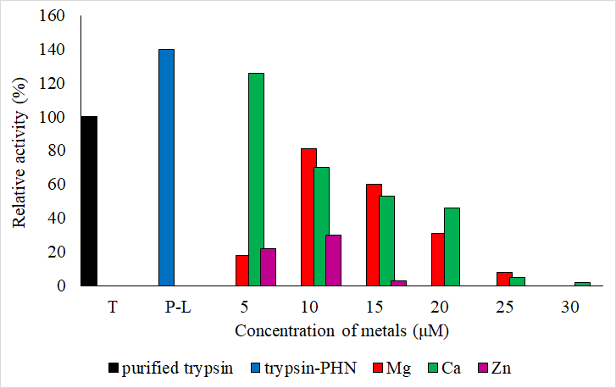

Figure 1. Effect of Mg²⁺, Ca²⁺ and Zn²⁺ metal ions at different concentrations (5 to 30µM) of the trypsin-PHN complex. Fe²⁺ inhibited activity at all concentrations (P-L denoted as Protein-Ligand)

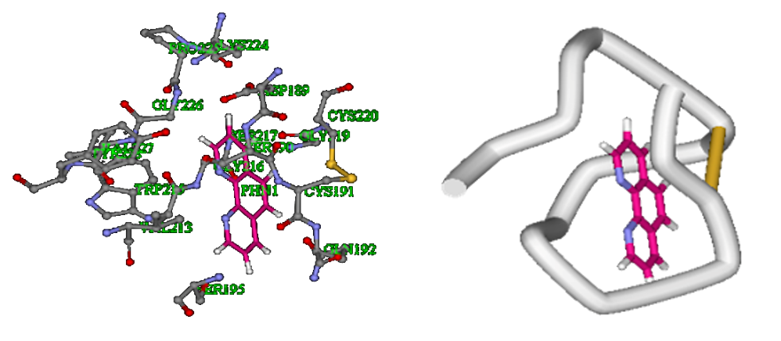

(a) (b)

Figure 2. Orientation of PHN at its lowest docked energy at pocket 24 (-8.74 kcal/mol) [13]. The presentation of interaction trypsin-PHN complex using (a) scaled ball and stick and (b) tube

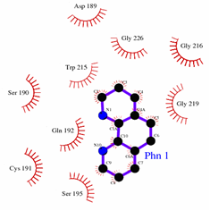

Figure 3. Interactions of PHN at pocket 24 of pancreatic bovine trypsin. Hydrophobic interactions of the lowest docked energy of PHN with pocket 24 of pancreatic bovine trypsin represented by LigPlot. The comb-like arrangements indicate the hydrophobic contacts

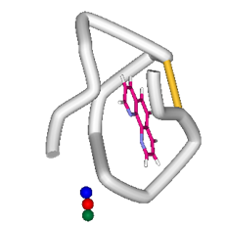
Figure 4. Result of the orientation of 24-PHN-metal complex at its lowest docked energy. The docked metal ions were rendered by CPK structure. The blue ball represents Ca²⁺ (-5.56 kcal/mol), the green ball represents Mg²⁺ (-6.99 kcal/mol), and the red ball represents Fe²⁺ (-9.33 kcal/mol)

Conclusion

It can be deduced that the complex trypsin-PHN-Ca²⁺ was probably the best complex to create semisynthetic metalloenzyme model, as it was capable to increase the activity of the complex in term of designing catalyst. Nevertheless, the association of Mg²⁺, Zn²⁺ and Fe²⁺ into complex trypsin-PHN would provide additional insight of potential inhibitor to the rational enzyme design.

Acknowledgement

This project was supported by the Ministry of Science, Technology and Innovation, Malaysia research grant (Vot. No. 5450618).

References
- Qi, D., Tann, C. M, Haring, D. and Distefano, M. D. (2001). Generation of new enzymes via covalent modification of existing proteins. Chemical Reviews, 101: 3081-3111.
- Mayer, C., Gillingham, D. G., Ward, T. R. and Hilvert, D. (2011). An artificial metalloenzyme for olefin metathesis, Chemical Communications, 47: 12068-12070.
- Heinisch, T. and Ward, T. R. (2010). Design strategies for the creation of artificial metalloenzymes, Current Opinion in Chemical Biology, 14(2), 184-199.

- Lu, Y., Yeung, N., Sieracki, N. and Marshall, N. M. (2009). Design of functional metalloproteins. Nature, 460, 855-862.
- Abdul Rahman, M. B. and Latif, M. A. M. (2019). Interaction studies of putative chemical ligands in binding sites of thermostable lipase from Geobacillus zalihae strain T1. Malaysian Journal of Analytical Sciences, 23(4): 613-624.
- Abdul Rahman, M. B., Jaafar A. H, Basri, M., Raja Abdul Rahman, R. N. Z. and Salleh, A. B. (2014). Biomolecular design and receptor-ligand interaction of a potential industrial biocatalyst: A thermostable thermolysin-phosphoeth-anolamine-Ca²⁺ protein complex. Journal of Advanced Catalysis Science and Technology, 1: 1-5.
- Villalonga, R., Villalonga M. R. and Gomez L. (2000). Preparation and functional properties of trypsin modified by carboxymethylcellulase. Journal of Molecular Catalysis B: Enzymatic, 10: 483-490.
- Bradford, M. M. (1976). A rapid and sensitive method for the quantitation of microgram quantities of protein utilizing the principle of protein-dye binding. Analytical Biochemistry, 72: 248-254.
- Tomarelli, R. M., Charney, J. and Harding, M. L. (1949). The use of azoalbumin as a substrate in the colorimetric determination of peptic and tryptic activity. Journal of Laboratory and Clinical Medicine, 34: 428-433.
- Morris, G. M., Goodsell, D. S., Halliday, R. S., Huey, R., Hart, W. E., Belew, R. K. and Olson, A. J. (1998). Automated docking using a Lamarckian genetic algorithm and an empirical binding free energy function, Journal of Computational Chemistry, 19: 1639-1662.
- Walczak, M. M. and Flynn, N. T. (1998) Spectroelectrochemical study of the generation of tris-(1,10-phenanthroline)iron(II/III) from μ-oxo-bis[aquabis(1,10-phenanthroline)iron(III)]. Journal of Electro-analytical Chemistry, 441(1–2): 43-49.
- Bao, T. and Pawlyszyn, J. (2006). Role of calcium binding in protein structural changes and phospholipid–protein interactions studied by capillary isoelectric focusing with whole column imaging detection, Analytica Chimica Acta, 559(1): 1-8.
- Abdul Rahman, M. B., Misran, A., Basri, M., Raja Abdul Rahman, R. N. Z., Salleh, A. B. and Abdul Wahab, H. (2005). Screening and docking chemical ligands onto pocket cavities of a protease for designing a biocatalyst. Biocatalysis and Biotransformation, 23: 211-216.
- Ananthanarayanan, V. S. and Kerman, A. (2006). Role of metal ions in ligand-receptor interaction: insights from structural studies. Molecular and Cellular Endocrinology, 246: 53-59.
- Katz, A. K., Glusker, J. P., Beebe, S. A. and Bock C. W. (1996). Calcium ion coordination: A comparison with that of beryllium, magnesium, and zinc. Journal of American Chemical Society, 118(24): 5752-5763.
- Steinreiber, J. and Ward, T. R. (2008). Artificial metalloenzymes as selective catalysts in aqueous media. Coordination Chemistry Reviews, 252: 751-766.

