
S

INFLUENCE OF HYDROXYMETHYLATED LIGNIN ON MECHANICAL PROPERTIES AND PAYNE EFFECT OF NR/BR COMPOUNDS

(Kesan Lignin Hidroksimetilasi Terhadap Sifat Mekanik dan Kesan Payne dalam Sebatian Campuran NR/BR)

Nor Anizah Mohamad Aini¹, Nadras Othman¹*, M. Hazwan Hussin², Kannika Sahakaro³, Nabil Hayeemasae³

¹School of Materials and Mineral Resources Engineering, Engineering Campus,
Universiti Sains Malaysia, 14300 Nibong Tebal, Penang, Malaysia
²School of Chemical Sciences,
Universiti Sains Malaysia, 11800 Minden, Penang, Malaysia

³Department of Rubber Technology and Polymer Science, Faculty of Science and Technology,

Prince of Songkla University, Pattani Campus, Pattani, 94000 Thailand

*Corresponding author: srnadras@usm.my

Received: 13 November 2019; Accepted: 3 September 2020; Published: 12 October 2020

Abstract

This work investigates the correlation between hydroxymethylated lignin and its performance in natural rubber (NR)/ butadiene rubber (BR) blend compounds, focusing on Payne effect and mechanical properties. Two types of lignin from kenaf biomass, organosolv lignin (OL) and soda lignin (SL) are modified by using hydroxymethylation modification process and named as hydroxymethylated organosolv lignin (HMOL) and hydroxymethylated soda lignin (HMSL). Every structural characteristic of lignin’s is characterized using Fourier Transform Infrared (FTIR). Then, the modified and unmodified lignin’s are utilized as a filler in NR/BR blends by conventional approach method viz., dry-mixing. Payne effect by rubber process analyzer (RPA) and mechanical properties (tensile properties and hardness) of lignin–filled NR/BR blends are investigated in both masterbatches and vulcanized compounds respectively. Based on the results obtained, it is revealed that alterations in the structural characteristics of hydroxymethylated lignin influence its filler-filler interaction and reinforcement capability. Therefore, a significant improvement has been observed in mechanical properties especially at low loading up to 10 phr. Comparing between two modified lignin, HMSL contributes higher enhancement than HMOL in rubber composites which increase the tensile strength from 15.78 to 17.20 MPa, modulus at 100% strain (1.09 to 1.93 MPa), modulus at 300% strain (3.22 to 7.06 MPa) and hardness (52 to 61.5 Shore A). In conclusion, the inclusion of modified lignin to rubber compounds improves the rubber compounds performance.

Keywords: lignin, hydroxymethylation, bio-filler, structural characteristic, Payne effect

Abstrak

Kajian ini menyiasat korelasi antara lignin hidroksimetilasi dan prestasinya dalam sebatian campuran getah asli (NR)/ butadiena getah (BR), memberi tumpuan kepada kesan Payne dan sifat mekanik. Dua jenis lignin daripada tumbuhan kenaf, organosolv lignin (OL) dan soda lignin (SL) diubahsuai menggunakan kaedah pengubahsuaian hidroksimetilasi dan dinamakan sebagai organosolv lignin hidroksimetilat (HMOL) dan soda lignin hidroksimetilat (HMSL). Ciri-ciri struktur lignin dicirikan menggunakan spektroskopi inframerah transformasi Fourier (FTIR). Kemudian, lignin yang diubahsuai telah digunakan sebagai pengisi dalam campuran NR/BR oleh kaedah pendekatan konvensional iaitu pencampuran kering. Kesan Payne menggunakan penganalisis process getah (RPA) dan sifat mekanik (sifat tegangan dan kekerasan) campuran NR/BR yang diisi dengan lignin diselidiki dalam kedua-dua kelompok induk dan sebatian tervulkan. Berdasarkan hasil yang diperoleh daripada ujian menunjukkan bahawa perubahan dalam ciri-ciri struktur lignin hidroksimetilasi mempengaruhi interaksi antara pengisi dan keupayaan pengukuhan. Oleh itu, penambahbaikan yang ketara telah dilihat dalam sifat mekanik terutama dalam kandungan rendah sehingga 10 phr. Perbandingan antara dua lignin yang diubahsuai, HMSL menyumbang peningkatan yang lebih tinggi daripada HMOL dalam komposit getah yang meningkatkan kekuatan tegangan dari 15.78 kepada 17.20 MPa, modulus pada 100% terikan (1.09 kepada 1.93 MPa), modulus pada 300% terikan (3.22 kepada 7.06 MPa) dan kekerasan (52 kepada 61.5 Shore A). Kesimpulannya, penggunaan lignin yang diubahsuai kepada sebatian getah meningkatkan prestasi sebatian getah.

Kata kunci: lignin, hidroksimetilasi, bio-pengisi, ciri struktur, kesan Payne

Introduction
In recent years, ‘green’ rubber composites containing natural materials have received particular attention due to the awareness towards environmental protection and utilization of biodegradable and sustainable resources. Many natural fillers have been utilized as filler in rubber composites to increase the mechanical properties of rubber product [1, 2, 3]. Among natural sources, lignin is a cheaper and abundant natural polymer obtained from non-food resources, making it suitable and has high potential to be used as reinforcing filler in the rubber compound.

Lignin possesses a unique complex structure. It consists of p-hydroxyphenyl (H), guaiacyl (G) and syringyl (S) with the presence of various of functional groups attached on the lignin’s structure: methoxyl, hydroxyl (alcoholic and phenolic) and the side propanoic chain. The propanoic units bound to each other through various of bonds, i.e., β-O-4, β-5, β-β, and etc. [4]. The functional group and reactivity of lignin depend on the species of origin and isolation methods. However, the functional group on the lignin structure makes polar and incompatible with non-polar rubber matrix. This is the main reason for the lack of utilization in a value-added application. Therefore, structural modifications of the lignin are required [5]. It becomes the pursued directions of researchers to improve the properties of lignin through reactions that may lead to increase functionality and diverse lignin applications. From this perspective, the hydroxymethylation reaction compromises high potentials of increasing the functionality of lignin and porosity which is a key element in rubber systems. Additionally, the addition of hybrid filler into rubber composites is successfully improving its properties and enhances overall mechanical properties in comparison with the solely conventional filler [6,7,8].

This work demonstrates the outcomes of a comparative study on the reactivity of two lignin’s isolated from kenaf biomass with different pulping methods, viz. organosolv and soda method. Both types of lignin have been modified with formaldehyde, as well as characterized structural characteristic by FTIR technique. Furthermore, the obtained modified lignin have been added to natural rubber/polybutadiene rubber (NR/BR) blend composites to partially substitute carbon black (CB) in varying loading content (5, 10, 15, 20 phr) with the total filler at 50 phr. The rubber composites have been further investigated to study the effectiveness of utilization of modified lignin in term of the Payne effect and mechanical properties.

Materials and Methods
Materials
Natural rubber (SMR10) and polybutadiene rubber (BR9000) are supplied by the Rubber Research Institute of Malaysia (RRIM) and Zarm Scientific (M) Sdn Bhd respectively. Two types of lignin are in-house isolated from kenaf biomass through different delignification process, organosolv and soda process. The particle size of both lignin is prepared in the average size less than 250 μm. Sodium hydroxide (NaOH), sodium sulfide (Na₂S), ammonium hydroxide (NH₄OH), formaldehyde, acetic anhydride, pyridine, sulphuric acid (H₂SO₄), and hydrochloric acid (HCl) are purchased from Merck (Petaling Jaya, Malaysia). The N220-grade carbon black (CB) is supplied by Cabot Corporation. Other rubber compounding ingredients are purchased from Bayer (M) Ltd. All the ingredients have been used once received.

Hydroxymethylation procedures
Hydroxymethylation process is performed on both lignin (OL and SL) to alter their structure by substitution of hydroxymethyl groups as outlined by Popa et al. [9]. This modification is expected to develop the interaction between phases of lignin and the rubber matrix. The complete procedure has been elaborated elsewhere [10]. The resultant formaldehyde-modified lignin is called hydroxymethylated organosolv lignin (HMOL) and hydroxymethylated soda lignin (HMSL).

Specimen preparation
Subsequently, modified lignin-containing NR/BR composites blends are prepared based on the formulation listed in Table 1 by using laboratory-scale open two-roll. It is further been hot-pressed into a 2 mm thick sheet at 150 °C after 24 hours of mixing. Moreover, the MDR 2000 moving die rheometer (Alpha Technologies, Akron, OH, USA) is used to determine the optimum cure time, t₉₀. The rubber composites are labeled as NR/BR/OL, NR/BR/SL, NR/BR/HMOL or NR/BR/HMSL, where OL and SL indicate unmodified lignin. The NR/BR/OL, NR/BR/SL and NR/BR/CB50 (no lignin) composites as control samples are prepared in a similar technique to the NR/BR/HMOL and NR/BR/HMSL composites.

Testing and characterization
FTIR spectra are recorded with a Thermo-Nicolet IR 200 Fourier transform infrared (FTIR) with attenuated total reflection (ATR). The range used is 600 - 4000 cm⁻¹ at a resolution of ±4cm⁻¹ with 32 scans. The filler-filler interaction of the uncured compounds is studied by strain sweep test in the range of 0.6-100% strain at 100 °C and a frequency of 0.50 Hz by a Montech D-RPA 3000, rubber process analyzer (RPA) instrument (Werkstoffprüfmaschinen Gmbh, Buchen, Germany). The differences in the storage shear moduli (G’) at low strain (0.6%) and high strain (100%) are reported. Tensile tests are carried out by using H10KS tensiometer (Hounsfield Test Equipment Co., Ltd., Croydon, UK) following guideline from the ASTM D412 method. The crosshead speed of 500 mm/min is applied to the die type C dumbbell-shaped specimen. Wallace Shore A durometer (Cambridge, UK) is used to determine the hardness of the rubber compounds following the ASTM D2240 method.

Table 1. Formulations of NR/BR and modified or unmodified lignin used in this work
Ingredients | Amount (phr)
Ingredients | NR/BR/  CB50  (No Lignin) | NR/BR/  Unmodified Lignin | NR/BR/  HM-5 | NR/BR/  HM-10 | NR/BR/  HM-15 | NR/BR/  HM-20
NR (SMR10)¹ | 50 | 50 | 50 | 50 | 50 | 50
BR (BR9000)² | 50 | 50 | 50 | 50 | 50 | 50
Zinc Oxide | 5 | 5 | 5 | 5 | 5 | 5
Stearic Acid | 2 | 2 | 2 | 2 | 2 | 2
Carbon Black (N220) | 50 | 40 | 45 | 40 | 35 | 30
Unmodified Lignin³ | - | 10 | - | - | - | -
Hydroxymethylated Lignin (HM)⁴ | - | - | 5 | 10 | 15 | 20
TDAE⁵ | 5 | 5 | 5 | 5 | 5 | 5
6PPD⁶ | 2 | 2 | 2 | 2 | 2 | 2
TMQ⁷ | 1 | 1 | 1 | 1 | 1 | 1

Results and Discussion
Structural analysis
Both lignin from kenaf biomass, OL and SL have been altered by hydroxymethylation method in the alkaline atmosphere known as HMOL and HMSL. In order to evaluate the differences in term of functional level between modified and unmodified lignin, the comparative spectral data are analyzed and displayed in Figure 1. Based on spectra presentations, absorption bands specific to C-H aromatic bonds, aliphatic bonds and hydroxyphenyl groups appeared in the 3000 – 2850 cm⁻¹ range. It is proven that the containing of hydroxylic groups and the introduction of hydroxymethyl groups in the lignin structure through the hydroxymethylation reaction. The 1710-1600 cm⁻¹ range corresponds to carbonylic groups bound by the aromatic nucleus. From the peak observed, the shifted C=O bands in the modified lignin’s spectra are due to interaction with the aromatic nucleus. Furthermore, the etheric bond and hydroxyphenolic peak appear in the range of ~1200 cm⁻¹ displays the peak for hydroxymethylated lignin samples increases because of the introduction of substitution. Lignin structure possesses G and S unit which have a free C5 position for G units and methoxy groups attached on the C3 and C5 positions for S units in the aromatic ring. The reactive G units can react and linked with hydroxymethyl groups which convert from formaldehyde, while the S units demonstrate no reactivity with formaldehyde [11].

The absorptions of G and S structural units appear in the region of 1600 – 900 cm⁻¹. However, when compared to unmodified lignin, the peak intensity of the modified lignin decreases. The 1400 – 1460 cm⁻¹ range is affected by the excitation of the C-H asymmetric aromatic nucleus, which reacts with formaldehyde. The methylene chains or known as methylene bridge in this study which formed by further condensations shows stronger vibrations, thus increment of absorption bands intensity may occur. The presence of absorption bands in the 1360 - 835 cm⁻¹ range presents a higher content of C-H bonds. The lignin displays both G and S characteristics absorption at 1219, 1324 and 1120 cm⁻¹. On the other hand, the band, the increasing of peak C-O stretching vibration for primary alcohol and ether (~1100 cm⁻¹) and peak of out-of-plane (820-835 cm⁻¹) deformation vibration of C2, C5 and C6 positions in G units become weaker. This proposes the presence of hydroxymethyl groups into lignin structure and connection of these hydroxymethyl lignin molecules through formation of methylene bridge. These data confirmed that the hydroxymethylation reaction occurred in the structure of lignin.

Payne effect
The strain sweep analysis is conducted for NR/BR/HMOL and NR/BR/HMSL containing various loading of modified lignin at 100 °C. The results of storage modulus (G’) as function of strain are shown in Figure 2a. The G’ value of all rubber compounds has decreased rapidly when the amplitude of strain reached above ~5% strain amplitude. This is due to the breakdown of the entangled chains in rubber compound [12], which is related to the dissociation of the hydrogen bonds and filler networks. Therefore, deformation contributes to changes in microstructure [13]. This phenomenon is well known as the “Payne effect”. The effect sharply reduces with increasing lignin content as shown in Figure 2b, which indicates the reduction of filler-filler interaction. The storage modulus of NR/BR containing hydroxymethylated lignin at low strains is higher than NR/BR containing unmodified lignin, demonstrating the development of strong hydroxymethylated linkages in the NR/BR blends matrix. The values of G’ of NR/BR with hydroxymethylated lignin composites decline with the upturn of the lignin contents. Nonetheless, lignin networks are relatively weaker than carbon black. The inclusion of lignin’s breaks the carbon black network, hence lead to a reduction of the interaction between carbon particles. Consequently the decreasing of Payne effect is due to the substitution of carbon black by lignin.

Curing characteristics
Cure characteristics of NR/BR compound with different content of modified lignin as compared to NR/BR with unmodified lignin and 50 phr of carbon black without lignin are shown in Figure 3. The scorch and cure times reduce with increasing modified lignin content up to 15 phr compared to unmodified lignin-filled as shown in Figure 3a before it rapidly increased when lignin content is above 15 phr. These trends result in increasing cure rate index (CRI) especially for NR/BR/HMSL than control samples as displayed in Figure 3c. The retardation effect at high lignin contents is due to the increment of the polar surface that absorbs more rubber additives in rubber system [14]. Moreover, hindered phenols in lignin structure also affect the vulcanization of rubber due to its radical scavenging effect. The maximum cure torque (M_{H}) and torque difference (M_{H}-M_{L}) are gradually decreased with increasing modified lignin contents (Figure 3b).This is due to the descent of crosslink density with the inclusion of lignin. However, the values are enhanced compared to unmodified lignin filled especially with the utilization of HMSL due to the presence of more solid filler that leads to contributions from hydrodynamic effect, filler-rubber and filler-filler interactions. The minimum torque (M_{L}) is similar with unmodified lignin-filled NR/BR composites at same lignin content. The reduction trend with increasing lignin content proposes greater flowability of the rubber composites, demonstrating the substitution of CB by lignin possibly will improve the process-ability behavior [7].

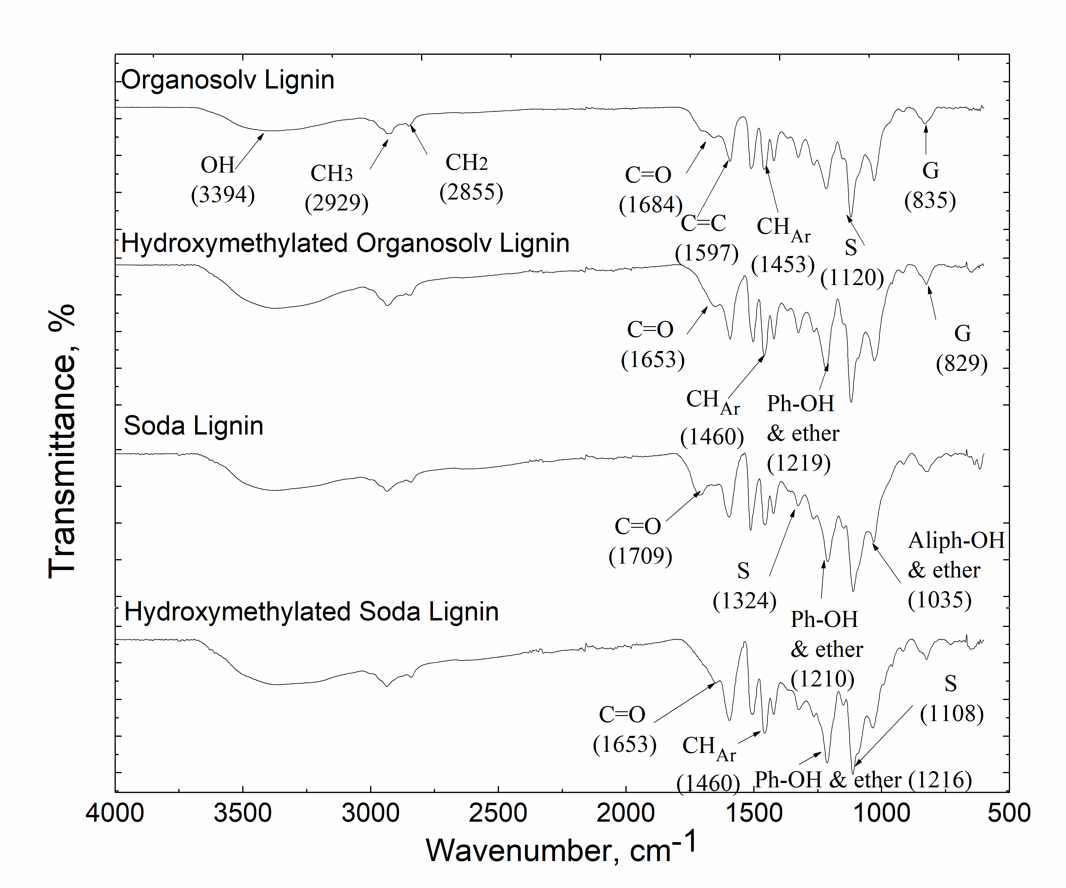
Figure 1. The Fourier transform infrared (FTIR) spectra of unmodified lignin (OL and SL) and hydroxymethylated lignin (HMOL and HMSL)

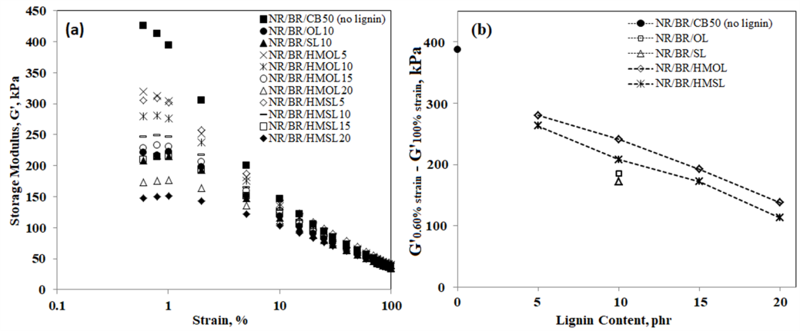
Figure 2. Storage modulus versus strain (a) and Payne effect (b) of NR/BR with unmodified and hydroxymethylated lignin with different loading

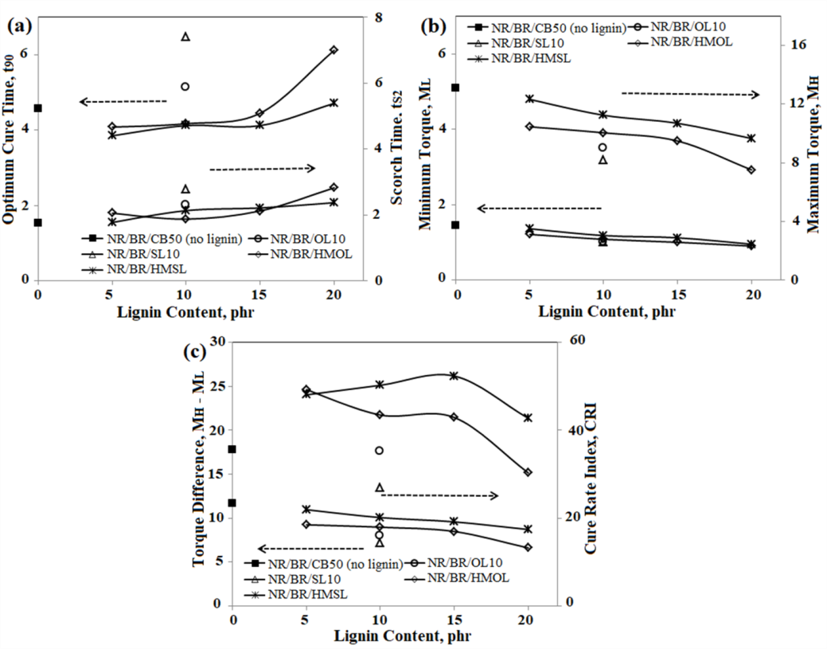
Figure 3. Cure characteristics of NR/BR with different hydroxymethlated lignin content, scorch time, cure time (a) and cure torque (b)

Mechanical properties
Theoretically, the utilization of fillers in the rubber compound may enhance the performance of unfilled rubber such as mechanical properties. This is because all main loads and obstructive deformation encouraged by external stress are hindered by the fillers. Therefore, several factors may improve the rubber performance, i.e. level of filler dispersion and filler-rubber interfacial adhesion. Figure 4 displays the stress-strain graph of the NR/BR composites containing unmodified (OL and SL) and modified lignin (HMOL and HMSL). The tensile properties and hardness of the composites with increasing lignin content are been summarized in Table 2. It shows that when comparing with unmodified and modified lignin-containing rubber composites, the improvement of hardness is demonstrated only by the inclusion of 5 phr HMOL in the NR/BR compounds, which increase the value from 57.0 (NR/BR/OL) to 60.5 Shore A (NR/BR/HMOL5). It contradicts to the hardness values during incorporation of HMSL in NR/BR compounds, in which 7 – 18% enhancement is observed for all HMSL loading. Meanwhile, the modulus 100% and 300% strain for both HMOL and HMSL increases with lignin loading up to 15 phr when compares to unmodified lignin. This is possibly due to stronger filler-rubber interaction in the modified lignin-filled NR/BR composites. This significant improvement can be ascribed to the hydroxymethyl groups of modified lignin which reacts with rubber molecules especially with the inclusion of HMSL in NR/BR composites at low contents (up to 15 phr). The values are comparable with NR/BR/CB50 (no lignin). This proposes the strongest interaction at rubber-filler interface and the rigid elastomeric network structure as observed in SEM micrograph in Figure 5d [15]. Moreover, it probably due to an effective surface modification towards SL filler originates from the alkaline extraction process. Thus, it is confirmed that hydroxymethylated lignin at low content contributes to the enhancement of interaction between lignin and rubber molecule.

The tensile strength of NR/BR with unmodified lignin, OL and SL are only 15.07 and 15.78 MPa respectively. However, utilization of 10 phr modified lignin improved the tensile strength for both HMOL and HMSL to be 16.72 and 17.20 respectively, which is better or comparable to NR/BR with 50 phr of solely CB. The strength of modified lignin-filled NR/BR composites increased significantly by approximately 10.9% and 8.9% for HMOL and HMSL respectively. This shows that hydroxymethylated lignin at low loading possesses a remarkable reinforcing effect on NR/BR. However, further addition of lignin to more than 10 phr constantly reduces the strength of the NR/BR composites. Nevertheless, HMSL-filled NR/BR composite shows better tensile strength with low content of lignin (up to 10 phr) compared to its HMOL counterpart. The former demonstrates better wetting effect than the latter with unmodified lignin, as evident from SEM micrograph in Figure 5.

Figure 5a and 5c display the fractured surface of rubber composite containing unmodified OL and SL respectively. The surface with OL and SL shows a smooth surface with lignin particles observed on the surface. Lignin distribution for SL seems to be more homogenous compared to OL, which correlates with low Payne effect value shown in Figure 2b and exhibit higher value of tensile strength compared to rubber containing OL. However, after modification, the fractured surface of HMOL- and HMSL-filled with 10 phr loadings becomes rougher compared to unmodified lignin as evident in Figure 5b and 5d respectively. Surface roughness indicates higher modulus and rigid surface with the presence of lignin particle. Moreover, better compatibility and better dispersion (Figure 5d) is observed for HMSL-filled, as its strength is higher than that of HMOL-filled composite. But, the effectiveness in term of the strength of the NR/BR composites is constantly declined with the addition of more than 10 phr of both modified lignin. This deteriorating trend is caused by poor dispersibility and modified filler-rubber interfacial, which is probably due to network formation between lignin particle.

Furthermore, the introduction of the hydroxymethylated group on the lignin structure leads to less elongation at break of the modified lignin-filled rubber composites compared to composite with unmodified lignin. This suggests that the bridge formation between lignin and rubber molecules through “methylene bridge” increases the rigidity of the rubber network structure. Additionally, the short chains bridging neighboring filler particles restrict the chain extensibility, as well as restriction of the slippage of rubber molecular chains on the surfaces fillers, contributed by the good chemical bonding between the filler and rubber matrix at low lignin content [15]. Moreover, the uniform dispersion contributes to strong interaction with the rubber matrix. However, incorporation of modified lignin higher than 10 phr deteriorates the properties due to the potential of filler agglomeration in the rubber matrix.

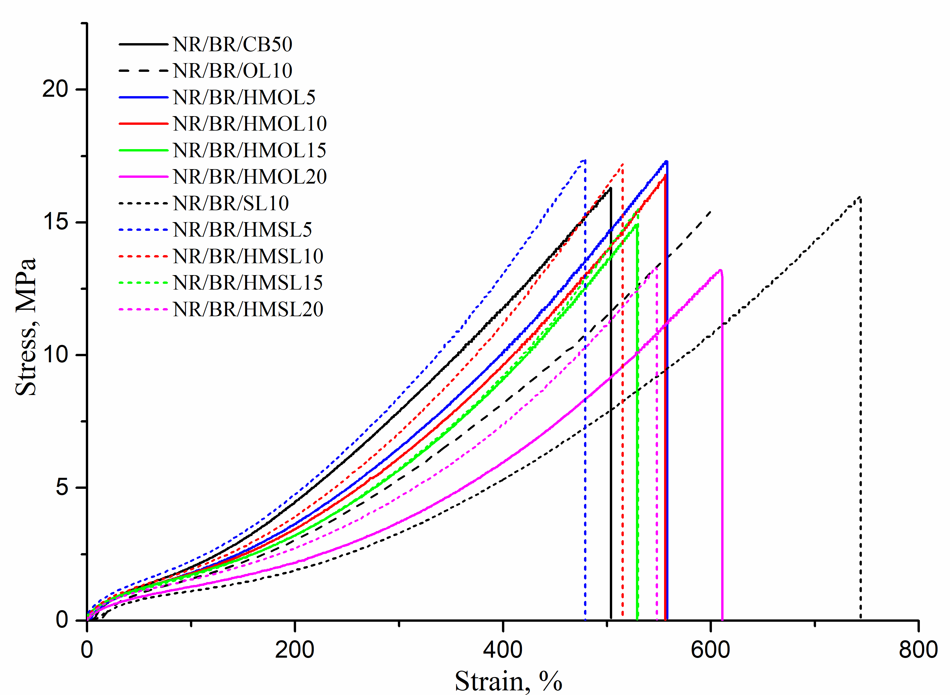

Figure 4. Stress-strain behavior of NR/BR with different hydroxymethlated lignin content

Table 2. Mechanical properties NR/BR compounds with incorporation of hydroxymethylated and
unmodified lignin
Sample | Hardness  (Shore A) | Modulus at 100% Strain, M100  (MPa) | Modulus at 300% Strain, M300  (MPa) | Tensile Strength  (MPa) | Elongation at Break  (%)
NR/BR/CB50 | 61.0±0.40 | 2.01±0.02 | 8.02±0.13 | 16.72±0.45 | 501±5.72
NR/BR/OL10 | 57.0±0.70 | 1.61±0.12 | 5.40±0.78 | 15.07±0.26 | 599±31.26
NR/BR/HMOL5 | 60.5±0.24 | 1.77±0.09 | 6.58±0.53 | 17.31±0.17 | 563±31.26
NR/BR/HMOL10 | 56.5±0.24 | 1.76±0.06 | 6.13±0.36 | 16.72±0.38 | 557±28.18
NR/BR/HMOL15 | 56.5±0.41 | 1.74±0.02 | 5.68±0.11 | 14.84±0.70 | 530±19.75
NR/BR/HMOL20 | 51.2±0.24 | 1.33±0.08 | 3.72±0.40 | 13.41±0.15 | 617±35.49
NR/BR/SL10 | 52.0±0.30 | 1.09±0.05 | 3.22±0.28 | 15.78±0.15 | 748±34.41
NR/BR/HMSL5 | 61.7±0.62 | 2.19±0.08 | 8.42±0.16 | 17.56±0.13 | 480±5.79
NR/BR/HMSL10 | 61.5±0.82 | 1.93±0.03 | 7.06±0.22 | 17.20±0.32 | 510±9.18
NR/BR/HMSL15 | 60.7±0.47 | 1.72±0.06 | 5.82±0.25 | 15.50±0.23 | 530±9.46
NR/BR/HMSL20 | 56.0±0.71 | 1.55±0.05 | 4.73±0.15 | 13.47±0.19 | 538±8.16

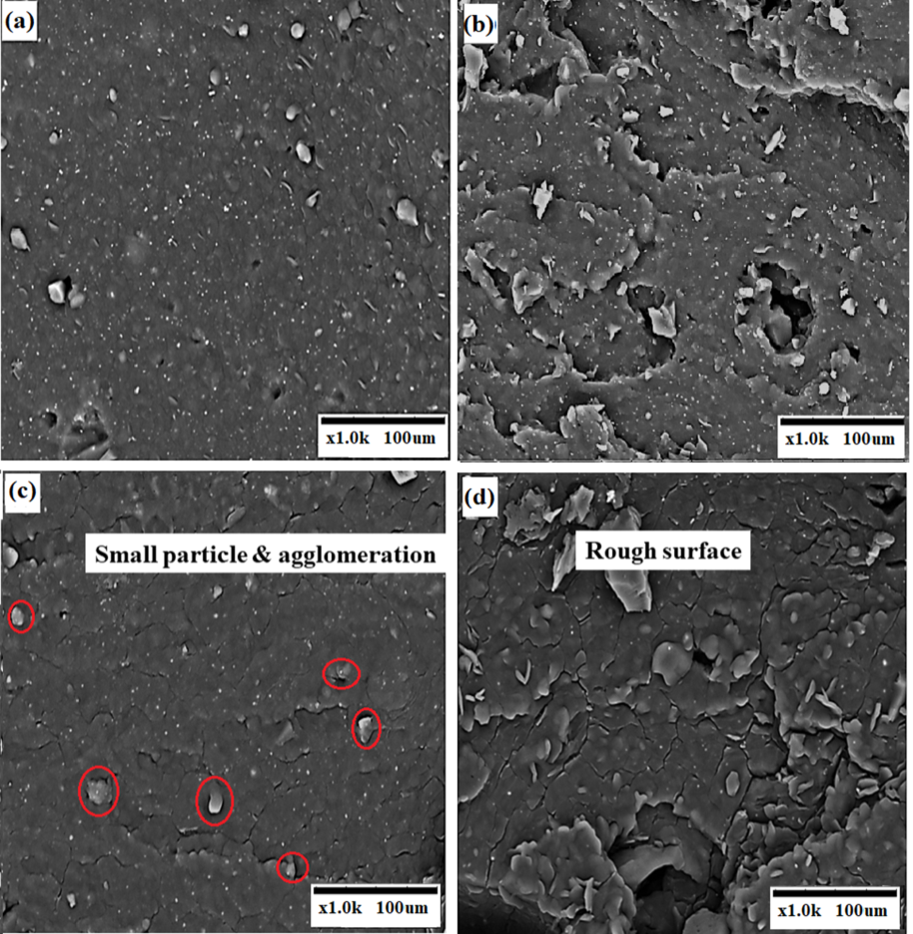
Figure 5. Scanning electronic microscopy (SEM) of NR/BR with 10 phr of (a) unmodified OL, (b) HMOL, (c) unmodified SL and (d) HMSL

Conclusion

A comprehensive characterization of structural organosolv and soda lignin, both unmodified and modified lignin by hydroxymethylation method has been accomplished. This treatment reveals the formation of methylene bridges which connect with the macromolecular lignin. Based on the Payne effect, it can be concluded that the presence of HMOL and HMSL in rubber composite weakens the filler-filler interaction and enhance the rubber’s processability as lignin content increases. As the consequences, the optimum cure time, t₉₀ and scorch time, t_{S2} reduced by 18% to 36% which contributes to shorter production period. Generally, the most important factors that lead to better reinforcement of rubber composite are filler dispersion and filler-rubber interaction. Unmodified lignin is poorly spread throughout the NR/BR matrix as well as poor interaction between phases. As opposed to unmodified lignin, the incorporation of hydroxymethylated lignin improves the performance of rubber composite contributed by the construction of crosslinking points between filler and rubber matrix. This interaction is advantageous to transmit the external stress from the rubber matrix to hydroxymethylated lignin particles. Low lignin content can endure much more stress than high lignin content thus producing better reinforcing ability on NR/BR composite since the latter has a high tendency of agglomeration. Subsequent enhancement of the mechanical properties of rubber composite at low hydroxymethylated lignin content of up to 10 phr is evident especially for HMSL filler. The hardness of NR/BR/HMSL has been enhanced 7 – 18% with an increment of lignin loading, while tensile strength is improved by almost 10% compared to unmodified lignin up to 10 phr. However, for compounds with HMOL, the hardness enhancement can only be observed for NR/BR/HMOL5. Furthermore, modulus at 100% and 300% strain is improving with the presence of lignin. Based on the results, replacing CB with HMSL up to 10 phr loading reduces the Payne effect and improves the curing and mechanical performance of rubber composite. This opened up an opportunity for safe manufacturing and green rubber tires.

Acknowledgement

The authors acknowledge School of Materials and Mineral Resources Engineering (SMMRE), Universiti Sains Malaysia (USM), and Prince of Songkla University, Pattani Campus (PSU), Ministry of High Education (MoHE) of Malaysia and Postgraduate Research Attachment (PGRA) Fund, Institute of Postgraduate Studies, USM for funding this research.

References
- Rajisha, K. R., Maria, H. J., Pothan, L.A., Ahmad, Z. and Thomas, S. (2014). Preparation and characterization of potato starch nanocrystal reinforced natural rubber nanocomposites. International Journal Biology Macromolecules, 67: 147-153.
- Abraham, E., Deepa, B., Pothan, L.A., John, M., Narine, S.S., Thomas, S. and Anandjiwala, R. (2013). Physicomechanical properties of nanocomposites based on cellulose nanofiber and natural rubber latex, Cellulose, 20: 417-427.
- Jong, L. (2014). Modulus enhancement of natural rubber through the dispersion size reduction of protein/fiber aggregates. Indian Crops Production, 55: 25-32.
- Upton, B. M., and Kasko, A. M. (2016). Strategies of the conversion of lignin to high-value polymeric materials: review and perspective. Chemical Reviews, 116: 2275-2306.
- Stewart, D. (2008). Lignin as a base material for material for materials applications, chemistry, application and economics. Indian Crops Production, 27: 202-207.
- Wang, M.-J., Kutsovsky, Y., Zhnag, P., Murphy, L. J., Laube, S. and Mahmud, K. (2002). New generation carbon-silica dual phase filler part 1. Characterization and application to passenger tire. Rubber Chemistry and Technology, 75: 247-263.
- Yu, P., He, H., Jia, Y., Tian, S., Chen, J., Jia, D. and Luo, Y. (2016). A comprehensive study on lignin as a green alternative of silica in natural rubber composites. Polymer. Testing, 54: 176-185.
- Bahl, K., Miyoshi, T. and Jana, S. C. (2014). Hybrid fillers of lignin and carbon black for lowering of viscoelastic loss in rubber compounds. Polymer, 55: 3825-3835.
- Popa, V. I., Căpraru, A. M., Grama, S. and Măluţan, T. (2011). Nanoparticles based on modified lignins with biocide properties. Cellulose Chemistry Technology, 45: 221-226.
- Mohamad Aini, N. A., Othman, N., Hussin, M. H., Sahakora, K. and Hayeemasae, N. (2019). Hydroxymethylation-modified lignin and its effectiveness as a filler in rubber composites. Processes, 7: 315.
- Tejado, A., Pena, C., Labidi, J. and Echeverria, J. M. (2007). Physico-chemical characterization of lignins from different sources for use in phenol-formaldehyde resin synthesis. Bioresource Technology, 98: 1655.
- He, S., Xue, Y., Lin, J., Zhang, L., Du, X. and Chen, L. (2016). Effect of silane coupling agent on the structure and mechanical properties of nano-dispersed clay filled styrene butadiene rubber. Polymer Composite, 37: 890-896.
- Jia, Q.-X., Wu, Y.-P., Wang, Y.-Q., Lu, M., Yang, J. and Zhang, L.-Q. (2007). Organic interfacial tailoring of styrene butadiene rubber-clay nanocomposites prepared by latex compounding method. Journal Applied Polymer Science, 103: 1826-1833.
- Zheng, H., Zhang, Y., Peng, Z. and Zhang, Y. (2004). Influence of clay modification on the structure and mechanical properties of EPDM/montmorillonite nanocomposites. Polymer Testing, 23: 217-223.
- Jiang, C., He, H., Yao, X., Yu, P., Zhou, L. and Jia, D. (2017). The aggregation structure regulation of lignin by chemical modification and its effect on the property of lignin/styrene-butadiene rubber composites. Journal Applied Polymer Sciences, 135: 45759.

