

ANTIMICROBIAL EFFICACY, ANTIOXIDANT PROFILE AND NINE
ALTERNATIVE ACTIVE CONSTITUENTS FROM PETROLEUM ETHER AND ETHYL ACETATE EXTRACT OF Entada spiralis

(Keberkesanan Antimikrob, Profil Antioksida dan Sembilan Komponen Alternatif Aktif dari Ekstrak Petroleum Eter dan Etil Asetat dari Pokok Entada spiralis)

Aiza Harun¹*, Noorshilawati Abdul Aziz², Nor Shazleen Mohd Azenan¹,
Nurfarah Farini Muhammad Kamarazzaman¹, Siti Zaiton Mat So’ad³

¹Faculty of Applied Science
² Faculty of Plantation and Agrotechnology
Universiti Teknologi MARA Pahang, 26400 Bandar Tun Razak Jengka, Pahang, Malaysia
³Kulliyyah of Pharmacy,
International Islamic University Malaysia, 25200 Bandar Indera Mahkota, Pahang, Malaysia

*Corresponding author: aizaharun@.uitm.edu.my

Received: 9 March 2020; Accepted: 25 June 2020; Published: xx October 2020

Abstract
This study aimed to investigate the antimicrobial activity of petroleum ether extracts and the identification of alternative antimicrobial and antioxidative constituents from petroleum ether extract and ethyl acetate extract of Entada spiralis stem. Antimicrobial activity was evaluated through disc diffusion method on five human superficial skin disease-caused microbes such as Staphylococcus aureus, Staphylococcus epidermidis, Microsporum gypseum, Trichophyton mentagrophytes, Trychophyton tonsurans and one plant pathogen namely Erwinia chrysanthemi. The presence of antioxidants was determined from thin layer chromatography (TLC) sprayed with 2,2-diphenyl-1-picrylhydrazyl. The isolation of antioxidant and antimicrobial compounds was performed through preparative TLC. The structure of isolated compounds was determined from gas chromatography mass spectrometry (GCMS) and liquid chromatography mass spectrometry (LCMS) equipped with Wiley Library matching individually. The petroleum ether extract successfully inhibited the growth of all bacteria and dermatophytes in a concentration dependent manner whereby S. epidermis was highly susceptible towards the extract with inhibition zone of 16.0 mm at concentration of 400 mg/mL as well as M. gypseum. Most of the components from petroleum ether extract and ethyl acetate extract developed on TLC were antioxidative which was seen as yellow spots against purple background after spraying with DPPH reagent. Four antioxidative constituents were successfully isolated and tentatively identified as 18,19-Secoyohimban-19-oic acid,16,17,20,21-tetradehydro-16-(hydroxymethyl)-methylester (1), Oxiraneoctanoic acid (2), 9,12-Octadecadienoic acid (3), and 11-O-p- Coumarylnepeticin (4). Five antimicrobial constituents were successfully isolated and tentatively identified as 4-benzyloxy-4-[2,2,-dimethyl-4-dioxolanyl]Butylaldehyde, (5), Isobutyl octadecyl benzoate ester (6), 3',8,8'-Trimethoxy-3-piperidyl-2,2'-binaphthalene-1,1',4,4'-tetrone (7), 1,2,4,5-tetramethylbenzene (8) and Hordatine B (9). Thus, E. spiralis is seen to be a promising source of bioactive ingredients which is very important as the basis of scientific information for the development of natural antimicrobial and antioxidant agents.

Keywords: Leguminoceae, Entada spiralis, antioxidant, antibacterial activity

Abstrak
Kajian ini memfokuskan kepada kajian sifat antimikrob ekstrak petroleum eter dan pencarian komponen aktif antimikrob dan antioksida dari ekstrak petroleum eter dan etil asetat dari batang pokok Entada spiralis. Aktiviti antimikrob dinilai menggunakan kaedah penyerakan cakera terhadap lima jenis mikrob penyakit kulit iaitu Staphylococcus aureus, Staphylococcus epidermis, Microsporum gypseum, Trichophyton mentagrophytes, Trychophyton tonsurans dan satu jenis mikrob tumbuhan iaitu Erwinia chrysanthemi. Ciri antioksidan ekstrak komponen yang telah dipisahkan di atas kromatografi lapisan nipis (KLN) telah dianalisa menggunakan kaedah penyemburan dengan bahan 2,2-difenil-1-pikrilhidrazil (DPPH) di atas KLN. Pemisahan komponen aktif antioksida dan antimikrob telah dijalankan dengan menggunakan KLN. Spektrometer jisim kromatografi gas dan spektrometer jisim kromatografi cecair dengan data Wiley telah digunakan untuk menganalisa dan mengenalpasti struktur bahan aktif. Ekstrak petroleum eter berkesan dalam menyekat pertumbuhan bakteria dan kulat di mana bakteria S. epidermis dan kulat M. gypseum paling kuat disekat pertumbuhannya oleh ekstrak dengan zon perencatan 16.0 mm pada kepekatan 400 mg/mL. Kebanyakan komponen dalam ekstrak petroleum eter dan etil asetat yg telah dipisahkan di atas KLN bersifat antioksida dengan memberikan kesan tompokan kuning setelah disembur dengan larutan DPPH. Sebanyak empat komponen antioksida berjaya dipisahkan dan dikenalpasti sebagai Asid 18,19-Sekoyohimban-19,16,17,20,21-tetradihidro-16-(hidroksimetil)-metilester (1), Asid okzairanoktanoik (2), Asid 9,12-Oktadekadienoik (3), dan 11-O-p- Koumarilnepetisin (4). Sebanyak lima jenis komponen antimikrob berjaya dipisahkan dan dikenali sebagai, 4-benziloksi-4-[2,2,-dimetil-4-dioksolanil]Butilaldehid(5), Isobutil oktadesil benzoat ester(6), 3',8,8'-Trimetoksi-3-piperidil-2,2'-binaftalin-1,1',4,4'-tetron (7), 1,2,4,5-tetramethylbenzene (8) dan Hordatin B (9). Maka, E. spiralis dilihat sebagai pokok yang berpotensi untuk mendapatkan bahan bioaktif semulajadi di mana bahan ini penting sebagai maklumat asas bagi kajian penghasilan bahan antioksida dan antimikrob semulajadi.

Kata kunci: Leguminosae, Entada spiralis, antioksida, aktiviti antibakteria

Introduction
Free radical which is usually known as a disease source can possibly come into contact with our body either directly or indirectly by damaging internal cell via oxidation process and this may cause several diseases. Thus, to combat free radicals, an antioxidant is a good alternative to consume externally or internally. It is a molecule that restrains the oxidation of other molecules. Generally, oxidation is a chemical reaction that can produce free radicals which lead to chain reactions that could destroy cells. Antioxidants such as thiols or ascorbic acid (vitamin C) stop these chain reactions by preventing some degeneration of certain diseases such as cancer by inhibiting the reaction of radical. Antioxidant of phytochemicals from plant such as flavonoids and terpenoids are able to block the reaction of free radical and in the same way, protect human body from suffering due to a disease [1]. The antifungal efficacy of E. spiralis against human pathogens has been well-documented [2] in which methanol extract was declared as the most active extract as well as its fractions [3]. The antibacterial activity of stem and leaves of E. spiralis against E. chrysanthemi has recently been reported [4] in which ethyl acetate extract was claimed as the most active extract.

The isolation and structure elucidation of compounds from seed kernels of E. rheedii showed the presence of two triterpenoid saponins [5] but unfortunately, they were not antioxidative. For the past few years, the antibacterial and antidermatophytic constituents from methanol extracts of E. spiralis have previously been isolated and identified [6, 7, 8], however, there was lack of identification of antioxidative and antimicrobial compounds from other E. spiralis extracts. Currently, antioxidative constituents from methanol extract of the stem bark of E. spiralis have been successfully determined and they were reported as tetrahydroxyflavone [9], ferulic ester such as (E)-hexyl 3-(4-hydroxy-3-methoxyphenyl) acrylate and five known phenolic constituents identified as kaempferol, 5,4’-dihydroxy-3,7,3’-trimethoxyflavone, gallic acid, (+)-catechin, as well as (-)-epicatechin, with gallic acid being the most antioxidative [10].

Therefore, we embarked our investigation upon antimicrobial activity, antioxidant profile and identification of alternative antioxidative and antimicrobial compounds from petroleum ether and ethyl acetate extracts from E. spiralis stem.

Material and Methods
Sample preparation
About 1 kg stem of E. spiralis was obtained from Pahang’s Tasik Chini forest and authenticated by a botanist with voucher specimen given as KMS-2558. It was ground into powdered form and soaked for three consecutive times with 3L of petroleum ether, dichloromethane and methanol. The maceration was filtered and evaporated under vacuum to obtain crude extracts. All extracts were kept in refrigerator before use.

Fourier transform infrared (FTIR) analysis
A small amount of stem extract was mixed with ethanol. Then, it was placed onto sample detector of Attenuated Total Reflectance FTIR (ATR-FTIR) Perkin-Elmer SPECTRUM 100 FTIR to generate an infrared spectrum. The interpretation of infrared spectrum was conducted by means of determining functional groups in the stem extract of E. spiralis.

Preparation of spraying reagents for thin layer chromatography (TLC) screening: FeCl₃ reagent
An amount 1 g of ferric chloride was dissolved in mixture of 50 mL of methanol and 50 mL of distilled water. Dark blue spot appearing on TLC sprayed with FeCl₃ solution was the indication of the presence of phenolic compound.

Vanillin/ H₂SO₄ reagent
An amount 1.5 mL of concentrated sulfuric acid was added to a mixture of 1% vanillin in absolute ethanol. The grey, pink, blue and purple spots appearing on TLC which was sprayed and heated on hot plate was the indication of terpenoid compounds.

Dragendorff’s reagent
Solution A: 0.85 g basic bismuth nitrate was added in mixture of 100 mL acetic acid and 40 mL of water. Solution B: 8g of potassium iodide was mixed with 20 mL of water. The spraying reagent was prepared by mixing 5 mL of solution A and 5 mL of solution B with a mixture of 20 mL of acetic acid and 70 mL of water. Orange spot against yellow background appearing on the sprayed TLC was the indication of alkaloid compound.

DPPH reagent
This reagent was prepared by mixing suitable amount of DPPH solid in methanol to obtain DPPH solution with concentration of 0.6% (w/v). The yellow spot against purple background that appeared on TLC of extracts sprayed with DPPH revealed the presence of antioxidative compounds.

TLC screening for phytochemicals
The petroleum crude extract was applied on a TLC plate as 1 cm fine bands with capillary tube. Then, the TLC plate was developed with suitable developing solvent in the chromatographic chamber until solvent front is reached. The plate was taken out and was dried for a few minutes. After completely dried, the plate was sprayed with chemical reagents. For terpenoid screening, the plate was heated directly on hot plate just after spraying with vanillin/H₂SO₄ reagent to visualize the terpenoid spots. The TLC screening process was repeated with other reagents such as FeCl₃, Dragendorff’s and DPPH reagent to screen phenolic, alkaloid and antioxidative spots respectively.

Isolation of active compounds from preparative thin layer chromatography (pTLC)
The stem extract was applied on 10 cm x 10 cm TLC plate and was subjected to chromatographic separation. The bands of active components were marked, and desired bands were scraped off. The isolated compound was separated from silica gel through filtration and then was re-subjected to thin layer chromatographic separation to screen the purity of active components.

Gas chromatography (GC-MS)
The GC-MS analysis of isolated constituents was performed using Agilent Technologies GCMS 5977A MSD. The isolated compounds from petroleum ether extract were introduced using splitless injection of 1.0 μL in hexane fitted with cross linked of 5% phenyl methyl siloxane capillary column. The oven temperature was at 60 - 290 °C with the rate of 5 °C min⁻¹. The injector temperature was about 220 °C.

Liquid chromatography mass spectrometer (LCMS)
The LCMS spectrum of isolated compounds from ethyl acetate extract were obtained using Vion IMS QTOF MS. Chromatographic separation was performed using Column Temperature at 40°C. The mobile phase for solvent A contained water and 0.1% formic acid, whereas for solvent B, it contained acetonitrile. The spectral data were collected at 254 nm. The high mass analysis performed was at 1000 m/z and low mass at 50 m/z under positive ion mode. The capillary voltage was set at 3.0 kV using a desolvation gas at 800 L/h. The voltage offset was at 0 mV and the full-scale voltage was at 2000 mV.

In vitro antimicrobial activity assay of petroleum ether extract
The antifungal activity and antibacterial activity assay of petroleum ether extract were evaluated through disc diffusion method as previously reported [2, 3]. In antibacterial assay, the disc diffusion method was repeated in the same manner as in antifungal assay, whereby extract impregnated discs were aseptically transferred on the inoculated agar plate of muller hinton agar (MHA) and incubated for 24 hours.

Results and Discussion
FTIR analysis
FTIR spectra of petroleum ether extract which depicted in Figure 1 is used to determine types of functional groups present in petroleum ether extract. The figure reveals absorption peak at 2917.63 cm⁻¹ which indicated the sp² C-H stretching vibration and absorption peak of sp³ C-H stretching at 2850.16 cm⁻¹. The visibility of C=C stretching vibration was traced at absorption peak 1462.33 cm⁻¹ and the adsorption peak at 1709.49 cm⁻¹ was for carbonyl group, C=O stretching. The absorption peak at 1364.80 cm⁻¹ belonged to absorption peak of N-H bending and the C-O functional group was determined at absorption peak of 1121.65 cm⁻¹. Since the petroleum ether extract contains C=O,C-O, C=C, C-H and N-H functional groups, we suggest that such constituents like alkaloid, ester derivatives and carboxylic acid derivatives are probably present in petroleum ether extract.

The types of functional groups present in ethyl acetate extract is illustrated in Figure 2 in which the presence of C=O stretching vibration was observed at 1709.49 cm⁻¹, C-O stretching at 1165.07 cm⁻¹, C-N stretching at 1242.86 cm⁻¹ and sp³ C-H stretching at 2917.65 cm⁻¹. The O-H stretching was found at 3240.45 cm⁻¹ and the absorption peak at 1606.13 cm⁻¹ and 1459.40 cm⁻¹ belonged to C=C aromatic. In both extracts, all the functional groups provided basic information to determine the structure of the compounds. As far as we are concerned, some compounds bearing OH and N-H groups are able to display antioxidant behavior [9] and compounds with aromatic ring and COOH linkage have revealed remarkable antimicrobial properties[11].

TLC analysis of petroleum ether extract and ethyl acetate extract
The spots on TLC were visualized under UV short wave (TLC a), long wave (TLC b) and also sprayed with certain chemical reagents (TLC c, d, e). According to Figure 3, TLC a and b illustrated that certain spots demonstrated aromatic character since black spots on TLC a and fluorescence spot on TLC b were visualized. Thus, we suggest that the structure of compounds from desired spots may contain benzenoid ring. TLC c indicated an obvious spot of an alkaloid (dark orange) after being sprayed with Dragendorff’s reagent, and it displayed its antioxidant properties since the spot was nearly in the same R_{f} with one of antioxidative spots from TLC d. Referring to TLC d, most of the compounds were antioxidative which were signaled by yellowish spot against purple background when sprayed with DPPH reagent.

Generally, the mechanism was based on the reduction of DPPH, a stable nitrogen-cantered and violet-coloured free radical, that upon reduction, was converted to yellow colour by electron or hydrogen donating ability of the antioxidant compound found in the extract [9]. The degree of discoloration indicated the scavenging potential of antioxidant compounds of extract in terms of hydrogen ability. The more the decolonization of purple colour, the greater the reduction ability was. TLC e illustrated various kinds of terpenoid compounds
(colour range of blue, purple, pink) and several of them were also antioxidative. Thus, the results of TLC analysis suggested that petroleum ether extract was antioxidative which was caused from the presence of alkaloid and terpenoid.

TLC screening method using DPPH spraying reagents is a convenient and the simplest way to detect antioxidant in extract sample because only a small amount of extract and reagent are needed, and it reveals a fast result. As depicted in Table 1, the antioxidant behaviour of ethyl acetate extract was caused by the emergence of terpenoid, alkaloid and phenolic compounds while in petroleum ether extract, only terpenoid and alkaloid were responsible for its antioxidant properties. The antioxidant properties of E. spiralis from methanol extract has been previously reported [10] but there is still no report of antioxidants being recorded from petroleum ether and ethyl acetate extract. Thus, this is the first report of antioxidant screening for petroleum ether extract and ethyl acetate extract from E. spiralis stem as well as the antimicrobial activity.

Antioxidative constituents from petroleum ether extract and ethyl acetate extract of E. spiralis stem
Figure 4 demonstrated three antioxidative constituents from petroleum ether extract labelled as (1), (2) and (3) and one constituent labelled as (4) from ethyl acetate extract of E spiralis stem. The structures of antioxidative constituents from petroleum ether extract were identified via GCMS with the assistance of Wiley Library matching individually and LCMS with Library Data was utilized for structure identification of constituent from ethyl acetate extract. Generally, the presence of functional groups in the structures are consistent with FTIR analysis of petroleum ether and ethyl acetate extract. FTIR analysis of petroleum ether extract has recorded the existence of C=O group, C=C for aromatic ring and nitrogen linkage. These data agreed with compound (1) as the structure showed the functional group of C=O, C=C, C-N and N-H linkage. Compound (2) and (3) revealed the appearance of C=O, C-O and C=C group which are still in the range of FTIR analysis data. The structure of compound (4) revealed the presence of OH, C=O group, C=C, C-O linkage and aromatic linkage and they were consistent with FTIR analysis of ethyl acetate extract.

According to all antioxidative structures, the hydroxyl group OH or NH group possibly functions as the main part for antioxidant effect towards DPPH radical. Theoretically, hydrogen atom from OH or NH group reacts with free radical species of DPPH through Hydrogen Atom Transfer (HAT) or Single Electron Transfer (SET). During radical scavenging process, the electron of hydrogen from NH or OH group is donated to nitrogen radical of DPPH which contains single electron through reduction reaction, which can be seen from the reduction of dark purple colour to yellow colour of DPPH [12]. After reduction process completes, the radical nitrogen has no more single electron as it has bonded with hydrogen from OH group.

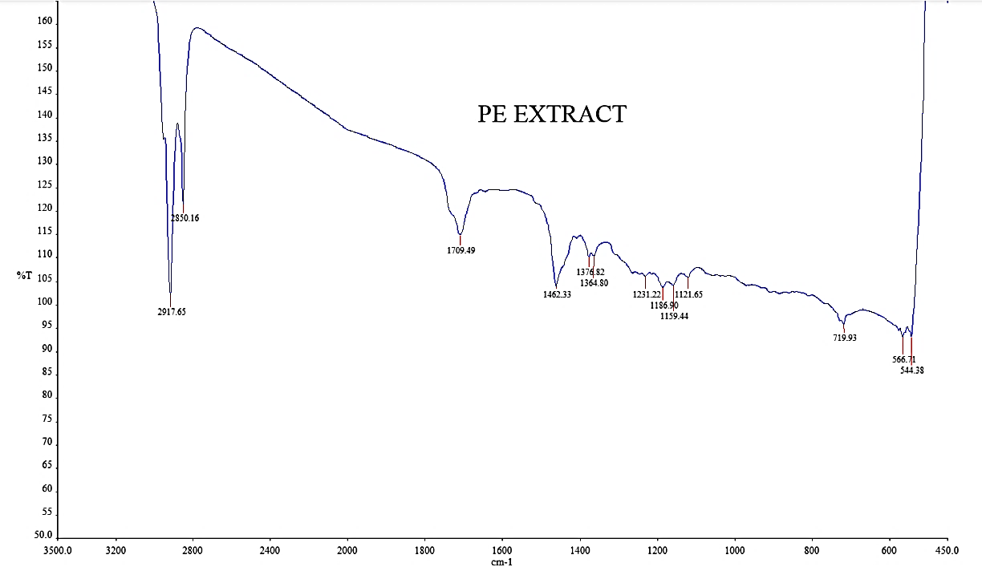
Figure 1. FTIR spectra of petroleum ether extract of E. spiralis

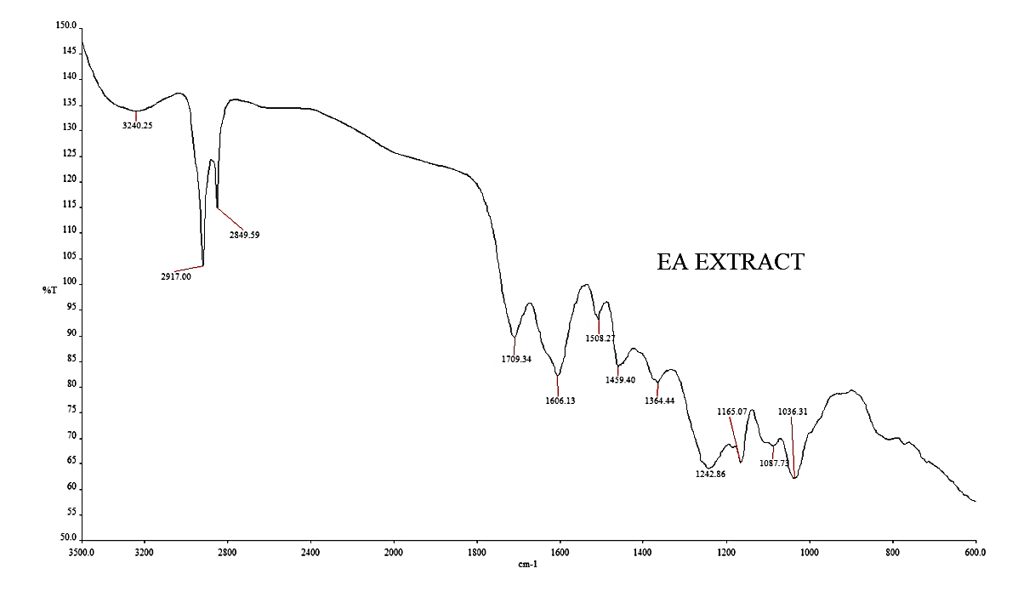
Figure 2. FTIR spectra of ethyl acetate extract of E. spiralis

Antioxidative spots (TLC d) are terpenoids (TLC e)
Antioxidative spots (TLC d) is an alkaloid (TLC c)
c
e
d
b
a

Figure 3. TLC analysis of petroleum ether extract (a) UV₂₅₄ (b) UV₃₆₆ (c) After spraying with Dragendorff’s reagent to visualize orange spot of alkaloid (d) After spraying with 2, 2 – Diphenyl – 1 – picryl – hydrazyl (DPPH) solution to visualize yellowish antioxidative spots against purple background and (e) After sprayed with Vanilin/ H₂SO₄ reagent and heated at 110ºC to visualize terpenoid spots

Table 1. Selected phytochemicals screened from petroleum ether and ethyl acetate extract
Extract | Terpenoid | alkaloid | phenolic
Petroleum ether | √* | √* | x
Ethyl acetate | √* | √* | √*
* Antioxidative ; √ = present; x = absent

Oxiraneoctanoic acid
(5)

18,19-Secoyohimban-19-oic acid,16,17,20,21-tetradehydro-16-(hydroxymethyl)-, methyl ester (1)

Oxiraneoctanoic acid (2)

Oxiraneoctanoic acid (2)

9,12-Octadecadienoic acid (3)

11-O-p- Coumarylnepeticin (4)

Figure 4. Antioxidative compounds from pet ether extract and ethyl acetate extract of E. spiralis stem

In vitro Antimicrobial activity of petroleum ether extract of E. spiralis stem
Table 2 and Table 3 depicted the result of antibacterial and antifungal activity of petroleum ether extracts against S. aureus, S. epidermidis, T. tonsurans, T. mentagrophytes and M. gypseum strains by means of the size of inhibition zone. In Kirby-Bauer disc diffusion method, the size of inhibition zone measures the compound’s effectiveness in which the greater the zone of inhibition is, the more effective the compound becomes. The petroleum ether extract was strongly inhibited the growth of S. epidermidis with inhibition zone of 16 mm compared to S.aureus. Among all bacteria, S. epidermidis (ATCC 12228) was found to be the one that is most susceptible toward petroleum ether extract, whereas S. epidermidis (ATCC 13518) was found to be resistant towards petroleum ether extract. All bacteria were sensitive towards positive control ampicillin.

The petroleum ether extract of E. spiralis stem also inhibited the growth of all dermatophytes in a concentration dependent manner as presented in Table 2. The extract strongly inhibited the growth of M. gypseum with inhibition zone of 16 mm at 400 g/mL. Thus, M.gypseum was recognized as the one that is most susceptible to petroleum ether extract compared to other dermatophytes. The results obtained could be generally explained in terms of the effect of the active principles in the extracts once they get into contact with cell wall of microconidia of dermatophytes. As a result, the microconidia lost its rigidity and became ruined and the growth of microconidia was no longer sustained. According to previous study [10], the sensitivity of all dermatophytes towards extracts could be due to the synergistic action of different group of active constituents comprised in the extracts, such as benzenoid compounds. These active constituents may interact with each other to enhance the antimicrobial activity of the extracts. Therefore, this action could possibly be one of the factors for our present results of antimicrobial activity of E. spiralis stem.

The inhibition effect in antibacterial activity was also most probably due to the interference by active sources existed in the extracts, which lead to the disruption of cell wall of bacteria and as a result, the cell wall lost its rigidity and caused cell death and consequently the growth of bacteria was no longer emerged.

Figure 5 illustrated the structures of five antimicrobial constituents from petroleum ether extract and ethyl acetate extracts of E.spiralis stem that may involve in inhibiting the growth of bacteria and dermatophytes. Compound (5),(6), (7) and (8) were identified from petroleum ether extract and compound (9) was identified from ethyl acetate extract. We had previously reported the data of antibacterial effect of ethyl acetate extract against plant pathogen [4]. Compounds (5), (6), (7) and (8) can be regarded as new antimicrobial constituents since no investigation to identify antimicrobial constituents from petroleum ether extract of E. spiralis has been reported. Meanwhile, compound (9) Hordatine B is not a new compound in other plant species, but it can be suggested as a new antimicrobial compound since it was identified for the first time from ethyl acetate of E. spiralis stem.

Theoretically, the action of antimicrobial activity starts when the constituent attacks the cell wall of bacteria to prevent them from keeping on synthesizing a peptidoglycan; a molecule that provides the strength of cell wall in order to survive in human body. Attacking cell wall may disrupt membrane potential through depolarization and this leads to the death of cell wall of bacteria. Antifungal agent works by affecting a substance in the cell membrane of fungi, causing the contents of the fungal cells to leak out and the cells to die, thus preventing the fungal cells from growing and reproducing. The antifungal agent such as azoles is a five-membered heterocylic compound containing nitrogen (N) atom. Since structure (7) and (9) are also compound containing nitrogen atom, it is possible for the structures to have same the function as antifungal agent just like azoles. Another antimicrobial agent is Echinocandin B [13]. The C=O(NH) linkage in Hordatine B (9) is quite consistent with the C=O(NH) linkage in Echinocandin B and benzene-OH group linkage. Thus, this similarity may explain the antimicrobial properties of (9).

Table 2. In vitro antibacterial activity of petroleum ether extract of E. spiralis stem
Extracts Concentration  (mg/mL) |  | Inhibition Zone  (mm)ª
 |  | SA 33591 | SA 33592 | SE 12228 | SE 13518
Petroleum ether extract | 50 | 14.0 ± 0.71 | 14.50 ± 0.71 | 12.0 ± 0 | -
 | 100 | 15.0 ± 0 | 15.0 ± 0 | 15.0 ± 0 | -
 | 200 | 15.0 ± 0 | 15.0 ± 0 | 15.5 ± 0 | -
 | 400 | 15.0 ± 0 | 15.33±0.58 | 16.0 ± 1.61 | -
Standard Ampicillin |  | 9.0 ± 0 | 10.0 ± 0 | 19.0 ± 1.0 | 23.0 ± 1.4
- No activity; SA, Staphylococcus aureus; SE, Staphylococcus epidermidis; ±, Standard deviation (S.D); ª Mean of three replicates. Statistical significance was determined using ANNOVA. Differences were considered significant at (p <0.05). 16 mm above: highly inhibited; 11-15 mm: moderately inhibited; 6-10 mm: weakly inhibited.

Table 3. In vitro antifungal activity of petroleum ether extract of E. spiralis stem
Extracts Concentration  (mg/mL) |  | Inhibition Zone  (mm)ª
 |  | TM | TT | MG
Petroleum ether extract | 50 | - | 8.67±0.58 | 9.50±0.71
 | 100 | 8.33±0.58 | 10.3±0.58 | 10.0±0
 | 200 | 9.0±0.00 | 9.00±1.0 | 13.0±0
 | 400 | 10.67±0.58 | 13.0±1.73 | 16.0±0
Standard Nystatin |  | 21.33±0.58 | 40.33±0.58 | 24.0±0
- No activity; TM, Trichophyton mentagrophytes; TT, Trichophyton tonsurans; MG, Microsporum gypseum; CG, Candida glabrata; ±, Standard deviation (S.D); ª Mean of three replicates. Statistical significance was determined using ANNOVA. Differences were considered significant at (p <0.05). 16 mm above: highly inhibited; 11-15 mm: moderately inhibited; 6-10 mm: weakly inhibited

4-benzyloxy-4-[2,2,-dimethyl-4-dioxolanyl] Butylaldehyde (5)

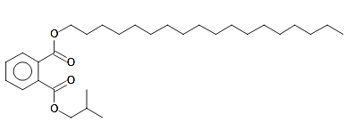
Isobutyl octadecyl benzoate ester (6)

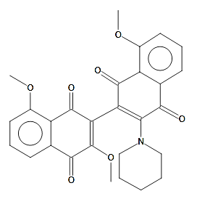
3',8,8'-Trimethoxy-3-piperidyl-2,2'-binaphthalene-1,1',4,4'-tetrone (7)

1,2,4,5-tetramethylbenzene (8)

Hordatine B (9)

Figure 5. Antimicrobial active constituents from petroleum ether extract of E. spiralis stem

Conclusion
The petroleum ether extract and ethyl acetate extract from stem of E. spiralis displayed antioxidant properties and potent antimicrobial activity. Four antioxidative constituents were successfully isolated and tentatively recognized as 18,19-Secoyohimban-19-oic acid,16,17,20,21-tetradehydro-16-(hydroxymethyl)-methylester (1), Oxiraneoctanoic acid (2), 9,12-Octadecadienoic acid (3), and 11-O-p- Coumarylnepeticin (4). Five antimicrobial constituents were isolated and tentatively identified as 4-benzyloxy-4-[2,2,-dimethyl-4-dioxolanyl]Butylaldehyde, (5), Isobutyl octadecyl benzoate ester (6), 3',8,8'-Trimethoxy-3-piperidyl-2,2'-binaphthalene-1,1',4,4'-tetrone (7), 1,2,4,5-tetramethylbenzene (8) and Hordatine B (9). All active constituents may be regarded as new compounds since no investigation from petroleum ether extract and acetate extract of E. spiralis were used and reported. Thus, this plant appears to be a good source of antimicrobial and antioxidant agents as well. However, further spectroscopic analysis study such as 1D and 2D NMR need to be carried out for structure confirmation.

Acknowledgement
We would like to express our gratitude to all science laboratory staff especially from Chemistry and Agrotechnology laboratories of UiTM Jengka, Pahang, for their contribution throughout the journey of completing this research work.

References
- Harun, A., Mat So’ad, S. Z., Mohd Hassan, N. and Che Mohd Ramli, N. K. (2011). In-vitro antifungal activity of Entada spiralis Ridl. crude extract against dermatophytes of superficial skin disease. Revelation and Science, 1(1): 57-61.
- Chandel, M., Sharma, U., Kumar, N., Singh, B. and Kaur, S. (2012). Antioxidant activity and identification of bioactive compounds from leaves of Anthocephalus cadamba by ultra-performance liquid chromatography/electrospray ionization quadrupole time of flight mass spectrometry. Asian Pacific Journal of Tropical Medicine, 5(12): 977-985.
- Nzowa, L. K., Barboni, L., Teponno, R. B., Ricciutelli, M., Lupidi, G., Quassinti, L., Bramucci, M. and Tapondjou, L. A. (2010). Rheediinosides A and B, two antiproliferative and antioxidant triterpene saponin from Entada rheedii. Phytochemistry 71(2): 254-261.
- Maha Yudden, N. K., Nordin, N. N., Harun, A., Mohd Rosli, N. H., Abdul Aziz, N. and Daud, S. (2019). Comparative study of antioxidant activity of stem and leaves of Entada spiralis and their antibacterial properties against Erwinia Chrysanthemi. Science Letters, 13(2): 37-47.
- Harun, A., Mat So’ad, S. Z., Mohd Hassan, N. and Che Mohd Ramli, N. K. (2014a). Bioactive terpenoids from the stem bark of Entada spiralis Ridl. (sintok). Proceeding of the International Conference on Science Technology and Social Science (ICSTSS) 2012. Chapter in Book Springer Science+Business Media Singapore: pp. 605-615.
- Harun, A., Mat So’ad, S. Z. and Mohd Hassan, N. (2015). Bioassay guided isolation of an antidermatophytic active constituent from the stem bark of Entada spiralis Ridl. Malaysian Journal of Analytical Sciences 19(4):752-759.
- Harun, A., Mat So’ad, S. Z., Mohd Hassan, N. and Che Mohd Ramli, N. K (2016). Two isolated crystalline solids from the stem of Entada spiralis Ridl. Malaysian Journal of Analytical Sciences, 20 (2):752-759.
- Harun, A., Mat So’ad, S. Z., Mohd Hassan, N. and Che Mohd Ramli, N. K. (2014). In-vitro Antidermatophytic activity of methanolic fractions from Entada spiralis Ridl. stem bark and its bioautographic profile. Pertanika Journal Science & Technology, 22(1): 113-121.
- Kedare, S. B. and Singh, R. P. (2011). Genesis and development of DPPH method of antioxidant assay. Journal of Food Science and Technology, 48(4): 412-422.
- Kuiate, J. R., Bessiere, J. M., Zollo, P. H. A. and Kuate, S.P., (2006). Chemical composition and antidermatophytic properties of volatile fractions of hexanic extract from leaves of Cupressus lusitanica Mill. from Cameroon. Journal of Ethnopharmacology, 103: 160-165.
- Dzoyem, J. P., Melong, R., Tsamo, A. T., Maffo, T., Kapche, D. G. W. F., Ngadjui, B. T., McGaw, L. J. and Eloff, J. N.(2013). Cytoxicity, antioxidant and antibacterial activity of four compounds produced by endophytic fungus Epicoccum nigrum associated with Entada Abyssinica. Brazillian Journal of Pharmacognosy, 27: 251-252.
- Opeyemi, R. F., Mat So’ad, S. Z., Ahmed, Q. U., and Mohd Hassan, N. (2019). α-glucosidase inhibitory and antioxidant activities of Entada spiralis Ridl. (Sintok) stem bark extracts. Pertanika Journal Tropical Agriculture Science, 42(1): 139-153.
- Shao, L., Li, J., Liu., A., Chang, Q., Lin, H. and Chen, D. (2013). Efficient bioconversion of echinocandin B to its nucleus by overexpression of deacylase genes in different host strains. Applied and Environmental Microbiology, 79(4): 1126-1133.

