A FEASIBILITY STUDY ON VOLATILE ORGANIC COMPOUNDS PROFILING OF OIL PALM-Ganoderma INFECTED WOOD
FOR BASAL STEM ROT DETECTION

(Kajian Kebolehlaksanaan Pemprofilan Sebatian Organik Meruap daripada Kayu Sawit yang Dijangkiti Ganoderma bagi Mengesan Penyakit Reput Pangkal Batang)

Zainol Hilmi Nur Hailini, Idris Abu Seman, Mohd Azmil Mohd Noor, Shariffah-Muzaimah Syed Aripin

Malaysian Palm Oil Board,
6, Persiaran Institusi, Bandar Baru Bangi, 43000 Kajang, Selangor, Malaysia

*Corresponding author: hailini@mpob.gov.my

Abstract
Volatile organic compounds (VOCs) are commonly released during plant-pathogen interactions due to pathogenicity or plant defence responses. Basal stem rot (BSR) disease caused by Ganoderma boninense fungus remains a serious threat to oil palm cultivation. This study aimed to investigate the feasibility of detecting VOCs released from oil palm wood tissue infected by G. boninense using headspace solid-phase microextraction (HS-SPME) method combined with gas-chromatography mass-spectrometry (GC-MS). Several factors affecting the HS-SPME extraction efficacy were investigated; 0.25 g of sample homogenised in liquid nitrogen was shown to be the most useful preparation procedure, while fibre divinylbenzene/carboxen/polydimethylsiloxane (DVB/Car/PDMS) was shown as the optimum extraction phase. The optimised method was capable of sampling VOCs with high reproducibility with a balanced VOCs profile of various chemical classes. The most abundant VOCs detected were the aliphatic compounds with eight-carbon atoms, 1-octen-3-ol (69.43%) and 3-octanone (10.34%). This preliminarily study reveals that the detected VOCs could also be used as biomarker candidates for basal stem rot disease detection. However, further study is required.

Keywords: basal stem rot, Ganoderma, oil palm, 1-octen-3-ol, 3-octanone

Abstrak
Sebatian-sebatian organik meruap (VOCs) biasanya dibebaskan semasa interaksi tumbuhan-patogen kesan kepatogenan atau tindak balas pertahanan tumbuhan. Penyakit reput pangkal batang (BSR) yang disebabkan oleh kulat Ganoderma boninense masih lagi menjadi ancaman serius terhadap penanaman sawit. Kajian ini dijalankan bertujuan menyelidik kebolehlaksanaan pengesanan VOC yang terbebas dari tisu kayu kelapa sawit yang dijangkiti oleh G. boninense menggunakan kaedah mikroekstraksi fasa pepejal-ruang tutupan (HS-SPME) yang digabung bersama kromatografi gas-spektrometri jisim (GC-MS). Beberapa faktor yang mempengaruhi keberkesanan pengambilan HS-SPME telah dikaji; 0.25 g sampel yang dihomogenkan dalam nitrogen cair terbukti sebagai prosedur penyediaan yang paling sesuai, sementara gentian divinilbenzena/karboksena/polidimetilsikloheksana (DVB/Car/PDMS) dibuktikan sebagai fasa pengekstrakan yang optimum. Kaedah yang optimum ini mampu mengekstrak VOCs dengan kebolehulangan yang tinggi dengan profil VOCs yang seimbang dari pelbagai kelas kimia. VOCs yang paling banyak dikesan adalah sebatian-sebatian alifatik dengan atom-atom lapan-karbon, 1-okten-3-ol (69.43%) dan 3-oktanon (10.34%). Kajian awal ini mendedahkan bahawa VOCs yang dikesan juga berpotensi digunakan sebagai penanda biologi bagi pengesanan penyakit reput pangkal batang. Walau bagaimanapun, kajian lanjutan adalah diperlukan.

Kata kunci: reput pangkal batang, Ganoderma, sawit, 1-okten-3-ol, 3-oktanon

Introduction
Oil palm (Elaeis guineensis Jacq.) is one of the major economic crops feeding the world. In 2018, the main palm oil producing countries, Indonesia and Malaysia, contributed 85% of the palm oil supply worldwide, accounted for 34% of the global vegetable oils consumption [1]. Oil palm as a monoculture plantation crop is exposed to serious threats by pests and diseases. In Southeast Asia, the basal stem rot (BSR) disease due to Ganoderma boninense is a major disease of oil palm plantation. BSR infection starts with the penetration of mycelia into oil palm roots and slowly spread to the stem bole [2]. The BSR infection can only be recognised at a very late stage with severe foliar chlorosis and breakage at older fronds, presence of decayed tissues at palm base and production of fruiting bodies [3]. BSR disease has caused severe economic losses due to reduction in oil yield, number of stands, and replanting cycle of new palms [4]. Therefore, rapid and accurate detection of Ganoderma fungus at the early stage of infections is desired to assist more efficient management practices for the reduction of disease spread.
Volatile organic compounds (VOCs) have gained attention for their application in both plant disease detection and discrimination. VOCs analysis for recognition of infected plant materials has been achieved on several economically important crops species such as apple and pear plants [5], grapevine plants [6], strawberries [7] and also potato tubers [8-10]. VOCs are carbon compounds with low molecular weight and high vapour pressure, making them easily evaporate at room temperature [11].
Detection of BSR disease in oil palm has been previously reported through the use of an electronic nose; but the VOCs identity has not yet been examined [12]. The determination of VOCs is claimed to be crucial in the development of electronic sensor systems, as shown in the studies of soft rot diseases [13, 14]. Therefore, the profiling of VOCs from oil palm infected with G. boninense is necessary to produce more effective electronic noses for BSR disease detection so that the disease spread can be reduced and suitable control management can be carried out. Sampling of VOCs is challenging as the VOCs profiles are highly dependent on the extraction method chosen, particularly when high temperature application is involved, pyrolysis and thermal rearrangement of VOCs may take place [15]. Because of that, solid phase microextraction (SPME) has been the most favourable method in the analysis of VOCs due to its simple preparation technique, particularly the ability to pre-concentrate analytes in the absence of solvent, and rapid detection. SPME is generally employed together with headspace analysis of VOCs because it is the most useful method to obtain a true volatile species at a given time. Thus, headspace-SPME (HS-SPME) are often demonstrated as the method of choice for VOCs detection from fungi and plants [6-8, 15-18]. However, optimisation of HS-SPME is required to ensure its extraction efficiency, which includes the sample preparation method, the sample weight and the type of SPME fibre.
The present work demonstrates VOCs released from in vitro infection of Ganoderma on oil palm wood tissues that were extracted through HS-SPME and profiled by gas chromatography-mass spectrometry (GC-MS). The main objective was to conduct preliminary assessment on the sampling method to obtain VOCs profile from the oil palm-Ganoderma infected wood tissues.

Materials and Methods

Preparation of oil palm-Ganoderma infected samples
Ganoderma boninense strain PER71 was obtained from the internal culture collection of Malaysian Palm Oil Board (MPOB). G. boninense (PER71) was grown on a sterilised cellophane membrane on top of potato dextrose agar (PDA) of pH 5.5 in 145 mm petri plate and incubated at 28±2 ºC for 7 days. Oil palm wood shavings were collected from areas in MPOB Kluang Research Station, Johor plantation with no Ganoderma incidence and autoclaved at 121 ºC, 103.4 kPa for 15 min. In vitro infection of oil palm wood was attained by placing the sterilised oil palm wood shavings on PDA with 7-day-old G. boninense and further incubated at 28±2 ºC for one week (Figure 1). For headspace analysis of VOCs, after 14 days of incubation, samples of oil palm-Ganoderma infected were collected and subjected to two types of sample preparation methods. The first sample preparation method was without any mechanical force, while the other preparation method was with mechanical force application where oil palm-Ganoderma infected sample was crushed into fine powder in the presence of liquid nitrogen. Each sample type was distributed into 0.25 g, 0.50 g and 1.00 g in 20 ml headspace vials. Headspace vials were sealed with PTFE/silicone-coated septa and aluminium crimp cap. Blank headspace vials were set up as controls. All samples were stored at -80 ºC until required.
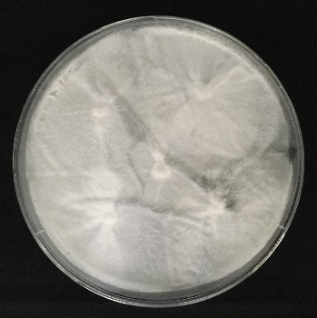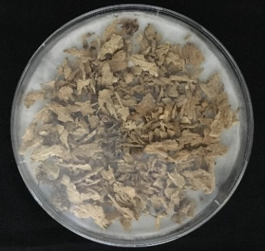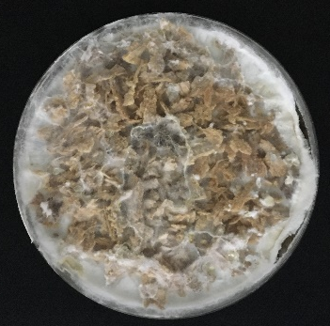
(c)
(b)
(a)

Figure 1. Preparation of artificial infection of oil palm wood tissues by Ganoderma boninense. Pure culture of G. boninense after 7 days of incubation at 28±2 ºC (a), sterilised oil palm wood on top of fully grown G. boninense (b), and oil palm wood colonised by G. boninense after 14 days (c)

Extraction of fungal VOCs
An SPME manual holder and four types of fibres i.e. 100 µm polydimethylsiloxane (PDMS), 85 μm carboxen/polydimethylsiloxane (CAR/PDMS), 65 μm polydimethylsiloxane/divinylbenzene (PDMS/DVB) and 50/30 μm divinylbenzene/carboxen/polydimethylsiloxane (DVB/Car/PDMS) were purchased from Supelco (Bellefonte, PA, USA). All the SPME fibres were conditioned according to manufacturer’s specification before VOCs sampling. SPME fibres were directly thermally desorbed in a GC inlet heated to 250 ºC for 30 min to eliminate contaminants. For analysis of headspace VOCs, in vitro oil palm-Ganoderma infected sample was preincubated for 30 min at 40 ºC before being exposed to SPME fibres (Figure 2). After 15 min of exposure, the SPME fibre was immediately desorbed into GC heated injection port, heated to 250 ºC in splitless mode. HS-SPME analyses were repeated four times.

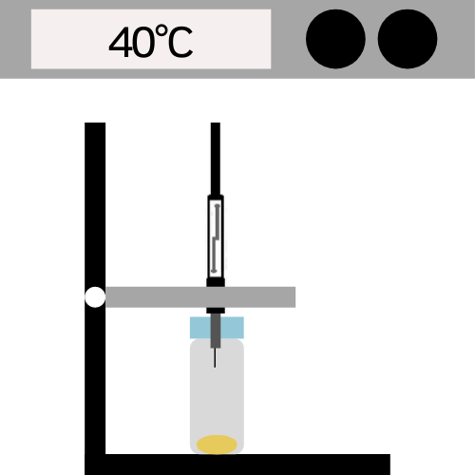
Aluminium crimp cap
SPME fibre
20 ml headspace vial
Oil palm-Ganoderma infected tissues
SPME fibre holder
Oven

Figure 2. Schematic diagram of experimental setup for headspace VOCs extraction from oil palm-Ganoderma infected tissues using SPME in an oven at 40 ºC.

GC-MS analysis
GC analysis was performed on an Agilent Technologies (CA, USA) GC 7890A, equipped with an inert MS Triple-Axis detector model 5975C. VOCs were separated on a fused-silica bonded-phase capillary column ZebronTM ZB-5HT Inferno, 30 m in length by 0.25 mm in internal diameter, with 0.25 µm of film thickness (5% phenyl 95% dimethylpolysiloxane). Helium was used as the carrier gas and the flow rate was 1 mL/min. The following three-step heating oven programme was applied: (1) 45 ºC for 1 minute; (2) 10 ºC min⁻¹ temperature increased to 260 ºC; (3) 260 ºC for 30 minutes. The transfer line temperature was 280 ºC. A mass range from 20–400 m/z was scanned in full scan mode at 70 eV ionisation energy. The chromatograms were analysed using Agilent Enhanced MSD ChemStation (Version E.02.00.493) and tentative identification of VOCs was performed by comparing their mass spectra and retention indices with the NIST data library.

Statistical analysis
Raw data generated from GC-MS analyses were extracted and imported into Microsoft Excel to create a data matrix. The differences between VOCs concentrations were examined using analysis of variance (ANOVA) at significant level of p <0.05 (IBM SPSS Statistics version 20.0).

Results and Discussion

Optimisation of HS-SPME sampling protocol
The performance of a given SPME application was highly dependent on the selected extraction phase which determined the selectivity and the reliability of the method. However, analysis of VOCs using SPME in biological studies should also examine sample stability and integrity to obtain a consistent profile because of their dynamic nature due to enzymatic and non-enzymatic reactions. Therefore, preliminary studies were conducted to analyse the experimental conditions that may influence the VOCs profiles generated.

Sample preparation method
The first factor investigated was the method of sample preparation, either with or without the application of mechanical force with the use of liquid nitrogen. Results showed that higher and well-balanced GC profile with wider range of chemical classes were obtained when biological tissues were disrupted at ultra-low temperature. In addition, the chromatograms of all replicates demonstrated consistent sequence of VOCs, which were hexanal, benzaldehyde, 3-octanone, 2-pentylfuran, octanal, (E)-2-octenal, 1-octanol, nonanal, naphthalene, dodecane, tetradecane and α-cardinene, eluted from the column (Figure 3). Constant chromatogram profiles indicated the sample was stable, and therefore, was used for further analyses.
Rep 1

Rep 2

Rep 3

Rep 4

Figure 3. Consistent total ion current chromatograms across HS-SPME extraction replicates using 100 µm PDMS extraction phase from 0.25 g of oil palm-Ganoderma infected tissues homogenised to fine powder using liquid nitrogen

This study reveals oil palm-Ganoderma infected samples crushed in the presence of liquid nitrogen were more stable and produced wider range of GC profile with various chemical classes compared to samples that were not given any pre-treatment. Similar observations were reported in the development of HS-SPME-GCMS protocol for herbivore-induced volatiles in Myrcia splendens [19]. This is due to the use of liquid nitrogen that has allowed tissue disruption to take place at very low temperature, minimising the loss of highly volatile compounds, and thus, providing higher exposure of biological cells that gives higher volatile emission. More importantly, processing samples at ultra-low temperature also limited the activities of the enzymes by quenching, subsequently reducing changes in compound composition due to internal and external environmental effects.

Sample weight
Sixteen commonly reported VOCs from fungi, i.e. hexanal, benzaldehyde, 1-octen-3-ol, 2-pentylfuran, (E)-2-octenal, 1-octanol, undecane, nonanal, naphthalene, dodecane, tridecane, butyl butanoate, tetradecane, 2,4-di-tert-butylphenol, α-cardinene and β-cardinene were chosen to perform HS-SPME optimisation using different sample weight [15, 17, 19-27]. VOCs were selected based on the highest total average peak area of the gas chromatogram with minimal variation between samples. The effect of sample weight is presented in Figure 4, where results were the average response of quadruplicate of extractions and normalised to the response obtained for 0.25 g.
The concentration or amount of sample injected into GC was generally increased to obtain better signal, thereby increasing the signal strength. However, in headspace analysis, increasing sample weight did not necessarily resulted in increased peak areas as greater sample weight caused reduction in the actual headspace volume [28, 29].
The oil palm-Ganoderma infected tissues released various compounds with different chemical and physical properties which explained the different responses observed across the headspace volumes tested (Figure 4). This work demonstrates the small sample weight that implied higher headspace volume in 20 mL headspace vial, making 0.25 g the most appropriate weight since the signal intensities observed was sufficient to achieve the satisfactory peak areas for the diverse chemical natures of the selected compounds. Thus, 0.25 g was chosen as the sample weight for subsequent experiments.

Figure 4. Effect of sample weight for selected compounds (HX = hexanal; BA = benzaldehyde; 1-OC-3 = 1-octen-3-ol; 2-FP = 2-pentylfuran; E-2-OC = (E)-2-octenal; 1-OCO = 1-octanol; UD = undecane; NN = nonanal; NAPH = naphthalene; DD = dodecane; TD = tridecane; BB = butyl butanoate; TE = tetradecane; 2,4-DB = 2,4-di-tert-butylphenol; α-C = α-cardinene and β-C = β-cardinene) obtained by HS-SPME-GCMS analysis of oil palm-Ganoderma infected tissues using 100 µm PDMS extraction phase. Response shown as normalised to response obtained for 0.25 g. Error bars represent standard deviation for four replicate ran of each weight.

Selection of SPME fibre extraction phase
Figure 5 summarises the average normalised areas of the total selected compounds obtained from different SPME fibre extraction phases. Higher absorption was generally observed in combined extraction phases in comparison to PDMS. ANOVA test showed significant differences between the SPME fibre extraction phases tested. No significant difference was observed between the responses obtained between CAR/PDMS and PDMS/DVB (p >0.05). The average normalised areas of total selected compounds of CAR/PDMS and PDMS/DVB were almost six times higher than PDMS, while extraction using DVB/Car/PDMS had shown nearly seven times higher than PDMS. Therefore, the composite DVB/Car/PDMS extraction phase exhibited superior extraction efficiency compared to other fibre extraction phases tested (Figure 5).

Figure 5. Effect of SPME fibre extraction phases (PDMS = polydimethylsiloxane; CAR/PDMS carboxen/polydimethylsiloxane; PDMS/DVB = polydimethylsiloxane/divinylbenzene and DVB/Car/PDMS = divinylbenzene/carboxen/polydimethylsiloxane) on extraction efficiency of headspace VOCs released from oil palm-Ganoderma infected tissues. Average areas of compounds obtained were normalised to response obtained for PDMS. Error bars represent standard deviation of four replicate ran for each SPME fibre.
Fibre coating selection was the most important factor in any development of SPME method. Assorted kinds of SPME fibres were introduced commercially with different extraction phase polarity and thickness to favour the adsorption of analytes for various classes and molecular weights during extraction. Unlike absorbents, in the solid coating, analytes were extracted via adsorption where analytes moved into the pores of the absorbent and got physically trapped or chemically bonded with the surface of the absorbent. Being a porous material, it is important to note on the degree of pore distribution and pore size since their ability to retain an analyte was dependent on the pore size diameter [30]. For instance, carboxen was generally developed for the adsorption of analytes with a molecular weight of less than 90 m/z due to its micropores with an opening diameter of 2 to 20 Å, making it less efficient for adsorption and desorption of large molecular weight analytes. In comparison, DVB was designed for the entrapment of larger analytes with high degree of mesopores (20 to 500 Å) and therefore, did not suitable for low molecular weight analytes extraction. Thus, the combination of both adsorbents’ properties coating in DVB/Car/PDMS has enabled excellent fibre coating for wide range molecular weight analytes during a single extraction [31].
Figure 5 presents the average normalised areas of total selected compounds of CAR/PDMS and PDMS/DVB that is almost six times higher than PDMS. In contrast, composite coating DVB/Car/PDMS exhibited superior extraction efficiency compared to other fibre coating extraction phase. This difference might be due to monoterpenes being compounds with molecular weights closed to the upper limit of the carboxen adsorbent, and thus were extracted by the fibre containing carboxen and/or DVB coating. Compounds such as 2-pentylfuran, naphthalene, α-terpinol, N,N-dibutylformamide, chloroxylenol, and dibutylhydroxytoluene were only detected if DVB-containing fibre was used. In DVB/Car/PDMS fibre, the layers were assembled with carboxen layer located on the inside and DVB layer on the outside of the coating, which means that molecules of both high and low molecular weight might be successfully adsorbed as DVB layer was efficient for large molecules but less efficient in the entrapment of smaller molecules [31]. The small molecules could then migrate to the inner part of the coating and be fully adsorbed by the carboxen layer [30]. Similar studies on fibre extraction phase selection in the development of SPME methods have demonstrated DVB/Car/PDMS as the most efficient extraction fibre [19, 32]. Based on these results, DVB/Car/PDMS was selected as the most efficient fibre extraction phase to extract VOCs from the oil palm-Ganoderma infected tissues.

Tentative VOCs profile
The optimised HS-SPME-GCMS condition was employed for the analysis of VOCs released from in vitro oil palm-Ganoderma infected tissues. The composition of VOCs released was expressed in percentage of the total ion count (TIC) and presented in Table 1. A total of 39 compounds were found in the headspace of oil palm-Ganoderma infected tissues. They belong to alcohols, alkanes, volatile acids, ketones, aldehydes, esters, sesquiterpenes and polycyclic aromatic hydrocarbon groups. Figure 6 shows the molecular structures of the compounds.

Table 1. Overview of tentative VOCS emitted by oil palm-Ganoderma infected tissues using the optimised HS-SPME-GCMS protocol

# | RT* | Compound Name | Molecular Formula | CAS | m/z | Percentage of Total Ion Current‡
1 | 3.72 | Toluene | C₇H₈ | 108-88-3 | 92 | 0.580
2 | 4.12 | Hexanal | C₆H₁₂O | 66-25-1 | 100 | 7.162
3 | 5.17 | m-Xylene | C₈H₁₀ | 108-38-3 | 106 | 0.321
4 | 5.30 | p-Xylene | C₈H₁₀ | 106-42-3 | 106 | 0.362
5 | 5.84 | Methyl (Z)-N-hydroxybenzenecarboximidate | C₈H₉NO₂ | 1000222-86-6 | 151 | 1.006
6 | 6.68 | Benzaldehyde | C₇H₆O | 100-52-7 | 106 | 0.181
7 | 6.97 | 1-Octen-3-ol | C₈H₁₆O | 3391-86-4 | 128 | 69.43
8 | 7.08 | 3-Octanone | C₈H₁₆O | 106-68-3 | 128 | 10.34
9 | 7.16 | 2-Pentylfuran | C₉H₁₄O | 3777-69-3 | 138 | 0.270
10 | 7.33 | Octanal | C₈H₁₆O | 124-13-0 | 128 | 0.554
11 | 7.65 | 4-Methyldecane | C₁₁H₂₄ | 2847-72-5 | 156 | 0.148
12 | 7.83 | 1,3-Hexadiene, 3-ethyl-2-methyl | C₉H₁₆ | 61142-36-7 | 124 | 0.770
13 | 8.21 | (E)-2-Octenal | C₈H₁₄O | 2548-87-0 | 126 | 2.100
14 | 8.30 | Eicosane | C₂₀H₄₂ | 112-95-8 | 282 | 0.047
15 | 8.35 | 2-Octen-1-ol | C₈H₁₆O | 22104-78-5 | 128 | 1.457
16 | 8.39 | 1-Octanol | C₈H₁₈O | 111-87-5 | 130 | 2.520
17 | 8.76 | 4-Octanyl butyrate | C₁₂H₂₄O₂ | 20286-46-8 | 200 | 0.231
18 | 8.86 | Undecane | C₁₁H₂₄ | 1120-21-4 | 156 | 0.042
19 | 8.93 | Nonanal | C₉H₁₈O | 124-19-6 | 142 | 0.293
20 | 9.77 | (E)-2-Nonenal | C₉H₁₆O | 18829-56-6 | 140 | 0.033
21 | 9.85 | Octanoic acid | C₈H₁₆O | 124-07-2 | 144 | 0.136
22 | 10.20 | 1-(2-Butoxyethoxy)ethanol | C₈H₁₈O | 54446-78-5 | 162 | 0.063
23 | 10.24 | Naphthalene | C₁₀H₈ | 91-20-3 | 128 | 0.038
24 | 10.30 | α-Terpineol | C₁₀H₁₈ | 98-55-5 | 154 | 0.100
25 | 10.36 | Dodecane | C₁₂H₂₆ | 112-40-3 | 170 | 0.113
26 | 11.20 | 1,3-Ditert-butylbenzene | C₁₄H₂₂ | 1014-60-4 | 190 | 0.151
27 | 11.25 | UNK§ m/z 314 | - | - | 314 | 0.064
28 | 11.52 | 7-Hexylicosane | C₂₆H₅₄ | 55333-99-8 | 366 | 0.047
29 | 11.71 | 2-Undecanone | C₁₁H₂₂ | 112-12-9 | 170 | 0.070
30 | 11.86 | N,N-dibutylformamide | C₉H₁₉NO | 761-65-9 | 157 | 0.050
31 | 12.85 | Butyl butanoate | C₈H₁₆O₂ | 109-21-7 | 144 | 0.460
32 | 12.95 | Chloroxylenol | C₈H₉ClO | 88-04-0 | 156 | 0.046
33 | 13.12 | Tetradecane | C₁₄H₃₀ | 629-59-4 | 198 | 0.039
34 | 14.55 | 2,4-Di-tert-butylphenol | C₁₄H₂₂O | 96-76-4 | 206 | 0.079
35 | 14.63 | Dibutylhydroxytoluene | C₁₅H₂₄O | 128-37-0 | 220 | 0.013
36 | 14.73 | α-Cardinene | C₁₅H₂₄ | 483-75-0 | 204 | 0.239
37 | 14.81 | δ-Cardinene | C₁₅H₂₄ | 483-76-1 | 204 | 0.032
38 | 15.62 | UNK§ m/z 286 | - | - | 286 | 0.395
39 | 15.63 | Propanoic acid, 2-methyl-, 1-(1,1-dimethylethyl)-2-methyl-1,3-propanediyl ester | C₁₆H₃₀O₄ | 74381-40-1 | 286 | 0.020
*RT, retention time.
‡The percentages were calculated using the peak area for each VOC relative to the total average normalised areas of the total ion current recorded.
§UNK, unknown.
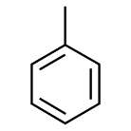 | 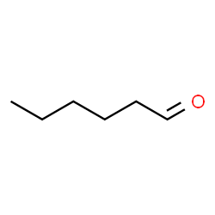 | 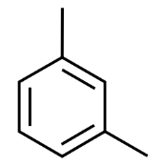 | 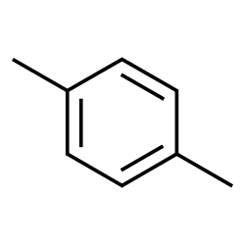
Toluene | Hexanal | m-Xylene | p-Xylene
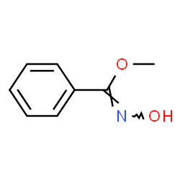 | 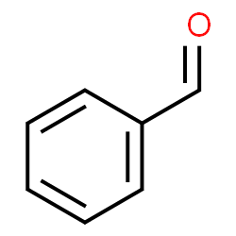 | 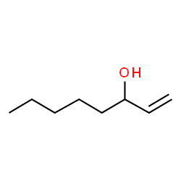 | 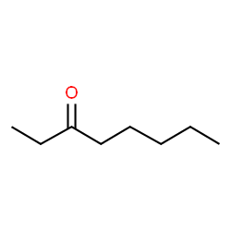
Methyl (Z)-N-hydroxybenzene-carboximidate | Benzaldehyde | 1-Octen-3-ol | 3-Octanone
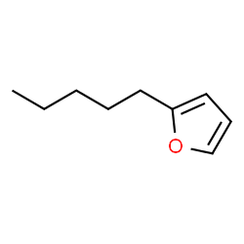 | 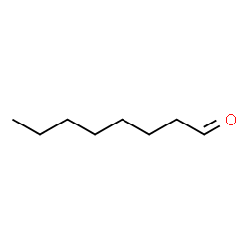 | 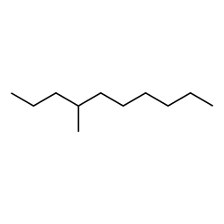 | 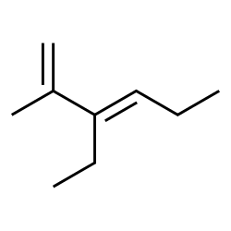
2-Pentylfuran | Octanal | 4-Methyldecane | 1,3-Hexadiene, 3-ethyl-2-methyl
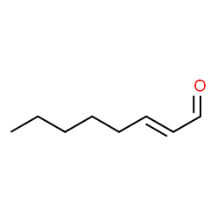 | 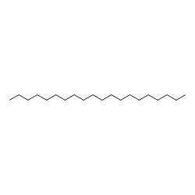 | 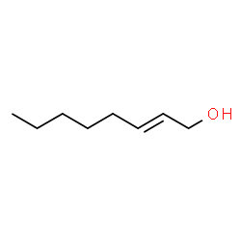 | 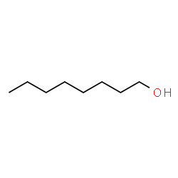
(E)-2-Octenal | Eicosane | 2-Octen-1-ol | 1-Octanol
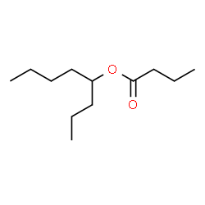 | 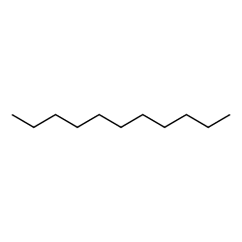 | 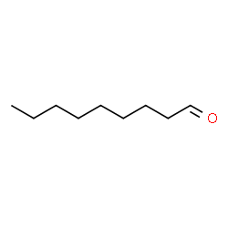 | 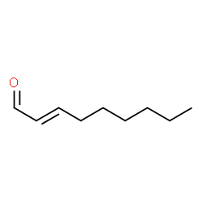
4-Octanyl butyrate | Undecane | Nonanal | (E)-2-Nonenal
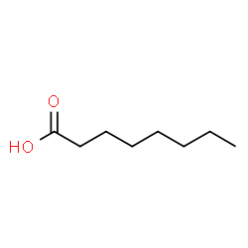 | 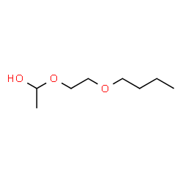 | 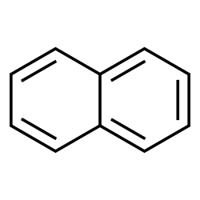 | 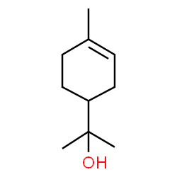
Octanoic acid | 1-(2-Butoxyethoxy)ethanol | Naphthalene | α-Terpineol
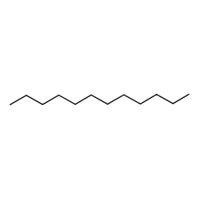 | 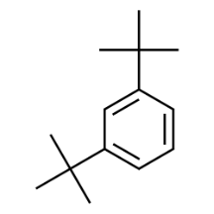 | 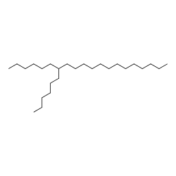 | 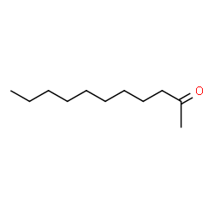
Dodecane | 1,3-Ditert-butylbenzene | 7-Hexylicosane | 2-Undecanone
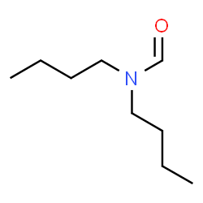 | 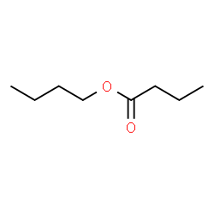 | 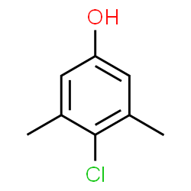 | 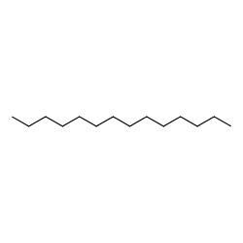
N,N-dibutylformamide | Butyl butanoate | Chloroxylenol | Tetradecane
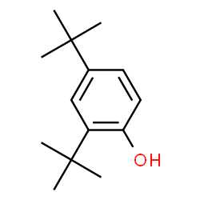 | 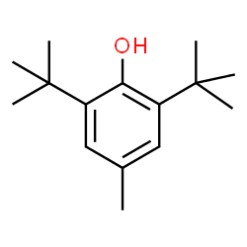 | 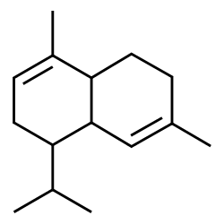 | 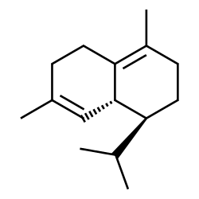
2,4-Di-tert-butylphenol | 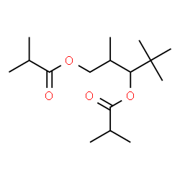  Dibutylhydroxytoluene | α-Cardinene | δ-Cardinene
Propanoic acid, 2-methyl-,
1-(1,1-dimethylethyl)-2-methyl-1,3-propanediyl ester

Figure 6. Molecular structures of tentative VOCs emitted
Qualitatively, the largest absorption of VOCs was with DVB/Car/PDMS fibre: chromatograms demonstrated that VOCs with low molecular mass were eluted first with short retention times, followed by long chain alcohols, aldehydes and ketones, then long chain hydrocarbons and acids, then terpenes and sesquiterpenes, and finally organic esters at long retention times (Table 1).
Some of the VOCs found in the oil palm-Ganoderma infected tissues were the aliphatic C₈-complex that were found ubiquitous in truffle species and fungi, i.e. 1-octen-3-ol, 3-octanone and 1-octanol. They had been described as the key contributors to mushroom flavour and fungal aroma giving the scent or the odour ranging from sweet, fruity, musty, lavender, detergent and soap to orange like [23]. The most abundant VOC detected, 1-octen-3-ol (sometimes referred to as “mushroom alcohol”), was reported to emit by decomposers and wood-rotting fungi, and the alcohol biosynthesis from 10-hydroperoxide isomer of linoleic acid was well discussed in several literature [15, 23, 33-35]. The detection of volatile compound 1-octen-3-ol in this study is expected considering G. boninense is a basidiomycete and a white rot fungi.
Similar findings on the detection of hexanal is shown in the study of VOCs emitted from wood-rotting fungi Serpula lacrymans on the shavings of Pinus sylvestris (pine) timber [15]. The aromatic compound benzaldehyde was released in the study of volatile constituents of wood-rotting basidiomycetes Piptoporus betulinus, while in Fomitopsis pinicola and Trametes suaveolens, another aromatic compound, 2-pentylfuran, was also detected [20]. A preliminary head-space gas chromatographic analysis of volatile flavour compounds released from Ganoderma sinense (a medicinal mushroom) emitted octanoic acid and 2,4-di-tert-butylphenol in the mushroom broth while in the mycelium, only the latter compound was found [25, 26]. Among the VOCs detected in this study was the two-ring polycyclic aromatic hydrocarbon naphthalene which is known as effective insect repellent. Endophytic fungus, Muscodor vitigenus is also claimed to produce naphthalene almost exclusively [36]. Naphthalene derivatives, α-cadinene and δ-cadinene, are released in the in vitro oil palm-Ganoderma infected tissues. The same volatile compounds are released when Myrcia splendens is attacked by gall-inducing insects, as a signal of plant-insect interaction [19]. Therefore, the same VOCs released in this study could be due to the metabolic changes that take place in oil palm (host plant) when it is under attack by G. boninense (plant pathogen).

Conclusion
The results showed the initial feasibility application of HS-SPME extraction method for VOCs profiling of in vitro oil palm-Ganoderma infected tissues. The HS-SPME-GCMS protocol developed here is capable of detecting a diverse volatile chemical profile with high reproducibility. Future research should focus on the VOC profiles of G. boninense culture and oil palm wood to complement the current study for the VOCs to be developed as biomarker candidates for BSR disease detection. Coupled with the available electronic tools such as handheld electronic noses or any portable air monitoring systems, it could raise the possibility for the on-site detection of BSR disease.

Acknowledgement
We acknowledge the Director-General of MPOB for approving the publication of this paper. We would also like to extend our appreciation to Mrs Bahariah Bilal from the Advanced Oleochemical Technology Division (AOTD) and all research personnel in the Plant Pathology and Biosecurity unit of Biological and Sustainability Research Division who have contributed to this work either directly or indirectly.

References

- Khusairi, A., Ong-Abdullah, M., Nambiappan, B., Hishamuddin, E., Mohd Noor Izzuddin, Z. B., Razmah, G., Subramaniam, V., Sundram, S. and Ahmad Parveez, G. K. (2019). Oil palm economic performance in Malaysia and R&D progress in 2018. Journal of Oil Palm Research, 31(2): 165-194.
- Rees, R. W., Flood, J., Hasan, Y., Potter, U. and Cooper, R. M. (2009). Basal stem rot of oil palm (Elaeis guineensis); Mode of root infection and lower stem invasion by Ganoderma boninense. Plant Pathology, 58: 982-989.
- Idris, A. S., NurRashyeda, R., Rusli, M. H., Sundram, S. and Norman, K. (2016). Standard operating procedures (SOP) guidelines for managing Ganoderma disease in oil palm. Malaysian Palm Oil Board, Malaysia: pp. 1-5.
- Ariffin, D., Idris, A. S. and Singh, G. (2000). Status of Ganoderma in oil palm, in: Ganoderma diseases of perennial crops (eds) Flood, J., Bridge, P. D. and Holderness, M. CABI Publishing, London: pp. 49- 68.
- Spinelli, F., Costa, G., Rondelli, E., Busi, S., Vanneste, J. L., Rodriguez, E. M. T., Savioli, S. and Cristescu, S. M. (2011). Volatile compounds produced by Erwinia amylovora and their potential exploitation for bacterial identification. Acta Horticulturae, 896: 77-84.
- Blasioli, S., Biondi, E., Braschi, I., Mazzucchi, U., Bazzi, C. and Gessa, C. E. (2010). Electronic nose as an innovative tool for the diagnosis of grapevine crown gall. Analytica Chimica Acta, 672: 20-24.
- Pan, L., Zhang, W., Zhu, N., Mao, S. and Tu, K. (2014). Early detection and classification of pathogenic fungal disease in post-harvest strawberry fruit by electronic nose and gas chromatography–mass spectrometry. Food Research International, 62: 162-168.
- Kushalappa, A. C., Lui, L. H., Chen, C. R. and Lee, B. (2002). Volatile fingerprinting (SPME-GC-FID) to detect and discriminate diseases of potato tubers. Plant Disease, 86: 131-137.
- Biondi, E., Blasioli, S., Galeone, A., Spinelli, F., Cellini, A., Lucchese, C. and Braschi, I. (2014). Detection of potato brown rot and ring rot by electronic nose: from laboratory to real scale. Talanta, 129: 422-430.
- Blasioli, S., Biondi, E., Samudrala, D., Spinelli, F., Cellini, A., Bertaccini, A., Cristescu, S. M. and Braschi, I. (2014). Identification of volatile markers in potato brown rot and ring rot by combined GC–MS and PTR–MS techniques: study on in vitro and in vivo samples. Journal of Agricultural and Food Chemistry, 62: 337-347.
- Bennett, J. W. and Inamdar, A. A. (2015). Are some fungal volatile organic compounds (VOCs) mycotoxins?. Toxins, 7: 3785-3804.
- Markom, M. A., Shakaff, A. Y. M., Adom, A. H., Ahmad, M. N., Hidayat, W., Abdullah, A. H. and Fikri, N. A. (2009). Intelligent electronic nose system for basal stem rot disease detection. Computers and Electronics in Agriculture, 66: 140-146.
- de Lacy Costello, B. P. J., Ewen, R. J., Gunson, H. E., Ratcliffe, N. M. and Spencer-Phillips, P. T. N. (2000). The development of a sensor system for the early detection of soft rot in stored potato tubers. Measurement Science and Technology, 11: 1685-1691.
- de Lacy Costello, B. P. J., Ewen, R. J., Gunson, H., Ratcliffe, N. M., Sivanand, P. S. and Spencer-Phillips, P. T. N. (2003). A prototype sensor system for the early detection of microbially linked spoilage in stored wheat grain. Measurement Science and Technology, 14: 397-409.
- Ewen, R. J., Jones, P. R. H., Ratcliffe, N. M. and Spencer-Phillips, P. T. N. (2004). Identification by gas chromatography-mass spectrometry of the volatile organic compounds emitted from the wood-rotting fungi Serpula lacrymans and Coniophora puteana, and from Pinus sylvestris timber. Mycological Research, 108(7): 806-814.
- Müller, A., Faubert, P., Hagen, M., zuCastell, W., Polle, A., Schnitzler, J. and Rosenkranz, M. (2013). Volatile profiles of fungi – Chemotyping of species and ecological functions. Fungal Genetics and Biology, 54: 25-33.
- Sawoszczuk, T., Syguła-Cholewi´nska, J. and del Hoyo-Meléndez, J. M. (2015). Optimization of headspace solid phase microextraction for the analysis of microbial volatile organic compounds emitted by fungi: Application to historical objects. Journal of Chromatography A, 1409: 30-45.
- Cellini, A., Biondi, E., Buriani, G., Farneti, B., Rodriguez-Estrada, M. T., Braschi, I., Savioli, S., Blasioli, S., Rocchi, L., Biasioli, F., Costa, G. and Spinelli, F. (2016). Characterization of volatile organic compounds emitted by kiwifruit plants infected with Pseudomonas syringae pv. actinidiae and their effects on host defences. Trees, 30 (3): 795-806.
- Souza Silva, E. A., Saboia, G., Jorge, N. C., Hoffmann, C., dos Santos Isaias, R. M., Soares, G. L. G. and Zini, C. A. (2017). Development of a HS-SPME-GC/MS protocol assisted by chemometric tools to study herbivore induced volatiles in Myrcia splendens. Talanta, 175: 9-20.
- Rӧsecke, J., Pietsch, M. and Kӧnig, W. A. (2000). Volatile constituents of wood-rotting basidiomycetes. Phytochemistry, 54: 747-750.
- Magan, N. and Evans, P. (2000). Volatiles as an indicator of fungal activity and differentiation between species, and the potential use of electronic nose technology for early detection of grain spoilage. Journal of Stored Products Research, 36: 319-340.
- Wheatley, R. E. (2002). The consequences of volatile organic compound mediated bacterial and fungal interactions. Antonie van Leeuwenhoek, 81: 357-364.
- Combet, E., Henderson, J., Eastwood, D. C. and Burton, K. S. (2006). Eight-carbon volatiles in mushrooms and fungi: properties, analysis, and biosynthesis. Mycoscience, 47: 317-326.
- Matysik, S., Herbarth, O. and Mueller, A. (2008). Determination of volatile metabolites originating from mould growth on wall paper and synthetic media. Journal of Microbiological Methods, 75: 182-187.
- Liu, G. Q., Wang, X. L. and Jin, X. C. (2009). Head-space gas chromatographic analysis for the volatile flavor compounds from submerged culture broth of Ganoderma sinense (a medicinal fungus). 3rd International Conference on Bioinformatics and Biomedical Engineering, pp. 1-3.
- Wang, X. L., Han, W. J. and Zhou, G. Y. (2009). Analysis of volatile flavor compounds in submerged cultured Ganoderma sinense mycelium by headspace gas chromatography. 2nd International Conference on Biomedical Engineering and Informatics, pp. 1-4.
- Morath, S. U., Hung, R. and Bennett, J. W. (2012). Fungal volatile organic compounds: A review with emphasis on their biotechnological potential. Fungal Biology Reviews, 26: 73-83.
- Kolb, B. and Ettre, L. S. (2006). Static headspace-gas chromatography: Theory and practice 2nd edition. JohnWiley and Sons, New York: pp. 73-80.
- Sithersingh, M. J. and Snow, N. H. (2012). Chapter 9 - Headspace-Gas Chromatography, In: Gas Chromatography. Elsevier, Amsterdam: pp. 221-233.
- Górecki, T., Yu, X. and Pawliszyn, J. (1999). Theory of analyte extraction by selected porous polymer SPME fibres. Analyst, 124: 643-649.
- Pawliszyn, J. (1999). Applications of solid phase microextraction. Royal Society of Chemistry, Cambridge: pp. 39-40.
- Cortina, P. R., Asis, R., Peralta, I. E., Asprellid, P. D. and Santiago, A. N. (2017). Determination of volatile organic compounds in andean tomato landraces by headspace solid phase microextraction-gas chromatography-mass spectrometry. Journal of the Brazilian Chemical Society, 28(1): 30-41.
- Tressl, R., Bahri, D. and Engel, K. H. (1982). Formation of eight-carbon and ten-carbon components in mushrooms (Agaricus campestris). Journal of Agricultural and Food Chemistry, 30: 89-93.
- Wurzenberger, M. and Grosch, W. (1983). Determination of 1 octen-3-ol in mushrooms and in products containing mushrooms. Z Lebensm-Unters-Forsch, 176: 16-19.
- Wurzenberger, M. and Grosch, W. (1984). The formation of 1-octen-3-ol from the 10-hydroperoxide isomer of linoleic-acid by a hydroperoxide lyase in mushrooms Psalliotta bispora. Biochimica et Biophysica Acta, 794: 25-30.
- Daisy, B. H., Strobel, G. A. Castillo, U., Ezra, D., Sears, J., Weaver, D. K. and Runyon, J. B. (2002). Naphthalene, an insect repellent, is produced by Muscodor vitigenus, a novel endophytic fungus. Microbiology, 148: 3737-3741.

