

PREPARATION AND CHARACTERIZATION OF COGON GRASS NATURAL FIBER AS A CONCRETE FILLER FOR GAMMA RADIATION SHIELDING

(Penyediaan dan Pencirian Serat Semula Jadi Rumput Cogon sebagai Pengisi Konkrit untuk Perisai Sinar Gama)

Yusrina Mohd Yusof and Siti Amira Othman*

Department of Physics and Chemistry, Faculty of Applied Sciences and Technology

Universiti Tun Hussein Onn Malaysia, 84600 Pagoh, Johor, Malaysia

*Corresponding author: sitiamira@uthm.edu.my

Received: 3 April 2021; Accepted: 2 June 2021; Published: xx June 2021

Abstract
Concrete is a combination of cement, fine aggregate, coarse aggregate, and water. Concrete has a high shielding potential against gamma radiation from radioactive source. Concretes having a higher attenuation coefficient may be produced by varying the additives of various specific densities to increase the shielding performance. This study uses a cogon grass fiber, an invasive and unwanted grass due to their ability to grow, and disrupt desirable vegetation efficiently as a reinforcement material mixed into the concrete composite to observe its performance in radiation shielding. Natural fiber is known to have a tolerance to post splitting, high energy absorption and increased fatigue resistance of cement-based composites. Cogon grass fibers are use with different percentages of 0%, 0.5%, 1.0% and 1.5% fiber content with four different thicknesses. In this study, the chemical and physical properties of cogon grass were characterized by the hydrolysis process (Chesson Method) and Atomic Force Microscopy (AFM), respectively. The effect of different percentage of cogon grass fiber in concrete with different thickness to linear attenuation coefficient, the difference of linear attenuation coefficient value between lead concrete and cogon grass fiber concrete and half value layer (HVL) were also investigated. The possibility of using cogon grass natural fiber as a block of concrete for gamma radiation shielding was also evaluated based on the results obtained in this study. The results show that the hemicellulose, cellulose and lignin content of raw cogon grass fiber were 27.60%, 36.62% and 6.11%, respectively. AFM micrograph of cogon grass showed a blocky and rough surface. The calculated linear attenuation coefficient of cogon grass fiber showed an increase with the increase of fiber content and thickness. However, lead concrete showed a higher attenuation coefficient and lower HVL value compared to cogon grass fiber. Despite that, cogon grass fiber concrete may have the potential to be used as shielding material with some improvement.

Keywords: cogon grass, fiber, concrete, filler, gamma radiation

Abstrak
Konkrit adalah campuran dari simen, agregat halus, agregat kasar, dan air. Konkrit mempunyai potensi pelindung yang tinggi terhadap sinaran radioaktif gama daripada sumber radioaktif. Konkrit yang mempunyai pekali pelemahan yang lebih tinggi dapat dihasilkan dengan mengubah bahan tambahan dari pelbagai ketumpatan tertentu untuk meningkatkan kadar pelindung. Kajian ini menggunakan serat semula jadi rumput lalang, sejenis rumput invasif dan tidak diingini kerana kemampuan mereka untuk tumbuh, dan mengganggu tumbuh-tumbuhan yang diinginkan dengan cekap sebagai bahan tambahan yang dicampurkan dalam komposit konkrit untuk menilai kemampuannya dalam pelindung radiasi. Serat semula jadi diketahui mempunyai toleransi terhadap pemisahan pasca, penyerapan tenaga yang tinggi dan peningkatan ketahanan komposit berasaskan simen. Serat rumput lalang yang digunakan dengan peratusan 0%, 0.5 %, 1.0% dan 1.5% kandungan serat dengan empat ketebalan yang berbeza. Dalam kajian ini, sifat fizikal dan kimia rumput lalang dicirikan dengan menjalankan proses hidrolisis (Kaedah Chesson) dan Mikroskop Daya Atom (AFM). Kesan peratusan serat rumput cogon yang berbeza terhadap pekali pelemahan linear konkrit, kesan ketebalan berbeza dari konkrit serat rumput lalang terhadap pekali pelemahan linear dan perbezaan pekali pelemahan linear antara konkrit plumbum dan konkrit serat rumput lalang juga disiasat. Potensi menggunakan serat semula jadi rumput lalang sebagai blok konkrit sebagai pelindung radiasi gamma juga dinilai berdasarkan hasil kajian ini. Kajian menunjukkan kandungan hemiselulosa, selulosa dan lignin dari serat rumput lalang masing-masing adalah 27.60%, 36.62% dan 6.11%. Mikrograf AFM rumput lalang menunjukkan permukaan yang tersekat dan kasar. Pekali pelemahan linear yang dikira dari konkrit serat rumput lalang menunjukkan peningkatan dengan peningkatan kandungan serat dan ketebalan konkrit. Walau bagaimanapun, konkrit plumbum menunjukkan pekali pelemahan yang lebih tinggi dan nilai HVL yang lebih rendah berbanding dengan serat rumput cogon. Walaupun begitu, konkrit serat rumput cogon mungkin berpotensi digunakan sebagai bahan pelindung dengan sedikit peningkatan.

Kata kunci: rumput cogon, serat, konkrit, pengisi, sinaran gama, perisai

Introduction
Radiation shielding effectiveness has always been a concern and priority for many engineers and scientists as radioactive materials are extremely dangerous materials that can lead to a harmful effect when exposed to them. Radiation shielding is very important in protecting people from harmful radiation effects that can cause damage to the human body system. Primarily, radiation is a process where energy travels through space as particles or electromagnetic (EM) waves from the atoms of a radioactive material and can potentially penetrate various materials.

There are two types of radiation which is ionizing and non-ionizing radiation. Non-ionizing radiations like light, microwaves and radio waves are less harmful as they have less energy compared to ionizing radiation since ionizing radiations can only cause the movement of molecules in an atom but not the electrons. On the other hand, common ionizing radiation comes from radioactive materials and also X-ray machines, including alpha radiation (α), beta radiation (β), neutron radiation, X-rays radiation, and gamma radiation (γ). Ionization can be produced by charged particles or ions in matter. This type of radiation can remove the electrons in an atom at the same time creating ions that contain a high amount of energy particles which makes it an extremely dangerous radiation. Thus, methods of shielding against these types of ionizing radiations that are harmful to humans need to be explored.

Fundamentally, shielding is when a source of radiation is blocked or shielded by barrier of solid or liquid material at which this material absorbs the energy from the radiation emitted by the source. Lead and concrete are the common materials used to shield radiation. However, according to AbuAlRoos et al. [1], in their review, indicate that lead exposure is a significant environmental disease that may harm the environment and has serious consequences for the human body. A suitable radiation shielding material is therefore desperately required to avoid the harmful effects of radiation on human beings and the environment. The most effective features of radiation shielding materials are high atomic numbers and high-density materials, such as tungsten and concrete. Hence, through this study, concrete is the choice to be used as a radiation shielding material. Basically, according to Ekolu et al. [2], concrete is a durable substance and most commonly used in construction material. The structures of the reinforced concrete can also be built to be resilient in extreme environmental conditions to withstand harsh winds, fire and earthquakes.

According to Gencel et al. [3], concrete is an ideal and appropriate shielding material for nuclear reactors, particulate accelerators, research reactors, hot laboratories and medical facilities. This material is commonly used as a shielding material. Concretes are a fairly low-cost material, easily treated and casted into complex shapes. It contains a mix of different light and heavy elements and a photon and neutron mitigation capability. According to Han et al. [4], the composite of cement, water and heavyweight aggregates are the materials in the radiation shielding concrete. Due to its high density and large content of crystal water, it can resist radiations including alpha rays, beta rays, gamma rays, x-rays and neutrons. The ability of concrete to be used in many fields that required shielding of radiation sources is well recognized and acknowledged by most researchers.

Radiation sources are integral parts of human daily lives and these sources exist in different forms and intensities. To maintain and protect the high quality of our everyday lives for instance, smoke sensors are used to alert people when the fire occurs, x-ray devices are used to detect concealed weapons, as well as other kinds of imaging techniques that are to identify diseases. However, without proper shielding, the ineptitude in handling the radiation emitting devices, or the failure to provide protective equipment to a person who handles these devices will likely cause permanent injuries and deaths due to prolonged or even brief exposures to radiations. This is where radiation shielding concrete plays a role to prevent such harmful and lethal radiation effects.

In this study, the natural fiber used as reinforcement in concrete to enhance the radiation shielding performance is “Imperata Cylindrica”, usually known as Cogon grass or “Lalang” in Malaysia. Among natural fibers, cogon grass is classified as a type of grass fiber together with bamboo, bagasse, Napier, corn and others [5]. According to Jumaidin et al. [6], cogon grass is one of the ten worst weeds in the world because it is capable of quickly colonizing, spreading and desirable attractive species. The weed comes from the Poaceae family, native to the temperate and tropical Old World areas. It is a persistent rhizomatized grass native to East and Southeast Asia, Micronesia, Australia, India, Melanesia and Africa.

Cogon grass is known as an invasive species in several countries beyond its native range. The plant is typically used for flood control and other cultivars are grown as ornamentals. Approximately 2 cm in diameter, it can grow up to 3 meters or between 2 and 10 feet tall. Cogon grass has historically been commonly used only in papermaking and making of bags and mats as well as in traditional Chinese medicine. However, the growth of this exotic invasive species is unstoppable and might have a major influence on either ecological or economic consequences in some area. So, the use of cogon grass needs to be redefined whether in construction, manufacturing, or any other fields so that the existence of this plant-life is not wasted. Therefore, cogon grass may be beneficial as it can be proposed as an alternative fiber to reinforced concrete as a radiation shielding material and at the same time enhance the shielding performance of concrete.

Concrete credibility and performance as a radiation shielding structure have been improved and upgraded from time to time by researchers that found new solutions to acquire better properties of concrete as it is also a better choice of material compared to lead where its toxicity is detrimental to the environment and the human body. Natural fiber will be used as an additive as reinforcement in the concrete proportion to increase the quality of concrete for radiation shielding performance and at the same time it can lead to environmental protection purposes. Moreover, natural fibers which refer to plant or vegetable fibers are the most utilized and applied in different engineering tools. Furthermore, cogon grass does not have any economic value and is commonly treated as waste by many.

Moreover, the breeding of cogon grass is also unstoppable as it continues to grow aggressively and may become a disturbance to new seedlings of desirable vegetations. Farmers and planters also may have difficulty in controlling cogon grass population as it costs a lot of energy, effort and money. Therefore, cogon grass breeding can be controlled by using it to reinforce concrete. This study will evaluate the practicality of adding cogon grass fiber in concrete to achieve a better radiation shielding performance based on the use of natural fiber guided by the literature. Concurrently, this study will also strive to establish beneficial usage cogon grass so that it may play a small part in the local economy development.

In Malaysia, the authority that license any ionizing radiation activities and industries is the Atomic Energy Licensing Board (AELB), which covers both medical and non-medical uses. Radiation safety and radiation control are being constantly boosted and challenged. Many agencies and organizations are involved in developing radiation protection policies. They also contribute to the new legislation for protection against risks caused by the ionizing radiation. Furthermore, the problem of cogon grass or “lalang” grass in this country can be overcome by using it in the construction field. Cogon grass can be an alternative fiber that can easily be found in Malaysia to improve the strength of concrete that can be used as radiation shielding materials in medical and non-medical purposes in Malaysia.

The potential of natural fiber especially cogon grass as reinforcement in concrete will be studied and determined in this study. Moreover, the ability of the fiber reinforced concrete in improving the radiation shielding performance will also be evaluated so that its feasibility can be used as an effective radiation protection in Malaysia can be determined.

Materials and Methods

Sample collection
Cogon grass is an abundantly inexpensive weed growing in Malaysia that can be easily cultivated through seeds and large rhizome systems [7]. Production of these grass fibers can turn the wasted leaves into a renewable and low-cost natural fiber that will be integrated into the concrete mixes. Cogon grass as seen in Figure 1, is often visible as a luxurious yellowish-green grass on the roadsides. The cogon grass for this study was collected from the field area in Klang, Selangor.

Preparation of the fiber sample
A multiple-step procedure is performed to prepare the samples of the cogon grass fiber. Firstly, the cogon grass was cleaned with water to eliminate dust, waste, and any harmful materials and then left to dry under the sunlight for a week. Secondly, the dried grasses were cut manually and sieved to ensure that each cut piece of fibers is about 1 mm to 2 mm in size. Next, they are placed in the airtight glass container and labelled as cogon grass (CGF). For further analyses, the cogon grass fibers were later analyzed for their physical and chemical characteristics. Then, they are chemically treated to improve their strength performance [8]. After that, the cut and dried cogon grasses were weighed using an analytical weighing balance according to 0.5%, 1.0% and 1.5% volume dosage of fiber.

Cogon grass characterization
Chemical properties
Natural fibers consist of some basic chemical compositions such as cellulose, hemicellulose, pectin, lignin, and others. Determination of chemical compositions such as the amount of lignin, cellulose, and hemicellulose in natural fiber can be accomplished by conducting a hydrolysis test. Therefore, in this study, the hydrolysis process is carried out using the Chesson method. To begin, approximately 1 g of dry cogon grass fiber (W1) was mixed with 150 mL of distilled water at a temperature of about 90 to 100 °C for an hour. Then, a filter was used to separate the residue fibers which were then cleaned with 300 mL of hot water. After that, the residual fibers were dried in an oven at 120 °C until a constant weight is observed (W2).
The process continued with a mixture of dry residue (W2) with 150 mL of ${1 N H}_{2}{SO}_{4}$ which after that being heated as previously done with the same temperature and period. To prepare 150 mL of ${1 N H}_{2}{SO}_{4},$ formula and steps below were followed.

Volume of sulphuric acid + Volume of distilled water = 150 ml

- Determine the gram of sulphuric acid

Gram of ${ H}_{2}{SO}_{4}$ = $\frac{molar mass of { H}_{2}{SO}_{4} }{number of moles}$ (1)
= $\frac{98.08 g/mol }{2}$
= 49. 04 g

- Determine the gram of compound needed

Compound needed = (N desired) (equivalent mass) (volume in litre desired)
= (1) (49.04g) (0.15 litre)
= 7.356 g

- The volume of concentrated acid needed

Concentrated acid needed = $\frac{gram of compund needed }{\left(percent of conc. acid\right)(specific gravity)}$ (2)
= $\frac{7.356 g}{(0.97)(1.84)}$
= 4.12 mL

Therefore, 4.12 ml concentrated ${ H}_{2}{SO}_{4}$ diluted into 145.88 mL of distilled water.

Then, the residues were filtered and washed again with 300 mL of distilled water then dried and weighed (W3). Next, the dried residues were soaked in 10 mL of $72\%{ H}_{2}{SO}_{4}$ at room temperature for about four hours. About 150 mL of ${N H}_{2}{SO}_{4}$ was added to the mixture and refluxed at a constant temperature of between 90° to 100°C for an hour. Then, the fibers were again washed with 400 mL of distilled water and being later heated in an oven at 120°C after which the weight is taken (W4). As for the final step, the fibers (W4) were heated until ashes were formed and the weight of ashes was recorded (W5).

Later on, the amount of cogon grass fiber’s chemical compositions (hemicellulose, cellulose and lignin) can be calculated using equation (3), equation (4) and equation (5) as below:
Hemicellulose, $He= \frac{W2- W3}{W1}× 100 \%$ (3)
Cellulose,$Ce = \frac{W3- W4}{W1}× 100 \%$ (4)
Lignin, $Li = \frac{W4- W5}{W1}× 100 \%$ (5)

Hence, using all the weights taken and the equations above, the percentage of hemicellulose (He), cellulose (Ce) and lignin (Li) in the cogon grass fiber can be obtained.

Chesson method
Determination of chemical compositions such as the amount of lignin, cellulose, and hemicellulose in natural fiber can be accomplished by conducting a hydrolysis test also known as Chesson Method. In this experiment, five different weights needed to be obtained as they were crucial for this test. These five weights are the weight of dry natural fiber labeled as W1, the weight of dry residue of fiber after being mixed with distilled water (W2), the weight of dry residue after being mixed with ${N H}_{2}{SO}_{4}$ (W3), the weight of solid after being mixed with$72\%{ H}_{2}{SO}_{4}$ and ${N H}_{2}{SO}_{4}$ (W4), and lastly, the weight of the fibers that were heated to ashes labeled as W5. All the weights recorded can be seen as shown in Table 1.

After that, the amount of cogon grass fiber’s chemical compositions (hemicellulose, cellulose and lignin) can be calculated using the equations below.

- Hemicellulose content
$$Hemicellulose, He= \frac{W2- W3 }{W1}× 100\%$$
$$He= \frac{0.9351- 0.6584 }{1.0024}× 100\%$$
$He= 0.2760× 100\%$
$He=27.60$%

- Cellulose content
$$Cellulose, Ce = \frac{W3- W4 }{W1}× 100\%$$
$$Ce= \frac{0.6584- 0.2909 }{1.0024}× 100\%$$
$$Ce=0.3662× 100\%$$
$$Ce=36.62\%$$

- Lignin content
$$Lignin, Li = \frac{W4- W5 }{W1}× 100\%$$
$$Li= \frac{0.2909- 0.2296 }{1.0024}× 100\%$$
$$Li=0.0611× 100\%$$
$$Li=6.11\%$$
Hence, using all the weights taken and the equations above, the percentage of hemicellulose (He), cellulose (Ce) and lignin (Li) in the cogon grass fiber can be obtained.

Table 1. All the weights recorded in the hydrolysis test
Sample of Cogon Grass Fiber | Weight of Cogon Grass Fiber Sample  (±0.0001 g)
Weight 1 (W1) | 1.0024
Weight 2 (W2) | 0.9351
Weight 3 (W3) | 0.6584
Weight 4 (W4) | 0.2909
Weight 5 (W5) | 0.2296

Physical properties
In this study, cogon grass specimens (Figure 1) were studied using Atomic Force Microscopy (AFM) (Bruker, United States) for their microstructural and surface characteristics where there were two locations were observed in this study, point 1 and point 2. A small piece of the specimen was placed onto a double-sided tape of the specimen stub. Nano scope Analysis Software was used to analyze the microstructural characteristics of cogon grass fiber.

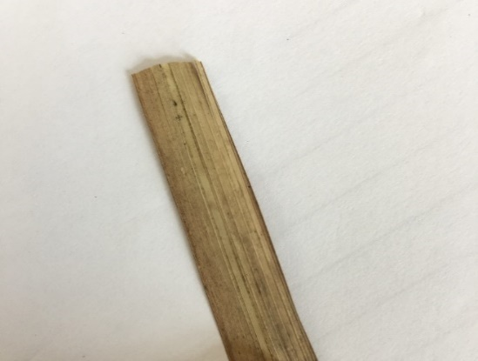
Point 1
Point 2

Figure 1. Cogon grass specimen used in Atomic Force Microscopy (AFM)

Chemical treatment of cogon grass fiber
In this study, the fibers were immersed in 4% of NaOH concentration with the soaking duration of these fibers being 24 hours as shown in Figure 2(a). This could partially remove the hemicellulose, waxes and lignin present on the surface of the fibers. This immersion led to an increase in thermal decomposition temperature and mechanical properties of the fibers themselves [17]. After the soaking process, the fibers were immersed in distilled water for one hour to remove excess sodium hydroxide. Then the fibers were dried for another week and kept in sealed plastic bags to help avoid any exposure to moisture (Figure 2(b)).

Preparation of concrete specimen
One (1) normal conventional concrete specimen, three (3) concrete sample sets utilizing different quantities of cogon grass fiber (0.5 %, 1.0 % and 1.5 %) and three (3) concrete sample sets utilizing different quantities of lead powder (Figure 3) (0.5 %, 1.0 % and 1.5 %) were prepared. All the samples had the same thickness of 2 centimeters. The percentage values of 0.5 %, 1.0 % and 1.5 % were chosen to see the trend and relationship between material. Later on, the same set of concrete specimens were produced with a thickness of 4 cm, 6cm, and 8 cm. Table 2 below shows the constituent of each sample according to concrete mixes ratio of 1:2:3.5.

Materials used in concrete preparation
Ordinary Portland Cement (OPC) (Figure 4a) was used to prepare the samples tested. Fine sand (Figure 4b), which passes by 4.75 mm to 63μm sieve size, while gravel (coarse aggregate) of 6.3 mm to 20 mm thickness has also been used.

Frame construction
Four sets of plywood frames with measurement of 10 cm × 10 cm were constructed to cast the concrete slabs with 2 cm, 4 cm, 6 cm, and 8 cm thickness (Figure 5).

Concrete mix design
Suggest mixing cement, fine sand (fine aggregate), gravel (coarse aggregate) and water at a ratio of 1:2:3.5:0.55 to produce the concrete specimens. Later on, a different percentage of reinforcement/ additive was added to the mixture.

Mixing process
Once the materials were fully organized according to specified weights in trays, the dried cogon grass fiber, cement, sand and rough aggregates were manually mixed. Dry mixing of the materials was carried out where cement was applied, followed by the addition of sand, coarse aggregates and fiber. Every component was applied gradually and uniformly so that the uniform distribution of the fibers through the concrete could be verified. The calculated quantity of water was then applied and gradually poured into the dry mixture until uniformity was accomplished. Then, the freshly mixed concrete was poured and spread out in a molds frame previously constructed. After that, the specimens were left to set for 24 hours. After the casts were set, the concrete slabs were de-molded from the plywood frames. The figure of concrete specimens with 2 cm (Figure 6a), 4 cm (Figure 6b), 6 cm (Figure 6c) and 8 cm (Figure 6d) thickness can be seen below.

Curing process
The concrete slabs were completely immersed and cured in a pool of water (Figure 7) for a day to achieve ultimate compressive strength. It is well understood that proper curing of concrete is very necessary not only to obtain the required compressive strength, but also needed in designing strong concrete. Finally, at the end of the curing phase, the specimens were left to be dried under the sun for 24 hours before being tested for gamma radiation shielding.

Gamma-ray linear attenuation coefficient measurement
The linear attenuation coefficients are often used to analyze the performance of radiation shielding of any type of materials. In this study, the developed radiation shielding concrete slabs as shown in Figure 8a were tested to determine the measurement of exposure dose rate using a survey meter (Figure 8b). The survey meter used was OD-02 survey meter with mode operation of H*(10). The type of radiation detector for this survey meter was an air-opened ionization chamber. Measurements were performed on gamma-rays emitted from Cobalt-60, ⁶⁰Co radioactive source.

The experimental setup used in this study is shown in Figure 8c. As shown in the figure, the concrete previously produced was placed between the radioactive source (in the container) and the survey meter and the distance between the detector and the radioactive source was fixed at 10 cm for all concrete samples. The measurements were taken at 20 minutes intervals for each sample.

After the exposure dose rate was recorded, the linear attenuation coefficients were determined by a calculation of $I$ and $I_{o}$, which are the count rates recorded by the survey meter, with and without the thickness absorber x, using equation (6) below.

${I=I}_{o}e^{-μx}$ (6)
where $I$ is the intensity of radiation transmitted through the material of thickness x, I₀ is the incoming radiation intensity, and µ is a linear attenuation coeﬃcient.

Besides that, through this study, the half value layer (HVL) was also calculated according to various concrete thickness. HVL is the thickness at which an absorber will reduces the radiation to half of its original intensity. The equation used to calculate the HVL value is as below.

HVL = $\frac{0.693}{µ}$ (7)

where µ is a linear attenuation coeﬃcient.

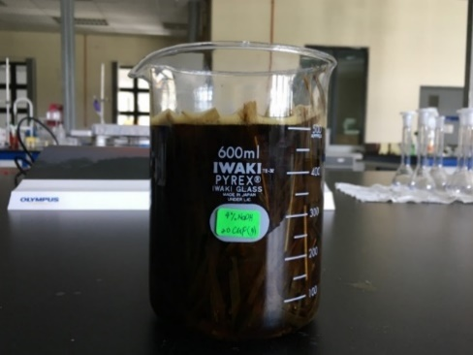
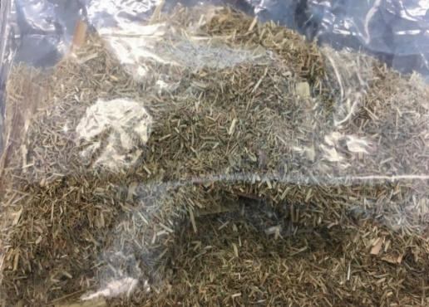
(a) (b)

Figure 2. (a) Cogon grass fibers immersed in 4% of NaOH concentration for 24 hours (b) Cogon grass fibers were kept in sealed plastic bags

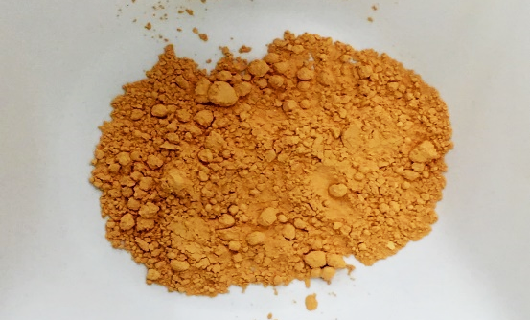

Figure 3. Lead powder used as a reinforcement in concrete

Table 2. Constituent of each sample according to concrete mixes ratio of 1:2:3.5
Percentage of Reinforcement in Concrete (%) | Thickness (cm) | Mass (± 0.01 g)
Percentage of Reinforcement in Concrete (%) | Thickness (cm) | Water | Cement | Sand | Aggregate | Fiber | Lead
0 | 2 | 37.53 | 68.23 | 137.42 | 248.77 | - | -
 | 4 | 75.05 | 136.47 | 274.83 | 497.54 | - | -
 | 6 | 112.59 | 204.70 | 412.25 | 746.31 | - | -
 | 8 | 150.11 | 272.94 | 549.66 | 995.08 | - | -
0.5 | 2 | 37.53 | 68.23 | 137.42 | 248.77 | 1.54 | 1.54
 | 4 | 75.05 | 136.47 | 274.83 | 497.54 | 3.08 | 3.08
 | 6 | 112.59 | 204.70 | 412.25 | 746.31 | 4.62 | 4.62
 | 8 | 150.11 | 272.94 | 549.66 | 995.08 | 6.16 | 6.16
Table 2 (cont’d). Constituent of each sample according to concrete mixes ratio of 1:2:3.5
Percentage of Reinforcement in Concrete (%) | Thickness (cm) | Mass (± 0.01 g)
Percentage of Reinforcement in Concrete (%) | Thickness (cm) | Water | Cement | Sand | Aggregate | Fiber | Lead
1.0 | 2 | 37.53 | 68.23 | 137.42 | 248.77 | 3.08 | 3.08
 | 4 | 75.05 | 136.47 | 274.83 | 497.54 | 6.16 | 6.16
 | 6 | 112.59 | 204.70 | 412.25 | 746.31 | 9.24 | 9.24
 | 8 | 150.11 | 272.94 | 549.66 | 995.08 | 12.32 | 12.32
1.5 | 2 | 37.53 | 68.23 | 137.42 | 248.77 | 4.62 | 4.62
 | 4 | 75.05 | 136.47 | 274.83 | 497.54 | 9.24 | 9.24
 | 6 | 112.59 | 204.70 | 412.25 | 746.31 | 13.86 | 13.86
 | 8 | 150.11 | 272.94 | 549.66 | 995.08 | 18.48 | 18.48

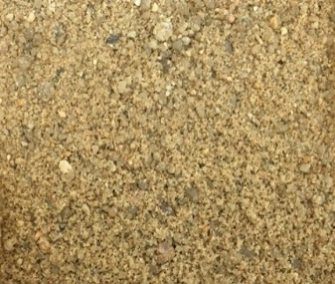
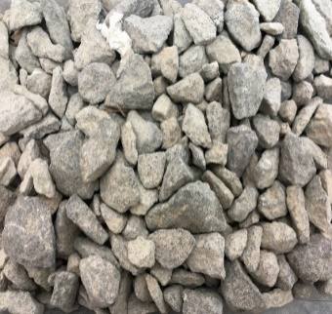
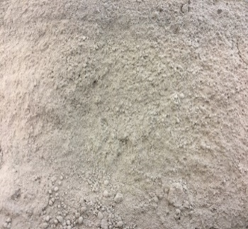
(a) (b) (c)

Figure 4. (a) Ordinary Portland cement (OPC) (b) Fine sands (fine aggregates) (c) Gravel (coarse aggregates)
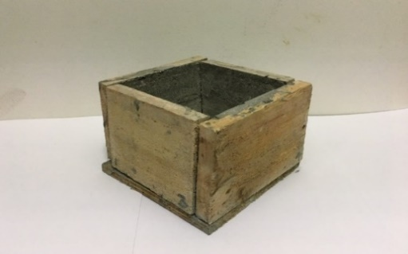

Figure 5. Constructed frame using plywood

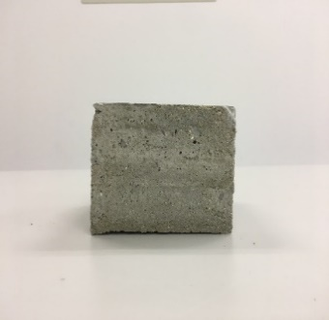
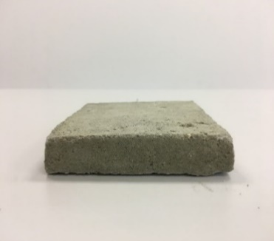
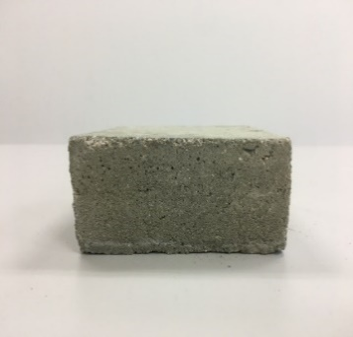
(a) (b) (c)

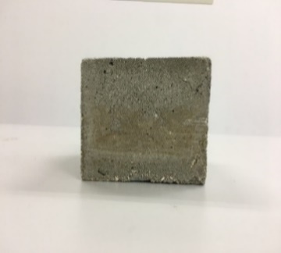
(d)

Figure 6. (a) 2 cm thickness of concrete specimen (b) 4 cm thickness of concrete specimen (c) 6 cm thickness of concrete specimen (d) 8 cm thickness of concrete specimen

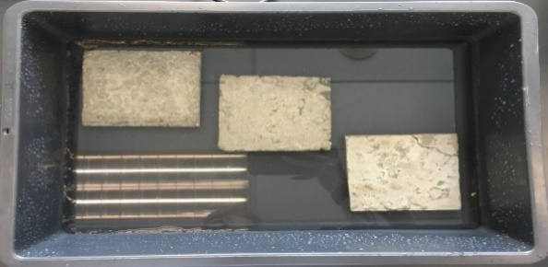

Figure 7. Soaking of slab into the water

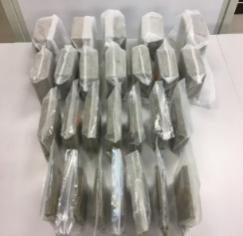
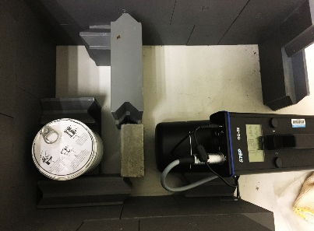
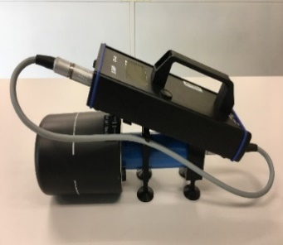
(a) (b) (c)
Concrete

Radioactive source

Survey meter

Figure 8. (a) Developed radiation concrete slabs (b) Survey meter (c) Experimental setup in this study

Results and Discussion
Chemical properties
Analysis using hydrolysis test
The percentage of chemical compositions in cogon grass natural fiber can be summarized in Table 3.

Table 3 above shows the chemical properties of cogon grass fiber which consist of cellulose, hemicellulose and lignin. For cellulose, this study shows that cogon grass contains 36.66% of cellulose, which is approximately similar with the result reported by Mohd Kassim et al. [9, 10] (37.1% of cellulose). Cellulose is a significant constituent because the increased cellulose content provides better quality and stronger materials. As for hemicellulose, cogon grass is characterized by a relatively low content of hemicellulose that is 27.60% where this amount could make a significant contribution to the product's strength. Lastly, the lignin content in cogon grass is 6.11% which is considered low. Different from the previous study, inaccuracies in composition percentage obtained from this study may have been influenced by several factors such as preparation of the solutions and how the method was carried out.

Physical properties analysis
The physical properties of cogon grass fiber were observed using atomic force microscopy (AFM).

Atomic force microscopy analysis
Atomic force microscopy images of raw cogon grass fiber can be observed as shown in Figure 9. Figure 9(a) and 9(b) show AFM images of cogon grass fiber at two different places. The images are shown in two-dimensional (2D) image. Whilst, Figure 9(c) and Figure 9(d) illustrated AFM images of cogon grass fiber in three-dimensional (3D). Surface roughness of this fiber can be seen from image size 6 × 6 ${µm}^{-1}$ scan area.

All figures above illustrated are AFM images of ultra-structural cogon grass fiber that appears to have a blocky and rough surface. In a three-dimensional image, cogon grass fiber is shown to have very obvious rough surface. Meanwhile, a blocky surface is due to the cuticular waxy layer which contains long chains of fatty acids, lipids and phenolic compounds [11]. Imperata cuticular waxy layer has very low permeability to cellulose-degrading enzymes, and it was expected that the alkaline NaOH pre-treatment can remove the outer granular waxy layer sufficiently and to allow direct contact with a digestive enzyme. Non-cellulosic materials on the surface of the Imperata can be seen in phase images in AFM as grains. Granules or grain surfaces consisted mostly of lignin but also hemicellulose and possible hemicellulose extractives.

Radiation shielding performance of fiber-reinforced concrete by measuring the gamma-ray linear attenuation coefficient
The radiation shielding performance of materials can be evaluated by determining the linear attenuation coefficient. The linear attenuation coefficient was calculated from the measurement of dose rate taken from the survey meter to analyze the effect of fiber reinforcement in concrete for radiation shielding performance as the amount of fiber increases. However, there are also other factors that affect linear attenuation coefficient including absorber thickness, x and density of the material. In this study, half value layer (HVL) was also calculated.

Effect of different percentage of cogon grass fiber reinforced in concrete to the linear attenuation coefficient
In this study, cogon grass fibers were added in concrete mixture with four different percentages of fiber content (0%, 0.5%, 1.0% and 1.5%). The obtained results of calculated linear attenuation coeﬃcients for cogon grass natural fiber concrete were presented in Table 4 and Figure 10.

From the line graph, it can be observed that the linear attenuation coefficient slightly increases as the increase of the percentage of the fiber for all tested absorber thickness, x. At 2 cm thickness, the value of the linear attenuation coefficient for 0 percent concrete fiber content is 0.1256 ${cm}^{-1}$ compared to 0.1479 ${cm}^{-1}$ for 0.5 percent fiber content, 0.1590 ${cm}^{-1}$ for 1 percent fiber content and 0.1736${ cm}^{-1}$ for 1.5% concrete fiber content.
Next, at 4 cm thickness, the value of the linear attenuation coefficient for 0 percent concrete fiber content is 0.1479 ${cm}^{-1}$ which is similar to the value for concrete with 0.5 percent fiber content, 0.1736 ${cm}^{-1}$ for 1 percent fiber content and 0.2168${ cm}^{-1}$ for 1.5% concrete fiber content. As for the 6 cm thick concrete sample, 0% concrete fiber content indicate 0.1327 ${cm}^{-1}$ linear attenuation coefficient, 0.5 percent concrete fiber content with 0.159 ${cm}^{-1}$ linear attenuation coefficient, 0.1884 ${cm}^{-1}$ for 1 percent concrete fiber content and 0.2218${ cm}^{-1}$ for 1.5% concrete fiber content. Lastly, for the 8 cm concrete, the value of the linear attenuation coefficient for 0 percent concrete fiber content is 0.1742 ${cm}^{-1}$ compared to 0.2177 ${cm}^{-1}$ for 0.5 percent fiber content, and 0.2653 ${cm}^{-1}$ for both 1.0 % and 1.5% concrete fiber content.

Overall, this line graph, indicates that the increase in the percentage of cogon grass fiber content in concrete can influence and increase the value of the linear attenuation coefficient for any absorber thickness, x. The linear attenuation coefficient shows and characterizes how easily a volume of material can be penetrated by a beam of light, sound, particles, or other energy or matter. A higher value of linear attenuation coefficient means that the beam or gamma radiation is quickly attenuated or weakened as it passes through the medium, in this case, cogon grass natural fiber. It can be observed that cogon grass natural fiber absorbed and attenuated the gamma radiation in a way that the fibers may affect of the radiation as it passes through the concrete. It is also found that the linear attenuation coefficient measured increases with the increase of fiber content, congruent to similar studies [12]. This also shows that the linear attenuation coefficient depends on the percentage of fiber content in concrete.

Effect of different thickness of cogon grass fiber reinforced concrete to the linear attenuation coefficient
Cogon grass fibers concretes were cast with four different thickness (2 cm, 4 cm, 6 cm and 8 cm). The obtained results of calculated linear attenuation coeﬃcients for cogon grass natural fiber concrete were presented in Table 5 and Figure 11.

From the line graph, it can be observed that the linear attenuation coefficient slightly increases as the thickness of fiber concrete increases for all different percentages of cogon grass fiber. At 0% fiber content, the value of linear attenuation coefficient for 2 cm concrete is 0.1256 ${cm}^{-1}$ compared to 0.1479 ${cm}^{-1}$ for 4 cm concrete, 0.1327 ${cm}^{-1}$ for 6 cm concrete and 0.1742${ cm}^{-1}$ for 8 cm concrete thickness.

At 0.5% fiber content, the value of linear attenuation coefficient for 2 cm concrete thickness is 0.1479 ${cm}^{-1}$ which is similar to the value for the concrete with 4 cm thickness, 0.1590 ${cm}^{-1}$ for 6 cm concrete and 0.2177${ cm}^{-1}$ for 8 cm concrete thickness. As for 1.0% fiber content, 2 cm thick concrete indicates a 0.1590 ${cm}^{-1}$ linear attenuation coefficient, 4 cm concrete with 0.1736 ${cm}^{-1}$ linear attenuation coefficient, 0.1884 ${cm}^{-1}$ for 6 cm concrete and 0.2653${ cm}^{-1}$ for 8 cm concrete thickness. Lastly, for 1.5% fiber content, the value of the linear attenuation coefficient for 2 cm thick concrete is 0.1736 ${cm}^{-1}$ compared to 0.2168 ${cm}^{-1}$ for 4 cm concrete, 0.2218 ${cm}^{-1}$ for 6 cm concrete and 0.2653 ${cm}^{-1}$ for 8 cm concrete.

Overall, this line graph, indicates that the increase in concrete thickness did influence and increase the value of the linear attenuation coefficient. It can be observed that the calculated linear attenuation coefficient increases with the increasing of concrete thickness [13]. Therefore, the greater the thickness of the attenuating material, the greater is the attenuation.

Table 3. Chemical compositions of cogon grass fiber
Chemical Composition  of Cogon Grass Fiber | Percentage of Chemical Composition  (% w/w)
Hemicellulose | 27.60
Cellulose | 36.62
Lignin | 6.11

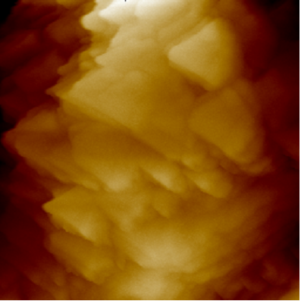
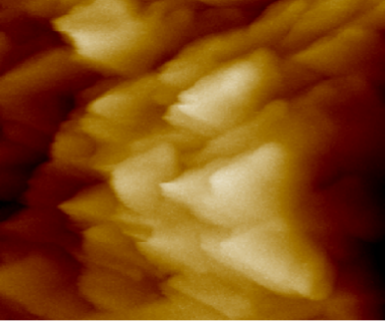
(a) (b)

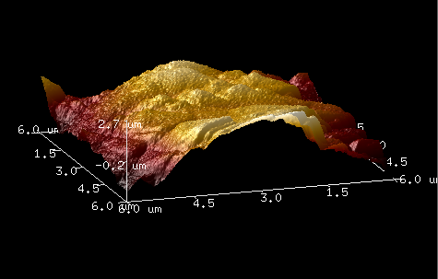
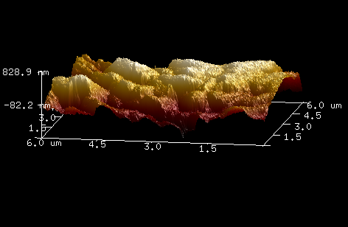
(c) (d)

Figure 9. (a) AFM 2D image of cogon grass fiber at point 1 (b) AFM 2D image of cogon grass fiber at point 2 (c)AFM 3D image of cogon grass fiber at point 1 (d) AFM 2D image of cogon grass fiber at point 2

Table 4. Calculated linear attenuation coeﬃcients (${cm}^{-1}$) for cogon grass fiber concrete
Percentage of Fiber  Reinforced in Concrete (%) | Thickness, x (cm)
Percentage of Fiber  Reinforced in Concrete (%) | 2 | 4 | 6 | 8
0 | 0.1256 | 0.1479 | 0.1327 | 0.1742
0.5 | 0.1479 | 0.1479 | 0.159 | 0.2177
1.0 | 0.159 | 0.1736 | 0.1884 | 0.2653
1.5 | 0.1736 | 0.2168 | 0.2218 | 0.2653

Figure 10. Line graph of linear attenuation coefficient (cm⁻¹) against the percentage of concrete fiber content (%)

Table 5. Calculated linear attenuation coeﬃcients (${cm}^{-1}$) for cogon grass fiber concrete for different thickness
Thickness (cm) | Percentage of Fiber Reinforced in Concrete (%)
Thickness (cm) | 0 | 0.5 | 1.0 | 1.5
2 | 0.1256 | 0.1479 | 0.159 | 0.1736
4 | 0.1479 | 0.1479 | 0.1736 | 0.2168
6 | 0.1327 | 0.1590 | 0.1884 | 0.2218
8 | 0.1742 | 0.2177 | 0.2653 | 0.2653

Figure 11. Line graph of linear attenuation coefficient (cm⁻¹) against the concrete thickness, x (cm)

Half value layer of concrete made with cogon grass fiber
Half value layer (HVL) is calculated using the equation of HVL =$\frac{0.693}{µ}$. In this study, the obtained results of half layer value were presented as in Table 6 and Figure 12.

The results of half value layer (HVL) of concrete containing different percentage of cogon grass natural fiber can be seen in Table 6 and Figure 12, respectively. As shown in in Figure, the half value layer (HVL) values of concrete with 0 %, 0.5 %, 1.0% and 1.5% cogon grass fiber decrease with the increase of concrete thickness. This shows that the increase in concrete thickness decreases the HVL values. The lower the values of HVL, the better are the radiation shielding materials in term of the thickness requirements. For instance, for concrete with 1.0% fiber, the HVL values decrease with the increase of concrete thickness where the values are 4.3585 cm$,$ 3.9919 cm, 3.6783 cm, and 2.6121 cm for the concrete thickness of 2 cm, 4 cm, 6 cm, and 8 cm, respectively. Figure 12 also shows that the half value layer (HVL) values of concrete with 1.5 % fiber are lower compared to concrete made with 0% fiber. Additionally, the figure also indicates that the half value layer (HVL) decreases with the increase of cogon grass fiber in the concrete.

Difference of linear attenuation coefficient between lead powder reinforced concrete and cogon grass fiber reinforced concrete
Concrete containing lead is commonly used to shield radiation. Therefore, in this study, the comparison between concrete containing cogon grass fiber and concrete containing lead at 2 cm concrete thickness was done. The comparison results of calculated linear attenuation coeﬃcients between concrete containing lead concrete and concrete containing cogon grass natural fiber were presented in Table 7 and Figure 13.

As shown in the table and figure above, the average trend line of the linear attenuation coefficient of concrete containing lead powder is higher than the concrete sample made with cogon grass natural fiber. At 0 percent reinforcement content, cogon grass fiber concrete recorded 0.1256 ${ cm}^{-1}$ of attenuation coefficient compared with 0.1316 ${ cm}^{-1}$ recorded for lead concrete. Next, at 0.5% reinforcement content, cogon grass concrete also shows a lower value of linear attenuation coefficient which is 0.1479 ${ cm}^{-1}$ than recorded by lead concrete which is 0.1756 ${ cm}^{-1}.$

However, at 1 percent content, lead concrete recorded 0.1552 ${ cm}^{-1}$ which is lower than fiber concrete which recorded 0.1590${ cm}^{-1}$. Lastly, at 1.5% content, the linear attenuation coefficient of lead concrete rose much higher than fiber concrete which is 0.2359${ cm}^{-1}$ compared to 0.1736${cm}^{-1}$. Overall, shows that lead concrete has a higher attenuation coefficient and shielding effectiveness compared to concrete containing cogon grass fiber. Lead is generally known to have a higher density compared to cogon grass fiber which has a much lower density. Therefore, this experiment also shows that the linear attenuation coefficient depends on the density of the shielding material.

Difference of half value layer between lead powder reinforced concrete and cogon grass fiber reinforced concrete
In this study, the comparison of half value layer (HVL) between concrete containing cogon grass fiber and concrete containing lead at 1.5 % content was done. The comparison results of calculated half value layer (HVL) were presented in Table 8 and Figure 14.

As shown in the Table 8 and Figure 14, the trend line of the half value layer (HVL) values of concrete containing lead powder are lower than the concrete sample made with cogon grass natural fiber. At 2 cm thickness, cogon grass fiber concrete recorded HVL value of 3.9919 cm which was higher than lead concrete with 2.9377 cm. At 4 cm, cogon grass concrete also showed a higher value of HVL which was 3.1965 cm than recorded by lead concrete which was 2.7472 cm. The 6 cm, lead concrete recorded lower HVL than the 6 cm fiber concrete with the HVL being 2.4623 and 3.1244 cm respectively. At 8 cm, the HVL values of lead concrete was lower than fiber concrete with 2.1289 cm compared to 2.6121 cm.

Overall, this graph indicates that the HVLs for both lead concrete and fiber concrete decrease as the concrete thicknesses increase of. However, lead concrete has a lower HVL value compared to concrete containing cogon grass fiber. The decrease of HVL value indicates a better radiation shielding materials in terms of thickness. It shows that concrete containing lead powder has better shielding properties compared to cogon grass fiber concrete. Despite that, cogon grass fiber concrete still exhibits the potential to decrease the HVL value with the increase of concrete thickness.

A higher value of linear attenuation coefficient means that the beam or gamma radiation is quickly attenuated or weakened as it passes through the medium. This study shows that the increase of cogon grass fiber content in concrete has increase the value of the linear attenuation coefficient for any absorber thickness, x. This study also indicates that the increase of concrete thickness also influences and increase the value of the linear attenuation coefficient. Linear attenuation coefficient is greater with the increase of concrete thickness. Besides that, the HVL of concrete containing cogon grass fiber decreases with the increase in concrete thickness. Furthermore, this study also shows that the HVL decreases with the increase of cogon grass fiber in the concrete.

By comparing the linear attenuation coefficient of cogon grass concrete and lead concrete, the results show that lead concrete has a higher attenuation coefficient and shielding effectiveness compared to cogon grass concrete. In gamma-ray shielding, lead contained in concrete increases the density of concrete compared to concrete containing cogon grass fiber. Therefore, this shows that the linear attenuation coefficient depends on the density of the shielding material, and the lead concrete are more effective materials for shielding gamma rays compared to cogon grass fibers. As for HVL, lead concrete has higher HVL values compared to cogon grass fiber concrete since. Lead has a higher density compared to cogon grass fiber which has a much lower density. This study shows that the values of HVL are inversely proportionate to the concrete density. Therefore, this result further consolidates that the HVL depends on the thickness and also the density of the materials. It is also found that lead concrete is superior to cogon grass concrete in gamma radiation shielding.

The results obtained in this study, indicate that adding fiber in the concrete can increase the gamma-ray linear attenuation coefficient. A higher attenuation coefficient of a material shows a better performance as a gamma-ray radiation shielding. The linear attenuation coefficient slightly increases as the increase of the percentage of the fiber for all tested absorber thickness, x where x is 2 cm, 4 cm, 6 cm and 8 cm. It can be assumed that cogon grass natural fiber can absorb and attenuate the gamma radiation by decreasing the intensity of the radiation as it passes through the concrete. This also shows that linear attenuation coefficient can be increased with the percentage increase of fiber content in concrete. Besides that, the HVL value of cogon grass fiber concrete decreases with the percentage increase of fiber content and thickness. Therefore, through this study, it can be assumed that cogon grass has the potential to be used as reinforcement in concrete in enhancing the radiation shielding with the right amount of fiber in appropriate concrete thickness.

Unfortunately, by comparing the linear attenuation coefficient of concrete containing cogon grass fiber and concrete containing lead powder, this study shows that lead concrete is still far better as a shielding material compared to cogon grass fiber concrete due to its high density. However, although lead concrete has a much higher linear attenuation coefficient, the study shows that cogon grass fiber concrete can also attenuated and reduce the intensity of incoming radiation from a radioactive source as the percentage of fiber content increases [14]. Nevertheless, cogon grass fiber concrete has shown its potential to be commercialized and used as a shielding material and its performance can be improved by adding other materials in concrete composite that has higher density such as heavyweight aggregate. This improvement may reduce the use of lead as a shielding material as its toxicity may harm and affect the environment.

Furthermore, natural fiber can be obtained from nature and the use of these fibers are safer and more environment friendly. Moreover, nowadays, we are trying to reduce the use of non-biodegradable materials to keep our environment free from pollution [15]. Hence, natural fibers are the potential candidate to be used as additives in the concrete to improve the performance of radiation shielding at the same time reduce the environmental pollution. Thus, it can be said that cogon grass fiber which is in the class of natural fiber may have the possibility for use in shielding. Cogon grass is embedded with silica and contains a durable fiber in which silica is usually used as an additive in concrete to add strength to it [16]. Additionally, natural fiber is becoming important materials for building construction due to its lightweight, high strength to weight ratio, corrosion resistance, and other benefits. Furthermore, cogon grass has an economic advantage an additive in the radiation shielding concrete since its growth rampantly and abundantly in nature.

Table 6. Half value layer (HVL) (cm) for cogon grass fiber concrete
Percentage of Fiber Reinforced in Concrete (%) | Thickness, x (cm)
Percentage of Fiber Reinforced in Concrete (%) | 2 | 4 | 6 | 8
0 | 5.5175 | 4.6856 | 5.2223 | 3.9782
0.5 | 4.6856 | 4.6856 | 4.3585 | 3.1833
1.0 | 4.3585 | 3.9919 | 3.6783 | 2.6121
1.5 | 3.9919 | 3.1965 | 3.1244 | 2.6121

Figure 12. Line graph of half layer value (cm) of cogon grass fiber concrete against the concrete thickness (cm)

Table 7. Calculated linear attenuation coeﬃcients (${cm}^{-1}$) for two types of concrete
Percentage of Reinforcement  in Concrete (%) | Type of Concrete
 | Fiber | Lead
0 | 0.1256 | 0.1316
0.5 | 0.1479 | 0.1756
1.0 | 0.159 | 0.1630
1.5 | 0.1736 | 0.2359

Figure 13. Line graph of linear attenuation coefficient (cm⁻¹) against the percentage of concrete reinforcement for two types of concrete (%)

Table 8. Half value layer (HVL) (cm) for two types of concrete
Thickness, x (cm) | Type of Concrete
Thickness, x (cm) | Fiber | Lead
2 | 3.9919 | 2.9377
4 | 3.1965 | 2.7472
6 | 3.1244 | 2.4623
8 | 2.6121 | 2.1289

Figure 14. Line graph of half value layer (HVL) (cm) against Concrete thickness (cm) for two types of concrete

Conclusion
As a conclusion, this study revealed that the chemical properties of cogon grass fiber are made up of 36.62% cellulose, 27.60% hemicellulose and 6.11% lignin content. AFM indicated that physically cogon grass fiber appears to have a blocky and rough surface due to the cuticular waxy layer which contains a long chain of fatty acids, lipids and phenolic compounds. More importantly, by comparing the results of the measurement of gamma-ray linear attenuation coefficient of concrete with different percentages of fiber, it is indicated that adding fiber into the concrete mixture can increase the gamma-ray linear attenuation coefficient with appropriate thickness in which at the same time, improves the performance of radiation shielding. Furthermore, it can be assumed that natural fiber has the potential for use as reinforcement in concrete in enhancing the radiation shielding. Therefore, cogon grass natural fiber can be used as an additive in the concrete to improve the performance of radiation shielding at the same time reduce the environmental pollution. Finally, the improvement with this product not only can be commercialize as a shielding material used in nuclear reactors, but also in the laboratory, medical purposes or any other purposes in Malaysia.

Acknowledgement

The authors would like to thanks Universiti Tun Hussein Onn Malaysia for facilities provided during research works.

References
- AbuAlRoos, N., Amin, N. B. and Zainon, R. (2019). Conventional and new lead-free radiation shielding materials for radiation protection in nuclear medicine: A review. Radiation Physics and Chemistry, 165: 108439.
- Ekolu, S. O., Dundu, M. and Gao, X. (2014). Construction materials and structures. Amsterdam Netherlands: IOS Press BV: p. 3.
- Gencel, O., Bozkurt, A., Kam, E. and Korkut, T. (2010). Determination and calculation of gamma and neutron shielding characteristics of concretes containing different hematite proportions. Annals of Nuclear Energy, 38(12): 2719-2723.
- Han, B., Zhang, L. and Ou, J. (2017). Smart and multifunctional concrete toward sustainable infrastructures. Springer, Singapore.
- Jamir, M. R. M., Majid, M. S. A. and Khasri, A. (2018). Natural lightweight hybrid composites for aircraft structural applications. Composites science and engineering, sustainable composites for aerospace applications. Woodhead Publishing: pp. 155-170.
- Jumaidin, R., Khiruddin, M., Asyul Sutan Saidi, Z., Salit, M. and Ilyas, R. (2019). Characteristics of cogon grass fibre reinforced thermoplastic cassava starch biocomposite: Water absorption and physical properties. Experimental Thermal and Fluid Science, 62: 43-52.
- Ibrahim, S., Baharuddin, S., Ariffin, B., Hanafiah, M. and Kantasamy, N. (2018). Cogon grass for oil sorption: Characterization and sorption studies. Key Engineering Materials, 775: 359-364.
- Hu, B., Zhang, N., Liao, Y., Pan, Z., Liu, Y., and Zhou, L. (2018). Enhanced flexural performance of epoxy polymer concrete with short natural fibers. Science China Technological Sciences, 61(8): 1107-1113.
- Mohd Kassim, A. S., Mohd Aripin, A., Ishak, N. and Zainulabidin, M. (2015). Cogon grass as an alternative fibre for pulp and paper-based industry: On chemical and surface morphological properties. Applied Mechanics and Materials, 773-774: 1242-1245.
- Mohd Kassim, A.S., Mohd Aripin, A., Ishak, N., Hairom, N. H. H., Fauzi, N. A., Razali, N. F. and Zainulabidin, M. H. (2016). Potential of cogon grass (Imperata cylindrica) as an alternative fibre in paper-based industry. Journal of Engineering and Applied Sciences. 11: 2681-2686.
- Haque, M., Barman, D., Kim, M., Yun, H. and Cho, K. (2015). Cogon grass (Imperata cylindrica), a potential biomass candidate for bioethanol: Cell wall structural changes enhancing hydrolysis in a mild alkali pretreatment regime. Journal of the Science of Food and Agriculture, 96(5): 1790-1797.

- Çakıroğlu, M. (2016). Investigation of radiation shielding properties of polypropylene fiber reinforced shotcrete. Acta Physica Polonica A, 129(4): 705-706.
- Ouda, A. (2014). Development of high-performance heavy density concrete using different aggregates for gamma-ray shielding. Advances in Materials Research, 3(2): 61-75.
- Abdo, A., Ali, M. and Ismail, M. R. (2003). Natural fibre high-density polyethylene and lead oxide composites for radiation shielding. Radiation Physics and Chemistry. 66: 185-195.

- Shahriar Kabir, M., Hossain, M., Mia, M., Islam, M., Rahman, M., Hoque, M. and Chowdhury, A. (2018). Mechanical properties of gamma-irradiated natural fiber reinforced composites. Nano Hybrids and Composites, 23: 24-38.
- Tagal, J. A. and Cataytay, J. D. (n.d.) Production and evaluation of cement-bonded particle board using cogon grass as constituent: pp. 9.
- Ruksakulpiwat, C., Wanasut, W., Singkum, A. and Yupaporn, R. (2013). Cogon grass fiber-epoxidized natural rubber composites. Advanced Materials Research, 747: 375-378.

