

APPLICATION OF WASTE CATALYST, CaO-SiO₂ IN THE TRANSESTERIFICATION OF PALM OIL

(Aplikasi Mangkin Bahan Buangan, CaO-SiO₂ dalam Transesterifikasi Minyak Sawit)

Siti Norhafiza Mohd Khazaai^{1,2}*, Sih Yiting¹, Mohd Hasbi Ab. Rahim¹, Mohd Lokman Ibrahim⁴,

Gaanty Pragas Maniam^{1,5}

¹Faculty of Industrial Sciences & Technology,

Universiti Malaysia Pahang, Lebuhraya Tun Razak, 26300 Gambang, Kuantan, Pahang, Malaysia

²Faculty of Applied Sciences,

Universiti Teknologi MARA Pahang, 26400 Jengka, Pahang, Malaysia

³Faculty of Applied Sciences,

Universiti Teknology MARA, 40450 Shah Alam, Selangor, Malaysia

⁴Centre of Nanomaterial Research, Institute of Sciences,

Universiti Teknologi MARA, Shah Alam 40450, Selangor, Malaysia

⁵Biotropic Centre,

Universiti Malaysia Pahang, Lebuhraya Tun Razak, 26300 Gambang, Kuantan, Pahang, Malaysia

*Corresponding author: ctnorhafiza03@yahoo.com

Received: 30 April 2021; Accepted: 7 June 2021; Published: xx June 2021

Abstract

The increment of global demand for energy resources and peaking of atmospheric carbon dioxide level have gained researcher's attention to study the alternative energy from renewable resources. In this work, biodiesel were produced by utilizing waste catalysts in converting palm oil into biodiesel. The waste eggshell and sea sand (sources of calcium oxide (CaO) and silicon oxide (SiO₂)) were used to produce CaO-SiO₂ heterogeneous solid catalyst. The effects of different ratio of both sources of catalysts and reaction variables such as reaction time, methanol to palm oil ratio and catalyst loading were studied. Surprising, the analysis using FTIR showed similar functional groups detected before and after the calcination process. Thus, uncalcined SiO₂ was chosen to assist the transesterification process. It was found that 93.01% biodiesel yield were produced at the optimal conditions studied: 65 ± 3 °C, 12:1 methanol to oil ratio within 1 hour 30 minutes, and the application of 5 wt.% catalysts. In conclusion, the CaO-SiO₂ heterogeneous solid catalyst derived from waste eggshell and sea sand showed high potential for biodiesel production from palm oil.

Keywords: biodiesel, eggshell, sea sand, calcium oxide

Abstrak

Peningkatan ke atas sumber tenaga secara global dan tahap kenaikan karbon dioksida dalam udara yang semakin meruncing mendapat perhatian para penyelidik untuk mengkaji sumber alternatif yang boleh diperbaharui. Di dalam kajian ini, biodiesel terhasil melalui penggunaan mangkin daripada bahan buangan untuk tindakbalas bersama minyak sawit. Di sini, bahan buangan seperti kulit telur dan pasir pantai merupakan sumber bagi kalsium oksida (CaO) dan silika oksida (SiO₂) yang digunakan untuk menghasilkan mangkin pepejal heterogenos CaO-SiO_{2.} Kesan terhadap nisbah yang berbeza oleh dua bahan tersebut serta parameter tindakbalas seperti masa tindakbalas, nisbah minyak sawit terhadap metanol dan jumlah mangkin telah dijalankan. Menariknya, analisis FTIR menunjukan kehadiran kumpulan berfungsi yang sama sebelum dan selepas berlakunya proses kalsin. Maka SiO₂ tanpa dikalsin telah dipilih untuk membantu dalam proses transesterifikasi. Optimal keadaan yang dihasilkan adalah 65 ± 3 °C dan 12:1 nisbah metanol kepada minyak sawit dalam 1 jam 30 minit dengan penggunaan mangkin sebanyak 5 wt.% menghasilkan 93.01% biodiesel. Kesimpulan, mangkin pepejal heterogenos CaO-SiO₂ yang terhasil dari bahan buangan kulit telur dan pasir pantai menunjukan potensi sebagai mangkin bagi menghasilkan biodiesel daripada minyak sawit.

Kata kunci: biodiesel, kulit telur, pasir pantai, kalsium oksida

Introduction

The growth of renewable energy has attracted significant attention due to increasing concern towards air pollution, global warming, and limited supplies of fossil fuels. Apart from global warming, carbon dioxide (CO₂) emission may trigger ocean acidification, hence reducing the ocean’s pH. Marine organisms such as corals and seashells become thinner and begin to dissolve. Losses of these species undoubtedly affecting the food chain, fishes, and marine mammals [1]. Therefore, a comprehensive approach is required to keep Earth habitable throughout the coming years. Substitution of conventional diesel with biodiesel may fulfill the environment mandate and regulation.

Biodiesel is also known as fatty acid methyl esters (FAME), can be produced from various animal fats and vegetable oils through transesterification reaction between the triglycerides and the short-chain alcohols, such as methanol and ethanol. Biodiesel has the highest potential in replacing petroleum diesel fuel as biodiesel is environmentally friendly, non-toxic, biodegradable, lower harmful exhaust emissions, as well as lower risk for fire than diesel [2].

Malaysia is the second-largest palm oil producer in the world and the production of palm oil is considered as the primary economic source of Malaysia. Statistically, 1.48 million hectares were planted with oil palm trees in 1985, increased to 4.85 million hectares of plantation in 2010, and surged up to about 5.74 million hectares in 2016 as reported by Malaysian Palm Oil Board (MPOB) [3]. Therefore, the total production of palm oil has achieved 25.64 million tonnes, a promising potential feedstock to produce biodiesel. To obtain the biodiesel from the palm oil, transesterification is recommended as stated in many types of research. There have few types of catalytic reaction that can be applied such as homogeneous transesterification, heterogeneous transesterification and enzymatic transesterification. However, there are certain limitations that existed in acid and enzyme catalyst. Onoji et al. [4] had proposed that the used of homogeneous base catalyst will lead to the formation of soap during transesterification due to the high content of free fatty acid (FFA). Therefore, homogeneous transesterification is not the best method to carry out. Heterogeneous catalyst has the potential to be reused and recovered quickly compared to homogeneous catalyst as the homogeneous catalytic reaction requires multi-purification and high amount of wastewater being produced. These create additional constraints to the industries. High production cost is the major obstacle of biodiesel industrial production which majorly contributed from the expensive feedstock and processes. The price for commercial biodiesel is about 1.5 times higher than the conventional petroleum diesel [5].

Ultimately, there is demand for a cost-effective and reliable catalyst in biodiesel production. The utilization of waste source helps to reduce wastes which create more economical and eco-friendly processes. Moreover, CaO extracted from eggshells, snail shells, clamshells, and mollusk shells is speculated to produce higher yield in the reaction when mixed with other oxides. The catalyst has been reported reusable almost three times and the percentage of methyl esters was higher than 90% [6]. In this study, the solid base catalyst CaO-SiO₂ was optimized for the transesterification of palm oil into methyl esters. The abundant and low cost sources of calcium oxide and silica from eggshells and sea sand were used as the alternative approach in exploring new avenues for the development of highly active, stable, and cost-effective solid base catalyst.

Materials and Methods

Palm oil (Saji) was bought in from a supermarket located at Kuantan, Pahang. Meanwhile, the sea sand and eggshells were collected from Pantai Teluk Cempedak, Kuantan and restaurants respectively. Analytical grade of methanol (99.8%), n-hexane (>95%), n-heptane (99.9%), petroleum ether (100%), and chloroform (99.8%) were obtained from Merck. Analytical grade of methyl heptadecanoate, phenolphthalein, 4-nitroaniline, and 2,4-dinitroaniline were purchased from Sigma Aldrich company (Switzerland).

The eggshells were washed with hot water to remove impurities and dried for 24 hours at 100 °C. The dried shells were pulverized using grinder and ball mill to obtain finer powders, and later calcined at 900 °C for 2 hours to produce CaO [7]. Silicon dioxide (SiO₂) was prepared by drying the sea sand in the oven until constant weight was obtained prior to grinding process using ball mill to obtain finer powders of SiO₂. Then, 20 g of SiO₂ was calcined at 900 °C for 2 hours. The CaO-SiO₂ catalysts were prepared by mixing both CaO and SiO₂ through ball milling method at different ratios (1:1, 2:1, and 1:2). The CaO-SiO₂ catalyst was analyzed via Fourier Transform Infrared (FTIR) spectrophotometer, in combination with Brunauer-Emmett-Teller (BET) analysis.

The reaction of transesterification was carried out in open system reflux technique equipped with a thermometer, magnetic stirrer, condenser, and 50 mL round bottom flask that were immersed in a water bath. The reaction was controlled at 65 ± 3 °C under the aid of constant magnetic stirring. Various reaction parameters such as duration of reaction, ratio of methanol to oil, and catalyst loading were tested for optimum conditions. Separation of products and layers of byproduct were conducted by centrifugation (4000 rpm) for 10 min to obtain pure methyl esters. These procedures were repeated for three different ratios of catalysts. The produced biodiesel was mixed with the 10 mg/mL (in heptane) internal standard of methyl heptadecanoate (C17) and analyzed with Gas Chromatography-Flame Ionization Detector (GC-FID) (Agilent 7890A). The HP-INNOWax (30 m length × 0.25 mm internal diameter × 0.25 µm film thickness) was used as a polar capillary column.

Results and Discussion

The physical and chemical properties of palm oil were evaluated using standard test methods (ASTM D1298; ASTM D1298) in order to determine the quality of the oil. The results obtained were as follows: density at 25 °C was 0.9087 g/cm3, kinematic viscosity at 25 °C was 79.34 mm²/s, and free fatty acid and moisture content were 0.13% and 0.11%, respectively. The palm oil used in the present work consists of 50.4% saturated fatty acids while the remaining 49.6% were unsaturated components as determined by chromatographic analysis. The most abundant fatty acid was palmitic acid which similar to [8].

The functional groups of the catalyst were determined by using FTIR analysis. Surprisingly, the absorption peaks for SiO₂ from sea sand (before and after calcination) were almost the same. The primary compound in sea sand was quartz (SiO₂ –Si-O symmetric) at the wavenumber of 796.89 cm⁻¹, 778.74 cm⁻¹, 796.38 cm⁻¹, and 778.19 cm⁻¹. Besides, the aliphatic stretch of Si–O–C was observed at the peaks of 1085.21 cm⁻¹ and 1084.83 cm⁻¹. Uncalcined sea sand was chosen to be incorporated with CaO as a catalyst (almost the same functional groups) compared to the calcined sea sand [9]. In fact, according to [10], significant components such as quartz in the sea sand will not change into other substances below 1000°C. Moreover, result obtained in Figure 2(c) depicted same observations, before and after calcination process. Hence, the uncalcined catalyst may reduce the preparation time and eco-environmental friendly. The vibration of O-H bond in the calcium hydroxide, Ca(OH)₂ was recorded at the absorption band of 3643 cm⁻¹ and this justified that CaO can be hydrolyzed into Ca(OH)₂ when exposed to air [5, 11]. The absorption bands at 1064.78 cm⁻¹ and 873.66 cm⁻¹ corresponded to the C=O stretching that occurred in CaO. The stretching of C=O in amides appeared at 1636.23 cm⁻¹. Besides, the spectra observed for uncalcined SiO₂ and the mixed catalysts were within the same absorption bands [12].

The identification phase of calcined CaO and CaO-SiO₂ in X-ray diffraction (XRD) profiling as presented in Figure 2 with the characteristic peaks at 2θ ranging from 10° to 80°. It demonstrated the CaO reflection at 32.484°, 37.635°, 54.109°, 64.404°, and 67.644°, respectively as shown in Figure 2(a) meanwhile 21.128°, 26.921°, 36.787°, 42.777°, 50.946°, and 55.542° for the composition of quartz, SiO₂ and confirmed the existing of CaO-SiO₂. Referring to Figure 2(b), there were no peaks of calcium carbonate (CaCO₃) since the eggshells were subjected to calcination process and converted to CaO. Meanwhile, a small reflection of diffraction peaks from CaO and SiO₂ suggested that the compound diffused well on the surface of the supported catalyst [13]. The average crystallite size of the catalysts were mathematically calculated using Debye-Scherrer equation based on the highest intensity in the XRD diagram [5], where 1.2295 nm and 0.95207 nm were obtained for calcined CaO and CaO-SiO₂, respectively. The crystallite size was inversely proportional to the surface area of the catalyst.

Table 1 shows the tabulated surface area, pore-volume, and pore size form BET analysis. The calcined CaO had higher surface area compared to CaO-SiO₂ due to the transformation process of the composition in the calcined CaO which may increase the surface area and the existing of close-packed arrangement to each other [12]. As expected, CaO-SiO₂ had the lower surface area due to the uncalcined SiO₂ and reflected by the catalyst alteration on the metal oxide. Meantime, the lower pore volume of CaO-SiO₂ indicates that SiO₂ was successfully impregnated with CaO.

The X-ray fluorescence (XRF) analysis was conducted to confirm the elemental compositions of sea sand (before and after calcination). The values obtained were almost identical. Remarkably, the uncalcined sea sand revealed a higher differential of percentage (5.73%) compared to calcined sea sand. Thus, it was chosen for the transesterification process. Similar observation was reported by other researchers [9].

In this study, the transesterification reaction of palm oil catalyzed by CaO-SiO₂ was successfully carried out. Figure 3 shows the effect of time on the methyl ester production. It was observed that at the initial first hour, the conversion yield obtained was only 62.05%, which gradually increased to 93.01% within 1 hours 30 minutes, and slowly decreased with the increasing reaction time. The triglyceride and methanol reacted in a lower rate of conversion with longer duration as they are immiscible [5]. It can be observed that after a particular reaction time, the intermediate products (mono- and diglycerides) present in the mixture and facilitated the diffusion between reactants and products. Consequently, the conversion yield showed increasing trend in achieving incredibly high conversion and later reduced with increasing reaction time. This is related to the reversible reaction of transesterification. As the reaction reached equilibrium, the reverse reaction took place, leading to the formation of soap, and reduced the conversion of methyl ester [14]. In order to determine the optimum amount of methanol to oil ratio, the range of 3:1 to 13:1 (methanol: oil) were used, and the highest conversion yield obtained was 93.01% at 12:1 methanol to oil ratio with catalyst amount, 5 wt.% at 65 ± 3 °C.

The Le Chatelier’s principle (Scheme 1) can be applied to explain the reversible process of the reaction. There are two reactions involved: (i) reverse reaction and (ii) forward reaction, shifting the equilibrium to the left and promoted the reaction of fatty acids and glycerol. Meanwhile, the reverse reaction leads to the formation of triglycerides. Hence, the conversion of methyl esters will obviously reduce [7]. Excess of methanol is not preferable as higher energy is required to recover and may increase the industrial production cost of methyl esters [5]. Catalyst with high amount of active sites will play an important role to facilitate the reaction. Therefore, 5 wt.% of the catalyst loading was used to

obtain the highest conversion of methyl ester (93.01%). Nevertheless, addition of more catalyst loading reduced the conversion yield due to the difficulties in mixing the solvent homogeneously. Furthermore, emulsion from the soap formation may also increase the viscosity of the mixture [15].

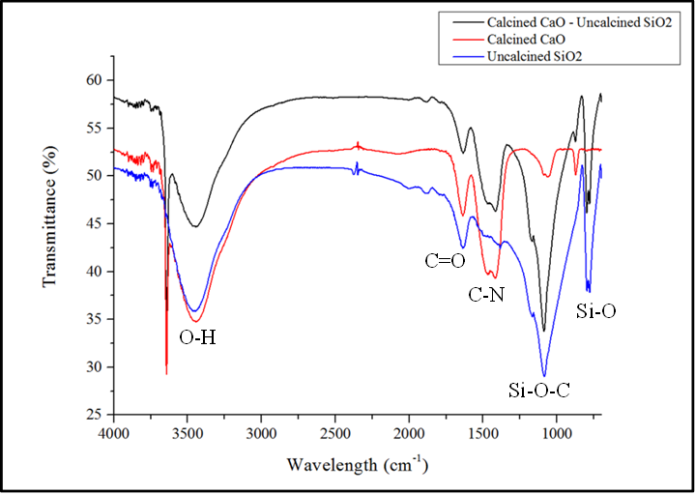

Figure 1. FTIR spectra of CaO-uncalcined SiO₂, Calcined CaO and Uncalcined SiO₂

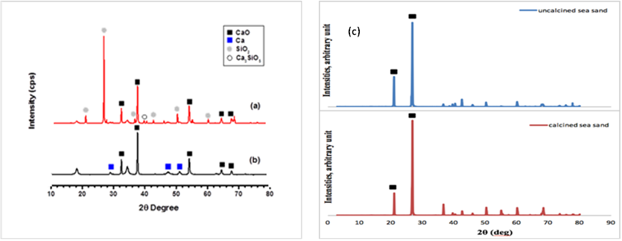

Figure 2. XRD patterns of (a) CaO-SiO₂ and (b) calcined CaO (c) Uncalcined and calcined SiO₂

Table 1. The Brunauer-Emmett-Teller (BET) result for calcined CaO and CaO-SiO₂
Characteristics | Calcined CaO | CaO-SiO₂
BET Surface Area (m²/g) | 9.11 | 2.73
Pore Volume (cm³) | 0.0358 | 0.0106
Pore Size (nm) | 15.7129 | 15.5863

Table 2. Elemental compositions of sea sand (before and after calcination)
Compounds | Percentage (%)
Compounds | Before Calcination | After Calcination
Silicon Dioxide | 43.37 | 37.64
Calcium Oxide | 2.51 | 2.38
Iron Oxide (Fe₂O₃) | 0.31 | 1.76
Aluminium Oxide (Al₂O₃) | 0.56 | 1.01
Phosphorus Pentoxide (P₂O₅) | 0.45 | 0.49

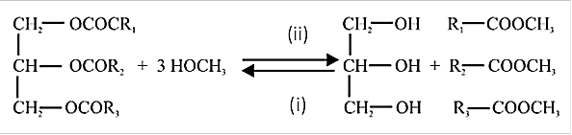

Scheme 1. Le Chatelier’s principle for the reaction of fatty acids and glycerol

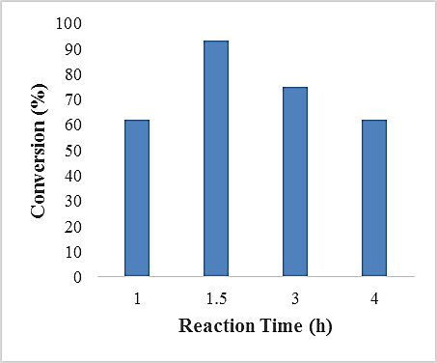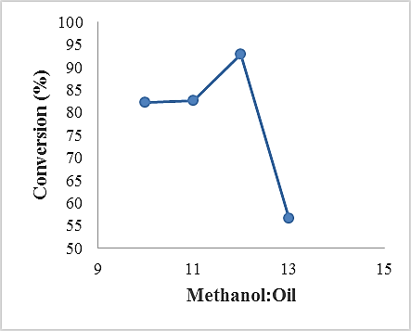
(a)
(b)

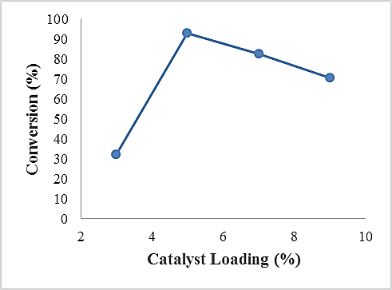
(c)
Figure 3. Effect of (a) reaction duration (b) methanol/oil molar ratio and (c) catalyst loading on the methyl ester yield

Conclusion

As a summary, heterogeneous catalyst from waste biomass, eggshell (CaO) and sea sand (SiO₂) were capable in producing methyl ester. Analyses using FTIR and XRF revealed successful preparation of CaOSiO₂ catalyst to assist the transesterification process of palm oil. It was reported that the prepared catalyst was able to produce 93.01% of methyl ester in 1 hour 30 minutes at 65 ± 3°C with MeOH/oil mass ratio of 12:1 and catalyst amount of 5 wt.%. This type of catalyst is a good potential than the existing catalyst for biodiesel production and more affordable as a cost-efficient and eco-friendly catalyst.

Acknowledgement

The authors would like to thank Ministry of Higher Education, Malaysia, Universiti Malaysia Pahang and Universiti Teknologi MARA Pahang for research project (600-TNCPI 5/3/DDN (06)(001/2020) and (FGRS/1/2019/STG01/UMP/02/2).

References
- Terhaar, J. Kwiatkowski, L. and Bopp, L. (2020). Emergent constraint on Arctic Ocean acidification in the twenty-first century, Nature, 582: 379-383.
- Bello, E. I. and Out, F. (2015). Physicochemical properties of rubber (Hevea brasiliensis) seed oil, its biodiesel and blends with diesel. British Journal of Applied Science & Technology, 6: 261-275.
- Sukiran, M. A., Abnisa, F., Daud, W. M. A. W., Bakar, N. A. and Loh, S. K. (2017). A review of torrefaction of oil palm solid wastes for biofuel production. Energy Conversion Management, 149: 101-120.
- Onoji, S. E., Iyuke, S. E., Igbafe, A. I. and Nkazi, D. B. (2016). Rubber seed oil: A potential renewable source of biodiesel for sustainable development in sub-Saharan Africa. Energy Conversion and Management, 110: 125-134.
- Syazwani, O. N., Teo, S. H., Islam, A. and Taufiq-Yap, Y. H. (2017). Transesterification activity and characterization of natural CaO derived from waste Venus clam (Tapes belcheri S.) material for enhancement of biodiesel production. Process Safety and Environmental Protection, 105: 303-315.
- Ngamcharussrivichai, C. P., Totarat, P. and Bunyakiat, K. (2008). Ca and Zn mixed oxide as a heterogeneous base catalyst for transesterification of palm kernel oil. Applied Catalysis A: General, 341: 77-85.
- Boey, P. L., Maniam, G. P. and Hamid, S. A. (2011). Performance of calcium oxide as a heterogeneous catalyst in biodiesel production: A review. Chemical Engineering Journal, 168: 15-22.
- Muthusamy, K., Nordin, N., Vesuvapateran, G., Ali, M., Mohd Annual, N. A., Harun, H. and Ullap, H. (2014). Exploratory study of rubber seed shell as partial coarse aggregate replacement in concrete. Research Journal of Applied Sciences, Engineering and Technology, 7: 1199-1202.
- Sanuzi, A. I., Tahir, S. M. and Khazaai, S. N. M. (2018) Clamshell and sea sand as heterogeneous catalysts for waste cooking oil-based biodiesel production via transesterification reaction. Malaysian Journal of Analytical Sciences, 22: 107-114.
- Mechri, M. L., Chihi, S., Mahdadi, N. and Beddiaf, S. (2017). Diagnosis of the heating effect on the electrical resistivity of Ouargla (Algeria) dunes sand using XRD patterns and FTIR spectra. Journal of African Earth Sciences, 125: 18-26.
- Jindapon, W., Jaiyen, S. and Ngamcharussrivichai, (2016). Seashell-derived mixed compounds of Ca, Zn and Al as active and stable catalysts for the transesterification of palm oil with methanol to biodiesel. Energy Conversion Management, 122: 535-543.
- Mutalib, A. A. A., Ibrahim, M. L., Matmin, J., Kassim, M. F., Sufri Mastuli, M., Taufiq-Yap, Y. H., Shohaimi, N. A. M., Islam, A., Tan, Y. H. and Kaus, N. H. M. (2020). SiO₂-rich sugar cane bagasse ash catalyst for transesterification of palm oil. Bioenergy Resources, 13: 986-997.
- Farooq, M., Ramli, A. and Subbarao, D. (2013). Biodiesel production from waste cooking oil using bifunctional heterogeneous solid catalysts. Journal of Cleaner Production, 59: 131-140.

- Boro, J., Thakur, A. J. and Deka, D. (2011). Solid oxide derived from waste shells of Turbonilla striatula as a renewable catalyst for biodiesel production. Fuel Processing Technology, 92: 2061-2067.

- Jaiyen, S., Naree, T. and Ngamcharussrivichai, (2015). Comparative study of natural dolomitic rock and waste mixed seashells as heterogeneous catalysts for the methanolysis of palm oil to biodiesel. Renewable Energy, 74: 433-440.

