
CO₂-EFFERVESCENT TABLET-ASSISTED DISPERSIVE LIQUID-LIQUID MICROEXTRACTION WITH CENTRAL COMPOSITE DESIGN FOR PRE-CONCENTRATION OF ACETAMINOPHEN DRUG: METHOD DEVELOPMENT, VALIDATION AND GREEN ASSESSMENT PROFILE

(Tablet Berbuak-CO₂ Berbantukan Sebaran Pengekstrakan Mikro Cecair-Cecair dengan Reka Bentuk Komposit Berpusat untuk Kepekatan Awalan Dadah Acetaminophen: Pembangunan Kaedah, Validasi dan Profil Penilaian Hijau)

Priya Murugan, Sarveishwhary Rajendran, Saw Hong Loh, Marinah Mohd Ariffin,
Wan Mohd Afiq Wan Mohd Khalik*

Faculty of Science and Marine Environment,
Universiti Malaysia Terengganu, 21030 Kuala Nerus, Malaysia

*Corresponding author: wan.afiq@umt.edu.my

Received: 15 April 2021; Accepted: 2 June 2021; Published: xx June 2021

Abstract
This study discovered the extraction procedure of acetaminophen from water samples using the effervescent tablet-assisted dispersive liquid-liquid microextraction (DLLME) method. The effervescent tablet that is composed of sodium dihydrogen phosphate (proton donor) and sodium carbonate (CO₂ source) was formulated using the wet granulation technique. In this study, high performance liquid chromatography coupled with ultraviolet visible detection (HPLC-UV) was used for qualitative and quantitative analysis of the targeted analyte. The chromatographic separation was conducted in less than 6 min (R_{t} 5.10 min) using a non-polar C₁₈ column and an isocratic elution (methanol: water of 40: 60 (v/v)) at a controlled flowrate of 1 mL min⁻¹. Optimum wavelength was set at 264 nm. Main variables that influenced the extraction efficiency namely the amount of extraction solvent (X₁), the number of tablets consumed (X₂) and the effect of extraction temperature (X₃) were tested during optimization work. Operation setting for extraction procedure was optimized using a 2³ full factorial central composite design, CCD (STATISTICA Version 10). The values of optimum extraction condition were set as 215 µL of extraction solvent, 5 pieces of tablets and 47 °C extraction temperature. Under optimal condition, a good linearity with determination coefficient R² = 0.995 was obtained. Extraction recoveries at spiked concentrations (500 ng mL⁻¹ and 100 ng mL⁻¹) were recorded ranging from 83% to 94.1%. The detection and quantification limits of the proposed method were calculated at 8.62 ng mL⁻¹ and 28 ng mL⁻¹, respectively. In terms of the precision method, the relative standard deviation was recorded ˂ 5%. Real analysis samples were performed, which fortified with commercial drugs dissolved in 80 mL of deionized water. The concentration levels were determined at 5.60 mg L⁻¹ (sample A) and 5.47 mg L⁻¹ (sample B) respectively.

Keywords: analgesic drug, CO₂-effervescence, central composite design, liquid phase microextraction

Abstrak
Kajian ini meneroka prosedur pengekstrakan bagi acetaminophen dari sampel air mengunakan kaedah tablet berbuak berbantukan sebaran pengekstrakan mikro cecair-cecair (DLLME). Tablet berbuak terdiri dari sodium dihidrogen fosfat (penderma proton) dan sodium karbonat (sumber CO₂) di formulasi mengunakan teknik penggranulan basah. Dalam kajian ini, kromatografi cecair berprestasi tinggi gabungan pengesan ultralembayung nampak (HPLC-UV) telah digunapakai bagi analisis kuantitatif dan kualitatif terhadap analit sasaran. Pemisahan kromatografi berlaku dalam masa kurang 6 min (R_{t} 5.10 min) mengunakan turus tak berkutub C₁₈ dan elusi isokratik (metanol: air 40:60 (v/v)) pada kawalan aliran 1 mL min⁻¹. Panjang gelombang optimum ditetapkan pada 264 nm. Pemboleh ubah utama yang mempengaruhi keberkesanan pengekstrakan seperti jumlah pelarut pengekstrak (X₁), bilangan tablet yang digunakan (X₂) dan kesan perubahan suhu (X₃) diuji semasa kerja pengoptimuman. Tetapan operasi bagi prosedur pengekstrakan bagi pengoptimuman mengunakan reka bentuk komposit berpusat, CCD (STATISTICA versi 10). Nilai yang diperolehi bagi keadaan optimum ialah pelarut pengekstrakan 215 µL, 5 biji tablet dan tetapan suhu 47 °C. Kelinearan yang baik dengan pekali regresi R² = 0.995 telah diperolehi pada keadaan optimum. Perolehan semula pengekstrakan pada kepekatan yang dipaku (500 ng mL⁻¹ dan 100 ng mL⁻¹) telah merekodkan nilai julat 83%-94.1%. Had pengesanan dan pengkuantitian bagi kaedah yang dibangunkan dihitung masing-masing pada 8.62 ng mL⁻¹ dan 28 ng mL⁻¹. Bagi aspek kejituan kaedah, sisihan piawai relatif telah direkodkan < 5%. Analisis sampel sebenar telah dijalakan dengan penambahan dadah komersial yang dilarut dalam 80 mL air ternyah ion. Kepekatan telah ditentukan masing-masing pada 5.60 mg L⁻¹ (sampel A) dan 5.47 mg L⁻¹ (sampel B).

Kata kunci: dadah analgesik, CO₂-berbuak, reka bentuk komposit berpusat, pengekstrakan mikro fasa cecair

Introduction
Effervescent reaction is one of the disperser-solvent-free techniques in DLLME. This novel work was first introduced by Lasarte-Aragones et al. [1] for the extraction of herbicides in water. Once the tablet is mixed with an aqueous solution, a simple reaction between the proton donor and carbon source (i.e. sodium carbonate) induces the formation of gas microbubbles (CO₂). The effervescence occurs from the bottom to top of the container and the extractant solvent is uniformly distributed [2]. This method accelerates the dispersion of the extraction solvent without additional energy. Large contact surface area between the target analyte and the extractant promotes mass transfer, which can vastly improve extraction efficiency [3]. Indeed, it reduces the partition coefficients of the hydrophobic analytes into the extraction solvent [4]. Other advantages include rapid, effective, reproducible, eliminating multi-stage operation, and low cost [2-6]. The effervescent tablets are easy to formulate because the proton donor, and carbon source are all solid substances that can be simply mixed and compressed using a tablet machine. The extraction solvent functions as a binder when it solidifies at low temperature.

Microextraction method uses effervescence reaction generated by a tablet for preconcentration of drugs include antibiotics [7, 8], nonsteroidal anti-inflammatories [9], steroid hormones [10], and stimulants [11]. Selection of extraction solvents varies from supramolecular to switchable hydrophilicity solvents. Supramolecular solvent is relatively cheap, low freezing points, and less volatile which has recently been used in microextraction especially for the effervescence method [12]. Meanwhile, switchable hydrophilicity solvents offer tunable properties like miscible liquid or biphasic mixture with water and easily ionized by adjustment the pH values [13, 14]. The extraction solvent can be efficiently dispersed into the aqueous sample owing to the use of effervescent tablets, which improves the effective mass transfer of target analytes, and reflects through high enrichment factors [15]. The extraction process needs a shorter time to complete and the utilization of extractant is always minimal.

Acetaminophen (N-acetyl-p-aminophenol; C₈H₉NO₂) is a mild analgesic that is effectively used to treat headaches, minor aches or pains [16]. This drug is considered as a first-line therapy due to its relatively low adverse side effects, efficacy and low price [17]. It has been reported that human urine excretes 58-68% of acetaminophen, a considerable low concentration of residue but frequently detected in the municipal wastewater systems, ranging between ng L⁻¹ to µg L⁻¹ [18, 19]. Development of the microextraction method for the preconcentration of acetaminophen drugs from waters includes solid phase (i.e., fiber coating, in-tube, molecularly imprinted polymer) or liquid phase (i.e., hollow fiber, dispersive) [20-24]. In the present work, dispersive liquid-liquid microextraction with the acceleration of dispersion mode by effervescent tablets was aimed for the extraction of acetaminophen (analgesic drug) in the water samples. To construct the experimental work, a full factorial central composite design was applied to optimize the microextraction procedure. Method validation and green profile assessment were also carried out.

Materials and Methods
Reagents and materials
Acetaminophen standard was purchased from Sigma-Aldrich (St. Louis, USA) with purity of 98%. HPLC-grade acetonitrile and methanol were purchased from Merck (Darmstadt, Germany). Analytical-grade sodium bicarbonate, sodium hydrogen phosphate, glycerin, 1-dodecanol were acquired from Merck. Due to its high enrichment factors and low price, 1-dodecanol was chosen as the extractant. Stock standard solution was initially prepared in methanol with a concentration of 5 µg mL⁻¹ and stored in the dark at 4 °C. The working standard solutions of the acetaminophen drug were prepared by appropriate dilution of the stock standard solution with methanol. The purified deionized water was obtained from a Millipore Milli-Q reference water purification system that has a resistivity of 18.2 MΩ.cm at 25 °C (Bedford, MA, USA). An analytical balance 210G/D.1MG HC-A Smith Model HC-A 210 was used for weighing. A stainless-steel tablet machine (Henan, China) was used to prepare the flat face radius edge effervescent tablets.

Instrumental and analytical conditions
HPLC–UV analysis was performed using a Shimadzu HPLC system (Kyoto, Japan) equipped with an autosampler (SIL-20A HT), vacuum degasser (DGU-20A 5R), system controller (LC-20AT), quaternary pump (LC-10ATVP), oven (CTO-10AS VP), and series multiple wavelength UV detector (SPD-20A). An Apollo C₁₈ column (250 mm x 4.6 mm, 5 µm Hichrom Limited) was used for the separation. The mobile phase was a mixture of methanol-water (40:60 v/v) at a flow rate of 1 mL min⁻¹, and the column temperature was held at 30 °C. The UV detection wavelength was set at 264 nm. The injection volume was set at 10 μL per analysis. Peak identification was observed in less than 6 min (Figure 1). Shimadzu Class VP version 6.41 SP1 software was used to control the HPLC–UV system and to perform the data analysis.

Preparation of the effervescent tablet
In this study, the effervescent tablets were produced using the wet granulation method. Sodium bicarbonate and sodium hydrogen phosphate salt (effervescence precursors), glycerin (binder) and 1-dodecanol (extraction solvent) were formulated in a tablet form. The effervescent precursors were dried in an oven at 60 °C overnight before mixing the materials. Sodium bicarbonate (1.0 g) and sodium hydrogen phosphate (1.0 g) salt were weighed into a glass mortar, and sufficiently ground to achieve homogeneous mixing. Then, a few drops of glycerin and a desired volume of 1-dodecanol (X₁) were added into the mixture. The homogenous mixture was transferred into a tablet mold with the dimension of 2.5 cm × 3.7 cm and subsequently compressed for 60 s to produce an effervescent tablet using a tablet press hammer. The effervescent tablets (dimension 2.5 cm (width) × 3.7 cm (height)) were stored in a 30 mL plastic bottle with a screw cap at 4°C to maintain the tablets’ shape.

Physical and chemical analysis
The morphology of effervescent tablet was observed using a Jeol JSM-6360LV (Tokyo, Japan) scanning electron microscope (SEM). The scanning electron microscope operated at an accelerating voltage of 10 kV with a probe current of ≈ 1 pA - 1 µA having a resolution of 3.0 nm. Prior to examination, the effervescent tablet was prepared by mounting approximately 0.1 to 1.0 g of powder onto a 10 mm × 10 mm SEM specimen aluminum stub via double-sided adhesive tape to permit a quick mounting of samples on a stub. The effervescent tablet was made electrically conductive by coating it with a thin layer of gold about 30 µm thickness using an auto fine coater (Jeol JFC-1600, Japan). The samples were coated for 60 s at a beam current of 30 mA. Attenuated total reflectance Fourier transform infrared (ATR-FTIR) Shimadzu IRTracer-100, (Kyoto, Japan) spectra equipped with a temperature controlled DLATGS detector were applied to study the occurrence of different functional groups in effervescent tablets. The spectra were recorded in transmittance mode at 40 scans and a resolution of 4 cm⁻¹ over the wavenumber region ranging between 4000 cm⁻¹ to 400 cm⁻¹.

Microextraction procedure
Eighty mL of water sample was transferred in a 150 mL glass volumetric flask prior spiked with 1 mL of working standard solution. Then, the flask was placed in a water bath and the water temperature was adjusted to the desired setting (X₃) as listed in Table 1. Once the temperature was achieved, the effervescent tablet was released into water samples and the ETA-DLLME was implemented. Number of the effervescent tablet (X₂) used was subject to design matrix. The effervescent tablets disintegrated in the aqueous solution when microbubbles started to form due to the releasing of CO₂ gas. The reaction was considered complete once no microbubbles were released from the tablet. Next, the top organic phase containing analyte was collected using a 1 mL syringe and placed into a 3 mL microcentrifuge tube. The extracted solution was centrifuged for 1 min at 3000 rpm. Then, the organic phase, 1-dodecanol was mixed with 1 mL of HPLC grade methanol prior injected into a HPLC-UV system.

Central composite design
Three variables, namely volume of extraction solvent (X₁), number of effervescent tablets (X₂), and extraction temperature (X₃), were subjected to optimization in this study (Table 1). A 2³ full factorial design of CCD was generated with STATISTICA version 10 (TIBCO software, Germany). For optimization of extraction conditions, peak area was used in the data processing. Profiling the desirability of responses involved specifying DF for each dependent variable, by assigning predicted values a scale ranging from 0.0 to 1.0 [25]. Three-dimensional graphs were used to evaluate the interactive effect of two variables on the response.
Method validation
The analytical figure of merits is investigated in terms of linearity, detection limit, recovery, and repeatability. A calibration curve was obtained by a series of 6 standard solutions ranging from 0.01 to 0.50 µg mL⁻¹ spiked into water samples. Detection and quantification limits were calculated using the linear regression method. The lowest concentration spiked was 0.01 µg mL⁻¹, and triplicate analysis was performed. The precision was evaluated through the repeatability (intra-day) and (inter-day) assay of the method with water samples spiked with acetaminophen. Both assays were calculated as %RSD with respect to the measurements made in triplicate (n=3). Extraction recovery was calculated by the following mathematical expression in equation 1:

$ER=EF x \frac{V_{org}}{V_{aq}} x 100\%$ (1)

where V_{Org}, and V_{aq} are the volume of acetaminophen in organic and aqueous phases, respectively. EF is calculated value from ratio between concentration of acetaminophen in organic phase and in aqueous phase, respectively.

Green assessment profile
The green profile of the proposed method was tested subject to analytical eco-scale and AGREE tools. Analytical eco-scale is a semi-quantitative tool, in which the calculation is based on maximum score of 100. Penalty points were subtracted from a base 100 for non-green aspects, which were linked to four parameters, namely amount of reagent used, hazardousness, energy consumption, and waste production. Eco-scale score was classified as ideal (100), excellent (> 75), acceptable (50-75) and inadequate (< 50), respectively [26-28]. AGREE: Analytical Greenness Calculator v. 0.5 beta (Universidade de Vigo, Gdańsk University of Technology) downloaded from https://mostwiedzy.pl/ en/wojciech-wojnowski,174235-1/AGREE. The evaluation metrics were extracted from the 12 principles of green analytical chemistry and converted score into a unified 0-1 scale. The overall score is depicted in the center of the pictogram, with values close to 1 and dark green color indicating that the evaluated method is
greener. Through this metric, highlighting the weakest points in analytical techniques that require further improvements in terms of greenness is possible [29, 30].

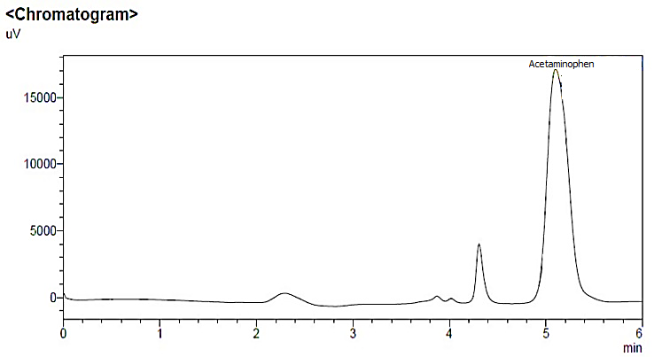
Figure 1. Peak identification of acetaminophen using standard spiked in water sample (Rt 5.10 min)

Table 1. Experimental variable and their levels

Parameter | Code | Unit | Range
Effect of extraction solvent | X₁ | µL | 132 – 468
Effect number of tablets | X₂ | Pieces | 1 – 5
Effect of temperature | X₃ | °C | 13 – 47

Parameter | -α | -1 | 0 | +1 | +α
Extraction solvent (X₁) | 132 | 200 | 300 | 400 | 468
Number of tablets (X₂) | 1 | 2 | 3 | 4 | 5
Temperature (X₃) | 13 | 20 | 30 | 40 | 47

Results and Discussion
Physical and chemical characterization
Under varied magnification, the rough surface was imaged link to the presence of both salt (citric acid and sodium bicarbonate) even after grind to produce small particles. In addition to extraction solvent, the precursor composition seemed agglomerate compared to auxiliary blank tablet samples, observed at x 100 magnification (Figure 2). Solidification of tablets in low temperature helped to compress the structure of effervescent tablet and provide good surface area. Tablets made by the wet granulation method well coated with a binder had a smaller number of void spaces in matrix structures. The targeted functional groups such as single C-O stretching (1043 cm⁻¹), O-H stretching (3236 cm⁻¹) and CH₂ (2930 cm⁻¹) were observed in spectra but the intensity of the main peaks was kept at medium. Band assignment was compared to literature documented by Zeng et al. [31] Thus, the appearance of main functional group for 1-dodecanol prove that the solution did not lose properties during wet granulation.

Method development: Microextraction procedure
The linear, interaction, and quadratic effects were optimized and evaluated using central composite design. A P-value in the ANOVA table indicates the statistical significance of an effect at 95% confidence level (Table 2). The second order polynomial regression equation gained for the optimized parameters is shown by Equation (2).

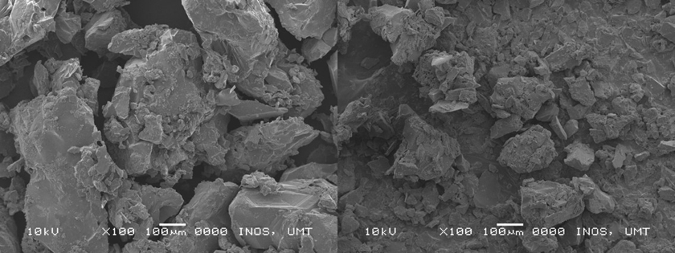
Figure 2. Morphology of surface tablet under x100 magnification (a) precursor only and (b) 1-dodecanol

Table 2. The analysis of variance (ANOVA) for the second-order regression model
Factor | SS | df | MS | F | P
Extraction solvent (L) | 22816 | 1 | 22816 | 6.050 | 0.049*
Extraction solvent (Q) | 10734 | 1 | 10734 | 2.846 | 0.142
No. of tablet (L) | 3899 | 1 | 3899 | 1.034 | 0.348
No. of tablet (Q) | 591 | 1 | 591 | 0.156 | 0.705
Effect of temperature (L) | 13368 | 1 | 13368 | 3.545 | 0.108
Effect of temperature (Q) | 16237 | 1 | 16237 | 4.306 | 0.038*
1L by 2L | 3087 | 1 | 3087 | 0.818 | 0.400
1L by 2L | 12276 | 1 | 12276 | 3.255 | 0.121
2L by 3L | 702 | 1 | 702 | 0.186 | 0.681
Error | 22625 | 6 | 37708
Total SS | 100641 | 15
L is linear, Q is quadratic, *p-value ˂0.05

Peak height = 57.34 + 0.41X₁ + 177.09X₂ - 23.49X₃ + 0.01X₁² + 25.26X₂² + 1.32X₃² - 0.62X₁X₂ -
0.12X₁X₃ - 2.96X₂ X₃ (2)

Variables namely extraction solvent (X₁) and number of tablets (X₂) have positive linearity values in the regression model. A positive symbol in front of terms denotes a synergistic effect, while a negative symbol represents an antagonistic effect. The optimization plot (Figure 3) showed the predicted conditions for the optimum point and desirability of prediction. The R² statistic indicated that the model explained 88% of the variability. R² is a calculation of the sum of variance around the mean explained by the model [32]. In this model, a desirability function of 1.0 was recorded. The desirability of 1 was assigned for maximum response of peak height (1145), 0.5 for middle (196), and 0 for minimum (140). In this study, the lack-of-fit recorded P-value of 0.049, indicated that the lack-of-fit in the model is not significantly relative to pure error, good predictive model. The optimum variables for the extraction procedure were proposed by the model as follows: volume of extraction solvent, X₁ (215 µL), effect of temperature, X₂ (47 °C), and number of tablets, X₃ (5 pieces), respectively. The total contribution of each variables on the extraction yield of acetaminophen was calculated at 56.93% (X₁), 33.36% (X₂) and 9.73% (X₃), respectively.

The normal probability plot demonstrated in Figure 4 signifies the values towards a constant straight line, which demonstrated normal distribution and no evidence of non-normality, skewness, outlier, or undefined variable. The dot (refer as datasets) present along the straight line indicated the ideal fitting of the modal, meanwhile the data deviated from the straight line was the least. The graph describes that the consistency of the variance in errors through equal scatter of the residual data close to 0 value on the y-axis. Residual is the vertical distance between data point and regression line. Each data point has one residual. The point is positive when it lies above the regression line and it is negative when it lies below the regression line. There is no discernible trend in the residual versus predicted response (Figure 5).

Effect volume of extraction solvent
Acetaminophen has low log K_{ow} 0.46, a relative indicator of high solubility in water. Although paracetamol is soluble in alcohols, its solubility decreases as the length of the carbon chain increases [33]. The immiscible property of 1-dodecanol in water helps the extraction of acetaminophen from an aqueous to organic phase. The acetaminophen molecules were extracted by the extraction solvent due to the hydrophobic interaction. The effect of the 1-dodecanol volume was investigated in the range of 132 - 468 µL. The effect on the volume of extraction solvent was dominant than the number of tablets. The extractant could not well disperse in the sample solution due to the low volume, so 1-dodecanol was added sufficiently to aid the mass transfer of analyte to complete the extraction. Other leverage of 1-dodecanol can form a biphasic system with methanol, and the target compound peak is unaffected during chromatographic analysis [34]. Surface shown in Figure 6 shows that the maximum point is outside the range studied, its recommended to re-run the experimental work. Nonetheless, additional experiment performed reveals the volume of extraction solvent has no significant difference in the range of 400-500 µL. The percentage of contribution for extraction solvent versus the number of tablets consumed in the study was calculated at 56.93%.

Effect number of tablets
Sodium dihydrogen phosphate and sodium bicarbonate were selected as proton donor and carbon dioxide source, respectively. With a sufficient number of effervescent tablets added into the aqueous sample, it can produce a larger amount of bubbles, which helps the acceleration of the targeted analyte towards the upper phase of the solution. The production of CO₂ microbubbles with gentle release creates good contact time between microbubbles and organic droplet, 1-dodecanol. The in-situ production of CO₂ microbubbles is responsible for breaking down the emulsion and promoting the phase separation process. Bicarbonate has shorter effervescence time [35], thus consumption of the five tablets seemed suitable to complete the extraction. The percentage of contribution by the number of tablets in the extraction process of acetaminophen was calculated at 9.73% (Figure 7).

Effect adjustment of temperature
A suitable temperature can allow the extraction solvent (1-dodecanol) to be fully dispersed into the aqueous solution and ensure a rapid acceleration of acetaminophen (mobility of analyte) from water phase into the extraction solvent. The percentage of contribution by the effect of water temperature towards the extraction efficiency was calculated at 33.36% (Figure 8). There is no significance on this relationship, but temperature must be maintained above 24 °C to hold the solvent in liquid form. For 1-dodecanol, the melting point near the room temperature (24 °C), tunable properties make easier change from liquid to solid or vice versa. Extractant droplets can be easily collected after solidifying at low temperatures due to their tunable properties. The floated extraction solvent (d = 0.8309 g·mL⁻¹) was much easier to collect and the extract was cleaner, compared to high density solvent. Besides, solidified floating phase was easily transferred, which avoided the loss of the analyte ensuring a high precision.

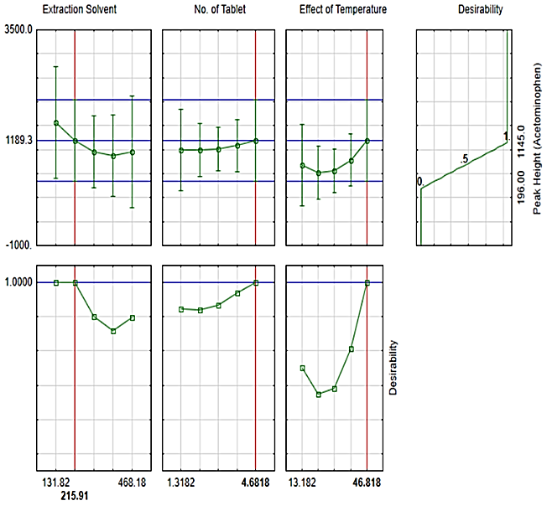
Figure 3. Optimizer plots for variables studied

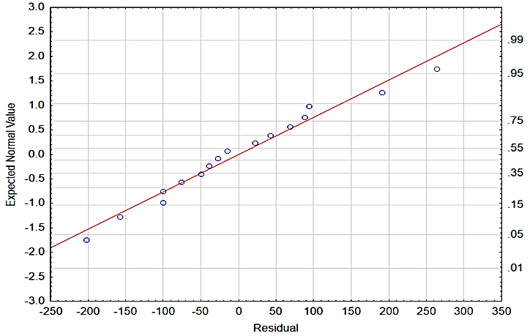
Figure 4. The normal probability plot

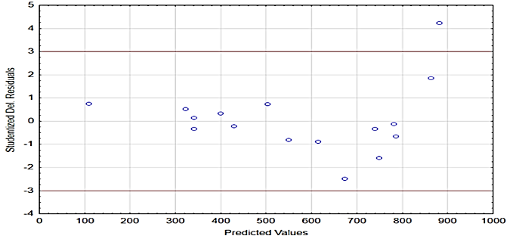

Figure 5. The residuals versus fitted data set

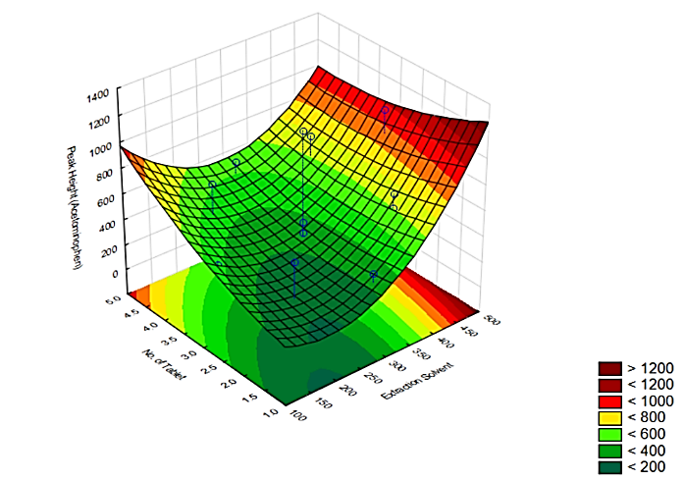

Figure 6. The 3D response shows the relationship between the number of tablet vs the extraction solvent

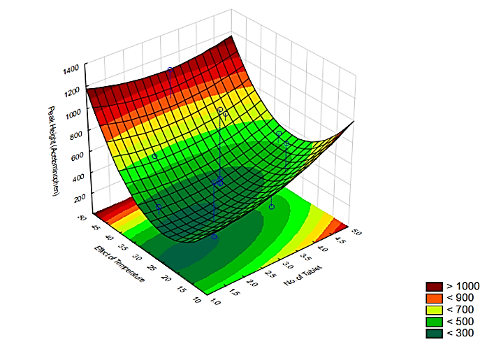

Figure 7. The 3D response shows the relationship between the effect of the temperature vs the number of tablets

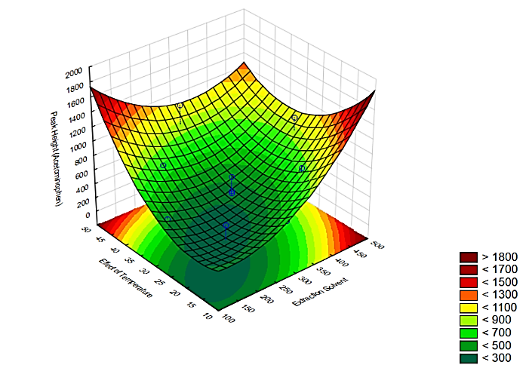
Figure 8. The 3D response shows the relationship between the effect of temperature vs the extraction solvent

Validation of the proposed method
A good linearity range was achieved at a satisfactory level of R² ≥ 0.995 (Table 3). The sensitivity of the proposed method was shown by calculating the limit of detection and quantification (LOD and LOQ), which were recorded at 0.008 µg mL⁻¹ and 0.028 µg mL⁻¹, respectively. Good extraction recovery of 85%-94% was recorded when two concentrations of spiked acetaminophen (500 and 100 ng mL⁻¹) were introduced into the matrix samples. Recovery of the proposed method was comparable with other liquid phase microextraction such as hollow fiber (96.8-127.8%), and dispersive using ionic liquid (95-96%), respectively [20-21]. The repeatability test indicated low bias measurement (i.e., <5% RSD), which was below the acceptable value proposed by AOAC guidelines.

Green assessment profile
The proposed method was a green methodology, which falls under excellent score (Table 4). On the eco-scale it recorded a high score of 88 and used low energy, either for extraction or chromatographic analysis. The deduction point was attributed by consumption of a reagent (methanol, dodecanol, glycerin), instrument and waste generation post analysis. The AGREE metric score of the proposed method was 0.65 (Figure 9). The AGREE metric showed that the proposed microextraction procedure was a green method based on criteria such as (4) integration of analytical processes for synchronous step (preparation, extraction and retrieval), (6) no derivatization agent used during extraction and analysis (7) minimal waste generation post analysis (8) high number of consecutive samples that can be analyzed in one hour due to reach fast equilibrium phase, (11) consumption of less toxic reagents and (12) minimal threats to operator and environment due to reagent used. Two criteria namely (2) minimal sample size and (3) in-situ measurement represented by red color received a low score. Thus, improvement on both criteria may be considered for future works.

Table 3. Analytical performance of extraction method
Analytical Assay | Figure of Merit
Linearity, r² | 0.995
LOD (µg mL⁻¹) | 0.008
LOQ (µg mL⁻¹) | 0.028
ER, % | 85-94
RSD (Intra-day), n = 3 | 0.70-1.02
RSD (Inter-day), n = 3 | 0.95-1.42
Real sample (µg mL⁻¹) | Fortified with brand A (5.60)
Real sample (µg mL⁻¹) | Fortified with brand B (5.47)

Table 4. The penalty points calculated for the proposed method
Assessment Criteria | Sub-Criteria | Consumption | Penalty Points
Reagents | Type (Hazard)
 | Methanol (3) | 10-100 mL | 6
 | 1-dodecanol (2) | < 10 mL | 2
 | Glycerin (1) | < 10 mL | 1
 | Sodium bicarbonate (1) | < 10 g | 1
 | Sodium hydrogen phosphate (0) | < 10 g | 0
Instruments | Energy
 | HPLC-UV |  | 1
 | Occupational hazard |  | 0
Waste |  | < 1 mL | 1
Total Penalty Point |  |  | 12
Eco-scale score |  |  | 88

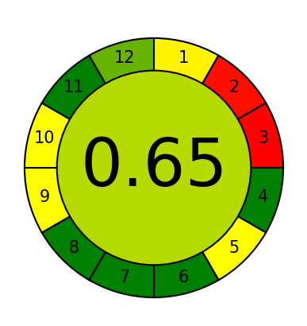
Figure 9. Generic result of AGREE assessment for the proposed method

Conclusion
The research work illustrated the successful application of the dispersive liquid-liquid microextraction combined with the effervescent tablet as a dispersive agent. The optimized method shows good performance to extract acetaminophen drugs in water samples at low-level concentration. This work provides some benefits in terms of method performance, including the short time required for sample preparation, extraction, and instrumental analysis. Low bias values obtained in calculated data suggest that the method is comparable to other developed liquid phase microextraction methods. It is worth to note that the method seems suitable for routine analysis. Analytical eco-scale and AGREE metric score have given concrete evidence about the greenness profile of the proposed method.

Acknowledgements
The authors acknowledge the Ministry of Higher Education, Malaysia and Universiti Malaysia Terengganu for providing financial support under the research grant FRGS/1/2019/STG01/UMT/03/3 (Vot 59585).

References
- Lasarte-Aragonés, G., Lucena, R., Cárdenas, S. and Valcárcel, M. (2014). Effervescence assisted dispersive liquid–liquid microextraction with extractant removal by magnetic nanoparticles. Analytica Chimica Acta, 807: 61-66.
- Jiang, W., Chen, X., Liu, F., You, X. and Xue, J. (2014). Effervescence‐assisted dispersive liquid–liquid microextraction using a solid effervescent agent as a novel dispersion technique for the analysis of fungicides in apple juice. Journal of Separation Science, 37(21): 3157-3163.
- Piao, H., Jiang, Y., Qin, Z., Tao, S., Ma, P., Sun, Y. and Song, D. (2020). Development of a novel acidic task-specific ionic liquid-based effervescence-assisted microextraction method for determination of triazine herbicides in tea beverage. Talanta, 208: 120414.
- Shishov, A., Sviridov, I., Timofeeva, I., Chibisova, N., Moskvin, L. and Bulatov, A. (2017). An effervescence tablet-assisted switchable solvent-based microextraction: On-site preconcentration of steroid hormones in water samples followed by HPLC-UV determination. Journal of Molecular Liquids, 247: 246-253.
- Wang, X., Wu, L., Cao, J., Hong, X., Ye, R., Chen, W. and Yuan, T. (2016). Magnetic effervescent tablet-assisted ionic liquid dispersive liquid–liquid microextraction of selenium for speciation in foods and beverages. Food Additives & Contaminants: Part A, 33(7): 1190-1199.
- Zhou, P., Zheng, R., Zhang, W., Liu, W., Li, Y., Wang, H. and Wang, X. (2019). Development of an effervescent tablet microextraction method using NiFe₂O₄-based magnetic nanoparticles for preconcentration/extraction of heavy metals prior to ICP-MS analysis of seafood. Journal of Analytical Atomic Spectrometry, 34(3): 598-606.
- Vakh, C., Pochivalov, A., Andruch, V., Moskvin, L. and Bulatov, A. (2016). A fully automated effervescence-assisted switchable solvent-based liquid phase microextraction procedure: liquid chromatographic determination of ofloxacin in human urine samples. Analytica Chimica Acta, 907: 54-59.
- Gao, M., Wang, J., Song, X., He, X., Dahlgren, R. A., Zhang, Z. and Wang, X. (2018). An effervescence-assisted switchable fatty acid-based microextraction with solidification of floating organic droplet for determination of fluoroquinolones and tetracyclines in seawater, sediment, and seafood. Analytical and Bioanalytical Chemistry, 410(11): 2671-2687.
- Fadzil, F. N. I. M., Loh, S. H., Ariffin, M. M. and Khalik, W. M. A. W. M. (2020). Development of effervescent-assisted liquid phase microextraction using 1-dodecanol for determination of ketoprofen drug in water. ASM Science Journal, 13: 1-8.
- Shishov, A., Gerasimov, A., Nechaeva, D., Volodina, N., Bessonova, E. and Bulatov, A. (2020). An effervescence-assisted dispersive liquid–liquid microextraction based on deep eutectic solvent decomposition: Determination of ketoprofen and diclofenac in liver. Microchemical Journal, 156: 104837.
- Tazulazhar, N., Loh, S. H., Ariffin, M. M. and Khalik, W. M. A. W. M. (2021). Optimization of effervescent tablet-assisted dispersive liquid-liquid microextraction with central composite design for preconcentration of stimulant drug. Sains Malaysiana, 50(1): 109-121.
- Liu, X., Shen, Z., Wang, P., Liu, C., Zhou, Z. and Liu, D. (2014). Effervescence assisted on-site liquid phase microextraction for the determination of five triazine herbicides in water. Journal of Chromatography A, 1371: 58-64.
- Moghadam, A. G., Rajabi, M., Hemmati, M. and Asghari, A. (2017). Development of effervescence-assisted liquid phase microextraction based on fatty acid for determination of silver and cobalt ions using micro-sampling flame atomic absorption spectrometry. Journal of Molecular Liquids, 242: 1176-1183.
- Jing, X., Cheng, X., Zhao, W., Wang, H. and Wang, X. (2020). Magnetic effervescence tablet-assisted switchable hydrophilicity solvent-based liquid phase microextraction of triazine herbicides in water samples. Journal of Molecular Liquids, 306: 112934.
- Medinskaia, K., Vakh, C., Aseeva, D., Andruch, V., Moskvin, L. and Bulatov, A. (2016). A fully automated effervescence assisted dispersive liquid–liquid microextraction based on a stepwise injection system. Determination of antipyrine in saliva samples. Analytica Chimica Acta, 902: 129-134.
- Villaroel, E., Silva-Agredo, J., Petrier, C., Taborda, G. and Torres-Palma, R. A. (2014). Ultrasonic degradation of acetaminophen in water: effect of sonochemical parameters and water matrix. Ultrasonics Sonochemistry, 21(5): 1763-1769.
- Montaseri, H. and Forbes, P. B. (2018). Analytical techniques for the determination of acetaminophen: A review. TrAC Trends in Analytical Chemistry, 108: 122-134.
- Lima, D. R., Hosseini-Bandegharaei, A., Thue, P. S., Lima, E. C., de Albuquerque, Y. R., dos Reis, G. S., and Tran, H. N. (2019). Efficient acetaminophen removal from water and hospital effluents treatment by activated carbons derived from Brazil nutshells. Colloids and Surfaces A: Physicochemical and Engineering Aspects, 583: 123966.
- Mashayekh-Salehi, A., Moussavi, G. and Yaghmaeian, K. (2017). Preparation, characterization and catalytic activity of a novel mesoporous nanocrystalline MgO nanoparticle for ozonation of acetaminophen as an emerging water contaminant. Chemical Engineering Journal, 310: 157-169.
- Salvatierra-stamp, V., Muñiz-Valencia, R., Jurado, J. M. and Ceballos-Magaña, S. G. (2018). Hollow fiber liquid phase microextraction combined with liquid chromatography-tandem mass spectrometry for the analysis of emerging contaminants in water samples. Microchemical Journal, 140: 87-95.
- Yao, C., Li, T., Twu, P., Pitner, W. R. and Anderson, J. L. (2011). Selective extraction of emerging contaminants from water samples by dispersive liquid–liquid microextraction using functionalized ionic liquids. Journal of Chromatography A, 1218(12): 1556-1566.
- Yu, H., Merib, J. and Anderson, J. L. (2016). Faster dispersive liquid-liquid microextraction methods using magnetic ionic liquids as solvents. Journal of Chromatography A, 1463: 11-19.
- Moeder, M., Schrader, S., Winkler, M. and Popp, P. (2000). Solid-phase microextraction–gas chromatography–mass spectrometry of biologically active substances in water samples. Journal of Chromatography A, 873(1): 95-106.
- Moliner-Martínez, Y., Prima-Garcia, H., Ribera, A., Coronado, E. and Campíns-Falcó, P. (2012). Magnetic in-tube solid phase microextraction. Analytical Chemistry, 84(16): 7233-7240.
- Asati, A., Satyanarayana, G. N. V. and Patel, D. K. (2017). Comparison of two microextraction methods based on solidification of floating organic droplet for the determination of multiclass analytes in river water samples by liquid chromatography tandem mass spectrometry using central composite design. Journal of Chromatography A, 1513: 157-171.
- Gałuszka, A., Migaszewski, Z. M., Konieczka, P. and Namieśnik, J. (2012). Analytical eco-scale for assessing the greenness of analytical procedures. TrAC Trends in Analytical Chemistry, 37: 61-72.

- Mohamed, H. M. and Lamie, N. T. (2016). Analytical eco-scale for assessing the greenness of a developed RP-HPLC method used for simultaneous analysis of combined antihypertensive medications. Journal of AOAC International, 99(5): 1260-1265.
- Tobiszewski, M., Marć, M., Gałuszka, A. and Namieśnik, J. (2015). Green chemistry metrics with special reference to green analytical chemistry. Molecules, 20(6): 10928-10946.
- Pena-Pereira, F., Wojnowski, W. and Tobiszewski, M. (2020). AGREE—Analytical GREEnness Metric Approach and Software. Analytical Chemistry, 92(14): 10076-10082.
- Gamal, M., Naguib, I. A., Panda, D. S. and Abdallah, F. F. (2021). Comparative study of four greenness assessment tools for selection of greenest analytical method for assay of hyoscine N-butyl bromide. Analytical Methods, 13(3): 369-380.
- Zeng, H., Qiao, K., Li, X., Yang, M., Zhang, S., Lu, R. and Zhou, W. (2017). Dispersive liquid–liquid microextraction based on the solidification of deep eutectic solvent for the determination of benzoylureas in environmental water samples. Journal of Separation Science, 40(23): 4563-4570.
- Khodadoust, S. and Ghaedi, M. (2013). Optimization of dispersive liquid–liquid microextraction with central composite design for preconcentration of chlordiazepoxide drug and its determination by HPLC‐UV. Journal of Separation Science, 36(11): 1734-1742.
- Granberg, R. A. and Rasmuson, Å. C. (1999). Solubility of paracetamol in pure solvents. Journal of Chemical & Engineering Data, 44(6): 1391-1395.
- Ojeda, C. B. and Rojas, F. S. (2011). Separation and preconcentration by dispersive liquid–liquid microextraction procedure: recent applications. Chromatographia, 74(9-10): 651.
- Jafarinejad, M., Ezoddin, M., Lamei, N., Abdi, K., Babhadi‐Ashar, N., Pirooznia, N. and Akhgari, M. (2020). Effervescent tablet‐assisted demulsified dispersive liquid–liquid microextraction based on solidification of floating organic droplet for determination of methadone in water and biological samples prior to GC‐flame ionization and GC‐MS. Journal of Separation Science, 43(16): 3266-3274.

