

SIMPLE METHOD DETERMINATION OF SATURATED AND UNSATURATED FATTY ACIDS SOURCES FOR DIESEL-BIODIESEL BLENDS

(Kaedah Mudah untuk Penentuan Sumber Asid Tepu dan Taktepu bagi Campuran Diesel-Biodiesel)

Nurul Hazwah Mohd Kamarulzaman¹, Siti Norhafiza Mohd Khazaai^{1,2}*, Muhammad Nor Fazli Abd Malek¹,

Mohd Hasbi Ab. Rahim¹, Gaanty Pragas Maniam^{1,3}

¹Faculty of Industrial Sciences & Technology,

Universiti Malaysia Pahang, Lebuhraya Tun Razak, 26300 Gambang, Kuantan, Pahang, Malaysia

²Faculty of Applied Sciences,

Universiti Teknologi MARA Pahang, 26400 Jengka, Pahang, Malaysia

³Biotropic Centre Laboratory,

Universiti Malaysia Pahang, Lebuhraya Tun Razak, 26300 Gambang, Kuantan, Pahang, Malaysia

*Corresponding author: ctnorhafiza03@yahoo.com

Received: 30 April 2021; Accepted: 6 June 2021; Published: xx June 2021

Abstract

Biodiesel is one of the fuel alternatives made from vegetable oils and animal fats that have low emission and biodegradable profiles that are currently being used to reduce pollutions. The optimum parameters for alkali-catalyzed transesterification is 1.5 wt.% of catalyst within 2 hours at 65 ℃, molar ratio methanol to the oil of 9:1. A series of diesel-biodiesel blends of B5, B7, B10, B15 and B20 was prepared by mixing the pure diesel with biodiesel produced. Each of the blends was analyzed using UV-Visible spectroscopy to identify and differentiate the absorbance of the blends. The characterization of diesel-biodiesel (acid value, peroxide value, density, viscosity, moisture content, flash point and refractive index) was performed according to the ASTM method. The UV-Vis analysis of saturated fatty acid and unsaturated fatty acid was compared to prove the suitability of the method used. All the parameters values for the blends meet the requirement of the American Standard Testing Material (ASTM) D6751 except for the moisture content. Rapid determination of blending for both types of fatty acids by UV-Vis analysis was obtained. This may benefit the related industries as well as monetary gain in countering any false claim on the percentage blend with a simple and low-cost method.

Keywords: biodiesel, UV-Vis analysis, rapid analysis

Abstrak

Biodiesel merupakan salah satu alternatif bahan bakar yang diperbuat daripada minyak sayuran dan lemak haiwan yang mempunyai tahap penyingkiran yang rendah dan profil biodegradasi bagi mengurangkan pencemaran. Parameter optimum bagi transesterifikasi bermangkin alkali adalah 1.5 wt.% mangkin dalam masa 2 jam pada suhu 65 ℃, dan nisbah metanol kepada minyak ialah 9:1. Suatu siri campuran diesel-biodiesel B5, B7, B10, B15 dan B20 telah disediakan dengan mencampurkan diesel dengan biodiesel yang terhasil. Setiap campuran tersebut dianalisa dengan menggunakan spektroskopi Ultralembayung-nampak (UV-Vis) untuk mengenali dan membezakan penyerapan setiap campuran. Pencirian bagi diesel-biodiesel seperti keasidan, nilai peroksida, ketumpatan, kelikatan, kelembapan, titik cahaya dan indeks refraktif telah dijalankan mengikut kaedah ASTM. Analisa UV-Vis antara asid tepu dan asid tak tepu digunakan untuk melihat kesesuaian kaedah tersebut untuk jenis asid yang berbeza. Semua parameter mematuhi keperluan “American Standard Testing Material” (ASTM) D6751 kecuali kelembapan. Penentuan pantas bagi campuran diesel-biodiesel daripada dua jenis asid yang berbeza telah dijalankan. Ini dapat memberi manfaat kepada industri serta menghalang sebarang kesalahan dalam penentuan peratusan minyak campuran dengan kaedah yang mudah dan murah.

Kata kunci: biodiesel, analisa UV-Vis, analisis pantas

Introduction

Biodiesel is one of the alternative fuels that can be produced using vegetable oils or animal fats by reacting it chemically with alcohol. Biodiesel is defined as fuels that make up of mono-alkyl esters of long chain fatty acids, for example fatty acid methyl ester (FAME), obtained from renewable sources that can be produced by transesterification under mild conditions with the presence of a base catalyst [1]. According to the news article of The Star on 21 February 2020 [2], Malaysia will adopt the use of B20 starting June 2021 with a little modification to the car engine to avoid biodiesel absorbing too much moisture [3]. The petroleum diesel percent used in the blending process has a significant influence on the properties of biodiesel. To compromise with the engine performance, a specific level of biodiesel is needed. Therefore, an analysis of the data and blend level of petroleum diesel-biodiesel is required. Every percentage of diesel-biodiesel blended may affect its properties, such as viscosity, density and may also make the market price changes at any time. If the blend level decreases, its price becomes higher. Therefore, it is important to validate each of the blend properties to ensure the diesel-biodiesel in the market meets its specification according to its label and to counter the false claims on biodiesel ratio by biodiesel producers. To validate each blend levels, a rapid method needs to be establishing to determine the blend level of diesel-biodiesel. The rapid method also needs to be applicable for both saturated and unsaturated fatty acids as different countries produce biodiesel from different types of vegetable oils. The development of methods for determining or verifying the content of the diesel/ biodiesel blend level is therefore of interest and need.

Different approaches have been used to determine the amount of blend in diesel/biodiesel. Nuclear Magnetic Resonance (NMR) spectroscopy is one the powerful techniques to elucidation the structure of chemical compound. NMR is one of a fast measurement and automatically setup that can allow large amount sample can be analyzed in short time [4]. However, the use of NMR spectroscopy to detect a blend is prohibitively costly based on the instrumentation price and maintenance costs. In addition, NMR cannot readily be implemented at point-of-sale locations. Another method can be used is Gas Chromatography (GC) by using a high-temperature capillary column and a flame ionization detector (FID) [5]. GC has the purpose of detecting the fatty acid, tri-, di- and monoglycerides in the oil from transesterification reaction. However, the limitation of using GC is the compound existing in the vapor phase at a temperature that can be produced by the GC and withstood by the column.

High Performance Liquid Chromatography (HPLC) is also the method to predict the blend level of diesel/biodiesel. HPLC is less energy intensive but the isolation of long-chain fatty acids and their glycerides requires different types of columns [5]. Meanwhile, UV spectroscopy is a reliable and affordable technology to detect blend level biodiesel based on absorption pattern of aromatic compound. In UV, the feedstock does not affect the absorbance of diluted biodiesel thus it shows in 245-305 nm range. The blend level biodiesel can be detected at 254 to 281 nm absorbance. When the diesel is known, blend level can be detected by using the single wavelength [6]. UV spectroscopy provides the easier and faster result analysis due to reduction analysis time and lower reagent consumption. In fact, UV spectroscopy has the potential to quantify biodiesel content [7].

Materials and Methods

The research was conducted in several stages; the first stage is the optimization of biodiesel, the parameters involved are catalyst concentration, reaction time and methanol to oil ratio (9:1) at constant reaction temperature (65 °C). The range catalyst used (1.2-2 wt.%) is sodium hydroxide (NaOH) with 5 g of oil to determine the highest percent yield of FAME within 60 minutes, 90 minutes and 120 minutes. The transesterification reaction was conducted to produce fatty acid methyl ester (FAME) for blending of diesel-biodiesel. 1.5 wt.% of catalyst was dissolved in the methanol then was added into three neck round-bottomed flask that contained olive oil using the ratio of 9:1. Transesterification reaction was carried out with the aid of magnetic stirrer for continuous stirring. The materials used for transesterification reaction were olive oil (Basso: Extra Virgin) that was bought in nearby supermarket.

The second stage is the preparation of the biodiesel in a large batch using the optimized condition. The mixture was cooled overnight in the fume hood and was separated into two layers using a separating funnel. The last two steps are washing and drying the biodiesel. The washing of biodiesel was done using water washing several times until the water becomes clearer or the pH of biodiesel is 7. After that, the biodiesel undergoes a drying process by heating it on a hotplate at 90-100 °C until its appearances become clear. The third stage is the blending of diesel-biodiesel. The biodiesel of olive oil will be split to produce five different concentrations of diesel-biodiesel with a ratio of blend levels as B5 (5% biodiesel, 95% petroleum diesel), B7 (7% biodiesel, 93% petroleum diesel), B10 (10% biodiesel, 90% petroleum diesel), B15 (15% biodiesel, 85% petroleum diesel) and B20 (20% biodiesel, 80% petroleum diesel). The last stage is the characterization of the diesel-biodiesel blends. Other properties of diesel-biodiesel blends that were analyzed are the viscosity, refractive index, moisture content, flash point, acid value, peroxide value and density of each blend. Each data from every analysis was then tabulated before the conclusion was made from the overall outcome of the research.

Results and Discussion

The transesterification process was carried out at a constant temperature (65 °C) and the same methanol to oil ratio (9:1). The parameters optimized were including the concentration of catalyst and reaction time to obtain the highest methyl ester yield. For the optimization of catalyst concentration, the variables used were 1.2 wt.%, 1.5 wt.% and 1.8 wt.% for the weight of the oil used in the transesterification process. Pullen & Saeed [8] stated that NaOH was the most potent catalyst in converting the oil to FAME and produced the highest FAME yield within the shortest time. The highest yield of FAME is 88.37% using 1.5 wt.% of catalyst. At first, the percent yield increased until 1.5 wt.%, which is the optimum amount of catalyst for this reaction. This showed that when the catalyst concentrations increase, the conversion of triglycerides also increases. After 1.5 wt.%, the FAME yield decreased due to the lesser conversion of triglycerides to FAME. If the amount of catalyst is insufficient, it will lead to incomplete conversion of triglycerides but exceeded the amount of catalyst, which will form more soap as the catalyst reacts with triglycerides [9].

Meanwhile, the reaction times used for the analysis were 60, 90, 120 and 150 minutes. FAME yield increases with the reaction time. The maximum yield was reached at a reaction time lower than 90 minutes and remained constant even though the reaction time increases [10]. The reaction time at 120 min produced the highest percent yield of FAME. This proves that the transesterification requires time for the reaction to occur, where the amount of FAME increases as the reaction time increases. However, a longer reaction time may reduce the FAME yield due to the reversible reaction of transesterification and the formation of the soap, resulting in loss of esters [9].

Acid value refers to the amount of potassium hydroxide in milligrams needed to neutralize the free fatty acids in 1 gram of sample. Based on ASTM D7467, the maximum acid value is 0.50 mgKOH/. The free fatty acid concentration is one of the direct measures of the quality of oil [11]. The volume of KOH decreases as the biodiesel blends increase as stated in Figure 1(a). The highest acid value is the B100 with the value of 0.2827 mgKOH/kg while the lowest acid value is pure diesel that was 0.0673 mgKOH/g. The correlation coefficient is strong between the acid value and biodiesel content with r² = 0.8187. Meanwhile, peroxide value is defined as the amount of peroxide oxygen per 1 kilogram of fat or oil. Based on Figure 1(b), the highest peroxide value is pure biodiesel (B100) which is 15.9000 meq/kg while the lowest peroxide value is pure diesel, which is 1.4000 meq/kg. Other peroxide values are 1.9000 meq/kg, 2.4000 meq/kg, 4.4000 meq/kg, 6.9000 meq/kg and 8.4000 meq/kg. The result shows that increasing the biodiesel amount in blended fuel will also increase the peroxide value. Generally, the oxidation rate increases when the temperature increases. The change in the partial pressure of the oxygen might affect the reaction rate of oxidation because the oxygen becomes less soluble in lipids and water [12]. The correlation is a strong coefficient between peroxide value and biodiesel content with r² equal to 0.8411.

Density can be described as the quantity of mass per unit volume of a substance. The density of biodiesel is slightly higher than petroleum diesel and it is directly proportional to the concentration of blending. FAME density is commonly affected by the unsaturation of the fatty acids; higher unsaturation will increase the density [9]. Based on Figure 1(c), pure biodiesel is denser than the other blends and pure diesel due to the higher chain length of biodiesel. Compared to pure diesel, the longer chain will decrease the density of the biodiesel. The density of pure biodiesel is 0.8699 while the density of pure diesel is 0.8400. The correlation coefficient between density and biodiesel content is 0.6905, which is a moderate correlation.

Based on Figure 1(d), the viscosity of pure biodiesel is the highest, which is 4.3677 mm²/s while the lowest is pure diesel at 1.6120 mm²/s. As for B5, B7, B10, B15 and B20, the viscosity is 2.3748 mm²/s, 2.3984 mm²/s, 2.5399 mm²/s, 2.5581 mm²/s and 2.5758 mm²/s, respectively. The viscosity of the biodiesel blends slightly increased but for B100, it increased sharply. The correlation coefficient relationship is moderate between viscosity and biodiesel content with r² equal to 0.6643. The nature and number of double bonds are the factors that strongly affect the kinematic viscosity of unsaturated fatty compounds as the presence of double bond will less affecting the viscosity of the biodiesel [13].

Flash point can be defined as the lowest temperature at which a liquid can give off vapor to form an ignitable mixture in air near the surface of the liquid. The lower the flash point, the easier it is to ignite the material. Pure biodiesel has the highest flash point at 170-175℃ and pure diesel has the lowest flash point at 70-75 °C. For blends of B5, B7 and B10, the range of flash point is the same at 90-95 °C while the flash points for B15 and B20 are 95-100 °C. The value of the flash point increases along with the increase in the blend level (Figure 2(a)). The production of biodiesel was affected by a high flash point value. The high flash point in biodiesel is due to the presence of predominate unsaturated acid chain length of C18:1 and C18:2 in the oil [14]. Biodiesel has a higher tendency to absorb water than pure diesel and this can cause problems, such as water accumulation and microbial growth. This is due to the hygroscopic character of biodiesel that can cause corrosion to the fuel tank components [15].

Based on Figure 2(b), the highest moisture content percentage was 0.06% for B20 while pure diesel has the lowest percentage which was 0.03%. The correlation coefficient of the relationship between moisture content and biodiesel content is strong with a value of r² equal to 0.8601. The moisture content for pure biodiesel was 0.06 %. B5 and B7 shared the same percentage of moisture content, which was 0.04% while for B10 and B15; the moisture content percentages were 0.05% and 0.06%, respectively. The parameter of the refractive index (RI) usually relates to molecular weight, fatty acid chain length, degree of conjugation and degree of saturation. The lowest RI value is for pure biodiesel, which was 1.4522 while the highest value was 1.4645 for pure diesel as shown in Figure 2(c). For B5, B7, B10, B15 and B20, the RI value is 1.4640, 1.4641, 1.4636, 1.4629 and 1.4623. The RI value for each blend slightly decreased and gave a moderate correlation coefficient with a value of r² = 0.5412. It is notable that the RI value

of biodiesel blends decreased as the amount of biodiesel contents increased.

Zawadzki et al. [6] stated that there is a possibility to distinguish between diesel and biodiesel due to the presence of aromatic compounds in diesel but is absent in biodiesel. The range for absorbance in biodiesel is 240 nm to 350 nm. As shown in Figure 3(a), the highest absorbance was by B15, which were 3.992 while the lowest is B20 that is 3.788 at 287 nm. The different values in absorbance were due to the presence of the aromatic compound in diesel fuel [16]. When the biodiesel content decreases, the aromatic compound in diesel increase, which makes the absorbance, becomes higher as the aromatic compound absorbs more ultraviolet light. For B15, an error must be occurring during the dilution. In addition, Figure 3(b) shows the saturated fatty acid analysis where B5 has the highest absorbance, which is 0.686. Meanwhile, the absorbance of B7 is 0.439, B10 is 0.132, B15 is 0.054 and B20 is 0.038, respectively. The absorbance of B5, B7 and B10 clearly showed a big different while B15 and B20 only showed a slightly different absorbance. Compared to the unsaturated fatty acid, the fluctuation data recorded with the highest absorbance is 4.652 for B15 and lowest absorbance is 3.910 for B7 while B5, B10 and B20 has the absorbance of 4.053, 3.944, and 4.229 respectively. The comparison between saturated and unsaturated fatty acid showed that the method used in this research is more suitable for saturated fatty acid as the UV-Vis spectra showed a decrease in absorbance as the biodiesel content increased and not suitable for unsaturated fatty acid like olive oil, since the degree of unsaturation is higher compare to palm oil.

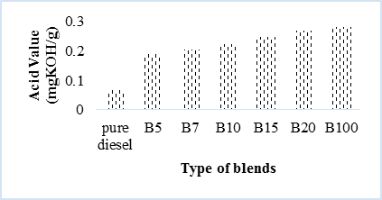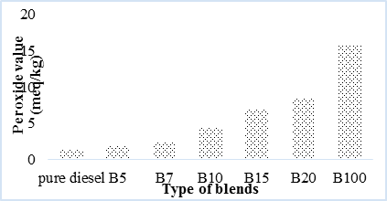
(a)
(b)

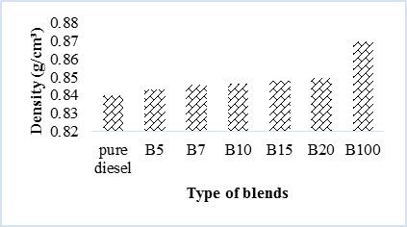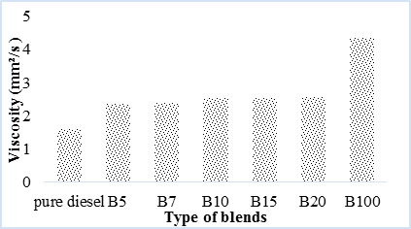
(d)
(c)

Figure 1. (a) acid value of each blends; (b) peroxide value of each blends; (c) density of each blends; (d) viscosity of each blends

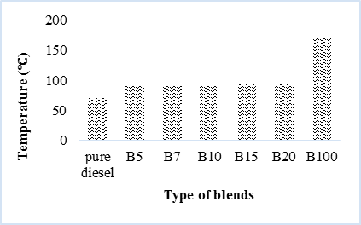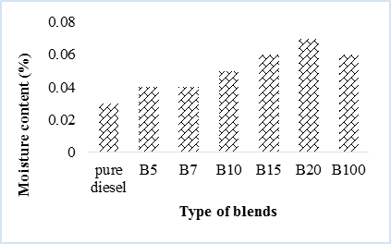
(b)
(a)

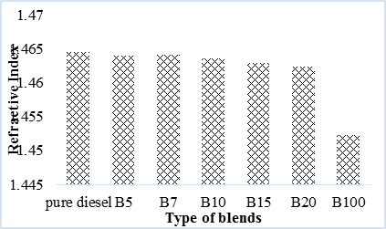
(c)

Figure 2. (a) flash point of each blend, (b) moisture content of each blends, (c) refractive index of each blends

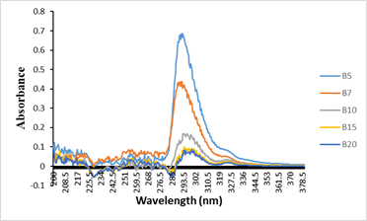
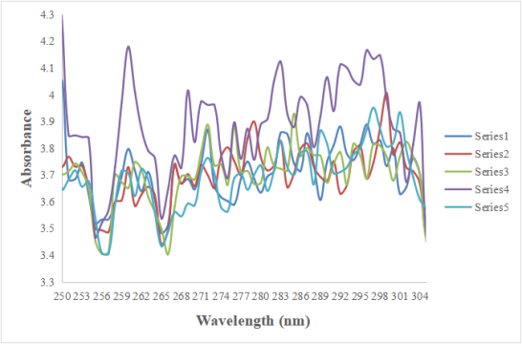
(b)
(a)

Figure 3. a) UV-Vis absorbance for unsaturated fatty acids b) UV-Vis absorbance spectra for saturated fatty acid

Conclusion

The focus of this research is the transesterification of olive oil to produce biodiesel. The optimization of the catalyst concentration and reaction time was conducted in order to obtain the highest percent yield of biodiesel. The absorbance of the blend levels increased as the percentage of biodiesel in each blend decreased. The characterization of biodiesel was done to observe the quality of the diesel-biodiesel blends and the parameter involved were acid value, peroxide value, density, viscosity, refractive index, flash point and moisture content. The correlation coefficient for each parameter was determined and the result showed that the higher the correlation coefficient, the better the quality of biodiesel.

Acknowledgement
The authors would like to thank Ministry of Higher Education, Malaysia, Universiti Malaysia Pahang and Universiti Teknologi MARA Pahang for research project (600-TNCPI 5/3/DDN (06)(001/2020) and (FGRS/1/2019/STG01/UMP/02/2).

References
- Knothe, G. (2010). Biodiesel and renewable diesel: A comparison. Progress in Energy and Combustion Science, 36(3): 364–373.
- The Star (2020). Bumps expected from B20 rollout. https://www.thestar.com.my/news/nation/2020/02/21/bumps-expected-from-b20-rollout. [Access online 20 Mac 2020].
- Chong, C. T., Jo-HanNg, B. T., Fan, L., Ni, S., Wong, K. Y. and Hochgreb, S. (2020). Quantification of carbon particulates produced under open liquid pool and prevaporised flame conditions: Waste cooking oil biodiesel and diesel blends. Fuel. 270: 117469.
- Silitonga, A. S., Masjuki, H. H., Mahlia, T. M. I., Ong, H. C., Chong, W. T., and Boosroh, M. H. (2013). Overview properties of biodiesel diesel blends from edible and non-edible feedstock. Renewable and Sustainable Energy Reviews, 22: 346-360.
- Chattopadhyay, S., Das, S. and Sen, R. (2011). Rapid and precise estimation of biodiesel by high performance thin layer chromatography. Applied Energy, 88(12): 5188-5192.
- Zawadzki, A., Shrestha, D. S. and He, B. (2007). Biodiesel blend level detection using ultraviolet absorption spectra. Transactions of The Asabe, 50(2): 1349-1353.
- Monteiro, M. R., Ambrozin, A. R. P., Lião, L. M. and Ferreira, A. G. (2009). Determination of biodiesel blend levels in different diesel samples by 1H NMR. Fuel, 88(4): 691-696.
- Pullen, J. and Saeed, K. (2015). Investigation of the factors affecting the progress of base-catalyzed transesterification of rapeseed oil to biodiesel FAME. Fuel Processing Technology, 130: 127-135.
- Mathiyazhagan, M. and Ganapathi, A. (2011). Factors affecting biodiesel production. Research in Plant Biology, 1(2): 1-5.
- Leung, D. Y. C., Wu, X. and Leung, M. K. H. (2010). A review on biodiesel production using catalyzed transesterification. Applied Energy, 87(4): 1083-1095.
- Nierat, T. H., Al-Smadi, D., Musameh, S. M. and Abdel-Raziq, I. R. (2014). Storage age dependence of olive oil acidity in different locations in Palestine. Journal of Physical Science, 25(1): 33-43.
- Popa, M., Glevitzky, I., Dumitrel, G.-A., Glevitzky, M. and Popa, D. (2017). Study on peroxide values for different oils and factors affecting the quality of sunflower oil. Series E. Land Reclamation Earth Observation & Surveying, Environmental Engineering, 6: 137-140.
- Saxena, P., Jawale, S. and Joshipura, M. H. (2013). A review on prediction of properties of biodiesel and blends of biodiesel. Procedia Engineering, 51: 395-402.
- Knothe, G. and Steidley, K. R. (2005). Kinematic viscosity of biodiesel fuel components and related compounds. Influence of compound structure and comparison to petrodiesel fuel components. Fuel, 84(9): 1059-1065.
- Silitonga, A. S., Masjuki, H. H., Mahlia, T. M. I., Ong, H. C., Chong, W. T. and Boosroh, M. H. (2013). Overview properties of biodiesel diesel blends from edible and non-edible feedstock. Renewable and Sustainable Energy Reviews, 22: 346-360.
- Delfino, J. R., Pereira, T. C., Costa Viegas, H. D., Marques, E. P., Pupim Ferreira, A. A., Zhang, L., Zhang, J. and Brandes Marques, A. L. (2017). A simple and fast method to determine water content in biodiesel by electrochemical impedance spectroscopy. Talanta, 179: 753-759.

