
²¹⁰PO DETERMINATION IN URINE SAMPLES AMONG RADIATION WORKERS BY ALPHA SPECTRUM ANALYSIS

(Penentuan ²¹⁰Po dalam Sampel Urin di Kalangan Pekerja Sinaran Melalui Analisis Spektrum Alpha)

Nurrul Assyikeen Md. Jaffary*, Nurul Zakila Azlan, Jalal Sharib @ Sarip, Mohd Tarmizi Ishak, Zulkifli Daud, Mohd Izwan Abdul Adziz

Radiochemistry and Environmental Laboratory, Waste and Environmental Technology Division,
Malaysian Nuclear Agency, Bangi, 43000 Kajang, Malaysia

*Corresponding author: assyikeen@nuclearmalaysia.gov.my

Received: 26 April 2021; Accepted: 11 June 2021; Published: xx June 2021

Abstract
The radioactivity of ²¹⁰Po in the urine sample of radiation workers working in radiochemical laboratory, Malaysian Nuclear Agency, was determined. Collected urine samples have to go through the hot acid dissolution process followed by the auto-deposition technique using HCl as the solution. Measurements using the alpha spectrometry system showed good ²⁰⁹Po retrieval, while ²¹⁰Po determination has no interference by other natural radionuclides. The specific radioactivity of ²¹⁰Po was determined from 1.33 mBqL⁻¹ to 49.84 mBqL⁻¹. This preliminary study was conducted to obtain reference data as part of methods development for further investigations in emergencies. The assessment of the data findings in terms of radiation safety was done. Such radioactivity measurement procedure would also be applying for the routine ²¹⁰Po analysis in the urine.

Keywords: polonium isotopes, radioactivity, radiochemical separation, alpha spectrometry, bioassay

Abstrak
Radioaktiviti ²¹⁰Po dalam sampel urin pekerja radiasi yang bekerja di makmal radiokimia, Agensi Nuklear Malaysia telah ditentukan. Sampel urin yang dikumpulkan mesti melalui proses pembubaran asid panas diikuti dengan teknik pemendapan-auto menggunakan HCl sebagai medium larutan. Pengukuran menggunakan sistem spektrometri alpha menunjukkan dapatan semula ²⁰⁹Po yang baik, sementara penentuan ²¹⁰Po tiada gangguan daripada kehadiran radionuklida semula jadi yang lain. Radioaktiviti spesifik ²¹⁰Po telah ditentukan dari 1.33 mBqL⁻¹ hingga 49.84 mBqL⁻¹. Kajian awal ini dilaksanakan untuk mendapatkan data rujukan sebagai sebahagian dari pengembangan kaedah bagi situasi kecemasan. Penilaian ke atas dapatan data dari segi keselamatan radiasi telah dilakukan. Prosedur pengukuran radioaktif seperti ini juga digunakan untuk aktiviti analisis rutin ²¹⁰Po dalam sampel urin.

Kata kunci: isotop polonium, radioaktiviti, pemisahan radiokimia, spektrometri alfa, bioasai

Introduction
²¹⁰Pb and ²¹⁰Po are associated with the ²³⁸U decay chain, a naturally occurring radionuclide. ²¹⁰Pb and its daughter ²¹⁰Bi are beta sources with a half-life of 22.3 years and 5.0 days, respectively. Meanwhile, ²¹⁰Po, the granddaughter of ²¹⁰Pb, is an alpha transmitter. The half-life of ²¹⁰Po is only 138.4 days, and it is the lengthiest polonium radioisotope. ²¹⁰Po occurrences have been continually supplied in the environment by ²¹⁰Pb, which is technologically enhanced from natural radioactive materials (TENORM) [1].

Owing to the natural background radiation, ²¹⁰Po contributes significantly to human internal dosage when absorbed into the body by inhalation or ingestion and is therefore essential to be monitored [1]. An excessive dose of ²¹⁰Po may cause acute radiation syndrome (ARS), which includes nausea, vomiting, diarrhea in the prodromal period, and later symptoms, including hair loss and bleeding. A lower dose can cause long-term organ failure, which could lead to death. The medical sequence can be defined when intake of ²¹⁰Po more than 1 GBq (109 Bq) occurs [2].

Historically, ²¹⁰Po has also been linked to the death of Mr. Alexande Litvinenko, a former Soviet spy. He died on 23rd November 2006, 22 days after consuming a cup of tea laced with ²¹⁰Po. The assassins left radioactive traces all over London. Following this attack, London Health officials used alpha spectrometry to track hundreds of urine samples from internally infected individuals [2, 3]. Despite the fact that ²¹⁰Po can be easily determined by measuring alpha radiation emissions, there is a shortage of reference on ²¹⁰Po in human tissues and body fluids used as a baseline in determining whether or not the individual would be contaminated [4].

The bioassay technique was used to measure the amount of actinide present in the body based on the rate of excretion of body fluids. In an emergency of high ²¹⁰Po activity spread, urine samples of individuals dealing specifically with ²¹⁰Po from open sources should be analysed. It is critical to act rapidly in an emergency to identify radiological threats, particularly to the general public. Urine bioassays are often used to assess internal ²¹⁰Po exposure [2], which can be separated into two types; spontaneous plating [5] and micro-precipitation technique [6]. However, the pre-concentration approach is tedious and time-consuming, which may not be appropriate in an emergency. Therefore, to measure ²¹⁰Po in urine samples, new and quick analysis methods are needed.

In this study, sample selection from the radiochemical laboratory of the Malaysian Nuclear Agency was used as a reference group to determine ²¹⁰Po. This paper defines the procedure used for determining ²¹⁰Po in urine samples, which involved wet decomposition followed by automated deposition for alpha spectrometry. Furthermore, this research focuses on the factors that affect polonium determination and the need to improve the method. Finally, the study results of ²¹⁰Po value will be used as the primary baseline reference data, and assessment in terms of radiation safety were done.

Materials and Methods

Materials
²⁰⁹Po was purchased from Perkin Elmer and was diluted to 30Bq. The diluted concentration was calibrated by preparing a set of a known amount of standards and using a calibration curve to create a radioactivity relationship between the amount spiked and an instrument response. Nitric acid (65% purity) and hydrogen peroxide (30% purity) were purchased from MERCK, used for acid dissolution. Hydrochloric acid (37% purity) was supplied by Scharlau, and distilled water was used for acid dilution in preparing final solution of 2M HCl for auto-deposition process. Mixed standard alpha reference sources (²³⁸U, ²³⁴U, ²³⁹Pu and ²⁴¹Am) were obtained from ANALYTICS used to calibrate the alpha spectrum energy for the alpha spectrometry system.

Sampling and sample analysis
A 24-hour urine specimen obtained from 6 radiochemical workers were used to examine. 50 mL of the obtained urine sample, moved to a 100 mL glass beaker and diluted with 50 mL of distilled water. Each sample was made in triplicate and heated to just below 90 ºC until almost dry. The known amount (approximately 6 Bq) of ²⁰⁹Po as the tracer was added. In the urine bioassay method, ²¹⁰Po has often been corrected using a ²⁰⁸Po tracer or ²⁰⁹Po to assess the recovery due to any depletion or cross contamination of ²¹⁰Po during the sample analysis. In this study, ²⁰⁹Po was used as a tracer due to the advantage in energy isolation from the ²¹⁰Po peak. The ²⁰⁸Po is not widely used as a tracer since its peak energy is closed to ²¹⁰Po and can be interference in mistake (Table 1).

Complete dissolution was carried out with 10 mL of 65% nitric acid and 1 mL of 30% hydrogen peroxide until all the organics had been decomposed. The solution was evaporated until almost dry after dissolution, and the digestive residue was converted to chloride form by applying 10 mL 37% hydrochloric acid. Once the evaporation process was completed, 3.5 mL of 37% hydrochloric acid was applied directly to dissolve the residue. The solution was then rendered to 0.5M hydrochloric acid medium by adding 80 mL of distilled water.

Auto plating
In each sample, hydroxylamine chloride and Bi carrier were added, which were then gently heated on a hot plate and dissolved before being placed on the silver disk as seen in
Figure 1. ²¹⁰Pb and its daughter ²¹⁰Bi must be entirely separated to maintain the secular equilibrium between ²¹⁰Bi and ²¹⁰Po with no interference of ²¹⁰Pb [3]. 4 hours of plating is needed to achieve optimum recovery [8]. Reducing the plating time (at room temperature) to speed up sample processing throughput could be an alternative, but it will reduce the recovery and increase the MDA. In this case, the volume of tracer used must be adjusted to account for the reduction of recovery.

Active source measurement using alpha spectrometry system
The 450 mm² silver discs active surface was then measured using an alpha spectrometry system consisting of Alpha Passivated Implanted Planar Silicon (PIPS) detectors, as shown in
Figure 2(a). Compared to other radiometric methods, such as γ-ray spectrometry, alpha spectrometry has a distinct advantage: the background is very low. The efficiency of more than 20% was measured based on efficiency measurement of ANALYTICS mixed standard alpha reference sources for a source to the sensor distance less than 1 cm (shelve number 1 in the alpha detector chamber), as shown in
Figure 2(b). The detector efficiency does not vary with energy (4 MeV to 9 MeV) due to the small distance of α-peak energy. Because of this efficiency’s freedom from energy (i.e. the intrinsic efficiency of one), the precise non-standard alpha activity ratio for peak energy’s efficiency calibration may be determined [9].

The duration of the active source measurements in this study was 24 hours. Due to its volatility, the polonium atoms readily exit the source disc in the vacuum counting chamber, allowing a significant fraction drift to the detector. Because of the drawback of the long half-life of ²⁰⁹Po, extra care was taken on sample handling to prevent detector contamination. Figure 3. shows the overall ²¹⁰Po analysis in the urine by wet decomposition for alpha analysis.

The polonium alpha spectrum with ²⁰⁹Po viewed in Alpha Vision software is shown in Figure 4. A particular amount of ²⁰⁹Po was added to the sample to be used as an internal isotope tracer, making it possible to calculate the results of the radiochemical analysis. The result was calculated from the peak area of ²⁰⁹Po using equation (1), while ²¹⁰Po activity was calculated from equation (2).

$η_{chem}=\frac{{Area}_{{209}_{Po}}}{A_{{209}_{Po}}∙tm{209}_{Po}.ε_{det}}$ (1)

$A_{210Po}=\frac{{Area}_{{210}_{Po}}}{tη_{chem}∙.ε_{det∙m_{s}}}$ (2)

where, A²¹⁰Po is activity of ²¹⁰Po in the sample, Bqkg⁻¹, A²⁰⁹Po is activity of ²⁰⁹Po in the sample, Bqkg⁻¹, Area²¹⁰Po is peak area of ²¹⁰Po, counts, Area²⁰⁹Po is peak area of ²⁰⁹Po, counts, t is measurement time, s, η_{chem} is yield of ²⁰⁹Po tracer,%, ε_{det} is counting efficiency, %, m²⁰⁹Po is tracer mass, g, and m_{s} is sample mass, kg.

Table 1. ²⁰⁸Po, ²⁰⁹Po, and ²¹⁰Po decay data
Radionuclides | Half-life  (t1/2) | Disintegration  Modes | Eα  (MeV) | Intensity  (%)
²⁰⁸Po | 2.898y | α:99.99777% | 5.1149  4.220 | 99.9956  4.220
²⁰⁹Po | 102y | α:99.52% | 4.885  4.883  4.622  4.310  4.110 | 19.7  79  0.551  1.5x10⁻⁴  5.6x10⁻⁴
²¹⁰Po | 138.376 | α:100 | 5.40746  4.60436 | 99.99876  1.24x10⁻³
References: [7]

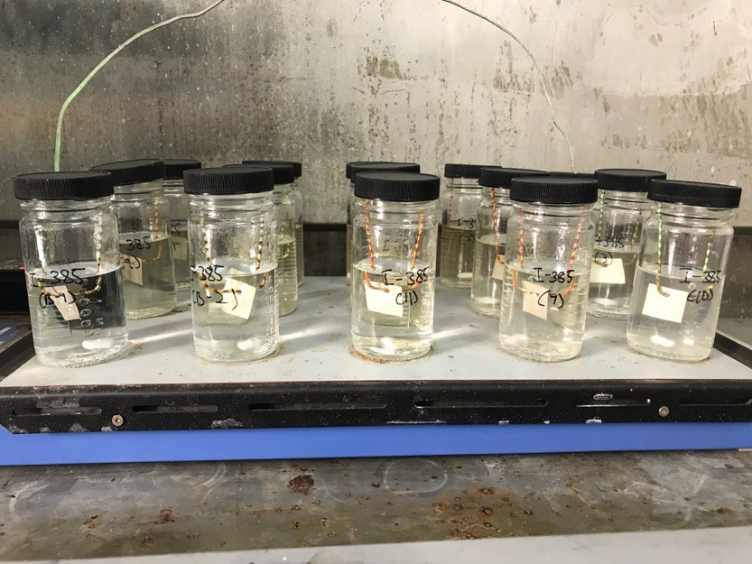
Figure 1. Image of an auto-deposition setup

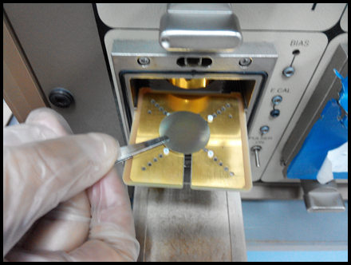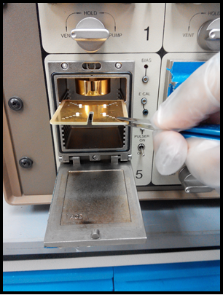
(a)
(b)
Figure 2. a) Active source placed paralleled to the detector b) Shelve placed at the same calibrated mixed alpha standard ANALYTICS source

Auto-deposition on a silver plate at 90ºC for 4hours
Sample
Measurement of ²¹⁰Po by alpha-spectrometry (24-hour counting time)
Sample preparation
Source preparation
Measurement
Sample was diluted to 100ml
Spike ²⁰⁹Po tracer
Sample was dried up

Mixture was dissolved with 3.5 ml conc HCl
Mixture was rinsed and marked up with distilled water until it reached 80 ml solution to be 0.5M
1 ml stable Bi³⁺ carrier was added
1 g of hydroxylammoniumchloride was added
²¹⁰Po deposition
- A sample was collected from 6 radiochemistry workers within a 24-hour urine specimen.
- 50 ml was used, each sample prepared in triplicate

Sampling
Sample digestion
Sample was added to 10 ml HNO₃⁺¹ ml H₂O₂

Figure 3. A flow chart for determination of ²¹⁰Po in urine samples using alpha spectrometry system

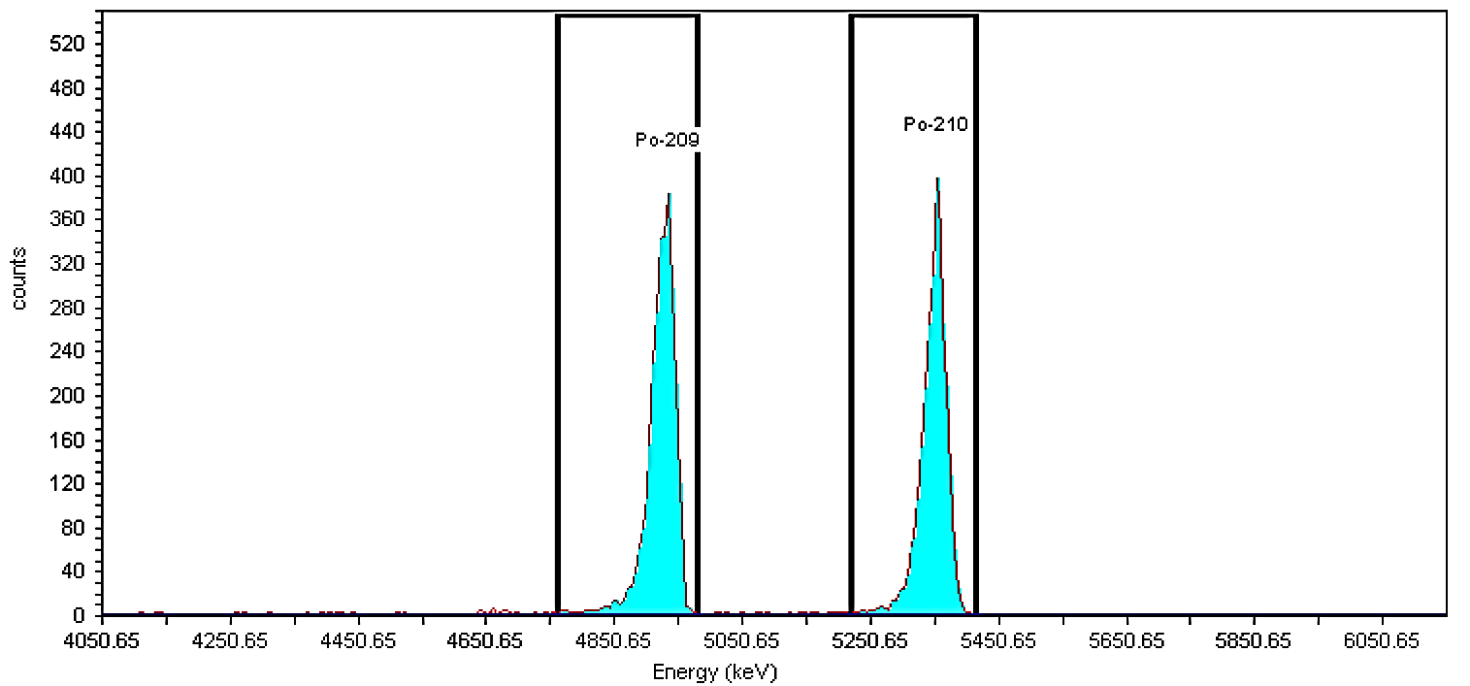

Figure 4. Polonium alpha, ²¹⁰Po spectrum with ²⁰⁹Po yield tracer from this study

Results and Discussion
Urine samples
Table 2 shows the ²¹⁰Po concentrations in the urine samples relative to blank samples. The average specific radioactivity measured is 17.93 mBqL⁻¹, with an estimated relative uncertainty of 0.80 mBqL⁻¹. The recovery data is quite good and comparable to other research [6,8]. The varies of ²¹⁰Po of each individual is greatly dependent upon the daily excretion rates between individuals. Individual variations in urine volume provided to the laboratory for examination may imply that specific urine samples can lead to a collection period of less than or more than 24 hours.

The results of the ²¹⁰Po bioassay are compared to those of the preceding sample in Table 3. In comparison to previous investigations, the data has showed that the specific radioactivity is slightly greater than other reported research [4, 10]. The variation of ²¹⁰Po in urine is influenced by the targeted person, with ²¹⁰Po in urine acquired from radiation workers in this study being more susceptible to internal exposure. Radiation workers who work with TENORM should wear personal protective equipment (PPE) such as a respiratory mask to prevent inhalation or ingestion of the radioactive gas or dust to avoid serious health effects due to external and or internal exposure on workers [12]. Considering the ²³⁸U decay series from TENORM activity, workers may internally expose to the radioactive ²²⁶Ra gas by inhalation if without applying radiation protection principles. The ²²⁶Ra then decays to its granddaughter of ²¹⁰Po in particulate form and is trapped and accumulated inside the body. The alpha particle will ionize the individual’s cell and cause damage to the cell and tissue. The considering pathway may give an acute health risk to the radiation worker. The reported data in this study, however, is still within the background levels of ²¹⁰Po in urine which has been examined and assessed for almost 550 measurements of the general public [11].

Assessment on the detection level
The ²¹⁰Po concentration in urine samples from the current study was computed into the daily excretion rate determined in mBq.d^{–1}, as shown in Table 4. Based on the UK Health Protection Agency’s experience in assessing ²¹⁰Po contamination of members of the public in London areas, the maximum committed effective dose to be considered is below 1 mSv.y^{–1}, which is computed by ²¹⁰Po daily excretion rate determined at or below 30 mBqd^{–1} [4]. It is well known that the ²¹⁰Po levels in urine differed from person to person based on environmental and lifestyle variables [6]. Studies have indicated that more than 80% of the contribution from ²¹⁰Po to the total annual background dose is derived from ²¹⁰Po associated with seafood consumption [14, 15]. The accumulation of ²¹⁰Po in various environmental products, including fish and shrimp, is well-reported [16, 17]. Hence, food intake across the district can also affect the data, while uptake through inhalation of air and cigarette smoke gives smaller contributions [18].

According to the category of public, occupational, and emergency, the level of exposure is tabulated in Error! Reference source not found.. According to the findings of the current report, the following screening thresholds were deemed to be of no significance in terms of radiation safety. The required detection level (RDL) for assessing background levels in human urine and chronic exposures is 3mBqd⁻¹ for the general public, indicating that the Malaysian Nuclear Agency's Radiochemistry Laboratory has been far from the criteria for the assessment of ²¹⁰Po in urine. Based on this study, we would like to emphasise that the suitability of experimental procedures can be ascertained as ²¹⁰Po measurements with alpha spectrometry are given in a standardised manner and have been extensively used for various biological samples such as marine samples, body fluids like urine and blood [4, 19].

Table 2. Results of determination ²⁰⁹Po in urine sample
Sample | ²¹⁰Po Determination  (mBqL⁻¹±1SD) | Recovery (%)
Blank | 2.85 | 77.59
P 1 | 12.67±0.44 | 72.78
P 2 | 38.42±0.26 | 74.93
P 3 | 41.46±0.51 | 79.08
P 4 | 12.48±0.18 | 76.32
P 5 | 10.78±0.23 | 80.61
P 6 | 17.86±0.57 | 78.48

Table 3. Comparison of ²¹⁰Po in urine with the previous study measured using alpha spectrometry system
Concentration (mBqL⁻¹) | Sample | References
Average: 23.27  Min: 1.33  Max: 49.84 | Radiochemistry laboratory worker | This study
Min: 0.5  Max: 4.8 | Reference group of Portuguese citizens | [4]
5.9  8.9  8.1 | Saudi Arabia Volunteer public  - Non-smokers  - Smokers  - Shisha smokers | [10]
Min: 0.6  Max: 69.6 | 550 measurements from the general public were examined | [11]
Table 4. ²¹⁰Po daily excretion rate compared with other studies measured using alpha spectrometry system
Country | Sample /Country | Average Daily Excretion Rate (mBqd⁻¹) |  | References
Malaysia | Radiochemistry laboratory worker | Average:1.16  Min: 0.07  Max: 2.49 | This study
Brazil | Monazite plant workers  - Non-smokers  - Smokers | 5.2  9.9 | [13]
Italy | Volunteer public  - Non-smokers  - Smokers | 11.8  12 | [5]
Portugal | Portuguese citizen potentially exposed to ²¹⁰Po in London | 3.06 | [4]
United Kingdom | UK residents acquired internal contamination | 30 mBq in 24 hours (when computed to committed effective dose is below 1mSvyr⁻¹) | [2]

Table 5. Level of exposure according to category
Category | Level of Exposure | Committed Effective Dose | References
1 | Public | 0-1 mSvyr-1 | [6]
2 | Occupational | 1-20 mSv yr-1 | [6]
3 | Emergency | >20mSv | [6]

Conclusion
The proposed method provided an easy way to determine ²¹⁰Po concentration in a urine sample. The most common method for measuring ²¹⁰Po in urine is sample digestion, Po isolation, and auto deposition, accompanied by α spectrometric counting. Urine samples are conventionally digested and evaporated in an open beaker on a hotplate in the presence of oxidising agents (acids and hydrogen peroxide). Since radioactive compounds like ²¹⁰Po are present in nature, they can also be found in the human body. To assess any contaminants, a clearer understanding of the population's baseline level is needed. The ²¹⁰Po excretion rate can be used to estimate doses resulting from ²¹⁰Po or a combination of ²³⁸U chain radionuclides that comprises ²¹⁰Po. The ²¹⁰Po of radiochemistry laboratory’s worker in this study were measured between 1.33 mBqL⁻¹ to 49.84 mBqL⁻¹. Finally, further research should be conducted to increase the precision and accuracy of ²¹⁰Po determination on urine samples significantly. The RAS laboratory must always get ready with ²¹⁰Po and other radionuclides on hand for bioassay research. This method should allow to measure low levels of ²¹⁰Po and a fast turnaround for screening. In an emergency, this preliminary study was suggested for further review, considering continuous method development.

Acknowledgments
The authors thank the management of the Waste and Environmental Technology Division for supporting the implementation of this project, and the staff of Alpha Laboratory, Radiochemistry and Environmental Laboratory for their assistance in this work.

References
- Vreček, P., Benedik, L. and Pihlar, B. (2004). Determination of ²¹⁰Pb and ²¹⁰Po in sediment and soil leachates and in biological materials using a Sr-resin column and evaluation of column reuse. Applied Radiation and Isotopes, 60(5): 717-723.
- Maguire, H., Fraser, G., Croft, J., Bailey, M., Tattersall, P., Morrey, M. and Troop, P. (2010). Assessing public health risk in the London polonium-210 incident, 2006. Public Health, 124(6): 313-318.
- Li, C., Sadi, B., Davis, K., Wyatt, H., Cornett, J., Kramer, G. and Canada, P. E. (2011). Is alpha spectrometry reliable for ²¹⁰Po urine bioassay? Radiation Protection Dosimetry, 143(1): 106-108.
- Carvalho, F. P. and Oliveira, J. M. (2009). Bioassay of ²¹⁰Po in human urine and internal contamination of man. Journal of Radioanalytical and Nuclear Chemistry, 280(2): 359-362.
- Meli, M. A., Desideri, D., Roselli, C. and Feduzi, L. (2009). ²¹⁰Po determination in urines of people living in Central Italy. Journal of Environmental Radioactivity, 100(1): 84-88.
- Manickam, E., Sdraulig, S. and O’Brien, R. (2010). An improved and rapid radiochemical method for the determination of polonium-210 in urine. Australian Journal of Chemistry, 63(1): 38-46.
- IAEA (2009). A procedure for the determination of Po-210 in water samples by alpha spectrometry. IAEA Analytical Quality in Nuclear Applications Series No. 12.
- Guérin, N. and Dai, X. (2015). An emergency bioassay method for ²¹⁰Po in urine. Applied Radiation and Isotopes, 103: 179-184.
- Aggarwal, S. K. (2016). Alpha-particle spectrometry for the determination of alpha emitting isotopes in nuclear, environmental and biological samples: Past, present and future. Analytical Methods, 8(27): 5353-5371.
- Al-Arifi, M. N., Alkarfy, K. M., Al-Suwayeh, S. A., Aleissa, K. A., Shabana, E. I., Al-Dhuwaili, A. A. and Al-Hassan, M. I. (2006). Levels of ²¹⁰Po in blood, urine and hair of some Saudi smokers. Journal of Radioanalytical and Nuclear Chemistry, 269(1): 115-118.
- Hodgson, A. (2018). Natural levels of Polonium-210 in urine. Journal of Radiological Protection. 38: 393.
- Jaffary, N. A., Khoo, K. S., Mohamed, N. H., Yusof, M. A. W. and Mohd Fadzil, S. (2019). Malaysian monazite and its processing residue: chemical composition and radioactivity. Journal of Radioanalytical and Nuclear Chemistry, 322(2): 1097-1105.
- Lipsztein, J. L., Melo, D. R., Sousa, W., Dias da Cunha, K. M., Azeredo, A. M. G., Julião, L. and Santos, M. (2003). Norm workers: A challenge for internal dosimetry programmes. Radiation Protection Dosimetry, 105(1–4), 317-320.
- Alonso-Hernandez, C., Diaz-Asencio, M., Munos-Caravaca, A., Suarez-Morell, E. and Avila-Moreno, R. (2002). ¹³⁷Cs and ²¹⁰Po dose assessment from marine food in Cienfuegos Bay (Cuba). Journal of Environmental Radioactivity, 61(2): 203-211.

- Noshkin, V. E., Robison, W. L. and Wong, K. M. (1994). Concentration of ²¹⁰Po and ²¹⁰Pb in the diet at the Marshall Islands. Science Total of Environment, 155: 87-104.
- UNSCEAR (2000). Sources and effects of ionizing radiation, New York: pp 1.
- Alam, L. and Mohamed, C. A. R. (2011). Natural radionuclide of Po210 in the edible seafood affected by coal-fired power plant industry in Kapar coastal area of Malaysia. Environmental Health: A Global Access Science Source, 10(1): 1-10.
- Carvalho, F. P. (1995). Origins and concentrations of ²²²Rn, ²¹⁰Pb, ²¹⁰Bi and ²¹⁰Po in the surface air at Lisbon, Portugal, at the Atlantic edge of the European continental landmass. Atmospheric Environment, 29(15): 1809-1819.
- García-Orellana, I. and García-León, M. (2002). An easy method to determine ²¹⁰Po and ²¹⁰Pb by alpha spectrometry in marine environmental samples. Applied Radiation and Isotopes, 56(4): 633-636.

