
S

STABILISATION OF PEAT SOIL USING MAGNESIUM OXIDE:

A PRELIMINARY STUDY

(Penstabilan Tanah Gambut Menggunakan Magnesium Oksida: Satu Kajian Awal)

Lily Suhaila Yacob* and Amelia Md Som

Green Chemistry & Sustainable Technology Cluster,

Universiti Kuala Lumpur-Malaysian Institute Chemical & Bioengineering Technology, 78000 Alor Gajah, Malacca, Malaysia

*Corresponding author: lilysuhaila@unikl.edu.my

Received: 20 November 2019; Accepted: 30 June 2020; Published: August 2020

Abstract

This is a preliminary study for the stabilisation of peat soil from Teluk Kerang, Pontian, Johor using ordinary Portland cement (OPC) and magnesium oxide (MgO) as binders. Spent garnet and sand were used as fillers. In Malaysia, peat soil has been identified as one of the major groups of soils with low shear strength and high compressibility. Peatlands are used as an alternative option for future development due to lack of suitable lands and expensive cost. The presence of soft or peaty soil is a major problem in construction. The properties of peat soil used in this study were analysed and it was found to be acidic with the pH value of 4.15. According to von Post classification, peat soil can be classified as H3. In this research, various ratios of mix design for binders (OPC and MgO) and fillers (spent garnet and sand) were studied. Peat soil and binders (70:30) were inserted into a PVC pipe with the diameter of 50 mm and length of 200 mm. Unconfined compressive strength (UCS) test was conducted to determine the strength gained after 28 days of curing period. The relationships between the UCS and binder of the specimen after curing were investigated to determine the effect of binder changes on the strength of stabilised peat. The results showed that the samples without MgO could not maintain their form even when the samples were assisted with fillers. For the OPC:MgO ratio of 50:50, the samples achieved the UCS value of 32.97 kPa. The findings showed the potential contribution of MgO in peat stabilisation, and the addition of OPC alone is insufficient to stabilise the peat. The pH values varied from 9.0 to 10.1. Overall, the UCS test results showed that peat soil stabilisation using MgO and spent garnet improved the strength of stabilised peat

Keywords: peat soil, magnesium oxide, unconfined compressive strength test, pH, moisture content

Abstrak

Ini adalah kajian awal untuk penstabilan tanah gambut dari Teluk Kerang, Pontian, Johor dengan menggunakan simen Portland biasa (OPC) dan magnesium oksida (MgO) sebagai pengikat. Garnet dan pasir yang digunakan sebagai pengisi. Di Malaysia, tanah gambut telah dikenalpasti sebagai salah satu daripada kumpulan utama tanah yang mempunyai kekuatan ricih yang rendah dan kebolehmampuan tinggi. Tanah gambut akan menjadi pilihan alternatif untuk pembangunan masa depan disebabkan kekurangan tanah yang sesuai dan harga mahal. Kehadiran tanah lembut atau tanah gambut adalah masalah utama dalam pembinaan. Sifat-sifat tanah gambut yang digunakan dalam kajian ini dianalisis dan didapati berasid dengan nilai pH 4.15. Mengikut klasifikasi von Post, tanah gambut dapat diklasifikasikan di antara H3. Dalam kajian ini, pelbagai nisbah reka bentuk campuran untuk pengikat (OPC dan MgO) dan pengisi (garnet dan pasir) dikaji. Tanah gambut dan pengikat (70:30) diletakkan di dalam PVC paip berukuran 50 mm diameter dan 200 mm panjang. Ujian kekuatan mampatan tak terkurung (UCS) telah dijalankan untuk menentukan kekuatan selepas 28 hari tempoh pengawetan. Hubungan antara UCS dan pengikat spesimen selepas pengawetan disiasat untuk menentukan kesan pengikat pada kekuatan gambut yang stabil. Keputusan menunjukkan bahawa sampel tanpa MgO tidak dapat mengekalkan bentuknya walaupun dibantu dengan pengisi dan nisbah OPC: MgO 50:50, sampel dapat mencapai nilai UCS sebanyak 32.97 kPa. Penemuan menunjukkan potensi sumbangan MgO dalam penstabilan gambut dan apabila penambahan OPC sahaja tidak mencukupi untuk menstabilkan gambut. Nilai pH berbeza dari 9.0 hingga 10.1. Secara keseluruhannya, keputusan ujian UCS menunjukkan bahawa penstabilan tanah gambut menggunakan MgO dan garnet menghasilkan peningkatan kekuatan gambut yang stabil.

Kata kunci: tanah gambut, magnesium oksida, kekuatan mampatan tak terkurung, pH, kelembapan

Introduction

Peat covers a substantial land area of many countries, including Malaysia. It consists of more than 75% organic substances and is well known for its low shear strength and high compressibility. There are four types of organic matters in peat soils, which are humin, humic acids, fulvic acids, and yellow organic acids [1]. However, the components of peat may vary by location, fibre origin, humidity, and temperature. These materials may also change chemically and biologically over time.

Land use activities increase intensely due to population and economic growth. To support the growing population, suitable lands for infrastructure development have decreased and may become a drawback in the near future. Many techniques have been carried out to support construction over peat. The soil stabilisation approach, especially for peat, is used to improve its stability, reduce settlement, lateral deformation, and increase bearing capacity [2]. Soil stabilisation can be defined as a method of soil improvement by blending and mixing with other materials [3]. This research focused on using chemical stabilisation for improving peat soil using a combination of magnesium oxide (MgO) and ordinary Portland cement (OPC), which is also known as magnesia cement or magnesia as binders, and spent garnet with sand as fillers.

Magnesia is a non-hydraulic cement produced by Stanislas Sorel in 1867. It has the potential to be used as a sustainable alternative to OPC [4]. The cement is an alkaline earth metal oxide that consists of a magnesium ion and an oxygen ion held together by an ionic bond. Magnesia is also known as a refractory binder, which has fast hardening properties, and several refractory and general repair applications [5]. Nowadays, magnesia is widely applied, such as in cement, steel, and super alloy industries. In the cement industry, magnesia is widely used as a curing agent at room temperature for phosphate cements. Meanwhile, magnesia is used in the steel industry to give optimum properties for corrosion resistance.

The variability nature of peat requires a trial-and-error approach to find the best mix design. In this preliminary study, the potential of using magnesia as a binder and industrial spent garnet as a filler is evaluated. The use of magnesia as an alternative binder and recycled industrial waste as a filler will reduce the carbon footprint and assist in the stabilization process into a more sustainable construction. To achieve this aim, several mix designs were prepared and tested for their unconfined compressive strength. The pH values of the mix design were also analysed.

Materials and Methods

Sampling and materials: Soil

A total 10 kg of peat samples were collected from Teluk Kerang, Pontian, Johor, Malaysia (1.419885° N, 103.440528° E). The peat samples were collected from 0.5-1.0 m depth below the surface. From initial investigation and observation, the soil colour was light brown with some roots and leaves on the surface. The sample transported to the laboratory were kept in a sealed plastic bag and screened through a sieve to remove larger objects (> 0.06 mm).

Binder

Ordinary Portland cement (OPC) and magnesium oxide (MgO) act as binders that hold peat, sand, and spent garnet. The presence of MgO will increase the capability of OPC.

Spent garnet and sand

In this research, spent garnet and sand were added for soil stabilisation and as fillers to increase the number of solid particles in soil. The recycled spent garnet was collected from a dockyard in Pasir Gudang Johor. The sand was bought from a local hardware. It was well-graded and its particle size distribution was in accordance with ASTM F2396-11 [6].

Mould preparation. A polyvinyl chloride (PVC) pipe was used as a split mould to determine the unconfined compressive strength (UCS) of the specimens. The PVC pipe was cut into 50 mm diameter and 100 mm length, as shown in Figure 1. The end of the PVC pipe was covered with a cotton cloth to prevent peat sample leakage. The top of the PVC pipe was covered with a zinc plate with the diameter of 50 mm. A steel bar weighed 3.6 kg was used to stimulate 18 kPa pressure on top of the peat.

Physical and chemical properties

Von Post method

The physical properties tests carried out were von Post classification (degree of decomposition). The von Post classification test was done at the sampling site on peat. One-third of the peat soil was passed between the fingers and the colour of the water released from the fingers was determined. Table 1 shows 10 degrees of humification (H1 to H10) in the von Post classification [2].

Moisture content

Water is naturally present in a peat sample. Moisture content is defined as the ratio of the mass of water in a sample to the mass of solids in the sample. It is expressed as a percentage. The moisture content of the collected peat soil sample was determined by weighing 20 g of the sample and dried in an oven at 90 °C for 16 hours as per ASTM D2974-71 [8]. The moisture content was calculated according to

A - B

Moisture Content, % = x 100 (1)

A

where A is mass of the as-received test specimen in gram (g) and B is mass of the oven-dried specimen, gram (g).

pH

The acidity or pH value was determined using ASTM D2976-71 [9]. 50 mL of deionised water was poured into 3 g of peat soil samples in a small container and left overnight. The samples were then tested using a pH meter.

Specific gravity

Specific gravity is defined as the ratio of the density of a substance to the density of a reference substance (water). The specific gravity test of the peat soil samples was carried out using a 50 mL density bottle. The test specimen for specific gravity was ground to smaller size and sieved through a 425 μm sieve.

Ash content

Ash content was determined according to ASTM D2974 [8] standard test methods for moisture, ash, and organic matter of peat and other organic soils. The ash content of the peat was determined by igniting the oven-dried (100 °C) sample in a muffle furnace at 550 °C according to Method C in ASTM standards.

Organic content

Organic matter content test is a very important test in the classification of peat soil and other organic soils. Organic matter influences the physical and chemical properties of soil, such as compressibility, structure, and shear strength. Organic matter also affects water holding capacity. It is expressed as the percentage of the mass of organic matter in each mass of soil to the mass of dry soil solids. The peat samples from the moisture content test were oven-dried. The samples were weighed and placed in a muffle furnace at 440 °C for 24 hours.

Bulk density

The bulk density of peat soil was determined by collecting an undisturbed sample using a cylindrical corer with the dimensions of 100 mm diameter and 130 mm high. Bulk density was calculated using Equation 2:

dry soil (g)

Bulk Density (g/cm³) = (2)

soil volume (cm³)

FTIR analysis

Fourier transform infrared (FTIR) was carried out using KBr pellets. In this study, KBr was mixed with powdered samples and pressed into disks. Three samples were compressed at 7000 kPa to obtain transparent pellets. Analysis was carried out in the frequency range of 400-4000 cm⁻¹ with 4.0 cm⁻¹ resolution.

Stabilization and water curing: Design mix

The design mix containing various ratios of peat, OPC, MgO, sand, and spent garnet are shown in Table 2. Triplicate samples were prepared for each varied condition. Peat, binders, and fillers were weighed according to the mix design and mixed well. The mixture was put inside the mould, as shown in Figure 1. After the mould had been covered, the water curing process was carried out for 28 days.

Unconfined compressive strength test
UCS test was conducted for the peat specimens after 28 days curing in water according to ASTM D2166 [10]. The specimens were loaded axially using UCS testing equipment at the rate 0.5% to 2% per minute. The samples were tested until the load values decreased, the sample failed, or the strain reached 15%.

Table 1. Degree of decomposition according to Von Post [7]
Condition of Peat Before Squeezing |  |  | Condition of Peat on Squeezing
Degree of Humification | Soil Colour | Degree of Decomposition | Plan Structure | Squeezed Solution | Material Extruded Between Fingers | Nature of Residue
H1 | white or yellow | none | easily identified | clear, colourless | nothing | not pasty
H2 | very pale brown | insignificant | easily identified | Yellowish/ pale brown yellow | nothing | not pasty
H3 | pale brown | very slight | still identified | dark brown, muddy | nothing | not pasty
H4 | pale brown | slight | not easily identified | very dark brown, muddy | some peat | somewhat pasty
H5 | brown | moderate | recognizable but indistinct | very dark brown, muddy | some peat | strongly pasty
H6 | brown | moderately strong | indistinct (clearer after squeezing) | very dark brown, muddy | about one-third of the peat | very strongly pasty
H7 | dark brown | strong | faintly recognizable | very dark brown, muddy | about one-half of the peat | very strongly pasty
H8 | dark brown | very strong | very indistinct | very dark brown, pasty | about two-thirds of the peat | very strongly pasty
H9 | very dark brown | nearly complete | almost unrecognizable | very dark brown, muddy | Nearly all peat as fairly uniform paste | very strongly pasty
H10 | black | complete | no discernible | very dark brown, muddy | all the peat; no free water visible | n/a

n/a is no data available

Table 2. Additive and filler dosage for peat samples of various ratios
 | OPC | MgO | Garnet | Sand | Peat
1 | 300 | 0 | 0 | 0 | 700
2 | 300 | 0 | 150 | 0 | 700
3 | 300 | 0 | 0 | 150 | 700
4 | 300 | 0 | 75 | 75 | 700
5 | 150 | 150 | 0 | 0 | 700
6 | 150 | 150 | 150 | 0 | 700
7 | 150 | 150 | 0 | 150 | 700
8 | 150 | 150 | 150 | 150 | 700
9 | 150 | 150 | 200 | 100 | 700
10 | 150 | 150 | 300 | 0 | 700
11 | 150 | 150 | 0 | 300 | 700
12 | 100 | 200 | 0 | 0 | 700
13 | 100 | 200 | 150 | 0 | 700
14 | 100 | 200 | 0 | 150 | 700
15 | 100 | 200 | 75 | 75 | 700

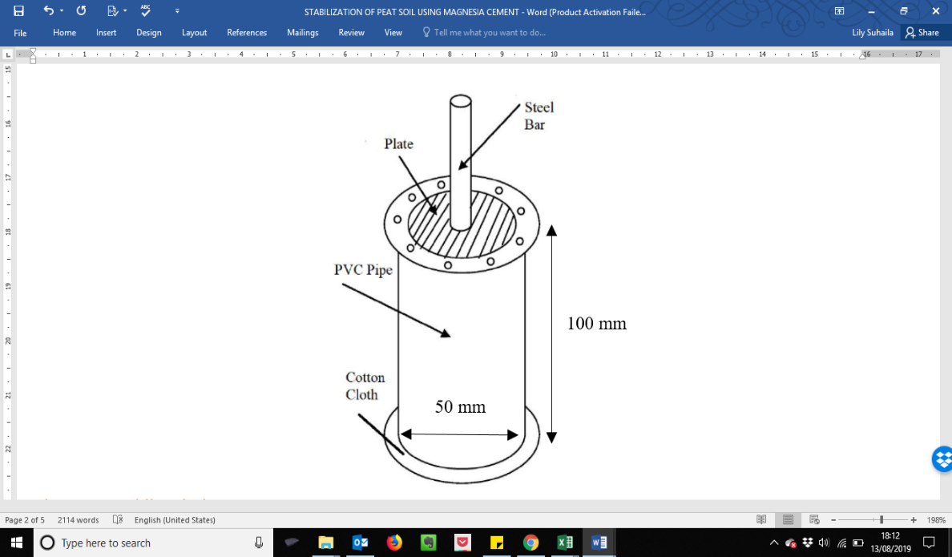
Figure 1. Molding design

Results and Discussion

Physical and chemical properties of unstabilized peat

The results for the von Post scale, natural moisture content, pH, specific gravity, ash, organic content, and bulk density for unstabilized peat are shown in Table 3. When crushing and squeezing the peat between fingers, more than two-thirds of its original amount remained in hand [2]. Based on the characteristic, the soil can be classified as H3 according to the von Post scale of humification. In this study, the moisture content of the peat soil is 230.8%, which shows that the water content in the peat soils is about 230.8% of the total mass of the peat soil. The lower pH value of 4.15 implies that the soil is acidic. The average value of the specific gravity obtained is 0.60 Gs. It shows that the peat soil is less dense than the water density, which has the potential to float on water. High organic content of 90% shows that the soil can be categorized as highly organic fibrous peat [2]. High organic content and very low ash content of 5.34% indicate that the peat soil has unique geotechnical properties and different from inorganic soils.

Unconfined compressive strength and binder

UCS test was performed on the cured peat soil samples after 28 days. Referring to Table 2, the peat soil was treated with various masses of MgO and OPC as binders, and sand with spent garnet as fillers. The results presented in Figure 2 show the relationship between the measured UCS with the binders and fillers ratio. These values are the averages of three specimens for each condition. Sample 1 to 4 are without MgO and 5 to 11 with 50:50 ratio of OPC: MgO but with a variable amount of fillers. The amount of MgO was doubled for Sample 12 to 15. The results show that without MgO, the samples (Sample 1 to 4) are unable to maintain their form even when assisted with fillers (sand and spent garnet). The reasons may have been that OPC does not have enough alkalinity to neutralize the humic acid in peat and the acids strongly retard hydration [11]. The cementing properties of cement come from its hydration products, such as calcium silicate hydrate (CSH) gel, portlandite, ettringite, and monosulfoaluminate. The functional groups OH, C=O, and COOH present in humic acid has strong affinity to Ca²⁺ [12]. The complex inhibits crystallization of calcium to form CSH.

However, the pH of the samples (Sample 1 to 4) varies from 9.4 to 10.1, which indicate that even though ettringite and monosulfoaluminate may have decomposed at this pH [13], CSH gel should be present for strength contribution. The comparison between Sample 5 and 12 shows that when the amount of MgO was doubled, the peat could achieve 30.18 kPa UCS even without the addition of any fillers. Sample 5 that has half the amount of MgO could not even maintain its form. The findings show the potential contribution of MgO in peat stabilization, and the addition of OPC alone is insufficient to stabilize the peat. The chemical reaction between MgO and water will lead to the formation of hydrate compound, Mg(OH)₂ or brucite, as shown in Equation 3.

In the presence of carbon dioxide (CO₂) as those in a peaty environment, the reaction may continue to form more carbonation products. The result of brucite reacting with CO₂ and additional water will produce hydrated magnesium carbonates (HMCs) that can form strength in stabilized peat. HMCs are mainly form nesquehonite (MgCO₃·3H₂O), hydromagnesite (4MgCO₃·Mg(OH)₂·4H₂O), and dypingite (4MgCO₃·Mg(OH)₂·5H₂O). The chemical reaction of brucite to form HMCs were shown in Equation 4 -6 [14].

MgO in carbonated concrete formulation is capable of leading the strength of stabilised peat due to the permanent sequestration of CO₂. The carbonation of magnesium oxide, followed by hydration reaction, can lead give strength and act as a permanent storage of CO₂ in the form of stable carbonates [15]. MgO hydration and brucite carbonation are expansive reactions that can increase MgO solid volume by 3.8-6.7 times and fill available pores [16]. Furthermore, humic acid has the potential to precipitate on the surface of MgO or MgO hydration and carbonation products [17].

In the presence of sand as a filler, the binder OPC: MgO with the ratio of 50:50 (Sample 7) has better UCS value of 32.97 kPa in comparison to 25.25 kPa for 33:67 ratio (Sample 14), with the pH values of 9.4 and 10.0, respectively. The formation of Mg (OH)₂ may also reduce the quantity of available C₂S and C₃S and consequently CSH phases to bind with the filler [18]. The effect of filler ratios was evaluated in Sample 7 to 11. Spent garnet, which is a chemically inert material, does not take part in hydration but acts as a filler that reduces the void ratio in stabilised peat. The highest result was recorded for the design mix containing well-graded sand only. Even though garnet has higher density than sand, it is not well graded, and when garnet is combined with sand, the combination becomes poorly graded and similar to a previous study, which found that poor graded gravels did not produce better results than those of well-graded sand [19]. The pH of unstabilized peat soil sample is 4.15, whereas the pH of stabilised peat sample is from 9.0 to 10.2, meaning that the acidic nature of peat soil is effectively neutralised by OPC and MgO.

Fourier transform infrared spectroscopy

Fourier transform infrared (FTIR) spectroscopy is an established and simple equipment that can be used to identify and characterise soil organic matter. This is because FTIR spectroscopy can show direct information of functional groups in the soil organic matter fraction analysed. The FTIR spectra of hydrated MgO, hydrated OPC, and stabilised peat soil are displayed in Figure 4. The bands at 800 cm–1000 cm⁻¹ belong to tricalcium silicate (C₃S, alite) or Ca₃SiO₅. The bands at 1100–1200 cm⁻¹ are due to CSH₂. The bands between 3000 and 3600 cm⁻¹ and at 1650 cm⁻¹ are the results of H₂O molecules. These bands underwent changes with the evolution of hydration. The peaks appeared at 900–1200 cm⁻¹ and 1350 cm⁻¹ represent the formation of CSH or 3CaO.2SiO₂.3H₂O. The bands at 3650 cm⁻¹ are due to the OH groups of calcium hydroxide (Ca(OH)₂). The bands at around 1400 cm⁻¹ in both dry and hydrated samples are carbonates, which arose from raw materials of cement and the reactions of atmospheric CO₂ with CH during storage and operation.

Table 3. Basic Properties of the unstabilized peat
Basic Soil Property | Average Value
Von Post scale | H₃
Natural moisture content (%) | 230.8
pH | 4.15
Specific gravity (G_{s}) | 0.60
Ash Content (%) | 5.34
Organic content (%) | 90.0
Bulk density (g/m³) | 890.17

MgO + H₂O Mg²⁺ + 2OH⁻ Mg (OH)₂ (Brucite) (3)

Mg(OH)₂ + CO₂ + 2H₂O MgCO₃.3H₂O (nesquehonite) (4)

5Mg(OH)₂ + 4CO₂ 4MgCO₃. Mg(OH)₂.4H₂O (hydromagnesite) (5)

5Mg(OH)₂ + 4CO₂ + H₂O 4MgCO₃.Mg(OH)₂.5H₂O (dypingite) (6)

Figure 2. Unconfined compressive strength for stabilizer mixes of stabilized peat

Figure 3. pH value of design mix

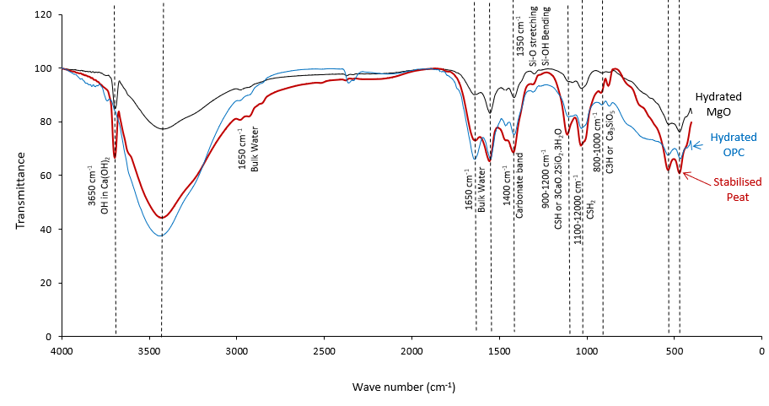

Figure 4. FTIR spectra of hydrated MgO, hydrated OPC and stabilized peat

Conclusion

In this research, a preliminary laboratory investigation using MgO and recycled spent garnet for the stabilisation of peat soil was carried out. Overall, the UCS test results show that peat soil stabilisation using MgO resulted in the improvement of strength of the stabilised peat. The addition of spent garnet as the filler altered the engineering properties of peat soils. Spent garnet has been proven as materials that have the potential to stabilise the road shoulder. This research will introduce recycled spent garnet to be partially added into peat soil. Alternatively, the industrial waste can be reused and reduced to prevent environmental issues. This preliminary research gives an idea about peat soils stabilisation using magnesium oxide and highlights their properties and importance in chemical and geotechnical engineering.

Acknowledgement

The authors would like to express deep gratitude for the financial support provided by Dana Penyelidikan Inovasi MARA (DPIM) and Universiti Kuala Lumpur (Malaysian Institute Chemical & Bioengineering Technology) for providing facilities to conduct the study.

References
- Nikookar, M., Arabani, M., Mirmoa’Zen, S. M. and Pashaki, M. K. (2016). Experimental evaluation of the strength of peat stabilized with hydrated lime. Periodica Polytechnica Civil Engineering, 60(4): 491-502.
- Wong, L. S., Hashim, R. and Ali, F. (2013). Improved strength and reduced permeability of stabilized peat: Focus on application of kaolin as a pozzolanic additive. Construction and Building Materials, 40: 783-792.
- Firoozi, A. A., Guney Olgun, C., Firoozi, A. A. and Baghini, M. S. (2017). Fundamentals of soil stabilization. International Journal of Geo-Engineering, 8(1): 26.
- Imbabi, M. S., Carrigan, C. and McKenna, S. (2012). Trends and developments in green cement and concrete technology. International Journal of Sustainable Built Environment, 1(2): 194-216.
- Walling, S. A. and Provis, J. L. (2016). Magnesia-based cements : A journey of 150 years, and cements for the future.
- ASTM (2000). Annual book of ASTM standards, section four: Construction. American Society of Testing Materials, USA.
- Landva, A. O. and Pheeney, P. E. (1980). Peat fabric and structure. Canadian Geotechnical Journal, 17(3): 416-435.
- ASTM D 2974 (2000). Standard test method for moisture, ash, and organic matter of peat and other organic soils. Annual book of ASTM Standards, ASTM, Philadelphia, USA.
- ASTM D2976-71(2004). Standard test method for pH of peat materials. ASTM International, Philadelphia, USA.
- ASTM D 2166 (2000). Standard test method for unconfined compressive strength of cohesive soil. Annual book of ASTM standards, ASTM, Philadelphia, USA.
- Wong, L. S., Hashim, R. and Ali, F. H. (2008). Strength and permeability of stabilized peat soil. Journal of Applied Sciences, 8(21): 3986-3990.
- Saride, S., Puppala, A. J. and Chikyala, S. R. (2013). Swell-shrink and strength behaviors of lime and cement stabilized expansive organic clays. Applied Clay Science, 85(1): 39-45.
- Lagerblad, B. (2005). Carbon dioxide uptake during concrete life cycle – State of the art. Stockholm.
- Unluer, C. and Al-tabbaa, A. (2014). Cement and concrete research enhancing the carbonation of MgO cement porous blocks through improved curing conditions. Cement and Concrete Research, 59: 55-65.
- Unluer, C. and Al-Tabbaa, A. (2013). Impact of hydrated magnesium carbonate additives on the carbonation of reactive MgO cements. Cement and Concrete Research, 54: 87-97.
- Yi, Y., Liska, M., Unluer, C. and Al-tabbaa, A. (2013). Carbonating magnesia for soil stabilization, 905: 899-905.
- Wall, N. A. and Mathews, S. A. (2005). Sustainability of humic acids in the presence of magnesium oxide. Applied Geochemistry, 20(9): 1704-1713.
- Gonçalves, T., Silva, R. V, Brito, J. De, Fern, J. M. and Esquinas, A. R. (2019). Hydration of reactive MgO as partial cement replacement and its influence on the macroperformance of cementitious mortars. Advances in Materials Science and Engineering, 2019: 1-12.
- Dehghanbanadaki, A., Ahmad, K. and Ali, N. (2013). Influence of natural fillers on shear strength of cement treated peat. Journal of the Croatian Association of Civil Engineers, 65(7): 633-640.

