
S

REAL-TIME MONITORING OF FOOD FRESHNESS USING DELPHINIDIN-BASED VISUAL INDICATOR

(Pemantauan Kesegaran Masa Nyata Makanan dengan Menggunakan Indikator Visual Berasaskan Delphinidin)

Nurdiyana Husin¹*, Mohd. Zulkhairi Abdul Rahim², Mohd. Azizan Mohd. Noor¹,

Ismail Fitry Mohammad Rashedi³, Nazatulshima Hassan²

¹Section of Bioengineering Technology

²Section of Technical Foundation

Universiti Kuala Lumpur Malaysian Institute of Chemical & Bioengineering Technology,

Lot 1988, Bandar Vendor, 78000 Alor Gajah, Malacca, Malaysia

³Faculty of Science and Food Technology,

Universiti Putra Malaysia, Serdang, 43400 Seri Kembangan, Selangor, Malaysia

*Corresponding author: mohd.zulkhairi@unikl.edu.my

Received: 20 November 2019; Accepted: 18 June 2020; Published: 11 August 2020

Abstract

Nowadays, there is an increasing demand from consumers for better quality and hygienic food products, particularly for vulnerable foods that are easily infected by microorganisms. At present, consumers only depend on the expiry date, but this information does not always portray the real indication of the actual progress of food spoilage. The use of a colorimetric freshness indicator can provide direct and real-time visual quality information, but most of the previous works focused on synthetic colours. In this project, a natural colour (anthocyanin-delphinidin derivative) from Clitoria ternatea (butterfly pea) flower was extracted using an ultrasonic processor, followed by immobilisation on indicator strips, and finally applied as a freshness indicator for the qualitative detection of beef freshness. The extracted colour changed obviously at different pH values, from dark blue (pH 5.93) to green (pH 8) and yellow at pH 12. The delphinidin-based visual indicator was also able to detect the spoilage of beef at hour 18 (pH 6.76 ± 0.29 and point of rejection at 25.67 ΔE*) at room temperature (25 ± 1 °C) and on day 6 (pH 6.71 ± 0.05 and point of rejection at 27.09 ΔE*) in chiller storage (4 ± 1 °C). The tested visual indicators at room and chiller temperature responded to the changes of pH as volatile compounds were gradually produced from the spoiled product. The colour of the indicators subsequently changed from dark blue to green and was easily visible to the naked eye. This study provides a foundation for developing a new visual indicator for monitoring real-time beef freshness and may also be used for intelligent packaging.

Keywords: beef freshness, butterfly pea, visual indicator, intelligent packaging

Abstrak

Kebelakangan ini, keinginan pengguna terhadap produk makanan yang bersih dan berkualiti semakin meningkat, terutama bagi produk makanan yang mudah dijangkiti mikroorganisma. Sehingga kini, pengguna hanya bergantung kepada tarikh luput untuk menentukan kualiti produk makanan, yang mana ia tidak menggambarkan keadaan sebenar makanan tersebut. Penggunaan indikator visual kesegaran berdasarkan warna akan membolehkan kesegaran makanan dapat dikenal pasti secara terus, akan tetapi kebanyakan kajian tersebut adalah lebih kepada menggunakan bahan pewarna sintetik. Dalam kajian ini, pewarna natural diekstrak daripada bunga telang dengan menggunakan kaedah ultrasonik, diserap ke atas kertas indikator, dan akhir sekali digunakan sebagai pengukur kesegaran bagi mengukur tahap kesegaran daging. Hasil kajian menunjukkan berlaku perubahan warna yang ketara pada pH yang berbeza; bermula daripada warna biru gelap pada pH 5.93 dan bertukar kepada warna hijau pada pH 8–9 dan berubah ke warna kuning pada pH 12. Pada suhu bilik (25 ± 1 °C), indikator visual berjaya mengesan kerosakan daging pada jam ke 18, pada pH 6.76 ± 0.29 dan titik penolakan pada 25.67 ΔE*. Manakala pada suhu penyejuk (4 ± 1 °C), kerosakan daging dapat dikesan pada hari ke 6, pada pH 6.71 ± 0.05 dan pada titik penolakan 27.09 ΔE*. Indikator visual yang diuji pada suhu bilik dan penyejuk telah menunjukkan tindak balas terhadap perubahan pH yang disebabkan oleh gas yang terhasil daripada daging yang rosak. Warna indikator visual kemudiannya telah bertukar daripada biru gelap ke hijau dan ia mudah dilihat dengan mata kasar. Kajian ini menyediakan asas kepada pembangunan indikator visual bagi mengukur kesegaran daging secara terus dan boleh juga digunakan untuk kegunaan pembungkusan pintar.

Kata kunci: kesegaran daging, bunga telang, visual indikator, pembungkusan pintar

Introduction

At present, the monitoring of superior quality and hygienic food products becomes a great concern due to the increasing awareness of consumers. Vulnerable foods like seafood, chicken, fish, and meat are products that are easily infected by microorganisms at ambient conditions (~ 25 °C). Poultry meat is a highly perishable food and usually deteriorates within one week of slaughter, regardless of the chilled storage system [1].

Commonly, the meat quality is checked through sensory evaluation and chemical experiments that involved the evaluation of microbial growth. Sensory evaluation is usually based on flavour, stickiness, elasticity, and colour of its texture. This so-called traditional method is sometimes rejected due to human errors that may come from the expert panels [2]. Furthermore, this method is inefficient and has low precision. Moreover, the microbiological test including bacterial counts is very time consuming and very far from real-time monitoring. These characteristics contradict with consumers' interest that would like to know the quality of food products. Therefore, in order to satisfy consumers and assist food manufacturers, a real-time quality control and safety system should be introduced for food products.

Meat, specifically beef, is considered fresh at pH 5.8 to 6.2. At pH above 6.5, the beef is considered spoiled, and it is a favourable growth condition for microorganisms to decompose the beef [3, 4]. As the pH of meat increases, the pH of volatile compounds gradually increases [5]. During the decomposition of meat by microorganisms, meat usually releases volatile compounds, such as methylamine, dimethylamine, trimethylamine, fatty acids, ketones, alcohols, hydrogen sulphide, methyl sulphide, and dimethyl sulphide to the air [6].

The pH of meat is measured at pH 7.1 and after being slaughtered, the pH becomes acidic (pH 5.4-5.7) within 18-24 hours due to the conversion of glycogen to lactic acid (Figure 1). After reaching the lowest point of acidic pH, the pH value will gradually increase to a neutral pH and known as the pH of fresh meat [5]. During the aging period of beef, muscle proteins are partially hydrolysed into ammonia, amines, and other alkaline substances by cathepsins, and thus the pH values of beef increased during this period [7, 8].

Several studies have demonstrated that colours can be used as sensing elements for a real-time freshness indicator on different food samples, but most of the researchers focused on synthetic colours rather than natural colours [1, 5, 9, 10, 11]. Natural colours are more favourable compared to chemical or synthetic colours (or dyes), which are harmful to human life, can cause lung diseases, and trigger skin infection. Natural colours have the merits obtained from renewable resources and are also non-hazardous and eco-friendly. Common natural colours are bell pepper, red cabbage (vegetable), spinach (leaf), annatto (seed), turmeric, beet juice (root), and many more [12, 13].

Clitoria ternatea (butterfly pea) is a perennial twining herb found abundantly in Malaysia, and the most outstanding feature is its intense deep blue flowers [14]. Traditionally, the blue dye aqueous extract from the petal is used to cover grey hair as a cosmetic for hair dying. It is also used in the pharmaceutical industry as a pH indicator, as well as confectionery colouring substances in the food industry [15]. Butterfly pea is originally from Southeast Asia and its petals store ternatins, a group of (poly)acylated anthocyanins. All anthocyanins in butterfly pea petals originated from delphinidin, which is responsible for the blue colour [15, 16]. Purified delphinidin from butterfly pea suffers from colour instability and bleaching, whereas non-purified delphinidin retains its original colour for months [17].

Saptarini et al. [18] revealed that the delphinidin derivative in butterfly pea contained flaviliumcation, which likely changed the colour of butterfly pea extract in different pH solutions. Thus, this indicates that the butterfly pea colour has a good potential to be used as an indicator in food quality measurement and at the same time, this indicator provides an inexpensive value-added approach for intelligent packaging, which acts as analytical instrument [19].

In this research, the natural colour from C. ternatea flower was extracted using an ultrasonic processor, followed by immobilisation on indicator paper, and finally applied as a freshness indicator for the qualitative detection of beef freshness. The idea of freshness indicators is that they monitor the quality of the packed beef by reacting in one way or another to changes occurring in the fresh food product due to microbial growth or metabolism. The employment of natural colour in the colorimetric indicator is advantageous because this indicator does not have any chemical effect on packed beef. Besides, this study provides a foundation for developing a new visual indicator in monitoring real-time meat freshness and may also be used in intelligent packaging.

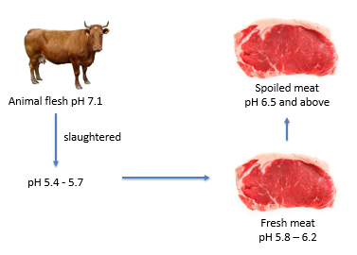

Figure 1. Chronology of pH in meat, from animal flesh until it becomes spoiled meat

Materials and Methods

Preparation of butterfly pea

Butterfly pea petals were collected from a private plantation based in Serdang, Selangor. The area of cultivation is free of fungicide and pesticide. The sampling was done by hand picking method and only the flowers with no visible symptoms of any diseases were collected. The collected materials were stored in zip-lock plastic bags and processed within 24 hours after the collection. In the laboratory, the samples were cleaned under running tap water and proceeded with the sample preparation method. Butterfly pea was dried in an oven at 40 °C for 24 hours. It was ground using a commercial grinder and sieved using sieve number 60 (250 µm) to achieve a constant particle size [20]. Powdered butterfly pea was stored in an air-tight container and kept in desiccators prior to analysis [21].

Extraction of natural colour from butterfly pea using water extraction assisted by ultrasonic irradiation

Water (100 mL) was added in powdered butterfly pea (15 g) and placed in a 250 mL beaker. The beaker was placed in an ultrasonic bath and sonicated for 5-30 minutes at 27-30 MHz and 160 V. After sonication, the content of the beaker was filtered through a filter cloth to remove solid particles. Then, the filtered extract was centrifuged at 2,000 rpm, 10 minutes, and 4 °C [22]. The delphinidin solution obtained was stored in a chiller at 4 °C for further analysis.

Total anthocyanin content

The determination of the total amount of anthocyanins (TAC) was adapted from the reported spectrophotometric method [23]. Absorbance was measured after centrifugation (at 3,000 ×g for 15 minutes) at 568 nm against a reagent blank. Delphinidin-3-glucoside-chloride (Cayman Chemical, USA) was used as a standard pigment, and TAC was expressed as mg delphinidin 3-glucoside equivalent per 100 mL of extract.

Analysis of pH on delphinidin solution

Butterfly pea extract was added to a 5 ml buffer solution of pH 1 to pH 14, and then the colour change was observed [18]. Colour changes were checked using a tintometer (Lovibond PFX880) to determine the CIE colour space coordinates, i.e. colour visible to the human eye, as specified by the International Commission on Illumination (Commission Internationale d’Eclairage, CIE) using L*, a*, and b* values. The values of L*, a*, and b* represent lightness, redness, and yellowness, respectively.

Ultraviolet-visible spectra measurement

The absorption spectra of butterfly pea extract were analysed using an ultraviolet-visible (UV-Vis) spectrophotometer (Varioskan Lux, ThermoFisher Scientific) for determining the wavelength and absorbance. UV-Vis spectrum of the extract was obtained at a wavelength of 400 to 700 nm. The absorption spectra of the extracted solutions were correlated with the standard, delphinidin glucoside, to validate the extraction process.

Fabrication of delphinidin-based visual indicator

A visual indicator was made of filter paper (Whatman 42) with the dimension of 4.2 cm × 1.5 cm (Figure 2). Butterfly pea extract was immobilised on the indicator paper using spin-coated method. Seven strips of indicator paper were centrifuged with 15 mL of butterfly pea extract at 3,000 rpm, 15 minutes, and 4 °C [24]. Then, the indicator was dried using a hair dryer for 15 minutes for uniform drying on both sides of the indicator.

Preparation of beef sample

Semimembranosus muscle was extracted from the top (inside) round of a cow carcass with insignificant fat content. The round portion obtained from the carcass (12 hours after slaughtered) was immediately kept in a cooler box and transported to the laboratory. Each portion obtained from the carcass was divided into 20 g of beef sample and placed in a sealed container.

Measurement of the response of delphinidin-based visual indicator

To evaluate the applicability of the developed visual indicator in monitoring the spoilage of beef, the delphinidin-based visual indicator was placed inside the package of the beef sample. The indicator was in direct contact with the atmosphere inside the container and stored at room temperature (25 ± 1 °C) and chiller temperature (4 ± 1 °C). This method was used to make sure that there would be no effect from external atmospheric conditions. For the control, the visual indicator was placed inside a container without beef sample. The distinct colour change of the indicator from the initial to the final stage was used as the measurable response of change, ΔE*. The colour changes on the indicator were checked using a hand-held colorimeter (Chroma Meter CR-10, Minolta Inc., Japan) to determine the CIE colour space coordinates (L*, a*, b*, and ΔE*). Here, ΔE* (i.e. colour change) was used as the indicator response for the colour changes of the visual indicator (in arbitrary units) that was calculated as [(a*2+b*2)0.5] [5].

Measurement of pH on meat

The pH of the beef sample was measured using a portable pH meter (LAQUAtwin, Horiba) with a flat sensor as the electrode. The beef sample was placed on the measuring electrode and the pH values were recorded with the accuracy of ± 0.1 pH.

Statistical analysis

The results from multiple samples were reported using analysis of variance (ANOVA) from Minitab version 18 (companion by Minitab®) by means of the average values ± standard deviation. The significance was defined at p < 0.05.

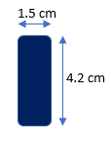

Figure 2. Delphinidin-based visual indicator

Results and Discussion

Extraction of natural colour from butterfly pea

The total anthocyanin concentration was calculated at 1.3 mg of delphinidin 3-glucoside equivalent per 100 mL of extract. The original colour of butterfly pea extract was dark blue at pH 5.93. The analysis of pH on butterfly pea extract showed that at pH 1-2, the colour was red, which then shifted to purple at pH 3-5, followed by blue at pH 6-7, changed to green at pH 8-11, and at pH above 11, the colour became yellow (Figure 3). The values of colours at each pH is presented in Table 1. The changes of colour are due to the presence of flaviliumcation in butterfly pea extract, which is unstable with the change of pH solution [18]. This result confirmed the potential of butterfly pea extract as a pH indicator.

The maximum absorption of the extract was recorded at two different wavelengths at maximum absorbance (λ_{max}), 568 and 618 nm, as shown in Figure 4 (appeared as a red line, pH 5.93). The difference between both wavelengths was on the bands at 568 (K-band) and 618 nm (R-band) [13, 16, 25]. Based on the standard (delphinidin 3-glucoside), the absorption maxima at the wavelength of 568 nm was selected for further analysis. The UV-Vis analysis done by Saptarini et al. [18] showed absorption at the maximum wavelength of 572 and 614 nm. As the pH changed, the absorption maxima shift was observed between 548 and 627 nm [25]. Figure 4 shows the UV-Vis spectra of butterfly pea extract at different pH. The wavelength showed a similar trend from pH 1 until 11; however, the peaks almost disappeared when the solution was at pH 13. The extract indicated a slight spectral shift in the spectrum due to the interaction between the extract and its microenvironment [26].

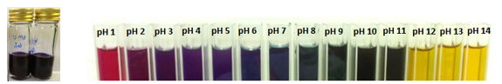

Figure 3. Butterfly pea extract (left) and butterfly pea extracts in different pH buffer solutions (right) [12]

Table 1: L*, a*, and b* values of delphinidin extract at different pH values
pH | L* | a* | b*
1 | 33.98 ± 0.12 | 60.01 ± 0.10 | 36.65 ± 0.34
2 | 15.62 ± 0.28 | 41.51 ± 0.36 | 4.21 ± 0.01
3 | 8.30 ± 0.23 | 32.15 ± 0.55 | -7.21 ± 0.44
4 | 8.51 ± 0.11 | 31.32 ± 0.14 | -11.77 ± 0.06
5 | 7.84 ± 0.16 | 26.18 ± 0.06 | -15.10 ± 0.11
6 | 8.69 ± 0.27 | 14.61 ± 0.06 | -14.71 ± 0.16
7 | 9.53 ± 0.16 | 7.85± 0.06 | -10.71 ± 0.10
8 | 5.41 ± 0.37 | 9.56 ± 0.37 | -0.64 ± 0.08
9 | 5.71 ± 0.21 | 10.96 ± 0.12 | 4.25 ± 0.03
10 | 5.69 ± 0.19 | 11.93 ± 0.21 | 6.44 ± 0.07
11 | 10.94 ± 0.16 | 14.45 ± 0.09 | 11.17 ± 0.09
12 | 65.81 ± 0.13 | 10.74 ± 0.03 | 83.88 ± 0.08
13 | 68.61 ± 0.05 | 11.74 ± 0.00 | 87.96 ± 0.29
14 | 70.03 ± 0.04 | 17.71 ± 0.24 | 97.07 ± 2.09
5.93 | 17.78 ± 0.16 | 32.15 ± 0.16 | -25.53 ± 0.11

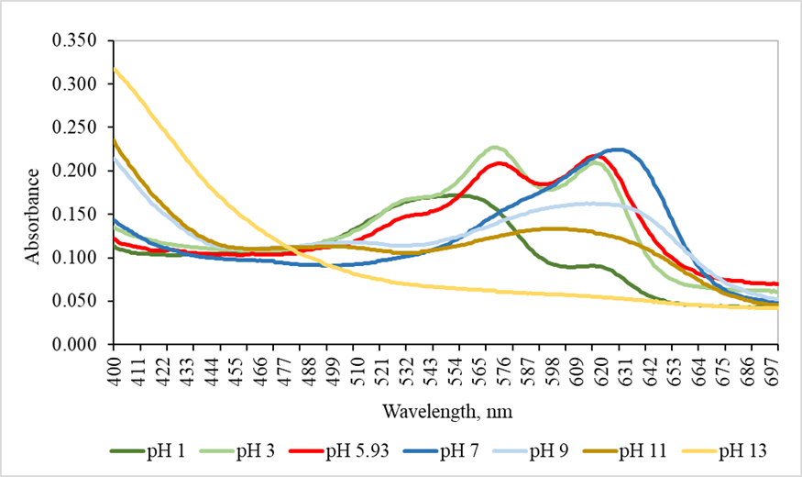

Figure 4. UV-Vis spectra of butterfly pea extract at different pH

Response of delphinidin-based visual indicator towards the beef sample

The delphinidin-based visual indicator was placed in a sealed container with a beef sample. The visual indicator was left unattached to the beef sample for the visual

indicator to respond to the increasing volatile amines generated by beef spoilage. The visual indicators were

monitored periodically until no further colour change was observed. The colour changes in the indicators were due to the reaction of the indicators with volatile bases produced during the storage of the beef [24].

Figures 5 and 6 show the changes in the visual indicators before and after the analysis of the beef sample. These visual indicators portrayed real-time freshness of the beef sample during storage by sensing volatile compounds or gases released by the sample. The chemical changes occurring in meat during storage are indicators of the freshness of muscle-based food products [27]. As reported by Mohebi and Marques [2], the characteristics of volatile compounds in each meat product are different; therefore, each beef might spoil at different time.

The indicators tested at different storage temperatures respond to the changes of pH in the package headspace. The pH increased due to the volatile compounds produced gradually by the beef sample during spoilage. This situation was subsequently reflected by the colour of the indicators, which changed from dark blue to green for spoilage indication and easily visible to the naked eye. These results showed that the delphinidin-based visual indicators reacted with the volatile compounds released by the beef sample inside the package. On the other hand, the control delphinidin visual indicator was tested inside an empty package without beef, where the colour of the indicator remained unchanged throughout the storage duration, as shown in Figure 7.

The colour values for indicators at room temperature and chiller temperature are tabulated in Table 2. The comparison of colour difference was done using Tukey's multiple comparison test, which is one of the tests that can be used to determine which means (μ) amongst a set of means differ from the rest [28]. The Tukey's test showed that for both storage temperatures, the initial colour value was significantly different (p < 0.005) with the colour value at the point of rejection at hour 18 (room temperature) and day 6 (chiller temperature), where the visual indicators changed its colour from dark blue to green. The difference was observed in a* and b* values, which referred to the redness and yellowness of the visual indicator, respectively. However, the L* value might remain same or different, as it only represents the lightness of the colour. This result proved that the delphinidin-based visual indicator is able to indicate the freshness of beef based on the significant colour change.

Figure 8 shows the indicator response (ΔE*) towards spoiling beef at room temperature. The indicator responded significantly at hour 18 as the indicator colour changed from dark blue to green, and the beef was found at pH 6.76 ± 0.29. The initial pH of the beef was at pH 6.01 ± 0.07, and it was considered spoiled at pH above 6.5. The colour indicator response was similar to the deterioration of the beef sample as stated by Kuswandi and Nurfawaidi [8].

A study by Kuswandi and Nurfawaidi [8] showed that beef (specifically at the flank part) spoiled at hour 8 at room temperature, whereas in this study, the beef (specifically at the top (inside) round part) spoiled at hour 18. The difference indicates that different parts of beef spoiled at different rates and this contributes to different real-time detection of beef freshness. Even if the beef spoiled at different rates, the freshness is still measurable based on the colour change. The rate of colour change at chiller temperature is shown in Figure 10. Initially, the pH value of the beef sample was at pH 6.01 ± 0.07 and increased to pH > 6.0 starting from day 4 of storage. At day 6, the pH of beef turned to pH 6.71 ± 0.05, which indicated that the beef was already spoiled. A study by Maggiolino et al. [29] showed that the highest volatile nitrogen released from aging beef was observed on day 6, which was similar with the point of rejection in this study.

During the spoilage period, many microorganisms started to reproduce and decompose proteins, which contributed to the rise of pH in beef [7]. Throughout the storage of beef, the proteins of muscle are decomposed by either enzymatic hydrolysis or microbial action, which leads to changes in the pH value [7]. Kuswandi and Nurfawaidi [8] stated that beef samples with a similar degree of freshness produced a similar amount of volatile compounds, which changed the pH to the similar pH inside the headspace of beef package. The result obtained in Figure 10 has a similar trend as in Figure 9, which means that the indicators responded well to the increase of pH value in the container headspace as the colour of the visual indicators is related to the pH level in the beef sample. The error values for both results are smaller than 5%, which demonstrated high precision of the indicator response related to the reproducibility of the measurement.

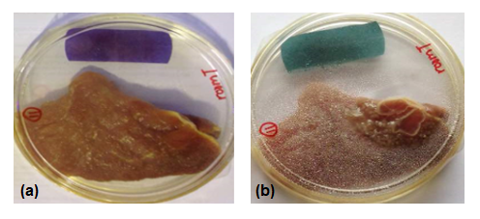

Figure 5. Changes in colour of the visual indicator in the closed container containing beef at room temperature (a) at 0 hour and (b) at hour 24

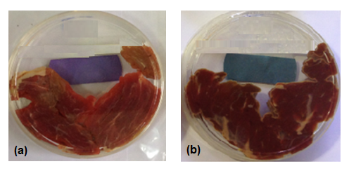

Figure 6. Changes in colour of the visual indicator in the closed container containing beef at chiller temperature (a) at day 0 and (b) at day 10

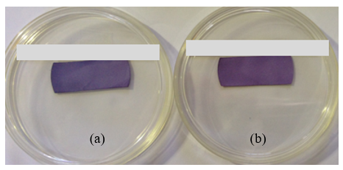

Figure 7. Control analysis of visual indicators throughout the storage duration (a) stored at room temperature and (b) stored at chiller temperature

Table 2. Colour space coordinate values of the visual indicators at (a) room temperature and (b) chiller temperature (Different superscripts in the same line indicate significant differences (p < 0.05) according to Tukey's test)
Colour  Value | - Room Temperature
Colour  Value | Hour 0 | Hour 18 | Hour 24
L* | 47.99 ± 1.30ª | 41.99 ± 1.69^{a,b} | 37.60 ± 1.70^{b}
a* | 16.15 ± 1.15^{c} | -9.52 ± 0.40^{d} | -13.39 ± 2.18e
b* | -24.59 ± 0.44^{f} | -24.44 ± 0.43^{g,h} | -19.59 ± 1.12^{h}

Colour  Value | (b) Chiller Temperature
Colour  Value | Day 0 | Day 6 | Day 10
L* | 47.99 ± 1.30^{i} | 41.93 ± 0.48^{j} | 35.79 ± 0.63^{k}
a* | 16.15 ± 1.15^{l} | -9.03 ± 0.97^{m} | -17.52 ± 0.47^{n}
b* | -24.59 ± 0.44º | -14.58 ± 1.79^{p,q} | -14.32 ± 1.14^{q}

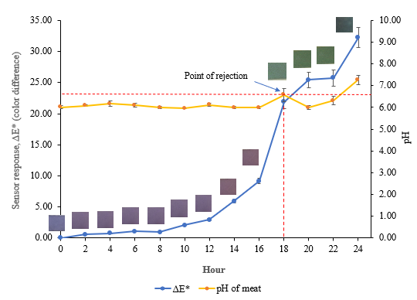

Figure 8. Rate of colour change of delphinidin visual indicators as sensor response (c*) towards beef spoilage at room temperature (29 ± 1 °C) (The yellow line referred to the pH of meat and the blue line referred to ΔE* compared to the initial colour of the indicator)

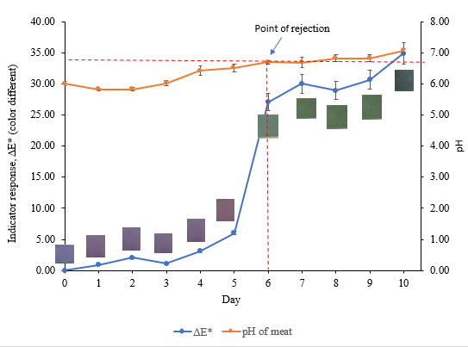
Figure 9. Rate of colour change of delphinidin visual indicators as sensor response (c*) towards beef spoilage at chiller temperature (4 ± 1 °C) (The yellow line referred to the pH of meat and the blue line referred to ΔE* compared to the initial colour of the indicator)

Conclusion

Delphinidin-based visual indicator was successfully developed and used for monitoring beef freshness. The produced visual indicator could be used for detecting the beef freshness quality as the colour changes of the visual indicators had a similar trend with the deterioration of the beef sample (i.e. when the delphinidin-based visual indicator changed to green). The visual indicator demonstrated accurate response to the beef freshness and intense colour changes (green) due to the spoilage of the meat sample. Thus, the developed visual indicator has a potential to be used as an attractive and effective tool for monitoring the microbial quality of packaged fresh beef and may serve as active shelf-life labelling devices to optimise distribution control, management of the stock rotation system, and most importantly, to reduce food waste.

Acknowledgement

The authors would like to thank Majlis Amanah Rakyat (MARA) for the funding “Skim Geran Penyelidikan Inovasi MARA” and also Universiti Kuala Lumpur Malaysian Institute of Chemical and Bioengineering Technology (UniKL MICET) for supporting this project.

References
- Rukchon, C., Nopwinyuwong, A. and Trevanich, S. (2014). Development of a food spoilage indicator for monitoring freshness of skinless chicken breast. Talanta, 130: 547-554.
- Mohebi, E. and Marquez, L. (2015). Intelligent packaging in meat industry: An overview of existing solutions. Journal of Food Science Technology, 52: 3947-3964.
- Kim, H. J., Kim, D., Kim, H. J., Song, S. O., Song, Y. H. and Jang, A. (2018). Evaluation of the microbiological status of raw beef in Korea: Considering the suitability of aerobic plate count guidelines. Korean Journal Food Science Animal Resource, 38(1): 43-51.
- Meat & Livestock Australia (2011). Meat standards Australia beef information kit. Access from https:// www.mla.com.au/globalassets/mla-corporate/ marketing-beef-and-lamb/msa_tt_beefinfokit _jul13_lr.pdf. [Access online on 9 October 2017].
- Kuswandi, B., Jember, U., Jayus, J. and Jember, U. (2015). Simple and low-cost on-package sticker sensor based on litmus paper for real-time monitoring of beef freshness. Journal of Mathematical and Fundamental Sciences, 47: 236-251.
- Dave, D. and Ghaly, A. E. (2011). Meat spoilage mechanisms and preservation techniques: A critical review. American Journal of Agricultural and Biological Sciences, 6(4): 486-510.
- Liu, H., Saito, Y., Dimas, F. A. R., Kondo, N., Yang, X. and Han, D. (2019). Rapid evaluation of quality deterioration and freshness of beef during low temperature storage using three-dimensional fluorescence spectroscopy. Food Chemistry, 287: 369-374.
- Kuswandi, B. and Nurfawaidi, A. (2017). On-package dual sensors label based on pH indicators for real-time monitoring of beef freshness. Food Control, 82: 91-100.
- Kuswandi, B., Anggi, R., Aminah, A., Lee, Y. H. and Musa, A. (2012). A novel colorimetric food package label for fish spoilage based on polyaniline film. Food Control, 25: 184-189.
- Kuswandi, B., Chrysnanda, M., Jayus, A. A and Lee, Y. H. (2013). Real time on-package freshness indicator for guavas packaging. Food Measure, 7: 29-39.
- Pacquit, A., Frisby, J., Diamond, D., Lau, K. T., Farrell, A., Quilty, B. and Diamond, D. (2007). Development of a smart packaging for the monitoring of fish spoilage. Food Chemistry, 102: 466-470.
- Mohd Zulkhairi, A. R., Nurdiyana, H., Mohd Azizan, M. N., Zaida Rahayu, Y. and Ismail-Fitry, M. R (2020). Screening of natural colours from various natural resources as potential reusable visual indicators for monitoring food freshness. Malaysian Journal of Analytical Sciences, 24(2): 288-299.
- Sharma, D. (2014). Understanding biocolour- a review. International Journal of Scientific & Technology Research, 3(1): 294-211.
- Pahune, B. (2013). Antimicrobial activity of Clitoria Ternatea L. flower extract and use as a natural indicator in acid base titration. Journal of Natural Product and Plant Resource, 3: 48-51.
- Tantituvanont, A., Werawatganone, P., Jiamchaisri, P. and Manopakdee, K. (2008). Preparation and stability of butterfly pea color extract loaded in microparticles prepared by spray drying. Thai Journal of Pharmaceutical Sciences, 32: 59-69.
- Wongs - Aree, C., Giusti, M. M. and Schwartz, S. J. (2016). Anthocyanins derived only from delphinidin in the blue petals of Clitoria ternatea. Acta Horticulturae, 712: 437-442.
- Dudnyk, I., Jane, E. R., Joanne, V. J. and Stellacci, F. (2018). Edible sensors for meat and seafood freshness. Sensors and Actuators B, 259: 1108-1112.
- Saptarini, N. M., Suryasaputra, D. and Nurmalia, H. (2015). Application of butterfly pea (Clitoria ternatea Linn) extract as an indicator of acid-base titration. Journal of Chemical and Pharmaceutical Research, 7: 275-280.
- Yoshida, C. M. P., Maciel, V. B. V., Mendonça, M. E. D. and Franco, T. T. (2014). Chitosan biobased and intelligent films: Monitoring pH variations. LWT - Food Sci Technology, 55: 83-89.
- Anuar, N., Mohd Adnan, A. F., Saat, N., Aziz, N., and Mat Taha, R. (2013). Optimization of extraction parameters by using response surface methodology, purification, and identification of anthocyanin pigments in Melastoma malabathricum fruit. The Scientific World Journal, 2013: 810547.
- Rabeta, M. S. and Nabil, Z. A. (2013). Total phenolic compounds and scavenging activity in Clitoria ternatea and Vitex negundo linn. International Food Research Journal, 20: 495-500.
- Mishra, P. K., Singh, P. and Gupta, K. K. (2012). Extraction of natural dye from Dhalia Variabilis using ultrasound. Chem Engineering, 37: 1-18.
- Kungsuwan, K., Singh, K., Phetkao, S. and Utama-ang, N. (2014). Effects of pH and anthocyanin concentration on color and antioxidant activity of Clitoria ternatea extract. Food and Applied Bioscience Journal, 2(1): 31-46.
- Shukla, V., Gurunathan, K. and Mangalathu, R. V. (2015). Development of on-package indicator sensor for real-time monitoring of buffalo meat quality during refrigeration storage. Food Analytical Methods, 8: 1591-1597.
- Kamat, S. S., Khairnar, B. S. and Patil, V. D. (2016). Investigation on new natural colour - acid violet from Clitoria ternatea Linn. Journal of Academia and Industrial Research, 5(1): 14-16.
- Mohammad, R. and Ahmad, M. (2019). Sol-gel/chitosan hybrid thin film immobilised with curcumin as pH indicator for pH sensor fabrication. Malaysian Journal of Analytical Sciences, 23(2): 204-211.
- Realini, C. E. and Marcos, B. (2014). Active and intelligent packaging systems for a modern society. Meat Science, 98: 404-419.
- Olleveant, N.A. (1999). Tukey multiple comparison test. Journal of Clinical Nursing, 8: 299-304.
- Maggiolino, A., Lorenzo, J. M., Marino, R., Malva, A. D., Centoducati, P. and Palo, P. D. (2019). Foal meat volatile compounds: Effect of vacuum ageing on semimembranosus muscle. Journal of Science Food Agriculture, 99(4): 1660-1667.

