
S

EVALUATION ON THE EFFICACY OF DIFFERENT DISRUPTION METHOD OF OIL PALM ROOTS AND Ganoderma boninense CELL WALL

(Penilaian ke atas Keberkesanan Kaedah Pemusnahan yang Berbeza pada Dinding Sel Akar Kelapa Sawit dan Ganoderma boninense)

Arnnyitte Alexander¹, Jedol Dayou², Coswald Stephen Sipaut³, Khim Phin-Chong¹*

¹Biotechnology Programme, Faculty of Science and Natural Resources

²Vibration and Sound Research Group (e-VIBS), Faculty of Science and Natural Resources

³Chemical Engineering Programme, Faculty of Engineering
Universiti Malaysia Sabah, 88400 Jalan UMS, Kota Kinabalu, Sabah, Malaysia

*Corresponding author: chongkp@ums.edu.my

Received: 31 May 2020; Accepted: 7 July 2020; Published: 11 August 2020

Abstract

The cell wall is the outermost layer of cell encountered by pathogens, determining the infection fate. However, the chemical composition involves during host-pathogen interaction has not been fully elucidated. Prior to determining the composition in the cell walls, the walls must be isolated first from the intercellular component. Selected methods for oil palm roots and G. boninense cell disruption were evaluated for their suitability for cell wall isolation and presented in this paper. The effect of selected disruption methods on the content of crude proteins and DNA absorbance under 260 and 280 nm wavelengths in the produced cell wall materials was established on the basis of their solubilized materials. The investigated methods were; i) homogenization with sonication; ii) grinding with liquid nitrogen and; iii) lyophilization with homogenization. The cell wall materials with the highest degree of cytoplasmic component released were produced using lyophilization with homogenization. This was confirmed with the highest DNA absorbance at 260/280 nm of 2.25/1.95 for G. boninense and 2.47/2.35 for oil palm roots in their solubilized materials. The thus-produced preparation also released 4.5 and 10.1 μg/g of crude proteins for G. boninense and oil palm roots respectively. The degree of cell wall purification from intracellular components was validated using Fourier Transform Infrared Spectroscopy (FTIR). Isolated cell wall can be further utilized in cell wall composition analysis.

Keywords: cell wall, disruption methods, lyophilization with homogenization

Abstrak

Dinding sel merupakan lapisan sel paling luar yang ditentang oleh patogen dan menentukan nasib jangkitan. Walau bagaimanapun, komposisi kimia yang terlibat semasa interaksi perumah-patogen masih lagi belum dijelaskan secara terperinci. Sebelum kajian ke atas komposisi dinding sel, dinding tersebut harus dipisahkan daripada komponen sel dalaman terlebih dahulu. Kesesuaian beberapa kaedah terpilih untuk memusnahkan sel akar kelapa sawit dan G. boninense telah dinilai untuk memisahkan dinding sel. Kesan kaedah pemusnahan sel terhadap kandungan protin dan penyerapan asid deoksiribonukleik di bawah panjang gelombang 260 dan 280 nm berdasarkan kepada bahan terlarut di dalam hasil bahan dinding sel telah dinilai. Kaedah pemusnahan yang dikaji adalah; i) homogenisasi dan sonikasi, ii) pengisaran dengan cecair nitrogen, iii) liofilisasi dan homogenisasi. Kaedah liofilisasi dan homogenisasi menghasilkan bahan dinding sel yang mempunyai komponen sitoplasma terbebas tertinggi. Keputusan ini disahkan dengan serapan asid deoksiribonukleik yang tinggi pada 260/280 nm di dalam bahan terlarut iaitu sebanyak 2.25/1.95 untuk G. boninense dan 2.47/2.35 untuk akar kelapa sawit. Selain itu, hasil dinding sel melalui keadah yang sama juga membebaskan 4.5 dan 10.1 μg/g protin masing-masing untuk G. boninense dan akar kelapa sawit. Tingkat kebersihan dinding sel daripada komponen dalaman telah disahkan dengan menggunakan spektrofotometer inframerah transformasi Fourier. Dinding sel yang terpisah seterusnya boleh digunakan di dalam analisa komposisi dinding sel.

Kata kunci: dinding sel, kaedah gangguan, liofilisasi dan homogenisasi

Introduction

Ganoderma boninense infection causes basal stem rot (BSR), a destructive disease that is responsible for considerable decrease in oil palm yield. However, to date there is no adequate control measure to control BSR disease. An improvement of the oil palm defense system against G. boninense is the alternative option, thus requires in-depth understanding on the pathogenesis of G. boninense in oil palm. Plants use various defense mechanisms during their interactions with the pathogens; this includes strengthening of physical barriers which is the cell walls. Living plant cell walls respond to fungal penetration rapidly through the deposition of cell wall components directly onto the inner layer of cellulose (papillae), a process known as cell wall apposition [1]. It has been suggested that cell wall-metabolites are involved in plant-pathogen interaction including communication between host pathogen, activation and implementation of plant defenses in response to pathogen attack [2, 3]. However, until today little is known about the specific component of metabolites in the cell walls. The location of metabolites in the cell wall structure requires disruption to enable the production of cell wall preparations then the metabolite isolation. Efficient breakage of cell wall strength-providing components is necessary to effectively remove intracellular compounds [4]. To date, very little literature has been reported on the evaluation of the suitability of different methodologies for the preparation of plant roots and fungal cell walls for metabolite isolation purpose. Therefore, in this current study we explore the efficacy of different selected methods for oil palm roots and G. boninense cell wall disruption. This includes thorough investigation on the effects of homogenization with sonication, grinding with liquid nitrogen and lyophilization with homogenization on the purity of the produced cell wall materials.

Materials and Methods

Sample preparation

For oil palm root sample preparation, root tissues from eight month-old oil palm seedlings (D x P purchased from Saplantco Sdn. Bhd.) were harvested and washed under running tap water to remove attached dirt. Then roots were soaked in 99% ethanol for 30 seconds and air-dried to remove ethanol and proceeded for further analysis. For G. boninense sample preparation, the pathogen culture was prepared in Potato Dextrose Broth (PDB).6 mm diameter mycelial plug was taken from the edge of a 14 days-old G. boninense culture (obtained from Universiti Malaysia Sabah microbial stock culture) using a cork borer and sub-cultured into PDB and incubated at 28 ºC in an orbital shaker at 150 rpm for 14 days to obtain bulky mycelia. The culture was filtered with muslin cloth to collect the fungal mycelia and rinsed with sterile distilled water thrice. Finally, the mycelia were filtered using Whatman® No.3 filter paper to remove excessive water and kept in sterile falcon tube at -80 °C until further use.

Procedures for cell disruption

The methods employed for physical disruption were selected based on the method’s feasibility, cost, and size of samples.

Grinding under liquid nitrogen

Oil palm roots (100 g fresh weight) were freeze in -80 ˚C overnight. The frozen samples were transferred into a sterile pre-cooled mortar and ground with adequate amount of liquid nitrogen with a pestle. The fine ground samples were then kept in a zip lock plastic bag until further use. G. boninense materials (5 g) were also prepared using similar steps as mentioned above.

Homogenization and sonication

Oil palm roots (100 g fresh weight) were cut into 1.5 cm in size and freshly blended with sterile deionized water using a commercial blender (Waring®, USA). The materials were sonicated using water bath sonicator (Branson, USA). Disruption includes four cycles consisting of 5 minutes of sonication and a 2 minutes break in-between each cycle. The ultrasound frequency was 20 kHz. The resulted materials were washed with distilled water twice, air-dried overnight and kept in zip lock plastic bag at -80 ˚C until further use. G. boninense materials (5 g) were also prepared using similar methods.

Lyophilization and Homogenization

Oil palm root (100 g fresh weight) were lyophilized for 48 hours. Then, the lyophilized materials were homogenized using commercial blender until fine powder and kept in zip lock plastic bag under room temperature ±25 °C until further use. G. boninense materials (5 g) were also prepared using similar methods.

The influence of the disruption methods on solubilized materials

The effectiveness of cell disruption methods was evaluated based on the DNA absorbance (260 and 280 nm) and protein content in their solubilized material.

Determination of UV absorption

The method was based on previous study [4] with some modifications. Solubilization of the studied roots and fungal intracellular materials was determined on the basis of the increase of sample absorbance read at 260 and 280 nm after tissue disruption. For that purpose, 1 g/mL of cell suspension in deionized water was prepared after cell disruption. Samples were centrifuged at 5,000 rpm for 5 minutes and the obtained supernatants were diluted eight times using sterile deionized water before measurements. Absorbance was read at 260 and 280 nm using microplate reader against water. The increase of absorbance of samples at each wavelength was calculated as a difference between the absorbance of samples after a particular disruption method.

Determination of Protein Content

The protein content in solubilized material after cell disruption was analyzed as described previously [5] with some modification. For that purpose, 1 g/mL of cell suspension in deionized water was prepared. Samples were centrifugated at 5,000 rpm for 5 minutes and supernatants were harvested. Four volumes of methanol (Merck, Germany) were added to one volume of the sample and the mixture was vortexed. Later, one volume of chloroform (Merck, Germany) was then added to the mixture, vortexed and centrifuged at 10,000 rpm for 5 minutes. The aqueous methanol layer was removed from the top of the sample. Extracted proteins remained at the boundary phase between the aqueous methanol layer and the chloroform layer. Four volumes of methanol were added, vortexed and centrifuged at 10,000 rpm for 15 minutes. The supernatant was removed and the pellet was air-dried. Then, protein pellets were re-solubilized in 50 μL Milli-Q water and the concentration was determined using Bradford assay (Bradford, 1976). A serial of Bovine serum albumin (99% pure, Sigma-Aldrich) standard ranging from 10-500 mg/mL was prepared for protein quantification.

Isolation and purification of cell walls (CW) material

The resultant CW preparations were pre-purified from cytosol components before further analyses. Only the best disruption method was used for CW isolation as described previously [6] with slight modification. The procedures were conducted at 4 ˚C unless mentioned otherwise. Disrupted cell tissues (3 g) were washed overnight in 50 mL of pre-cooled extraction buffer (5 mM acetate, 0.4 M sucrose, (Sigma-Aldrich, USA) pH 4.6) added with 1% of polyvinylpolypyrrolidone on an orbital shaker. CW were separated from soluble cystoplasmic fluid by centrifuging at 1,000 rpm for 15 minutes. The pellet was re-suspended in 50 mL of 5 mM acetate buffer at pH 4.6 with 0.6 M sucrose followed by centrifugation at 1,000 rpm for 15 minutes. The pellet was further washed in 50 mL of 5 mM acetate buffer at pH 4.6 with 1 M sucrose and centrifuged at 1,000 rpm for 15 minutes. The residue was washed extensively with 50 mL of 5mM acetate buffer at pH 4.6 and centrifuged at 1,000 rpm for 15 minutes, thrice. The supernatant was discarded and the final pellet was lyophilized overnight. Most intercellular components were removed from the CW given the advantage of sucrose gradients and extensive washing with low ionic strength of acidic buffer.

Characteristics of produced cell walls (CW) material

The purity of produced CW was evaluated based on the DNA absorbance (260 and 280 nm) and protein content in the CW material as mentioned previously. In addition, the CW components were also validated using FTIR spectroscopy. FTIR based analysis was preferable due to its sensitivity, high throughput means to access carbon allocation change and less time consuming.

Validation of cell walls (CW) extract using Fourier transform infrared spectroscopy (FTIR) analysis

The chemical composition of isolated CW from oil palm roots seedling and G. boninense were studied using FTIR (Fourier transform infrared) spectroscopy. Raw materials (disrupted cells) were compared with extracted CW. The analysis was performed using FTIR spectrometer (Perkin Elmer, USA) with an attached unit to measure attenuated total reflectance (ATR unit). FTIR spectra were recorded for the wave number range of 4000 to 450 cm⁻¹ with a spectral resolution of 4 cm⁻¹. 32 spectra per sample were added and averaged to improve the signal-to-noise ratio. Spectra were baseline corrected, smoothed and used to compare differences in the spectra. Five replicates were analyzed per sample and data were reported as representative spectra per sample.

Statistical analysis
Statistical differences between methods were determined using one-way ANOVA with Post-Hoc test via Tukey testing with significant value at p = 0.05 using Statistical Package for the Social Sciences (SPSS) software, ver. 21 (SPSS Inc., Rochester, NY).

Results and Discussion

Cell disruption enhances the release of intercellular components, thus improving extraction efficiency and higher CW purity. Extraction of CW metabolite involves three major stages including tissue disruption, isolation, purification of CW materials and finally extraction of CW metabolite. The current study prompted to verify suitable methods to be selected for both oil palm and G. boninense CW isolation at the highest purity to ensure optimum metabolite extraction.

The influence of the tested disruption methods on DNA and proteins contents
The effectiveness of the selected cell disruption’s methods in producing cytoplasm-free CW preparation procedures was determined. The investigated methods included: homogenization with sonication, grinding with liquid nitrogen, and lyophilization with homogenization. According to the study assumptions, CW preparations should be characterized by the highest release of possible content of impurities like proteins and genetic material which served as indicators of complete cell disruption. Effectiveness of the disruption methods on the purity of extracted cell wall of oil palm root and G. boninense are shown in Table 1. The effect of different disruption methods on DNA and proteins contents in the produced solubilized materials was analyzed. Low percentage of protein content and UV absorbance at 260 nm and 280 nm indicated the poorest effectiveness of cells disruption. The highest level of protein release was noted after cell disruption using lyophilization and homogenization for both oil palm roots and G. boninense with 10.1 and 4.5 μg/g respectively. Protein release is one of the key characteristic of microbial cell disruption [7]. The absorbance values at the mentioned wavelengths correspond to absorption by nucleic acid and proteins, respectively, which are the main intracellular constituents of biological cells [8]. The results of absorbance at 260 nm and 280 nm (8-fold diluted samples) presented in Table 1 confirmed the release of intracellular genetic material and proteins during the tested disruption processes.

The highest absorbance values of 260 nm were observed in lyophilization with homogenization method for both oil palm and G. boninense. Homogenization with sonication method was characterized by the lowest efficiency of nucleic acids release (based on absorbance values of 260 nm) applied on oil palm roots. Meanwhile no significant difference observed between the latter method compared to grinding with liquid nitrogen method on G. boninense. In the case of homogenization with buffer followed with sonication, the method is not

sufficient enough to disrupt the sample tissues. Homogenization of hard materials and indirect sonication apparently does not lyse all cells equally, as plant and fungi CW are far more resistant to cell lysis sonication compared to cell membranes, thus making them difficult to rupture. Middleberg [7] explained that mild heat treatment during the sonication primarily kills the cells which may lead to smaller and toughened cells, thus making subsequent mechanical disruption less efficient. A similar result was also observed for the cells subjected to direct grinding with liquid nitrogen. Interestingly, this result contradicts with the findings [9] which reported this method facilitated higher level of CW disruption in Chlorella vulgaris. However, due to the differences in CW structure, not all samples respond the same to similar pre-treatment. Furthermore, this method was not applicable to larger sample volumes as it is quite costly. Both G. boninense and oil palm CW preparations with the highest degree of cytosol component release were produced with lyophilization followed with homogenization. Therefore, this method was selected for the next CW isolation work.

Previous researcher [10] produced Populus tremoloides CW preparations as a result of grinding freeze-dried materials. In effective cell disruption for oil palm roots and G. boninense tissue, lyophilization with homogenization method showed higher released of intercellular components. Apart from providing a complete destruction of the root and fungal cells, this method is apparently simple and consumes less energy. Removal of water molecules from the cells through lyophilization makes the walls structure fragile upon disruption. This allows hypothesizing that the shear forces during homogenization in a blender more easily damaged these cells whose walls were already losing its rigidity producing powder materials. Samples in powder prior to solvent extraction produce a more homogeneous sample and increase the surface area of CW metabolites exposed to the solvent.

Table 1. Effect of different disruption methods of cell disruption on the DNA and total soluble protein content

in oil palm and Ganoderma cell wall
Method | Protein (µg/g) |  | DNA Absorbance
Method | GB | OP | GB |  | OP
Method | GB | OP | 260 nm | 280 nm | 260 nm | 280 nm
M1 | 3.11 ± 0.22^{b} | 2.9 ± 0.2^{c} | 1.62 ± 0.2^{b} | 0.75 ± 0.1^{b} | 1.81 ± 0.2^{b} | 1.60 ± 0.3^{b}
M2 | 3.13 ± 0.3^{b} | 5.03 ±0.5^{b} | 1.7 ± 0.3^{b} | 0.84 ± 0.6^{b} | 1.71 ± 0.2^{c} | 1.52 ± 0.1^{c}
M3 | 4.5 ± 0.21ª | 10.1 ± 0.4ª | 2.25 ± 0.2ª | 1.95 ± 0.4ª | 2.47 ± 0.6ª | 2.35 ± 0.7ª

Notes; * M1 = Homogenization with sonication; M2 = Grinding with liquid nitrogen; M3 = Lyophilization with homogenization; GB = Ganoderma boninense; OP = oil palm; same letter in columns are not significantly different (Tukey’s test, p = 0.05). Each sample consists of three replicates in each disruption methods.

Effectiveness of lyophilization with homogenization method in CW isolation

Lypophilization with homogenization method turned out to be the most effective cell disruption method for both OP roots and G. boninense. Disrupted materials resulted from this method were preceded to CW isolation and purification. Based on Table 2, protein content in the isolated CW of G. boninense and oil palm decreased to 0.001 and 0.005 μg/g respectively. Similarly, lower absorbance at 260 nm and 280 nm in solubilized material after CW purification observed in both G. boninense and oil palm.

The method was proven to be the most effective method for cell disruption and purification from cytosol components for both OP roots and G. boninense based on the lowest reading of protein content and absorbance at 260 nm and 280 nm in solubilized material after CW purification. Lower content of protein and DNA absorbance in CW solubilized material also demonstrated the effectiveness of washing steps in CW purification stage. Plant and fungal cell walls are mainly build with highly dense polysaccharides [11], therefore, purification of their CW materials from cytoplasmic fraction were conducted through density gradients by centrifugation. Low centrifugation and extensive washing with cold buffer were able to wash CW materials free from intercellular contaminants [12]. It is often necessary to dry purified CW materials prior to solvent extraction because many organic solvents cannot penetrate into CW with water content, and therefore extraction would be inefficient. Dried samples that were ground finely prior to solvent extraction would produce a more homogenous sample and increase the surface area of metabolites exposed to the solvent.

Spectral analysis of CW extracts using FTIR

Purity of the produced CW was validated using infrared spectroscopy. Figure 1 shows the IR spectrum of G. boninense disrupted cells and its purified CW. The purified CW exhibited weak intensities at 3280 cm⁻¹, 1630 cm⁻¹, 1550 cm⁻¹ and 1370 cm⁻¹ corresponding to proteins components of amide A, amide I, amide II and amide III respectively [13]. These were correlated with the total protein content as mentioned previously in Table 2. Bands at 1050 cm⁻¹ and 550 cm⁻¹ are characteristic of polysaccharides (α- and β-glucans, α-mannan) [14]. Band absorption at 1230 cm⁻¹ influenced by PO3 groups from nucleic acid residues was absent in purified CW. The absorption band in the spectral region at 2900 cm⁻¹ confirmed the presence of lipid residues (CH3 and CH2 groups) in the studied CW, similarly, absorption band at 2160 cm⁻¹ (C ≡ C group) derived from fatty acid in lipids [15].

Figure 2 shows the IR spectrum of disrupted OP roots and its purified CW via lyophilization and homogenization method. Bands at 3340 cm⁻¹, 1250 cm⁻¹, 1030 cm⁻¹ and 550 cm⁻¹ are characteristics of polysaccharides. Absorption bands located in the spectral region at approximately between 775 cm⁻¹ to 1030 cm⁻¹ in disrupted root cells could be a consequence of genetic material residue and the presence of glycogen in the analyzed sample [16]. For example, guanine and cytosine absorption bands occur at 775 cm⁻¹ while the bands at 820 cm⁻¹, 867 cm⁻¹ and 1030 cm⁻¹ could result from deoxyribose and phosphodiester backbones. Subsequently these bands were not observed in purified CW, thus showing the effectiveness of the washing stage in CW purification stage which is also correlated to the DNA absorbance result as shown in Table 2. Therefore, CW materials are considered to be cytoplasmic free. Meanwhile, absorption bands at 2930 cm⁻¹ (C-H group) and 1645 cm⁻¹ (C-O group) confirmed the presence of lipid residues [15]. Bands at 1425 cm⁻¹ and 1370 cm⁻¹ attributed to methyl and amine group from protein are absence in purified CW.

Table 2. Effect of lyophilization with homogenization method in cell wall isolation and purification
Protein (µg/g) |  | DNA Absorbance (260/280 nm)
GB | OP | GB |  | OP
GB | OP | 260 nm | 280 nm | 260 nm | 280 nm
0.001 ± 0.9 | 0.005 ± 1.3 | 0.002 ± 1.5 | 0.001 ± 0.3 | 0.002 ± 0.6 | 0.003 ± 0.4

Notes: GB = Ganoderma boninense; OP = oil palm. Each sample consists of three replicate

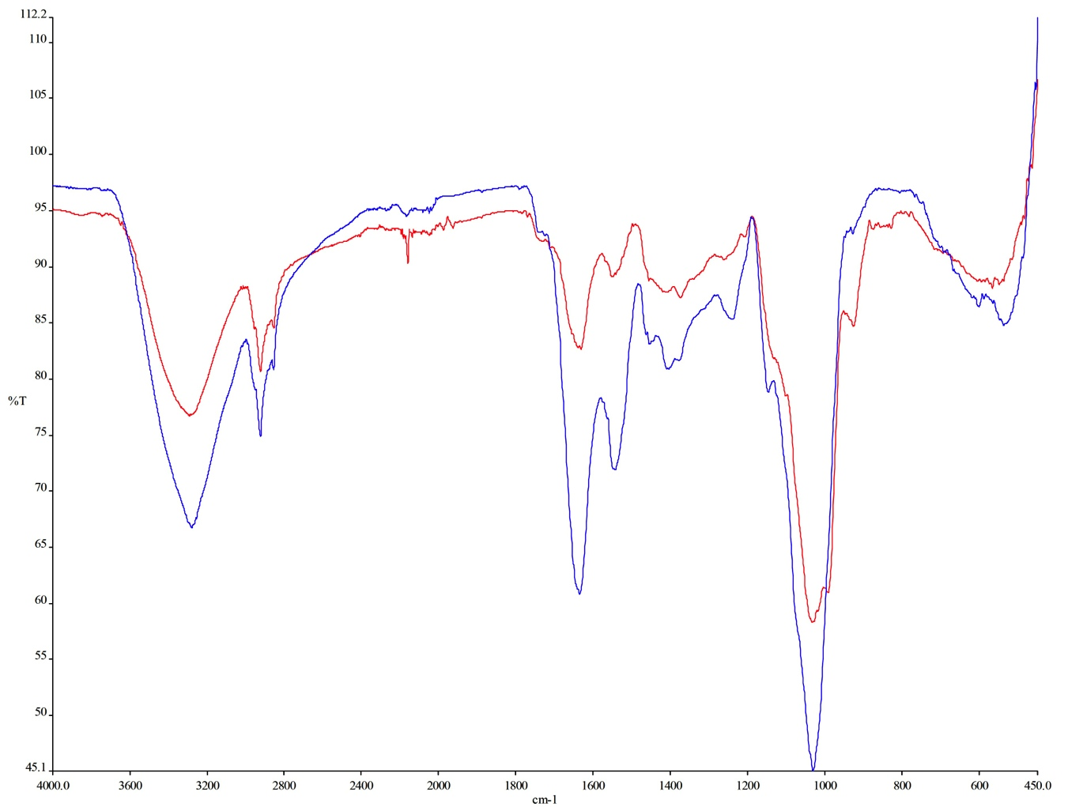
3280 cm⁻¹

2900 cm⁻¹

1630 cm⁻¹

1550 cm⁻¹

2160 cm⁻¹

1370 cm⁻¹

1230 cm⁻¹

1050 cm⁻¹

550 cm⁻¹

Figure 1. Infra-red spectrum of disrupted cells and purified cell wall of G. boninense via lyophilization with homogenization disruption method. Notes: Red line indicates purified cell wall; Blue line indicates disrupted cells before cell wall purification
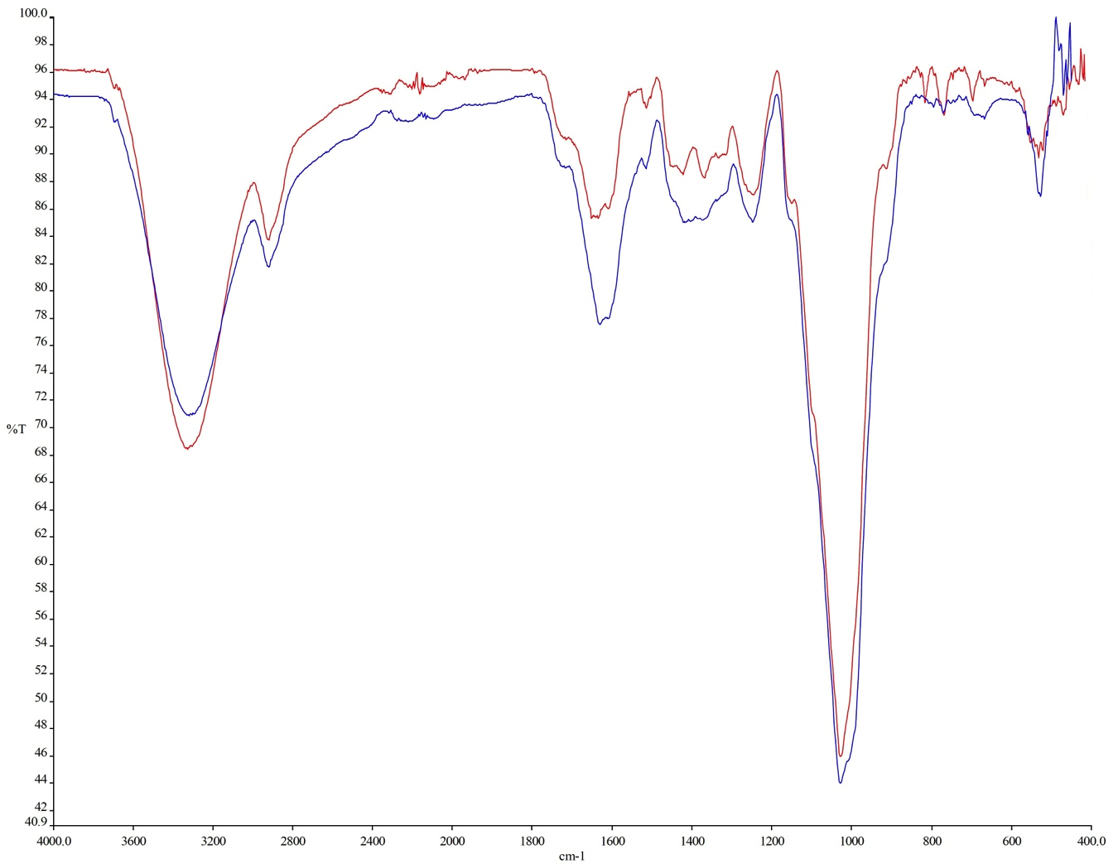
3340 cm⁻¹
2930 cm⁻¹
1645 cm⁻¹
1425 cm⁻¹
1370 cm⁻¹
1250 cm⁻¹
1030 cm⁻¹
867 cm⁻¹
820 cm⁻¹
775 cm⁻¹
550 cm⁻¹
Figure 2. Infra-red spectrum of oil palm roots cell wall preparation after disruption with lyophilization with homogenization. Notes: Red line indicates disrupted roots; Blue line indicates purified cell wall

Conclusion

The use of different methods for oil palm and G. boninense cell disruption had a significant effect in the resulting cell wall outcome. Among the analyzed methods, the most promising result was achieved by using lyophilization followed by homogenization disruption method. Cell wall preparation produced with this method was characterized by the lowest proteins content and DNA absorbance under 260 and 280 nm. Isolation of CW at the highest purity will ensure optimum metabolites extraction.

References
- Underwood, U. (2012). The plant cell wall: A dynamic barrier against pathogen invasion. Frontier Plant Science, 3: 85.
- Shah, J. and Chaturvedi, R. (2009). Lipid signals in plant-pathogen interactions. Annual Plant Reviews, 34: 292-333.
- Siebers, M., Brands, M., Wewer, V., Duan, Y., Georg, H. and Peter, P. (2016). Lipids in plant-microbe interactions. Biochimica et Biophysica Acta, 1861(9): 1379-1395.
- Liu, D. Zeng, Z. A. Sun, D. W. and Han, Z. (2013). Disruption and proteins release by ultrasonication of yeast cells. Innovative Food Science and Emerging Technologies, 18: 132-137.
- Fic, E., Krok, S. K., Jankowska, U., Pirog, A. and Wasylewska, M. D. (2010). Comparison of protein precipitation methods for various rat brain structures prior to proteomic analysis. Electrophoresis, 31: 3573-3579.
- Canut, H., Albenne, C. and Jamet, E. (2016). Isolation of the cell wall. Methods in Molecular Biology, 1511: 171-185.
- Middleberg, A. J. (1995). Process-scale disruption of microorganisms. Biotechnology Advance, 113: 491-551.
- Cheung, M. C., LaCroix, R. and McKenna, B. K. (2013). Intercellular protein and nucleic acid measured in eight cell types using deep-ultraviolet mass mapping. Cytometry, 83(6): 540-551.

- Zheng, H., Yin, J., Gao, Z., Huang, H., Ji, X. and Dou, C. (2011). Disruption of Chlorella vulgaris cells for the release of biodiesel-producing lipids: A comparison of grinding, ultrasonication, bead milling, enzymatic lysis, and microwaves. Applied Biochemistry and Biotechnology, 164: 1215-1224.
- Siebers, M., Brands, M., Wewer, V., Duan, Y., Georg, H. and Peter, P. (2016). Lipids in plant-microbe interactions. Biochimica et Biophysica Acta, 1861(9): 1379-1395.
- Cooper, G. M. (2000). The cell: A molecular approach (2nd edition). Sinauer associates: Sunderland, Massachusetts.
- Dallies, N., Jean, F. and Veranique, P. (1998). A new method for quantitative determination of polysaccharides in the yeast cell wall. Application to cell wall defective mutants of Saccharomyces cerevisiae. Yeast, 14: 1297-1306.
- Tatulian, S. A. (2013). Structural characterization of membrane proteins and peptides by FTIR and ATR-FTIR spectroscopy. Methods in Molecular Biology, 974: 117-218.
- Galichet, A., Sockalingum, G. D., Belarbi, A. and Manfait, M. (2001). FTIR spectroscopic analysis of Saccharomyces cerevisiae cell walls: Study of an anomalous strain exhibiting a pink-colored cell phenotype. FEMS Microbiology Letters, 197: 179-186.
- Adt, I., Toubas, D., Pinon, J. M., Manfait, M. and Sockalingum, G. D. (2006). FTIR spectroscopy as a potential tool to analyse structural modifications during morphogenesis of Candida albicans. Archeology Microbiology, 185: 277-285.
- Tajmir-Rhiai, H. A., N’soukpoé-Kossi, C. N. and Joly, D. (2009). Structural analysis of protein-DNA and protein-RNA interactions by FTIR, UV-visible and CD spectroscopic methods. Spectroscopy, 23: 81-101.

