OPTIMIZATION OF MONTMORILLONITE K10 ION-EXCHANGE WITH Fe³⁺ FOR THE APPLICATION OF BIODIESEL PRODUCTION

(Pengoptimuman Pertukaran Ion Montmorilonit K10 dengan Fe³⁺

untuk Aplikasi Penghasilan Biodiesel)

Syahirah Yahya¹ and Farah Wahida Harun^{2, 3*}

¹Department of Chemistry and Food Technology,

Politeknik Tun Syed Nasir Syed Ismail,

Hab Pendidikan Tinggi Pagoh, KM1 Jalan Panchor, 84600 Pagoh, Johor, Malaysia

²Faculty of Science and Technology,

²Frontier Materials Research Group,

Universiti Sains Islam Malaysia,

Bandar Baru Nilai, 71800 Nilai, Negeri Sembilan, Malaysia

*Corresponding author: farahw@usim.edu.my

Abstract

The modification of montmorillonite K10 with Fe³⁺ was investigated to study the optimum ion-exchange occurred in the interlayers of clays. Montmorillonite K10 was modified to be applied as a catalyst in biodiesel production from waste cooking oil (WCO). Three methods to optimize the ion-exchange process were investigated. For method 1 and method 2, respective 14% and 27% by mass of Fe in montmorillonite K10 were stirred in a closed cap system for 7 hours while method 3 applied 20% of Fe stirred with montmorillonite K10 for 24 hours until it became mold and slurry. The ability of ion-exchange was tested using SEM/EDX. It was found that 1.21% Fe composition increased by using method 1 while 2.66% Fe increased using method 2. The highest Fe exchange was detected using method 3 with 5.23% increment. For more accurate result, 20% Fe-MMT K10 from method 3 was characterized using XRF and it was found that the ion exchange occurred with interchangeable Ca²⁺. In correlation, the effect of Fe increment on acidity was studied by using TPD-NH₃. Naturally, montmorillonite K10 possessed 0.232 mmol/g of acidity. The results found that the highest acidity was detected for 20% Fe-MMT K10 (14.261 mmol/g). The application of montmorillonite K10 on biodiesel production increased the yield up to 38.39% compared to the reaction without catalyst (26.80%). With the aid of modified montmorillonite K10, 66.54% and 69.32% biodiesel were produced using catalyst from method 1 and 2 respectively. Amazingly, an outstanding yield was produced by using catalyst from method 3 (84.58%). Therefore, 20% Fe-MMT K10 catalyst was selected for further biodiesel optimization via conventional method. It was found that 96.49% biodiesel was successfully produced with 28.65% acid conversion at 150 °C, 6 h, 12:1 methanol: oil and 4 wt.% mass of catalyst. The investigations on acid conversion and biodiesel yield proved that the modification of montmorillonite K10 with 20% Fe is the optimum and the catalyst can undergo both esterification and transesterification reactions simultaneously to produce optimum biodiesel yield.

Keywords: Montmorillonite K10, Fe³⁺ ion-exchange, simultaneous esterification-transesterification, biodiesel, waste cooking oil

Abstrak

Pengubahsuaian montmorilonit K10 dengan Fe³⁺ telah dijalankan untuk mengkaji pertukaran ion yang optimum pada lapisan tanah liat. Montmorilonit K10 diubahsuai untuk dijadikan sebagai pemangkin dalam pengeluaran biodiesel dari minyak masak terpakai (WCO). Tiga kaedah untuk mengoptimumkan proses pertukaran ion telah dikaji. Untuk kaedah 1 dan kaedah 2, masing-masing 14% dan 27% jisim Fe dalam montmorilonit K10 telah dicampur dalam sistem tertutup selama 7 jam. Manakala kaedah 3 menggunakan 20% Fe dikacau dengan montmorilonit K10 selama 24 jam sehingga pekat seperti tanah liat. Keupayaan penukaran ion telah diuji menggunakan SEM/EDX. Hasil kajian mendapati bahawa komposisi Fe meningkat sebanyak 1.21% dengan menggunakan kaedah 1 manakala 2.66% Fe meningkat dengan menggunakan kaedah 2. Pertukaran Fe tertinggi telah dikesan menggunakan kaedah 3 dengan kenaikan Fe sebanyak 5.23%. Untuk hasil yang lebih tepat, 20% Fe-MMT K10 dari kaedah 3 dicirikan dengan menggunakan XRF dan didapati ion Ca²⁺ bertukar dengan Fe³⁺. Kesan kenaikan Fe terhadap tahap keasidan dikaji dengan menggunakan TPD-NH₃. Pada asalnya, montmorilonit K10 mempunyai tahap keasidan 0.232 mmol/g. Setelah diubahsuai, keasidan tertinggi dikesan pada sampel 20% Fe-MMT K10 (14.261 mmol / g). Penggunaan montmorilonit K10 dalam pengeluaran biodiesel menghasilkan 38.39% produk berbanding tindak balas tanpa pemangkin (26.80%). Dengan bantuan montmorilonit K10 yang diubahsuai, masing-masing 66.54% dan 69.32% biodiesel dihasilkan menggunakan pemangkin yang diubahsuai dari kaedah 1 dan 2. Namun, biodiesel yang paling tinggi dihasilkan dengan menggunakan pemangkin daripada kaedah 3 (84.58%). Oleh itu, pemangkin 20% Fe-MMT K10 telah dipilih untuk pengoptimuman biodiesel melalui kaedah konvensional. Hasil kajian mendapati bahawa 96.49% biodiesel berjaya dihasilkan dengan penukaran asid sebanyak 28.65% pada 150 °C, 6 jam, 12: 1 metanol: minyak dan 4% berat masa pemangkin. Kajian penukaran asid dan hasil biodiesel telah membuktikan bahawa pengubahsuaian montmorilonit K10 dengan 20% Fe adalah optimum dan 20% Fe-MMT K10 boleh menjalani tindak balas esterifikasi dan transesterifikasi secara serentak untuk menghasilkan biodiesel yang optimum.

Kata kunci: Montmorilonit K10, pertukaran ion Fe³⁺, esterifikasi-transesterifikasi serentak, biodiesel, minyak masak terpakai

Introduction

The application of heterogeneous catalyst in many reactions is important in recent time. Many natural catalysts were investigated on selective organic transformations as synthetic techniques under green chemistry. Currently, the natural catalyst under investigation includes natural clay like montmorillonite. It can work under mild condition and the catalyst can be recovered by simple filtration and evaporation, and then can be regenerated and reused. In nature, montmorillonite possessed Lewis and Brønsted acidity [1] that enable the clay to function in esterification and transesterification reactions simultaneously. The Lewis acidity mainly originates from the metal atoms at the edge sites while the Brønsted acidity is from the interlamellar water coordinated to exchangeable cations.

Montmorillonite was used in biodiesel production, however the production was low with around 60% yield and required a long reaction time and a large amount of catalyst loading to achieve the yield [2, 3]. Hence, some modification is required to be done on montmorillonite to improve the acidity. There are two modification methods to improve the acidity which are pillaring method [4] and ion-exchange method [5]. The pillaring method was successful in laboratory synthesis. However, it is not an ideal preparation technique for large-scale production because of the long preparation period as well as waste water and chemical [4, 6]. Therefore, ion-exchange method is considered as a relevant technique to modify the montmorillonite as it involves simple stirring method in short duration.

In biodiesel production, iron (Fe) was considered as efficient Lewis metal when the single metal can act as a catalyst and produced up to 94% biodiesel from waste cooking oil (WCO) [7]. The collaboration of Fe with montmorillonite can reduce the metal consumption in biodiesel production as it is able to improve the acidic sites of montmorillonite. However, the review from literature noticed that the ion exchange of montmorillonite with Fe could only achieve 70% conversion [8, 9]. Some modification in the preparation technique is required to optimize the ion exchange.

In this study, we employed a simple technique, modified from the previous methods [10, 11] to optimize the ion exchange and acidity of montmorillonite K10. The montmorillonite interchangeable cations were exchanged with iron (III) ion (Fe³⁺) and the ion exchange and acidity were tested using scanning electron microscope with energy dispersive X-ray (SEM/EDX) and temperature programmed desorption with ammonia (TPD-NH₃). The ion exchange method was confirmed by X-ray fluorescence (XRF) analysis. The performance was evaluated based on biodiesel production from WCO to study the effect of metal concentrations on the catalyst efficiency. The optimum condition for the catalytic activity was also investigated for the maximum biodiesel production.

Materials and Methods

Materials

WCO sample was collected from restaurants near USIM and was previously characterized [12] with free fatty acid content (%FFA) of 3.97% ± 0.01. Another purchased materials like montmorillonite K10 powder (CAS Number: 318-93-0) and FAME Mix C8 – C24 (CAS Number: CRM18918) were purchased form Sigma-Aldrich, iron(III) chloride, 98%, pure, anhydrous (CAS Number: 7705-08-0) was purchased from Acros Organics™, Methanol anhydrous (CAS Number: 67-56-1) was purchased from SupraSolv and silver nitrate (AgNO₃) (CAS Number: 7761-88-8) was purchased from Fischer Scientific.

Modification of catalyst: Method 1

The modification steps of montmorillonite K10 by using ion-exchange method were modified from Almadani et al. [10] and Sabri et al. [11]. 14% Fe in montmorillonite K10 was weighed by using FeCl₃. The mass of Fe was calculated using equation 1.

$mass of MClx$
(1)
$$=14\text{\%}×5g of montmorillonite K10$$
$$×\frac{molecular mass of MClx}{Atomic mass of M}$$

Then, FeCl₃ was dissolved in 80 mL distilled water and mixed with 5 g of montmorillonite K10 clay. The mixture was let in stirring condition at 300 rpm for 7 hours at 80 °C with loose closed cap to avoid evaporation. After that, it was filtered and rinsed for a few times until no Cl⁻ ion was detected by AgNO₃ drop. This is to ensure the excessive ions were removed. The residue was collected and dried in the oven at 105 °C for overnight before allowed to be calcined at 500 °C for 4 hours. After the calcination process, the modified clay was kept in a screw capped bottle and labelled as 14% Fe-MMT K10.

Method 2
The same steps as in Method 1 were repeated by using 27% FeCl₃ and denoted as 27% Fe-MMT K10.

Method 3
The modification method was improved by weighing 20% Fe in montmorillonite K10 by mass and dissolved in 25 mL of distilled water. The FeCl₃ solution was mixed with 5 g of montmorillonite K10 clay and left in stirring condition at a slightly lower temperature i.e. 40 °C as compared to method 1 and 2. The mixture was stirred until it became slurry to allow the optimum ions exchange [14, 15]. It took 24 h to let the mixture became slurry. The purpose of slurry condition was to ensure the Fe rich environment surrounded the montmorillonite K10, hence promoted the ion exchange to occur. After that, the slurry mixture was washed with distilled water to remove excessive ions followed by drying and calcination steps as in Method 1. The catalyst was labeled as 20% Fe-MMT K10. Figure 1 shows the steps of ion-exchange method.

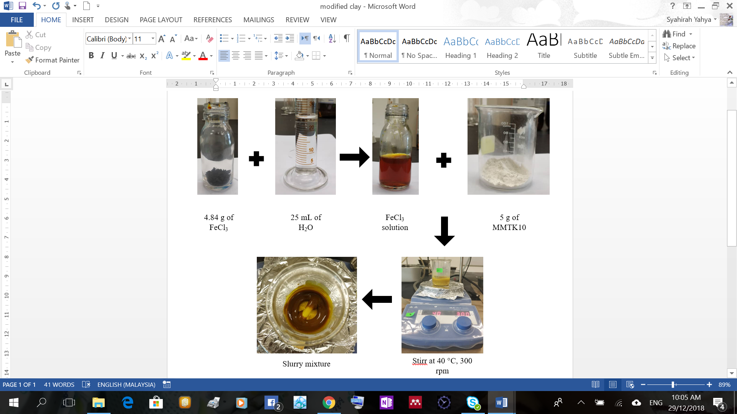

Figure 1. Catalyst modification steps

Characterization of catalyst: X-ray diffractometers (XRD)
The diffraction patterns of montmorillonite K10 and the modified montmorillonite K10 were identified by using SHIMADZU X-ray Diffractometers (Lab X, XRD-6000). The XRD was calibrated with zero diffraction plate which was made up of silica. After that, dry sample was pressed compactly on the plate. The method of analyzing was set-up at continuous mode with the scan axis 2Theta/Theta, with the scan condition range 5 – 80°, step 0.02°, speed 2°/min and the preset time 0.6 sec while the voltage used was 30 kV and current 30 mA.

Scanning electron microscope with energy dispersive X-ray (SEM-EDX)
The morphology of catalysts was analyzed using Hitachi SU 1510 SEM. It was analyzed with magnification 1500x at 15 kV with 8.0 mm distance of laser tip to dental surface. Temperature-programmed desorption with ammonia desorption (TPD-NH₃): The Lewis and Brønsted acid sites were analyzed using Thermo Scientific TPDRO 1100. About 0.05 g of sample was placed in the reactor, treated under 150 °C for 20 minutes in N₂ (20 mL/min). The sample was exposed to the flow of NH₃ in fume hood for 60 minutes. Then, the excess NH₃ in the gas phase was removed by purging with N₂ for 45 minutes. The analysis of NH₃ desorbed was carried out between 50 °C and 950 °C under helium flow (10 °C/min, 30 mL/min) and detected by a thermal conductivity detector.

X-ray fluorescence (XRF)
The metal composition of the clay catalysts was determined by XRF method using wavelength dispersive X-ray fluorescence (WD-XRF) spectrometer Bruker S8 TIGER equipped with 4 kW Rh anode as the source of X-rays; elements from Na to U were detected and semi-quantitative analyses was performed by using software SuperQ versión 5.0 L – OMNIAN database standards.

Catalytic screening
The prepared solid acid catalysts were evaluated for the synthesis of biodiesel from WCO under identical reaction conditions; 6 hours reaction period, 12:1 methanol to oil molar ratio and 4% w/w catalyst at 130 °C via reflux system connected to circulatory chiller (Figure 2). Prior to the reaction, WCO was filtered to remove insoluble impurities and further heating above 105 °C for overnight to remove the moisture. This was to ensure no strange particle that may inhibit the reaction. The efficiency of catalyst was studied based on the acid conversion (Equation 2) and fatty acid methyl ester (FAME) yield (Equation 3).

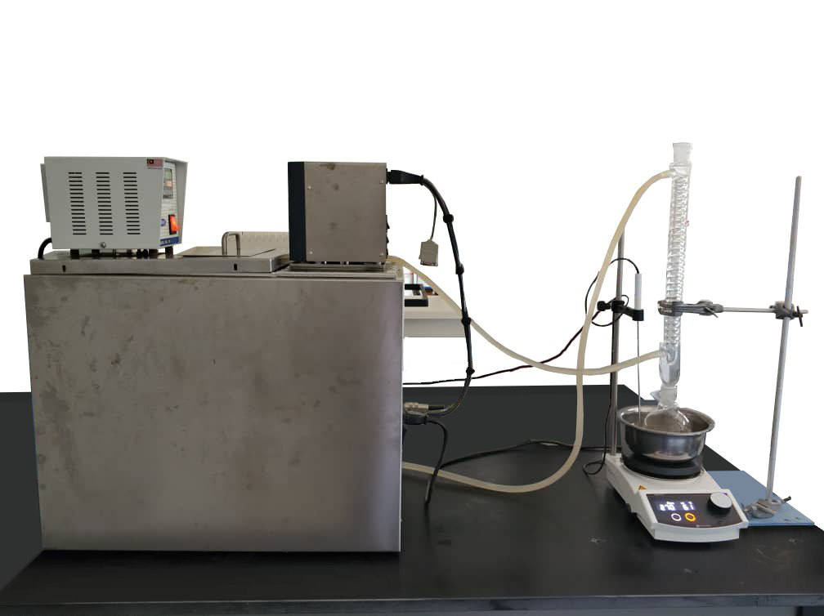
Water flow out
Water flow in
Temperature probe
Reflux
Circulatory Chiller
(8° C)
Figure 2. Reflux system to produce biodiesel.

$\% Acid Conversion= \frac{{AV}_{i}- {AV}_{f}}{{AV}_{i}} ×100$
(2)
(3)
$\%yield= \frac{mass of FAME }{mass of fed WCO} X 100$

Optimization of biodiesel production
From the catalytic screening, the most efficient catalyst capable of producing the highest FAME yield was considered to optimize the biodiesel production conventionally. Four parameters at three levels were studied and the conditions were varied at temperature of 100, 150 and 200 ºC; reaction time of 3, 6 and 9 hours; methanol to WCO ratio 10:1, 12:1 and 14:1 and catalyst loading 2, 4 and 6 wt.% [14, 16]. The acid conversion and FAME yield were calculated according to equation 2 and 3.

Results and Discussion

Characterization of catalyst: XRD patterns

XRD patterns of the samples are shown in Figure 3. The X-ray patterns reveal that the modified samples have structural characteristics nearly identical to the unmodified montmorillonite K10. This refers to the interlayer clay that was not affected by Fe³⁺ exchange reaction and the clay structure was retained during the exchange processes. The basal spacing of d001 observed for all samples at 8.8° (ca. 10.01 Å) indicated the presence of 2:1 (T:O:T) structure [17, 18]. This can perceive maintenance of reflection characteristic of this clay mineral. According to Michelle et al. [19], this is an important point, since the preservation of the crystal structure is essential for the material to maintain its thermal stability when applied in catalytic processes. Figure 3 shows that the montmorillonite K10 is composed of mixed phases and this result is in good agreement with previously reported data [20–22].

The treatment of the montmorillonite K10 with Fe³⁺ did not have a marked effect on its phase structure. The intensity of the diffraction peaks at 25.6° decreased when the samples were modified using method 3. It could be due to the leaching of existing cations from the octahedral layers of the montmorillonite K10 to exchange with new loaded metal [22] and crystallinity reduction. However, no diffraction peaks resulting from the metal compounds were observed, indicating that the metal cations were highly dispersed throughout the catalysts by the displacement of small cations [22]. Fe³⁺ gradually occupied the interlayer vacancies by the exchangeable metal ions in the montmorillonite K10 clay interlayers, thus retained the clay structure during the exchange processes. The findings of consistent structure after modification have been studied previously in the case of Cu²⁺, Zn²⁺ and Fe³⁺ ions exchanged montmorillonite clay [10, 13].

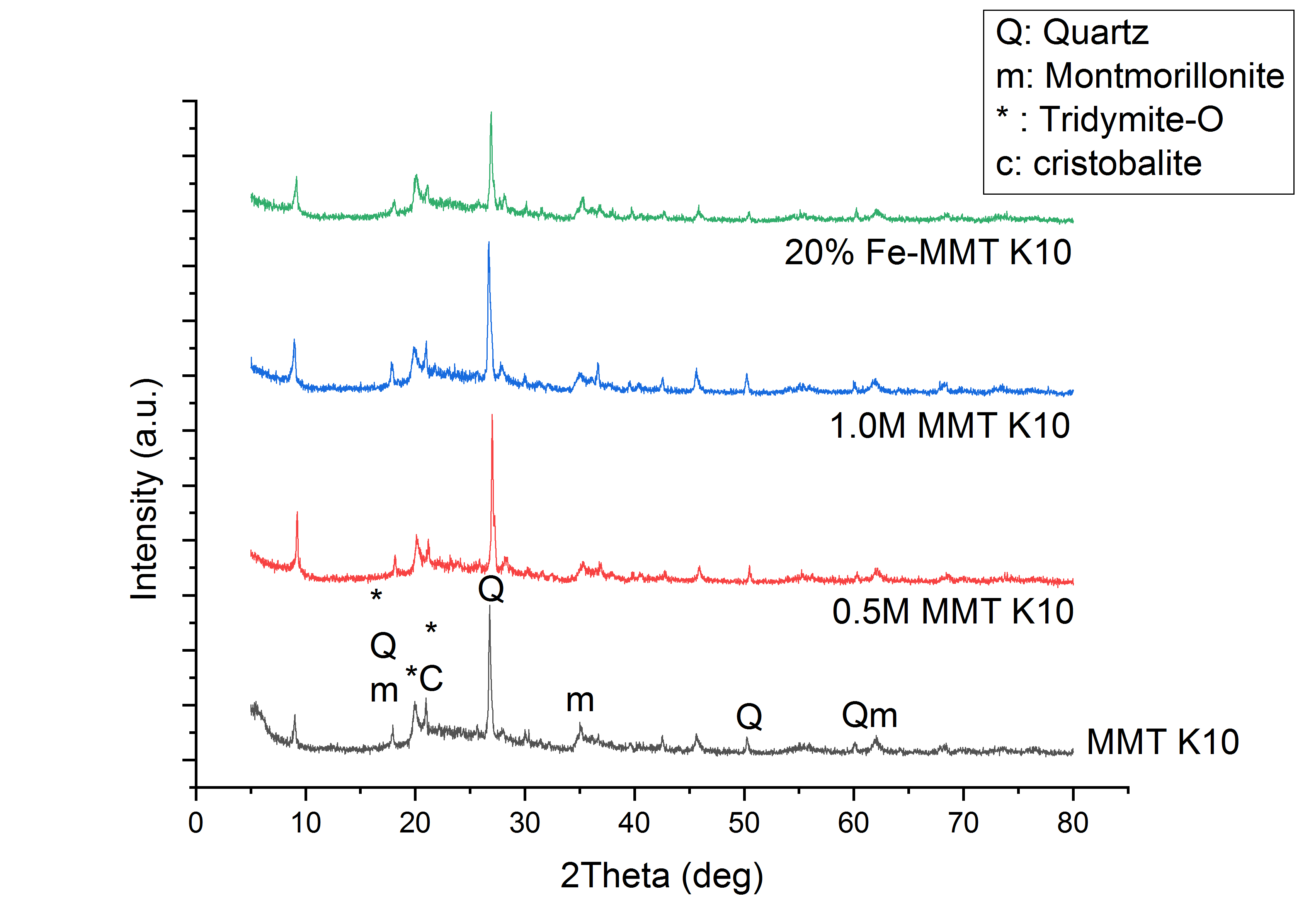
27% Fe-MMT K10
14% Fe-MMT K10

Figure 3. XRD patterns of montmorillonite K10 and its modified samples

SEM morphology
The SEM images of montmorillonite K10 and modified samples with 1500x magnification are depicted in Figure 4. From the morphology images, the montmorillonite K10 consisted of large particles. After modifications, the modified catalysts were found to be more compact compared to the original montmorillonite K10. This was due to the grinding steps that reduced the size of the particles. It can be clearly seen that the clay surface after exchanged process has non-aggregated morphology. Similar result was obtained by Almadani et al. in the modification of montmorillonite K10 with Fe [5]. In addition, the morphology of 20% Fe-MMT K10 seems to have shinier particles compared to 14% and 27% Fe-MMT K10. This was probably contributed by the metal properties with higher composition.

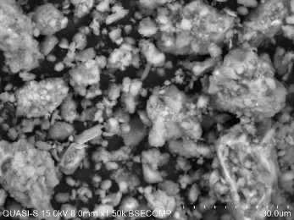  (a) | 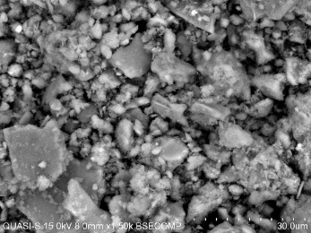  (b) | 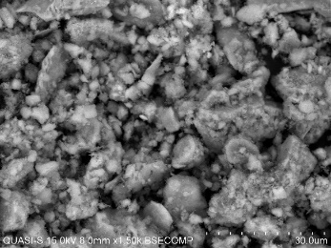  (c) | 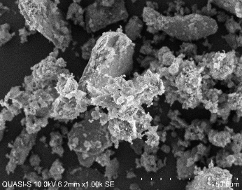  (d)

Figure 4. SEM morphology of montmorillonite K10 and its modifications with (b) 14% Fe³⁺, (c) 27% Fe³⁺ and (d) 20% Fe³⁺

EDX analysis
For screening purpose, all catalyst samples were characterized using EDX. Table 1 shows the elemental composition of montmorillonite K10 and modified samples from the EDX analysis, while Table 2 shows the change of Fe after the modification with Fe³⁺. The result shows that the composition of Fe increased with the increase of metal concentration during modification. In method 3, the concentration of Fe increased by stirring period until it became slurry. It can be concluded that, the longer the stirring period during modification step, the higher the opportunity for the montmorillonite K10 to be exposed with the environment that possessed high Fe concentration.

Table 1. Elemental compositions of montmorillonite K10 and its modified samples

Type of catalyst | C | O | Mg | Al | Si | K | Fe
Montmorillonite K10 | 28.97 ± 3.03 | 53.52 ± 3.09 | 0.58 ± 0.08 | 2.97 ± 1.66 | 13.64 ± 1.52 | 0.39 ± 0.11 | 0.45 ± 0.13
14% Fe-MMT K10 | 26.30 ± 1.58 | 53.63 ± 0.80 | 0.41 ± 0.09 | 3.35 ± 1.06 | 14.51 ± 1.40 | 0.30 ± 0.03 | 1.66 ± 0.60
27% Fe-MMT K10 | 15.30 ± 1.35 | 54.69 ± 3.61 | 0.58 ± 0.10 | 3.32 ± 0.48 | 23.61 ± 2.59 | 0.31 ± 0.14 | 3.11 ± 0.66
20% Fe-MMT K10 | 26.13 ± 1.99 | 40.26 ± 2.50 | 0.94 ± 0.09 | 3.70 ± 1.07 | 22.72 ± 1.84 | 0.57 ± 0.09 | 5.68 ± 0.46

Table 2. Change of Fe composition in montmorillonite K10 after modification

Type of Catalyst | Change of Fe Composition (%)
Montmorillonite K10 | 0
14% Fe-MMT K10 | 1.21
27% Fe-MMT K10 | 2.66
20% Fe-MMT K10 | 5.23

XRF analysis
According to the EDX results, method 3 shows the highest Fe compositions in the catalyst. However, due to the large error of EDX, a confirmatory test using XRF was done on 20% Fe-MMT K10 for more accurate result. From Table 3, montmorillonite K10 primarily consisted of octahedral Al³⁺ and tetrahedral Si⁴⁺ with Na⁺, K⁺, Mg²⁺ and Ca²⁺ as exchangeable interlayer cations [14]. The decrease in Ca²⁺ and increase in Fe³⁺ compositions confirmed the occurrence of ion-exchange in the MMT clay. Similar result was found in the modification of montmorillonite K10 with erbium ion [22]. The decrease of other elements concentrations indicate that the erbium ions gradually occupied the interlayer vacancies by replacing H⁺ and exchangeable metal ions in the montmorillonite K10 clay interlayers.

Table 3. The elemental compositions of catalysts as determined by XRF

Elements | Mass Compositions (%)
Elements | Montmorillonite K10 | 20% Fe-MMT K10
Na  Mg  Al  Si  K  Ca  Fe  Zn | 0.0992  0.739  5.88  28.0  1.04  0.211  1.69  0.0026 | 0.156  0.705  6.05  30.0  1.30  0.0685  3.46  0.0031

TPD-NH₃ analysis
TPD of adsorbed ammonia is a reliable method to feature the acidity strength but not the nature (Brønsted or Lewis) of surface acid sites in solid acid catalysts [23]. Liu et al. revealed the definition of acidic sites as weak, medium and strong at desorption temperatures of 150-250 °C, 250-500 °C and >500 °C respectively [24]. Figure 5 and Table 4 show that montmorillonite K10 was readily consisted of small ammonia desorption band corresponding to the weak and strong acidic sites with total NH₃ desorption of 0.232 mmol/g. The result obtained was similar to Phukan et al., who obtained 0.20 mmol/g NH₃ desorption for montmorillonite K10 [25]. The trend of acidity increased from 14% Fe-MMT K10, followed by 27% and 20% Fe-MMT K10 was in line with the increasing Fe composition as shown in Table 2. Figure 5 shows that the most obvious NH₃ peak elevated by 20% Fe-MMT K10 with 14.261 mmol/g desorption. The modification of montmorillonite K10 with 20% Fe³⁺ was found to be better compared to the Fe-pillared montmorillonite done by Bharate et al. [26] with total acidity of 7.91 mmol/g. The maximum acidity possessed by method 3 correlated to the elemental compositions in Table 2 indicates the optimum cation exchange has occurred.

Table 4. Ammonia desorption of montmorillonite K10 and its modified samples

Type of Catalysts | NH₃ Desorption (mmol/g)
Type of Catalysts | Weak Acidic Site | Strong Acidic Site | Total Acidity
MMT K10 | 0.090 | 0.142 | 0.232
14% Fe-MMT K10 | 1.350 | 0.220 | 1.57
27% Fe-MMT K10 | 1.494 | - | 1.494
20% Fe-MMT K10 | - | 14.261 | 14.261

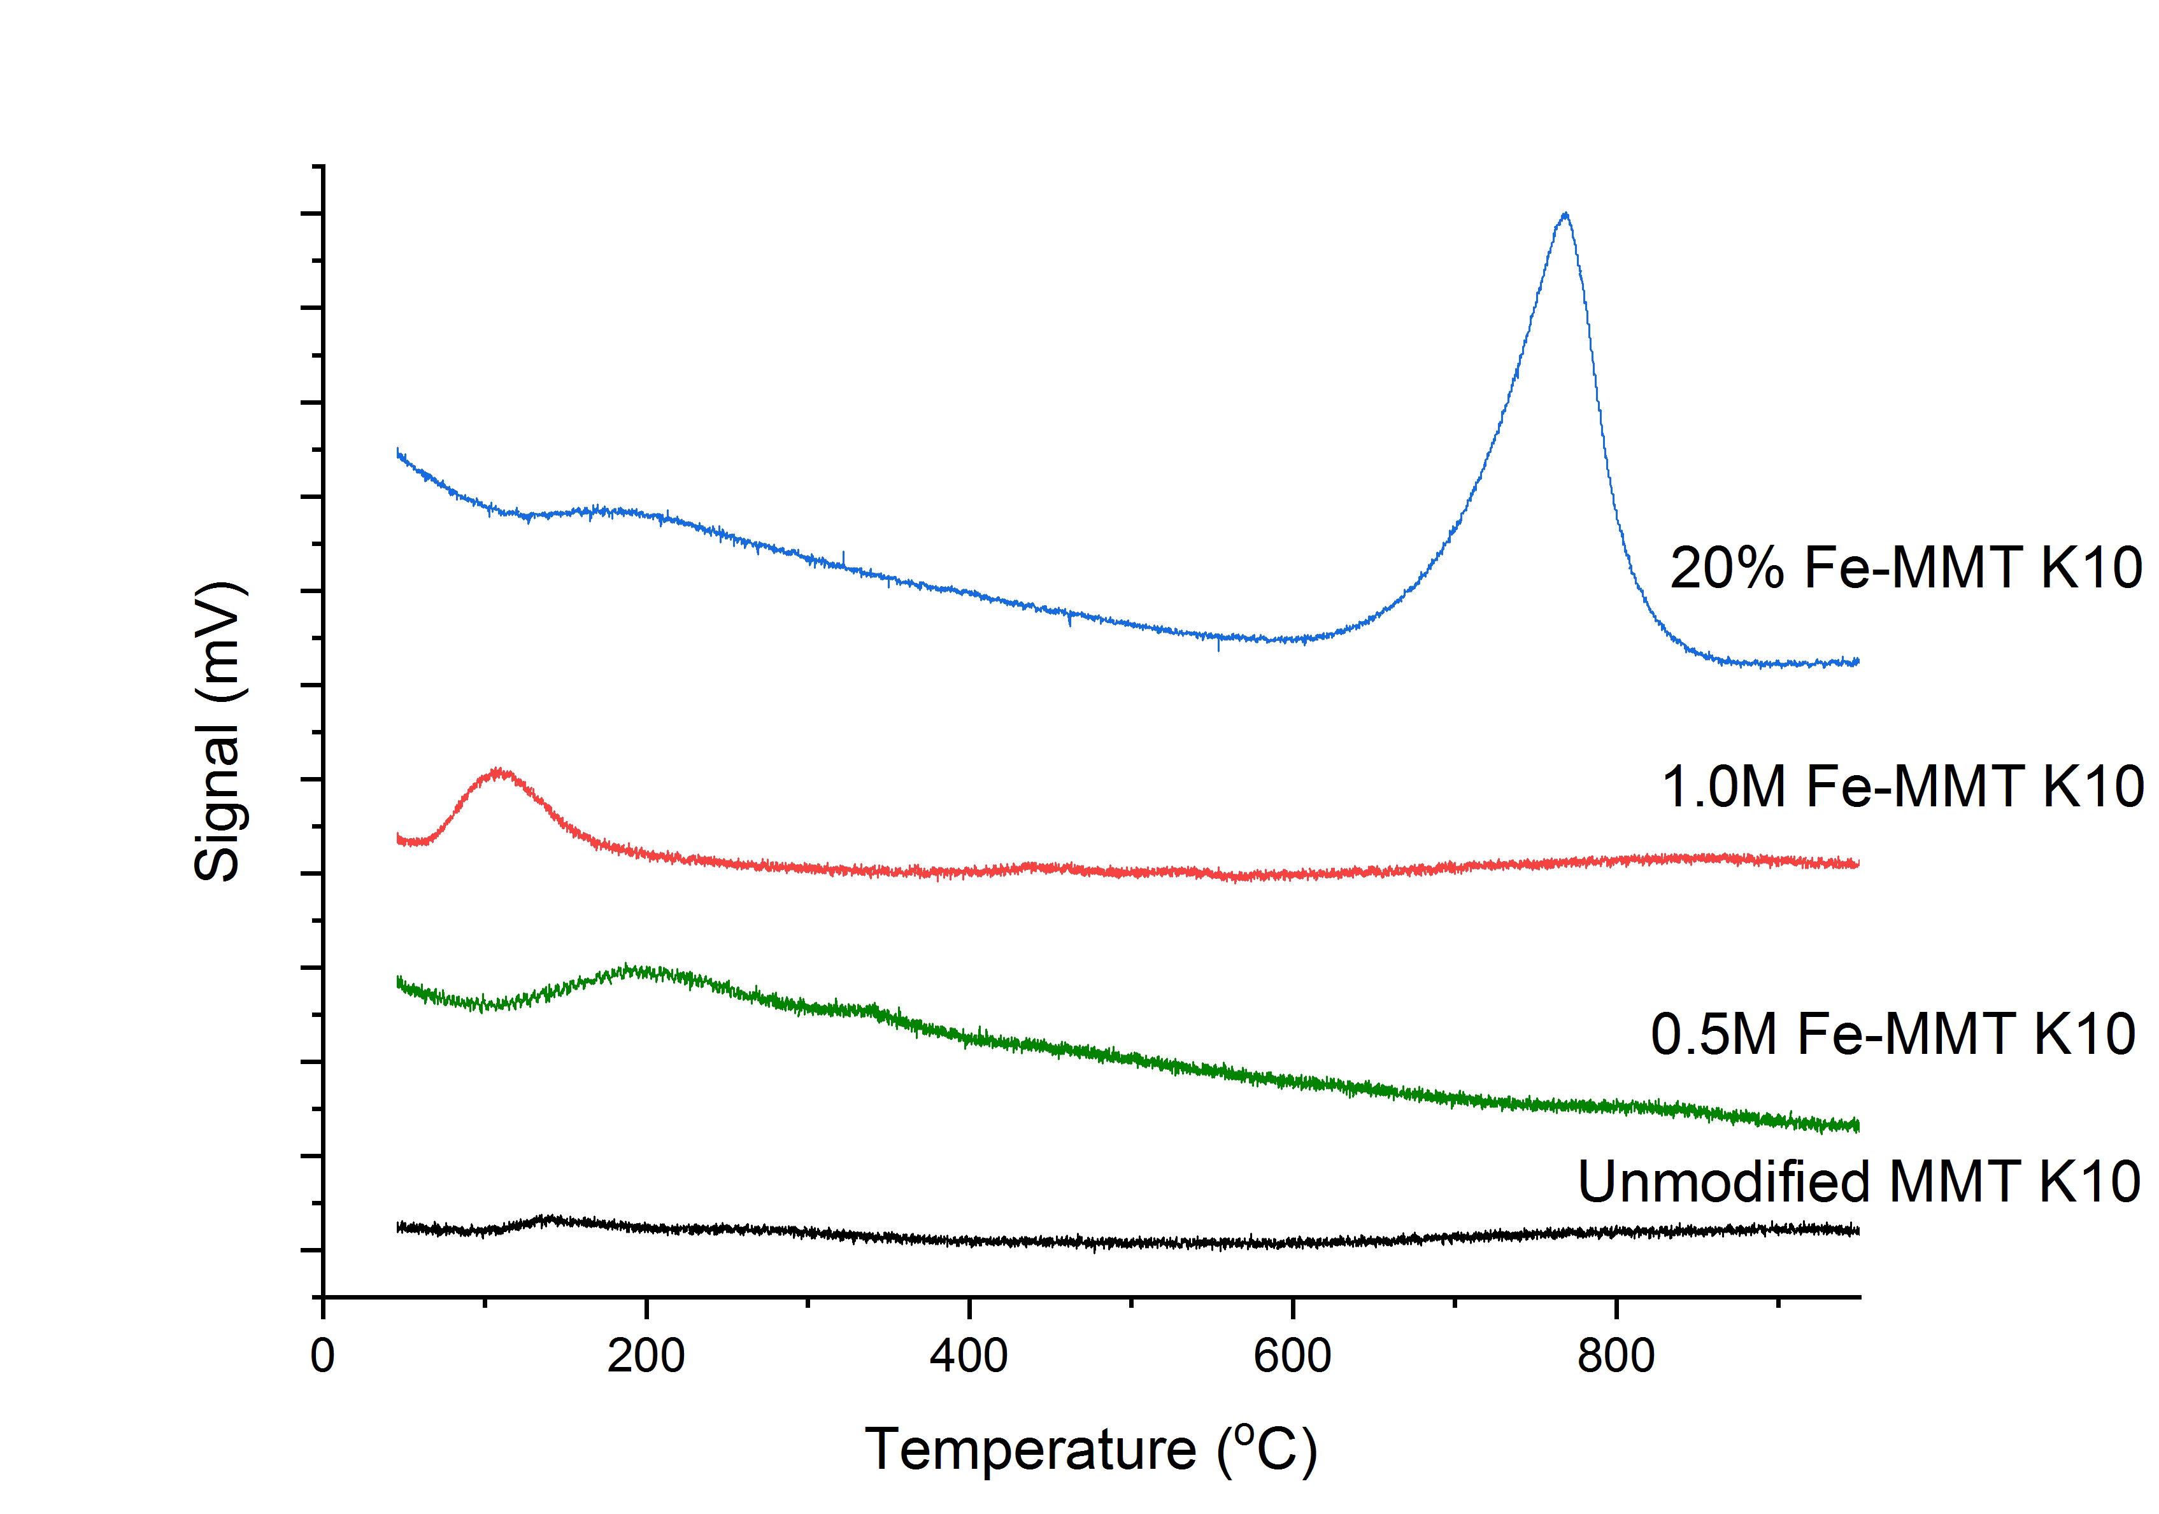
27% Fe-MMT K10
14% Fe-MMT K10

Figure 5. Peak of acidity of montmorillonite K10 and its modifications from TPD-NH₃ analysis

Catalytic screening
In order to determine the catalytic activity, esterification and transesterification reactions were done simultaneously on WCO by reflux system connected to rotatory chiller at 8 °C. An optimum condition of 130 °C, 6 h, 12:1 methanol to oil ratio and 4 wt.% catalyst loading were selected according to Munir et al. [27] and Olutoye et al. [16], to study the activity of montmorillonite K10 and its modified samples. As a control, a reaction without catalyst was carried out. The efficiency of the catalysts was summarized and compared in Figure 6 and Figure 7, respectively. From the results, it was proven that montmorillonite K10 has the potential to undergo simultaneous esterification and transesterification reactions to produce biodiesel compared to the reaction without catalyst as the biodiesel yield increased from 26.80 to 38.39% and the acid conversion increased from 13.15 to 18.22%. Among the reactions, 20% Fe-MMT K10 shows the highest biodiesel yield (84.58%) and acid conversion (37.56%) compared to 14% Fe-MMT K10 (yield: 66.54%; acid conversion: 24.86%) and 27% Fe-MMT K10 (yield: 69.32%; acid conversion: 25.02%). The results obtained show the correlation between metal cation concentration, elemental composition and acidity as the yield and acid conversion increased from 14% to 20% modifications accordingly.

In conclusion, the modification of montmorillonite K10 with 20% Fe concentration shows the optimum ion exchange which contributed to the most efficient catalyst with highest biodiesel yield and acid conversion, and eventually was selected for further investigation.

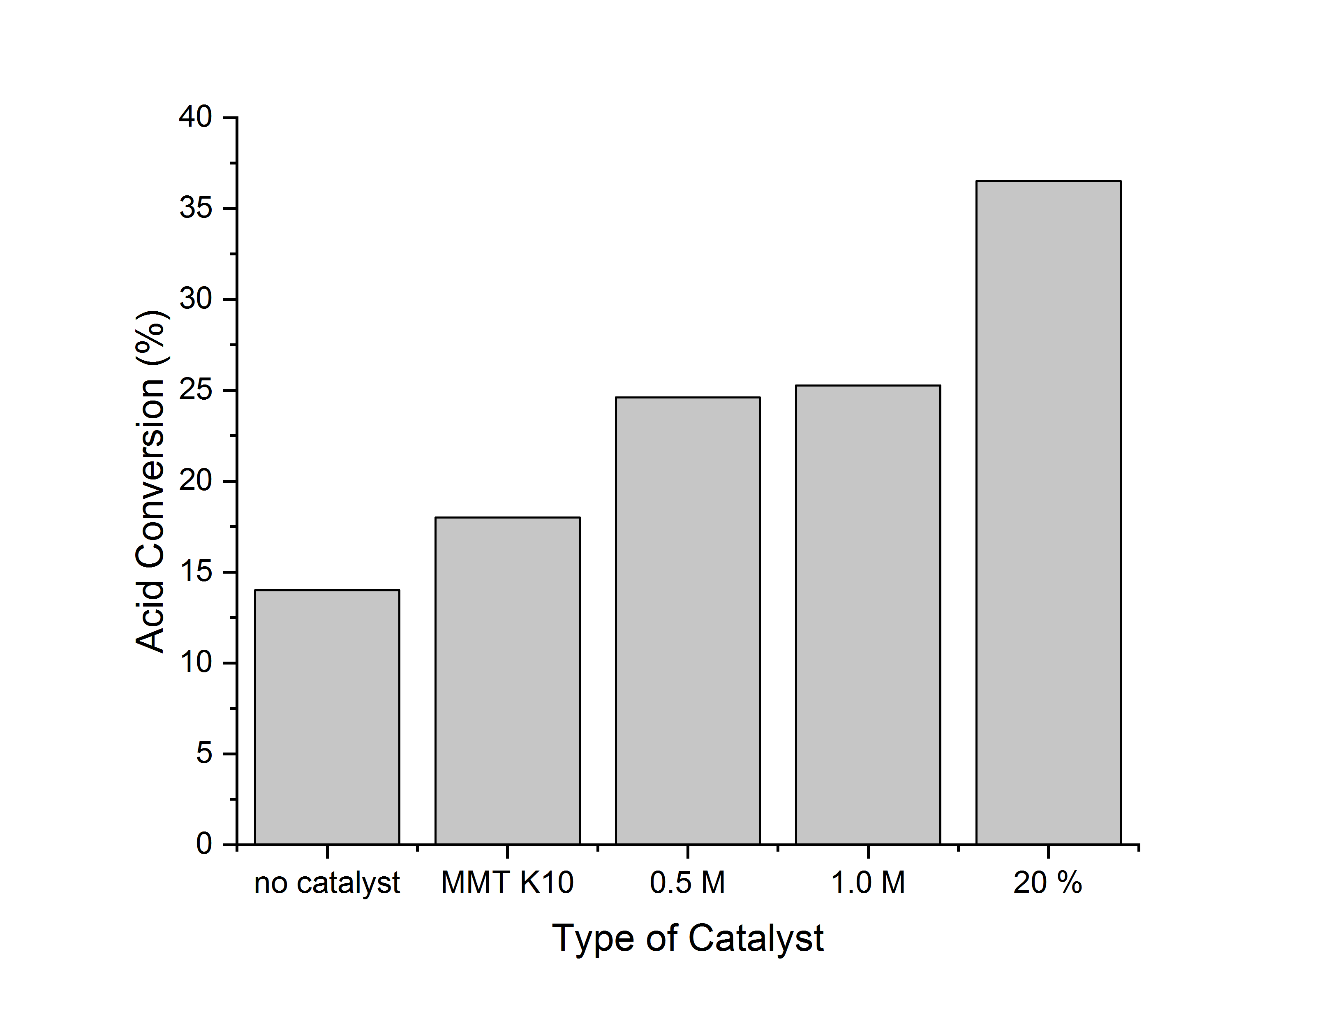
No catalyst MMT K10 14% 27% 20%
Type of catalyst

Figure 6. Acid conversion of WCO at 6 hours reaction period, 12:1 methanol to oil molar ratio and 4% w/w catalyst at 130 °C

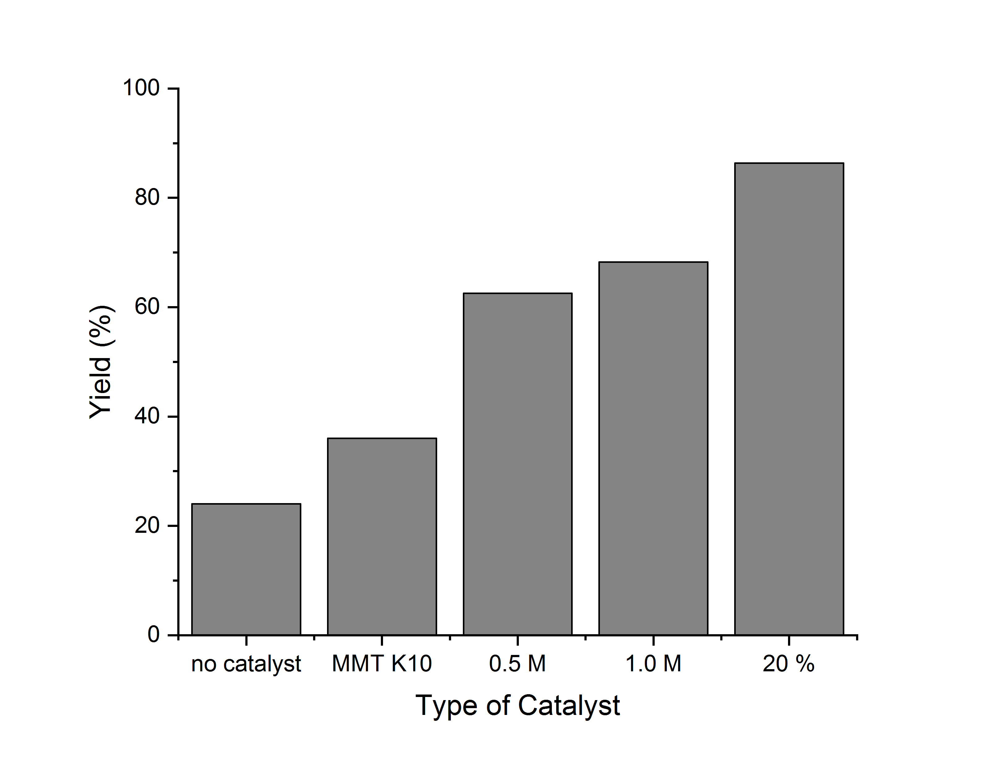
No catalyst MMT K10 14% 27% 20%
Type of catalyst

Figure 7. Percentage of FAME yield at 6 hours reaction period, 12:1 methanol to oil molar ratio and 4% w/w catalyst at 130 °C

Optimization of biodiesel production
From the catalytic screening, 20% Fe-MMT K10 was selected as the most efficient catalyst to produce high biodiesel yield. The biodiesel production was optimized by varying four parameters; temperature (100 – 200 °C), reaction time (3 – 9 hours), catalyst loading (2-8 wt.%) and methanol to oil ratio (8 to 16:1) [14, 16]. The ability on esterification was examined (Figure 8) to ensure that the catalyst can convert the free fatty acid content as shown in Table 1 into FAME. 28.65% acid was converted at optimum condition of maximum biodiesel production. However, the optimization of esterification was not considered since the optimum condition for acid and triglyceride seemed to be different. In addition, it was quite difficult to find the optimum condition since WCO consisted of different types of FFA, which favor different conditions [27]. The benefit of selecting raw material with small amount of FFA content (3.97%) was it would give insignificant effect to produce high FAME yield. Furthermore, high FFA content would lead to the incomplete conversion of WCO due to the FFA conversion limitation. The esterification of FFA also produced water by product that would significantly decrease the ester production by hydrolysis [29]. In this case, since triglyceride is the main composition of WCO, more attention was given on the percentage yield of biodiesel compared to acid conversion.
The effect of temperature on the activity of 20% Fe-MMT K10 was investigated within the range from 100 °C to 200 °C, at fixed reaction time 6 hours, methanol to oil ratio 12:1 and catalyst loading 6 wt.%. From the results in Figure 9, it seems that the optimum temperature was 150 °C with yield 96.49%. At low temperature (100 °C), only 46.35% biodiesel yield was produced. The catalyst could not complete the conversion of WCO within 6 hours because less heat energy was supplied to the endothermic reaction, which is inadequate to activate the total sites of 4 wt.% catalyst [30]. Therefore, more reaction period is required. This situation was observed when Jung et al. optimized the reaction within 2 hours at 360 ºC [2]. However, when Olutoye et al. and Munir et al. used lower temperature between 120 – 150 ºC, 5 hours was taken to optimize the reaction [16, 27]. Beyond the optimum temperature, the yield decreased to 65.36% because reflux system did not really work to condense the vigorous vaporized methanol. Hence, the methanol took a very short time to contact with oil-catalyst phase before reverted. Thus, little contact between methanol and WCO restricted the complete conversion of WCO. In this case, a closed reactor is required.

The effect of reaction time on the activity of 20% Fe-MMT K10 was investigated within range 3 to 6 hours at fixed reaction temperature 150 °C, methanol to oil ratio 12:1 and catalyst loading 6 wt.%. At 3 hours reaction time, the biodiesel yield was low (60.24%) due to the incomplete reaction. As the reaction time increased to 6 hours, more contact time between reactants and catalyst became available, which led to more frequent collision and reached the optimum period. A further increase in reaction time beyond optimum condition (6 hours) decreased the biodiesel yield to 74.52%. It was probably due to the reverse transesterification [16].

The concentration of catalyst loading was studied between 2 and 6 wt.% at fixed reaction temperature of 150 °C, reaction time of 6 hours and methanol to oil ratio at 12:1. The results proved that the presence of 4 wt.% catalyst optimized the catalytic activity with 96.49% FAME yield. Below than 4 wt.%, the result showed a partial conversion of WCO by producing only 58.59% biodiesel due to the insufficient amount of catalyst [16]. The increasing amount of catalyst increased the surface contact between the catalyst and the reactants [31]. The excess catalyst led to a marked reduction in the product yield (65.20%) due to the viscous reaction medium [32]. It decreased the interaction between the catalyst and reaction component [33, 34].

The effect of methanol concentration was investigated by varying the methanol to oil ratio from 8:1 to 16:1 at fixed reaction temperature 150 °C, reaction period 6 hours and catalyst loading 4 wt.%. Methanol to oil ratio of 12:1 showed the optimum amount for the reaction with WCO. Below than 12:1 led to incomplete conversion even after 6 hours of reaction as part of methanol was dissolved by glycerol by product [35], thus produced lower biodiesel (59.51%) compared to the optimum condition. Meanwhile, beyond the limit, the biodiesel yield reduced to 66.13%. This is because the catalyst started to degrade due to the leaching of active components from the catalyst [36]. The absence of active components on the catalyst caused the catalyst inactivation to complete the reaction. However, the problem could be overcome by increasing the amount of catalyst, so it would be sufficient enough to enhance the activity of excess methanol with WCO towards biodiesel production [37].

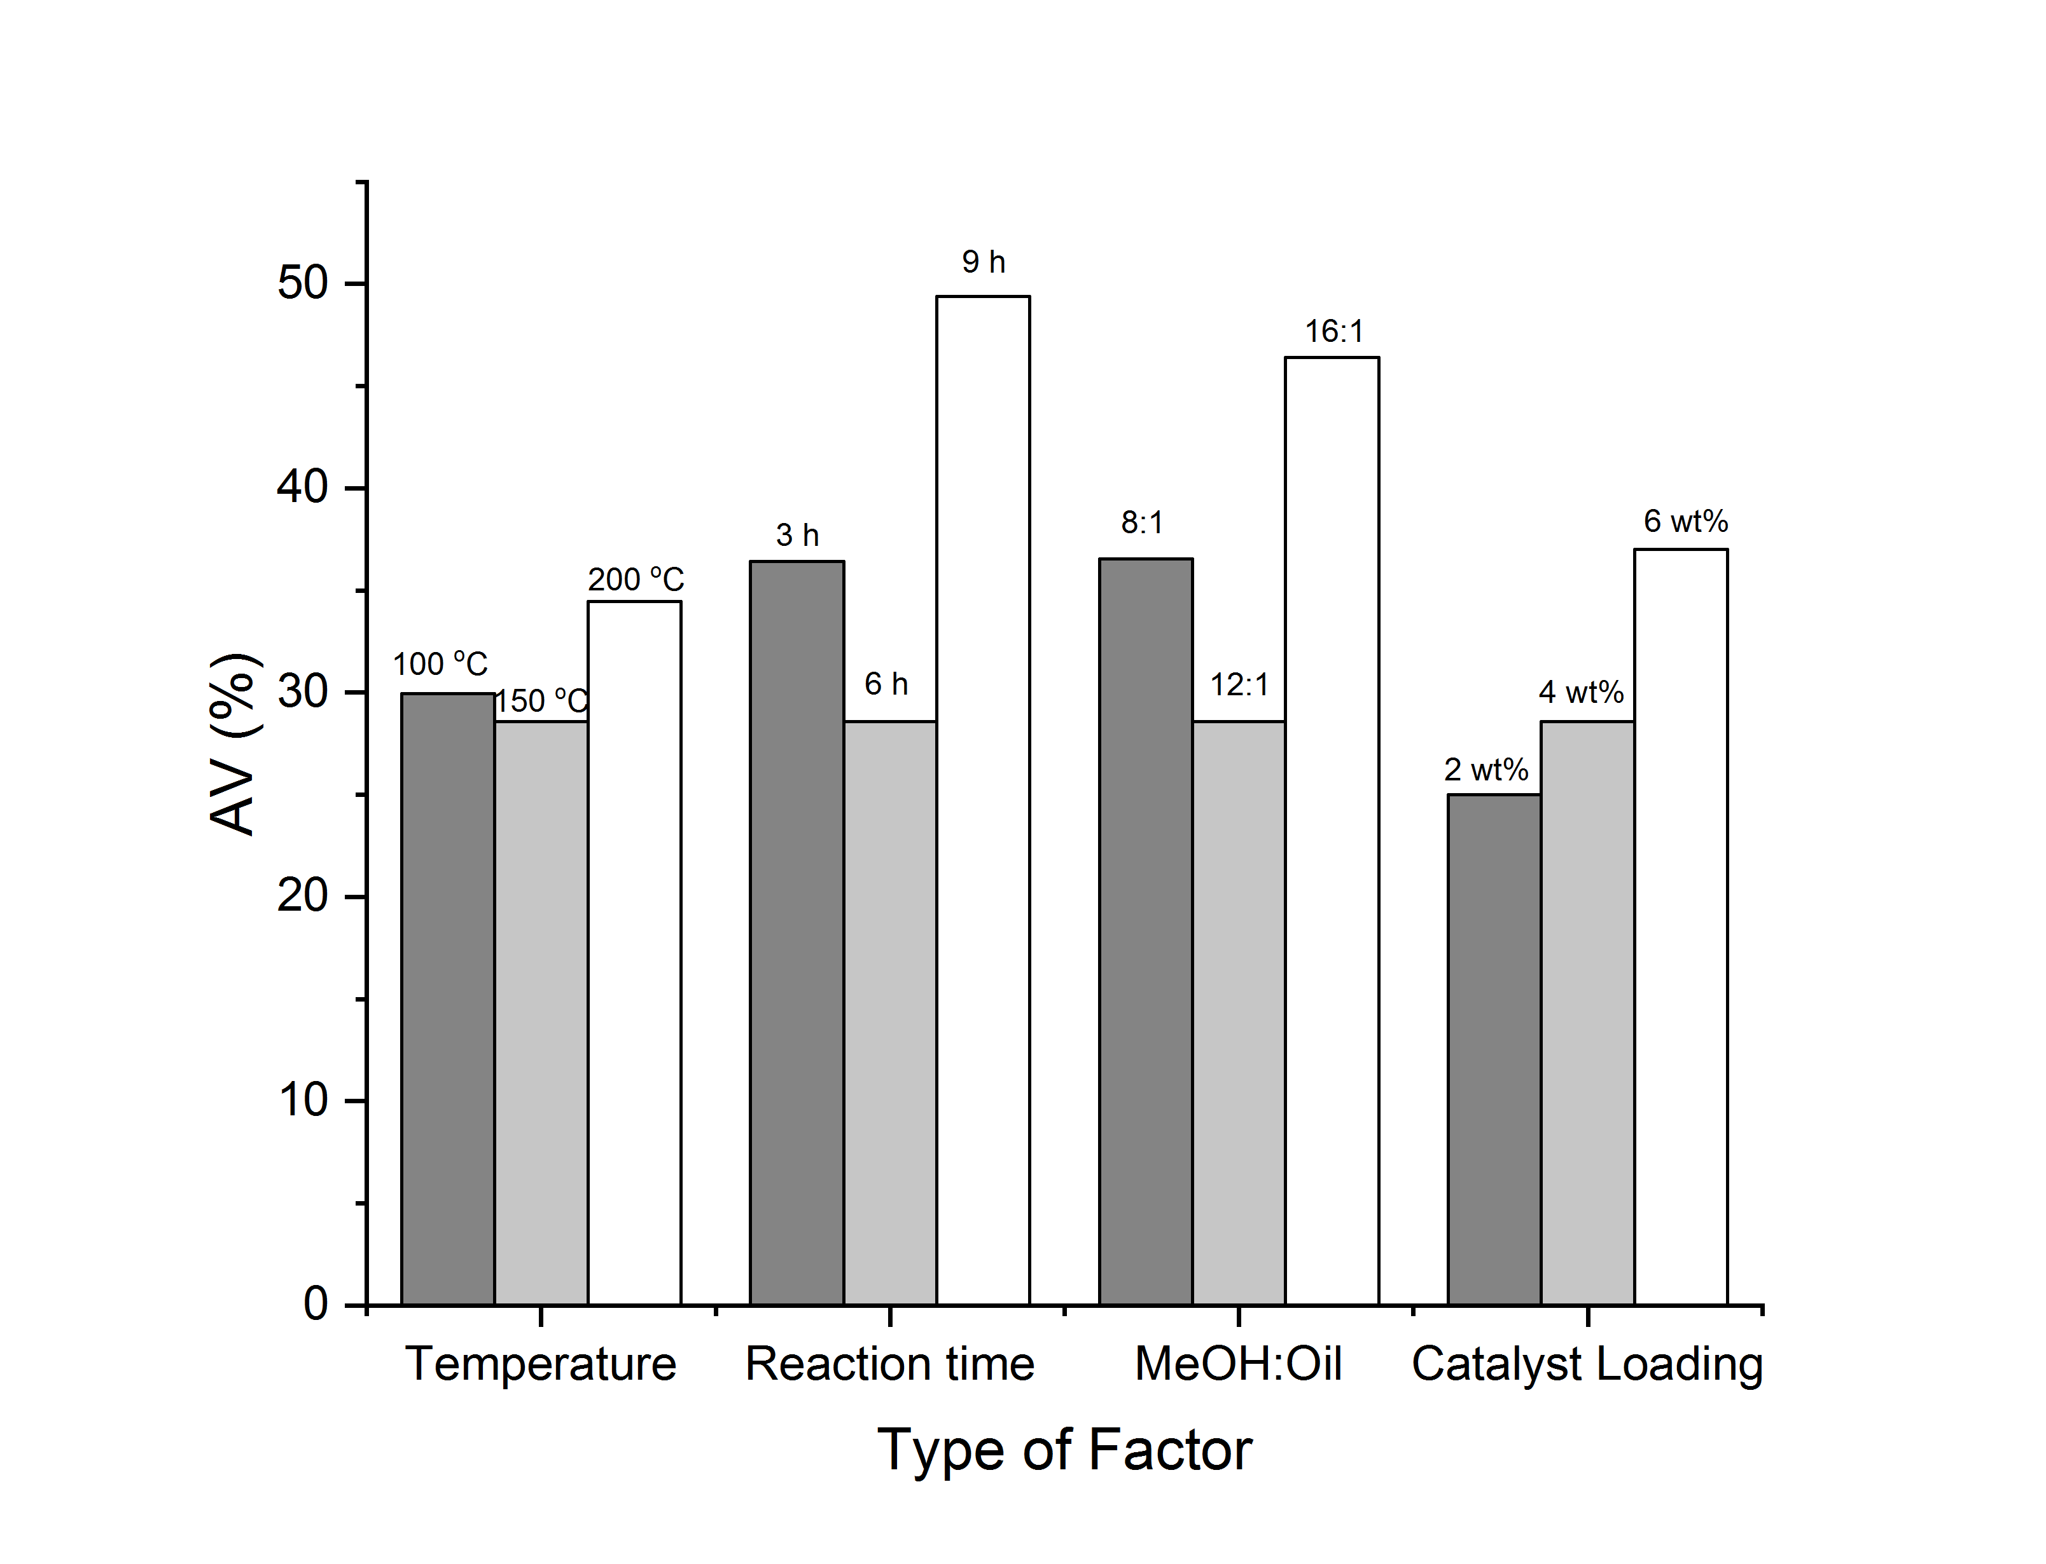

Figure 8. Effect of parameters in acid conversion

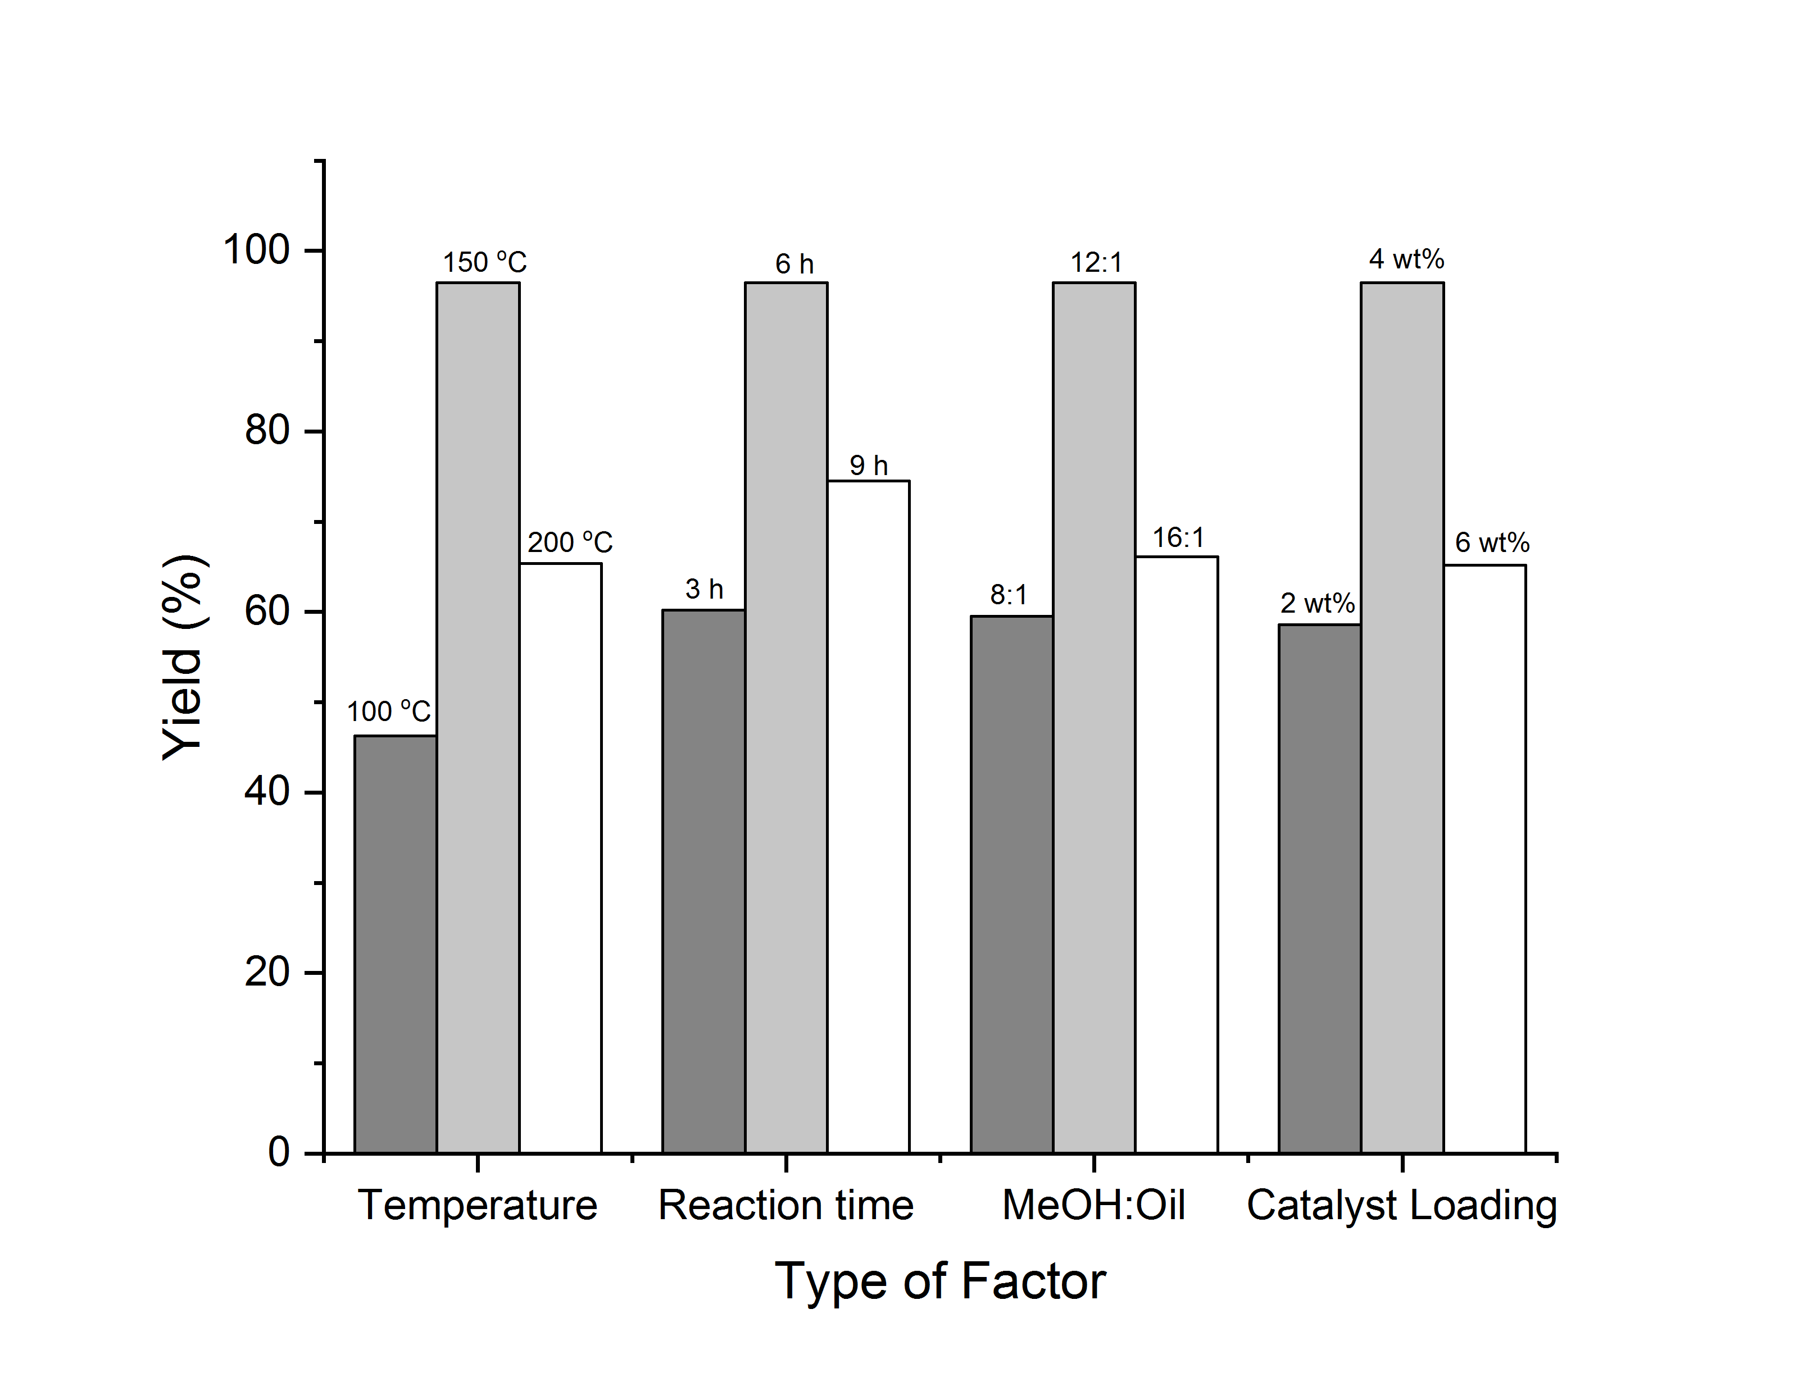

Figure 9. Effect of parameters in FAME yield

From the investigation of optimization of biodiesel production, it was found that the optimum condition to activate the 20% Fe-MMT K10 catalyst was 150 °C, 6 h, 12:1 methanol: oil and 4 wt.% catalyst loading. The biodiesel production could be optimized up to 96.49%.

Conclusion

From the investigations, it was proven that the optimum ion exchange occurred with high concentration of Fe³⁺ within long stirring duration. It gave chance to the montmorillonite K10 interchange layer in contact with high concentration metal to exchange the ion. In this study, 20% Fe³⁺ to the mass of montmorillonite K10 optimize the ion exchange up to 5.68% with the highest acidity contribution up to 14.261 mmol NH₃/g compared to 14% and 27%. The catalytic improvement was proven by the catalytic screening in the application of biodiesel production. 20% Fe-MMT K10 produced the highest biodiesel of 84.58% with 37.56% acid conversion compared to the other two catalysts. After optimization, it was found that the optimum conditions for the activity of 20% Fe-MMT K10 in the biodiesel production was 150 °C, 6 hours, 12:1 methanol: oil and 4 wt.% catalyst loading with 96.49% biodiesel production. It proved that the modification of montmorillonite K10 with 20% Fe³⁺ successfully optimized the ion exchange capacity to enhance the acidity property, which was responsible in the esterification and transesterification reaction simultaneously.

Acknowledgement

The author acknowledges the Ministry of Education Malaysia (MOE) for the financial support through Grant USIM/FRGS/FST/055002/51417 and facilities provided by Faculty of Science and Technology, Universiti Sains Islam Malaysia (USIM) and Centre of Excellence for Catalysis Science and Technology (PutraCAT), Universiti Putra Malaysia (UPM).

References

- Reddy, C. R., Nagendrappa, G. and Prakash, B. J. (2007). Surface acidity study of Mn⁺-montmorillonite clay catalysts by FT-IR spectroscopy: Correlation with esterification activity. Catalysis Communications, 8(3): 241-246.
- Jung, J. M., Oh, J. I., Park, Y. K., Lee, J. and Kwon, E. E. (2019). Biodiesel synthesis from fish waste via thermally-induced transesterification using clay as porous material. Journal of Hazardous Materials, 371: 27-32.
- Bouguerra Neji, S., Trabelsi, M. and Frikha, M. H. (2009). Esterification of fatty acids with short-chain alcohols over commercial acid clays in a semi-continuous reactor. Energies, 2(4): 1107-1117.
- Fatimah, I., Hidayat, A. and Setiawan, K. H. (2010). Preparation of aluminium pillared clay from Indonesian montmorillonite and its catalytic activity in bio-oil cracking. Asian Journal of Chemistry, 22(5): 3793.
- Almadani, E. A., Radzi, S. M. and Harun, F. W. (2016). Stearic acid esters synthesized using iron exchanged montmorillonite K10 clay catalysts. International Journal of Applied Chemistry, 12(1): 62-67.
- Kloprogge, J. T., Duong, L. V. and Frost, R. L. (2005). A review of the synthesis and characterisation of pillared clays and related porous materials for cracking of vegetable oils to produce biofuels. Environmental Geology, 47(7): 967-981.
- Ma, Y., Wang, Q., Sun, X., Wu, C. and Gao, Z. (2017). Kinetics studies of biodiesel production from waste cooking oil using FeCl₃-modified resin as heterogeneous catalyst. Renewable Energy, 107: 522-530.
- Harun, F. W., Almadni, E. A. and Ali, E. S. (2017). M-MMT K10 (M: Cu, Al and Fe) as catalysts for the esterification of acetic acid and stearic acid with methanol. In Proceedings of the World Congress on Engineering and Computer Science, 2: 606-609.
- Liu, J., Yun, Z. and Gui, X. (2018). Ce/kaolin clay as an active catalyst for fatty acid methyl esters production from cottonseed oil in a new integrated apparatus. Brazilian Journal of Chemical Engineering, 35(1): 147-154.
- Almadani, E. A., Harun, F. W., Radzi, S. M. and Muhamad, S. K. (2018). Cu²⁺ montmorillonite k10 clay catalyst as a green catalyst for production of stearic acid methyl ester: optimization using response surface methodology (RSM). Bulletin of Chemical Reaction Engineering & Catalysis, 13(1): 187-195.
- Sabri, S. M. M., Yahya, S., Razali, F. H. and Harun, F. W. (2019). Modification of montmorillonite K10 with Al³⁺ and its potential in biodiesel production. Malaysian Journal of Science Health & Technology, 4: 30-34.
- Yahya, S., Razali, F. H. and Harun, F. W. (2019). Physicochemical properties of refined palm cooking oil and used palm cooking oil. Materials Today: Proceedings, 19: 1166-1172.
- Jha, A., Garade, A. C., Shirai, M. and Rode, C. V. (2013). Metal cation-exchanged montmorillonite clay as catalysts for hydroxyalkylation reaction. Applied Clay Science, 74: 141-146.
- Liu, J., Wang, X. Q., Yang, B. B., Liu, C. L., Xu, C. L. and Dong, W. S. (2018). Highly efficient conversion of glucose into methyl levulinate catalyzed by tin-exchanged montmorillonite. Renewable Energy, 120: 231-240.
- Ramesh, S., Prakash, B. J. and Bhat, Y. S. (2010). Enhancing Brønsted acid site activity of ion exchanged montmorillonite by microwave irradiation for ester synthesis. Applied Clay Science, 48(1-2): 159-163.
- Olutoye, M. A., Wong, S. W., Chin, L. H., Amani, H., Asif, M. and Hameed, B. H. (2016). Synthesis of fatty acid methyl esters via the transesterification of waste cooking oil by methanol with a barium-modified montmorillonite K10 catalyst. Renewable Energy, 86: 392-398.
- Dharne, S. and Bokade, V. V. (2011). Esterification of levulinic acid to n-butyl levulinate over heteropolyacid supported on acid-treated clay. Journal of Natural Gas Chemistry, 20(1): 18-24.
- Harun, F. W., Almadani, E. A. and Radzi, S. M. (2016). Metal cation exchanged montmorillonite K10 (MMT K10): surface properties and catalytic activity. Journal of Scientific Research and Development, 3(3): 90-96.
- Nascimento, A. R. D., Alves, J. A. B. L. R., Melo, M. A. D. F., Melo, D. M. D. A., Souza, M. J. B. D. and Pedrosa, A. M. G. (2015). Effect of the acid treatment of montmorillonite clay in the oleic acid esterification reaction. Materials Research, 18(2): 283-287.
- Shimizu, K. I., Higuchi, T., Takasugi, E., Hatamachi, T., Kodama, T. and Satsuma, A. (2008). Characterization of Lewis acidity of cation-exchanged montmorillonite K-10 clay as effective heterogeneous catalyst for acetylation of alcohol. Journal of Molecular Catalysis A: Chemical, 284(1-2): 89-96.
- Varadwaj, G. B. B. and Parida, K. M. (2013). Montmorillonite supported metal nanoparticles: an update on syntheses and applications. RSC Advances, 3(33): 13583-13593.
- Wang, F. F., Liu, J., Li, H., Liu, C. L., Yang, R. Z. and Dong, W. S. (2015). Conversion of cellulose to lactic acid catalyzed by erbium-exchanged montmorillonite K10. Green Chemistry, 17(4): 2455-2463.
- Wen, K., Zhu, J., Chen, H., Ma, L., Liu, H., Zhu, R., Xi, Y. and He, H. (2018). Arrangement models of Keggin-Al30 and Keggin-Al13 in the interlayer of montmorillonite and the impacts of pillaring on surface acidity: A comparative study on catalytic oxidation of toluene. Langmuir, 35(2): 382-390.
- Liu, D., Yuan, P., Liu, H., Cai, J., Tan, D., He, H., Zhu, J. and Chen, T. (2013). Quantitative characterization of the solid acidity of montmorillonite using combined FTIR and TPD based on the NH₃ adsorption system. Applied Clay Science, 80: 407-412.
- Phukan, A., Bhorodwaj, S. K., Sharma, P. P. and Dutta, D. K. (2018). Mesoporous aluminosilicate: Efficient and reusable catalysts for esterification of sec-butanol with acetic acid. Journal of Porous Materials, 25(1): 129-136.
- Bharate, J. B., Sharma, R., Aravinda, S., Gupta, V. K., Singh, B., Bharate, S. B. and Vishwakarma, R. A. (2013). Montmorillonite clay catalyzed synthesis of functionalized pyrroles through domino four-component coupling of amines, aldehydes, 1, 3-dicarbonyl compounds and nitroalkanes. RSC Advances, 3(44): 21736-21742.
- Munir, M., Ahmad, M., Saeed, M., Waseem, A., Rehan, M., Nizami, A.S., Zafar, M., Arshad, M. and Sultana, S. (2019). Sustainable production of bioenergy from novel non-edible seed oil (Prunus cerasoides) using bimetallic impregnated montmorillonite clay catalyst. Renewable and Sustainable Energy Reviews, 109: 321-332.
- Olutoye, M. A., Wong, S. W., Chin, L. H., Amani, H., Asif, M. and Hameed, B. H. (2016). Synthesis of fatty acid methyl esters via the transesterification of waste cooking oil by methanol with a barium-modified montmorillonite K10 catalyst. Renewable Energy, 86, 392-398.
- Babaki, M., Yousefi, M., Habibi, Z., Mohammadi, M., Yousefi, P., Mohammadi, J. and Brask, J. (2016). Enzymatic production of biodiesel using lipases immobilized on silica nanoparticles as highly reusable biocatalysts: effect of water, t-butanol and blue silica gel contents. Renewable Energy, 91: 196-206.
- Ayoub, M., Ullah, S., Inayat, A., Bhat, A. H. and Hailegiorgis, S. M. (2016). Process optimization for biodiesel production from waste frying oil over montmorillonite clay k-30. Procedia Engineering, 148: 742-749.
- Tan, Y. H., Abdullah, M. O., Nolasco-Hipolito, C. and Taufiq-Yap, Y. H. (2015). Waste ostrich-and chicken-eggshells as heterogeneous base catalyst for biodiesel production from used cooking oil: Catalyst characterization and biodiesel yield performance. Applied Energy, 160: 58-70.
- Maneerung, T., Kawi, S., Dai, Y. and Wang, C. H. (2016). Sustainable biodiesel production via transesterification of waste cooking oil by using CaO catalysts prepared from chicken manure. Energy Conversion and Management, 123: 487-497.
- Liu, H., shuang Guo, H., jing Wang, X., zhong Jiang, J., Lin, H., Han, S. and Peng Pei, S. (2016). Mixed and ground KBr-impregnated calcined snail shell and kaolin as solid base catalysts for biodiesel production. Renewable Energy, 93: 648-657.
- Negm, N. A., Sayed, G. H., Yehia, F. Z., Habib, O. I. and Mohamed, E. A. (2017). Biodiesel production from one-step heterogeneous catalyzed process of Castor oil and Jatropha oil using novel sulphonated phenyl silane montmorillonite catalyst. Journal of Molecular Liquids, 234: 157-163.
- Ghoreishi, S. M. and Moein, P. (2013). Biodiesel synthesis from waste vegetable oil via transesterification reaction in supercritical methanol. The Journal of Supercritical Fluids, 76: 24-31.
- Refaat, A. A. (2011). Biodiesel production using solid metal oxide catalysts. International Journal of Environmental Science & Technology, 8(1): 203-221.
- Liu, X., He, H., Wang, Y., Zhu, S. and Piao, X. (2008). Transesterification of soybean oil to biodiesel using CaO as a solid base catalyst. Fuel, 87(2): 216-221.

