

CYTOTOXIC ACTIVITY OF Erythrina fusca LOUR. LEAF, TWIG

AND FLOWER EXTRACTS

(Aktiviti Sitotoksik Ekstrak Daun, Ranting, dan Bunga Erythrina fusca Lour.)

Adiez Sapura Azmi¹, Norina Abdul Rahim¹, Zuriati Zahari¹, Fatimah Salim^{2,3}*

¹Faculty of Applied Sciences,

Universiti Teknologi MARA, Shah Alam, 40450, Selangor, Malaysia
²Atta-ur-Rahman Institute for Natural Product Discovery (AuRIns),

Universiti Teknologi MARA Selangor Branch, Puncak Alam Campus, 42300 Bandar Puncak Alam, Selangor, Malaysia.
³Centre of Foundation Studies,

Universiti Teknologi MARA Selangor Branch, Dengkil Campus, 43800 Dengkil, Selangor, Malaysia

*Corresponding author: fatimah2940@uitm.edu.my

Received: 29 November 2019; Accepted: 2 April 2020; Published: 9 June 2020

Abstract

Erythrina fusca Lour. belongs to the legume family (Fabaceae) is a species of flowering tree, locally known as ‘chengkering’. The plant is traditionally used for reducing inflammation, relieving migraine, reducing skin irritation and for dressing fresh wounds. This work reports on cytotoxic activities of the methanolic leaf, twig and flower extracts of E. fusca Lour. against human liver cancer cell line (HepG2) and monkey kidney normal cell line (Vero). The extracts were found to be nontoxic on both cell lines with IC₅₀ values of more than 100 µg/mL and therapeutic index of less than 2. In order to obtain comparative information on the chemical composition and the complexity of the structure, the methanolic extracts were profiled on a reversed-phase ultrahigh-performance liquid chromatography (UHPLC).

Keywords: Erythrina fusca Lour., cytotoxic activities, HepG2, Vero, ultrahigh-performance liquid chromatography

Abstrak

Erythrina fusca Lour. berasal daripada famili legume (Fabaceae) merupakan spesies pokok berbunga dan nama tempatannya ialah chengkerng. Tumbuhan ini digunakan secara tradisional untuk mengurangkan keradangan, melegakan migrain, mengurangkan kegatalan kulit dan pembalut luka. Kajian ini melaporkan aktiviti sitotoksik ekstrak metanol daun, ranting dan bunga E. fusca Lour. terhadap sel tunggal kanser hati manusia (HepG2) dan sel tunggal buah pinggang monyet (Vero). Kesemua ekstrak didapati tidak toksik kepada kedua jenis sel tunggal yang diuji dengan nilai IC₅₀ lebih daripada 100 µg/mL dengan indeks teraputik kurang daripada 2. Bagi memperolehi data perbandingan mengenai komposisi kimia dan kerumitan dalam struktur mereka, kesemua ekstrak metanol ini telah diprofilkan dalam fasa terbalik kromatografi cecair berprestasi tinggi ultra (UHPLC).

Keywords: Erythrina fusca Lour., aktiviti sitotoksik, HepG2, Vero, kromatografi cecair berprestasi tinggi ultra

Introduction

Erythrina is a genus belonging to the legume family, Fabaceae. The name “Erythrina” is derived from the Greek word "erythros" which means "red" referring to the flowers although some species exhibit pink, purple, orange, white, green, yellow and even coral colors [1-2]. Out of 290 species of the genus, 7 are available in Malaysia including Erythrina fusca Lour. and is locally known as ‘chengkering’ [3-5].

Erythrina fusca Lour. has been traditionally used in several countries including Malaysia. The bark of this plant is used to relieve migraines in Peru [6], while the bark and leaves are utilized to relieve inflammation in Thailand [7]. The seeds are used to cure skin irritation [8] while the inner bark is scraped for dressing fresh wounds in Indonesia [9]. The latter practice has also been observed among Malaysians population [10]. Moreover, the flowers are eaten as vegetables in Guatemala, and young leaves, in Java and Bali, Indonesia [11]. A thorough literature search revealed that most of the parts of the plant have been subjected to biological activities including anti-viral, anti-inflammatory, antitussive, rheumatism, hematuria, central nervous system depressor, hypotensive and as uterine stimulant [7-15]. Interestingly, none of the parts has been subjected to cytotoxic activity. Despite the traditional use and the biological activities reported thus far, there is no available data on the cytotoxic effect of the plant to our knowledge.

Thus in the present study, the methanolic crude extracts of the leaves, twigs and flowers of E. fusca Lour. were assessed for cytotoxic activity against human liver cancer cell line (HepG2) and on normal monkey kidney cell line (Vero). The extracts were also profiled on a reversed-phase ultrahigh-performance liquid chromatography (UHPLC) to obtain the comparative information on the chemical composition and their complexity in structure.

Materials and Methods

Chemical and reagents

Methanol (MeOH) analytical grade and acetonitrile (MeCN) HPLC grade were purchased from RCI Labscan (Bangkok, Thailand) and ultra-pure water (UPW) was from Sartorius. The leaves, twigs and flowers of E. fusca Lour. were collected from Bangi, Malaysia. A voucher specimen HTBP 5273 was identified by a certified botanist, Mr. Ahmad Zainudin Ibrahim, and deposited at the Herbarium of Atta-Ur-Rahman Institute for Natural Product Discovery (AuRIns).

Extraction procedure

The leaves, twigs and flowers of E. fusca Lour. were separately cut into small pieces, air-dried and ground into fine powder. The leaf (1.2 kg), twig (0.045 kg) and flower (0.060 kg) fine powder were subjected to exhaustive extraction using MeOH for 72 hours in room temperature. The extracts were filtered, and the solvent was evaporated under reduced pressure by using rotary evaporator yielding 60 g, 0.783 g, 2 g of leaf, twig and flower extracts, respectively. The crude extracts were stored at 4 °C prior to analysis.

Reversed-phase ultrahigh-performance liquid chromatography

The reversed-phase UHPLC analysis was performed using the DIONEX Ultimate 3000 HPLC system (Thermo-Fisher, USA) coupled with a diode array detector and equipped with an auto-sampler injector. The chromatography was performed on Hypersil GOLD C18 column (Thermo Scientific, Malaysia) with particle size 5 µm, height 250 mm and 4.6 mm internal diameter and pore size of 175 A. The control of the instrument and the data analyses were conducted by software Chromeleon version 7.2 provided by the supplier.

Sample preparation

Two mg/mL of each of the extracts were fully dissolved in MeCN and the samples were filtered with PTFE 0.45 μm filter (Agilent). Then the samples were subjected to a reversed phase UHPLC analyses. MeCN (acted as non-polar solvent) and ultra-pure water (acted as polar solvent) were used as solvent system.

UPHLC procedure

Chromatographic conditions were optimized in order to reach baseline separated peaks of the overall observable chemical components. For this purpose, different mobile phases with varying gradients were employed. The mobile phase consisting of MeCN/UPW with a gradient set up delivered good baseline separation of the overall observable components. The initial gradient was set at 5% MeCN: 95% UPW and gradually increased to 30% MeCN: 70% UPW at 12 minutes then increased to 95% MeCN: 5% UPW at duration of 33 minutes. The column conditioning and equilibrium were performed in 5 minutes attaining the initial condition. A 20 μL of the sample extracts were injected into the chromatographic column thermostatically maintained at 24.5 °C. The flow rate used was 1.00 mL/min and the detection of the eluted peaks was performed at 208 nm.

Cell Lines Culture

HepG2 cell was acquired from Dr. Normala at AuRIns, UiTM, while Vero cell was obtained from Malaysia Institute of Pharmaceutical & Nutraceuticals (IPharm). Both cell lines were cultured in growth medium containing Dulbecco Minimal Essential Media (Sigma) supplemented with 10% (v/v) Fetal Bovine Serum (Sigma) and 1% of 1000 µg/mL of Penicillin/Streptomycin (Nacalai Tesque). Incubation was carried out at 37 °C with an atmospheric 5% (v/v) CO₂ to allow the growth of the cells. Growth media were changed every 2 days and subculture was carried out when it reached 80% cell growth confluency.

MTT Assay

The cytotoxic activity on HepG2 and Vero cells were determined by the MTT assay described by Widianto et al. [7] with slight modifications. Briefly, 100 µL of 150,000 cells/mL suspension was added into 96-well-plate. The plates were incubated overnight in an incubator supplemented with 5% (v/v) CO₂ at 37 ºC to allow cells to be attached. The next day, the media was removed from the wells and 100 µL of fresh growth media were added into all wells except for the highest concentration wells. One hundred fifty µL of fresh growth media containing the highest concentration of drug was added into the highest concentration wells.

Serial dilutions of a 2-fold factor covering a range from 1000 – 15.625 μg/mL were then performed. Fifty μL were removed from the highest concentration wells into the next column and mixed appropriately. This step was repeated until the last column. The final 50 μL aspirated from the last column was discarded. Then, 100 μL of media with 1% (v/v) DMSO were added into the wells which served as a negative control while, other wells served as positive control without drugs. Plates were served in triplicate. The plates were placed in an incubator supplemented with 5% (v/v) CO₂ at 37 °C for 24 hours. After 24 hours of incubation, the test plates were inspected under an inverted microscope (Nikon, Japan) to observe the normal growth of both cells. Additional information was recorded, such as drug insolubility or contamination, etc. All media were discarded from the wells. Then 50 µl of MTT solution of 1 mg/mL was added to each well of test plates and incubated for 3 to 4 additional hours (until a subtle colour change was observed, but the maximum hour taken was not more than 4 hours).

The cell absorbance from the assay plate, illustrated in Figure 1, was measured by using a microplate reader (Tecan, USA) at a selected wavelength of 570 nm. The percentage growth inhibition was calculated using the formula (equation 1):

Cell viability (%)

Absorbance value of test compound

= x100% (1)

Absorbance value of Negative Control

Statistical analysis was performed by SPSS 23.0 using one-way ANOVA. All results were presented as mean ± standard deviation.

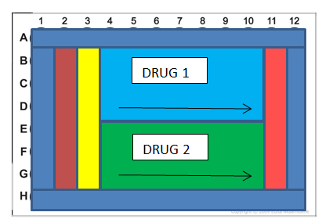

Figure 1. Illustration of assay plate

Results and Discussion

Cytotoxicity activities on HepG2 and Vero cell lines

According to the American National Cancer Institute guidelines [16], the limit of activity for crude extracts at 50% inhibition (IC₅₀) of proliferation was set less than 30 µg/mL after an exposure time of 24 hours [17]. As shown in Table 1, the IC₅₀ values of the methanolic extracts of the leaves (MLE), twigs (MTE) and flowers (MFE) on HepG2 cancer cells were considered to be non-active due to their very high concentrations required to obtain 50 percent of cell viability. Similarly, a higher concentration of the extracts was required to achieve 50% cell viability (CC₅₀) on the normal cell Vero that considered them to be non-toxic. Despite this, the Vero cells still showed proliferation on those high concentrations. The pattern for inhibition for both cell lines by the extracts is shown in Figure 2 below. The therapeutic index for all the extracts are also less than 2, indicating they are not potent for the tested activities [17].

UHPLC Profiling

UHPLC chemical profiling exercises have been widely established in plant extracts. They are reputable practices for quality control and authentication. In this study, the purpose of UHPLC profiling on leaf, twig and flower extracts of E. fusca Lour. is to obtain comparative information on the chemical composition and the structure complexity that possibly exist in the extracts. By referring to Figure 3, based on the peak intensity and retention time, the three extracts produced different profiles of chemical constituents. The variety in the constituents is well distributed in the flower (c) extract compared to the leaf (a) and twig (b) extracts. The amount and the existence of major constituents (minutes 2.83, 15.92, 22.98 and 24.48) are also clearly different in the extracts. Notably, based on the elution time (14 - 25 minutes), most of the chemical constituents exhibited moderate polarity.

Table 1. IC₅₀, CC₅₀ and therapeutic values of extracts
Sample | HepG2 (IC₅₀)  (µg/ml) | Normal Vero (CC₅₀)  (µg/ml) | Therapeutic Index (CC₅₀/ IC₅₀)
Sample | HepG2 (IC₅₀)  (µg/ml) | Normal Vero (CC₅₀)  (µg/ml) | CC₅₀ Vero/ IC₅₀HepG2
MLE | 771.76 ±15.85**** | 588.06±9.36**** | 0.76
MTE | 315.07±6.98**** | 309.95±15.24**** | 0.98
MFE | 182.09±11.62**** | 223.33±2.56**** | 1.23
*CC₅₀ is the concentration at which 50% cells survive and IC₅₀ is the concentration at which 50% cell death occurs with ± standard deviation. MLE refers to leaves methanolic crudes while MTE refers to twigs methanolic crudes and (MFE) refers to flower methanolic crudes. Statistical analysis was conducted using one-way ANOVA (p<0.0001) where **** denotes statistically significant difference between the MLE, MTE and MFE.

Figure 2. IC₅₀ (µg/ml) and CC₅₀ (µg/ml) of three extracts MLE, MTE and MFE against cancer liver cell line (HepG2) and compared with normal cell line (Vero), respectively, after 24 hours of incubation. Statistical analysis was conducted using one-way ANOVA (p< 0.0001) where **** denotes statistically significant difference between the MLE, MTE and MFE.

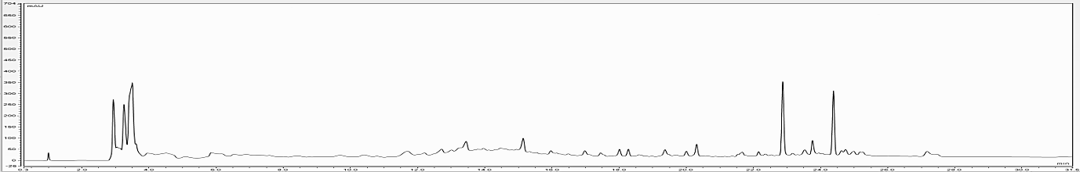

t: 2.83 min
a
t: 24.48 min

t: 22. 98 min

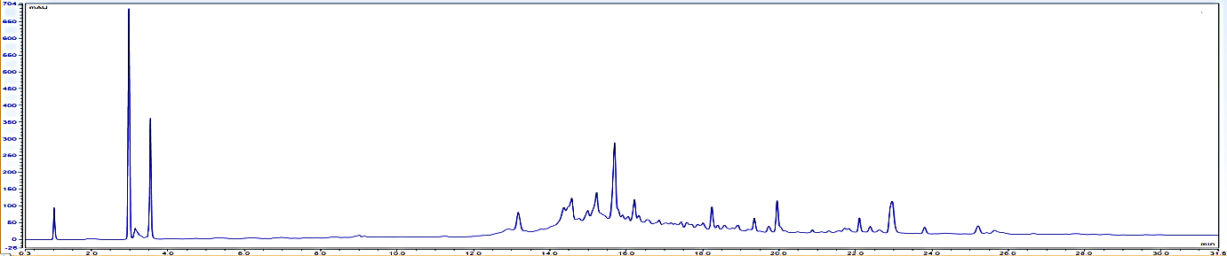

b
t: 15.92 min

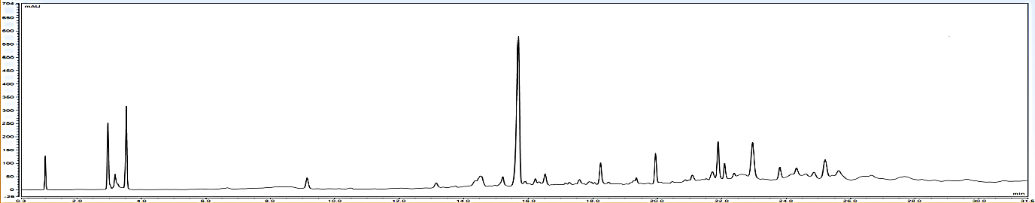
c

Figure 3. Chromatograms of methanolic extracts of the (a) leaves, (b) twigs and (c) flowers of E. fusca Lour. using gradient mode UHPLC and MeCN/UPW as the solvent system

The qualitative analysis on the chromatogram of the extracts is complemented with a thorough literature review on the classes of chemical composition reported for the species E. fusca Lour. and the genus Erythrina. Among the classes of compounds that have been reported in the Erythrina genus are alkaloids, flavonoids, pterocarpans and terpenoids as well as other miscellaneous [18]. Among those classes of compounds reported, the alkaloids are the major components where a total of 143 have been isolated from all plant parts [18-19]. However, for E. fusca Lour., very little has been reported. To date only 12 chemical components, which all are alkaloids, have been identified: erysodine, erysovine, erysopine, erysotrine, erythraline, erysothiovine, erysothiopine, epierythratidine, erythratinone, erythramine, erythratine and erythrinane [19].

All the alkaloids exhibit moderate polarity thus should be eluted in the middle of the chromatograms, supporting our early observation reported above. Furthermore, the detection was obtained at 208 nm where strong absorption for π-π* and n-π* electronic transitions usually observed for the alkaloid classes of compound [20]. This could be further supported by our preliminary qualitative phytochemical screening which revealed the presence of a high density of alkaloids in the flower, followed by the twig and the leaf extracts. Interestingly, since most of the biological activities reported for the Erythrina species were related to their alkaloids content [21], the pattern of extracts inhibition (Figure 2) in the cytotoxic activity on both tested cell lines also agreed with this claim. Nonetheless, this claim needs to be confirmed by further structural identification analysis on the extracts.

Conclusion

This work reports on the nontoxic property of the methanolic leaf, twig and flower extracts of E. fusca Lour. against human liver cancer cell line (HepG2) and monkey kidney normal cell line (Vero). Based on the peak intensity and retention time, the three extracts exhibited different UHPLC profile; the pattern of cytotoxic activities could be due to the alkaloid class of compounds. However, further studies are necessary to confirm and identify the chemical constituents that give rise to the peaks in the chromatogram and to strengthen the claim on the existence of alkaloids.

Acknowledgement

The authors would like to acknowledge Atta-ur-Rahman Institute for Natural Product Discovery (AuRIns) and Faculty of Applied Sciences (FSG), Universiti Teknologi MARA, for providing equipment and workplace to conduct the work. Appreciation also goes to Mr. Ahmad Zainudin Ibrahim for collecting and identifying the sample.

References
- Stein, G. (2009). Introduction to the coral trees (Erythrina species). https://davesgarden.com/ guides/articles/ view/2594. [Access online 29 March 2020].
- Salma, K., Gabr, R. O., Bakr, H. M., Elshishtawy, Ahlam, M. and Taha, S. E. (2017). Botanical and genetic characters of Erythrina neillii cultivated in Egypt. Revista Brasileira de Farmacognosia, 27(3): 273-281.
- Atta-Ur-Rahman (2005). Studies in natural products chemistry. Elsevier B.V, Amsterdam: pp. 822.
- Kumar, A., Lingadurai, S., Jain, A. and Barmanthat, N. R. (2010). Erythrina variegata Linn: A review on morphology, phytochemistry,

and pharmacological aspects. Pharmacognosy Review, 4(8): 147-152.
- Fazleen, I. A. B., Mohd, F. A. B., Norazlin, A., Susi, E. and Asmah, R. (2018). A review of Malaysian medicinal plants with potential anti-inflammatory activity. Advances in Pharmacological Sciences, 18: 13.
- Valkenburg, J. L. C. H. and Bunyapraphatsara, N. (2001). Plant resources of South-East Asia: Medicinal and poisonous plants 2. Backhuys Publishers, Netherlands: pp. 252-532.
- Widianto, M. B., Padmawinata, K. and Suhalim, H. (1980). An evaluation of the sedative effect of the seeds of Erythrina fusca Lour. 4th Asian Symposium on Medicinal Plants and Spices, Thailand: pp. 147.
- Duke, J. A. (1994). Amazonian ethnobotanical dictionary. CRC Press, United States.
- Singapore Botanic Gardens (2013). Erythrina fusca Lour. https://florafaunaweb.nparks.gov.sg/ specialpages /plant-detail.aspx?id=2879. [Access online 1st July 2019]
- Wasuwat, S. (1967). A list of Thai medicinal plants. ASRCT, Bangkok: pp. 22.
- Russo, R. O. and Baguinon N. T. (1997). Erythrina fusca Loureiro. http://www.proseanet.org. [Access online 29 March 2020].
- Mc Kee, T. C., Bokesch, H. R., Mc Cormick, J. L., Rashid, A., Spielvogel, D., Gustafson, K. R., Alavanja, M. M., Cardelina, I. I. J. H. and Boyd, M. R. (1997). Isolation and characterization of new anti-HIV and cytotoxic leads from plants, marine and microbial organisms. Journal of Natural Products, 60(5): 431-438.
- Perry, L. M. (1980). Medicinal plants of East and Southeast Asia. MIT Press, Cambridge.
- Ross, S. A., Megalla, S. E., Bishay, D. W. and Awad, A. H. (1980). Studies for determining antibiotic substances in some egyptian plants. Part I. Screening for antimicrobial activity. Fitoterapia, 51: 303-308.
- Ratnasooriya, W. D. and Dharmasiri, M. G. (1999). Aqueous extract of Sri Lankan Erythrina indica leaves had sedative but not analgesic activity. Fitoterapia, 7(3): 311-313.
- Fadeyi, S. A., Fadeyi, O. O., Adejumo, A. A., Okoro, C. and Myles, E. L. (2013). In vitro anticancer screening of 24 locally used Nigerian medicinal plants. BMC Complementary and Alternative Medicine, 13: 79.
- Suffness, M. and Pezzuto, J. M. (1990). Assays related to cancer drug discovery. In: Hostettmann K (ed). Methods in plant biochemistry: assays for bioactivity. Academic Press, London: pp. 71-133.
- Hussain, M. M., Tuhin, Md. T. H., Akter, F., and Rashid, M. A. (2016). Constituents of Erytrina – A potential source of secondary Metabolites: A Review. Bangladesh Pharmaceutical Journal, 19(2): 237-253.
- Fahmy, N., Alsayed, E., El-Shazly, M. and Singab, A. N. (2019). Alkaloids of genus Erythrina: An updated review. Natural Product Research, 2019: 1-22.
- Challener, C. A. (2001). Overview of chirality: In Chiral drug. Aldershot, England: pp. 3-14.
- Daniel, R. C., Thalita, B. R., Luis, G. P. F., Thais, G., Denise, B. S., Achyut, A., Shrestha, R.L., Lucas, M. M., Marques, M. D., Baruffi, João, L. C. L. and Norberto, P. L. (2014). Leishmanicidal evaluation of tetrahydro-protoberberine and spirocyclic Erythrina-alkaloids. Molecules, 19(5): 5692-5703.

